**The University of Azad Jammu and Kashmir**

*Department of Software Engineering*

## 



***Lab Task #02***

*Submitted To: Engr. Tahir Abbasi*

*Submitted By: Hassan Ali*

*Roll Number: 2022-SE-23*

*Semester: 3rd*

*Course: Computer Networks*

*Course Code: CS-2105*

Table of Contents

- **Part – I** 1

- **Part – II** 2

- **Part – III** 4

* **Part – I: Lab Report Briefly discuss the topic covered in Lab.**

Last lab was about:

1. Ports
2. Ethernet Standards
3. Twisted-Pair Cables

* Ports:

Ports are the connection point on devices where we connect devices. RJ 45 is most common port being used.

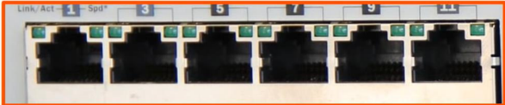

Figure 1

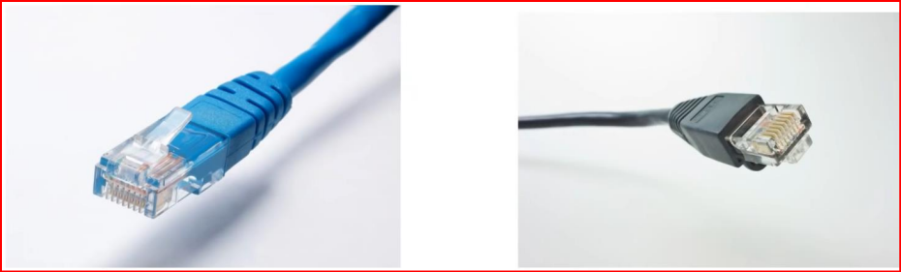

Figure 2

* Ethernet:

Networking technologies commonly used in local area networks (LAN), metropolitan area networks (MAN) and wide area networks (WAN). Ethernet is the collections of protocols.

* Bits and bytes:

Network speed is measured in bits per seconds (Kbps, Mbps, Gbps), not bytes per second.

* Twisted-Pair Cables:

The most common type of cabling used for connecting computing devices. Allows for duplex communication. Common twisted-pair cables are:

* Straight through cables
* Crossover cables
* Auto – MDIX:

Automatic – Medium Dependent Interface allows the switch interface to detect the required cable connection type (straight-through or crossover).

* Duplex Communication:

* **Part – II Ports:**

1. *Fiber optic cables are divided into two categories. Read about them and create a 100-word summary highlighting the key distinctions. The word count should not exceed the set limit, and the summary should be written in your own words.*

Unshielded Twisted Pair and Shielded Twisted Pair cables differ in their susceptibility to electromagnetic interference and radio frequency interference. UTP cables, cost-effective and widely used, lack shielding. Commonly employed in low-interference environments, like offices, UTP is suitable for shorter distances. In contrast, STP cables feature added shielding, protecting against external interference and minimizing signal degradation. Although more expensive, STP is preferred in high-interference settings such as industrial environments. The choice between UTP and STP depends on the specific networking requirements and the desired level of interference protection.

1. *The Straight-through and Crossover cables were discussed in depth in today's session. Write a 100-word paragraph describing their applications and differences.*

Straight through is used to connect different types of devices, such as a computer to a switch or a router to a hub. Both ends of the cable have the same wiring sequence. That is, the wires at one end of the cable are in the same order as the wires at the other end.

Crossover Cable used to connect similar devices, such as two computers or two switches, without an intervening hub or switch. The wiring at one end of the cable is reversed compared to the other end. For example, what is on pin 1 on one end might be on pin 3 on the other end.

1. *What is Auto – MDIX?*

Automatic medium-dependent interface (AutoMDIX) is a feature that allows the switch interface to detect the required cable connection type and automatically configure the connection appropriately. Weather it is straight-through or crossover.

1. *What are different types of cabling as defined by Ethernet standards?*
2. Unshielded Twisted Pair Cabling
3. Fiber Optic Cabling
4. Shielded Twisted Pair Cabling
5. *Which type of UTP cable will be used to connect two routers together, in order to transmit and receive data successfull. Assume Auto – MDIX is not enabled.*

While connecting two routers directly without the use of a switch or hub, and assuming Auto-MDIX (Automatic Medium-Dependent Interface Crossover) is not enabled, you would typically use a crossover cable. A crossover cable is made in such a way that to swap, transmit and receive pairs of wires in the cable, allowing two same devices (such as two routers) to communicate directly with each other.

1. *Which type of UTP cable will be used to connect a PC and a switch together, in order to transmit and receive data successfully. Assume Auto – MDIX is not enabled.*

Straight through cable should be used because it is used to connect the devices with different functionalities e.g. PC and switch*.*

1. *You connect two old routers together with a UTP cable, however data is not successfully sent and received between them. What could be the problem? Choose the correct option and give proper explanation. a) They are connected with a straight-through cable. b) They are connected with a crossover cable. c) They are operating in Auto MDIX mode.*

Older routers typically do not have Auto-MDIX (Automatic Medium-Dependent Interface Crossover) functionality, which means we need to use a crossover cable when connecting them directly. Allowing two like devices (in this case, two routers) to communicate effectively.

* **Part – III Practical Demonstration**

