
COMSATS University Islamabad
Sahiwal Campus (Department of Computer Sciences)

Course Title: | Database Systems |  |  |  | Course Code: |  | CSC270 |  | Credit Hours: | 4(3,1)
Course Instructor: | Afia Afzaal |  |  |  | Program Name: |  |  | BSE
Semester: | 3rd | Batch: | FA24 | Section: | B |  |  | Due Date: | 06-10-2025
CLO 2 | Applying |  |  |  | Maximum Marks: |  |  |  | 10
Student’s Name: |  |  |  |  | Reg. No.

Assignment no.1

(CLO2) Apply the concept of domain and tuple relational calculus.

University Database System
A university is developing a relational database to manage student enrollments, courses, instructors, and academic performance. The database should store information about students, the courses they enroll in, and the instructors who teach them. Each student has a unique student ID, name, and department. Courses have unique course codes, titles, and credit hours. Instructors have unique faculty IDs and names. Students enroll in courses, and their grades are recorded.
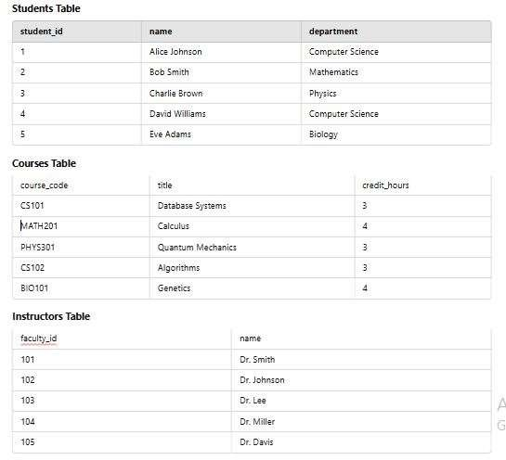

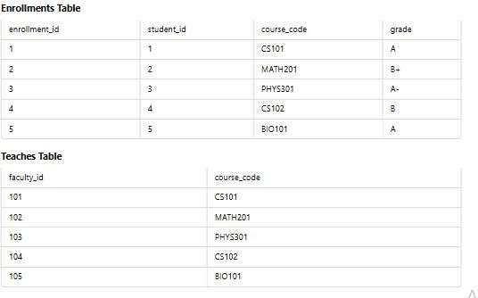

Relational Algebra
Apply relational algebra expressions for these statements Using the given university database schema,:
- Retrieving all students from the 'Computer Science' department.
- Listing all courses with more than 3 credit hours.
- Finding instructors who teach 'Database Systems'.
- Fetching all students enrolled in a specific course (e.g., 'Algorithms').
- Find students who are enrolled in both 'Database Systems' and 'Algorithms'.
- Retrieve the names of students who have not enrolled in any course.
- Display all courses taught by more than one instructor.
- Show students along with the number of courses they have enrolled in.

Instructions : Assignment should be handwritten

