COMSATS UNIVERSITY ISLAMABAD (Average)
(Sahiwal Campus)

SUBMITTED BY:

Name: Minahil Iqbal
Registration No: FA24-BSE-150
Date: 10-12-2025

SUBMITTED TO:
Ma’am Afia Afzal
(Department of Software Engineering)

Q#1: Produce queries for these problems
Task 1:
Construct a SQL statement that creates and populate the DEPT2 table with data from the DEPARTMENTS table. Include only columns that you need.
CODE:
-- Q#1 : Create and Populate DEPT2 Table from DEPARTMENTS
CREATE TABLE DEPT2 AS
SELECT
department_id,
department_name,
location_id
FROM
departments;
DESC DEPT2;
SELECT * FROM DEPT2;
SELECT COUNT(*) AS total_rows FROM DEPT2;

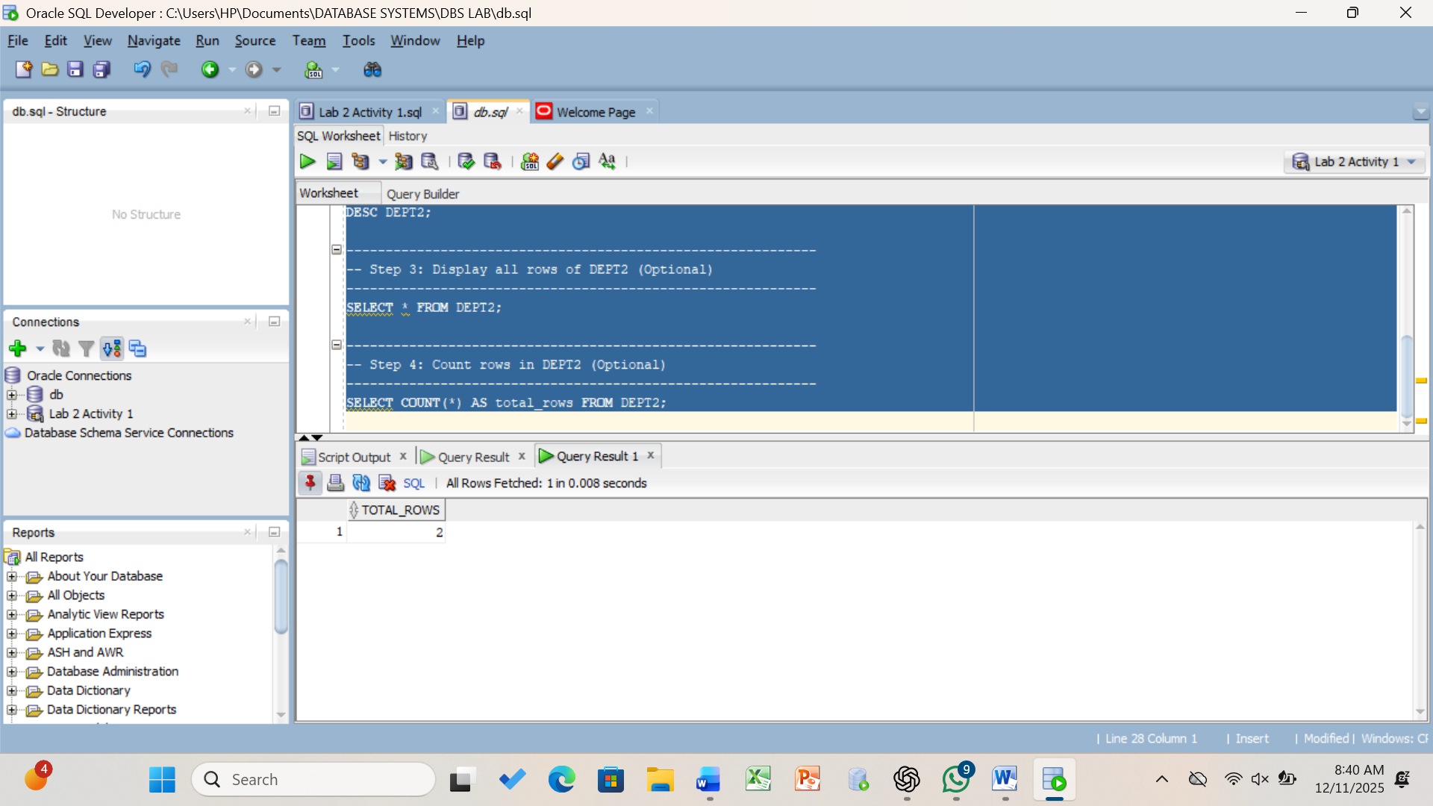

\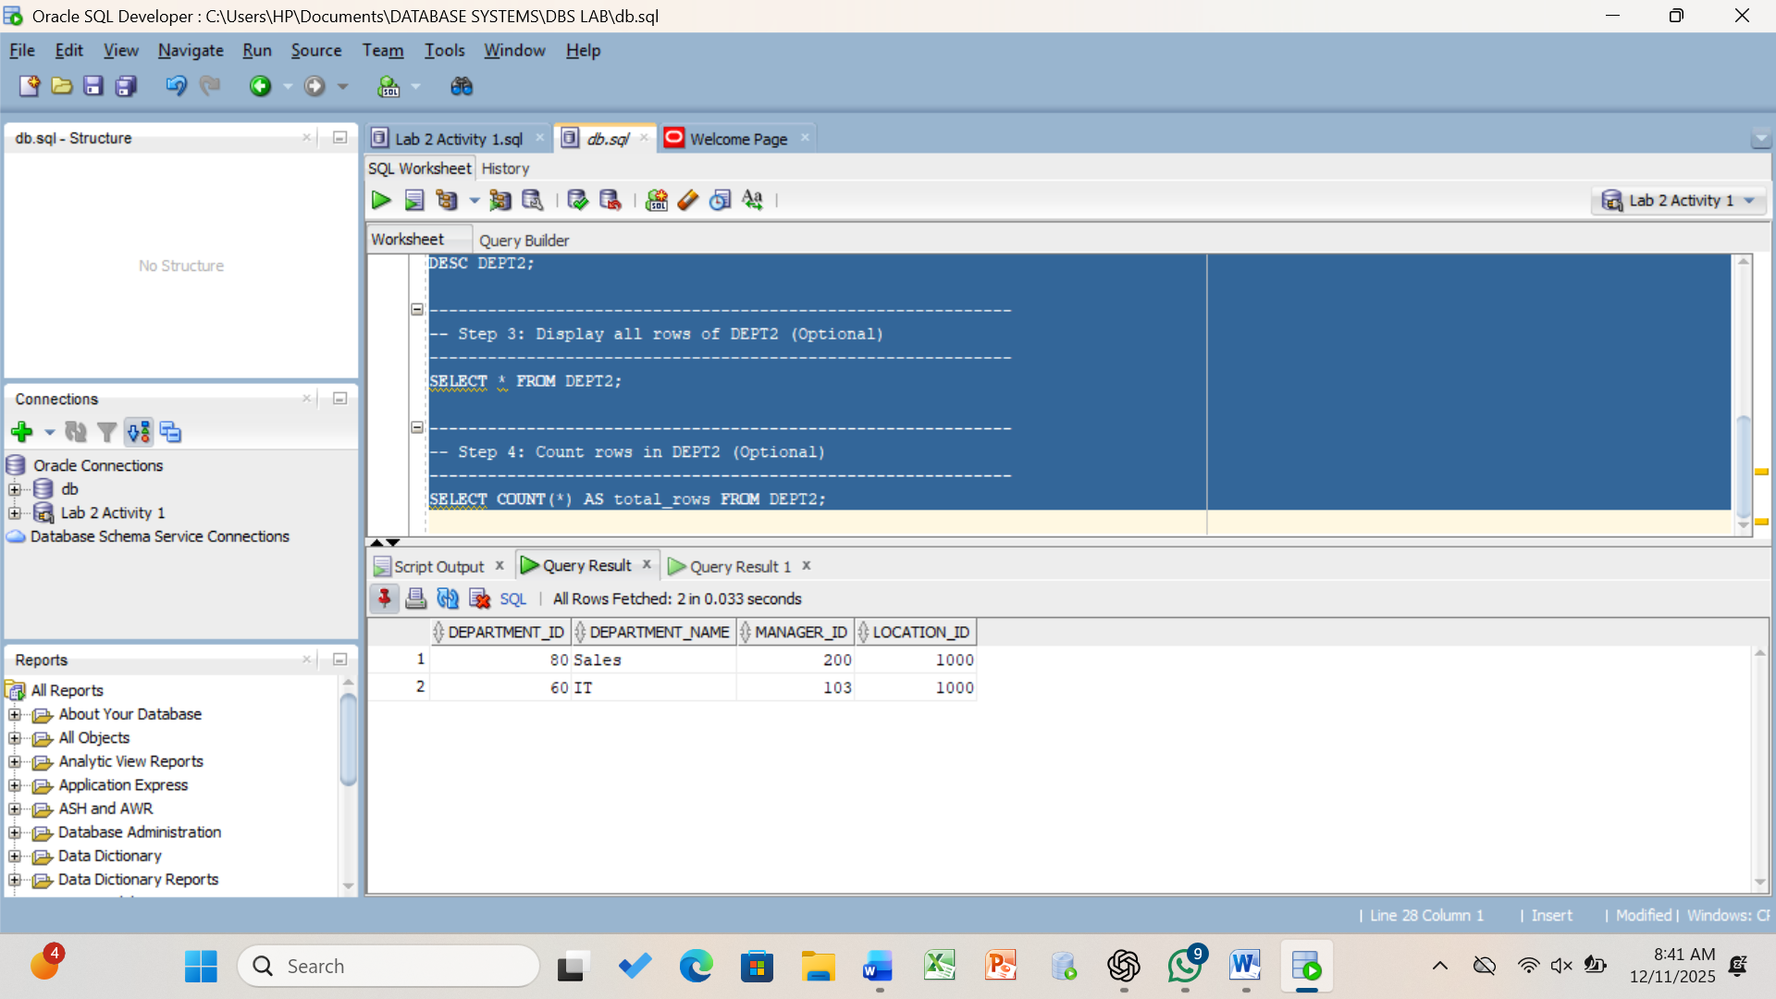

Task 2:
Construct a SQL statement that creates the EMPLOYEES2 table based on the structure of the EMPLOYEES table. Include only the EMPLOYEE_ID, FIRST_NAME, LAST_NAME, SALARY, and DEPARTMENT_ID 114 columns. Name the columns in your new table ID, FIRST_NAME, LAST_NAME, SALARY, and DEPT_ID, respectively
CODE:
-- TASK 2:
-- Create EMPLOYEES2 table based on EMPLOYEES table
-- Include only: EMPLOYEE_ID, FIRST_NAME, LAST_NAME, SALARY, DEPARTMENT_ID
-- Rename them to: ID, FIRST_NAME, LAST_NAME, SALARY, DEPT_ID
CREATE TABLE EMPLOYEES2 AS
SELECT
employee_id AS ID,
first_name AS FIRST_NAME,
last_name AS LAST_NAME,
salary AS SALARY,
department_id AS DEPT_ID
FROM
employees;
DESC EMPLOYEES2;
SELECT * FROM EMPLOYEES2;
SELECT COUNT(*) AS total_rows FROM EMPLOYEES2;

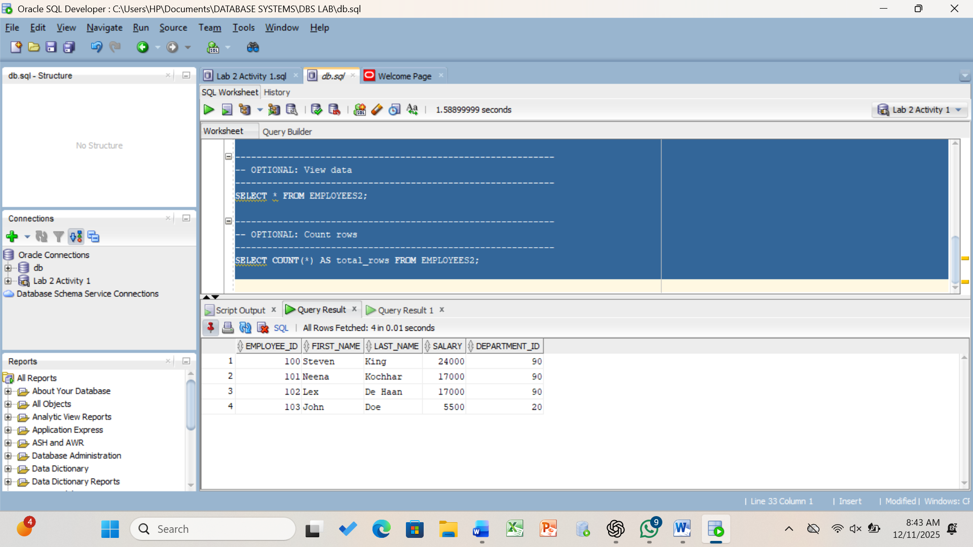

Task 3:
Construct a SQL statement that inserts one row in Employees2. Drop table Employees2

CREATE TABLE EMPLOYEES2 AS
SELECT
employee_id AS ID,
first_name AS FIRST_NAME,
last_name AS LAST_NAME,
salary AS SALARY,
department_id AS DEPT_ID
FROM
employees;
DESC EMPLOYEES2;
SELECT * FROM EMPLOYEES2;
INSERT INTO EMPLOYEES2 (ID, FIRST_NAME, LAST_NAME, SALARY, DEPT_ID)
VALUES (999, 'AliZEY', 'Khan', 50000, 90);
SELECT * FROM EMPLOYEES2 WHERE ID = 999;

DROP TABLE EMPLOYEES2;
-- SELECT * FROM EMPLOYEES2;

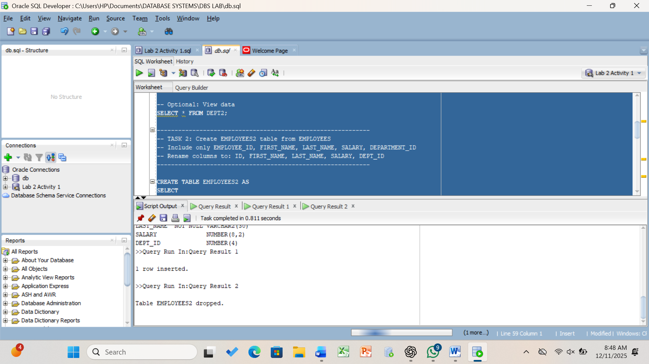
Task 4:
Construct a SQL statement that alters the data type of first_name to varchar2(50)

CREATE TABLE EMPLOYEES2 AS
SELECT
employee_id AS ID,
first_name AS FIRST_NAME,
last_name AS LAST_NAME,
salary AS SALARY,
department_id AS DEPT_ID
FROM employees;
DESC EMPLOYEES2;
-- Step 3: Alter FIRST_NAME column to VARCHAR2(50)
ALTER TABLE EMPLOYEES2
MODIFY first_name VARCHAR2(50);
DESC EMPLOYEES2;

\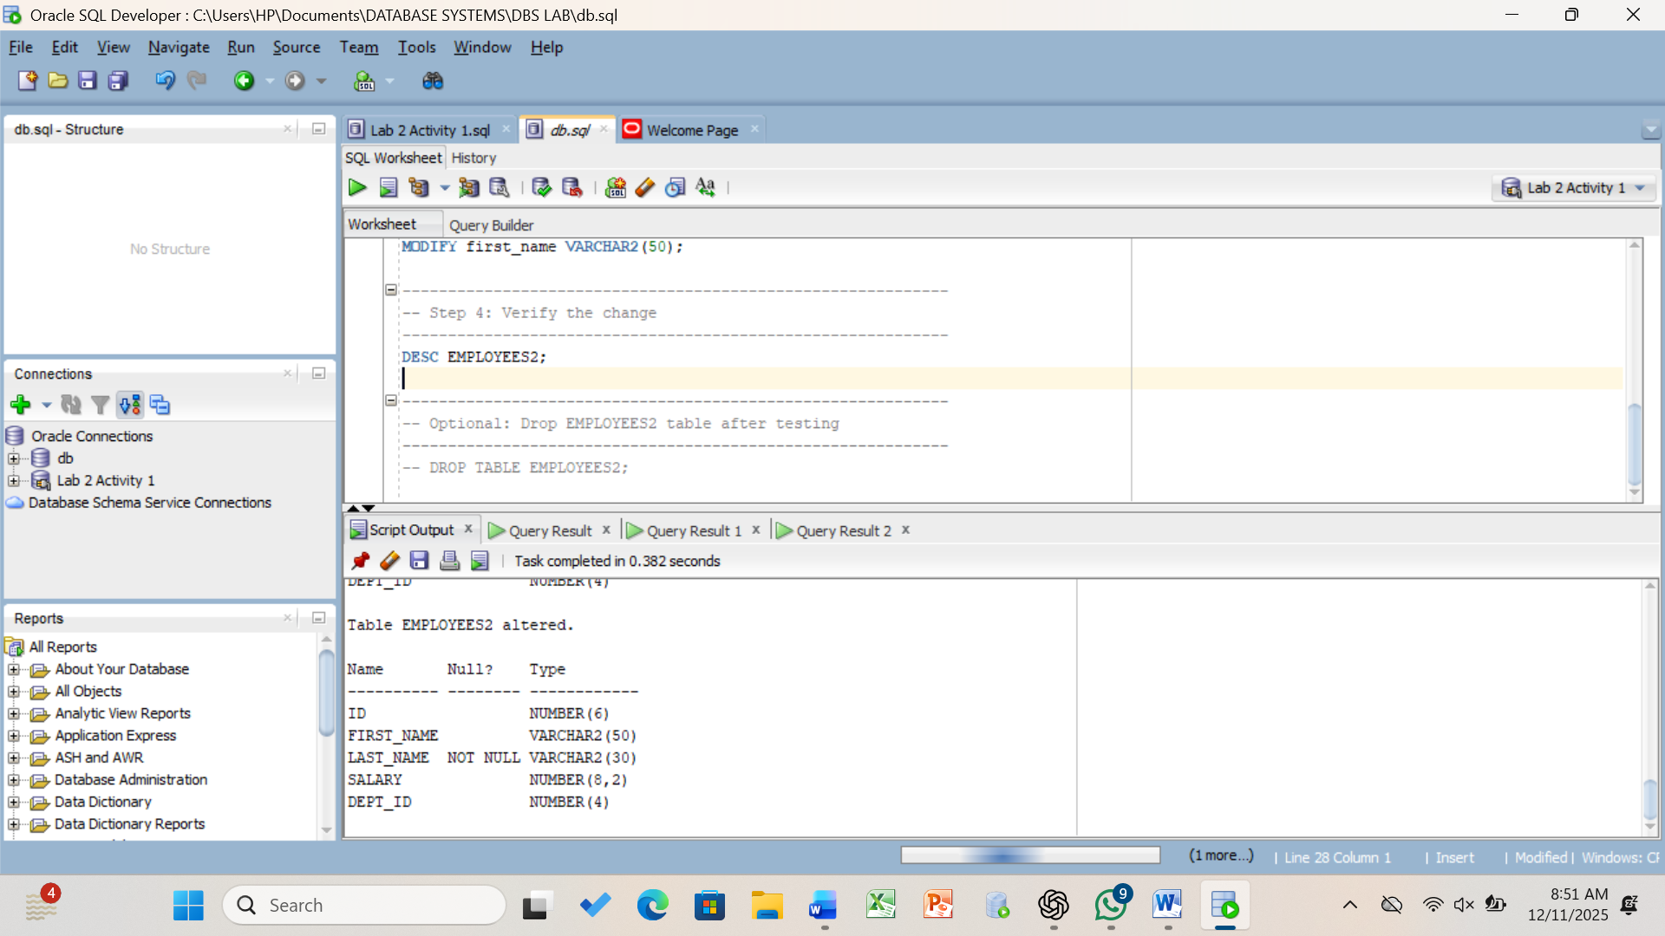

Question 2:
WORKING ON MongoDB
Task 1:
Listings where property_type is House
db.listings.find({ property_type: "House" });
db.listings.countDocuments({ property_type: "House" });
Output:
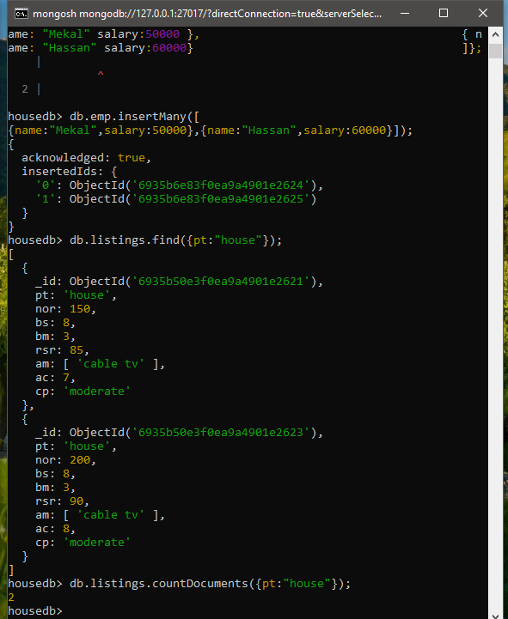
Task 2:
Listings with more than 100 reviews
db.listings.find({ number_of_reviews: { $gt: 100 } });
db.listings.countDocuments({ number_of_reviews: { $gt: 100 } });
Output:
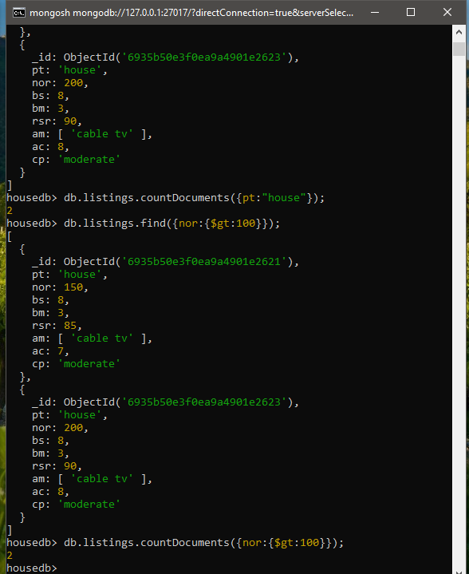

Task 3:
Count listings having 8 beds
db.listings.countDocuments({ beds: 8 });
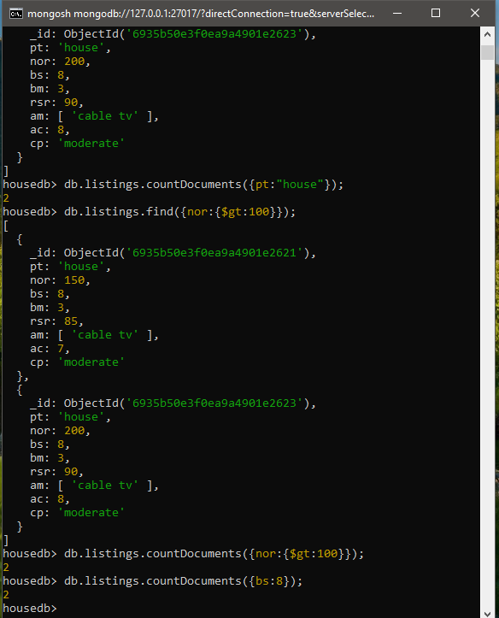
Output:

Task 4:
Listings with 3 bedrooms & rating > 80
db.listings.countDocuments({
bedrr

Rooms: 3,
review_scores_rating: { $gt: 80 }
});
Output:
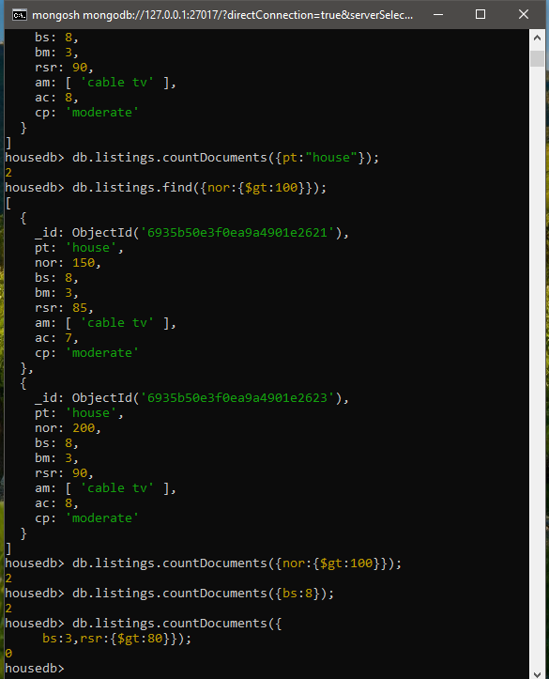

Task 5:
Listings with Cable TV, >6 accommodates & moderate cancellation

db.listings.find({
amenities: "Cable TV",
accommodates: { $gt: 6 },
cancellation_policy: "moderate"
});
db.listings.countDocuments({
amenities: "Cable TV",
accommodates: { $gt: 6 },
cancellation_policy: "moderate"
});

Outp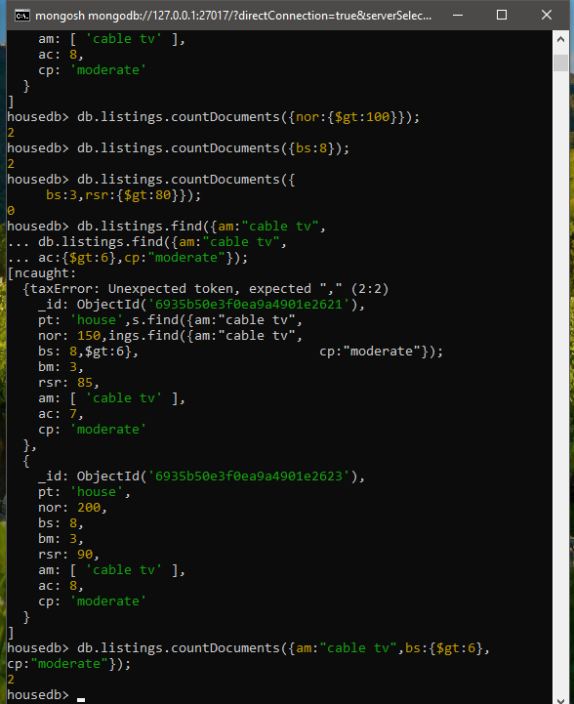ut:



Task 6:
Increase salary of all employees by 10%
db.employees.updateMany( {},{ $mul: { salary: 1.10 } });

