University of Azad Jammu & Kashmir Muzaffarabad



Name |  | Hassan Gillani
Roll No. |  | 2024-SE-42
Instructor Name |  | Engr. Asma Javed
Course Title |  | Computer Network
Semester |  | 4nd Semester
Assignment |  | 02
Submission Date |  | 2026-09-21

Department of Software Engineering

COMPUTER NETWORKS Lab 8

MAC ADDRESS TABLE AND SWITCH LEARNING

1. Objective
To observe how a switch learns MAC addresses by checking the MAC address table before and after communication between PCs, and to clear the learned MAC-address entries.

2. Network Setup
We create a simple switched network in Cisco Packet Tracer with a switch and two PCs. Assign IPv4 addresses to both PCs in the same network so that they can communicate.
Device | Example IPv4 Address | Subnet Mask
PC1 | 192.168.1.10 | 255.255.255.0
PC2 | 192.168.1.11 | 255.255.255.0

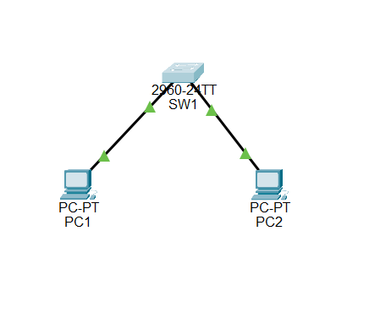

3. Procedure

Part A — Create and Configure the Network
- Place one switch and two PCs in the Packet Tracer workspace.
- Connect each PC to the switch using copper straight-through Ethernet cables.
- Configure the two PCs with the IPv4 addresses shown above and subnet mask 255.255.255.0.

Part B — Check the MAC Address Table Before Ping
Open the switch CLI and enter:
Switch> enable
Switch# show mac address-table

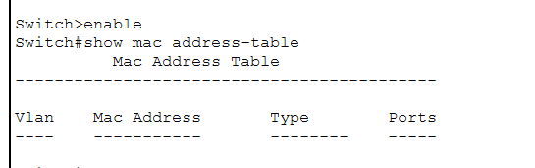
Depending on the Packet Tracer state and traffic already generated, the table is empty.

Part C — Ping Between PCs
On PC1, open Desktop → Command Prompt and enter:
ping 192.168.1.11

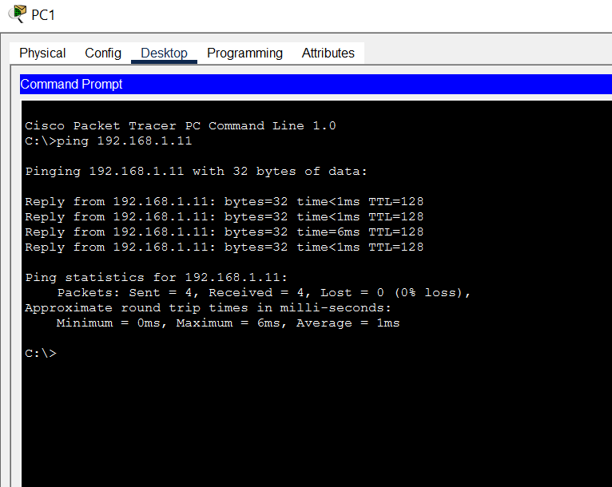
Successful replies confirm connectivity between the two PCs and generate Ethernet traffic that allows the switch to learn source MAC addresses.

Part D — Check the MAC Address Table After Ping
Return to the switch CLI and enter:
show mac address-table
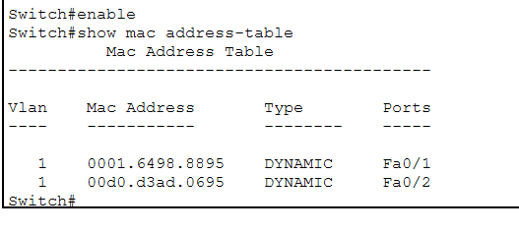
Compare the table with the earlier observation. The switch should have learned dynamic MAC addresses associated with the active switch ports.

Part E — Clear the MAC Address Table
On the switch, use:
clear mac address-table dynamic
Then verify with:
show mac address-table
The dynamic entries should be cleared, although new entries can appear again when traffic is generated.

5. Result
The switch MAC address table was observed before and after PC communication. The switch learned MAC addresses from network traffic, and the dynamic MAC-address entries were cleared using the appropriate CLI command.
Before the ping, the MAC address table contained no dynamic entries. After PC1 successfully pinged PC2, the switch learned the MAC addresses of both PCs and associated them with Fa0/1 and Fa0/2. The entries were displayed as DYNAMIC. After using the clear mac address-table dynamic command, the dynamic MAC entries were removed from the table.

6. Conclusion
This lab demonstrated the basic MAC-learning behavior of a Layer 2 switch. Checking the table before and after a ping showed how communication causes the switch to associate source MAC addresses with switch ports.

