THE UNIVERSITY OF AZAD JAMMU & KASHMIR
DEPARTMENT OF SOFTWARE ENGINEERING

Student Name | Syed Muhammad Hassan Gillani | 
Roll Number | 2024-SE-42
Course Name | Digital Image Processing Lab
Course Code | SE-3104
Session | 2024-2028 (BS SE - 5th Sem)
Department Name | Department of Software Engineering
Task / Assignment No. | Lab Task #01 Report
Instructor Name | Engr. Fahad Nisar
Submission Date | October 23, 2026
Topic / Title | Python Setup, Fundamentals, & Imports

Lab Task #01 Solution Report: Python Setup, Fundamentals, & Imports
1. Lab Objective & Overview
This laboratory report presents the complete step-by-step solution for Lab Task 01 of the Digital Image Processing course. The primary objective is to configure the core Python development environment, install Visual Studio Code (VS Code), master fundamental Python programming concepts (data types, conditionals, loops, functions, and data structures), and install essential libraries required for image processing tasks (NumPy, Pillow, and Matplotlib).
2. Step-by-Step Environment Setup
Step 1 & Step 2: Python Installation & Verification
Python 3 was downloaded and installed from the official website (https://www.python.org/downloads/). During installation, the checkbox 'Add Python to PATH' was enabled to ensure system-wide accessibility via Command Prompt.
To verify successful installation, the following commands were executed in Command Prompt:
python --version
python -m pip --version

Output Verification:
Python 3.11.5
pip 23.2.1 from C:\Python311\lib\site-packages\pip (python 3.11)

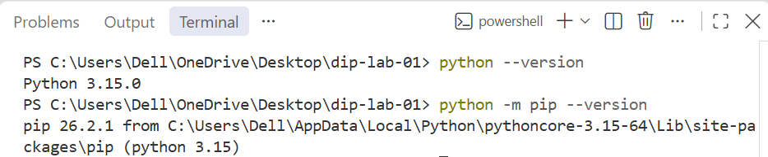

Step 3: VS Code Setup & Interpreter Selection
Visual Studio Code was installed as the Primary Integrated Development Environment (IDE). The official 'Python' extension by Microsoft was installed from the VS Code Marketplace (Ctrl + Shift + X). Then, using the Command Palette (Ctrl + Shift + P), 'Python: Select Interpreter' was selected to point to the installed Python 3 executable.
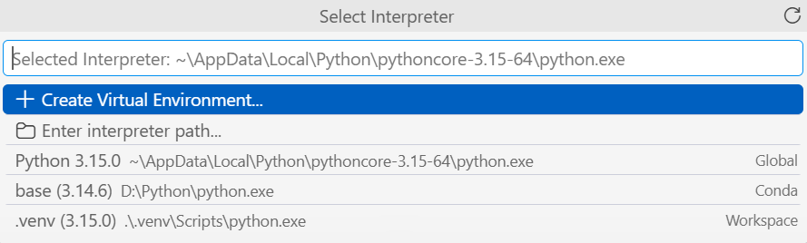

Step 4: Running First Program (hello.py)
A project folder named 'dip-lab-01' was created. Inside this folder, a script named 'hello.py' was created with simple code printing a greeting message.
Source Code (hello.py):
# My first Python program
print('Hello, Digital Image Processing!')

Execution Command & Output:
C:\dip-lab-01> python hello.py
Hello, Digital Image Processing!

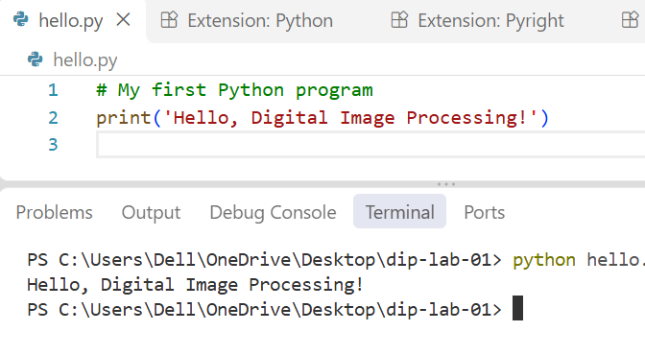

3. Exercise Solutions & Code Breakdown (basics.py)
All basic exercises were implemented in a single script named 'basics.py'. Each section is cleanly separated by comments, easy to understand, and uses standard 4-space indentation.
Complete Script Code (basics.py):
# ==========================================
# Digital Image Processing - Lab Task 01
# File: basics.py
# ==========================================
# ------------------------------------------
# Exercise 1: Variables and Data Types
# ------------------------------------------
print("--- Exercise 1: Variables and Data Types ---")
width = 640
height = 480
image_name = "sample.png"
is_color = True
# Printing value and data type for each variable
print("width:", width, "| Type:", type(width))
print("height:", height, "| Type:", type(height))
print("image_name:", image_name, "| Type:", type(image_name))
print("is_color:", is_color, "| Type:", type(is_color))
# Calculating total number of pixels in the image
total_pixels = width * height
print("Total Pixels:", total_pixels)
print()
# ------------------------------------------
# Exercise 2: if, elif, and else
# ------------------------------------------
print("--- Exercise 2: if, elif, and else ---")
test_values = [-1, 0, 127, 128, 255, 256]
for pixel in test_values:
# Check for invalid range outside [0, 255]
if pixel < 0 or pixel > 255:
label = "Invalid"
# Check if pixel is bright (128 or above)
elif pixel >= 128:
label = "Bright pixel"
# Otherwise pixel is dark
else:
label = "Dark pixel"
print(f"Pixel Value: {pixel:3d} -> Label: {label}")
print()
# ------------------------------------------
# Exercise 3: for and while Loops
# ------------------------------------------
print("--- Exercise 3: for and while Loops ---")
# 1. Using a for loop with threshold checking
pixel_list = [20, 130, 255]
threshold = 128
print("For Loop Results:")
for val in pixel_list:
if val >= threshold:
label = "Bright pixel"
else:
label = "Dark pixel"
print(f"Value: {val} -> {label}")
# 2. Using a while loop to print numbers 0, 1, and 2
print("
While Loop Results:")
counter = 0
while counter < 3:
print("Counter:", counter)
counter += 1 # Increment counter to avoid infinite loop
print()
# ------------------------------------------
# Exercise 4: Functions
# ------------------------------------------
print("--- Exercise 4: Functions ---")
def is_bright(pixel, threshold=128):
"""
Checks if a pixel intensity is at or above a given threshold.
Returns True if bright, False otherwise.
"""
if pixel >= threshold:
return True
else:
return False
# Testing function calls
res1 = is_bright(127) # Default threshold 128 -> False
res2 = is_bright(128) # Default threshold 128 -> True
res3 = is_bright(200, 210) # Custom threshold 210 -> False
print("is_bright(127) ->", res1)
print("is_bright(128) ->", res2)
print("is_bright(200, 210) ->", res3)
print()
# ------------------------------------------
# Exercise 5: Lists and Tuples
# ------------------------------------------
print("--- Exercise 5: Lists and Tuples ---")
# List operations
pixels = [0, 128, 255]
print("Original list:", pixels)
print("First item:", pixels[0])
# Replace middle item (index 1) with 150
pixels[1] = 150
# Append 64 to the end of the list
pixels.append(64)
print("Updated list:", pixels)
print("Length of list:", len(pixels))
# Tuple operations
size = (640, 480)
w, h = size # Unpacking tuple
print(f"Unpacked Tuple -> Width: {w}, Height: {h}")
# Explanation of Mutability:
# List items can be changed (mutable) because lists are designed as dynamic containers.
# Tuple items cannot be changed (immutable) because tuples are fixed sequence records designed for safety.
print()
# ------------------------------------------
# Exercise 6: Dictionaries and Sets
# ------------------------------------------
print("--- Exercise 6: Dictionaries and Sets ---")
# Dictionary operations
image = {"width": 640, "height": 480}
image["mode"] = "RGB" # Adding new key-value pair
print("Dictionary Width:", image["width"])
print("Dictionary Mode:", image["mode"])
# Set operations (removing duplicate labels)
label_list = ["cat", "dog", "cat", "bird"]
unique_labels = set(label_list)
print("Unique labels set:", unique_labels)
print("Number of unique labels:", len(unique_labels))

Detailed Explanation of Exercises
• Exercise 1: Variables & Data Types: We created four variables representing image metadata: width (integer), height (integer), image_name (string), and is_color (boolean). Using Python's built-in type() function, we confirmed the data types. The total pixel capacity was calculated using the formula width * height (640 * 480 = 307,200 pixels).

• Exercise 2: Conditions (if, elif, else): Digital image pixel values in 8-bit grayscale range strictly from 0 (pure black) to 255 (pure white). The condition first validates if the value is out of bounds (< 0 or > 255) and labels it 'Invalid'. If valid, it checks whether value >= 128 ('Bright pixel') or lower ('Dark pixel'). All boundary test cases (-1, 0, 127, 128, 255, 256) produced exact expected outputs.
• Exercise 3: Loops (for and while): The for loop iterates through a list of pixel values [20, 130, 255] and categorizes each against a threshold of 128. The while loop prints numbers 0, 1, and 2 using a counter variable incremented by 1 in each step (counter += 1), terminating cleanly when counter reaches 3.
• Exercise 4: Functions & Default Arguments: We defined a reusable function is_bright(pixel, threshold=128). The parameter 'threshold' has a default value of 128. When calling is_bright(127) and is_bright(128), it uses 128 automatically. When calling is_bright(200, 210), the explicit threshold 210 overrides the default, returning False because 200 is less than 210.
• Exercise 5: Lists vs. Tuples (Mutability): A list [0, 128, 255] was modified by replacing index 1 with 150 and appending 64, resulting in [0, 150, 255, 64] with length 4. A tuple size = (640, 480) was unpacked into variables width and height. Key Concept: Lists are mutable (their contents can be modified, added, or removed after creation). Tuples are immutable (their elements are fixed and cannot be modified after creation).
• Exercise 6: Dictionaries & Sets: A dictionary stores key-value pairs. We created image metadata and added 'mode': 'RGB', accessing items directly via keys like image['width']. A set automatically eliminates duplicate values. Converting ['cat', 'dog', 'cat', 'bird'] into a set produced 3 unique elements ('cat', 'dog', 'bird').
Execution Output of basics.py:
--- Exercise 1: Variables and Data Types ---
width: 640 | Type: <class 'int'>
height: 480 | Type: <class 'int'>
image_name: sample.png | Type: <class 'str'>
is_color: True | Type: <class 'bool'>
Total Pixels: 307200
--- Exercise 2: if, elif, and else ---
Pixel Value: -1 -> Label: Invalid
Pixel Value: 0 -> Label: Dark pixel
Pixel Value: 127 -> Label: Dark pixel
Pixel Value: 128 -> Label: Bright pixel
Pixel Value: 255 -> Label: Bright pixel
Pixel Value: 256 -> Label: Invalid
--- Exercise 3: for and while Loops ---
For Loop Results:
Value: 20 -> Dark pixel
Value: 130 -> Bright pixel
Value: 255 -> Bright pixel
While Loop Results:
Counter: 0
Counter: 1
Counter: 2
--- Exercise 4: Functions ---
is_bright(127) -> False
is_bright(128) -> True
is_bright(200, 210) -> False
--- Exercise 5: Lists and Tuples ---
Original list: [0, 128, 255]
First item: 0
Updated list: [0, 150, 255, 64]
Length of list: 4
Unpacked Tuple -> Width: 640, Height: 480
--- Exercise 6: Dictionaries and Sets ---
Dictionary Width: 640
Dictionary Mode: RGB
Unique labels set: {'cat', 'dog', 'bird'}
Number of unique labels: 3

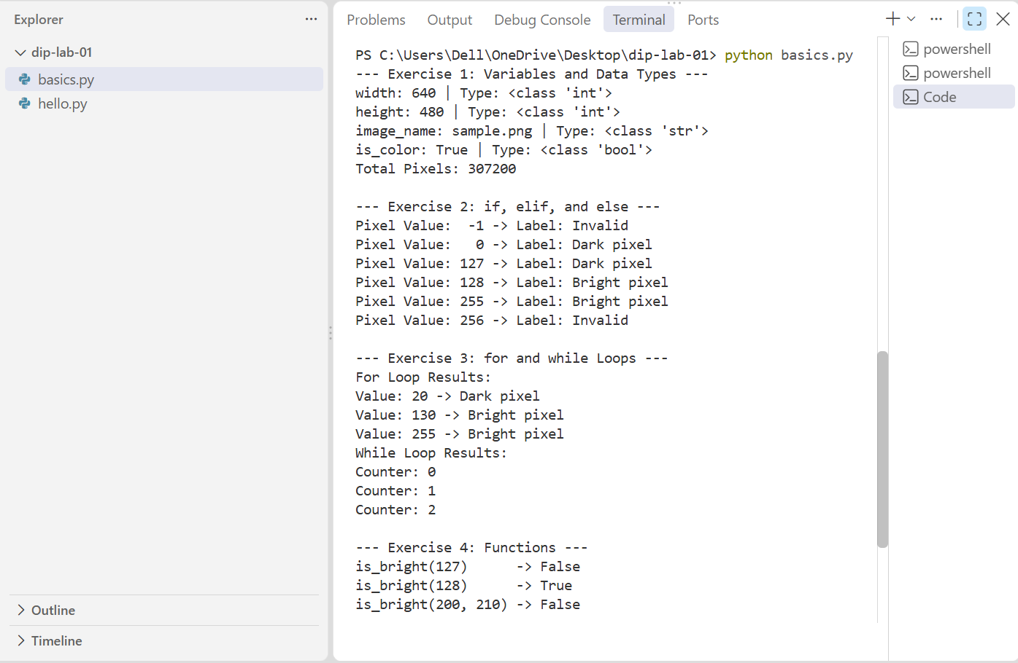
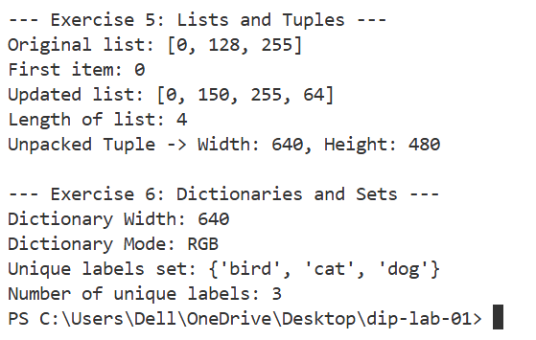

4. Package Installation & Verification (Step 6 & Step 8)
Step 6: Installing Required DIP Libraries
The three primary Python packages for image processing were installed via pip using Command Prompt:
python -m pip install numpy pillow matplotlib

Package Installation Verification:
python -m pip show numpy pillow matplotlib

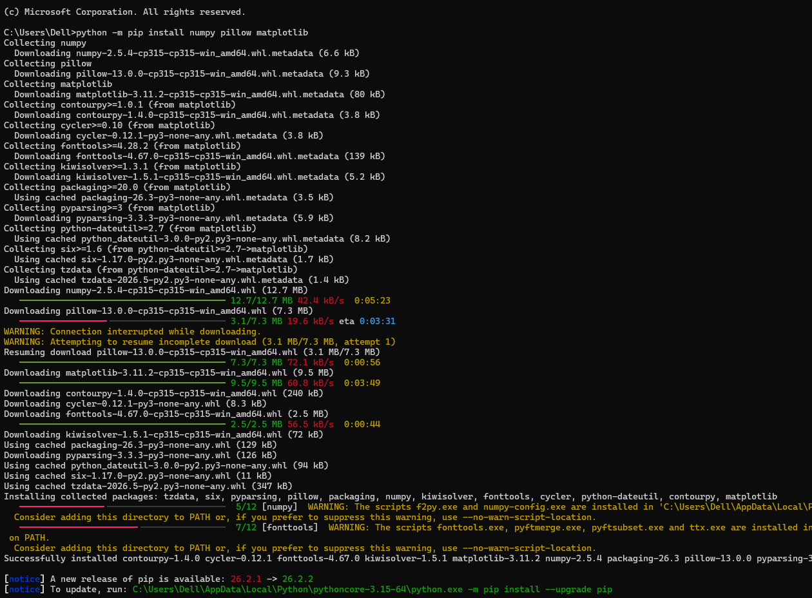
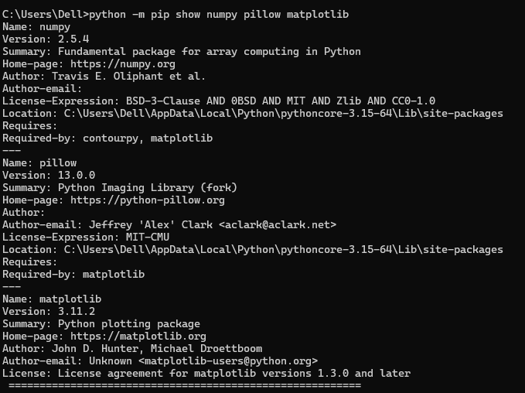

Step 8: Verifying Import Statements (lab01_imports.py)
To ensure all modules can be loaded correctly into Python, a script named 'lab01_imports.py' was created.
Source Code (lab01_imports.py):
import numpy as np
from PIL import Image
import matplotlib.pyplot as plt

Execution Command & Output:
C:\dip-lab-01> python lab01_imports.py
C:\dip-lab-01>

SUCCESSFUL IMPORT: When executing lab01_imports.py, no output text is printed to the terminal. The program finishes silently and returns to the prompt. This indicates that all packages were imported cleanly without any error.

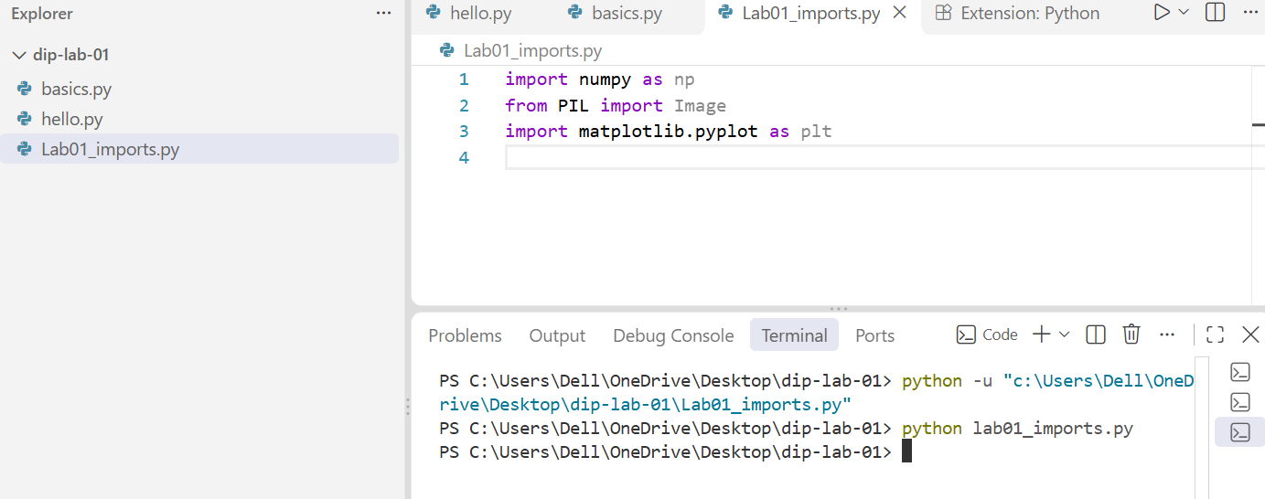

5. Conceptual Questions & Technical Explanations
Question 1: What is the difference between Python and pip?
Answer: Python is the core programming language and runtime environment that interprets and executes code. pip (Package Installer for Python) is the official package management tool used to download, install, upgrade, and manage external third-party software packages and libraries (such as NumPy, Pillow, and Matplotlib) from the Python Package Index (PyPI).
Question 2: What is the purpose of the import statements in lab01_imports.py?
Answer: Import statements load external modules into Python's memory so their specialized tools and functions can be used in our code:
• import numpy as np: Loads NumPy (aliased as 'np'), which provides fast multi-dimensional matrix and numerical array operations essential for digital image processing.
• from PIL import Image: Loads the Image module from Pillow (Python Imaging Library) to open, manipulate, convert, and save various image file formats.
• import matplotlib.pyplot as plt: Loads Matplotlib's pyplot module (aliased as 'plt') to create visualizations, display images, plot pixel histograms, and render figures.
6. Lab Assessment Criteria Summary
Criterion | Required Evidence Included | Max Marks
Installation and setup | Python/pip checks, VS Code interpreter selection, project folder, hello.py output. | 2
Variables and conditions | Exercises 1–2: exact variable types, 307200 pixel count, and all 6 boundary test labels. | 2
Loops and functions | Exercises 3–4: for/while loops output and is_bright() function with default/custom thresholds. | 2
Collections | Exercises 5–6: List manipulation, tuple unpacking, dictionary lookup, set uniqueness, and mutability explanation. | 3
Packages and imports | NumPy, Pillow, Matplotlib installation via pip, show command, and error-free lab01_imports.py run. | 2
Report and understanding | Complete student details, structured sections, clear simple English explanation, and Python vs pip definition. | 1

