THE UNIVERSITY OF AZAD JAMMU & KASHMIR
DEPARTMENT OF SOFTWARE ENGINEERING

Student Name | Syed Muhammad Hassan Gillani | 
Roll Number | 2024-SE-42
Course Name | Digital Image Processing Lab
Course Code | SE-3104
Session | 2024-2028 (BS SE - 5th Sem)
Department Name | Department of Software Engineering
Task / Assignment No. | Lab Task #03 Report
Instructor Name | Engr. Fahad Nisar
Submission Date | November 1, 2026
Topic / Title | Image Enhancement & Pointwise Intensity Transformation

LAB TASK REPORT 03
Image Enhancement & Pointwise Intensity Transformations

1. Overview and Objectives
The core objective is to master spatial domain pointwise intensity transformations, understanding both the manual mathematical operations and their Python implementation inside VS Code using Jupyter Notebooks (.ipynb).
Lab Task Objectives:
- Perform step-by-step calculations for pixel intensity transformations prior to coding.
- Implement overflow prevention algorithms (8-bit unsigned integer clipping within [0, 255]).
- Calculate Brightness adjustment (+40 and -40) using NumPy array arithmetic.
- Compute Midpoint Centered Contrast scaling (alpha = 1.5 around midpoint 128).
- Generate Image Negatives (s = 255 - r) and binary Thresholding (T = 127).
- Develop an interactive VS Code Jupyter Notebook pipeline to verify array math and display transformed images.
2. Student Exercise: Theoretical Manual Calculations (Page 30)
As instructed on Page 30 of the lab manual, the input pixel array r = [30, 80, 128, 180, 240] is processed step-by-step through Tasks A, B, and C.
Task A: Brightness Adjustment (+40 and -40)
Formula: s = clip(r + beta, 0, 255)
Original Pixel (r) | Add +40 | Brightness +40 (Clipped) | Subtract -40 | Brightness -40 (Clipped)
30 | 70 | 70 | -10 | 0 (Clipped)
80 | 120 | 120 | 40 | 40
128 | 168 | 168 | 88 | 88
180 | 220 | 220 | 140 | 140
240 | 280 | 255 (Clipped) | 200 | 200

Task B: Midpoint Centered Contrast (alpha = 1.5 around 128)
Formula: s = clip(round((r - 128) * 1.5 + 128), 0, 255)
Original (r) | r - 128 | Multiply x 1.5 | Add 128 | Exact Float | Final Clipped Pixel
30 | -98 | -147 | -19 | -19.0 | 0 (Clipped)
80 | -48 | -72 | 56 | 56.0 | 56
128 | 0 | 0 | 128 | 128.0 | 128 (Unchanged)
180 | 52 | 78 | 206 | 206.0 | 206
240 | 112 | 168 | 296 | 296.0 | 255 (Clipped)

Task C: Image Negative & Binary Thresholding (T = 127)
Negative Formula: s_neg = 255 - r
Threshold Formula: s_thresh = 255 if r > 127 else 0
Original Pixel (r) | 255 - r | Negative Pixel | r > 127 ? | Threshold Output (T=127)
30 | 255 - 30 | 225 | 30 > 127 (No) | 0
80 | 255 - 80 | 175 | 80 > 127 (No) | 0
128 | 255 - 128 | 127 | 128 > 127 (Yes) | 255
180 | 255 - 180 | 75 | 180 > 127 (Yes) | 255
240 | 255 - 240 | 15 | 240 > 127 (Yes) | 255

3. VS Code Jupyter Notebook Implementation
The complete solution was implemented in a VS Code Jupyter Notebook file (lab03_tasks.ipynb). Python's NumPy, OpenCV, and Matplotlib libraries were used to compute array math and display image enhancement outputs.
Cell 1: Verification of Page 30 Pixel Array Operations
# Cell 1: Verification of Manual Calculations (Page 30)
import numpy as np
# Original pixel array from Page 30
pixels = np.array([30, 80, 128, 180, 240], dtype=np.int16)
# Task A: Brightness (+40 and -40) with np.clip
bright_plus = np.clip(pixels + 40, 0, 255).astype(np.uint8)
bright_minus = np.clip(pixels - 40, 0, 255).astype(np.uint8)
# Task B: Midpoint Centered Contrast (alpha=1.5, pivot=128)
contrast_centered = np.clip((pixels.astype(np.float32) - 128) * 1.5 + 128, 0, 255).astype(np.uint8)
# Task C: Negative and Binary Thresholding (T=127)
negative = (255 - pixels).astype(np.uint8)
thresholded = np.where(pixels > 127, 255, 0).astype(np.uint8)
print("Original Pixels: ", pixels.tolist())
print("Brightness +40: ", bright_plus.tolist())
print("Brightness -40: ", bright_minus.tolist())
print("Centered Contrast: ", contrast_centered.tolist())
print("Image Negative: ", negative.tolist())
print("Thresholded (T=127): ", thresholded.tolist())
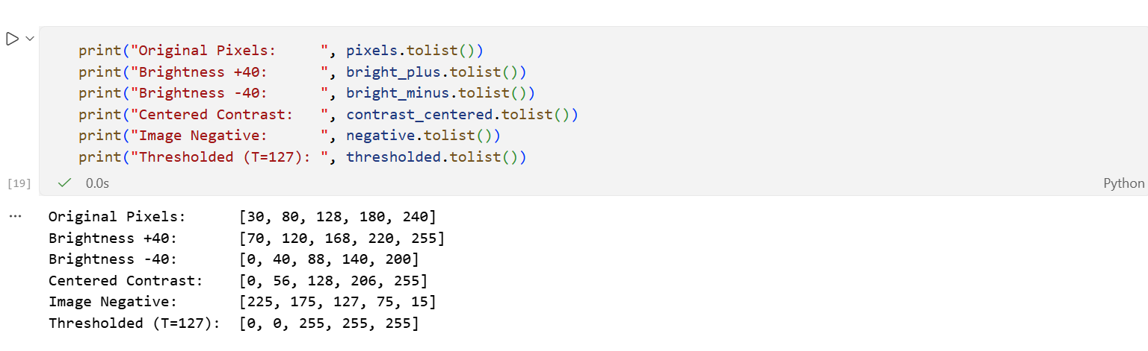
Cell 2: Image Transformation Pipeline & Matplotlib Visualizations
# Cell 2: Image Enhancement Pipeline
import cv2
import numpy as np
import matplotlib.pyplot as plt
# Load test grayscale image (or generate synthetic gradient)
img = cv2.imread("image.jpg", cv2.IMREAD_GRAYSCALE)
if img is None:
img = np.tile(np.linspace(0, 255, 256, dtype=np.uint8), (256, 1))
# Transformations
bright_img = np.clip(img.astype(np.int16) + 40, 0, 255).astype(np.uint8)
dark_img = np.clip(img.astype(np.int16) - 40, 0, 255).astype(np.uint8)
contrast_img = np.clip((img.astype(np.float32) - 128) * 1.5 + 128, 0, 255).astype(np.uint8)
negative_img = (255 - img).astype(np.uint8)
_, thresh_img = cv2.threshold(img, 127, 255, cv2.THRESH_BINARY)
gamma_img = np.clip(255 * np.power(img.astype(np.float32)/255.0, 0.5), 0, 255).astype(np.uint8)
equalized_img = cv2.equalizeHist(img)
# Plotting in Jupyter Notebook
fig, axes = plt.subplots(2, 4, figsize=(15, 7))
titles = ["Original", "Bright (+40)", "Dark (-40)", "Centered Contrast",
"Negative", "Threshold (127)", "Gamma (0.5)", "Equalized"]
images = [img, bright_img, dark_img, contrast_img, negative_img, thresh_img, gamma_img, equalized_img]
for ax, im, title in zip(axes.ravel(), images, titles):
ax.imshow(im, cmap="gray", vmin=0, vmax=255)
ax.set_title(title, fontsize=11, fontweight="bold")
ax.axis("off")
plt.tight_layout()
plt.show()

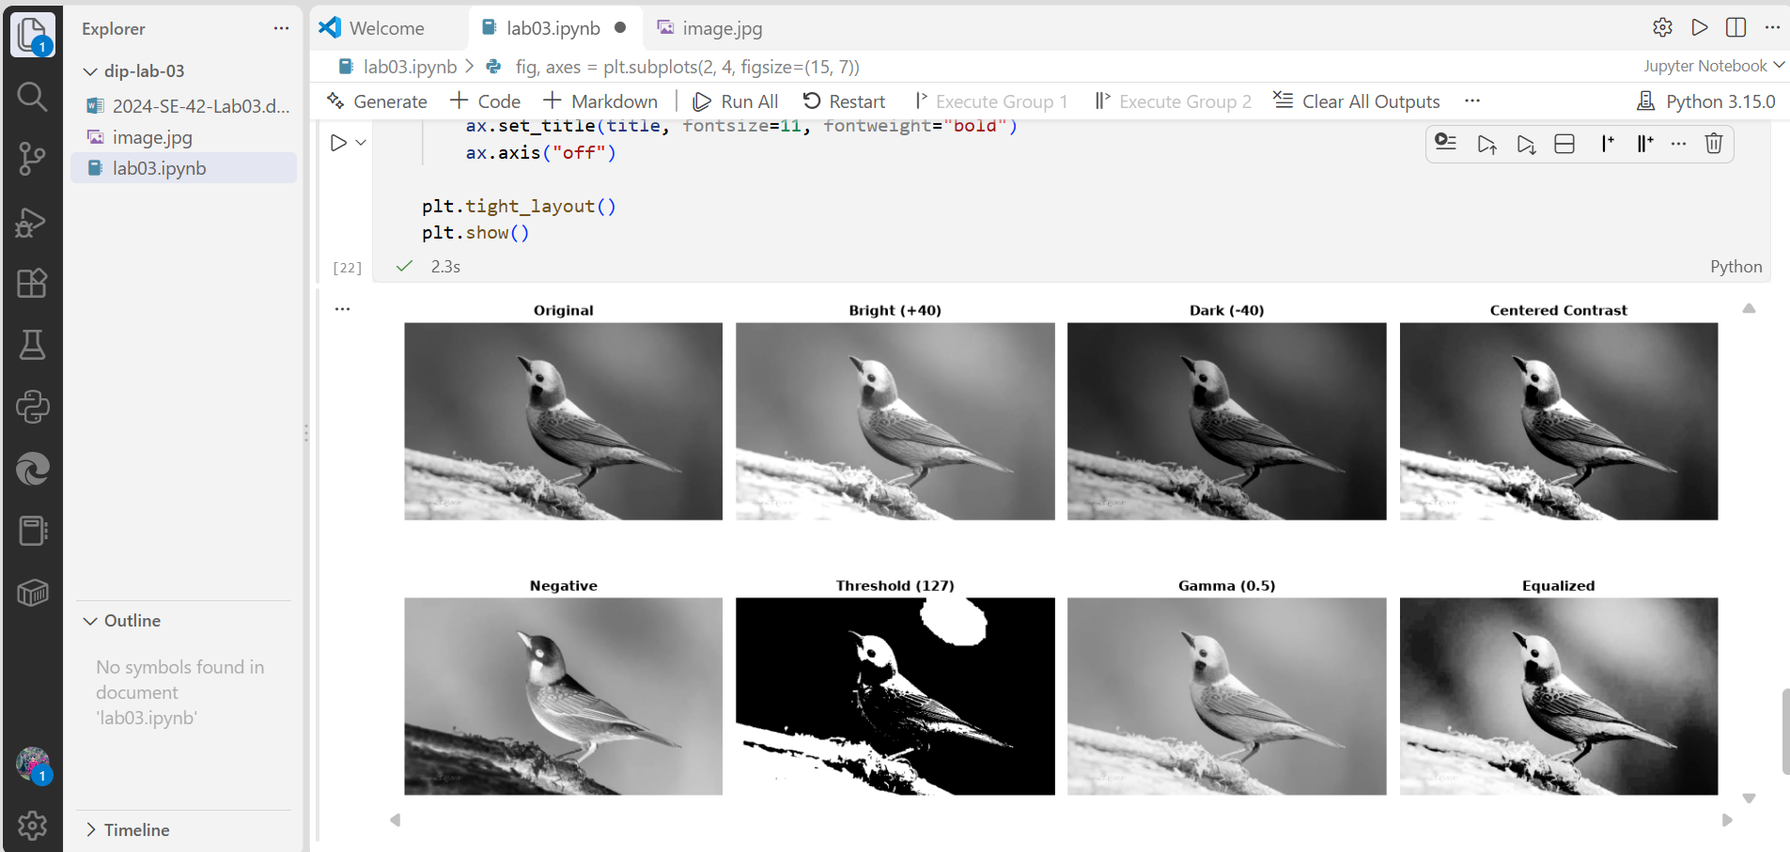

4. Comprehensive Theoretical Analysis & Lab Concepts
4.1 Overflow Prevention & Clipping in 8-Bit Images
In digital image processing, 8-bit images store pixel intensities using unsigned 8-bit integers (np.uint8), which are strictly bounded in the range [0, 255]. Standard uint8 arithmetic wraps around upon overflow (e.g., 240 + 40 = 280 % 256 = 24, causing a bright white pixel to turn dark black). To prevent this arithmetic overflow, intermediate operations must be performed in wider data types (e.g., np.int16 or np.float32), bounded using np.clip(array, 0, 255), and then converted back to uint8.
4.2 Simple Linear Contrast vs. Midpoint Centered Contrast
Simple linear contrast scaling (s = alpha * r) scales all non-zero pixel intensities away from zero. While it increases contrast, it also shifts overall image brightness upward, causing highlight clipping. Conversely, Midpoint Centered Contrast uses intensity 128 as a fixed pivot: pixels darker than 128 become darker, pixels brighter than 128 become brighter, and pixels at 128 remain unchanged. This expands dynamic contrast symmetrically around middle gray.
4.3 Image Histogram and Histogram Equalization
An image histogram plots intensity levels (0–255) against pixel frequency. Histogram Equalization uses the Cumulative Distribution Function (CDF) of pixel frequencies to stretch narrow or clustered intensity distributions across the full [0, 255] range, maximizing global contrast and exposing subtle details in poorly lit images.

