THE UNIVERSITY OF AZAD JAMMU & KASHMIR
DEPARTMENT OF SOFTWARE ENGINEERING

Student Name | Syed Muhammad Hassan Gillani | 
Roll Number | 2024-SE-42
Course Name | Digital Image Processing Lab
Course Code | SE-3104
Session | 2024-2028 (BS SE - 5th Sem)
Department Name | Department of Software Engineering
Task / Assignment No. | Lab Task #03 Report
Instructor Name | Engr. Fahad Nisar
Submission Date | November 07, 2026
Topic / Title | IMAGE ENHANCEMENT AND  INTENSITY TRANSFORMATIONS

LAB TASK 03

Table of Contents
- 1. Introduction and Objectives
- 2. Tools, Libraries and Image Data
- 3. Numeric Handling and Clipping
- 4. Task 1 — Brightness Adjustment
- 5. Task 2 — Linear Contrast from Zero
- 6. Task 3 — Contrast Centered at 128
- 7. Task 4 — Image Negative
- 8. Task 5 — Gamma Correction
- 9. Task 6 — Grayscale Histogram
- 10. Task 7 — Global Histogram Equalization
- 11. Task 8 — CLAHE
- 12. Task 9 — Fixed Binary Thresholding
- 13. Task 10 — Otsu Thresholding
- 14. Task 11 — Adaptive Gaussian Thresholding
- 15. Comparative Discussion
- 16. Conclusion and Learning Outcomes

1. Introduction and Objectives
Digital image processing is the use of computational techniques to analyze and modify digital images. An image can be represented as a matrix of pixel intensity values. In an 8-bit grayscale image, each pixel normally has an intensity between 0 (black) and 255 (white).
This lab explores image enhancement and segmentation methods using Python, OpenCV, NumPy and Matplotlib. The notebook includes hand-calculation dry runs and image-based implementations. Each operation is followed by output checks or observations.

Objectives
- Understand how brightness and contrast transformations change grayscale intensities.
- Implement image negative and gamma correction.
- Calculate and interpret grayscale histograms.
- Apply global histogram equalization and CLAHE for contrast enhancement.
- Separate image regions using fixed, Otsu and adaptive thresholding.
- Prevent arithmetic overflow by using wider numeric types, clipping results and then converting to 8-bit pixels.
- Compare the generated outputs and explain the effect of each method.

2. Tools, Libraries and Image Data
Tool / Property | Use in the notebook
Python | Programming language used to implement the image-processing operations.
OpenCV (cv2) | Image reading, histogram equalization, CLAHE and thresholding.
NumPy | Pixel arrays, arithmetic transformations, clipping and numerical calculations.
Matplotlib | Displaying the original image, transformed images and histograms.
Image dimensions | 529 × 378 pixels
Pixel data type | uint8
Intensity range | 0 to 255

The notebook output reports an image array shape of (529, 378), a uint8 data type, and minimum and maximum intensities of 0 and 255. The exact image filename is not stated in the notebook's introductory text, so this report identifies it by the measured dimensions and output statistics rather than inventing a filename.

3. Numeric Handling and Clipping
The notebook follows a numeric policy: perform arithmetic in a wider data type, restrict values to the valid grayscale interval [0, 255], and only then convert the result to uint8. This avoids overflow and underflow during intermediate calculations.
result = np.clip(raw_values, 0, 255).astype(np.uint8)
Clipping means values below 0 become 0 and values above 255 become 255. Direct arithmetic in uint8 can wrap around because uint8 cannot represent negative values or values greater than 255. Wider types such as int16, int32 or float32 are therefore used for calculations.
Term | Meaning
Overflow | A calculated value exceeds the maximum representable value of the data type.
Underflow | A calculated value falls below the minimum representable value.
Clipping | Restricting values to the permitted range, here 0–255.
Saturation | Multiple out-of-range values become the same endpoint value, possibly losing detail.

4. Task 1 — Brightness Adjustment
Brightness adjustment adds or subtracts a constant β from every pixel. The operation shifts the intensity values without directly changing the distance between unsaturated pixel values.
s = r + β

Sample calculation
The dry-run input is [30, 80, 128, 180, 240]. For β = +40, the raw result is [70, 120, 168, 220, 280]; after clipping it becomes [70, 120, 168, 220, 255]. For β = −40, the raw result is [−10, 40, 88, 140, 200]; after clipping it becomes [0, 40, 88, 140, 200].

Implementation and verification
The notebook also implements the operation using a nested loop and compares it with the vectorized NumPy result. The check reports: Nested-loop result matches NumPy: True.

Observation
Adding 40 makes the image brighter, while subtracting 40 makes it darker. Values that cross the 0–255 limits are clipped, so details may be lost in saturated dark or bright regions.

5. Task 2 — Linear Contrast from Zero
Linear contrast from zero multiplies each input intensity by α. The notebook uses α = 1.5 and β = 0. It increases the distance of pixel values from zero and can push bright values beyond the valid grayscale range.
s = αr + β where α = 1.5 and β = 0
For the sample [30, 80, 128, 180, 240], the raw result is [45, 120, 192, 270, 360]. After clipping and conversion, the result is [45, 120, 192, 255, 255]. The input values 180 and 240 are saturated at 255.
For the actual image, the notebook reports an original mean intensity of 124.9527 and a transformed mean intensity of 179.5960. A total of 50,806 pixels were clipped to 255.
Interpretation: the mean intensity increases substantially. The transformation brightens the image but also compresses high-intensity details when several values saturate at white.

6. Task 3 — Contrast Centered at 128
This transformation changes contrast around the midpoint 128. The midpoint remains fixed while values below and above it move farther away or closer to it depending on α.
s = (r − 128)α + 128
The notebook tests α = 1.5 and α = 0.5 using the sample [30, 80, 128, 180, 240].
Input r | Output α = 1.5 | Output α = 0.5
30 | 0 (clipped from −19) | 79
80 | 56 | 104
128 | 128 | 128
180 | 206 | 154
240 | 255 (clipped from 296) | 184

Interpretation: α = 1.5 expands contrast around mid-gray and may clip dark and bright extremes. α = 0.5 compresses intensities toward 128 and reduces contrast. The pivot intensity 128 remains unchanged in both cases.

7. Task 4 — Image Negative
The image-negative transformation reverses the grayscale intensity scale. A dark pixel becomes bright and a bright pixel becomes dark, while the spatial arrangement of pixels remains unchanged.
s = 255 − r
For the sample [30, 80, 128, 180, 240], the negative is [225, 175, 127, 75, 15]. Applying the same operation a second time restores [30, 80, 128, 180, 240].
The notebook verifies this property and reports: Recovered original: True. This confirms that applying the negative transformation twice returns the original pixel values.

8. Task 5 — Gamma Correction
Gamma correction is a nonlinear intensity transformation. The notebook normalizes pixel values to the range 0–1, applies the power γ, and scales the result back to 0–255.
s = 255 × (r / 255)^γ
The notebook tests γ = 0.5 and γ = 2.0 using [0, 64, 128, 192, 255].
Input | γ = 0.5 | γ = 2.0
0 | 0 | 0
64 | 127 | 16
128 | 180 | 64
192 | 221 | 144
255 | 255 | 255

With the convention used here, γ below 1 brightens darker regions, while γ above 1 darkens them. Both transformations preserve the endpoints 0 and 255. The notebook confirms that both outputs have endpoints 0 and 255.
Interpretation: gamma correction adjusts brightness nonlinearly. It is useful when a simple constant brightness shift is not suitable and the darker or brighter parts of an image need selective adjustment.

9. Task 6 — Grayscale Histogram
A grayscale histogram counts the number of pixels at each intensity level. The notebook uses 256 bins to represent the possible grayscale values from 0 through 255. The histogram describes the distribution of intensities but does not preserve pixel positions.
For the small dry-run matrix, the total pixel count is 8. The nonzero frequencies are shown below.
Intensity | Frequency | Probability
0 | 1 | 0.1250
50 | 2 | 0.2500
100 | 2 | 0.2500
150 | 1 | 0.1250
200 | 1 | 0.1250
255 | 1 | 0.1250

For the loaded image, the most frequent intensity is 91, occurring 1,950 times. The intensity range present is 0 to 255.
Interpretation: the histogram helps identify whether the image contains more dark, middle-gray or bright pixels. It cannot show where those pixels are located in the image.

10. Task 7 — Global Histogram Equalization
Global histogram equalization improves contrast by using the cumulative distribution function (CDF) to map the existing intensity values across a wider range. OpenCV provides this operation through cv2.equalizeHist(). One global mapping is applied to the entire image.
equalized = cv2.equalizeHist(gray_image)
In the dry run [50, 50, 100, 150], the frequencies are 2, 1 and 1. The cumulative counts are 2, 3 and 4, producing CDF values 0.50, 0.75 and 1.00. The notebook compares two mappings: 255 × CDF gives [128, 128, 191, 255], while minimum-CDF normalization gives [0, 0, 128, 255].
The notebook notes that OpenCV's discrete implementation may differ in edge cases from a hand-calculated mapping because of its histogram and lookup-table handling.
Interpretation: global equalization can improve overall contrast when the original intensity values occupy a limited range. However, it may amplify noise and may be less effective when illumination varies strongly across different parts of the image.

11. Task 8 — CLAHE
CLAHE stands for Contrast Limited Adaptive Histogram Equalization. Unlike global equalization, it enhances contrast in local image regions. The notebook uses clipLimit = 2.0 and tileGridSize = (8, 8), meaning eight tiles across and eight tiles down.
clahe = cv2.createCLAHE(clipLimit=2.0, tileGridSize=(8, 8))
clahe_image = clahe.apply(gray_image)
The simplified dry run starts with a four-bin histogram [6, 2, 0, 0] and an absolute cap of 4. After clipping, the histogram is [4, 2, 0, 0], with an excess of 2. Redistributing 0.5 to each bin produces [4.5, 2.5, 0.5, 0.5]. The resulting CDF is [0.5625, 0.875, 0.9375, 1.0]. The notebook explicitly explains that this simplified model is not OpenCV's exact integer redistribution and that the absolute cap is not the clipLimit parameter.
Interpolation between neighboring tile mappings helps prevent abrupt transitions or visible block boundaries at tile edges.
Interpretation: CLAHE is often useful when lighting varies across an image because local regions receive separate contrast mappings. It can reveal local detail, although noise may also become more visible.

12. Task 9 — Fixed Binary Thresholding
Fixed binary thresholding converts a grayscale image into a two-level image. The notebook uses the rule that a pixel becomes white (255) when its intensity is strictly greater than the threshold T; otherwise, it becomes black (0).
output = 255 if r > T else 0
For sample pixels [0, 80, 127, 128, 180, 255], threshold T = 127 produces [0, 0, 0, 255, 255, 255], with 3 white pixels. Threshold T = 180 produces [0, 0, 0, 0, 0, 255], with 1 white pixel.
The notebook checks that the fixed-threshold image contains only two unique values: [0, 255].
Interpretation: fixed thresholding is simple and useful when foreground and background intensities are reasonably separated and illumination is consistent. A single threshold may not work well if brightness varies across the image.

13. Task 10 — Otsu Thresholding
Otsu's method automatically selects a global threshold by maximizing between-class variance. For each candidate threshold, the pixels are divided into two groups: class 0 contains intensities r ≤ T and class 1 contains intensities r > T.
threshold, otsu_mask = cv2.threshold(gray_image, 0, 255,
cv2.THRESH_BINARY + cv2.THRESH_OTSU)
For the dry-run values [0, 1, 4, 5], the notebook evaluates candidate thresholds 0 through 4. The maximum between-class variance score is 4.0000 at thresholds 1, 2 and 3. The notebook selects the smallest maximizing threshold, T = 1. The predicted mask is [0, 0, 255, 255].
OpenCV returns a dry-run threshold of 1.0 and the same mask as the manual prediction. For the actual image, OpenCV returns a threshold of 124.0. The output mask contains only 0 and 255. The notebook reports 3,143 pixels differing between the fixed-threshold and Otsu masks.
Interpretation: Otsu works well when the histogram contains distinguishable intensity groups. It still uses one global threshold, so uneven lighting can reduce its effectiveness.

14. Task 11 — Adaptive Gaussian Thresholding
Adaptive thresholding calculates a separate threshold for each pixel using its local neighborhood. The notebook uses Gaussian weighting, binary output, blockSize = 11 and C = 2. The 11 × 11 block is the neighborhood used to calculate local thresholds.
adaptive = cv2.adaptiveThreshold(gray_image, 255,
cv2.ADAPTIVE_THRESH_GAUSSIAN_C, cv2.THRESH_BINARY,
11, 2)
The dry-run neighborhood is [[100, 100, 100], [100, 120, 140], [140, 140, 140]]. The Gaussian weights are [[1, 2, 1], [2, 4, 2], [1, 2, 1]] / 16. The weighted mean is 120.0, so the local threshold is 120 − 2 = 118.0. The center pixel 120 becomes white (255). A pixel equal to the threshold, 118, becomes black (0), because the comparison is strictly greater than T.
For the actual image, the adaptive mask contains only 0 and 255. It differs from the fixed-threshold mask at 56,693 pixels and from the Otsu mask at 55,354 pixels.
Interpretation: adaptive Gaussian thresholding can be effective when brightness changes across the image because the threshold is based on local neighborhoods rather than one global value.

15. Comparative Discussion
The tasks demonstrate that image enhancement and thresholding methods solve different problems. Brightness adjustment shifts intensity values, while contrast transformations change the separation between intensities. Gamma correction applies a nonlinear mapping. Histogram methods redistribute intensities to improve contrast, while thresholding methods convert grayscale images into binary masks.
Method | Type | Main effect / distinction
Brightness adjustment | Point intensity transform | Adds or subtracts a constant from each pixel.
Linear contrast from zero | Point intensity transform | Scales intensities and can saturate highlights.
Contrast centered at 128 | Point intensity transform | Expands or compresses values around a fixed midpoint.
Image negative | Point intensity transform | Reverses grayscale intensity values.
Gamma correction | Nonlinear transform | Brightens or darkens tonal ranges depending on γ.
Grayscale histogram | Image analysis | Counts pixel frequencies at each intensity.
Global equalization | Global enhancement | Uses one CDF-based mapping for the full image.
CLAHE | Local enhancement | Enhances local tiles with contrast limiting.
Fixed threshold | Global segmentation | Uses a user-selected single threshold.
Otsu threshold | Global segmentation | Automatically selects a threshold using between-class variance.
Adaptive Gaussian threshold | Local segmentation | Uses a neighborhood-based weighted threshold.

Important observations from the notebook
- The original image has dimensions 529 × 378 and uses 8-bit grayscale values.
- The nested-loop brightness result matches the vectorized NumPy result.
- The linear contrast transformation raises mean intensity from 124.9527 to 179.5960 and clips 50,806 pixels to 255.
- Applying image negative twice recovers the original sample exactly.
- Gamma correction preserves both endpoint values, 0 and 255.
- The most frequent original-image intensity is 91, with a frequency of 1,950 pixels.
- The image's Otsu threshold is 124.0.
- Adaptive thresholding produces a mask that differs considerably from both global threshold masks.

16. Conclusion and Learning Outcomes
This lab implemented eleven image-processing tasks covering intensity transformation, histogram analysis, contrast enhancement and image thresholding. The dry-run calculations helped verify the mathematical behavior of the methods, while the image-based implementations demonstrated their effects on a real grayscale image.
A key programming lesson is to carry out calculations in a wider numeric type, clip the results to the valid 0–255 range, and then convert them to uint8. The tasks also show that no single enhancement or thresholding method is best for every image. The choice depends on the intensity distribution, contrast and illumination conditions.

Learning outcomes
- Explain and implement common grayscale intensity transformations.
- Distinguish brightness changes from contrast changes.
- Apply gamma correction using a defined exponent convention.
- Read and interpret grayscale histograms and cumulative distributions.
- Compare global histogram equalization with local CLAHE enhancement.
- Explain the difference between fixed, Otsu and adaptive thresholding.
- Use NumPy and OpenCV to perform image operations and validate outputs.

Appendix A — Verification Notes
The submitted notebook contains executed output cells for the dry-run calculations and image-processing tasks. No Python error outputs were found in the saved notebook during report preparation. The report summarizes the outputs stored in that notebook; it does not claim that the notebook was independently re-executed in this report-generation step.

Appendix B — Source and assignment-file clarification
This report is based on the uploaded solved file 2024-SE-42-LAB03.ipynb, whose title and content identify a Digital Image Processing Lab Task 03 on image enhancement and intensity transformations. The separately uploaded file named “Lab 3.docx” contains a different Software Construction & Development lab sheet: it asks for an ATM cash-withdrawal sequence diagram and an online ticket-reservation sequence diagram. Those questions do not match the solved notebook, so they have not been mixed into this report. The notebook identifies the lab instructor as Engr. Fahad Nisar. Confirm the correct course/instructor and assignment before submission if both files were intended to describe the same lab.

Appendix C — Visual Outputs from the Solved Notebook
The following figures are reproduced from the image/png outputs stored in the submitted Jupyter Notebook. They provide visual evidence of the transformations and comparisons discussed in the report.
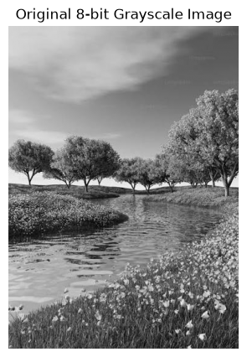
Original grayscale image loaded for the lab.
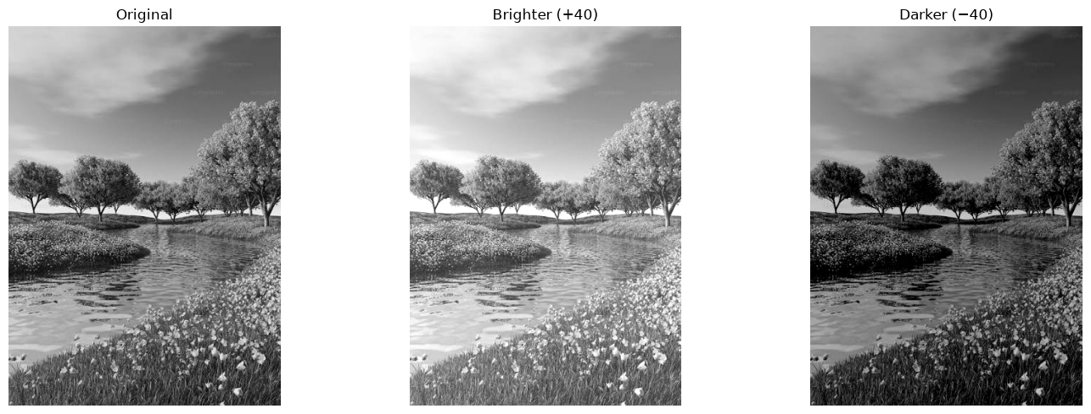
Brightness adjustment: original image compared with brighter and darker results.
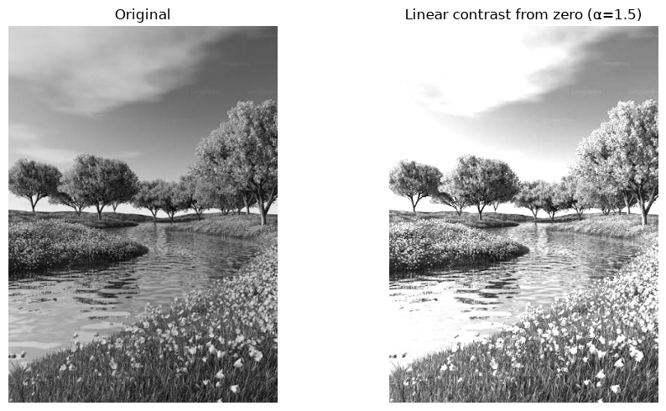
Linear contrast from zero (α = 1.5).
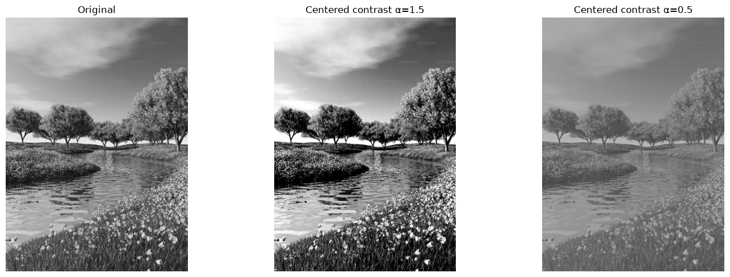
Contrast centered at 128 using α = 1.5 and α = 0.5.
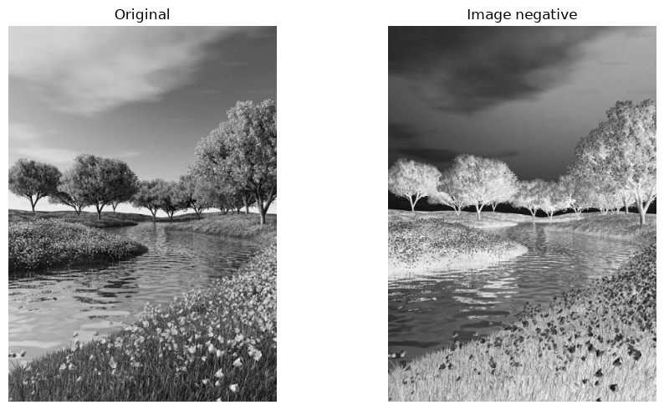
Image negative.
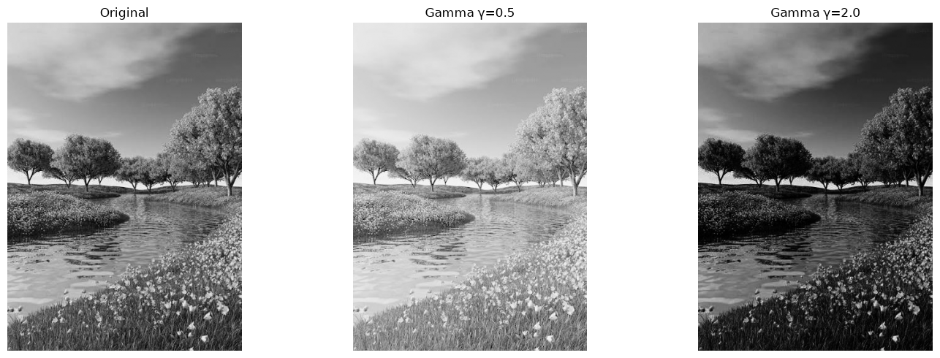
Gamma correction outputs for γ = 0.5 and γ = 2.0.
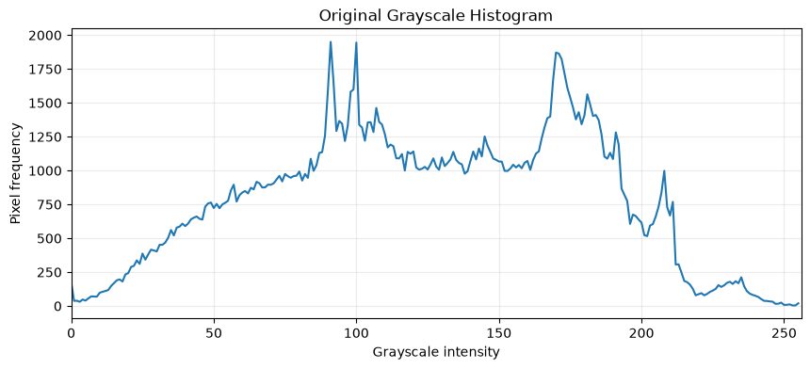
Grayscale histogram of the loaded image.
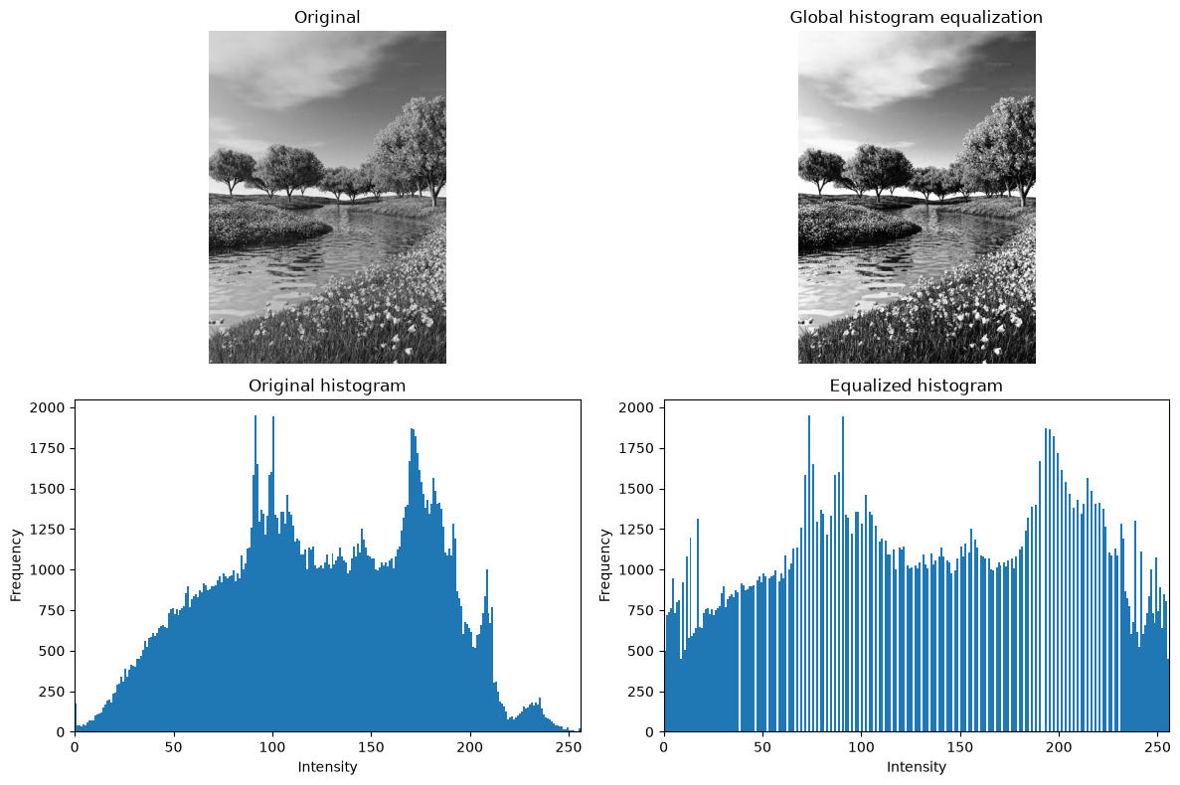
Global histogram equalization and histogram comparison.
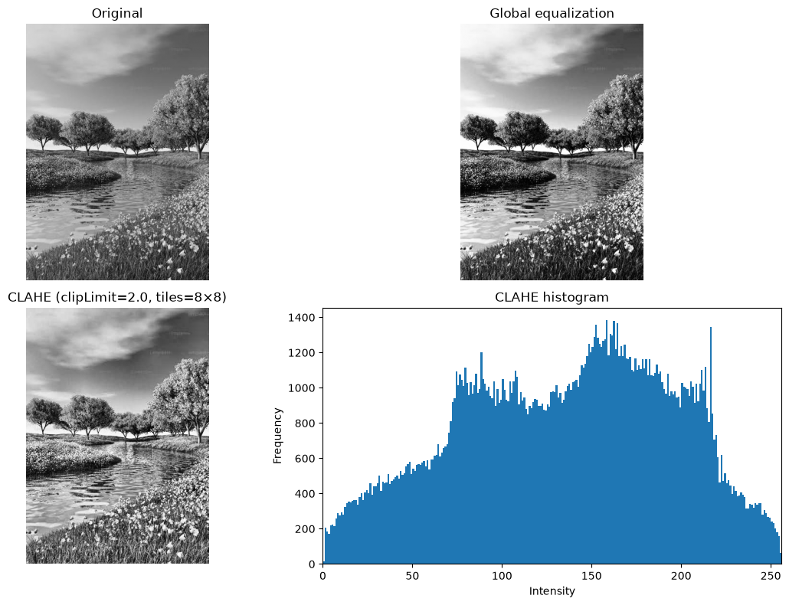
CLAHE local contrast enhancement.
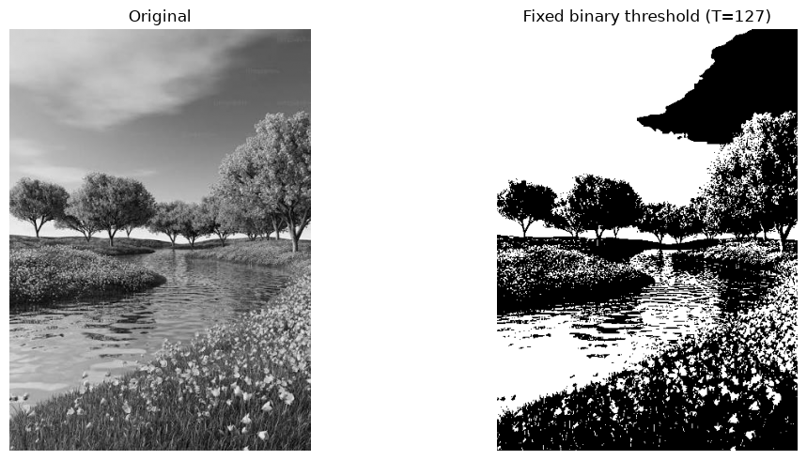
Fixed binary thresholding.
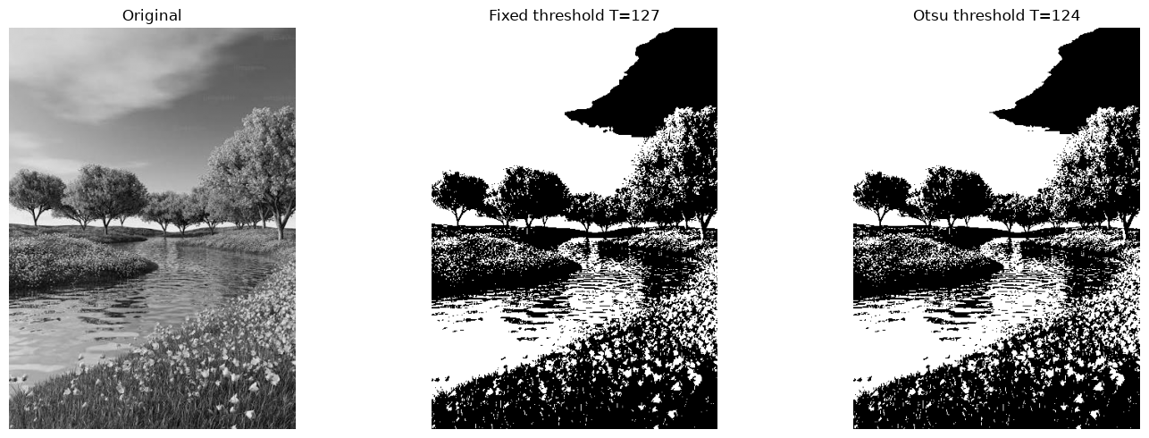
Otsu thresholding and comparison.
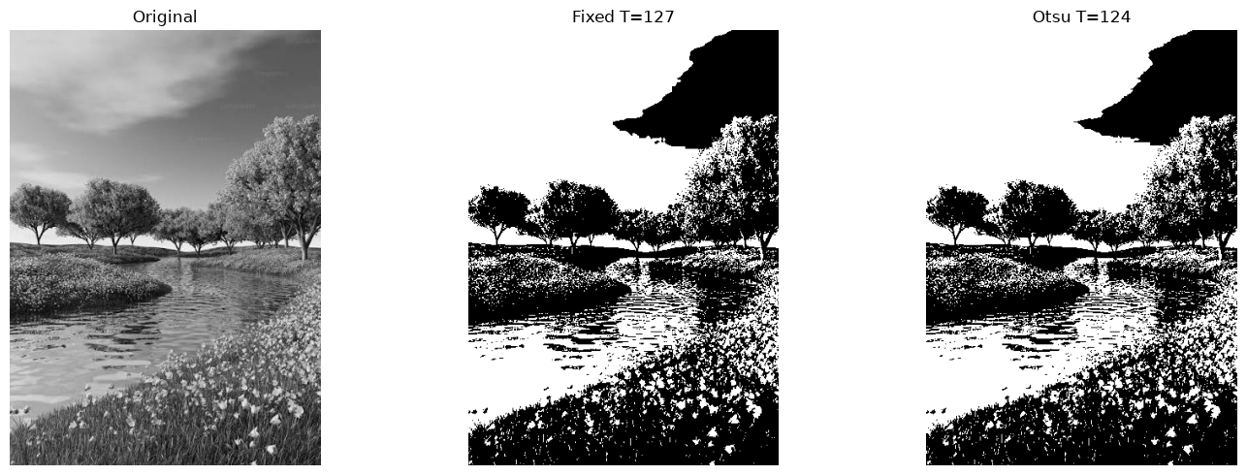
Adaptive Gaussian thresholding and mask comparisons.

