THE UNIVERSITY OF AZAD JAMMU & KASHMIR
DEPARTMENT OF SOFTWARE ENGINEERING

Student Name | Syed Muhammad Hassan Gillani | 
Roll Number | 2024-SE-42
Course Name | Digital Image Processing Lab
Course Code | SE-3104
Session | 2024-2028 (BS SE - 5th Sem)
Department Name | Department of Software Engineering
Task / Assignment No. | Lab Task #04 Report
Instructor Name | Engr. Fahad Nisar
Submission Date | November 07, 2026
Topic / Title | Geometric Transformations with Custom Inputs

Lab Task 04 - Detailed Report

1. Objective and Scope
The aim of this lab is to build one reusable image-transformation function that accepts custom values, validates every input, and produces correct geometric transformations. The function is called transform(image, operation, **params) and supports five operations: scaling/resizing, cropping, flipping, translation and rotation.
Everything required by the task sheet is implemented: image validation, a single reusable entry point, user-driven parameter entry with correction of bad input, operation-specific validation rules, a demonstration of every operation with custom values, an interpolation comparison, rejected-input demonstrations, identity checks, and brief explanations of the key concepts.

2. Design and Conventions

2.1 Project files
File / folder | Purpose
2024-SET-2024-SE-42-LAB04.ipynb | Completed, fully executed notebook (code, outputs, validation, checks, observations)
transforms.py | Helper source file: transform(), validators, affine matrices, text parsers, interactive prompt loops
make_input_image.py | Script that generated the input image (reproducible, no download needed)
input/sample_image.png | Input image, 600 x 400 px (gradient, circle, triangle, text, checkerboard, arrow)
outputs/ | 25 saved transformed images (PNG): 21 from the operation demos and sessions, plus 4 interpolation enlargements
outputs/comparisons/ | 14 labelled comparison figures (original vs result)
README.md, requirements.txt, .gitignore | Repository documentation, dependencies and exclusions (no virtual environments or caches)

2.2 Conventions declared
- Colour handling: images are read with OpenCV (BGR) and converted once to RGB inside load_image; every operation and display uses RGB uint8 arrays. Conversion back to BGR happens only when saving with cv2.imwrite.
- Coordinates: a point is (x, y) = (column, row) with the origin at the top-left and y increasing downward. NumPy indexing is image[row, column] = image[y, x].
- Background: areas exposed by translation or rotation are filled with black (0).
- Rotation: about the image centre ((W-1)/2, (H-1)/2); a positive angle rotates counter-clockwise on screen.
- Maximum output size: 4000 px per side and 16,000,000 px in total. Anything larger is rejected.
- Original preserved: the loaded array is set read-only and a backup copy is compared at the end; transform always returns a new array.

3. The Reusable transform Function
transform receives an image, an operation name and that operation's parameters as keyword arguments. Nothing is hard-coded: all values come from the caller, either typed by the user through the notebook prompts or supplied explicitly in the demonstrations.
Operation | Custom inputs | Validation rules enforced inside transform
scale | sx, sy, interpolation | sx, sy finite and > 0; output width = round(W*sx), height = round(H*sy), both >= 1 and within the size limit; interpolation in nearest / bilinear / bicubic / lanczos
crop | left, top, right, bottom | integers only; 0 <= left < right <= W and 0 <= top < bottom <= H; right and bottom are exclusive
flip | direction | only horizontal, vertical or both
translate | tx, ty | any finite number (positive, negative or zero); canvas size unchanged
rotate | angle, expand | any finite angle (including 0 and negative); expand must be True or False

General checks applied to every call: the image must be a non-empty uint8 NumPy array; the operation must be a known string; all required parameters must be present and no unexpected ones are allowed; booleans and strings are never accepted as numbers; NaN and infinity are rejected; an empty or oversized output is rejected. Zero offsets, zero angles and negative offsets/angles are valid and are never rejected.

3.1 Interactive input
run_interactive asks for the operation and then for each parameter with input(). The text is parsed (parse_float, parse_int, parse_choice, parse_bool); a bad entry prints a clear message and the question is asked again, so there is no unhandled crash and no silent default is substituted. Problems that only appear when all values are combined (for example right <= left, or an output that is too large) are caught from transform itself and the parameters are re-entered. For a reproducible notebook, the answers are replayed through ScriptedInput, including deliberate mistakes; setting INTERACTIVE = True lets the user type their own values.

4. Image Loading and Validation
load_image checks that the file exists, is a file, decodes successfully, and has non-zero dimensions. The input image is 600 x 400 px, array shape (400, 600, 3), dtype uint8, RGB.
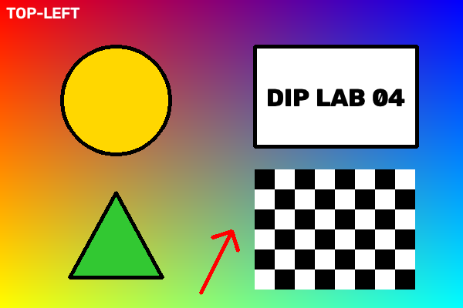
Figure 1 - Input image (600 x 400 px, shape (400, 600, 3))
Invalid image case | Result
Missing file | REJECTED - File not found: 'input/does_not_exist.png'
File that is not an image | REJECTED - File exists but could not be decoded as an image
Directory instead of file | REJECTED - Not a file: 'input'
Zero-height array (0, 5, 3) | REJECTED - Image has an empty dimension
Floating-point image array | REJECTED - image must be uint8, got float64

5. Demonstration of the Operations
Every operation was run with custom values. Each figure labels the operation, the parameters and the output dimensions. All 25 transformed images (21 operation results plus the 4 interpolation enlargements) are saved in the outputs folder.

5.1 Scaling / resizing
Enlargement (2.0 x 2.0, bicubic -> 1200 x 800), reduction (0.5 x 0.5, bilinear -> 300 x 200), proportional (1.5 x 1.5, Lanczos -> 900 x 600) and non-proportional (2.0 x 0.5, bilinear -> 1200 x 200) scaling were demonstrated. Equal factors keep the 3:2 aspect ratio (1.500); unequal factors change it to 6.000 and visibly stretch the picture.
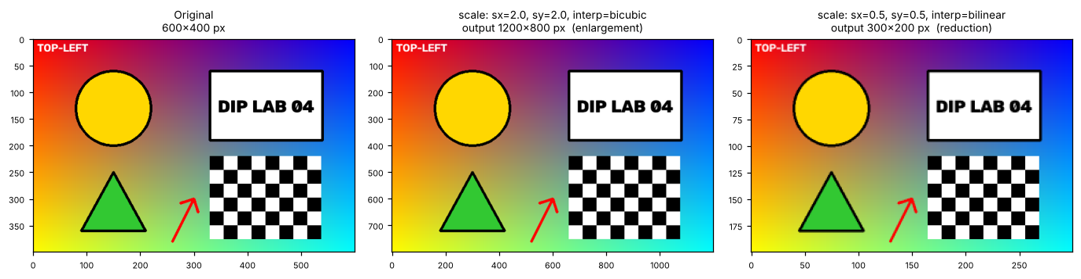
Figure 2 - Enlargement and reduction
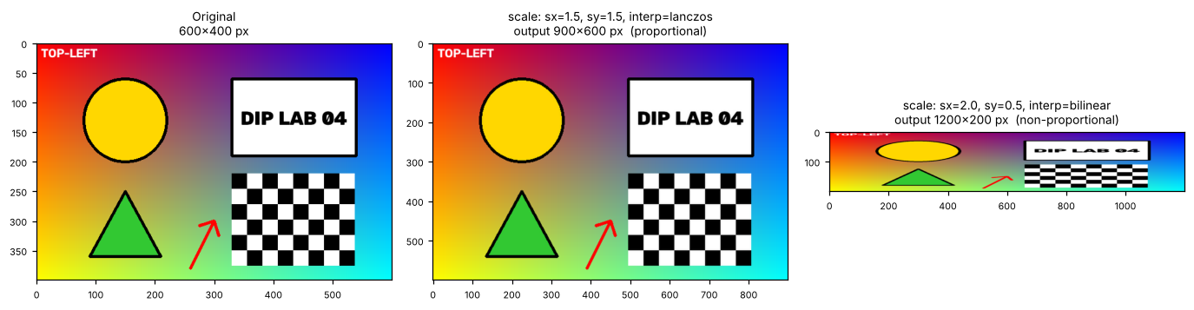
Figure 3 - Proportional versus non-proportional scaling

5.2 Cropping
Crop (70, 40, 230, 220) returns 160 x 180 px and crop (330, 220, 538, 376) returns 208 x 156 px. Because right and bottom are exclusive, the output size is (right - left) x (bottom - top); the result was verified to be identical to the NumPy slice original[40:220, 70:230].
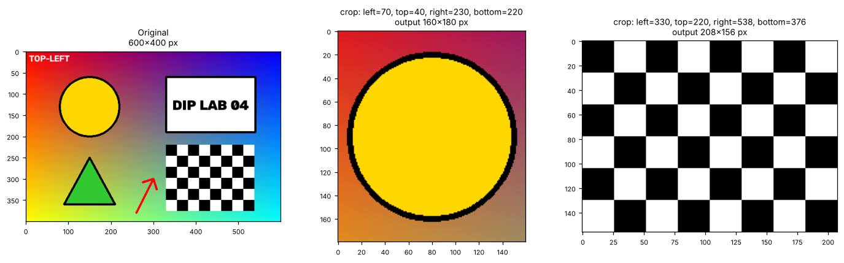
Figure 4 - Cropping with custom coordinates

5.3 Flipping
All three directions were displayed and verified against NumPy slicing (original[:, ::-1], original[::-1, :] and original[::-1, ::-1]); all comparisons returned True.
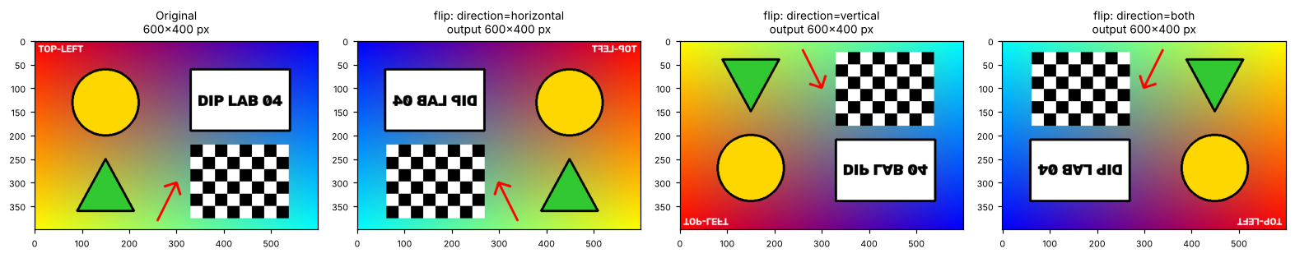
Figure 5 - Horizontal, vertical and both flips

5.4 Translation
Shifts in opposite directions were used: (tx = +120, ty = +60) moves the content right and down; (tx = -150, ty = -80) moves it left and up. The canvas stays 600 x 400. For the first shift 76,800 of 240,000 original pixels (32.0 %) are clipped, and for the second 96,000 (40.0 %); the same number of canvas pixels are exposed as black background.
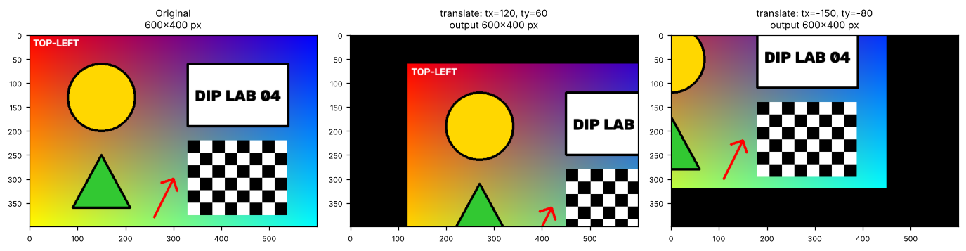
Figure 6 - Translation in opposite directions (clipping and exposed background)

5.5 Rotation
Angles +30, -45, +90 and -30 degrees were applied with and without canvas expansion. The positive direction is counter-clockwise: the red arrow, originally pointing up-right, turns to point straight up after +30 degrees. Without expansion the canvas stays 600 x 400 and the corners are clipped; with expansion the canvas becomes 720 x 647 (+30), 708 x 708 (-45) and 400 x 600 (+90), which matches W' = W|cos a| + H|sin a| and H' = W|sin a| + H|cos a|. The +90 degree expanded result is pixel-identical to np.rot90(original, 1).
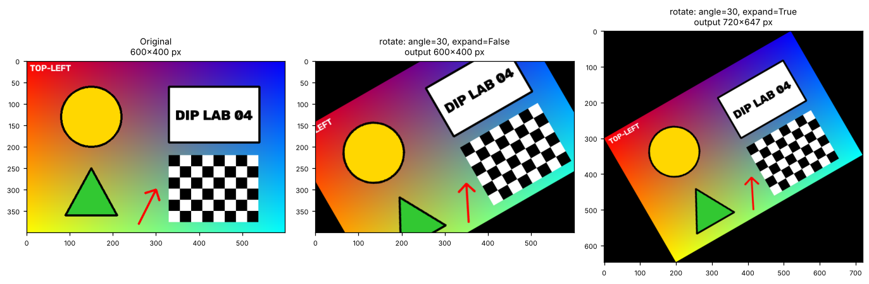
Figure 7 - Positive rotation without and with canvas expansion
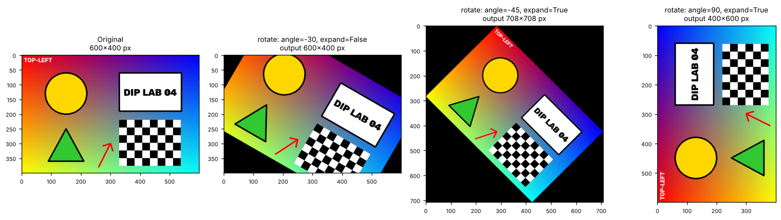
Figure 8 - Negative rotations and a 90-degree rotation

5.6 Affine matrices
Translation and rotation are affine maps with a 2 x 3 matrix. For tx = 120, ty = 60 the matrix is [[1, 0, 120], [0, 1, 60]]. For +30 degrees with expansion the matrix is [[0.866, 0.5, 0.3754], [-0.5, 0.866, 299.9779]] and the canvas is 720 x 647. Applying these matrices directly with cv2.warpAffine reproduced the transform outputs exactly, and the image centre (299.5, 199.5) is a fixed point of the non-expanded rotation, confirming that rotation is about the centre.

6. User-Driven Input Sessions
The notebook replays five recorded sessions that include deliberate mistakes. In each case the error message appears and the question is asked again:
Session | Mistakes entered | Final accepted values | Output
Scaling | unknown operation 'zoom'; sx = 'abc'; sx = 'nan'; interpolation 'cubic' | sx = 1.5, sy = 0.75, bicubic | 900 x 300
Cropping | left = 10.5 (not an integer); right 80 <= left 100 (rejected by transform) | left 100, top 50, right 400, bottom 250 | 300 x 200
Flipping | direction 'diagonal' | both | 600 x 400
Translation | ty = 'inf' | tx = -80, ty = 40 | 600 x 400
Rotation | angle 'abc'; expand 'maybe' | angle -30, expand yes | 720 x 647

7. Interpolation Comparison
An 80 x 60 patch containing the arrow head and the corner of the checkerboard was enlarged 8 x 8 (to 640 x 480) with the four interpolation methods, all through the same transform call.
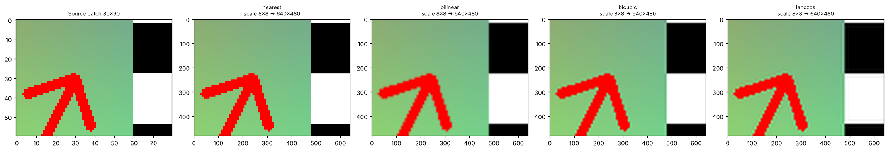
Figure 9 - Source patch and the four enlarged results
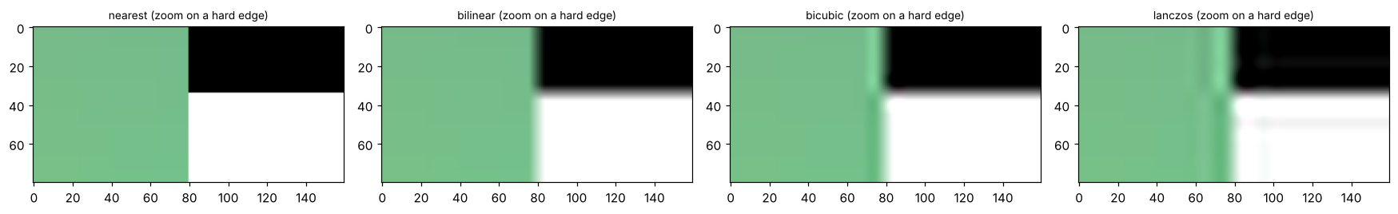
Figure 10 - Zoom on a hard black/white edge
Method | Unique colours | Soft-edge pixels (%) | Ringing (grey levels) | Visible result
Nearest-neighbour | 903 | 0.00 | 0.0 | Hard staircase blocks; no new colours; fastest
Bilinear | 4206 | 5.28 | 1.0 | Smooth but soft edges; no ringing
Bicubic | 4883 | 5.06 | 22.0 | Slightly less soft; faint light halo next to edges
Lanczos | 6152 | 4.85 | 24.0 | Least soft of the smooth methods; ripples extend furthest; slowest

Soft-edge pixels is the share of pixels in the checkerboard area that are neither near-black nor near-white; ringing is the largest brightness deviation from the nearest-neighbour result in the flat green strip beside the edge.

8. Input Validation - Rejected Inputs
Twenty-six invalid inputs were passed directly to transform; all 26 were rejected with a clear TransformError and no crash. At least one case is shown for every operation:
Operation | Invalid input | Message (shortened)
scale | sx = 0; sx = -2 | Scale factors must be greater than zero
scale | sx = NaN; sy = inf; sx = "two" | must be finite (not NaN/infinity) / must be a number
scale | interpolation = 'cubic' | Unsupported interpolation; choose from nearest, bilinear, bicubic, lanczos
scale | sx = 0.0001 (0-px width); sx = sy = 100 | would give an empty image (0x400) / above the size limit (60000x40000)
crop | left = right = 100; right = 601; left = -1; bottom < top | Invalid range: need 0 <= left < right <= width (600) ...
crop | top = 10.5 | 'top' must be an integer, got 10.5 (float)
flip | direction = 'diagonal'; direction = 1 | Unsupported flip direction; choose from horizontal, vertical, both
translate | tx = inf; ty = NaN; tx = "ten" | must be finite / must be a number
rotate | angle = 'abc'; angle = NaN; angle = -inf | 'angle' must be a number / must be finite
rotate | expand = 'yes' (a string, not a bool) | 'expand' must be True or False
any | unknown operation 'warp'; missing parameter; extra parameter | Unknown operation / missing required parameter(s) / unexpected parameter(s)

Boundary values that must be accepted were also tested and were accepted: zero offsets, a negative tx, angle 0, angle -90, angle 725.5, a crop of the whole image (right = W, bottom = H), a single-pixel crop at the bottom-right corner, scale factor 1, and a tiny factor (0.01) that still yields a 6 x 4 image.

9. Identity Checks
An identity case must return an image of the same shape with every pixel equal to the original. The actual behaviour was measured with numpy.array_equal and the maximum absolute pixel difference.
Case | Expected behaviour | Actual behaviour | Result
Scale 1 x 1 (nearest) | Same shape, all pixels equal | Same shape, max difference 0 | Pass
Scale 1 x 1 (bilinear) | Same shape, all pixels equal | Same shape, max difference 0 | Pass
Scale 1 x 1 (bicubic) | Same shape, all pixels equal | Same shape, max difference 0 | Pass
Scale 1 x 1 (Lanczos) | Same shape, all pixels equal | Same shape, max difference 0 | Pass
Translate (0, 0) | Same shape, all pixels equal | Same shape, max difference 0 | Pass
Rotate 0, no expand | Same shape, all pixels equal | Same shape, max difference 0 | Pass
Rotate 0, expand | Same shape, all pixels equal | Same shape, max difference 0 | Pass
Rotate 360, no expand | Same shape, all pixels equal | Same shape, max difference 0 | Pass
Crop whole image | Same shape, all pixels equal | Same shape, max difference 0 | Pass
Flip both, applied twice | Same shape, all pixels equal | Max difference 0 | Pass

All 10 identity checks passed. The final cell of the notebook also confirms that the original image array is unchanged (np.array_equal with the backup copy is True, and the array is read-only).

10. Explanations

10.1 Image coordinates versus array indexing
Image coordinates are written (x, y): x is the column (horizontal, to the right) and y is the row (vertical, downward) measured from the top-left corner. NumPy arrays are indexed [row, column] = [y, x], and shape is (height, width, channels). For example the point (x = 150, y = 130) is stored at original[130, 150] and has the RGB value [255, 215, 0]. OpenCV functions such as resize and warpAffine take sizes as (width, height), the opposite order to shape. Mixing the two orders causes transposed or wrongly cropped images, so transform takes left/right as x, top/bottom as y and slices image[top:bottom, left:right]; valid indices are x in [0, 599] and y in [0, 399], and right/bottom may equal 600/400 because they are exclusive.

10.2 Aspect-ratio distortion
The aspect ratio is W/H. Scaling with sx = sy preserves it (the 1.5 x 1.5 result is 900 x 600, still 1.500). With sx different from sy the ratio becomes (W*sx)/(H*sy): the 2.0 x 0.5 result is 1200 x 200 (ratio 6.000), so circles turn into wide ellipses and text is stretched.

10.3 Rotation canvas expansion
With expand = False the canvas stays W x H, so the corners of the rotated picture fall outside it and are clipped while empty triangles of black background appear. With expand = True the canvas grows to W' = W|cos a| + H|sin a| and H' = W|sin a| + H|cos a| (720 x 647 for +30 degrees, 708 x 708 for -45 degrees), so no content is lost, at the price of a larger image with more black background. Rotation is about the image centre and a positive angle is counter-clockwise.

10.4 Translation clipping
Translation keeps the original canvas size. Pixels pushed beyond an edge are lost (clipped) and the opposite side is exposed and filled with black. For tx = +120, ty = +60 the left 120 columns and top 60 rows become background, while the right 120 columns and bottom 60 rows of the original disappear. Shifting back later would not restore the clipped content.

11. Assessment Rubric Self-Check
Criterion (marks) | Evidence | Where
Reusable function and custom input (2) | One entry point transform(image, operation, **params); operation selection and every parameter entered through input() prompts and passed in; transformed images returned | Notebook sections 2-3; transforms.py
Geometric operations (4) | Scaling (enlarge, reduce, proportional, non-proportional), crop, three flips, translation in opposite directions, positive and negative rotation with and without expansion, affine matrices verified | Notebook section 4; report section 5
Input validation (3) | Image checks; parameter checks inside transform and in the text parsers; 26 rejected cases; boundary values accepted; identity checks | Notebook sections 1, 6, 7; report sections 4, 8, 9
Comparisons and observations (2) | Four-method interpolation comparison with numbers and description; labelled outputs with dimensions; clipping, aspect-ratio, expansion and coordinate explanations | Notebook sections 4, 5, 8; report sections 7, 10
Repository submission (1) | README.md, executed notebook, input image, saved transformed images, helper source, requirements.txt, .gitignore; no virtual environment or caches | Project folder

Note on repository submission
The task sheet asks for an accessible repository link. This ZIP contains the complete repository content; upload the extracted folder to a public GitHub repository (or similar) and submit that link. The notebook should be re-run from a restarted kernel (Kernel > Restart & Run All) before submission if any change is made.

12. Conclusion
A single, validated, reusable transform function now performs scaling, cropping, flipping, translation and rotation using caller-supplied values. Invalid input is reported clearly and can be corrected without crashing; all identity checks pass; rotation and translation outputs were verified against their affine matrices and against NumPy references; and the interpolation study shows the trade-off between blockiness (nearest), softness (bilinear), and sharpness with ringing (bicubic, Lanczos).

