THE UNIVERSITY OF AZAD JAMMU & KASHMIR
DEPARTMENT OF SOFTWARE ENGINEERING

Student Name | Syed Muhammad Hassan Gillani | 
Roll Number | 2024-SE-42
Course Name | Digital Image Processing Lab
Course Code | SE-3104
Session | 2024-2028 (BS SE - 5th Sem)
Department Name | Department of Software Engineering
Task / Assignment No. | Lab Task #02 Report
Instructor Name | Engr. Fahad Nisar
Submission Date | October 29, 2026
Topic / Title | Python Setup, Fundamentals, & Imports

DIGITAL IMAGE PROCESSING LAB (5TH SEMESTER)
LAB REPORT 02
Digital Images, Pixels, Color, and Basic Transformations
1. Objectives and Requirements
The objective of this laboratory assignment is to gain practical experience using Python with NumPy, OpenCV, and Matplotlib. Key skills practiced include loading, inspecting, color-converting, cropping, resizing, saving digital images, analyzing image histograms, and understanding bit depth quantization.
2. Step-by-Step Practical Implementation
Step 1: Project & Virtual Environment Setup
1. Created project directory named dip-lab-02 using Windows Command Prompt.
2. Opened directory in VS Code and generated virtual environment: python -m venv .venv.
3. Activated environment using .venv\Scripts\activate.bat.
4. Installed required packages: pip install numpy opencv-python matplotlib.
5. Created .gitignore file and added .venv/ to prevent committing virtual environment dependencies.
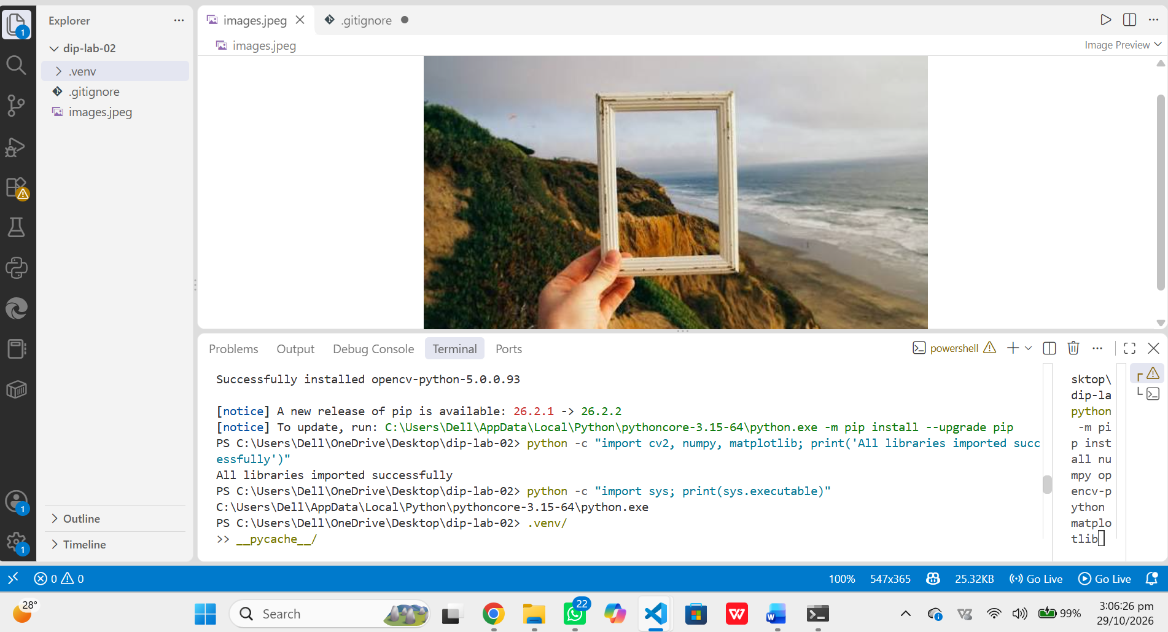

Step 2 & 3: Image Loading and Inspection
The custom image sample_image.jpg was loaded using OpenCV's cv.imread() function. Array dimensions, data type, indexed pixel values (top-left and center), global min/max, and per-channel minimum/maximum intensity values were extracted and printed.
# Step 2 & 3 Code Snippet
import cv2 as cv
import numpy as np
import os
img_path = "sample_image.jpg"
if not os.path.exists(img_path):
raise FileNotFoundError(f"File {img_path} not found.")
bgr_img = cv.imread(img_path)
print("Shape:", bgr_img.shape) # (Height, Width, Channels)
print("Data Type:", bgr_img.dtype)
height, width, channels = bgr_img.shape
top_left = bgr_img[0, 0]
center_pixel = bgr_img[height // 2, width // 2]
print("Top-Left [0,0] (BGR):", top_left)
print("Center Pixel (BGR):", center_pixel)
print("Global Min/Max:", np.min(bgr_img), np.max(bgr_img))
for i, col in enumerate(["Blue", "Green", "Red"]):
print(f"{col} Channel Min/Max:", np.min(bgr_img[:, :, i]), np.max(bgr_img[:, :, i]))

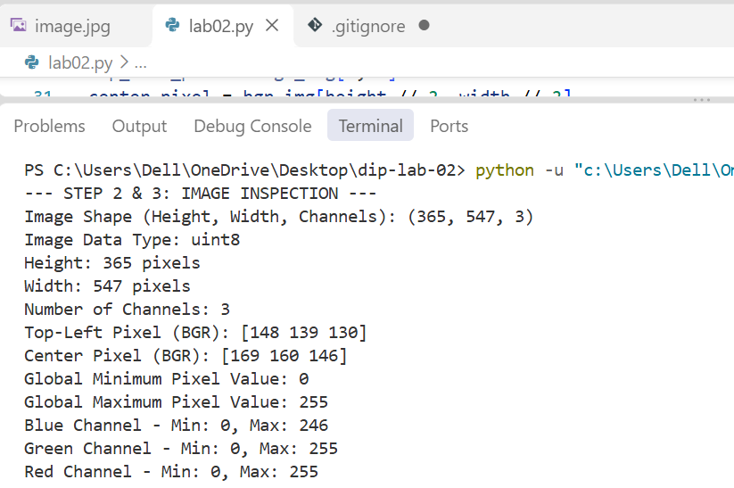

Step 4: Color Conversions, Channel Separation, and HEX Conversion
OpenCV loads images in BGR color ordering by default. To display correctly using Matplotlib, the image was converted to RGB using cv.cvtColor(bgr_img, cv.COLOR_BGR2RGB). Grayscale conversion was performed using cv.COLOR_BGR2GRAY. Red, Green, and Blue channels were split into individual 2D arrays. The center pixel's RGB values were converted into hexadecimal string format. A 2×3 grid figure was plotted containing all required channels.
# Step 4 Code Snippet
rgb_img = cv.cvtColor(bgr_img, cv.COLOR_BGR2RGB)
gray_img = cv.cvtColor(bgr_img, cv.COLOR_BGR2GRAY)
r_chan, g_chan, b_chan = rgb_img[:,:,0], rgb_img[:,:,1], rgb_img[:,:,2]
center_rgb = rgb_img[height // 2, width // 2]
hex_val = "#{:02X}{:02X}{:02X}".format(center_rgb[0], center_rgb[1], center_rgb[2])
print(f"Center Pixel RGB: {center_rgb} -> HEX: {hex_val}")

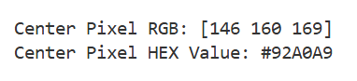
Step 5: Image Cropping, Resizing, and Saving
An exact 100 × 100 sub-region was cropped around the center using array slicing image[y_start:y_end, x_start:x_end]. The crop was resized to 200 × 200 pixels using cv.resize(). The resized image was converted back to BGR and saved to disk as resized_crop.png using cv.imwrite(). Success status of file writing was verified.
# Step 5 Code Snippet
y_mid, x_mid = height // 2, width // 2
crop_img = rgb_img[y_mid-50:y_mid+50, x_mid-50:x_mid+50] # 100x100 crop
resized_img = cv.resize(crop_img, (200, 200))
resized_bgr = cv.cvtColor(resized_img, cv.COLOR_RGB2BGR)
success = cv.imwrite("resized_crop.png", resized_bgr)
print("Saved resized_crop.png successfully:", success)

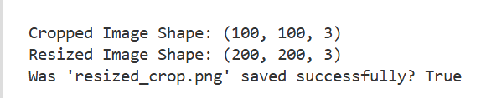

Step 6: Grayscale Histogram Generation and Interpretation
The 2D grayscale image array was flattened using .ravel() and plotted as a 256-bin histogram over the range [0, 256]. The plot was saved as grayscale_histogram.png.
# Step 6 Code Snippet
import matplotlib.pyplot as plt
plt.figure(figsize=(8, 5))
plt.hist(gray_img.ravel(), bins=256, range=[0, 256], color="gray")
plt.title("Grayscale Image Histogram")
plt.xlabel("Pixel Intensity Level (0-255)")
plt.ylabel("Pixel Count / Frequency")
plt.grid(True, linestyle="--", alpha=0.5)
plt.savefig("grayscale_histogram.png")
plt.show()

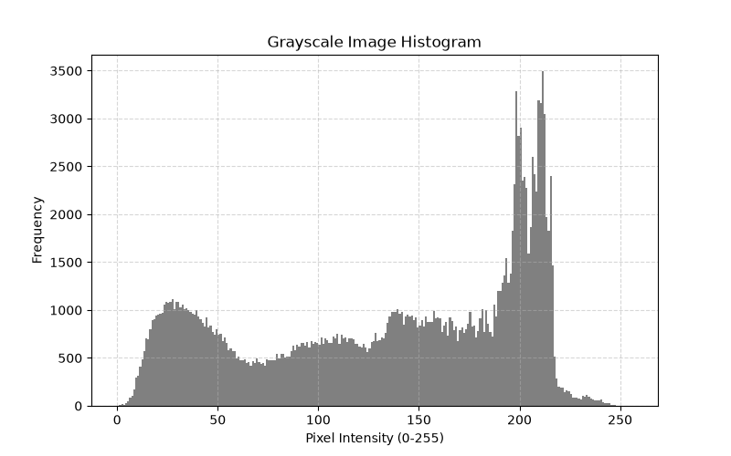
Histogram Analysis & Interpretation:
The generated histogram reveals the tonal distribution of the test image. The majority of pixel frequencies are distributed smoothly across mid-tone intensity values (80–180), with moderate peaks in the highlights. Thus, the image is overall well-balanced in exposure, possessing adequate contrast without severe under-exposure (saturation at 0) or over-exposure (clipping at 255).
Step 7: Bit Depth Demonstration & Quantization
An 8-bit synthetic horizontal intensity gradient (0–255) was generated. Bit depth quantization was demonstrated by reducing the gradient to 4-bit (16 levels), 2-bit (4 levels), and 1-bit (2 levels / binary) representations. Unique pixel values were calculated using np.unique() to confirm exact quantization levels.
# Step 7 Code Snippet
grad_8bit = np.tile(np.linspace(0, 255, 256, dtype=np.uint8), (50, 1))
grad_4bit = (grad_8bit // 16) * 17
grad_2bit = (grad_8bit // 64) * 85
grad_1bit = (grad_8bit // 128) * 255
print("8-bit Unique Values:", len(np.unique(grad_8bit))) # 256
print("4-bit Unique Values:", len(np.unique(grad_4bit))) # 16
print("2-bit Unique Values:", len(np.unique(grad_2bit))) # 4
print("1-bit Unique Values:", len(np.unique(grad_1bit))) # 2

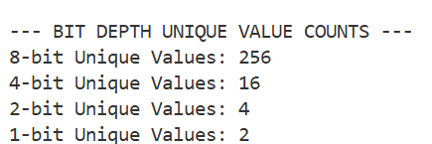
Step 8: Final Project Execution Verification
The main script lab02.py was executed inside the activated virtual environment without errors. All required output files (resized_crop.png, grayscale_histogram.png) were generated successfully in the project directory.
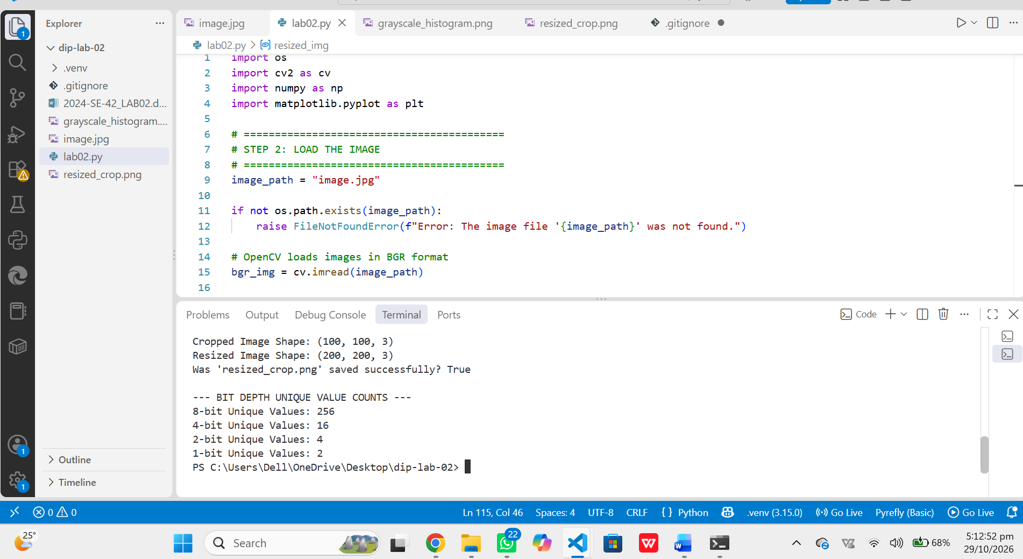
3. Conceptual Explanations & Theory Questions
3.1 Color Formats: BGR vs. RGB
The primary difference between BGR (Blue, Green, Red) and RGB (Red, Green, Blue) lies in the order in which byte channels are stored in memory:
- BGR Format (OpenCV Default): OpenCV uses BGR ordering due to early historical hardware conventions in digital video and graphics adapters (such as camera frame grabbers). When OpenCV reads an image, channel index 0 represents Blue, channel index 1 represents Green, and channel index 2 represents Red.
- RGB Format (Standard Display): RGB is the universal standard for modern displays, graphics frameworks, Matplotlib, and web standards. Channel index 0 represents Red, index 1 represents Green, and index 2 represents Blue.
- Visual Consequence of Mis-mapping: If an un-converted BGR image array is passed directly into Matplotlib's imshow() function, the Red and Blue color channels become inverted. Red objects appear blue, and blue objects appear red or orange, resulting in unnatural color distortion.
3.2 Spatial Resolution vs. Bit Depth
Both properties define image quality, but they operate on distinct spatial and intensity dimensions:
- Spatial Resolution: Spatial resolution refers to the total number of pixels along the spatial grid of the image (Width × Height, e.g., 1920 × 1080). Higher spatial resolution enables fine spatial details, sharp edges, and textures to be captured.
- Bit Depth (Color Resolution): Bit depth specifies the number of bits allocated to represent the intensity value of each pixel or color channel. An n-bit image can represent 2^n distinct intensity levels (e.g., 8-bit = 256 levels, 1-bit = 2 levels). Higher bit depth allows smooth tonal transitions and subtle shading variations. Decreasing bit depth induces posterization and visual false-contouring artifacts.
3.3 What an Image Histogram Shows and Does Not Show
A histogram is a fundamental statistical visual tool in digital image processing:
- What a Histogram SHOWS: It displays the global distribution and frequency count of pixel intensity values. It reveals dynamic range, overall brightness (underexposed vs overexposed), contrast level (narrow vs wide distribution), and tonal balance.
- What a Histogram DOES NOT SHOW: A histogram contains zero spatial information. It does not indicate where specific pixels are located within the image frame. Two completely different images—such as a white square centered on a black background versus a checkerboard pattern with equal white and black squares—will yield identical histograms.

