University of Azad Jammu & Kashmir Muzaffarabad



Name |  | Hassan Gillani
Roll No. |  | 2024-SE-42
Instructor Name |  | Engr. Awais Rathore
Course Title |  | Database Systems
Semester |  | 4nd Semester
Assignment |  | Open Ended Lab
Submission Date |  | 2026-09-21

Department of Software Engineering

DATABASE MANAGEMENT SYSTEM
OPEN-ENDED LAB REPORT
CAR RENTAL MANAGEMENT SYSTEM

CLO-6 (C-4): Analyze | CLO-7 (C-5): Design/Develop | Total Marks: 20

Table of Contents
- 1. Executive Summary
- 2. Assignment Requirements
- 3. Problem Scenario
- 4. Database Design and Implementation
- 5. Normalization (1NF–3NF)
- 6. Required JOIN Queries
- 7. Consolidated VIEW
- 8. TRIGGER
- 9. STORED PROCEDURE
- 10. Optimization Analysis
- 11. Additional Management Reports
- 12. phpMyAdmin Execution Guide
- 13. Screenshot Checklist
- 14. Conclusion
- 15. Final Submission Checklist

1. Executive Summary
This Open-Ended Lab develops a relational database solution for CarGo Rentals, a local car rental company. The provided assignment describes a spreadsheet-based process that suffers from duplicate information, inconsistent records and difficulty generating reports. The required database must manage customers, vehicles, rentals, returns, charges and payments, while preventing a vehicle from being available for another rental while already rented.
The implemented design uses Customer, Vehicle, Rental and Payment tables with primary keys, foreign keys and appropriate integrity constraints. It also demonstrates 1NF, 2NF and 3NF, four business JOIN queries, a consolidated VIEW, a trigger for the vehicle-availability rule, a stored procedure for registering rentals and calculating charges, and an optimization analysis using indexes and EXPLAIN.

2. Assignment Requirements
The provided OEL assesses CLO-6 (C-4: Analyze) and CLO-7 (C-5: Design/Develop). The assignment requires database design and implementation, normalization, JOIN queries, a VIEW, a STORED PROCEDURE, optimization analysis, and—within the submission requirements and rubric—a TRIGGER.
Component | Required Work
Task 1 — Database Design | Tables/attributes, PKs, FKs, NOT NULL, UNIQUE, CHECK, DEFAULT, creation and realistic sample data.
Task 2 — Normalization | Analyze the supplied rental record and demonstrate 1NF, 2NF and 3NF; explain redundancy, dependencies and anomalies.
Task 3 — JOINs | Four business queries; each requires SQL plus screenshot/output.
Task 4 — VIEW | One consolidated rental report using customer, vehicle, rental and payment information; explain usefulness.
TRIGGER | Required by the submission requirements/rubric; enforce the vehicle availability business rule.
Task 6 — Stored Procedure | Useful rental operation with input parameters and meaningful processing.
Task 7 — Optimization | Identify inefficiency, explain impact, propose improvement and show improved query/design.
Submission | SQL file, short report, screenshots/output and realistic sample data.

3. Problem Scenario
CarGo Rentals rents vehicles for daily or weekly use. Customer, vehicle, rental, return and payment information is currently kept in spreadsheets. With increasing rentals, duplicate data, inconsistent records and reporting difficulties occur.
- Maintain customer and vehicle information.
- Record rentals and returns.
- Calculate rental charges.
- Maintain payment information.
- Prevent a vehicle from being rented while already actively rented.
- Provide customer history, current-rental and vehicle-activity reports.

4. Database Design and Implementation

4.1 Database Structure
Table | Purpose | Key Relationship
Customer | Customer identity/contact data | CustomerID referenced by Rental
Vehicle | Vehicle number, model, rates and status | VehicleID referenced by Rental
Rental | Rental dates, duration, charge and status | CustomerID + VehicleID foreign keys
Payment | Payments made against rentals | RentalID foreign key

4.2 Important Constraints
- Primary keys uniquely identify records.
- Foreign keys enforce valid relationships.
- UNIQUE prevents duplicate phone, email, CNIC and vehicle numbers.
- NOT NULL protects required business fields.
- CHECK validates rates, dates, rental days and charges.
- DEFAULT supplies timestamps and status values.

4.3 Implemented Tables
Customer(CustomerID, CustomerName, Phone, Email, CNIC, Address, CreatedAt)
Vehicle(VehicleID, VehicleNumber, VehicleModel, VehicleYear, DailyRate, WeeklyRate, Status)
Rental(RentalID, CustomerID, VehicleID, RentalDate, ExpectedReturnDate,
ActualReturnDate, DailyRate, RentalDays, RentalCharge, RentalStatus, CreatedAt)
Payment(PaymentID, RentalID, PaymentDate, Amount, PaymentMethod, PaymentStatus)

4.4 Supporting Indexes
CREATE INDEX idx_rental_customer ON Rental(CustomerID);
CREATE INDEX idx_rental_vehicle_status ON Rental(VehicleID, RentalStatus);
CREATE INDEX idx_rental_dates ON Rental(RentalDate, ExpectedReturnDate);
CREATE INDEX idx_payment_rental ON Payment(RentalID);
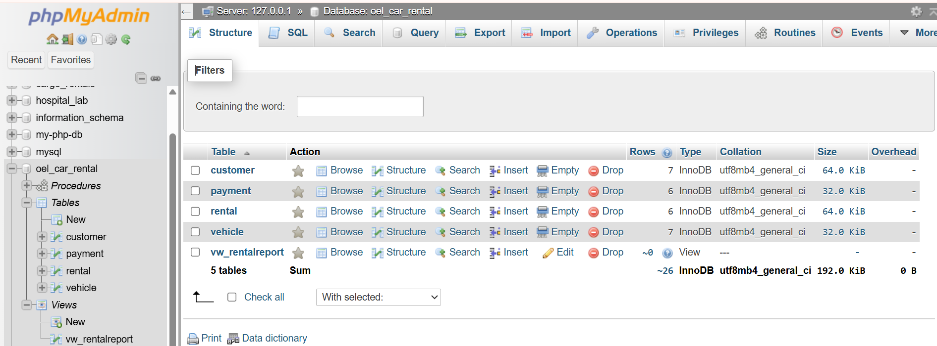

5. Normalization (1NF–3NF)
The OEL supplies this original single rental record: RentalID, CustomerName, CustomerPhone, VehicleNumber, VehicleModel, DailyRate, RentalDate, ReturnDate, PaymentAmount. Example: R001, Ali Khan, 0300-1234567, ABC-123, Toyota Corolla, 5000, 2026-09-01, 2026-09-04, 15000.

5.1 1NF
1NF requires atomic values, no repeating groups and uniquely identifiable rows. The supplied example has atomic values and RentalID can identify the rental row. However, customer and vehicle facts would still be repeated when the same customer or vehicle appears in multiple rentals.

5.2 2NF
The design separates customer and vehicle facts from rental facts. Customer attributes depend on CustomerID, vehicle attributes depend on VehicleID, and rental transaction attributes depend on RentalID. This removes repeated entity information from every rental row.
Entity | Representative attributes | Functional dependency
Customer | CustomerID, CustomerName, Phone, Email, CNIC | CustomerID → customer attributes
Vehicle | VehicleID, VehicleNumber, VehicleModel, DailyRate, Status | VehicleID → vehicle attributes
Rental | RentalID, CustomerID, VehicleID, dates, charge | RentalID → rental attributes

5.3 3NF
The final design separates Payment from Rental as well. Payment attributes depend on PaymentID and are linked to the relevant Rental through RentalID. Customer, Vehicle, Rental and Payment therefore each store facts about one entity/transaction type, reducing transitive dependencies and anomalies.
Anomaly | Original risk | Final design
Update | Repeated customer/vehicle details could become inconsistent. | Update the entity once in Customer or Vehicle.
Insert | A customer/vehicle could be difficult to store without a rental. | Customer and Vehicle are independent tables.
Delete | Deleting a rental could remove the only copy of entity information. | Entity information remains in its own table.
Payment | Payment information could be mixed/repeated with rental data. | Payment is separately linked to Rental.

6. Required JOIN Queries

6.1 Query 1 — Every Rental
SELECT c.CustomerName, v.VehicleNumber, v.VehicleModel,
r.RentalDate, r.ExpectedReturnDate, r.ActualReturnDate
FROM Rental r
JOIN Customer c ON r.CustomerID = c.CustomerID
JOIN Vehicle v ON r.VehicleID = v.VehicleID;
This INNER JOIN returns the customer and vehicle details for every rental.
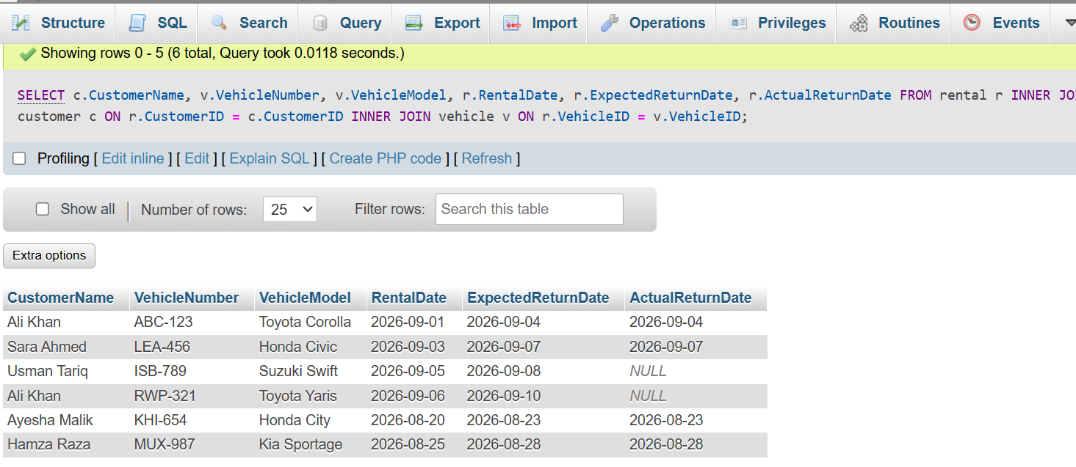

6.2 Query 2 — All Customers, Including No Rental
SELECT c.CustomerName, v.VehicleNumber, v.VehicleModel
FROM Customer c
LEFT JOIN Rental r ON c.CustomerID = r.CustomerID
LEFT JOIN Vehicle v ON r.VehicleID = v.VehicleID
ORDER BY c.CustomerName;
LEFT JOIN preserves customers even when no rental exists; unmatched vehicle fields appear as NULL.
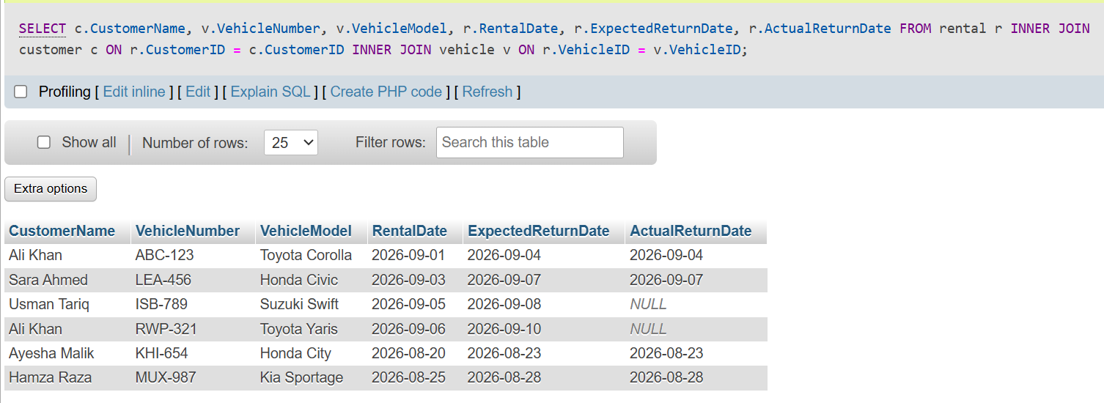

6.3 Query 3 — All Vehicles, Including Currently Unrented
SELECT v.VehicleNumber, v.VehicleModel,
r.RentalDate, r.ExpectedReturnDate, r.RentalStatus
FROM Vehicle v
LEFT JOIN Rental r ON v.VehicleID = r.VehicleID
ORDER BY v.VehicleNumber;
LEFT JOIN preserves every vehicle, including vehicles with no matching rental.
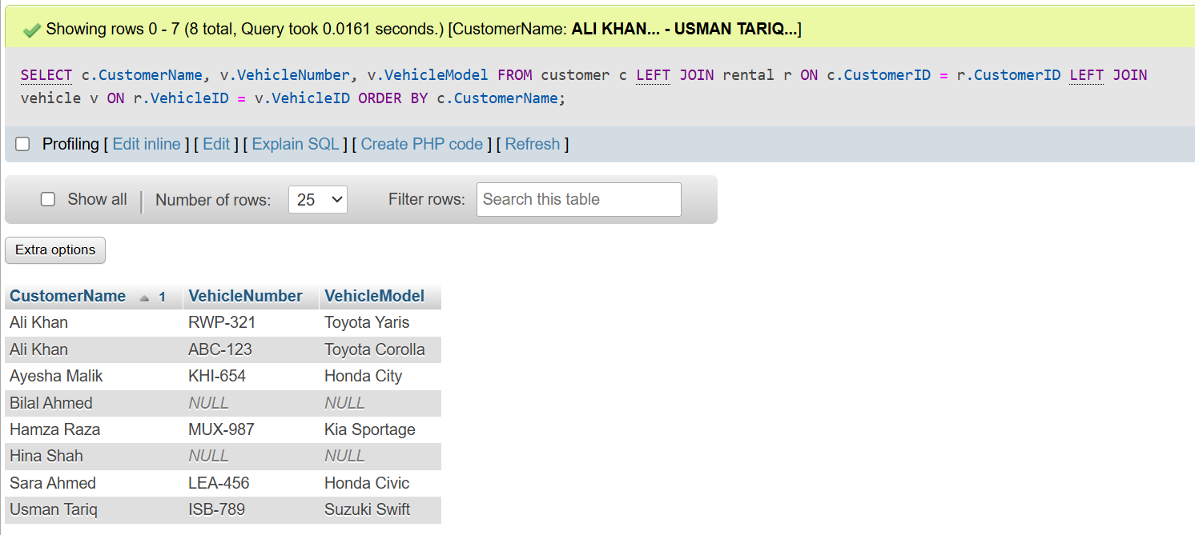Paste the actual phpMyAdmin result here.

6.4 Query 4 — Total Rentals Per Customer
SELECT c.CustomerName, COUNT(r.RentalID) AS TotalRentals
FROM Customer c
LEFT JOIN Rental r ON c.CustomerID = r.CustomerID
GROUP BY c.CustomerID, c.CustomerName
ORDER BY c.CustomerName;
COUNT(RentalID) returns zero for a customer with no matching rental because the LEFT JOIN still preserves the customer.
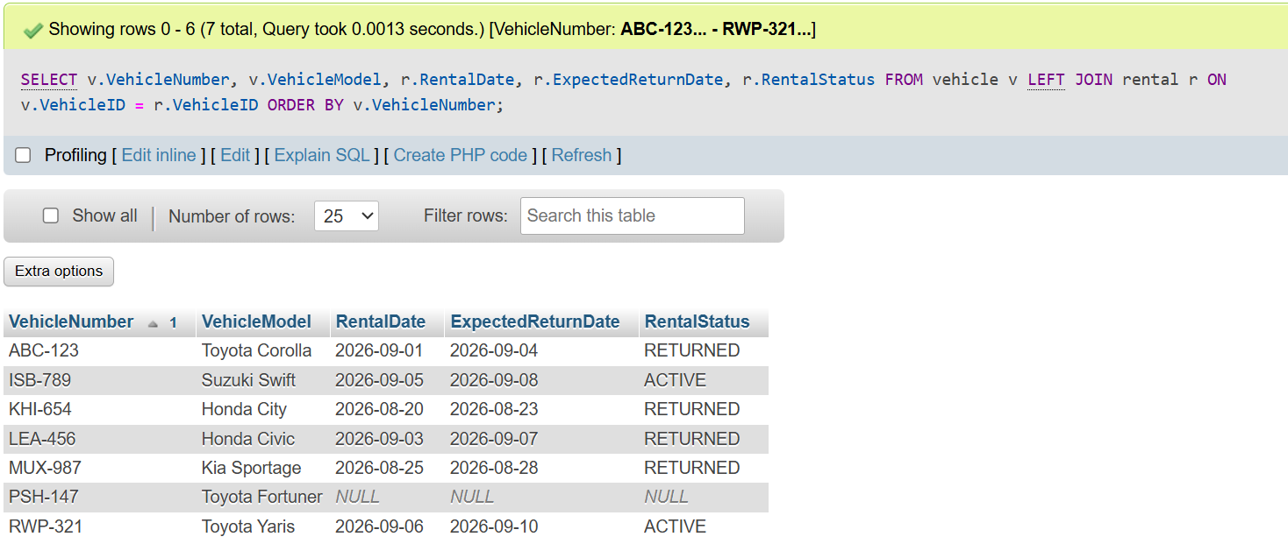

7. Consolidated VIEW
CREATE OR REPLACE VIEW vw_RentalReport AS
SELECT r.RentalID, c.CustomerName, c.Phone,
v.VehicleNumber, v.VehicleModel,
r.RentalDate, r.ExpectedReturnDate, r.ActualReturnDate,
r.RentalDays, r.DailyRate, r.RentalCharge,
COALESCE(SUM(p.Amount),0) AS AmountPaid,
r.RentalCharge - COALESCE(SUM(p.Amount),0) AS Balance,
r.RentalStatus
FROM Rental r
JOIN Customer c ON r.CustomerID=c.CustomerID
JOIN Vehicle v ON r.VehicleID=v.VehicleID
LEFT JOIN Payment p ON r.RentalID=p.RentalID
GROUP BY r.RentalID,c.CustomerName,c.Phone,v.VehicleNumber,v.VehicleModel,
r.RentalDate,r.ExpectedReturnDate,r.ActualReturnDate,
r.RentalDays,r.DailyRate,r.RentalCharge,r.RentalStatus;

7.1 Run the View
SELECT * FROM vw_RentalReport;
The view consolidates customer, vehicle, rental and payment information into one reusable reporting interface. It also calculates AmountPaid and Balance, reducing repeated multi-table reporting queries.
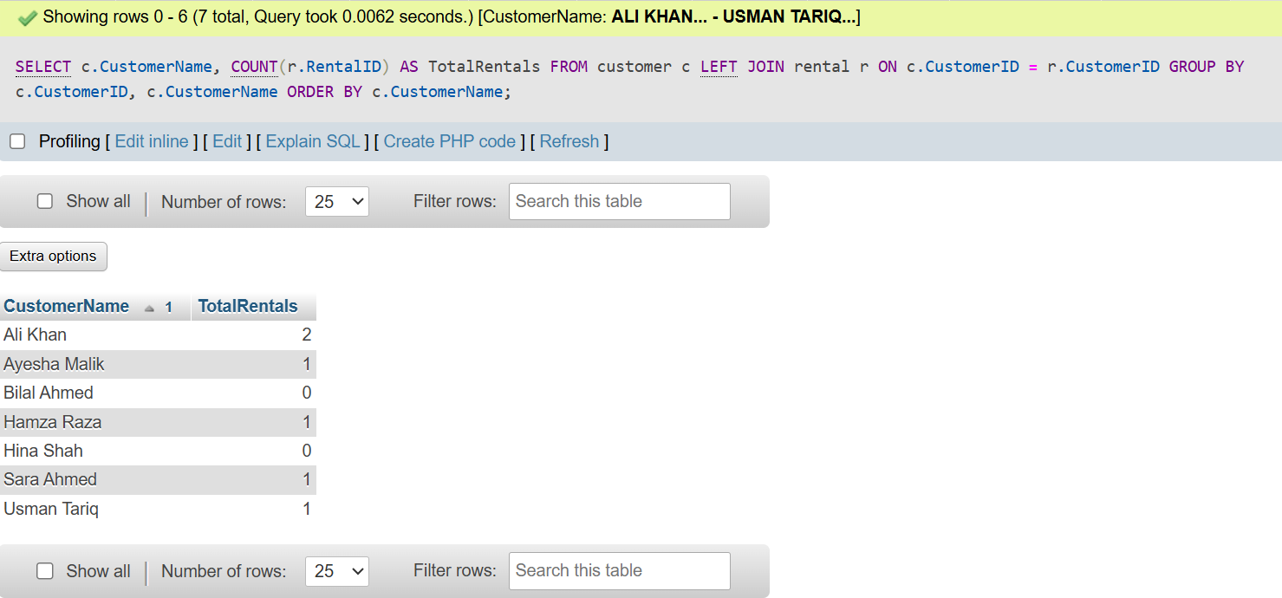

8. TRIGGER
The database must enforce the scenario rule that a vehicle should not be available for another rental while it is already rented. The following trigger rejects an inserted ACTIVE rental when the same vehicle already has an ACTIVE rental.
DELIMITER $$
CREATE TRIGGER trg_PreventDoubleRental
BEFORE INSERT ON Rental
FOR EACH ROW
BEGIN
IF NEW.RentalStatus='ACTIVE'
AND EXISTS (
SELECT 1 FROM Rental
WHERE VehicleID=NEW.VehicleID
AND RentalStatus='ACTIVE'
)
THEN
SIGNAL SQLSTATE '45000'
SET MESSAGE_TEXT='Vehicle is already booked for an active rental.';
END IF;
END$$
DELIMITER ;

8.1 Trigger Test
SELECT RentalID, VehicleID, RentalDate, ExpectedReturnDate, RentalStatus
FROM Rental
WHERE RentalStatus='ACTIVE';
Choose a VehicleID returned by the query above and attempt another ACTIVE rental for the same vehicle.
INSERT INTO Rental
(CustomerID,VehicleID,RentalDate,ExpectedReturnDate,
DailyRate,RentalDays,RentalCharge,RentalStatus)
VALUES
(2,1,'2026-09-02','2026-09-05',5000,4,20000,'ACTIVE');
Replace VehicleID 1 with an actually active vehicle from your database. The expected result is a MySQL error/rejection from the trigger.
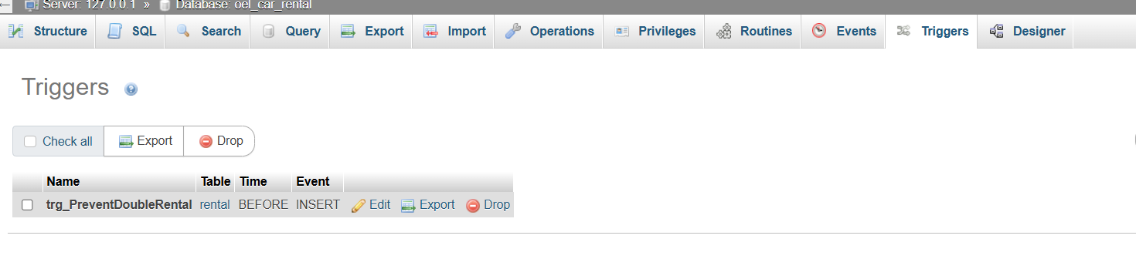

9. STORED PROCEDURE
The procedure follows the assignment's suggested operation: register a new rental and calculate the rental charge from the rental period and the vehicle's daily rate.
DELIMITER $$
CREATE PROCEDURE RegisterRental(
IN p_customer_id INT,
IN p_vehicle_id INT,
IN p_rental_date DATE,
IN p_return_date DATE
)
BEGIN
DECLARE v_daily_rate DECIMAL(10,2);
DECLARE v_days INT;
DECLARE v_charge DECIMAL(12,2);
DECLARE v_status VARCHAR(20);
IF NOT EXISTS (SELECT 1 FROM Customer WHERE CustomerID=p_customer_id) THEN
SIGNAL SQLSTATE '45000' SET MESSAGE_TEXT='Customer does not exist.';
END IF;
IF p_return_date < p_rental_date THEN
SIGNAL SQLSTATE '45000' SET MESSAGE_TEXT='Return date cannot be before rental date.';
END IF;
SELECT Status, DailyRate INTO v_status, v_daily_rate
FROM Vehicle WHERE VehicleID=p_vehicle_id;
IF v_status IS NULL THEN
SIGNAL SQLSTATE '45000' SET MESSAGE_TEXT='Vehicle does not exist.';
END IF;
IF v_status <> 'AVAILABLE' THEN
SIGNAL SQLSTATE '45000' SET MESSAGE_TEXT='Vehicle is not available.';
END IF;
SET v_days = DATEDIFF(p_return_date,p_rental_date)+1;
IF v_days < 1 THEN SET v_days=1; END IF;
SET v_charge = v_days*v_daily_rate;
INSERT INTO Rental
(CustomerID,VehicleID,RentalDate,ExpectedReturnDate,
DailyRate,RentalDays,RentalCharge,RentalStatus)
VALUES
(p_customer_id,p_vehicle_id,p_rental_date,p_return_date,
v_daily_rate,v_days,v_charge,'ACTIVE');
UPDATE Vehicle SET Status='RENTED'
WHERE VehicleID=p_vehicle_id;
SELECT * FROM Rental WHERE RentalID=LAST_INSERT_ID();
END$$
DELIMITER ;

9.1 Find an Available Vehicle
SELECT VehicleID, VehicleNumber, VehicleModel, Status FROM Vehicle WHERE Status='AVAILABLE';

9.2 Execute Procedure
CALL RegisterRental(
1,
2,
'2026-09-15',
'2026-09-18'
);
Use an actual available VehicleID. The procedure validates the customer, dates and vehicle status, calculates rental days and charge, inserts the rental and changes the vehicle status to RENTED.

9.3 Verify
SELECT * FROM Rental ORDER BY RentalID DESC LIMIT 5;
SELECT * FROM Vehicle ORDER BY VehicleID;
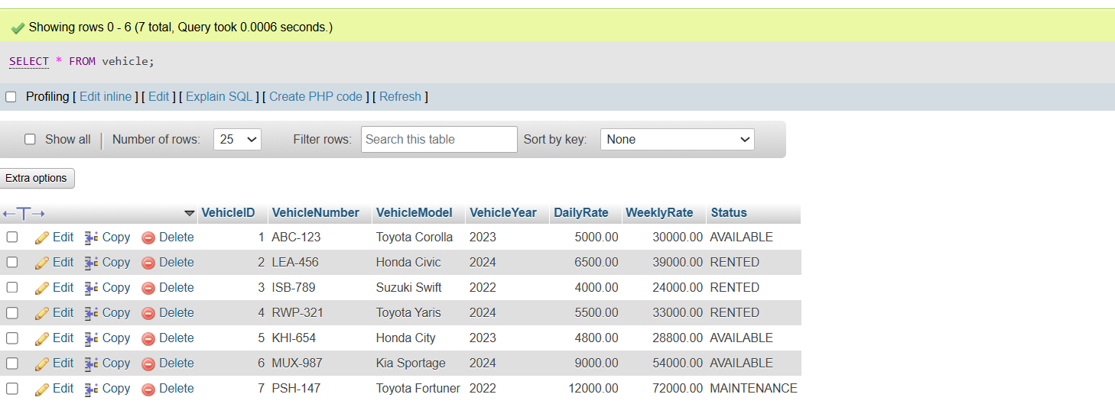

10. Optimization Analysis

10.1 Identified Problem
A frequent business operation is checking whether a vehicle has an ACTIVE rental. As Rental grows, filtering by VehicleID and RentalStatus can become inefficient if the relevant columns are not indexed.

10.2 Impact
- More rows may need to be examined as the table grows.
- Availability checks may take longer with larger rental histories.
- The business rule should be enforced at database level, not only in an application.

10.3 Improvement
CREATE INDEX idx_rental_vehicle_status ON Rental(VehicleID, RentalStatus);
The composite index supports the exact pair of columns used by the active-rental check. The trigger and stored procedure additionally centralize validation in the database.

10.4 EXPLAIN Verification
EXPLAIN
SELECT RentalID, CustomerID, VehicleID, RentalDate, ExpectedReturnDate
FROM Rental
WHERE VehicleID=1 AND RentalStatus='ACTIVE';
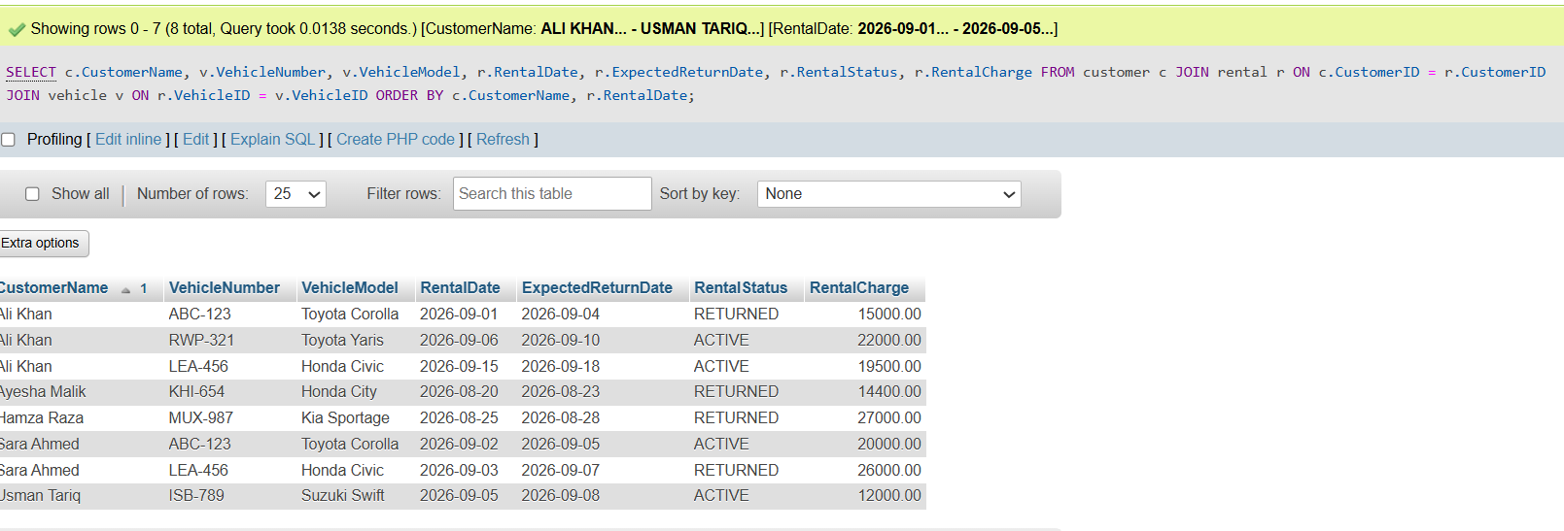.

10.5 Supporting Indexes
CREATE INDEX idx_rental_customer ON Rental(CustomerID);
CREATE INDEX idx_rental_dates ON Rental(RentalDate, ExpectedReturnDate);
CREATE INDEX idx_payment_rental ON Payment(RentalID);

11. Additional Management Reports

11.1 Customer Rental History
SELECT c.CustomerName,v.VehicleNumber,v.VehicleModel,
r.RentalDate,r.ExpectedReturnDate,r.RentalStatus,r.RentalCharge
FROM Customer c
JOIN Rental r ON c.CustomerID=r.CustomerID
JOIN Vehicle v ON r.VehicleID=v.VehicleID
ORDER BY c.CustomerName,r.RentalDate;

11.2 Currently Rented Vehicles
SELECT v.VehicleNumber,v.VehicleModel,c.CustomerName,
r.RentalDate,r.ExpectedReturnDate
FROM Vehicle v
JOIN Rental r ON v.VehicleID=r.VehicleID
JOIN Customer c ON r.CustomerID=c.CustomerID
WHERE r.RentalStatus='ACTIVE';

11.3 Vehicle Rental Activity
SELECT v.VehicleNumber,v.VehicleModel,
COUNT(r.RentalID) AS TotalRentals
FROM Vehicle v
LEFT JOIN Rental r ON v.VehicleID=r.VehicleID
GROUP BY v.VehicleID,v.VehicleNumber,v.VehicleModel
ORDER BY TotalRentals DESC;

12. phpMyAdmin Execution Guide
- Start Apache and MySQL from XAMPP and open phpMyAdmin.
- Select the oel_car_rental database in the left sidebar.
- Open the SQL tab and run the queries in this report one section at a time.
- Run JOIN 1, JOIN 2, JOIN 3 and JOIN 4 and save a screenshot of each result.
- Run SELECT * FROM vw_RentalReport; and save the VIEW screenshot.
- Check the trigger and test an overlapping ACTIVE rental; save the rejection screenshot.
- Find an AVAILABLE vehicle and execute CALL RegisterRental(...); save the procedure output.
- Verify the new rental and vehicle status.
- Create/verify the optimization indexes and run EXPLAIN; save the output.
- Insert all actual screenshots into the corresponding placeholders before submission.

13. Screenshot Checklist
# | Evidence | What it demonstrates
1 | Database structure | Tables and VIEW exist.
2 | JOIN 1 | Every rental with customer and vehicle.
3 | JOIN 2 | All customers including no-rental customers.
4 | JOIN 3 | All vehicles including unrented vehicles.
5 | JOIN 4 | Rental count including zero.
6 | VIEW | Consolidated rental/payment report.
7 | TRIGGER | Overlapping active rental rejected.
8 | Stored Procedure | Rental registered and charge calculated.
9 | Verification | New rental and vehicle status.
10 | EXPLAIN | Optimization evidence.
Important: these are evidence placeholders only. Insert your own phpMyAdmin screenshots; do not submit fabricated execution evidence.

14. Conclusion
The CarGo Rentals database converts the spreadsheet process into a structured relational system. Customer, vehicle, rental and payment information is separated into appropriate entities, reducing redundancy and supporting data integrity. The normalized design, JOIN queries, VIEW, trigger, stored procedure and indexes address the major technical requirements of the OEL.
The solution also provides a practical workflow for management reporting and rental processing. The stored procedure centralizes rental registration and charge calculation, while the trigger enforces the vehicle availability rule at the database level. The optimization section identifies a realistic performance concern and demonstrates an index-based improvement with EXPLAIN.

15. Final Submission Checklist
- Complete student/instructor/course information on the cover.
- Submit the SQL file containing database creation, tables, constraints, sample data, JOINs, VIEW, TRIGGER and STORED PROCEDURE.
- Include normalization analysis and optimization analysis in the report.
- Insert actual screenshots for all four JOIN queries, VIEW, TRIGGER and STORED PROCEDURE.
- Include the optimization EXPLAIN screenshot if required/available.
- Confirm screenshots were captured from the same database/SQL version being submitted.
- Review the report and remove any remaining screenshot placeholders before final submission.

