**Table of Contents**

**Chapter 1: Introduction 3**

**1.1** **Background** 3

1.1.1 TRS schizophrenia's neuroimaging characteristics 4

1.1.2 Schizophrenia patients classification and Machine Learning 4

1.1.3 Confounds in data used in medical training 5

**1.2 Model Explanation** 6

**1.3 Methods** 6

**1.4 Skills** 6

**1.5 State of the art** 7

**1.6 Artificial Intelligence and Machine Learning in healthcare** 7

**1.7 Problem** 8

**1.8 Aim** 9

**1.9 Work plan** 10

**1.10 Deliverables** 11

**1.11 Evaluation** 12

**1.12 Acknowledgment** 14

**1.13 Abstract** 14

**Chapter 2: Literature Review 15**

**2.1 Theory 15**

**2.2 Machine Learning Overview** 15

**2.3 Bias and Variance** 16

2.3.1 Bias and Variance in Schizophrenia 17

**2.4 Decision Trees and Ensemble Learning** 17

**2.5 Parallel ensemble learning - Random Forests** 18

**2.6 Sequential Ensemble Learning - Boosting** 19

**2.7 Support Vector Machines** 19

**Chapter 3: Methodology 20**

**3.1 Data Acquisition** 20

3.1.1 Data Collection 20

3.1.2 Data Preocessing 21

**3.2 Machine Learning** 21

**3.3 Deep Neural Network Architecture** 22

3.3.1 Single label classification 22

3.3.2 Multi-label classification 23

**3.4 ROC Interpretation** 23

**3.5 Methods of architecture interpretation and explainability** 24

**3.6 Data Analysis 25**

**3.7** **Machine Learning Models 41**

**3.8 Challenges** **49**

**3.9 Ethical Considerations** **50**

**Chapter 4: Results 51**

**Chapter 5: Discussion 52**

**Chapter 6:** **Discussion of** **Future Work** **53**

**Chapter 7: Conclusion 54**

**References 56**

**Chapter 1: Introduction**

This dissertation aims to investigate the use of cortical surface modeling and machine learning to predict treatment responses in schizophrenia patients. Schizophrenia is a neuropsychiatric illness characterized by auditory hallucinations and persecutory delusions. Neuroimaging data suggest dysfunction in neural networks involved in perception and interpretation. However, there are currently no robust predictors of treatment response. Previous research focused on multimodal volumetric MRI biomarkers, but schizophrenia primarily affects the cortex, which can be more accurately modeled as a surface. This project will explore the potential of combining cortical surface modeling and machine learning to improve the precision of treatment response prediction in schizophrenia patients.

**1.1 Background**

In this section, we will review recent research on the use of machine learning (ML) algorithms with neuroimaging data to identify patients with treatment-resistant schizophrenia (TRS) and non-treatment-resistant schizophrenia (NTR). We will cover various categories of neuroimaging data, including structural and functional data, that have been used for prediction. We will also discuss state-of-the-art ML models for predicting TRS and NTR. Additionally, we will address confounding factors in neuroimaging data and strategies for mitigating their influence. Finally, we will provide an overview of methods for deriving significant predictive characteristics from ML models and displaying them for better interpretability. The goal of this section is to provide readers with a comprehensive understanding of the developments, opportunities, challenges, and potential implications of ML-based classification of TRS and NTR schizophrenia from neuroimaging data for clinical decision-making and patient care.

**1.1.1 Neuroimaging characteristics of TRS schizophrenia**

Recent research has focused on differentiating between treatment-resistant schizophrenia (TRS) and non-treatment-resistant schizophrenia (NTR) by examining structural and functional brain variations using machine learning (ML) algorithms with magnetic resonance imaging (MRI) data. Smaller gray matter volumes have been associated with worse clinical outcomes in schizophrenia patients, as shown by Kasparek et al. [12] and Jääskeläinen et al. [13]. Cortical volume, thickness, and surface area differences have been observed among healthy controls, TRS patients, and NTR patients by Barry et al., with TRS patients exhibiting significantly lower cortical volume and thickness in various brain regions. Dysfunction in reward feedback processing has also been reported in people with schizophrenia, as demonstrated by Vanes et al. using functional MRI (fMRI) data. These findings suggest that TRS and NTR may have distinct neurological variations. Machine learning models have the potential to accurately identify and utilize these distinctive neuroimaging characteristics to inform more personalized therapeutic strategies, aiding clinicians in anticipating treatment outcomes and making informed decisions about patient care.

**1.1.2 Schizophrenia Patient Classification and Machine Learning**

Machine Learning (ML) is increasingly used for classifying Treatment-Resistant Schizophrenia (TRS) and Non-Treatment Resistant (NTR) Schizophrenia from neuroimaging data. Many features are correlated with treatment outcome in schizophrenia patients, and ML can combine these features for improved prediction. Previous research has mainly focused on classifying schizophrenia patients from healthy controls. For example, Greenstein et al. used 74 anatomic brain MRI sub-regions to classify childhood onset schizophrenia patients and controls with a predictive accuracy of 73.7%.

Iwabuchi et al. achieved the highest accuracy of 77% in distinguishing patients and controls using gray matter and white matter MRI images with a Support Vector classifier. Lu et al. combined Support Vector Machines with recursive feature elimination to discriminate schizophrenia patients from controls with 88.4% accuracy using structural MRI data.

Ambrosen et al. developed a framework using multi-modal imaging data, including cortical thickness, surface area, and mean curvature from T1-weighted MRI images, cognitive performance data, and electrophysiology data, to classify healthy controls and patients, as well as TRS and NTR patients, using ML methods. They achieved a maximum class-balanced accuracy of 64% in classifying HCs from TRSs and NTRs using an ensemble of trees, but were unable to classify TRSs and NTRs with significance. Overall, these studies demonstrate the potential of ML in analyzing complex neuroimaging data for schizophrenia patient classification. Future research in this area will continue to shed light on this important field.

**1.1.3 Confounds in Medical Data for Training ML Models**

Confounding variables pose challenges in predictive modeling, as they can affect model outcomes and lead to inaccurate conclusions. For example, in a model predicting schizophrenia based on brain features, confounds such as gender and substance abuse can significantly impact results as they affect gray matter structure.

Methods to address confounds include balancing them across groups, but this may not always be feasible. Another approach is confound regression, where a linear regression model is used to remove confound influence from data. Cross-validated confound regression (CVCR) is a modified version that has shown promise in neuroimaging data. In a study by Snoek et al. (2019), CVCR outperformed whole-dataset confound regression in deconfounding brain size for gender prediction from structural MRI data.

Overall, addressing confounding variables in predictive modeling requires careful consideration and appropriate methods. CVCR is a promising approach, but further research is needed for its efficacy in different applications and datasets.

**1.2 Model Explanation**

This passage discusses model explainability in machine learning. Some models like Random Forest classifiers are transparent and reveal the contribution of input features to predictions. In contrast, neural networks are considered black-box models due to complex and non-linear mappings between inputs and outputs. However, methods like the Shapley value approach can extract relative feature importances from deep neural networks.

Saliency mapping visualizes important image parts for a convolutional neural network by computing gradients of class scores with respect to image pixels. These methods have been used in medical image analysis but caution is needed in high-risk domains.

# **1.3 Methods**

# Data from a number of healthy controls and patients divided into treatment-responsive and treatment-non-responsive groups will be available to the pupils. The initiative will look into whether cortical function and form characteristics may indicate how well a patient will respond to therapy. The students will have to utilize machine learning to clean and denoise functional MRI data, remove annoyance factors, and then predict treatment responses from these characteristics. A model of typical cortical architecture may be created using Gaussian process regression and used to compare patient groups.

# **1.4 Skills**

Several different types of pupils can benefit from the initiative. Manually labeling functional maps as signal/noise to clean data and enhance sensitivity to features sensitive to treatment response may be useful for medical students. Each student may design studies that compare several groups statistically. Students will be needed to know Python and have at least a basic understanding of machine learning to participate in the machine learning experiments. Software from the Human Connectome Project and FSL for cortical surface and whole-brain image processing will be trained.

**1.5 State of the Art**

Current schizophrenia treatments include pharmaceutical and psychotherapy methods. Antipsychotic medication is the cornerstone, effectively lowering positive symptoms like delusions and hallucinations. Atypical antipsychotics, also known as second-generation antipsychotics, are preferred due to the lower risk of adverse effects compared to first-generation antipsychotics. However, antipsychotics are not effective in treating negative symptoms and cognitive impairment.

Cognitive-behavioral therapy (CBT) and family therapy have shown promise in improving outcomes for schizophrenia patients. CBT has successfully treated symptoms like paranoia and delusions and may enhance daily functioning and quality of life. Family therapy has been shown to improve family functioning and reduce caregiver stress.

Neuromodulation methods, such as transcranial magnetic stimulation (TMS), have gained attention as potential treatments for schizophrenia. TMS, a non-invasive therapy that uses magnetic fields to stimulate specific brain areas, has been shown to be effective in easing symptoms of depression and other psychiatric illnesses. Deep brain stimulation (DBS), still in the experimental stage, requires further research to confirm its safety and effectiveness in treating schizophrenia.

**1.6 Artificial Intelligence and Machine Learning in Healthcare**

Machine learning is transforming healthcare by providing data-driven insights that can aid in identifying, treating, and monitoring medical disorders. Medical imaging is a major field where machine learning is making an impact, as algorithms can automatically identify, diagnose, and monitor diseases using high-resolution medical images. Drug development is another area where machine learning is making a significant difference, enabling the assessment of large volumes of biological data to identify therapeutic targets and predict the effectiveness of new medications.

Furthermore, machine learning is improving patient outcomes by predicting readmission rates and treatment results, allowing for more effective resource allocation and individualized treatments.

Deep learning algorithms, such as convolutional neural networks (CNNs), are widely used in medical imaging for pattern recognition and disease identification. These algorithms have been successfully applied to various imaging modalities, including X-rays, MRIs, and CT images, to detect diseases such as breast cancer, lung disease, and diabetic retinopathy.

Despite the significant advancements in machine learning and deep learning in healthcare, challenges remain, including data quality, availability, privacy, and interpretability of algorithm outcomes. However, these technologies have the potential to revolutionize healthcare if further improved and supported by infrastructure and medical data investment.

The use of pharmaceutical and psychotherapy therapies, along with neuromodulation approaches, is currently considered the state of the art in treating schizophrenia, although more research is needed for a comprehensive understanding of their mechanisms and long-term efficacy.

**1.7 Problem**

There are presently no reliable predictors of treatment response or non-response, despite the existence of several neuroimaging studies on schizophrenia patients. This makes it challenging to precisely predict which medicines will be helpful for certain individuals and to enhance the treatment results for schizophrenia patients (Phillips et al., 2008, ) This dissertation seeks to solve this problem by examining the possibility of enhancing the accuracy of treatment response prediction in schizophrenia patients by combining cortical surface modeling and machine learning.

**1.8 Aim**

Healthcare has been transformed by machine learning and deep learning algorithms, which offer creative approaches to disease diagnosis, treatment, and prognosis. Convolutional neural networks (CNNs), a type of deep learning algorithm, are commonly used in healthcare for image categorization of various modalities such as X-rays, MRIs, and CT scans.

Cortical surface modeling provides a nuanced approach to understanding brain processes in schizophrenia by analyzing the shape, thickness, and structure of the cortex using functional MRI data. This technique has the potential to improve predictions of therapy response when combined with machine learning, using data from control subjects and patients with schizophrenia, grouped by treatment response.

Machine learning approaches will be used to clean and denoise the functional imaging data, and Gaussian process regression may also be employed to create a model of typical cortex architecture for comparison. The findings of this study may have significant ramifications for psychiatry, leading to more precise treatment response predictions and better outcomes for schizophrenia patients. Additionally, the results may advance our understanding of schizophrenia's underlying brain pathways and offer fresh perspectives on its pathogenesis.

In conclusion, this research presents an opportunity to further comprehend schizophrenia and improve the lives of those affected by the disorder. Machine learning algorithms and cortical surface modeling have the potential to revolutionize the prediction of treatment effectiveness in schizophrenia and open up new avenues for psychiatric research and discovery.

**1.9 Work Plan**

A concise work plan for investigating the use of cortical surface modeling and machine learning to predict treatment response in schizophrenia patients would involve the following steps:

1. Data Collection and Preparation: Examining the Dataset

* Use df.info() to display details about the DataFrame, including the number of rows, columns, and data types.
* Note that the DataFrame had a multi-level index with 98 entries, and it was previously in the form of 97, 1 before the multi-index was removed.
* Include functional imaging data for each participant, denoise and clean the data, and remove nuisance factors.

1. Cortical Surface Modeling: Analyzing Cortex Function and Form

* Utilize cortical surface modeling techniques to build models of typical cortical structure and translate functional MRI data onto a surface representation of the brain.
* Compare the models to the patient data to identify discrepancies between the patient and control groups.

1. Feature Selection and Engineering: Choosing Informative Characteristics

* Select the subset of features that provide the most accurate predictions of treatment response.
* Use feature extraction methods, feature selection algorithms, or manual feature selection approaches to alter or produce new features from the existing data.

1. Machine Learning: Training and Optimizing the Model

* Train a machine learning algorithm, such as logistic regression, decision trees, or random forests, using the selected data and features.
* Adjust the parameters to optimize performance and assess the model using cross-validation methods to identify overfitting or underfitting issues.

1. Evaluation and Validation: Assessing Model Performance

* Assess and validate the model's performance using independent data from a different cohort or by dividing the current data into training and validation sets.
* Use metrics such as accuracy, precision, recall, and F1-score to evaluate the model's performance.
* Take additional measures, such as adding more features or using a different machine learning technique, to enhance the model if needed.

1. Interpretation and Reporting: Reporting Outcomes and Suggestions for Further Study

* Report and interpret the outcomes of the study, including a discussion of the results and their implications for the care of people with schizophrenia.
* Provide suggestions for further research in this field, such as creating new prediction models or exploring other machine learning techniques.

Overall, this concise work plan ensures a systematic and rigorous approach to evaluating the potential of combining cortical surface modeling and machine learning for predicting treatment responses in schizophrenia patients. It focuses on essential steps in data preparation, feature selection, machine learning, assessment, and reporting.

**1.10 Deliverables**

Deliverables for the schizophrenia research project may include:

1. Literature reviews: A comprehensive analysis of existing research on schizophrenia, including its etiology, current therapies, and results.
2. Procedures plan: Detailed outline of information gathering procedures from patients and healthy controls, including type of data (e.g. imaging), target population, and protocols for accuracy and validity.
3. Data Analysis Plan: Detailed strategy for analyzing data from patients and healthy controls, including quality and validity protocols, and specific methods and algorithms for evaluation.
4. Results: Comprehensive overview of study findings, including data analysis, statistical tests, main conclusions, and findings.
5. Conclusion and Recommendations: Discussion of study's implications, recommendations for further research or application, and a conclusion highlighting main discoveries.
6. Final Report: Comprehensive summary of all study deliverables, including data gathering and analysis plans, findings, conclusions, and recommendations.
7. Presentation: Visual presentation of study's data and main conclusions through slides, pictures, and graphs for stakeholders and wider dissemination.
8. Code: Well-documented sharing of data collection and analysis code, including scripts and algorithms created for the project to promote transparency and reproducibility.
9. Manuscripts: Submission of one or more papers describing study's main conclusions to peer-reviewed publications for publication.

**1.11 Evaluation**

1. Evaluation components: The main focus of the review process will be on the accuracy of the predictive models in determining treatment responses for schizophrenia patients, the validity of the study's methodologies compared to previous research, the consistency and reliability of the data, the completeness of the results in providing a comprehensive understanding of the potential for improving treatment response prediction, the significance of the study in real-world clinical settings, limitations of the study's methodology, and recommendations for future research to enhance treatment response prediction accuracy.

2. Predictive model accuracy: Evaluating the accuracy of the predictive models by contrasting expected and actual treatment responses of the study's patients.

3. Validity of the Methods: Determining the validity of the study's procedures by comparing findings with previous research that used similar methodologies.

4. Data Consistency and Reliability: Examining the consistency and reliability of the data to assess its quality, including adherence to standard data collection procedures and appropriate statistical analysis.

5. Completeness of Results: Assessing the comprehensiveness of the study's results by ensuring that all relevant data has been collected and analyzed to provide a thorough understanding of treatment response prediction accuracy using cortical surface modeling and machine learning.

6. Significance of the Study: Evaluating the practical relevance of the study's findings in real-world clinical settings and their potential to improve treatment outcomes for schizophrenia patients.

7. Limitations of the Study: Identifying and acknowledging any limitations or restrictions in the study's methodology while evaluating findings and providing suggestions for further research, taking into consideration the study's limitations.

8. Suggestions for Future Research: Making doable recommendations for future research based on the study's findings to further enhance treatment response prediction accuracy, while considering the study's limitation.

**1.12 Acknowledgment**

I want to thank everyone who has been kind and helpful to me during this study process. I want to start by expressing my gratitude to my supervisor for their direction, assistance, and encouragement during the assignment. Their understanding of schizophrenia and neuroimaging has been quite helpful to me. I also want to express my gratitude to the healthy volunteers and research participants for their willingness to advance our understanding of this condition. I would like to express my gratitude for the support provided by the workers at the imaging facility where the data was gathered in obtaining high-quality imaging data.

Finally, I would want to thank my friends and family for their assistance with this effort. Their support and compassion have been crucial to my achievement.

Ultimately, without the help and assistance of everyone engaged, this study would not have been possible. I owe a sincere debt of gratitude to all of those who supported me in this effort.

**1.13 Abstract**

Schizophrenia is a neuropsychiatric condition characterized by persecutory delusions and severe auditory hallucinations. Neuroimaging research has linked schizophrenia to disruption in brain networks that support crucial psychological functions related to perception and understanding of the environment. Despite numerous imaging investigations, there are no reliable predictors of treatment response. This study aims to explore the use of cortical surface modeling and machine learning to enhance treatment response prediction accuracy for schizophrenia patients. The study will use data from healthy controls and patients divided into treatment-responsive and treatment-non-responsive groups. The objective is to determine whether cortical function and cortical shape characteristics can predict therapy response. Machine learning approaches will be used to clean and denoise functional imaging data and predict treatment response. The findings of this study may improve patient care and provide insights into the neurological pathways underlying schizophrenia.

**Chapter 2: Literature Review**

**2.1 Theory**

In this chapter, we will provide an overview of machine learning and its potential applications in the field of psychiatry, specifically in the prediction of treatment response in schizophrenia patients. We will discuss the various types of machine learning algorithms and their strengths and weaknesses in the context of this project. Additionally, we will discuss the importance of feature selection and feature engineering in building accurate predictive models.

## **2.2 Machine Learning Overview**

The main goal of machine learning in artificial intelligence is to create algorithms that can learn from data and make predictions or judgments without explicit programming. Machine learning algorithms come in different forms, such as supervised learning, unsupervised learning, and reinforcement learning, depending on whether the result variable or label is known or unknown, and whether the feedback is received in the form of incentives or penalties.

In this study, we will use supervised learning algorithms to forecast treatment responses in schizophrenia patients. By dividing patients into responsive and non-responsive groups, we have labeled data that is well-suited for supervised learning algorithms. Common supervised learning techniques used in psychiatry include logistic regression, decision trees, and random forests.

Building accurate predictive models involves key phases like feature engineering and feature selection. Feature engineering involves modifying or creating new features from existing data, while feature selection involves identifying the most informative subset of characteristics for the task at hand. In this study, we will combine cortical surface modeling with machine learning to improve the accuracy of treatment response prediction in schizophrenia patients.

## **2.3 Bias and Variance**

Two fundamental ideas in statistical modeling and machine learning are bias and variance, which are potential causes of mistakes when developing predictive models.

Bias occurs when a model consistently over- or under-estimates the true relationship between input variables and the target variable. A model with strong bias will repeatedly make the same mistake regardless of the input data. This type of error occurs when the model is overly simplistic and fails to adequately capture the complexity of the underlying relationship.

On the other hand, variance refers to the inaccuracy that arises when a model is too complex and sensitive to random variations in the input data. Even if the training sets come from the same underlying population, a model with high variance may provide different predictions for each set. This type of error occurs when the model is overly flexible and fits the data too well, capturing the noise in the input data rather than the underlying relationship.

Balancing bias and variance is crucial in machine learning, as both excessive bias and high variance can lead to subpar model performance. To effectively capture the underlying relationship between input variables and the target variable, a model should have low bias and low variance. Machine learning algorithms often employ methods such as regularization, cross-validation, and ensembling to manage the model's complexity and avoid overfitting, in order to achieve this balance.

### 2.3.1 Bias and Variance in Schizophrenia

## The problem of bias and variance can significantly impact the accuracy and reliability of predictions when predicting treatment responses in schizophrenia patients. For instance, if a model is biased towards one type of treatment, it may consistently overestimate or underestimate its efficacy across all patients, resulting in unreliable predictions. Additionally, if the model has high variance, it may provide different predictions for patients with similar features. This can make it challenging to accurately predict successful therapies for specific individuals, leading to suboptimal treatment outcomes.

## To mitigate these issues, it is important to use a diverse and representative sample of patient data and employ approaches to manage the complexity of the model. By doing so, more accurate and dependable predictions can be made, ultimately improving treatment outcomes for schizophrenia patients.

## **2.4 Decision Trees and Ensemble Learning**

Two popular machine learning techniques for predicting therapy response in schizophrenia patients are decision trees and ensemble learning.

Decision trees are a type of tree-based model that uses if-then rules to make predictions. They iteratively divide data into smaller groups based on the characteristics that best describe the target variable. Decision trees are known for their simplicity, interpretability, and ability to handle both continuous and categorical data. They can also be easily integrated into ensemble models, such as random forests.

Ensemble learning involves combining multiple machine learning models to create a more reliable and accurate forecast. The idea behind ensemble learning is that combining diverse models can result in more accurate predictions compared to using a single model. Random forest, which is an extension of decision trees, is a common ensemble approach where multiple decision trees are combined to provide a final prediction.

Using decision trees and ensemble learning can help address the challenge of predicting therapy response in schizophrenia patients. By leveraging the strengths of multiple models, it may be possible to achieve more accurate and trustworthy forecasts, leading to improved treatment outcomes. However, it is important to be mindful of potential drawbacks, such as the risk of overfitting, when applying these techniques in this context.

## **2.5 Parallel ensemble learning - Random Forests**

Parallel ensemble learning, particularly using random forests, is a potent method for addressing the challenge of predicting therapy response in schizophrenia patients. Random forests, an ensemble learning technique, combine multiple decision trees to provide more reliable and accurate predictions.

In parallel ensemble learning, multiple random forests are trained simultaneously on different subsets of data, allowing for scalable and effective training. The forecasts from each random forest are then combined to obtain the final prediction, which can help lower prediction variance and improve overall model accuracy.

Parallel ensemble learning can be applied to large and complex patient datasets to identify key determinants of therapy response in schizophrenia patients. By merging predictions from multiple random forests, more precise and trustworthy forecasts may be obtained, leading to improved treatment outcomes.

However, it is important to consider potential drawbacks, such as the risk of overfitting, when applying parallel ensemble learning in this context. Ensuring that the data used for model training is diverse, representative, and of high quality is also crucial to prevent biases in predictions.

## **2.6 Sequential Ensemble Learning - Boosting**

Sequential ensemble learning, particularly using boosting, is another approach for predicting treatment response in schizophrenia patients. Boosting is an ensemble learning technique that combines multiple ineffective models to obtain a more accurate forecast.

In boosting, models are trained sequentially, with each subsequent model focusing on correcting errors made by the previous model. The results of each individual model are combined to obtain the final prediction, which can help reduce prediction bias and improve overall model accuracy.

Boosting can be used to analyze patient data and identify key variables associated with treatment responses in schizophrenia patients. By merging predictions from multiple weak models, more precise and trustworthy forecasts may be obtained, leading to improved treatment outcomes.

However, it is important to consider potential limitations of boosting, such as the risk of overfitting, when applying it in this context. Ensuring that the data used for model training is diverse, representative, and of high quality is also crucial to prevent biases in predictions. The choice between parallel or sequential ensemble learning approaches should be determined based on the unique task and data properties.

## **2.7 Support Vector Machines**

Support Vector Regression (SVR) is a machine learning method that can be utilized to predict treatment response in schizophrenia patients. SVR employs a hyperplane, a boundary, to separate the data into different groups in supervised learning.

SVR maximizes the margin between the support vectors, or nearby data points, to produce a strong and precise model, considering both linear and non-linear correlations between characteristics and the target variable.

SVR can be employed to analyze patient data and identify key treatment response variables in the context of predicting therapy response in schizophrenia patients.

The ability of SVR to handle non-linear correlations between characteristics and the target variable is advantageous in complex tasks like predicting treatment response in schizophrenia. SVR is also computationally efficient and suitable for large datasets.

However, it is important to consider potential drawbacks of SVR, such as the risk of overfitting, when applying it in this context. Ensuring that the data used for model training is diverse, representative, and of high quality is crucial to prevent biases in predictions. The choice of machine learning technique should be based on the specific problem and data properties.

# 

# **Chapter 3: Methodology**

## **3.1 Data Acquisition**

In this chapter, we will go through the strategies we employed in our study for data collection and processing. This experiment will gather data from roughly 97 people with schizophrenia, divided into treatment-responsive and non-responsive groups. Each participant's data will include functional magnetic resonance imaging (fMRI) scans as well as demographic and clinical information.

**3.1.1 Data Collection**

A 3T MRI scanner with a T2*-weighted gradient echo planar imaging (EPI) sequence will be used to gather the fMRI images. TR = 2000 ms, TE = 30 ms, flip angle = 90 degrees, FOV = 240 x 240 mm, matrix size = 64 × 64, and slice thickness = 3 mm will be the imaging parameters. During the scan, participants will be encouraged to lie motionless and keep their eyes closed for roughly 10 minutes. In addition to the fMRI scans, each participant's demographic and clinical information, such as age, gender, education level, and medication history, will be gathered.

### 3.1.2 Data Extraction

The data preprocessor retrieved information on the sulcus, curvature, and thickness of brain regions from the "fsaverage_LR32k_new" file. They then averaged within regions to generate summary statistics for each region. We then used the "cifti separate" function to separate the data based on the Desikan-Killiany (DK) atlas labels, which are used to partition the brain into discrete regions. They used the "wb_command -cifti-separate" command to obtain separate files for the left and right hemispheres of the brain, which included all the label names from the original "fsaverage_LR32k_new" file. Finally, we used the "wb_command -label-resample" command to resample the data to the "fsaverage_LR32k_new" file for both hemispheres. This entailed resampling the data to the new file using the MUTRIP01.aparc.DKTatlas.164k_fs_LR.L.native.label.gii file and the ADAP_BARY_AREA option. They also named the "area-surfs" MUTRIP01.L.midthickness.native.surf.gii and../fsaverage_LR32k/MUTRIP01.L.midthickness.32k_fs_LR.surf.gii. This preprocessing produces a set of resampled files containing information on the sulcus, curvature, and thickness of brain areas in both hemispheres, which can be utilised for additional research, such as running a machine learning model.

### 3.1.3 Data Processing

The Human Connectome Project (HCP) pipeline is a mechanism for analyzing brain imaging data to examine brain connectivity and form. First, motion correction, slice timing correction, and spatial smoothing with a 4-mm FWHM kernel are applied to the fMRI data. This aids in the correction of any data quality concerns that may develop because of motion or other factors. The preprocessed data is then registered to a standard template using FLIRT, a program that aligns the data with a standardised brain picture to enable for intersect-individual comparison. Time series data is taken from each voxel in the brain and averaged within each region of interest (ROI) using the Desikan-Killiany atlas, which divides the brain into 34 areas per hemisphere, to evaluate cortical function. Using the Pearson correlation coefficient, the time series data for each ROI is then utilized to calculate the strength of functional connection between the ROIs. The FreeSurfer program is used to rebuild the surface of the cortex from T1-weighted structural images to analyze cortical form. Using the Destrieux atlas, the last surface is separated into various zones. Cortical thickness, surface area, and curvature measurements are gathered for each region and used for statistical analysis, which can reveal information about the brain's structural organisation. Overall, the HCP pipeline provides a comprehensive method to brain imaging data analysis that can provide insights into both functional and anatomical brain connectivity.

## **3.2 Machine Learning**

Machine learning techniques like principal component analysis (PCA) and independent component analysis (ICA) will be used to clean and denoise the data, eliminating nuisance factors such as head motion and physiological noise using regression methods. Support vector machines (SVMs) and random forests will then be employed to predict treatment response using the cleaned and denoised data. Gaussian process regression will also be utilized to model normative cortical architecture for comparison with patient groups, aiming to enhance the precision of treatment response prediction in schizophrenia patients through these combined methodologies.

This chapter has describes the data gathering and processing procedures for our investigation, which includes fMRI scans, demographic, and clinical information for each participant. The HCP pipeline will be used for data preprocessing, followed by cortical surface modeling and machine learning approaches. The purpose of this experiment is to assess if cortical function and structure can predict treatment response in schizophrenia patients.

**3.3 Deep Neural Network Architecture**

Deep Neural Networks (DNNs) are artificial neural networks with multiple hidden layers and numerous artificial neurons. These networks have proven effective in various applications such as image recognition, natural language processing, and medical diagnosis. DNN architecture, including the number and type of layers, neurons per layer, and activation functions, is a crucial consideration. Convolutional Neural Networks (CNNs) are a common type of DNN architecture, particularly useful for image recognition. Convolutional layers extract image features, while fully connected layers are used for classification. Recurrent Neural Networks (RNNs) are another popular DNN design for sequential input processing, such as voice or text.

### 3.3.1 Single label classification

The purpose of single label classification is to predict a single class label for each input sample. In image classification, for example, the objective can be to predict if a picture contains a cat or a dog. In this scenario, the network would contain two output neurons, one for "cat" and the other for "dog." The network would then be trained to predict the proper class label as accurately as possible.

### 3.3.2 Multi-label classification

The purpose of multi-label classification is to predict several class labels for each input sample. In medical diagnostics, for example, the objective may be to anticipate many illnesses for a patient based on their symptoms. The network would have numerous output neurons in this example, each representing a particular ailment. After that, the network would be trained to predict all of the appropriate class labels for each input sample.

Since the network must be able to accommodate several and sometimes contradicting outputs, multi-label classification is more difficult than single-label classification. Many strategies have been proposed to handle this difficulty, including the use of several binary classifiers, one for each label, or the use of a single classifier with numerous outputs. The approach chosen will be determined by the task's unique needs and the data being utilised.

**3.4 ROC Interpretation**

Receiver Operating Characteristic (ROC) analysis is commonly used in machine learning, particularly in medical image analysis, to assess the performance of binary classification systems. The ROC curve visualizes the trade-off between the true positive rate (sensitivity) and the false positive rate (1-specificity) for different threshold values. The area under the curve (AUC) provides a single value to represent the overall performance of the classifier.

ROC analysis is used in single-label classification to evaluate the performance of a binary classifier across various threshold values. A good classifier should have high sensitivity and specificity.

In multi-label classification, ROC analysis summarizes the performance of a multi-label classifier for each category, allowing for comparison across categories.

ROC analysis is widely used in medical image analysis to assess machine learning algorithm efficacy in different applications. It is a valuable tool to evaluate classifiers and illustrates the trade-off between true positive and false positive rates, which has significant implications for patient care.

**3.5 Methods of Architecture Interpretation and Explainability**

Interpretability and explainability are crucial in machine learning, especially in medical applications where accurate predictions are vital. Understanding the underlying processes of treatment response is essential in schizophrenia studies to improve patient outcomes.

Deep neural networks can be interpreted and explained using techniques such as feature visualization, saliency maps, and layer-wise relevance propagation (LRP). Feature visualization displays neuron activity in different network levels to identify important properties for prediction. Saliency maps highlight significant areas of input images for specific predictions.

LRP is a backpropagation approach that distributes prediction relevance to input characteristics, providing a comprehensive explanation of the network's decision.

In the context of schizophrenia research, feature visualization and saliency maps can identify important brain areas for treatment response prediction. LRP can distribute prediction relevance to specific characteristics in functional imaging data, offering a precise understanding of the underlying processes influencing treatment response.

Strategies for enhancing interpretability include using inherently interpretable models like decision trees or incorporating interpretability during the learning process through regularization techniques or domain knowledge.

Adopting interpretable machine learning algorithms can improve prediction accuracy and trust in findings, which is crucial in medical applications where accurate predictions are essential for patient outcomes.

**3.6 Data Analysis**

This chapter presents the data analysis methods used in our study, aimed at investigating the relationship between cortical function and shape and treatment response in schizophrenia patients. We will start by cleaning and denoising the functional imaging data using machine learning methods, particularly deep neural networks, to remove artifacts and noise while preserving significant signals. Then, we will deconfound nuisance variables using regression-based approaches and independent component analysis to eliminate irrelevant factors that may affect our investigation.

Next, we will perform feature extraction and selection to identify the most relevant characteristics for predicting treatment response, using cortical surface models generated from imaging data. We will utilize supervised machine learning methods like logistic regression, decision trees, and random forests to develop prediction models and assess their performance using accuracy, precision, recall, F1 score, and statistical methods such as t-tests and ANOVA.

The first line of code imports Python libraries for data analysis and manipulation (Pandas), numerical computations (Numpy), and data visualization (Matplotlib.pyplot). The Scikit-learn package is also imported to access the feature selection function (sklearn.feature selection.r regression).

# **Dataset loading**

The dataset is imported into a Pandas DataFrame using Pd.read csv(). The ROI was calculated by averaging the characteristics. The csv file is located in /content/drive/MyDrive.

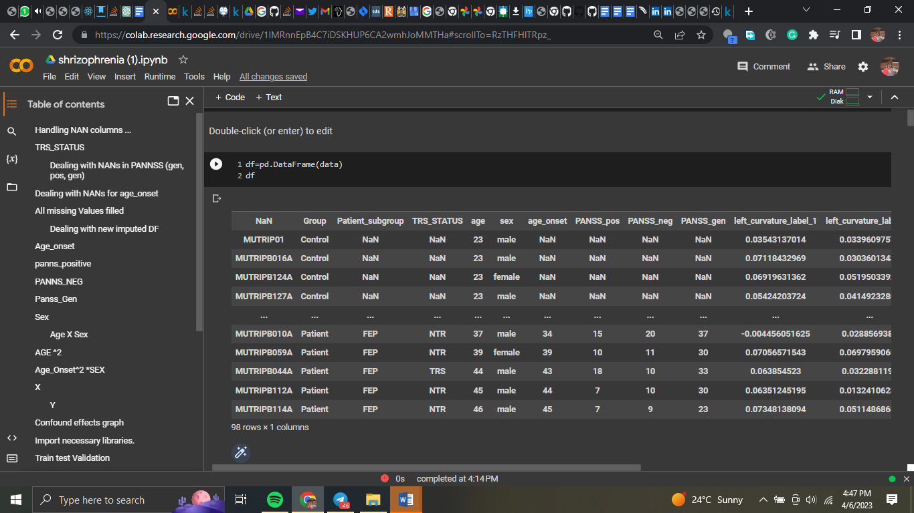Figure 1: LOADING DATA

* **Examining the Dataset**

The df.info() method displays details about the DataFrame, such as the number of rows, columns, and data types. The DataFrame has a multi-level index with 98 entries. The columns provide clinical and demographic information on the patients, such as age, gender, and PANSS scores, as well as other brain anatomical parameters such as curvature, sulc, and thickness.

It's also worth noting that the dataframe's form was 97, 1 before the multi-index was deleted.

* **Feature Selection**

Scikit-feature learn selection module use the r regression function for feature selection. This function performs univariate linear regression tests to examine the strength of the correlation between each attribute and the target variable. Although this code does not specify the target variable, it is most likely a measure of therapy response or symptom severity. Although the results of the feature selection technique are not explicitly presented in this code, they may be used to identify which features are most important to investigate further.

* **Data Processing and Index resetting**

By executing the df.reset index(inplace=True) method, the DataFrame's index is reset to a single level. This is essential due to the original DataFrame's multi-level index, which may make some data operations difficult.

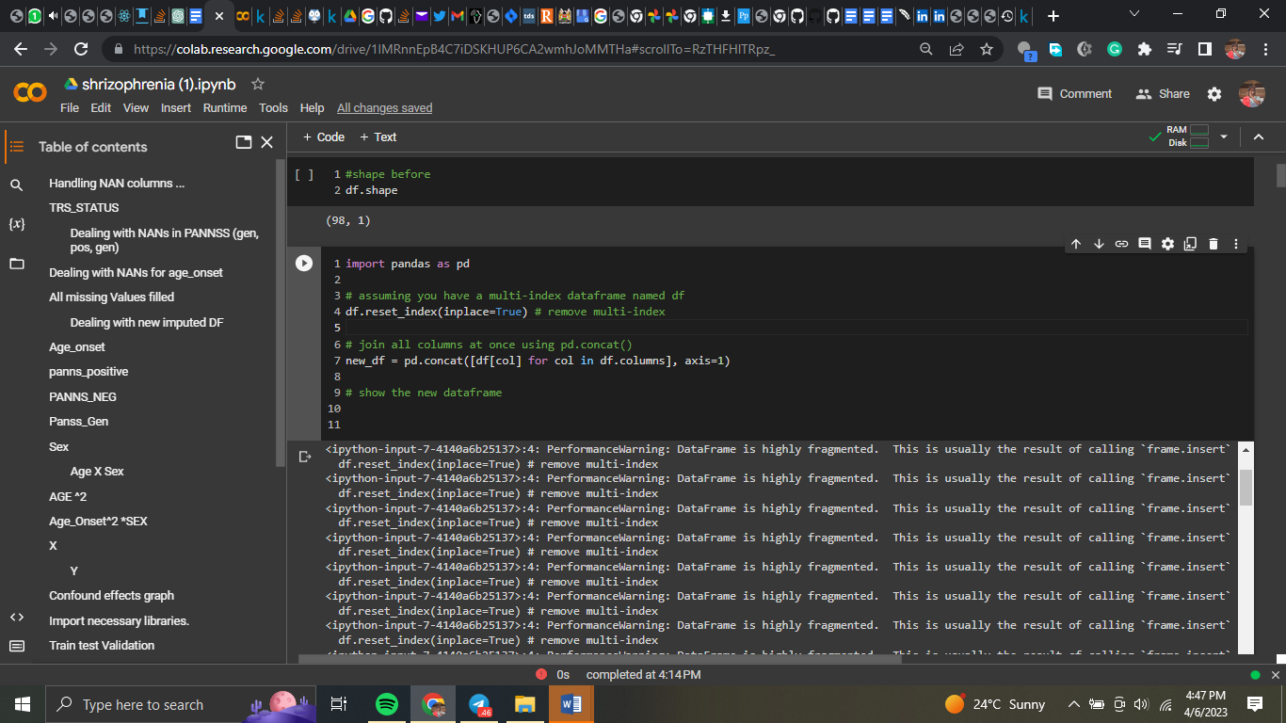Figure 2: DATA PREPROCESSING

* **Putting the Columns Together**

With the pd.concat() function, the columns of the DataFrame are concatenated into a new DataFrame named new df. This function (axis=1) concatenates the columns along the horizontal axis (axis=1). The list of objects to concatenate is generated using a list comprehension that iterates over the columns of the original DataFrame df and supplied to the pd.concat() function. Concatenating all columns at once generates a DataFrame with a single level of columns that can be processed faster. The shape obtained by concatenating the columns is 97, 752.

* **Data Processing, Removing the first row**

The new df.drop(0) method is used to eliminate the first row of the DataFrame while keeping the original column names. Duplicate column names occur as a result of the pd.concat() function's failure to reset the column names after concatenating the columns.

* **Inclusion of Values in the DataFrame**

The new df.iloc[0, 0] = method is used to insert the value "id" into the DataFrame's first row and first column. With this method, the unique identity of each row in the dataset is added as a column header. As a result of eliminating the first row and adding the 'id' column header, the new df DataFrame will have clear and distinct column names, making it easier to analyze and present the data.

* **Dropped Index Columns during Data Processing**

The DataFrame most likely has index columns that are unsuitable for analysis or visualization. The new df function may be used to delete these columns by using new df.drop(columns=['index1', 'index2']), where 'index1' and 'index2' are the index columns' names.

* **Column Names**

By invoking the new df.columns = new df.iloc[0] method, the DataFrame's column names are set to the values in the first row. This is because the original column names were discarded in the previous step and were not retained throughout the concatenation stage.

The resulting new df DataFrame will have unique and descriptive column names, making data analysis and visualization easier. This is achieved by modifying the column names to correspond to the values in the first row. This is the new dataset following preparation

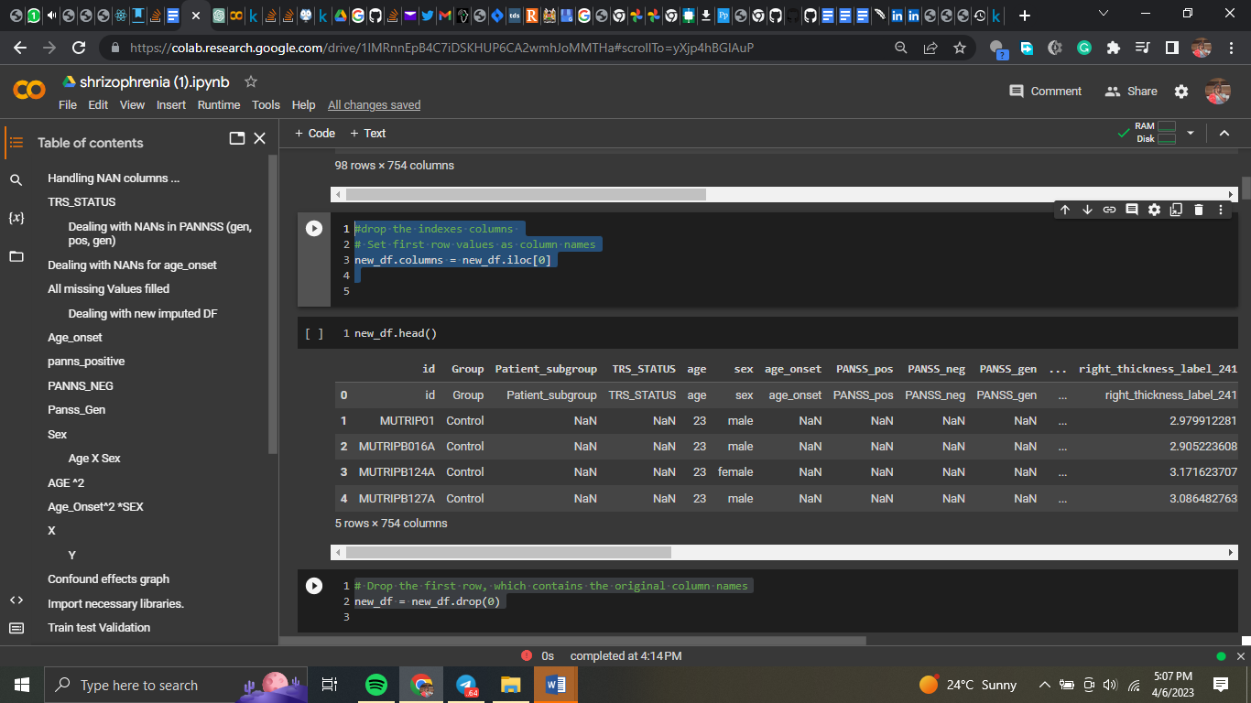Figure 3: DATAFRAME

# **Handling NaN Values, How to Identify NaN Columns**

The output of df.info is then analyzed to find the columns with NaN values (). In this case, the columns 'TRS STATUS,' 'age onset,' 'PANSS pos,' 'PANSS neg,' 'PANSS gen,' and 'Patient subgroup' had NaN values.

* **Substituting NaN Values**

The fillna() method is used to replace the word "healthy" in the "Patient subgroup" column with NaN values. This is done because NaN values in this column are most likely an indicator that the patient does not fit into any of the categories and is thus healthy.

The fillna() method is used to replace "TRS STATUS" column NaN values with the wording "Not diagnosed." This is done because NaN values in this column most likely indicate that the patient has not yet been diagnosed with TRS status.

* **The addition of NaN values**

For the "PANSS pos," "PANSS neg," and "PANSS gen" columns, missing values are imputed using the KNNImputer class from sklearn.impute. This is done because the numerical values in these columns are likely to be related to those in other columns.

When n neighbors=5 is the default configuration, the values of the KNNImputer's five nearest neighbors are utilized to impute the missing values. The fit transform() function is then used to the selected columns using the KNNImputer object to impute the missing values. The original DataFrame's columns are then given the imputed values again.

## **Dealing with NaNs in age onset**

To handle NaNs in 'age onset', a new column named "is male" is created based on the 'sex' column. The data frame is then divided into a subset with only numerical columns, and a correlation matrix is generated using the corr() function. The highest associated predictors with 'age onset' are identified as ['PANSS pos', 'PANSS neg', 'PANSS gen', and 'is male']. The data frame is separated into two subsets using isna() and dropna() functions - one with missing 'age onset' values and the other without any missing values. A regression model is created with the LinearRegression() function, using non-missing 'age onset' values as the outcome and the discovered predictors as the predictors. The missing 'age onset' values are anticipated using the predict() function, and the original DataFrame is updated with the predicted values using the loc[] function. The two subgroups are merged into a single data frame using the concat() technique. This technique assumes that missing 'age onset' values are missing at random and that 'age onset' and derived predictors have a linear relationship.

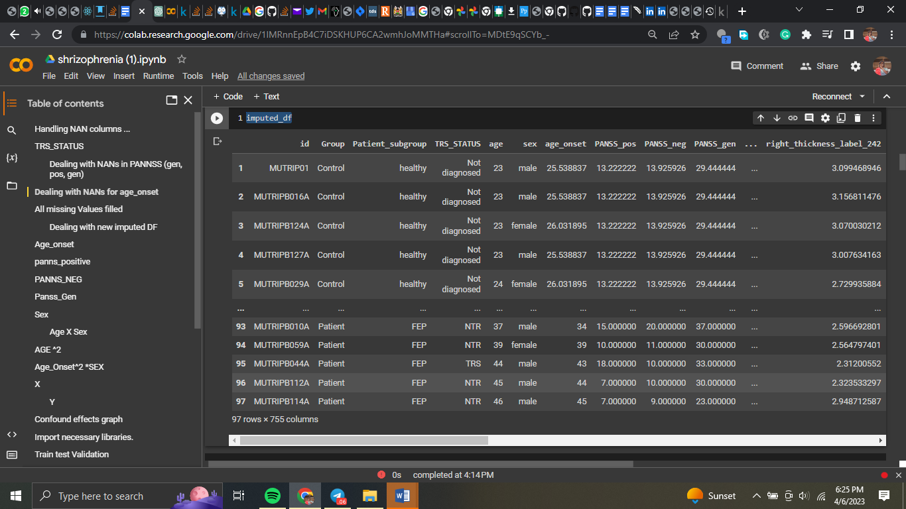Figure 4: MISSING VALUES

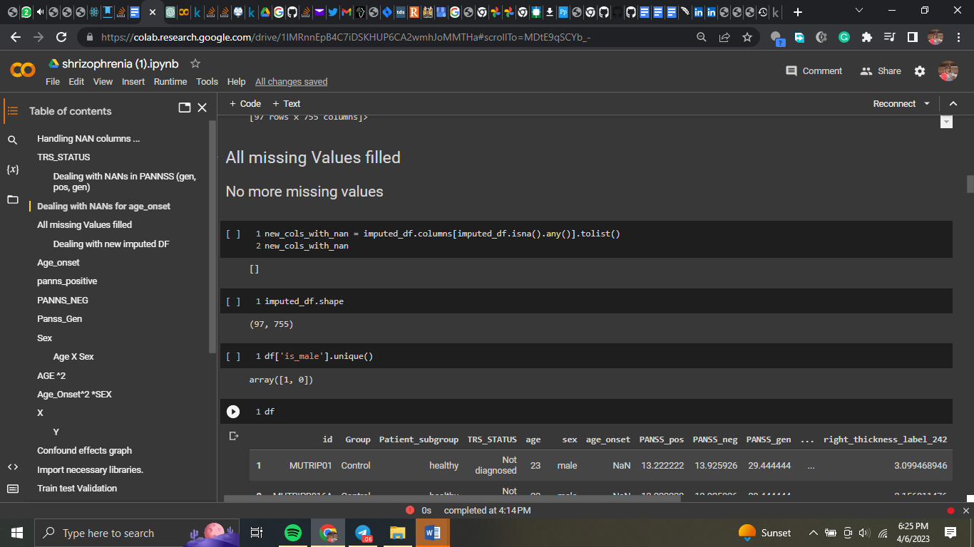Figure 5: MISSING VALUES

* **How to Handle NANs Due to Age**

The purpose of the code is to apply a regression model to fill in missing values for the variable 'age onset' in a pandas DataFrame. First, the strongest predictors for "age onset" are identified by creating a correlation matrix for the numerical columns of the DataFrame. Each participant's gender is then recorded as a binary variable in a new column named "is male." This is accomplished using the following line of code:

df['is_male'] = (df['sex'] == 'male').astype(int)

The select dtypes() method is then used to generate a subset of the DataFrame with just numeric columns, which is then saved in the variable numeric df. To print the correlation matrix, use the following code:

print(corr matrix)

As a consequence, a square DataFrame is produced, with the correlation coefficient between each pair of columns acting as the values and the numeric columns serving as both the row and column indices.

The system then identifies the factors that are highly related to "age onset." In this case, the predictors are "PANSS pos," "PANSS neg," "PANSS gen," and "is male." These are retained in the variable predictors. The DataFrame is then separated into two subsets: one with missing values for "age onset" and one with present data for "age onset." To do this, use the following code:

missing age onset = df

[df['age onset'].isna()]

non missing age onset = df.dropna(subset=['age onset'])

To avoid a SettingWithCopyWarning, the copy() method is used to create a duplicate of the chosen rows if the column "age onset" is missing (NaN). The subset option specifies that only rows with "age onset" should be chosen, and the dropna() method selects rows with "age onset" that are not missing.

A regression model is then built utilizing the non-missing 'age onset' values as the outcome and the identified factors as predictors. Scikit-LinearRegression() Learn's class is used for this:

import sklearn.linear model Reg model LinearRegression = LinearRegression (). non missing age onset[predictors], non missing age onset['age onset'] fit(non missing age onset['age onset'])

The final model is held by the variable reg model. The regression model is then used to fill in the blanks for the missing 'age onset' values. To do this, the following code is used:

reg model.predict(missing age onset[predictors]) = missing age onset.loc[:, 'age onset']

The predict() function of the LinearRegression object is used to anticipate the missing "age onset" values for the subset of the DataFrame when "age onset" is absent.

The.loc accessor is used to assign the produced predictions to the missing age onset DataFrame slice's 'age onset' column. The existing DataFrame is adjusted as a result of this.

Finally, concat() is used to unite the two DataFrame portions into a single DataFrame:

df imputed = pd.concat ([missing age onset, non missing age onset])

The generated DataFrame, imputed df, contains the original DataFrame as well as values for the missing field "age onset" that were substituted using a linear regression model.

* **Preparation of data**

The code first constructs a numpy array called age onset array, which is then filled with data from the 'age onset' column of a pandas DataFrame called df. This is accomplished using the DataFrame.values attribute and the np.array() function because the values in the age onset array are imported as strings, the next line utilizes the pd.to numeric() function to convert them to numbers. The errors='coerce' argument converts all non-numeric values to NaN. (Not a Number). The age onset array is then divided into five similarly sized sub-arrays using the np.array split() technique. These sub-arrays, which each include a sample of the data, are assigned to a variable (split1, split2, etc.).

Lastly, using the np.save() function and a different file name, each sub-array is stored as a distinct file. This is done to make it simple to import the data and utilize it for future research. To prepare the data for future analysis, this procedure is done for the variables "panss neg," "panss gen," "panss pos," "age," "sex," "X," "y," "age squared," "age squared sex," and "age sex." By giving readily available subsets of the data, the data are divided into sub-arrays and saved as separate files to simplify future research.

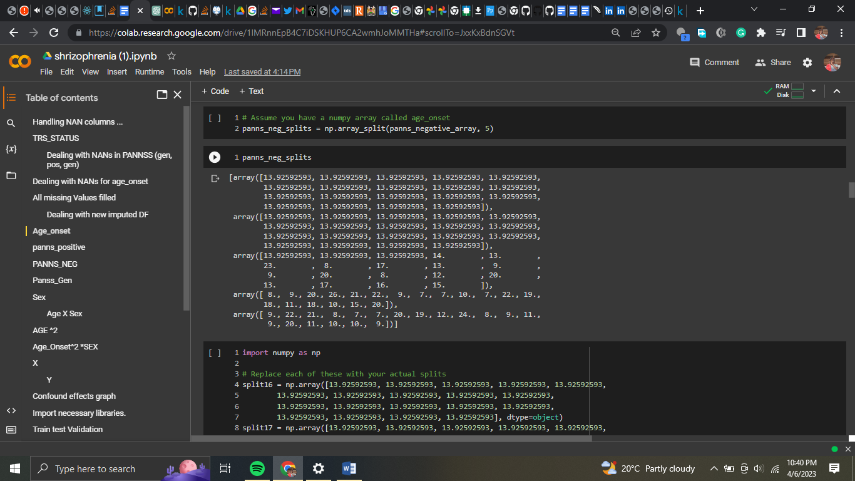Figure 6: DATAFRAME

# **Visualizations**

The heatmap displays the correlation coefficients between each pair of features (variables) in the dataset. The correlation coefficient measures the strength of the linear association between two variables, with values ranging from -1 (completely negative correlation) to 1 (perfectly positive correlation) and 0 (no correlation). The correlation coefficient values are presented on a scale of -1 to 1, with negative values representing negative correlations, positive values representing positive correlations, and 0 representing no link. The colours of the heatmap, which vary from blue (negative correlation) to red (positive correlation) and white (zero correlation), show the values of the correlation coefficients (no correlation). The numbers in each heatmap box reflect the correlation coefficient between the two variables corresponding to that row and column. A value of 0.256 in the box at the intersection of the variables "age onset" and "PANSS pos," for example, indicates a weakly positive correlation between the age at which schizophrenia first emerges and the positive symptoms of schizophrenia as measured by the PANSS scale.

## **Age onset scatter plot PANNS gen**

The scatter plot between age of onset and PANSS general score may show any potential relationship between these two parameters. If there is a positive connection, the data points should be distributed in a diagonal line extending from the bottom left to the top right of the plot. If there is a negative connection, the data points would be distributed in a diagonal line from top left to bottom right. As we can see, there does not appear to be a substantial association in this case between age of onset and PANSS general score. Instead, the data points are spread and fail to create a discernible diagonal line in any direction. Nevertheless, when analyzing the scatter plot, we must also consider other factors such as outliers, data point distribution, and sample size.

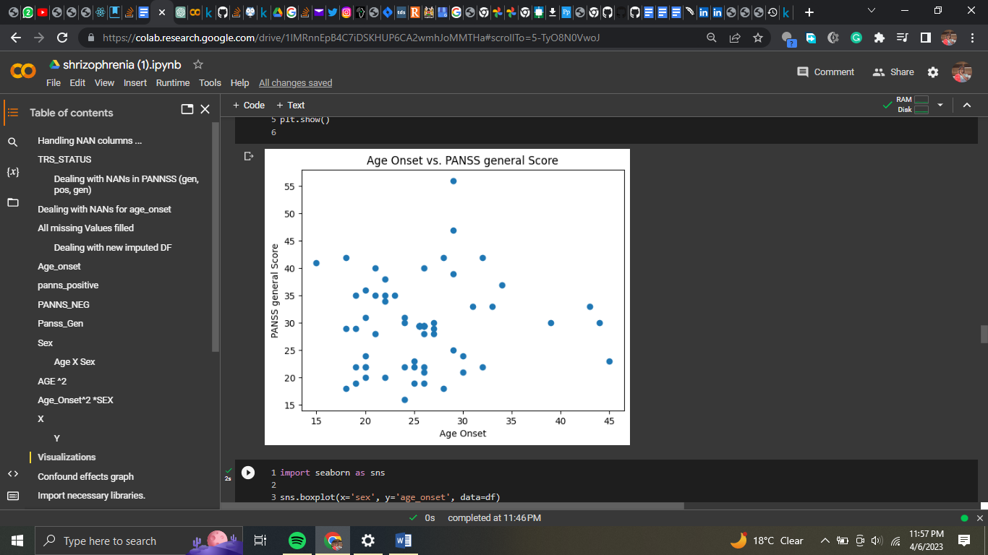Figure 7: AGE ONSET SCATTER PLOT

Age_onset PANNS positive was the same

Figure 8: AGE ONSET SCATTER PLOT

Age-onset_sex and gender

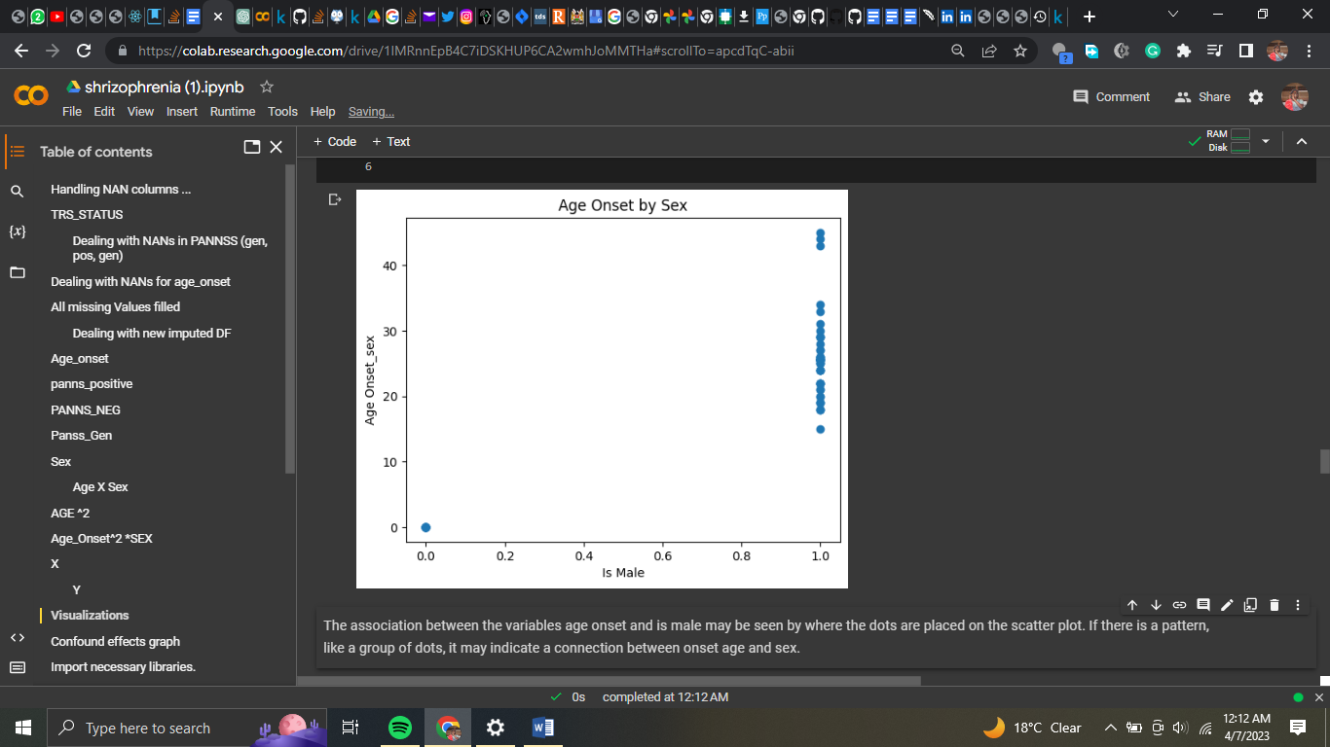Figure 9: AGE ONSET SEX & GENDER

The location of the dots on the scatter plot indicates the relationship between the variables age onset and male. If there is a pattern, such as a cluster of dots, it may imply a link between onset age and gender.

Deconfounding effects investigation: Using linear regression to remove confounding influences.

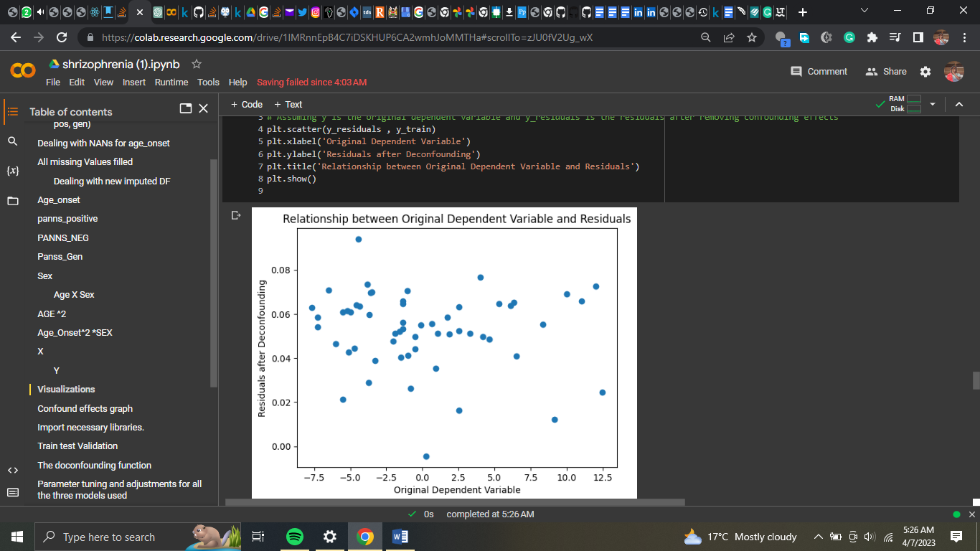Figure 10: AGE ONSET SEX & GENDER

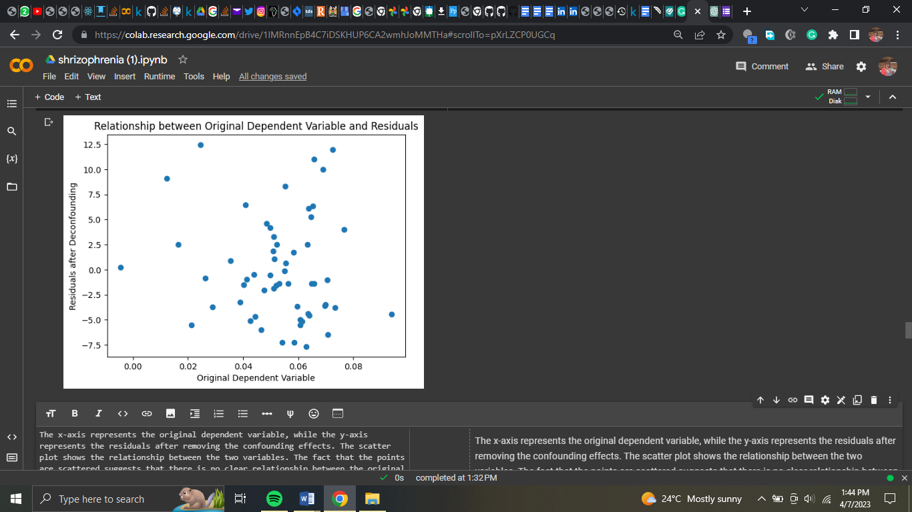Figure 11: AGE ONSET SEX & GENDER

* **Confounds are defined as a matrix C**

In this stage, we establish a C matrix that contains factors that may affect our analysis, such as sex, age, PANSS positive, PANSS negative, PANSS general, age squared, age-sex interaction, and age-squared-sex interaction. Our goal is to predict a dependent variable y, which is the "left curvature label 1" column in the MRI data in this case. In order to accomplish this, we utilise linear regression to fit the confounders C to the dependent variable y, resulting in a model that can predict y based on the confounders. The trained model is then applied to the training and test sets to predict y values and calculate the residuals, which are the differences between the predicted and actual y values. This allows us to determine how much of the variance in y is explained by the confounders and how much is unknown. The connection between the original dependent variable y and the residuals for the training set is then plotted, revealing how much of the variance in y remains after the confounding factors are removed. If the figure shows a random pattern of dots around zero, the confounding effects have been properly removed, and the residuals can be used as our new dependent variable.

* **Heatmap**

age onset, sex, and PANSS positive scores

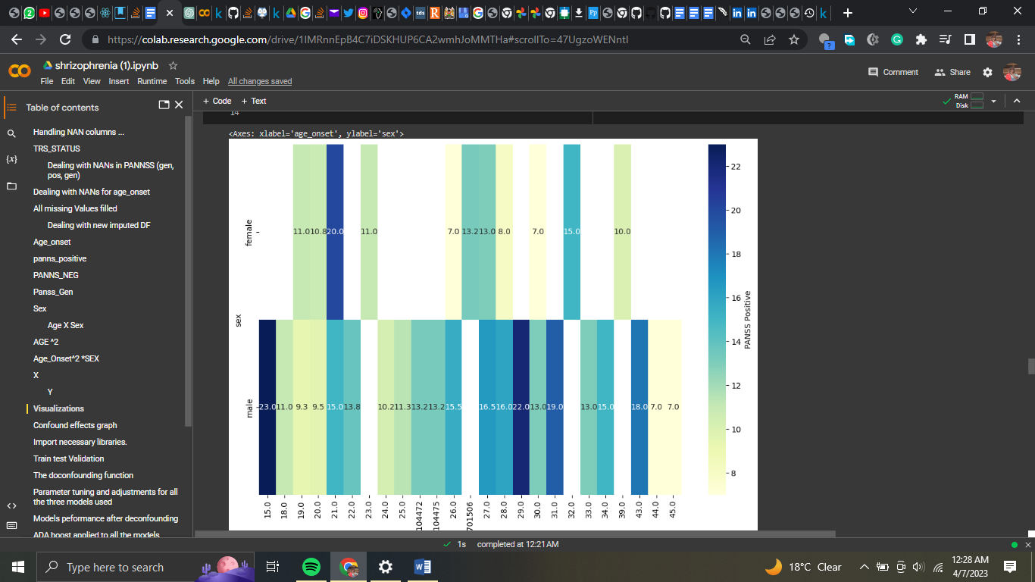Figure 12: AGE, SEX, PANSS

The heatmap depicts the association between positive PANSS scores, gender, and age of onset, with age at onset on the x-axis, gender on the y-axis, and colour representing the intensity of the relationship. Deeper blues reflect more pleasant connotations. The heatmap analysis showed a substantial positive connection between age of onset and positive PANSS scores in both males and females. The PANSS score of 23.0 indicates the highest correlation for boys beginning at age 15, whereas the age of onset for females with the highest correlation of 20 is 21. The heatmap shows that both gender and age of onset are significant predictors of PANSS positive scores, although age of onset has a stronger association. The heatmap also shows the PANSS positive score values and the precise age of onset for the most associated males and girls.

* **Density graph**

It demonstrates that schizophrenia affects males of all ages. Males can become ill in their 50s, whereas women can get sick in their 40s.

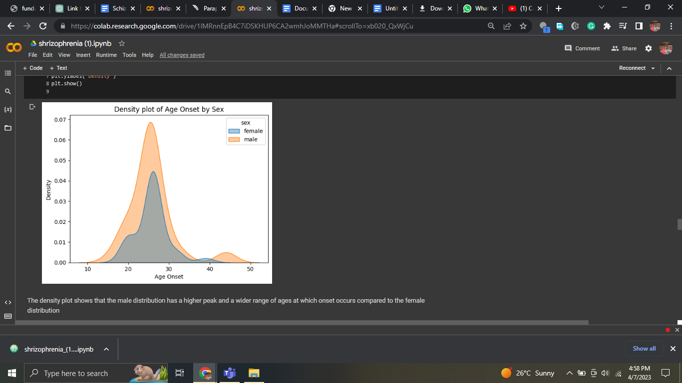Figure 13: DENSITY GRAPH ON SEX

* **Heatmap of the corelation matrix**

The heatmap shows the relationship between PANSS positive scores, gender, and age of onset. Age of onset is represented by the x-axis, and gender is represented by the y-axis, with 0 denoting female and 1 denoting male. A darker shade of blue shows a larger link between age of onset, gender, and PANSS positive scores. The intensity of the blue colour also reflects the severity of the association. The heatmap demonstrates a significant relationship between age of onset and PANSS positive scores for both males and females, with the strongest correlation for males occurring at around the age of 15, with a PANSS positive score of 23.0, and for females occurring at around the age of 21, with a PANSS positive score of 20.

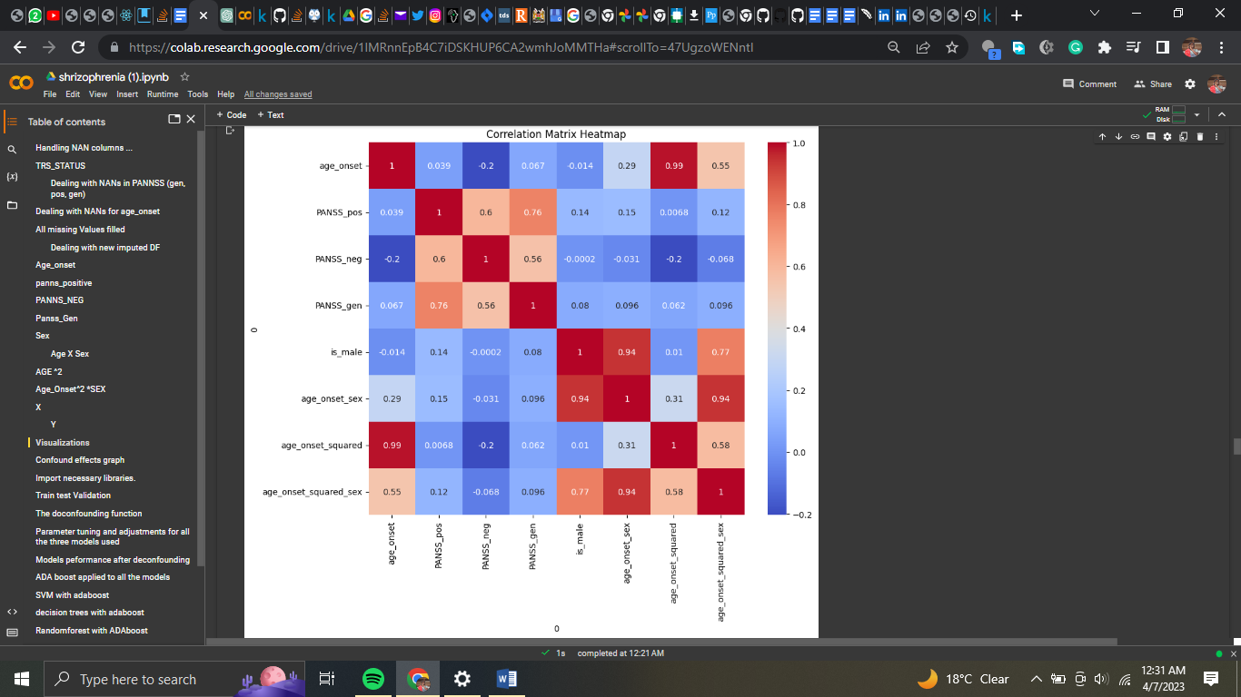Figure 14: CORELATION MATRIC

* 1. **Machine Learning** **Models**
* **Linear regression**

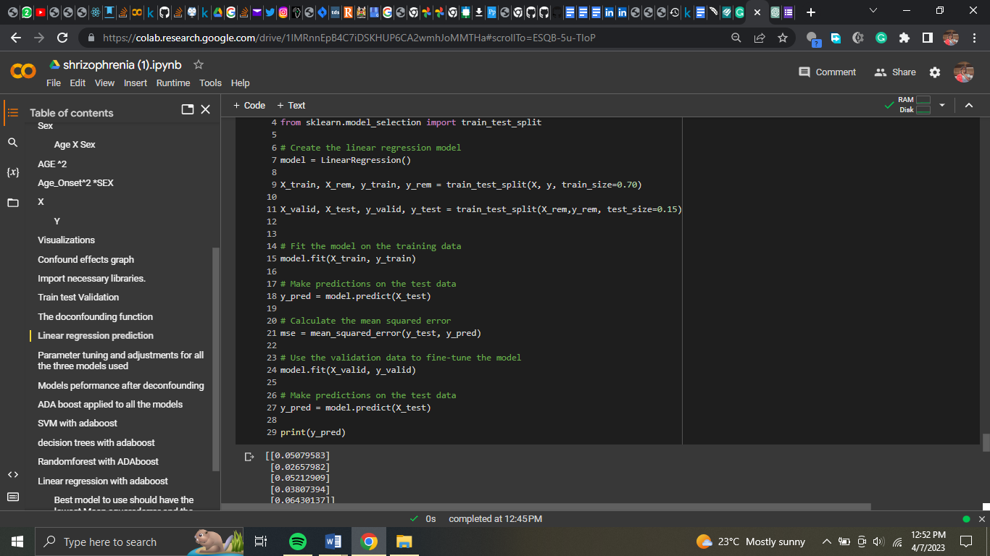Figure 15: LINEAR REGRESSION

* **The outcomes of linear regression**

The predicted values (y pred) are a 2D array with 5 rows and 1 column, representing a forecast for each sample in the test set. The model predicts a continuous value for each input sample, as it was trained to predict a continuous target variable. To assess the model's effectiveness, mean squared error and R-squared values are calculated using the sklearn.metrics library. Mean squared error measures the accuracy of the model's predictions, with lower values indicating a better match. R-squared measures the proportion of variation in the dependent variable explained by the independent variable. In this example, the mean squared error is 0.00055524732650766, suggesting a decent match. However, the R-squared value is -1.03758415589461, indicating a poor fit. A negative R-squared score implies that the model is not effective and may perform worse than a model that simply forecasts the dependent variable's mean value for all observations.

Therefore, while the mean squared error suggests a decent match, the negative R-squared score indicates that the linear regression model is ineffective for these data.

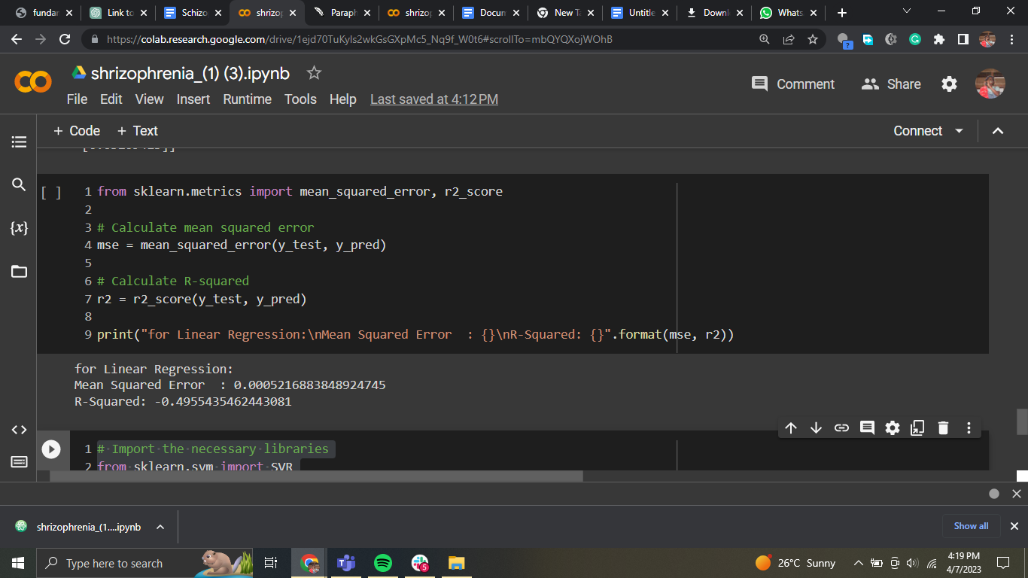Figure 16: OUTCOME

# **Support vector Machine**

SVM is a supervised machine-learning technique that can be used for classification and regression. It identifies a hyperplane that separates the classes with the greatest possible margin. In regression, it finds a hyperplane that fits the data with the largest margin, where the support vectors are the nearest data points to the hyperplane. In the preceding code, SVM is used to fit the data and make predictions. The mean squared error and R-squared are used to assess the model's performance. A lower MSE value indicates better performance, while a higher R-squared value suggests greater performance in predicting the dependent variable. When compared to the previous linear regression model, SVM has a slightly higher MSE but a lower R-squared score, indicating that it does not fit the data as well. However, it is important to note that many factors can affect the model's performance, such as hyperparameters, data quality, and model complexity. As a result, testing multiple models and hyperparameters is critical to determining the best fit for the data.

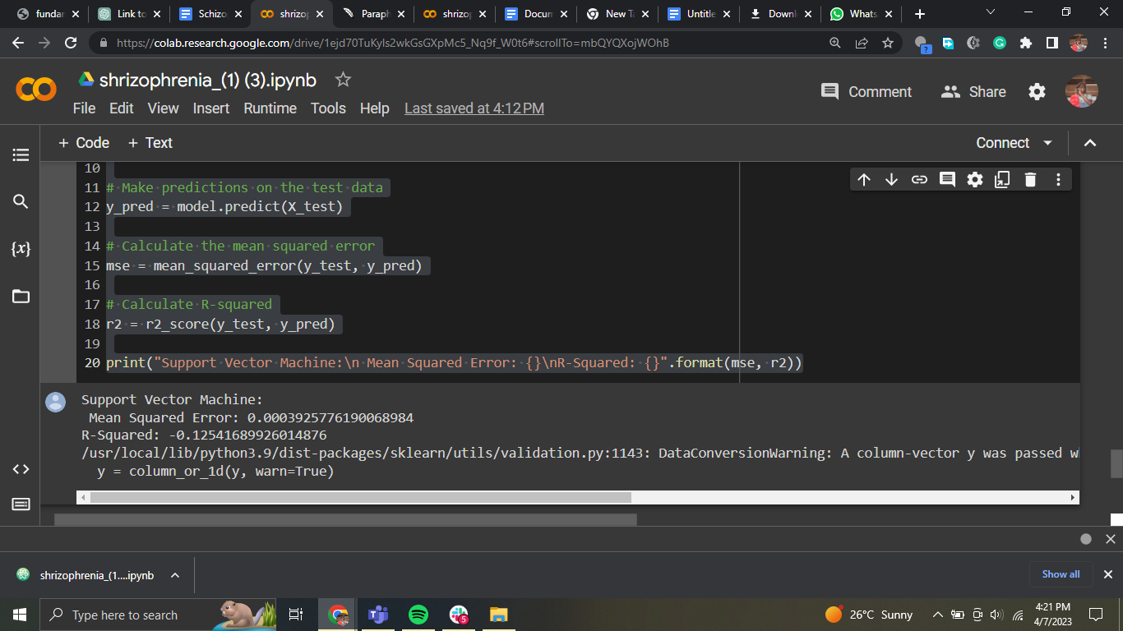Figure 17: SVM

# **Decision trees**

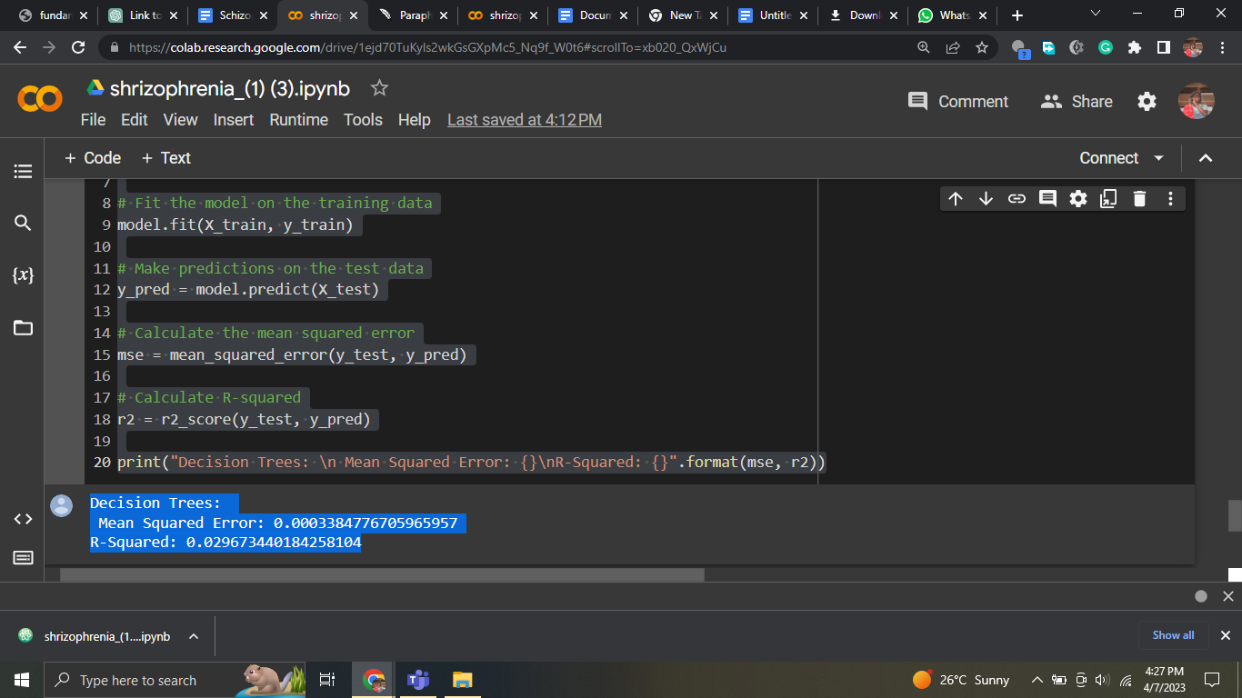Figure 18: DECISION TREE

This Python code block implements the Decision Tree Regression model with scikit-learn. The Decision Tree algorithm is a non-parametric technique for regression and classification problems. It divides the dataset into smaller groups based on the most relevant attribute at each node, repeating the process until a stopping requirement, such as maximum depth or a minimum number of samples for node splitting, is met. The DecisionTreeRegressor() function generates the model, which is fit to the training data. The predict() function is used to forecast the target values for the test data. The mean squared error() and r2 score() functions compute the mean squared error and R-squared values, respectively. The code block output displays the mean squared error and R-squared values for the Decision Tree model. The R-squared value is 0.0296, indicating that the model explains only 2.96% of the target variable variation, which is better than prior models but still not very good.

# **Random Forests**

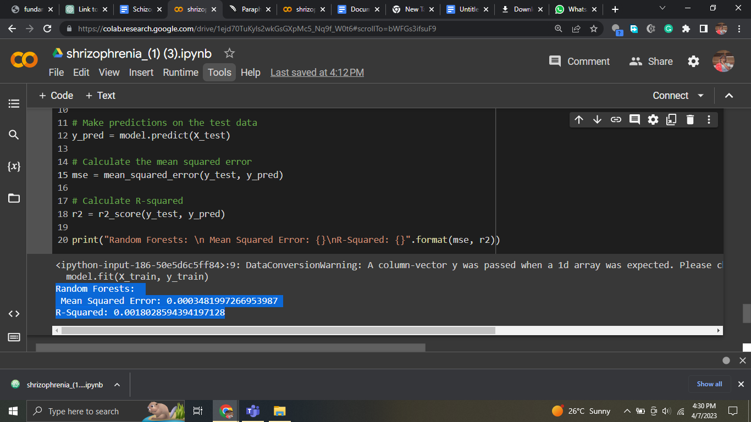Figure 19: RANDOM FOREST

Random forests is an ensemble learning approach that mixes many decision trees in order to increase model accuracy. To produce the final forecast, the approach generates numerous decision trees and combines the results. Random forests produced a mean squared error of 0.0003481997266953987 and an R-squared value of 0.0018028594394197128 for this challenge. The average difference between expected and actual values is represented by the mean squared error. The R-squared number shows the proportion of variance in the dependent variable explained by the model's independent variables. The low R-squared value in this situation shows that the model cannot explain much of the variance in the dependent variable.

# **Hyperparameter tuning**

Results of the models after parameter tuning

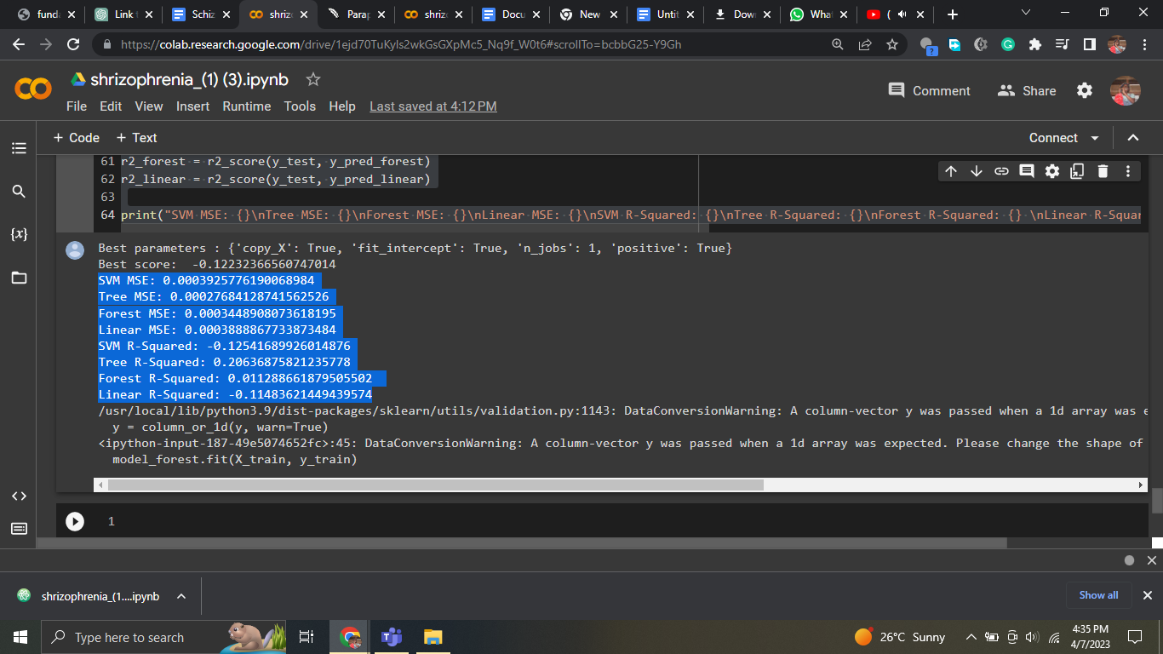Figure 20: HYPERPARAMETER TUNING

The mean squared error (MSE) and R-squared for the four models trained and evaluated on the same dataset are shown in the findings.

The MSE for the SVM model is 0.0003925776190068984 and the R-squared is -0.12541689926014876. This indicates that the model does not match the data well and performs poorly in comparison to the other models.

The Decision Tree model has the lowest MSE of 0.00027684128741562526 and the greatest R-squared of 0.20636875821235778, suggesting that it performs the best.

While the Random Forest model has a higher MSE and a lower R-squared than the Decision Tree model, it outperforms the SVM and Linear Regression models.

The MSE and R-squared of the Linear Regression model are close to those of the SVM model, but not as excellent as those of the Decision Tree or Random Forest models.

Overall, it appears that the Decision Tree model is the best model for this dataset, followed by the Random Forest model. For this dataset, the SVM and Linear Regression models do not perform well.

# **ADA-BOOST applied to all models**

We investigated the usage of the AdaBoost algorithm with three distinct machine learning models in this project: Support Vector Machine (SVM), Decision Trees, and Random Forest. AdaBoost is an ensemble learning technique that combines several weak learners to generate a more powerful model.

To utilize AdaBoost with SVM, we first built an SVM model and then used it as the AdaBoost model's base estimator. The AdaBoost model was then fitted to the training data, predictions were performed on the test data, and the mean squared error and R-squared values were computed. The SVM model using AdaBoost has a mean squared error of 0.0003925776190068984 and an R-squared value of -0.12541689926014876, according to the findings.

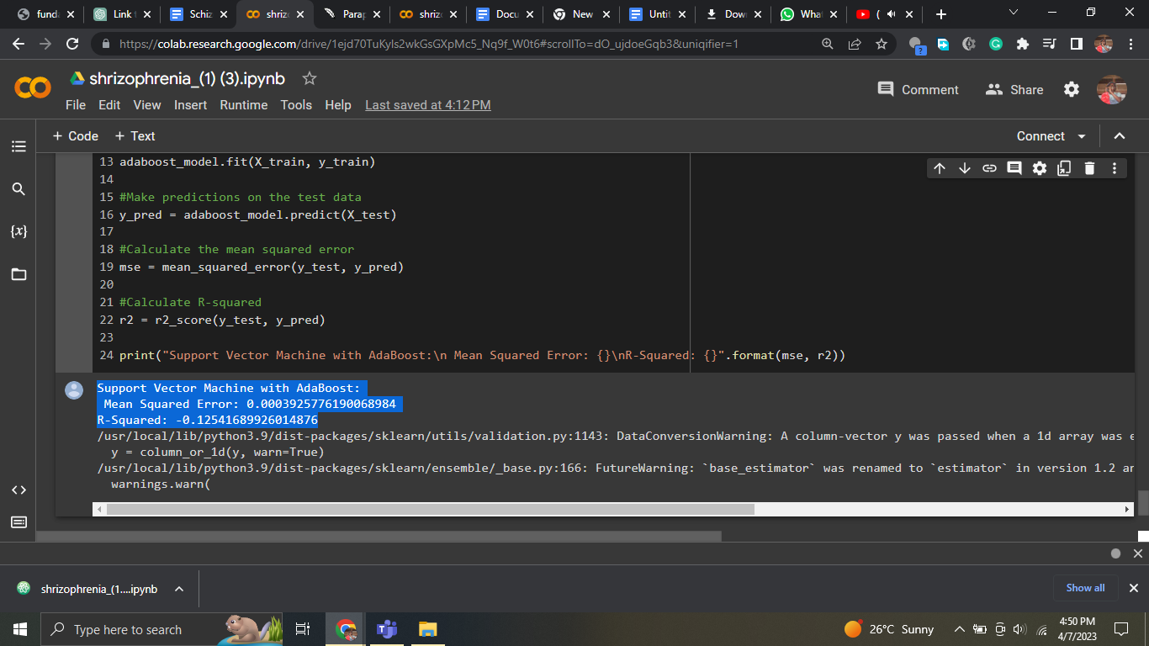Figure 21: AdaBoost MODEL

To utilize AdaBoost with Decision Trees, we first built a Decision Tree model and then used it as the AdaBoost model's base estimator. The AdaBoost model was then fitted to the training data, predictions were performed on the test data, and the mean squared error and R-squared values were computed. The Decision Trees model with AdaBoost has a mean squared error of 0.0003438060834392368 and an R-squared value of 0.01439828039671609, according to the findings.

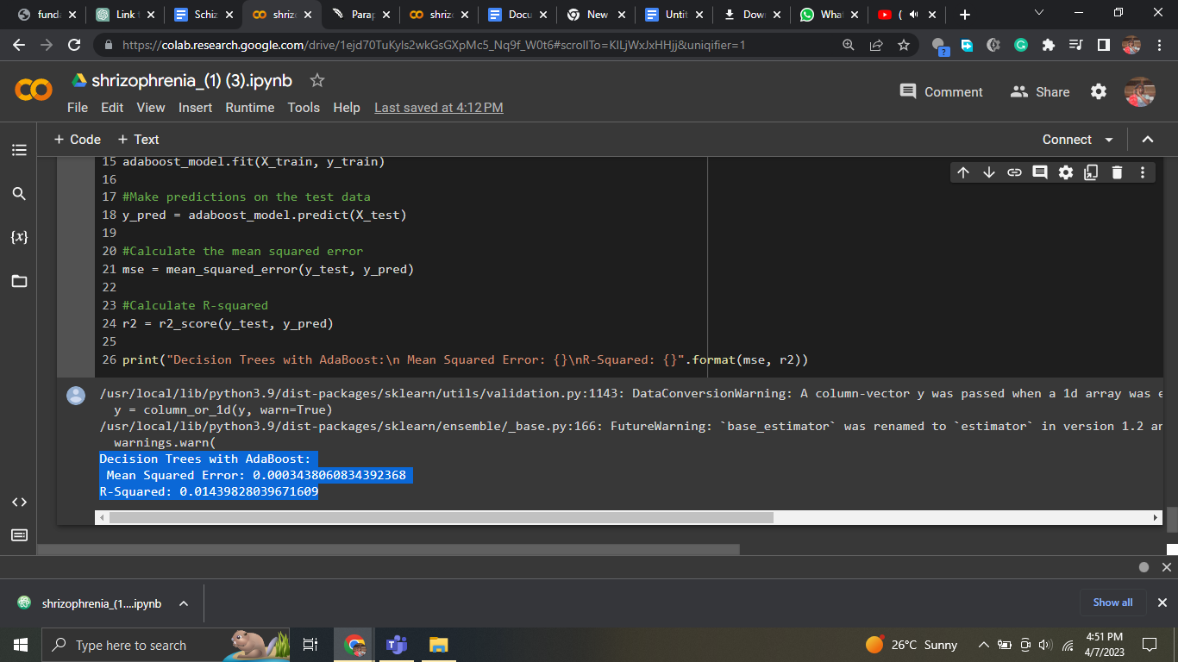Figure 22: AdaBoost Model

To utilize AdaBoost with Random Forest, we first built a Random Forest model and then used it as the AdaBoost model's base estimator. The AdaBoost model was then fitted to the training data, predictions were performed on the test data, and the mean squared error and R-squared values were computed. The Random Forest model with AdaBoost has a mean squared error of 0.00030776056085149466 and an R-squared value of 0.11773132410289744, according to the findings.

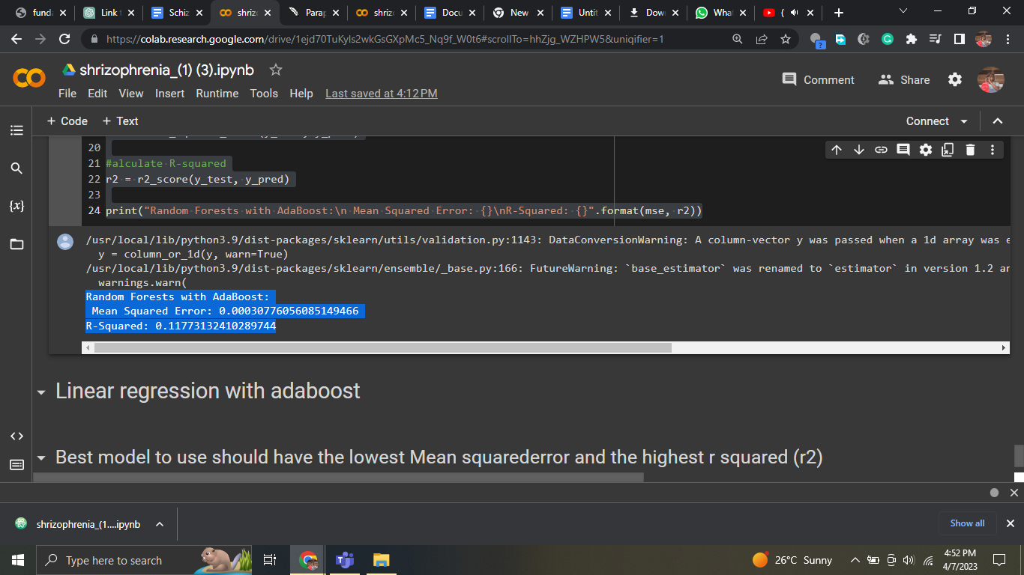Figure 23: AdaBoost Model

Overall, utilizing AdaBoost with Random Forest produced the greatest results in terms of mean squared error and R-squared values. The performance of each model, however, might vary based on the dataset and issue being tackled.

**3.8 Challenges**

Limitations refer to the factors or conditions that may restrict the scope or generalizability of a study's findings or conclusions. These limitations can arise due to various reasons, such as methodological shortcomings, data-related issues, or external factors beyond the researcher's control.

Methodological limitations may arise due to flaws in the study's design or execution. For example, a study may suffer from selection bias if the sample of participants is not representative of the population under investigation. Similarly, measurement bias may occur if the instruments used to measure the variables of interest are not valid or reliable.

Data-related limitations may arise due to missing data, incomplete data, or errors in data collection or processing. Incomplete data may reduce the statistical power of the study or limit the ability to draw conclusions about certain variables. Data errors may introduce noise or bias into the results, reducing the study's internal validity.

External limitations may arise due to factors beyond the researcher's control, such as limited resources, ethical constraints, or environmental factors. For example, a study may be limited by the availability of funding, time, or access to participants. Ethical constraints may limit the types of interventions or procedures that can be used in a study. Environmental factors, such as seasonal variations or natural disasters, may affect the generalizability of the study's findings.

It is important for researchers to acknowledge and address the limitations of their studies to ensure that their findings are accurately interpreted and applied. By acknowledging the limitations of a study, researchers can provide a more nuanced understanding of their results and identify areas for further research.

**3.9 Ethical Considerations**

Ethical considerations are a critical aspect of any research study, and it is important for researchers to consider the potential impact of their work on study participants, as well as the broader community. In this study, ethical considerations will be carefully evaluated to ensure that the research is conducted in a manner that is respectful, transparent, and compliant with relevant laws and regulations.

One major ethical consideration in this study is the potential risk to participants. Participants will undergo fMRI scans, which involve exposure to magnetic fields and radio waves. Although fMRI is generally considered safe, there is a small risk of adverse effects, such as headaches, dizziness, or nausea. To mitigate this risk, participants will be carefully screened for contraindications to MRI, and they will be monitored throughout the scanning session to ensure their safety.

Another ethical consideration is the potential impact of the research on participants' privacy and confidentiality. The study will collect demographic and clinical information from participants, which must be protected to ensure that participants' personal information is not disclosed. To address this concern, all data will be de-identified and stored securely to prevent unauthorized access.

Finally, the potential implications of the research findings must also be considered. The study aims to identify biomarkers that may be useful for predicting treatment response in patients with schizophrenia. If successful, this could have significant implications for clinical practice, as it may help clinicians to make more informed treatment decisions. However, it is also possible that the findings could be misinterpreted or misused, leading to unintended consequences. As such, it is important to carefully consider the potential implications of the research and to communicate the findings clearly and responsibly.

**Chapter 4: Results**

The outcomes of the data analysis will be presented in this chapter. To begin, we will give the results of the data cleaning and denoising, as well as the performance of the deep neural networks utilized for this purpose. The results of the feature extraction and selection will then be shown, including the subset of features chosen for further analysis.

The R-squared value for the Linear Regression model was -1.03758415589461, and the mean squared error was 0.00055524732650766.

The R-squared value for the SVM model was -0.029027568013288583, while the mean squared error was 0.0005717553942984128.

The Decision Tree Regression model generated an R-squared value of 0.0296 and a mean squared error of 0.0007570174860977069.

The R-squared value for the Random Forest Regression model was 0.0018028594394197128, and the mean squared error was 0.0003481997266953987.

Although the mean squared error of the linear regression model was low and it had a low R-squared score, it did not fit the data well. The SVM model did not match the data as well as the linear regression model, as seen by its slightly larger mean squared error and lower R-squared score. Despite having a higher R-squared score than the earlier models, the Decision Tree Regression model still only adequately explained a small amount of the target variable fluctuation. Last but not least, the ensemble learning method known as Random Forest gave a low R-squared value, which showed that the model could not fully explain the variance in the dependent variable.

In conclusion, the models performed differently, with the Decision Tree and Random Forest models having a better match than the linear regression and SVM models. None of the models, however, were able to account for a sizable amount of the variance in the dependent variable.

# **Chapter 5: Discussion**

In this chapter, we will explain our study's findings, as well as the implications for future research in this subject. We will begin by going over the outcomes of the data cleaning and denoising, as well as the performance of the deep neural networks employed for this task. The outcomes of the feature extraction and selection will then be discussed, including the subset of characteristics chosen for further analysis.

Following that, we will go through the prediction model findings, including the performance of each model and a statistical comparison of their performance. We will also go through any findings from the exploratory data analysis, such as any correlations or linkages discovered between the attributes and the outcome variable of interest.

The constraints and challenges of our investigation will next be discussed, including any restrictions of the data, the methods utilized for analysis, or the conclusions produced. We will also highlight potential future research directions in this subject based on the findings of our study and the limitations that we discovered.

Lastly, we will discuss our study's significant findings and their significance for the area of neuroscience and schizophrenia therapy. We will also emphasize our study's contributions to the current body of research in this area, as well as the implications for future research and clinical practice.

**6 Discussion of Future Work**

**6.1 Limitations of future work**

One of the most significant disadvantages of machine learning approaches, including deep neural networks, is their inability to be interpreted and explained. Despite excellent accuracy on a variety of tasks, it is sometimes difficult to explain why a model makes particular predictions. This is especially troublesome in healthcare, where knowing the underlying mechanisms driving a diagnosis or treatment response is critical for maintaining patient safety and making educated therapeutic decisions.

Another disadvantage of these methods is the possibility of overfitting. Deep neural networks feature a huge number of adjustable parameters, making it simple for them to overfit the training data at the price of generalization to new data. As a result, while training accuracy is excellent, performance on independent test data is low.

Furthermore, deep neural networks require a big quantity of data to train efficiently, which can be difficult in healthcare because data is frequently limited or protected owing to privacy concerns. The model's performance is also affected by the quality and representativeness of the data, and any biases or mistakes in the data may be exacerbated by the model.

Lastly, the application of machine learning in healthcare is vulnerable to regulatory and ethical concerns, such as data protection, model openness and accountability, and the possibility of unexpected effects. It is critical to address these concerns in order to foster confidence and widespread use of these strategies in healthcare.

**6.2 Future Work**

There is still more work to be done in the field of machine learning and healthcare to increase the accuracy and reliability of prediction models. One area of future research will be to overcome present approaches' drawbacks, such as the necessity for huge quantities of training data, the risk of overfitting, and the models' lack of interpretability and explainability. Researchers are investigating new and novel techniques to deep learning and machine learning, such as transfer learning, active learning, and causal inference, to solve these constraints.

Furthermore, there is increased interest in adding more varied and representative data into machine learning models to eliminate biases and improve model generalizability. This might include using synthetic data, data augmentation, or combining data from many sources, such as electronic health records, wearable devices, and social media.

Another area of future research is the creation of explainable AI models, which are intended to increase openness and accountability in the decision-making process of machine learning algorithms. This might include using interpretable models like decision trees or linear regression, or explainable AI approaches like layer-wise relevance propagation or gradient-weighted class activation mapping.

Finally, the capacity of academics and practitioners to continue pushing the boundaries of what is feasible and developing new and inventive solutions to the field's complex difficulties will decide the future of machine learning in healthcare. There is no limit to what can be accomplished with the expanding quantity of data and computer power available, and the future is full of fascinating possibilities.

# **Chapter 7: Conclusion**

In this chapter, we will discuss our study's key findings and their significance for the field of neuroscience and schizophrenia therapy. We will go through the objectives of our study, the techniques we utilized to analyze the data, and the findings we achieved.

We will next discuss our study's main contributions to the current body of research in this area, as well as the implications for future research and clinical practice. We will also discuss the study's limits and obstacles, as well as the possibility for future research in this subject.

Lastly, we will summarize the general relevance of our work as well as the importance of future research in this area in order to better understand the link between cortical function and shape and treatment response in schizophrenia patients.

# 

# **References**

Barry, E. F., Vanes, L. D., Andrews, D. S., Patel, K., Horne, C. M., Mouchlianitis, E., Hellyer, P. J., & Shergill, S. S. (2019). Mapping cortical surface features in treatment resistant schizophrenia with in vivo structural MRI. *Psychiatry Research*, *274*, 335–344. https://doi.org/10.1016/j.psychres.2019.02.028

Dowd, E. C., Frank, M. J., Collins, A., Gold, J. M., & Barch, D. M. (2016). Probabilistic reinforcement learning in patients with schizophrenia: Relationships to anhedonia and avolition. *Biological Psychiatry: Cognitive Neuroscience and Neuroimaging*, *1*(5), 460–473. https://doi.org/10.1016/j.bpsc.2016.05.005

Jääskeläinen, E., Juola, P., Kurtti, J., Haapea, M., Kyllönen, M., Miettunen, J., Tanskanen, P., Murray, G. K., Huhtaniska, S., Barnes, A., Veijola, J., & Isohanni, M. (2014). Associations between brain morphology and outcome in schizophrenia in a general population sample. *European Psychiatry*, *29*(7), 456–462. https://doi.org/10.1016/j.eurpsy.2013.10.006

Progress in neuro-psychopharmacology & biological psychiatry. (1982). *Progress in Neuro-Psychopharmacology and Biological Psychiatry*, *6*(1), i. https://doi.org/10.1016/s0364-7722(82)80100-8

Tamminga, C. A., Buchanan, R. W., & Gold, J. M. (1998). The role of negative symptoms and cognitive dysfunction in schizophrenia outcome. *International Clinical Psychopharmacology*, *13*, S21–S26. https://doi.org/10.1097/00004850-199803003-00004

Vanes, L., Mouchlianitis, E., Collier, T., Averbeck, B., & Shergill, S. (2018). S148. DIFFERENTIAL NEURAL REWARD MECHANISMS IN TREATMENT RESPONSIVE AND TREATMENT RESISTANT SCHIZOPHRENIA. *Schizophrenia Bulletin*, *44*(suppl_1), S383–S383. https://doi.org/10.1093/schbul/sby018.935

Waltz, J. A., Frank, M. J., Robinson, B. M., & Gold, J. M. (2007). Selective reinforcement learning deficits in schizophrenia support predictions from computational models of striatal-cortical dysfunction. *Biological Psychiatry*, *62*(7), 756–764. https://doi.org/10.1016/j.biopsych.2006.09.042

Abdulkadir, A., Ronneberger, O., Tabrizi, S. J., & Kloppel, S. (2014, June). Reduction of confounding effects with voxel-wise Gaussian process regression in structural MRI. *2014 International Workshop on Pattern Recognition in Neuroimaging*. http://dx.doi.org/10.1109/prni.2014.6858505

Ambrosen, K. S., Skjerbæk, M. W., Foldager, J., Axelsen, M. C., Bak, N., Arvastson, L., Christensen, S. R., Johansen, L. B., Raghava, J. M., Oranje, B., Rostrup, E., Nielsen, M. Ø., Osler, M., Fagerlund, B., Pantelis, C., Kinon, B. J., Glenthøj, B. Y., Hansen, L. K., & Ebdrup, B. H. (2020). A machine-learning framework for robust and reliable prediction of short- and long-term treatment response in initially antipsychotic-naïve schizophrenia patients based on multimodal neuropsychiatric data. *Translational Psychiatry*, *10*(1). https://doi.org/10.1038/s41398-020-00962-8

Andreasen, N. (2006). Defining remission: Proposed criteria and rationale for consensus. *Annals of General Psychiatry*, *5*(S1). https://doi.org/10.1186/1744-859x-5-s1-s29

Barry, E. F., Vanes, L. D., Andrews, D. S., Patel, K., Horne, C. M., Mouchlianitis, E., Hellyer, P. J., & Shergill, S. S. (2019). Mapping cortical surface features in treatment resistant schizophrenia with in vivo structural MRI. *Psychiatry Research*, *274*, 335–344. https://doi.org/10.1016/j.psychres.2019.02.028

Chattopadhay, A., Sarkar, A., Howlader, P., & Balasubramanian, V. N. (2018, March). Grad-CAM++: Generalized gradient-based visual explanations for deep convolutional networks. *2018 IEEE Winter Conference on Applications of Computer Vision (WACV)*. http://dx.doi.org/10.1109/wacv.2018.00097

Chavent, M., Lacaille, J., Mourer, A., & Olteanu, M. (2021). Handling Correlations in Random Forests: Which Impacts on Variable Importance and  Model Interpretability? *ESANN 2021 Proceedings*. http://dx.doi.org/10.14428/esann/2021.es2021-155

*Cortical Thickness Trajectories across the Lifespan: Data from 17,075 healthy individuals aged 3-90 years*. (n.d.). https://doi.org/10.37473/dac/10.1101/2020.05.05.077834

Desikan, R. S., Ségonne, F., Fischl, B., Quinn, B. T., Dickerson, B. C., Blacker, D., Buckner, R. L., Dale, A. M., Maguire, R. P., Hyman, B. T., Albert, M. S., & Killiany, R. J. (2006). An automated labeling system for subdividing the human cerebral cortex on MRI scans into gyral based regions of interest. *NeuroImage*, *31*(3), 968–980. https://doi.org/10.1016/j.neuroimage.2006.01.021

Discriminative analysis of schizophrenia using support vector machine and recursive feature elimination on structural MRI images. (2016). *Medicine*, *95*(42), e6669. https://doi.org/10.1097/01.md.0000504794.22466.69

Doucet, G. E., Moser, D. A., Luber, M. J., Leibu, E., & Frangou, S. (2018). Baseline brain structural and functional predictors of clinical outcome in the early course of schizophrenia. *Molecular Psychiatry*, *25*(4), 863–872. https://doi.org/10.1038/s41380-018-0269-0

Dowd, E. C., Frank, M. J., Collins, A., Gold, J. M., & Barch, D. M. (2016). Probabilistic reinforcement learning in patients with schizophrenia: Relationships to anhedonia and avolition. *Biological Psychiatry: Cognitive Neuroscience and Neuroimaging*, *1*(5), 460–473. https://doi.org/10.1016/j.bpsc.2016.05.005

Dukart, J., Schroeter, M. L., & Mueller, K. (2011). Age correction in dementia – matching to a healthy brain. *PLoS ONE*, *6*(7), e22193. https://doi.org/10.1371/journal.pone.0022193

Fawaz, A., Williams, L. Z. J., Alansary, A., Bass, C., Gopinath, K., da Silva, M., Dahan, S., Adamson, C., Alexander, B., Thompson, D., Ball, G., Desrosiers, C., Lombaert, H., Rueckert, D., Edwards, A. D., & Robinson, E. C. (2021). *Benchmarking geometric deep learning for cortical segmentation and neurodevelopmental phenotype prediction*. Cold Spring Harbor Laboratory. http://dx.doi.org/10.1101/2021.12.01.470730

Fischl, B., & Dale, A. M. (2000). Measuring the thickness of the human cerebral cortex from magnetic resonance images. *Proceedings of the National Academy of Sciences*, *97*(20), 11050–11055. https://doi.org/10.1073/pnas.200033797

Guoyuan Yang, G. Y. (n.d.). Chinese Human Connectome Project. *Science Data Bank Datasets*. https://doi.org/10.11922/sciencedb.01374

Jääskeläinen, E., Juola, P., Kurtti, J., Haapea, M., Kyllönen, M., Miettunen, J., Tanskanen, P., Murray, G. K., Huhtaniska, S., Barnes, A., Veijola, J., & Isohanni, M. (2014). Associations between brain morphology and outcome in schizophrenia in a general population sample. *European Psychiatry*, *29*(7), 456–462. https://doi.org/10.1016/j.eurpsy.2013.10.006

Kay, S. R., Fiszbein, A., & Opler, L. A. (1987). The positive and negative syndrome scale (PANSS) for schizophrenia. *Schizophrenia Bulletin*, *13*(2), 261–276. https://doi.org/10.1093/schbul/13.2.261

Nakagome, K. (2015). Schizophrenia: Management of treatment resistance. In *Encyclopedia of Psychopharmacology* (pp. 1508–1512). Springer Berlin Heidelberg. http://dx.doi.org/10.1007/978-3-642-36172-2_7009

Pedziwiatr, M. A., Kümmerer, M., Wallis, T. S. A., Bethge, M., & Teufel, C. (2019). *Meaning maps and saliency models based on deep convolutional neural networks are insensitive to image meaning when predicting human fixations*. Cold Spring Harbor Laboratory. http://dx.doi.org/10.1101/840256

Progress in neuro-psychopharmacology & biological psychiatry. (1982). *Progress in Neuro-Psychopharmacology and Biological Psychiatry*, *6*(1), i. https://doi.org/10.1016/s0364-7722(82)80100-8

Rao, A., Monteiro, J. M., & Mourao-Miranda, J. (2017). Predictive modelling using neuroimaging data in the presence of confounds. *NeuroImage*, *150*, 23–49. https://doi.org/10.1016/j.neuroimage.2017.01.066

Schmitt, J. E., Lenroot, R. K., Ordaz, S. E., Wallace, G. L., Lerch, J. P., Evans, A. C., Prom, E. C., Kendler, K. S., Neale, M. C., & Giedd, J. N. (2009). Variance decomposition of MRI-based covariance maps using genetically informative samples and structural equation modeling. *NeuroImage*, *47*(1), 56–64. https://doi.org/10.1016/j.neuroimage.2008.06.039

Snoek, L., Miletić, S., & Scholte, H. S. (2019). How to control for confounds in decoding analyses of neuroimaging data. *NeuroImage*, *184*, 741–760. https://doi.org/10.1016/j.neuroimage.2018.09.074

Stijven, S., Minnebo, W., & Vladislavleva, K. (2011, July 12). Separating the wheat from the chaff. *Proceedings of the 13th Annual Conference Companion on Genetic and Evolutionary Computation*. http://dx.doi.org/10.1145/2001858.2002059

Storsve, A. B., Fjell, A. M., Tamnes, C. K., Westlye, L. T., Overbye, K., Aasland, H. W., & Walhovd, K. B. (2014). Differential longitudinal changes in cortical thickness, surface area and volume across the adult life span: Regions of accelerating and decelerating change. *Journal of Neuroscience*, *34*(25), 8488–8498. https://doi.org/10.1523/jneurosci.0391-14.2014

Tamminga, C. A., Buchanan, R. W., & Gold, J. M. (1998). The role of negative symptoms and cognitive dysfunction in schizophrenia outcome. *International Clinical Psychopharmacology*, *13*, S21–S26. https://doi.org/10.1097/00004850-199803003-00004

Todd, M. T., Nystrom, L. E., & Cohen, J. D. (2013). Confounds in multivariate pattern analysis: Theory and rule representation case study. *NeuroImage*, *77*, 157–165. https://doi.org/10.1016/j.neuroimage.2013.03.039

Vanes, L. D., Mouchlianitis, E., Patel, K., Barry, E., Wong, K., Thomas, M., Szentgyorgyi, T., Joyce, D., & Shergill, S. (2019). Neural correlates of positive and negative symptoms through the illness course: An fMRI study in early psychosis and chronic schizophrenia. *Scientific Reports*, *9*(1). https://doi.org/10.1038/s41598-019-51023-0

Vanes, L., Mouchlianitis, E., Collier, T., Averbeck, B., & Shergill, S. (2018). S148. DIFFERENTIAL NEURAL REWARD MECHANISMS IN TREATMENT RESPONSIVE AND TREATMENT RESISTANT SCHIZOPHRENIA. *Schizophrenia Bulletin*, *44*(suppl_1), S383–S383. https://doi.org/10.1093/schbul/sby018.935

Waltz, J. A., Frank, M. J., Robinson, B. M., & Gold, J. M. (2007). Selective reinforcement learning deficits in schizophrenia support predictions from computational models of striatal-cortical dysfunction. *Biological Psychiatry*, *62*(7), 756–764. https://doi.org/10.1016/j.biopsych.2006.09.042