Movie Success Prediction Using Naïve Bayes, Logistic Regression and Support Vector Machine

In this paper author has used traditional machine learning algorithms called SVM, Logistic Regression and Naïve Bayes but not use any advanced machine learning algorithms such as Bagging Classifier or XGBOOST or CNN or Extreme Learning Machine (ELM). So in this project as extension we have experiment with ELM algorithm and it’s giving better accuracy compare to other 3 traditional algorithms.

Extreme Learning Machines (ELMs) are single-hidden layer feed-forward neural networks (SLFNs) capable to learn faster compared to gradient-based learning techniques. It’s like a classical one hidden layer neural network without a learning process. This kind of neural network does not perform iterative tuning, making it faster with better generalization performance than networks trained using back-propagation method.

So ELM is simple neural network with fast processing and better performance.

SCREEN SHOTS

To run project follow old screen shots format and I just added extra module called Extension ELM

Double click on ‘run.bat’ file to get below screen



In above screen selecting and uploading dataset and then click on ‘Open’ button to load dataset and then click all button one by one to get performance accuracy of each algorithm

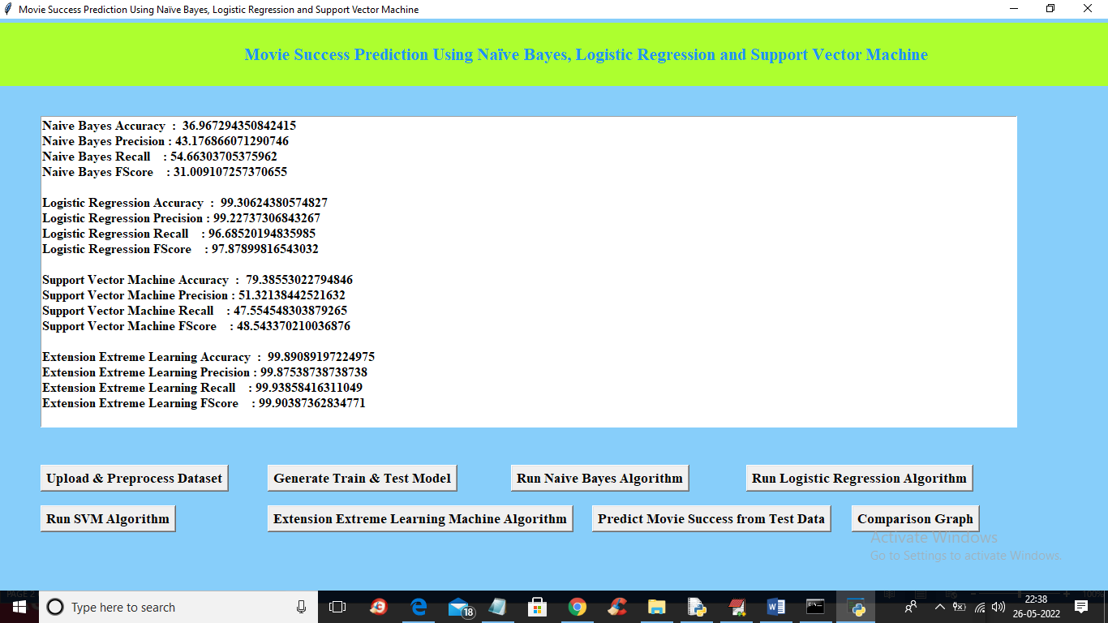

In above screen Logistic Regression existing algorithm got 99.30% as accuracy and extension Extreme Learning Machine (ELM) got 99.89% accuracy which is highest in all algorithms and below is the comparison graph

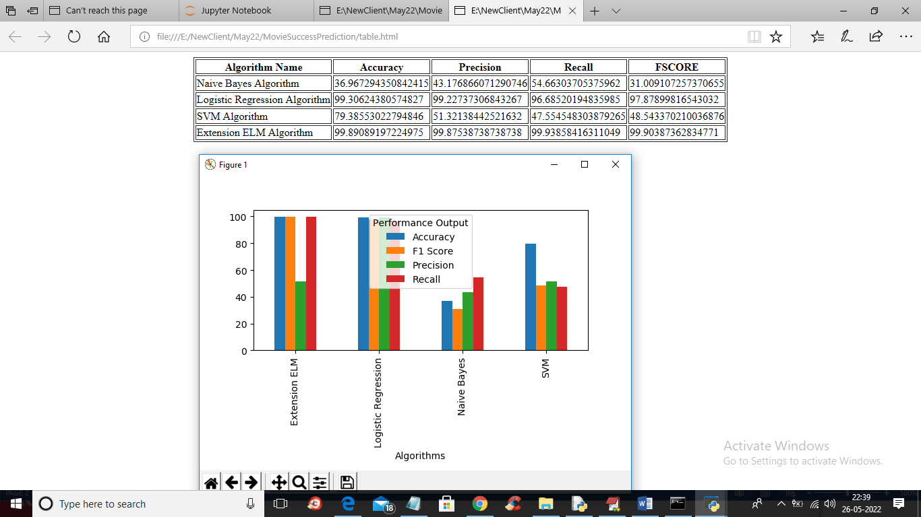

In above graph and comparison table you can see in all algorithms extension ELM has got high accuracy