Autonomous Drone Route Planning
and Obstacle Simulation
Project Report — Data Structures & Algorithms

Name: _____Muhammad Hassan____
Roll No: ____L1F24BSSE0365______
Course: ______DSA_______________
Section: ______SED 3_____________
Github Link: _______ Link __________

Table of Contents
Table of Contents 2
1. Project Overview 3
1.1 Data Structures Used 3
2. System Architecture 4
2.1 Application Window Layout 4
3. Waypoint and Edge Classes 5
4. AirspaceGraph — Adjacency List, Dijkstra & A* 5
4.1 Dijkstra's Algorithm 5
4.2 Path Reconstruction with a Stack 6
5. ObstacleEvent and the Min-Heap Priority Queue 6
6. Drone — State Machine, Backtracking 6
6.1 Stepping the Drone 6
6.2 Backtracking with the Stack 6
7. Console interface 7
9. Conclusion 8

1. Project Overview
Autonomous Drone Route Planning and Obstacle Simulation is a console-based Java application that models a drone navigating from a starting point to a destination while avoiding sudden obstacles. The map is built as a graph of connected waypoints, and the system uses standard pathfinding logic to find the shortest, safest route

This project demonstrates core Data Structures and Algorithms (DSA) in a beginner-friendly way, using simple lists, min-heap priority queues, and stacks, all controlled through a text-based terminal menu.

1.1 Data Structures Used
Data Structure | Used In | Purpose
Graph (Adjacency List) | AirspaceGraph | Models the map using HashMaps and ArrayLists to connect waypoints and distance weights.
Min-Heap Priority Queue | Drone | Orders dynamic obstacles so the closest threat to the drone is always processed first.
Stack (Deque, LIFO) | Drone | Keeps a history of visited waypoints so the drone can backtrack if it hits a dead end.
Simple Lists (ArrayList) | AirspaceGraph | Keeps track of visited nodes during pathfinding in a simple, readable way.

2. System Architecture
The application is built using standard, beginner-friendly Java and is organized into six core files:
- Waypoint.java — A single location on the map.
- Edge.java — A weighted connection or path between two waypoints.
- AirspaceGraph.java — The map manager that handles the data and finds the shortest path.
- ObstacleEvent.java — Represents a hazard, sorted by how close it is to the drone.
- Drone.java — The drone's brain, keeping track of its position, memory (Stack), and upcoming dangers (Heap).
- ConsoleApp.java — The main menu that lets the user interact with the simulation via text input.

2.1 Application Window Layout
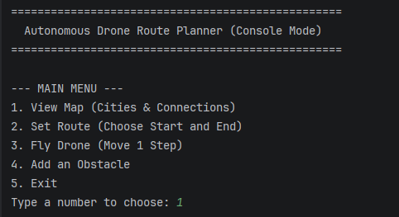
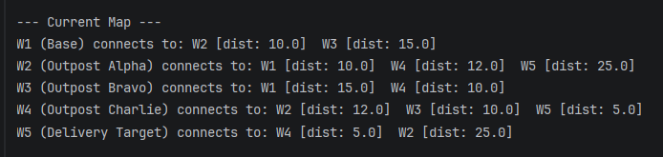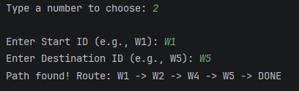

3. Waypoint and Edge Classes
These two classes form the basic building blocks of our map.
A Waypoint simply stores an ID (like "W1"), a readable label, its coordinates, and a boolean flag (isObstacle) that flips to true if the path becomes blocked. An Edge connects a starting waypoint to an ending waypoint and stores the travel distance (weight).
public class Waypoint {
public String id;
public int x, y;
public String label;
public boolean isObstacle;
}

public class Edge {
public Waypoint from;
public Waypoint to;
public double weight;
}

4. AirspaceGraph — Adjacency List, Dijkstra
The AirspaceGraph stores the map using an Adjacency List (a HashMap connecting a Waypoint's ID to an ArrayList of its Edges). This is very efficient for looking up neighbors..
private final Map<String, Waypoint> waypoints = new LinkedHashMap<>();
private final Map<String, List<Edge>> adjacencyList = new HashMap<>();

4.1 Dijkstra's Algorithm
Dijkstra's algorithm finds the shortest path from start to finish. Instead of complex data structures, this simplified version uses standard for and while loops to check all unvisited nodes and pick the one with the smallest distance.
PriorityQueue<String> pq = new PriorityQueue<>(
Comparator.comparingDouble(id -> dist.getOrDefault(id, Double.MAX_VALUE)));
Set<String> visited = new HashSet<>();
...
while (!pq.isEmpty()) {
String curr = pq.poll();
if (!visited.add(curr)) continue;
if (curr.equals(goalId)) break;
for (Edge e : adjacencyList.get(curr)) {
if (e.to.isObstacle) continue;
double newDist = dist.get(curr) + e.weight;
if (newDist < dist.getOrDefault(e.to.id, Double.MAX_VALUE)) {
dist.put(e.to.id, newDist);
prev.put(e.to.id, curr);
pq.add(e.to.id);
}
}
}

4.2 Path Reconstruction
Once the destination is found, the code uses a loop to walk backward through the recorded history, building a complete forward path for the drone to follow.

5. Obstacle Event and the Min-Heap Priority Queue
Dynamic hazards are represented by the ObstacleEvent class. Each event stores the blocked waypoint and its proximity to the drone.
public class ObstacleEvent implements Comparable<ObstacleEvent> {
public Waypoint waypoint;
public double proximity;

@Override
public int compareTo(ObstacleEvent other) {
if (this.proximity < other.proximity) return -1;
// ...
}
}

Because this class implements Comparable, we can store them in a PriorityQueue inside the Drone class. This naturally creates a Min-Heap, guaranteeing that the drone always reacts to the closest danger first.

6. Drone — State Machine, Backtracking
The Drone class acts as a state machine, moving between phases like IDLE, FLYING, REROUTING, and BLOCKED.
public enum State { IDLE, FLYING, BACKTRACKING, REROUTING, ARRIVED, BLOCKED }

private final Deque<Waypoint> visitedStack = new ArrayDeque<>();
private final PriorityQueue<ObstacleEvent> obstacleQueue = new PriorityQueue<>();

6.1 Stepping the Drone
Every time the user tells the drone to move, it first checks the Priority Queue for obstacles. If the path is clear, it moves to the next node and pushes that node onto its visited Stack.

6.2 Backtracking with the Stack
If an obstacle blocks the path, the drone uses its Stack memory to safely reverse. It pops waypoints off the top of the stack (Last In, First Out) until it finds a previous location that has a clear, unblocked path branching off.
private void backtrackToSafeNode(AirspaceGraph graph) {
state = State.BACKTRACKING;
while (!visitedStack.isEmpty()) {
Waypoint node = visitedStack.pop();
if (!node.isObstacle && /* has a safe neighbour */) {
currentPosition = node;
pathIndex = 0;
return;
}
}
state = State.BLOCKED;
}

7. Console interface
The entire simulation is run through ConsoleApp.java using a simple Scanner terminal menu, replacing the need for complex graphical panels.
The user interacts by typing numbers to select actions:
- View Map: Prints out all waypoints and their connected neighbors.


- Set Route: Prompts the user to type a start and end ID to calculate a path.
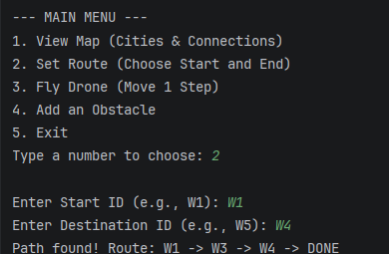
- Fly Drone: Moves the drone one step forward and prints its updated status and log.
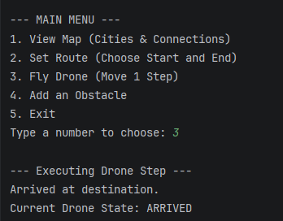
- Add Obstacle: Allows the user to manually block a waypoint to test the drone's rerouting memory.
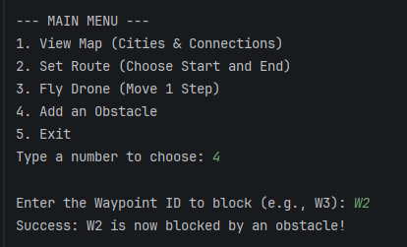

9. Conclusion
This project demonstrates how fundamental data structures and algorithms — graphs and adjacency lists, min-heap priority queues, stacks, and hash maps — combine to solve a realistic, dynamic pathfinding problem. Dijkstra's algorithm guarantees a globally optimal route, while A* reaches the same quality of result faster by using a distance heuristic. The min-heap ensures that, no matter how many obstacles appear, the nearest threat is always handled first. The stack-based backtracking mechanism allows the drone to gracefully recover from a blocked route without restarting the entire search. Together, these structures allow the simulation to replan in real time, mirroring how a real autonomous drone's navigation stack might behave.
The accompanying Java Swing GUI makes every one of these structures visible and interactive, turning an otherwise abstract set of algorithms into a tangible, observable system.

