***Real-Time Workout Posture Correction using OpenCV and MediaPipe***

**Introduction:**

In response to the COVID-19 pandemic and subsequent lockdowns, there has been a surge in interest in digital home exercise programs· While these programs offer convenience, there are risks associated with incorrect posture and lack of professional guidance· This paper proposes a solution to address these concerns by introducing a program that guides users to exercise with correct posture and monitors the number of workouts, all without the need for a professional trainer.

The program utilizes body posture estimation technology, specifically the landmark model of MediaPipe Pose, a machine learning solution, to analyze users' posture in real-time· If the user's posture deviates from correct exercise posture criteria, the program provides on-screen guidance for correction· Conversely, if the posture is correct, the program incrementally counts the number of workouts, providing both visual and auditory feedback to the user.

In this paper, we review existing studies related to posture recognition, discuss the theoretical background of the proposed system, outline the methodology for posture correction, and present the experimental results.

**Methodology:**

The proposed exercise posture correction system utilizes computer vision and machine learning techniques to analyze users' posture during exercises such as squats and push-ups.

**Exercise Posture Correction System:**

The system processes images captured by the webcam and converts them to RGB using OpenCV.

The historical model of MediaPipe Pose is then used to detect the body landmarks needed for pose analysis.

Postural angles are calculated using the coordinates of these landmarks, and the system determines whether the posture meets pre-defined criteria for correct exercise posture.

If not, debugging instructions will be displayed on the screen as shown in Figure 1.

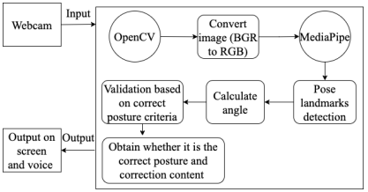

Figure 1: Posture analysis flowchart.

The program workflow starts with a HTTP request from the client framework React to the web server nginx, then relayed to Flask via Gunicorn.

Flask employs OpenCV and MediaPipe to analyze client image frames, storing data in MongoDB.

Redis and Celery handle asynchronous DB tasks for faster processing.

The chosen exercises are squats and push-ups, suited for equipment-free workouts.

Nginx enhances server performance, while OpenCV and MediaPipe aid in posture estimation as shown in Figure 2.

Figure 2: System architecture.

**Definition of Correct Posture:**

For squats, correct posture is defined by three conditions: maintaining a hip angle close to 90 degrees, ensuring thighs are nearly horizontal to the floor, and aligning knee and toe lines. The program verifies correct squats based on these conditions:

1) hip angle between 60 and 120 degrees.

2) minimal difference in y-values between knees and thighs.

3) slight difference in x-values between knees and toes. Guidance is provided for correction based on these conditions.

Push-up correctness is determined by:

1) elbow angle between 70 and 100 degrees, and

2) body angle between 160 and 200 degrees.

**Pose Landmark:**

Key points from the MediaPipe landmark model are used to validate correct posture conditions.

For instance, in squats, angles between various body parts are calculated to ensure correct posture as shown in Figure 3.

Figure 3. Landmarks for validating correct squat posture.

**Camera Calibration:**

Image calibration is essential for webcam use to correct for camera position and angle variations, ensuring accurate representation of real-world objects. A method is applied to determine a modified rotation angle, aligning with a fixed indicator of exercise posture and rotating the image accordingly.

Exercise posture demands specific foot angles; squats need horizontal angles, while push-ups require vertical ones. Foot angles are measured along a line from the heel to the toe tip. To accommodate foot angle variations, the rotation angle is averaged across both feet.

Figure 7 illustrates the key points used to calculate the foot angle. For the left foot, the key points are the left heel and left foot, while for the right foot, they are the right heel and right foot.

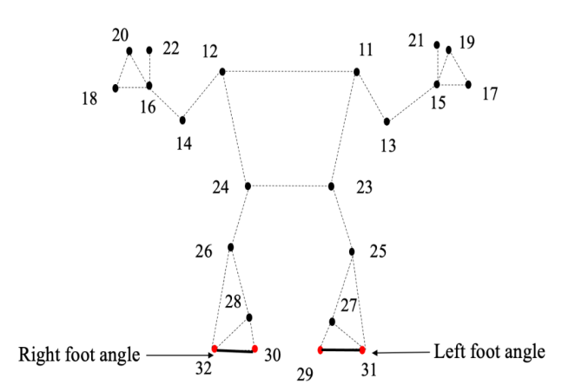

Figure 4. Landmarks used to find the angle of the foot.

**Calculate Angle:**

Angles between body parts are calculated using x, y, and z coordinates obtained from pose estimation. These angles are crucial for determining correct posture during exercises and in Figure 5 shows the angle between the three points.

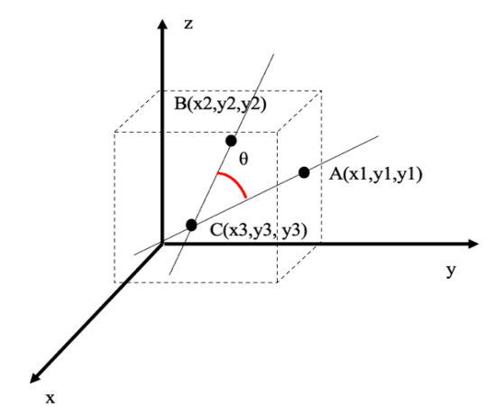

Figure 5. Angle between three points.

**Results:**

the program's output for both correct and incorrect postures for squats and push-ups.

In Fig. 6, the program output confirms correct squat posture, characterized by a hip angle between 60 and 120 degrees, thighs positioned near the floor, and knees not crossing the toe line. When these conditions are met, the screen displays an increased workout count, with the number also verbally announced.

Figure 6. Correct squat posture.

In Figure 10, the program output indicates incorrect squat posture, as the thigh is not maintained horizontally with the floor. Consequently, a guideline is displayed to correct this, and the exercise count remains unchanged.

Figure 7. Incorrect squat posture.

In Figure 8, the program output indicates an incorrect push-up posture, as the elbow angle exceeds 100 degrees. Consequently, a guideline is displayed to bend the arm more to approximately 90 degrees, and the exercise count remains unchanged.

Figure 8. Incorrect push-up posture.

In Figure 9 demonstrates the correct user posture during push-ups. A proper posture requires an elbow angle between 70 and 100 degrees, with the body angle close to 180 degrees. In this posture, guidelines are not displayed, and the exercise count increases. Additionally, the number of workouts number is verbally output.

Figure 9. Correct push-up posture.

Screenshots demonstrate how the system displays correction messages or workout counts.

An experiment is conducted to evaluate the program's success rate in counting exercises performed with correct posture.

The success rate formula is provided.

In Table1 summarizes the experimental results (presumably showing high success rates).

Table 1. Calculation success rate