Shop Ease Outage Root Cause Analysis Prompt
Below is the screenshot-style prompt with JSON structure exactly like the provided example.
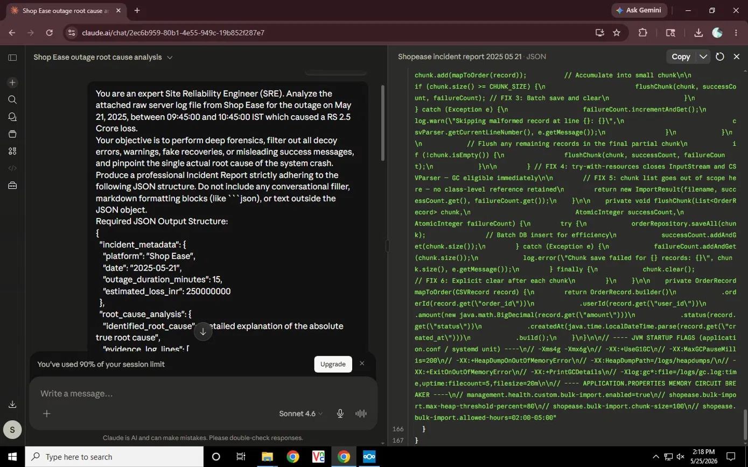
Screenshot Reference

