Innehåll

Initial setup 2

Features 3

Planned improvements 7

# Initial setup

After you have installed the plugin, setup your preferences in Tools / Options in Visual Studio.

Code markup

Type your name in the Name field it will be used in the code tags inserted by the tool. The markup strings are disabled to avoid accidental changes, it is important that the comments and check in comments follow the project’s defined process.

To enable editing, check the edit strings checkbox.

The code tag is built using a start string and stop string. The string also consists of constants that you can pick from the combo box at the bottom of the screen. Place the cursor in the field you wish to add the constant to, select it from the combo box and press the insert button.

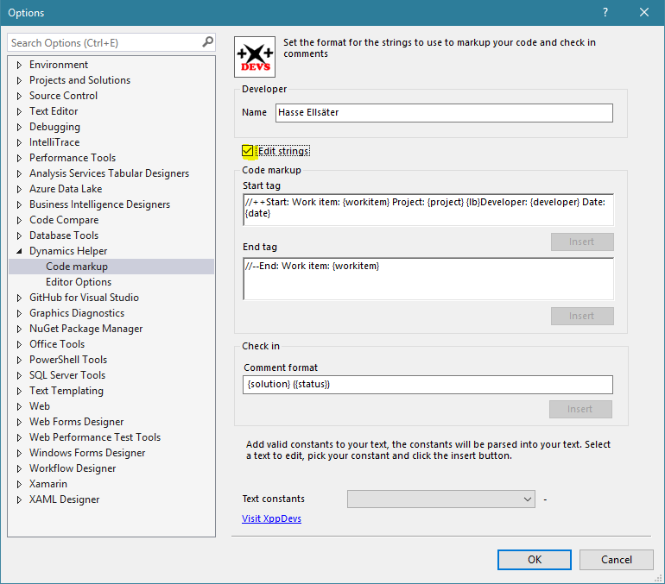

Editor options

Select if you want to highlight the current row, if so select a color for the highlighted row. The highlight option will use the color you select to highlight when you double click a word or select it with the cursor.

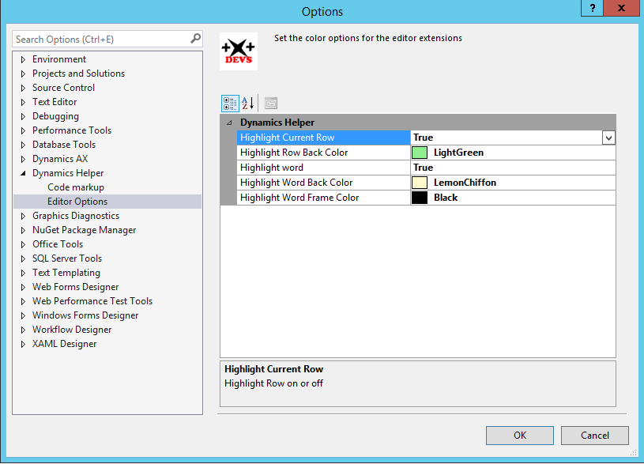

# Features

The home page on the Team Explorer has a new button, the Recent Changes button, this button will display the recent changes page. The My work button has a new section, the Pending changes has also a new section.

The new functions are described in this section.

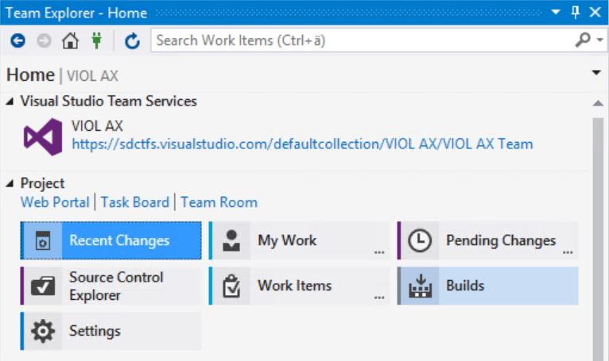

Recent Changes – New page

The recent changes page will list the last 100 changes for you and for the project. Double clicking on a change set will show the details. From there you are able to drill down to all details of a change. This page is based on Microsoft Samples “Extending Team Explorer in Visual Studio 2012”, it was so useful that I included it in my tool, it became useful from day one.

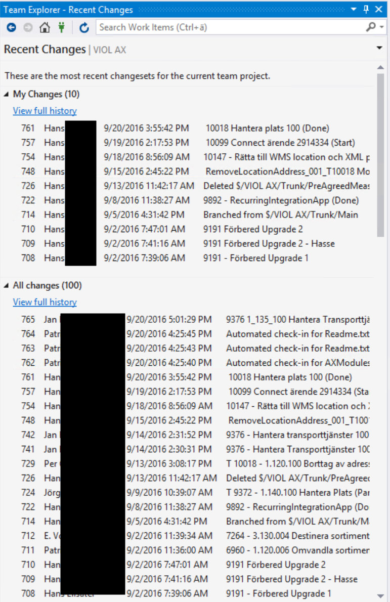

My Work – Modified page

The My Work page has a new section, ***Select Work Item***. Before you start to work with a task, you should drag an available work item to the “In Progress Work” section, or you should add a work item by typing in the work item id by clicking the Actions link in the “In Progress Work” section. When you have selected the work in progress items, you should type in the work item id in the selected work item section, if you have more work item id’s, separate them with a comma sign.

This id will be used in your code tags that you add to markup the connection to the work item and the FDD/TDD.

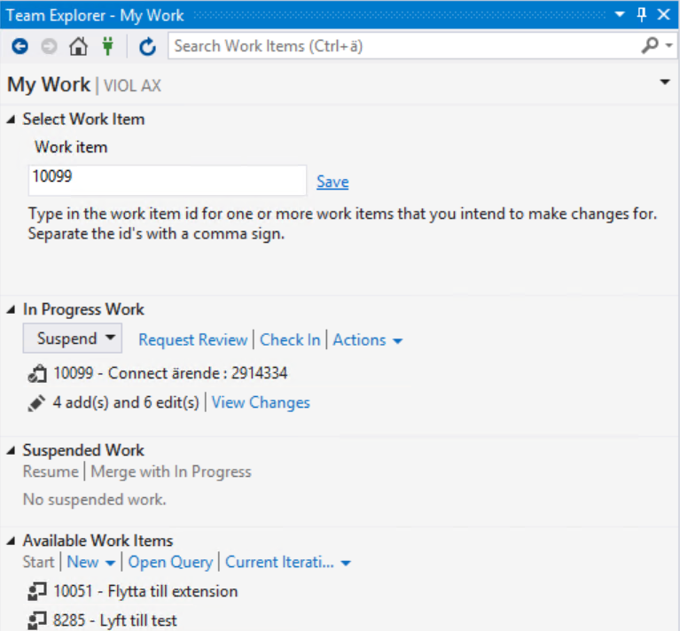

Pending Changes – Modified page

The pending changes page has a new section; the section is used to create a check in comment from rules defined in the settings. In this picture the comment is defined as: {solution} ({status}) it will then take the solution name and the selected status, and from that build a check in comment. In this case the work item id is in the solution name therefore it is not needed in the format string.

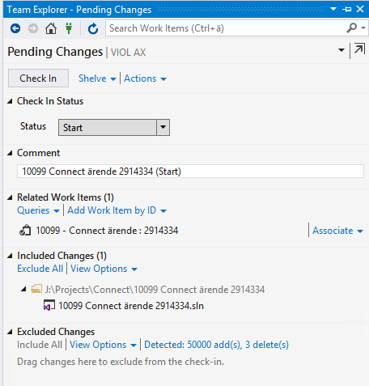

Insert code tag

To insert a code tag, select a section in your code, the lightbulb will appear and a preview of the comment will be shown. The code tag will contain the information specified in the settings. The settings should be setup the same for all developers to make the tags consistent and traceable.

The <empty> section is for future features.

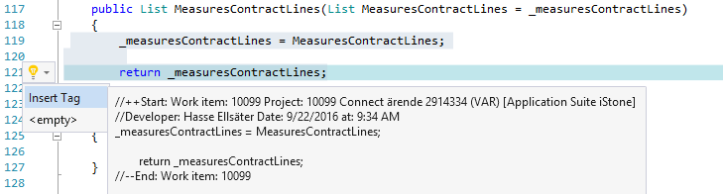

Highlight current row

The current row can be highlighted and displayed in a selected color.

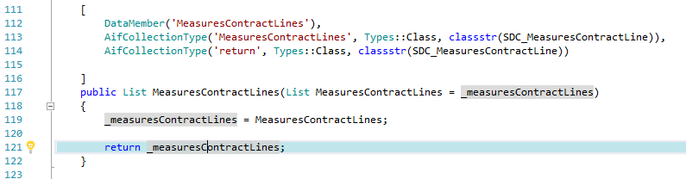

In this example the settings for row is Highlight Current Row = true and Color is Powder Blue.

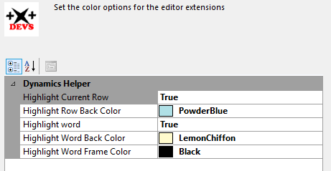

Highlight word

In this example the Highlight word is set to true, a word is selected with single click and the default implementation in the plugin from MS will set it to the default highlight color.

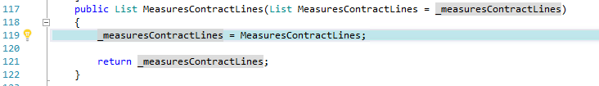

By double clicking on a word it will be displayed in the selected color, this can also be achieved by selecting the word using the cursor and marking the word by dragging.

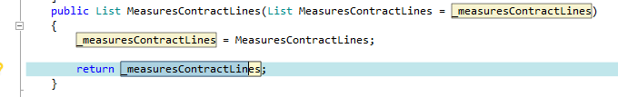

If the highlight word is set to false it will override the Microsoft implementation of highlight word and directly highlight the word in the selected color.

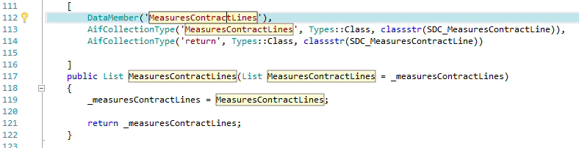

# Planned improvements

My Changes page

Listen for the event to add work item id’s automatically to the selected work items text box when dragged or added by link.

X++ Editor

* Improve regions
* Improve tooltip (as in the 2012 tool with the possibility to control the number of rows in the tooltip)
* Refactoring of code, would be really cool ☺
* Bug fix of inserting code tag (correct tab indention in the editor)
* Insert markup to description of methods added by ///

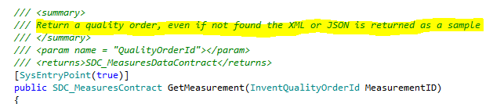

General

* Wizard to generate custom services data contracts
* Wizard to generate solutions and projects from template (correct naming).
* Tool options should use color settings according to Visual Studio standard
* Get access to properties should be done using property pages (if possible) Make sure that the DTE is accessible from classes not inherited from package,