A Radar-Based Simulator of Daily and Nightly Behaviour Patterns in Seniors

Project Proposal

Project summary
This project will develop a simulator that generates synthetic daily and nightly behaviour and physiology summaries for older adults, as they would appear after processing signals from two radar sensors — one covering room-level occupancy, posture, and motion, and one covering nighttime respiration. The simulator produces one aggregate record per resident per day and per night, without modelling room geometry, raw radar returns, or activity sequences. It supports slow health decline, acute deterioration events, and treatment effects, and emits ground-truth latent-state labels for each day. The purpose is to provide realistic longitudinal data, with controllable deterioration and known labels, for developing and evaluating anomaly-detection and health-monitoring methods before large real-world labelled datasets are available. The work is scoped as an eight-week Version 1 effort culminating in a validated, documented, and calibratable simulator together with example scenario datasets.

1. Introduction and motivation
Contactless radar sensing is an attractive modality for long-term monitoring of older adults because it preserves privacy, requires no wearable compliance, and can capture both movement and respiration. Translating raw radar signals into clinically meaningful trends, however, requires monitoring algorithms that must be trained and validated on longitudinal data spanning gradual decline and acute events. Such data are scarce, expensive to collect, and rarely labelled with ground truth. A behaviour simulator that produces realistic aggregate radar-derived features, with configurable decline and known latent states, addresses this gap and enables rapid, reproducible development of monitoring methods.
The simulator is intentionally built at the level of daily and nightly aggregates rather than raw signals. This keeps the model interpretable, keeps its parameters directly calibratable from radar-derived summary statistics, and avoids dependence on room layout or sensor-event rendering that would limit portability across homes.

2. Objectives and scope
The project has five objectives:
- Define a radar-derived feature set covering daytime activity and posture, nighttime sleep and motion, and respiration.
- Formulate a personal baseline model that captures each resident’s stable pattern.
- Formulate latent health-state progression and acute-event models for reduced mobility, heart failure, chronic obstructive pulmonary disease (COPD), and sleep-disordered breathing.
- Implement an interpretable Version 1 simulator that generates labelled longitudinal records.
- Validate the simulator statistically and define a calibration pathway toward real radar data.
In scope: aggregate daily/nightly record generation, slow decline, acute events, treatment effects, and validation against summary distributions. Out of scope for Version 1: room layout, raw signal synthesis, event sequences, per-disease latent separation, hierarchical multi-resident fitting, and clinical validation. The expected feature changes described in Section 6 are modelling priors grounded in clinical and sensing literature; they are not diagnostic rules and require calibration before any clinical interpretation.

3. Background and related work
Radar-based sleep monitors have been validated for respiratory-rate measurement in the home, and personalized baselines built from nightly averages can flag deviations [1]. Radar technology combined with pulse oximetry and machine learning has also demonstrated feasibility for detecting individual apnea events [2]. These results provide the sensing basis for the nighttime respiration and apnea features generated here. For daytime behaviour, ambient sensing offers a close analogue: gradual mobility loss in older adults has been detected from binary motion sensors using behavioural time-series forecasting [3], and multimodal community datasets have been published for monitoring functional decline after lower-limb fracture [4]. These non-radar sources motivate the daytime feature design and provide realistic calibration targets.
The clinical direction of each feature is grounded in the disease literature. Nocturia in stable heart failure is associated with reduced sleep efficiency, daytime sleepiness, and impaired functional performance [5]. Cheyne–Stokes respiration and central sleep apnoea are strongly linked to heart failure and carry prognostic weight [6]–[8]. Reduced physical activity is the strongest predictor of all-cause mortality in COPD [9], and COPD is accompanied by night-time symptoms, fragmented sleep [10], [11], and sleep-related hypoventilation and desaturation [12]. In obstructive sleep apnoea, nocturia is common and associated with worse sleep quality [13]. The fatigue and sleep-debt coupling used in the model follows the two-process framework of sleep regulation [14].
Throughout Sections 5 and 6, evidence is graded strong (S), moderate (M), or weak/indirect (W), and features are flagged confounded (C) when they are shared across two or more target conditions and therefore of low discriminative value.

4. Radar-derived feature set
For each resident and date the simulator emits one aggregate feature vector of derived features. The daytime features rest on the ambient-sensing analogues cited above and are treated as calibratable modelling assumptions; the nighttime respiration and apnea features rest on published radar evidence [1], [2].
Feature group | Example variables
Daytime occupancy and social | occupancy duration, number of people present, visitor minutes
Daytime posture and dwell | chair duration, daytime bed duration, inactive duration
Daytime activity and motion | active duration, large-motion count, small-motion count
Nighttime sleep window | bed occupancy duration, estimated sleep window
Nighttime motion and fragmentation | small motions in bed, large motions, bed-exit-like events, sleep-fragmentation index
Nighttime respiration | mean breathing rate, breathing-rate variability, apnea count, apnea duration, Cheyne–Stokes-like duration
Bathroom and nocturia | night bathroom-visit count

5. Clinical rationale and expected feature changes
The tables below define the priors used to drive synthetic decline. Direction symbols are ↑ increase, ↓ decrease, ↔ no direct effect. Features marked C are generated as distributional shifts of a stated magnitude rather than deterministic changes.
Reduced mobility. A slow, largely monotonic impairment state with step-downs after falls or hospitalization and partial recovery after rehabilitation, affecting activity and posture but not respiration.
Feature | Direction | Strength | Specificity | Rationale | Ref
Active duration | ↓ | M | C | Less independent movement | [3]
Large-motion count | ↓ | M | C | Fewer transfer/walk-like episodes | [3]
Inactive duration | ↑ | M | C | Longer low-motion bouts | [3]
Chair duration | ↑ | W | C | Sedentary shift; also pain/mood/illness | [4]
Daytime bed duration | ↑ | W | C | Daytime rest; non-specific | —
Breathing features | ↔ | S | — | Mobility alone must not create apnea/CSR | —
Worsening heart failure. Not monotonic: stable periods punctuated by decompensations with partial recovery, modelled as a regime-switching process with acute events.
Feature | Direction | Strength | Specificity | Rationale | Ref
Cheyne–Stokes-like duration | ↑ | S | HF-specific | Central apnoea / periodic breathing in HF | [7], [8]
Night bathroom visits (nocturia) | ↑ | M | C | Nocturia prevalent in stable HF | [5]
Bed-exit-like events | ↑ | M | C | Nighttime voiding and arousals | [5], [13]
Sleep-fragmentation index | ↑ | M | C | Shared with COPD and SDB | [5]
Mean breathing rate / variability | ↑ / variable | M | C | Periodic breathing; phenotype dependent | [7]
Active duration | ↓ | M | C | Fatigue, reduced capacity | [5]
COPD progression and exacerbation. Slow progression plus episodic, partly reversible exacerbations, often winter-clustered. Cheyne–Stokes is not driven by COPD.
Feature | Direction | Strength | Specificity | Rationale | Ref
Active duration | ↓ | M | C | Reduced activity; worse in exacerbation | [9], [10]
Large-motion count | ↓ | M | C | Lower exercise tolerance | [9], [10]
Sleep-fragmentation index | ↑ | M | C | Disturbed, fragmented sleep | [10], [11]
Small motions in bed | ↑ | W–M | C | Cough, dyspnea, repositioning | [10], [11]
Mean breathing rate | ↑ | W–M | C | Effort and exacerbation; to be calibrated | [9], [10]
Chair / bed / inactive duration | ↑ | M | C | Dyspnea and fatigue increase rest | [9], [10]
Sleep-disordered breathing. Largely stationary around a personal burden set-point, with treatment step-changes and adherence-driven variation; drives next-day fatigue.
Feature | Direction | Strength | Specificity | Rationale | Ref
Apnea count / duration | ↑ | S | SDB-specific | Direct output of SDB burden | [2]
Small motions in bed | ↑ | M | C | Arousal-related repositioning | [2], [13]
Sleep-fragmentation index | ↑ | M | C | Arousals reduce sleep efficiency | [13]
Night bathroom visits / bed-exits | ↑ | M | C | Nocturia common in OSA | [13]
Effective sleep window | ↓ | M | — | Time in bed stable, effective sleep falls | [13]
Next-day active duration | ↓ | W–M | C | Via fatigue feedback | [5], [13], [14]

6. Modelling approach
The model has three layers: a personal baseline that fixes each resident’s stable pattern, a set of latent health states that evolve over time and push features away from baseline, and observation models that turn baseline and state into the simulated feature values. The notation used throughout is summarized below; formula-specific coefficients are defined where they first appear.
Symbol | Meaning
i, j, d | Indices for resident, feature, and day
x(i,j,d) | Simulated value of feature j for resident i on day d
theta(i,j) | Personal baseline level of feature j for resident i, on the link scale
mu(i,j,d), phi(i,j) | Expected value (location) and dispersion (spread) of a feature
g(·), Family_j | Link function and distribution family chosen per feature type
W, S, V | Weekday/weekend, season, and visitor-exposure covariates on a day
z = (M, CP, SDB) | Latent health states: mobility impairment, cardiopulmonary burden, sleep-disordered-breathing burden, each in (0,1)
CP_HF | Heart-failure-attributable part of cardiopulmonary burden
F | Fatigue / sleep-debt state, in (0,1)
B, A | State-transition matrix (day-to-day persistence and coupling) and loading matrix (how states shift features)
logit, logit⁻¹ | Maps between a bounded state in (0,1) and the unconstrained real line
A latent state of 0 means healthy or at baseline, and 1 means the maximum modelled severity; features respond to states through interpretable sensitivity coefficients whose signs encode the clinical directions of Section 5.

6.1 Personal baseline model
Each resident’s stable pattern is represented by a person-specific baseline with population priors, so short or sparse histories shrink toward the population while longer histories dominate their own data [1]. Feature families are matched to their data-generating process: durations use Gamma or log-normal models bounded by day length; counts use negative-binomial models, zero-inflated for bed-exit and apnea nights; fractions and indexes use Beta or logit-normal models; breathing rate uses a person-specific normal or log-normal model; and zero-heavy burdens such as Cheyne–Stokes and apnea duration use zero-inflated Gamma or hurdle models. Robustness is obtained through heavy-tailed observation models or a two-component normal/abnormal mixture, and the baseline is frozen only after a stationarity check to exclude device-novelty effects. Baseline windows are variable-specific — stable durations settle within roughly two weeks, while rare-event rates require weeks to months — implemented as a minimum window with continuous forgetting-factor updates. Weekday, weekend, and seasonal effects enter only as regularized covariates, and caregiver or visitor presence enters as an explicit exogenous input that inflates occupancy and motion independently of health.
For feature j, resident i, day d:
$$theta_{ij} \sim Population_prior_{j} \\ g(mu_{ijd}) = theta_{ij} + beta_{wk}*W_{d} + gamma_seas*S_{d} + delta_{vis}*V_{d} \\ x_{ijd} \sim Family_{j}(location = mu_{ijd}, dispersion = phi_{ij})$$
Here theta_ij is drawn from a population prior Population_prior_j, which is what makes the baseline hierarchical: when a resident has only a few days of history, the estimate is pulled toward the population, and as history accumulates, the resident’s own data dominates. The link function g places the linear predictor on an unconstrained scale so that additive covariate terms cannot push a feature into an impossible value; its inverse returns the day’s expected value mu_ijd. The covariates W_d, S_d, and V_d (weekday/weekend, season, and visitor exposure) carry regression weights beta_wk, gamma_seas, and delta_vis; the visitor term is included explicitly so that social variation in occupancy and motion is separated from health-driven change rather than being misread as decline. Each feature is then drawn from the family Family_j matched to its type — Gamma or log-normal for positive, skewed durations, negative-binomial for over-dispersed counts, Beta or logit-normal for bounded fractions, and zero-inflated Gamma for zero-heavy burdens — with dispersion phi_ij controlling spread. Choosing the family and link this way guarantees that simulated values stay in valid ranges and reproduce realistic shapes and variance, which a single Gaussian model would not. Correlated residuals are captured by a low-rank factor covariance so that related features co-occur.

6.2 Health-state progression and acute events
Health states are latent simulation-control variables, not diagnoses. Three latent states — mobility, cardiopulmonary burden, and sleep-disordered-breathing burden — evolve one day at a time and modulate the baseline. States evolve in logit space to remain bounded and smooth, separating a slow chronic trend from fast transient episodes. Acute episodes are generated by a jump process with Poisson-triggered onset and exponential recovery:
$$z_{\left\{d+1\right\}} = logit^{\left\{-1\right\}}( B*logit(z_{d}) + drift_{d} + jump_{d} - recovery_{d} + noise ) \\ x_{d} = f_{family}( baseline_person, A*z_{d} )$$
The first line advances the latent states. Working in logit space and mapping back with logit⁻¹ keeps every state inside (0,1) and lets it move smoothly, which avoids the artifacts of hard clipping (states sticking at 0 or 1 and distorted noise near the bounds). The matrix B sets how much of yesterday’s state carries into today: diagonal entries near one produce the slow change expected of chronic conditions, while off-diagonal entries let states influence each other (for example, worsening heart failure can raise sleep-disordered-breathing burden). The three additive terms separate the two timescales that real decline shows: drift_d is the gradual chronic worsening, jump_d is the sudden increment contributed by an acute episode from the Poisson-triggered event process, and recovery_d is the exponential decay that returns the state toward baseline after an event or under treatment; noise is ordinary day-to-day process variation. Splitting these terms means each can be calibrated independently and together they reproduce the stable-periods-punctuated-by-flares pattern seen clinically. The second line generates the day’s features: the loading matrix A maps latent severity onto feature shifts, and f_family adds those shifts to the personal baseline and draws the observed values through the same family-specific models used for the baseline, so state effects are expressed as deviations from each resident’s own normal.
Reduced mobility uses a gradual chronic trend with downward jumps for falls and bounded upward recovery for rehabilitation. Heart failure uses a regime-switching process with a hazard model for time to decompensation and exponential recovery, and includes treatment effects on nocturia and Cheyne–Stokes. COPD uses a slow trend with seasonally clustered exacerbation regimes and partial recovery. Sleep-disordered breathing uses a mean-reverting process around a personal set-point with a treatment step-change. Because the target conditions share several non-specific features, Version 1 uses a single shared cardiopulmonary burden latent for generation while anchoring each condition on its specific markers — Cheyne–Stokes for heart-failure central apnoea, obstructive-apnea morphology for sleep apnoea, and respiratory-rate elevation with winter exacerbation for COPD.

6.3 Fatigue and sleep-debt feedback
Poor nights increase next-day inactivity and rest, following the two-process framing [14]:
$$F_{\left\{d+1\right\}} = logit^{\left\{-1\right\}}( rho_{F}*logit(F_{d}) + q1*fragmentation_{d} + q2*apnea_burden_{d} \\ + q3*CSR_{d} + q4*COPD_{d} + q5*HF_{d} - q6*recovery_{d} + noise )$$
F_d is the fatigue and sleep-debt state on day d. The coefficient rho_F, between zero and one, is the carry-over of fatigue from one day to the next, so that a run of bad nights accumulates rather than resetting; the same term ensures fatigue also decays when nights improve. The weights q1 through q5 are non-negative and set how strongly each driver from the preceding night — sleep fragmentation, apnea burden, Cheyne–Stokes burden, and the current COPD and heart-failure states — raises the next day’s fatigue, while q6 scales the restorative effect of a good day or adequate rest that lowers it. This is the mechanism that closes the night-to-day loop: elevated fatigue then reduces next-day active duration and increases rest in the observation models, matching the two-process view of sleep regulation [14]. Because the loop couples nights to subsequent days, rho_F together with the feedback gains is constrained so that the combined transition is contractive (spectral radius below one); without this constraint the loop could amplify itself into runaway inactivity, so the condition is checked at configuration time.

6.4 Version 1 simulator specification
Version 1 is a linked linear-Gaussian latent state-space model with logit-bounded states, an explicit acute-event jump process, distribution-specific observation models, the fatigue and sleep-debt feedback, and a robust hierarchical baseline. Representative observation links are:
$$active_duration = baseline_active - a1*M - a2*CP - a4*F + noise \\ chair_duration = baseline_chair + b1*M + b2*CP + b3*F + noise \\ large_motion_count \sim NegBin(mean = baseline_large * exp(-c1*M - c2*CP - c3*F)) \\ night_bathroom_visits \sim NegBin(mean = baseline_bath * exp(h1*CP_HF + h2*SDB + h3*diuretic)) \\ CheyneStokes_duration \sim ZeroInflatedGamma(mean = baseline_CSR + k1*CP_HF) \\ fragmentation_index = Beta_mean(baseline_frag + s1*SDB + s2*CP + s3*night_bathroom_visits)$$
Each line starts from the resident’s personal baseline for that feature and adds the effect of the current latent states, where M, CP, SDB, and F are the mobility, cardiopulmonary, sleep-disordered-breathing, and fatigue states, and CP_HF is the heart-failure part of cardiopulmonary burden. The coefficients a, b, c, h, k, and s are sensitivity (effect-size) parameters to be calibrated from data, and their signs are fixed to match Section 5: active duration falls as mobility, cardiopulmonary burden, and fatigue rise, so those terms are subtracted, whereas chair duration rises with the same states, so they are added. The two count features use a negative-binomial model with a multiplicative exp(...) term because counts are non-negative and over-dispersed; the exponential keeps the mean positive and makes each state act as a proportional change in rate rather than a fixed offset. Nocturia is driven specifically by the heart-failure component and by sleep-disordered breathing, with a diuretic term because treatment and its timing change nighttime voiding. Cheyne–Stokes duration uses a zero-inflated Gamma because most nights have none while affected nights have a positive, skewed duration, and it is driven only by CP_HF, which keeps it as a heart-failure-specific marker that COPD does not trigger. The fragmentation index uses a Beta model because it is bounded in (0,1), and it responds to sleep-disordered breathing, cardiopulmonary burden, and the number of bathroom visits, reflecting that arousals from several sources all reduce sleep continuity. In every case the family is chosen so the simulated value stays in its natural range, and the state effects are expressed as departures from the resident’s own baseline rather than absolute levels.
The daily pipeline builds the resident profile and baseline, updates latent states and acute events, generates daytime, nighttime, and breathing features, computes sleep quality, updates fatigue and sleep-debt, writes labelled output tables, and validates the results against reference distributions.

7. Software architecture and block diagram
Each module has a narrow, testable interface. Anomaly and deterioration labels are a first-class output, since the simulator knows the true latent state for every day.
Module | Inputs | Outputs
Resident profile generator | Configuration (demographics, comorbidities, severities, medications) | Static resident profile
Radar-derived baseline model | Profile, population priors, optional real baseline | Per-feature baseline distributions, covariance factors
Health-state progression model | Profile, previous states, acute triggers, treatment schedule | Latent states, trajectory point
Acute-event generator | Latent states, hazard and seasonal parameters | Event onsets, durations, recovery signals
Daytime-pattern generator | Latent states, day baseline, visitor input | Daytime feature row
Nighttime-pattern generator | Latent states, night baseline | Night feature row
Breathing-pattern generator | Cardiopulmonary and SDB states, respiration baseline | Breathing-rate, apnea, Cheyne–Stokes features
Sleep-quality estimator | Night and breathing rows | Fragmentation, effective sleep, efficiency
Fatigue / sleep-debt update | Prior sleep quality and burdens | Updated fatigue and sleep-debt
Output writer | All rows and latent states | Labelled CSV/Parquet tables
Validation and visualization | Simulated outputs, optional real distributions | Distance metrics and plots
Configuration and parameter library | Parameter sets | Validated parameter objects
The block diagram in Fig. 1 shows the aggregate-level data flow. No room layout, raw radar signals, or sensor-event rendering appear; the only cross-day edge is the fatigue feedback loop. An editable diagram file accompanies this proposal.
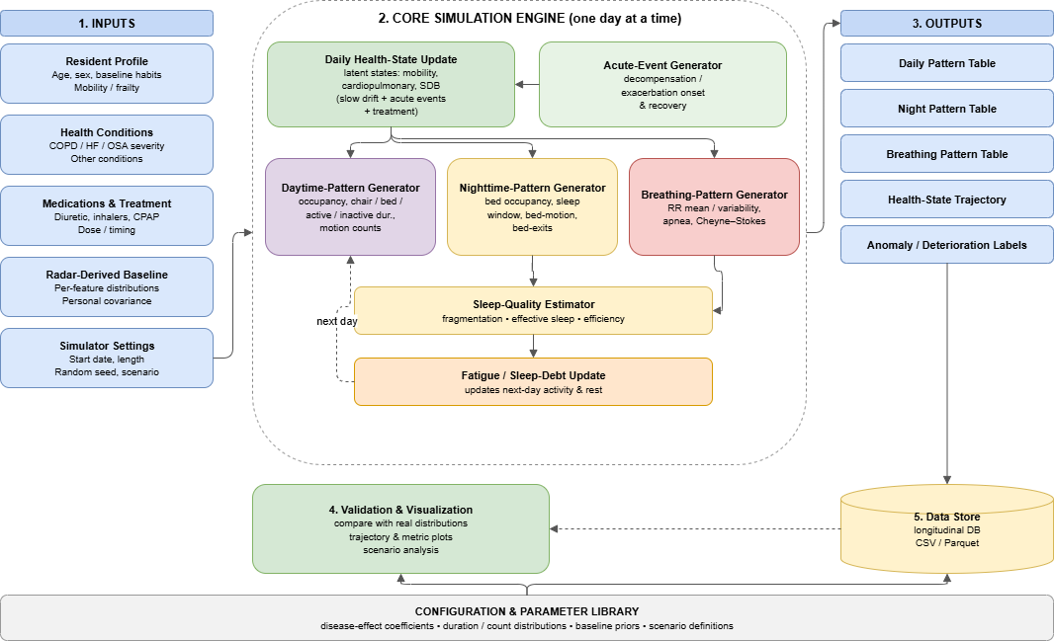
Figure 1. Simplified simulator block diagram showing inputs, the daily core simulation engine, outputs, data store, validation, and the configuration library. The dashed edge is the fatigue feedback loop.

8. Validation and calibration plan
Validation proceeds from static realism to dynamics and is framed as statistical and face validity rather than clinical validity. First, per-feature marginal distributions are matched using the Kolmogorov–Smirnov statistic, Wasserstein or energy distance, and quantile comparison, and pairwise correlations are compared through correlation matrices and multivariate energy distance. Second, temporal structure is assessed through autocorrelation, trend slopes, change-point frequency, and the distribution of episode durations. Third, injected decline is validated by testing whether a simple detector recovers it, using the area under the receiver-operating curve against ground-truth labels together with detection latency. Fourth, acute events are validated through detection lead time, false-alarm rate, and the realism of post-event recovery. Clinician face-validity review of sample trajectories and sensitivity analyses over the priors guard against over-claiming. Calibration requires a longitudinal radar deployment in older adults with the same derived features and linked clinical events; interim analogues include longitudinal contactless sleep datasets and multimodal decline datasets [4].

9. Project plan and timeline
The work is organized as an eight-week Version 1 project with four milestones: a working baseline model (M1, end of Week 2), the complete core generators (M2, end of Week 5), an integrated and labelled simulator (M3, end of Week 6), and a validated and documented release (M4, end of Week 8). The weekly plan is summarized below and in the timeline of Fig. 2.
Week | Focus | Key tasks | Deliverables
1 | Setup and parameters | Fix requirements and feature definitions; build configuration schema and literature-derived parameter library; implement resident profile generator | Requirements note; parameter library; profile generator with tests
2 | Personal baseline model | Implement hierarchical, robust, distribution-specific baseline with population priors, forgetting-factor updates, stationarity gate, and visitor covariate | Baseline module with unit tests and demonstration (M1)
3 | Progression and acute events | Implement logit-bounded latent states and the Poisson-triggered acute-event generator with hazard and seasonal onset | Progression and acute-event modules; trajectory plots
4 | Daytime and nighttime generators | Map latent states and baseline to daytime posture, activity, and motion features and to nighttime sleep and motion features | Daytime and nighttime generators with example outputs
5 | Breathing, sleep, and feedback | Implement the breathing-pattern generator, sleep-quality estimator, and fatigue/sleep-debt feedback with the stability check | Breathing and sleep modules; stability verification (M2)
6 | Integration and scenarios | Add the output writer and daily loop; build reduced-mobility, heart-failure, COPD, sleep-apnea, and comorbid scenario configurations | Integrated simulator with five labelled scenario datasets (M3)
7 | Validation | Implement distributional and temporal validation metrics and the decline and acute-event recovery tests | Validation module and validation report
8 | Calibration and delivery | Calibrate against reference distributions; run sensitivity analysis; complete documentation and clinician face-validity review | Final report, calibrated parameters, demonstration, user guide (M4)
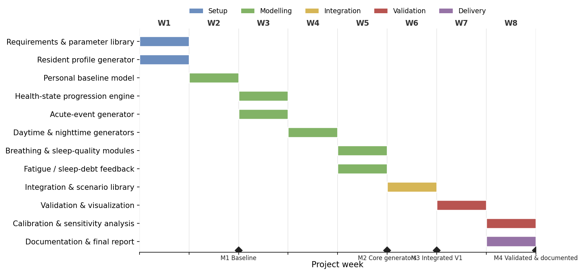
Figure 2. Eight-week project timeline with milestones M1–M4.

10. Deliverables
The project will deliver the Version 1 simulator source code with unit tests; the configuration and parameter library; five labelled scenario datasets covering reduced mobility, heart failure, COPD, sleep-disordered breathing, and combined comorbidity; the validation module and validation report; the calibrated parameter set and calibration pathway description; a demonstration and user guide; and this proposal’s accompanying block diagram in editable form.

11. Risks and mitigation
The daytime posture, activity, and motion features rest on ambient-sensing analogues rather than direct radar validation; this is mitigated by treating them as explicitly calibratable assumptions and by prioritizing a real-radar calibration study. Several clinical anchors are cross-sectional and support associations rather than longitudinal directions; this is mitigated by grading evidence and expressing confounded features as distributional shifts. The target conditions overlap in their non-specific features, creating an identifiability limit; this is mitigated by anchoring each condition on its specific markers and by using the simulator’s known latent states to quantify confounding. The fatigue feedback loop could become unstable; this is mitigated by the contractivity constraint. Finally, synthetic outputs must not be interpreted as clinical diagnoses; this is mitigated by the validation framing and by requiring calibration and clinician review before any decision-support use.

12. Expected outcomes and significance
The project will produce an interpretable, calibratable simulator that generates realistic labelled longitudinal radar-derived behaviour data with controllable decline and acute events. This will accelerate the development and benchmarking of monitoring algorithms, enable reproducible evaluation against known ground truth, and provide a principled foundation for later versions that separate disease-specific latent states, fit hierarchically across residents, and calibrate against real radar cohorts.

References
[1] S. Toften, J. T. Kjellstadli, O. K. F. Thu, and O. J. Ellingsen, “Noncontact longitudinal respiratory rate measurements in healthy adults using a radar-based sleep monitor (Somnofy): Validation study,” JMIR Biomed. Eng., vol. 7, no. 2, p. e36618, 2022, doi: 10.2196/36618.
[2] S. Toften, J. T. Kjellstadli, S. S. Tyvold, and M. H. Moxness, “A pilot study of detecting individual sleep apnea events using noncontact radar technology, pulse oximetry, and machine learning,” J. Sensors, vol. 2021, art. no. 2998202, 2021, doi: 10.1155/2021/2998202.
[3] I. Susnea, E. Pecheanu, A. Cocu, A. Istrate, C. Anghel, and P. Iacobescu, “Non-intrusive monitoring and detection of mobility loss in older adults using binary sensors,” Sensors, vol. 25, no. 9, art. no. 2755, 2025, doi: 10.3390/s25092755.
[4] A. Abedi, C. H. Chu, and S. S. Khan, “Multimodal sensor dataset for monitoring older adults post lower-limb fractures in community settings,” Sci. Data, vol. 12, art. no. 733, 2025, doi: 10.1038/s41597-025-05069-7.
[5] N. S. Redeker et al., “Nocturia, sleep and daytime function in stable heart failure,” J. Card. Fail., vol. 18, no. 7, pp. 569–575, 2012, doi: 10.1016/j.cardfail.2012.05.002.
[6] M. Rudrappa, P. Modi, and P. C. Bollu, “Cheyne-Stokes respirations,” in StatPearls. Treasure Island, FL, USA: StatPearls Publishing, 2023. [Online]. Available: https://www.ncbi.nlm.nih.gov/books/NBK448165/
[7] W. Randerath, O. C. Deleanu, S. Schiza, and J.-L. Pépin, “Central sleep apnoea and periodic breathing in heart failure: Prognostic significance and treatment options,” Eur. Respir. Rev., vol. 28, no. 153, art. no. 190084, 2019, doi: 10.1183/16000617.0084-2019.
[8] T. D. Bradley and J. S. Floras, “Sleep apnea and heart failure,” Circulation, vol. 107, no. 12, pp. 1822–1826, 2003, doi: 10.1161/01.CIR.0000061758.05044.64.
[9] X. Xiang, L. Huang, Y. Fang, S. Cai, and M. Zhang, “Physical activity and chronic obstructive pulmonary disease: A scoping review,” BMC Pulm. Med., vol. 22, no. 1, art. no. 301, 2022, doi: 10.1186/s12890-022-02099-4.
[10] A. Agustí, J. Hedner, J. M. Marin, F. Barbé, M. Cazzola, and S. Rennard, “Night-time symptoms: A forgotten dimension of COPD,” Eur. Respir. Rev., vol. 20, no. 121, pp. 183–194, 2011, doi: 10.1183/09059180.00004311.
[11] R. Budhiraja, T. A. Siddiqi, and S. F. Quan, “Sleep disorders in chronic obstructive pulmonary disease: Etiology, impact, and management,” J. Clin. Sleep Med., vol. 11, no. 3, pp. 259–270, 2015, doi: 10.5664/jcsm.4540.
[12] W. T. McNicholas, D. Hansson, S. Schiza, and L. Grote, “Sleep in chronic respiratory disease: COPD and hypoventilation disorders,” Eur. Respir. Rev., vol. 28, no. 153, art. no. 190064, 2019, doi: 10.1183/16000617.0064-2019.
[13] Y. H. Chung, J. R. Kim, S. J. Choi, and E. Y. Joo, “Prevalence and predictive factors of nocturia in patients with obstructive sleep apnea syndrome: A retrospective cross-sectional study,” PLoS ONE, vol. 17, no. 4, art. no. e0267441, 2022, doi: 10.1371/journal.pone.0267441.
[14] A. A. Borbély, “A two process model of sleep regulation,” Hum. Neurobiol., vol. 1, no. 3, pp. 195–204, 1982.

