Radar Behaviour Simulator
How It Works and How It Could Be Improve
Hassen Medles
Project: Radar-Based Simulator of Daily and Nightly Behaviour Patterns in Seniors
Repository: Hassen-Medles/generator

Summary:
2. Acknowledgments: 3
3. What I built: 3
4. How it's built: 3
5. How the simulation logic works 4
5.1 Baseline values 4
5.2 Latent health states 4
5.3 From hidden state to daily features 5
5.4 Labelling each day 5
6. Limitations and what I would improve 6

Acknowledgments :

I want to thank Prof. Bolic for his guidance on this project, as well as the team Yunze Lu, Charles Jia, Chenzhe Zhao and Han Zixiong for their help and feedback along the way.

What I built:
For this project I built a small web app that generates synthetic daily data for a senior, as if it came from a radar sensor. You pick a resident, tick one or more conditions (reduced mobility, heart failure, COPD, sleep-disordered breathing), choose mild or severe for each, and choose how many days to simulate. The app then generates a full day-by-day dataset with things like active duration, sleep window, bathroom visits, breathing rate, and it labels each day as normal or as a decline event. I can see the results as charts and a table in the browser and download the data as CSV.

How it's built:
The project has three parts:
- A frontend (index.html, script.js, style.css): the page where I pick the conditions and severities, run the simulation, and see the charts (made with Chart.js) and the results table:
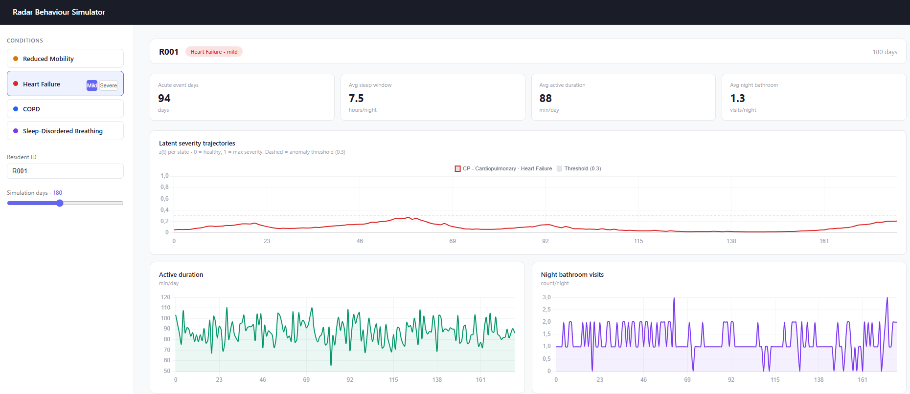
- A backend (app.py): a small Flask server with one route to serve the page and one route (/simulate) that receives my choices and sends back the generated data as JSON.
- The simulation itself (simulator.py): this is where the actual data generation happens. I first built and tested the logic in a Jupyter notebook (radar_simulator.ipynb), then moved the same logic into simulator.py so the web app could use it.

How the simulation logic works
I kept the logic in a few simple steps:

5.1 Baseline values
Each feature (active duration, breathing rate, sleep window, etc.) has a starting average value that I picked myself or from aruba casas dataset, not from real data. I did not have access to real radar recordings from seniors, so I could not build a proper personalized baseline like the proposal described (where each resident's baseline would come from their own history and shrink toward a population average). Instead I used one fixed, generic average per feature, taken from what seemed reasonable, and this same average is used for every resident.

5.2 Latent health states
For each condition family (mobility, cardiopulmonary, sleep-disordered breathing) I simulate a hidden severity value that evolves day by day between 0 and 1. Most days it moves slowly (slow decline), and from time to time it can jump up suddenly (an acute event) and then slowly recover, using a random process. Choosing "severe" instead of "mild" makes this hidden value grow faster and jump more often.
For each condition family (mobility, cardiopulmonary, sleep-disordered breathing) I simulate a hidden severity value that evolves day by day between 0 and 1. Most days it moves slowly (slow decline), and from time to time it can jump up suddenly (an acute event) and then slowly recover, using a random process. Choosing "severe" instead of "mild" makes this hidden value grow faster and jump more often. Below is the math behind this, written out step by step.
I call the hidden severity on day t simply z_{t}, a value between 0 and 1.
Instead of updating z_{t} directly, I work in “logit space” (log-odds), which makes small additive changes behave smoothly even near 0 or 1:
$$logit\left(z\right)=ln⁡(\frac{z}{1-z})$$
Each day, the new hidden state is:

$$logit\left(z_{t}\right)=B×logit\left(z_{t-1}\right)+drift+jump-recovery+noise$$

- B = 0.97 (persistence): today's hidden state mostly just copies yesterdays. This is why the trajectory moves slowly most of the time nothing changes drastically from one day to the next.
- drift: a small constant added every day (between 0.001 and 0.0025 depending on the condition and severity), which pushes the state slowly upward over time, this is the "slow decline".
- noise: small random variation added each day, so the curve isn't perfectly smooth.
Whether an acute event (a sudden jump) happens on day t depends on a hazard rate that grows with how severe the state already is:

$$λ_{T}=λ_{0}×e^{∝×zt-1}$$

Every day I draw a random number from a Poisson distribution with this rate; if the number is greater than 0, a jump is triggered that day (fixed size = 0.4, added to the logit value). Because the hazard rate grows with the current severity, the higher z already is, the more likely another acute event becomes
Choosing severe instead of mild for a condition changes three parameters for the corresponding hidden state:

Parameter | Mild | Severe | Effect
Drift | +0.0012 / day | +0.0025 / day | Faster baseline decline
λ₀ (base hazard) | × 1.25 | × 1.7 | More frequent jumps
α (hazard sensitivity) | +0.2 | +0.4 | Jumps trigger sooner as severity rises

5.3 From hidden state to daily features
Every day, for every feature, I check which selected conditions affect it and by how much (I defined these effects myself, direction and rough size, based on the clinical reasoning from the proposal). I multiply the current hidden severity by that effect, add it to the baseline, add a bit of random noise, and clip the result to a realistic range.
These effect sizes are hard-coded constants in the code (a DISEASE_PARAMS table with a fixed delta_mild and delta_severe per feature per condition), not values estimated from real patients. I chose them by hand based on what seemed clinically reasonable, so they're really just my guess at the direction and rough size of each effect as you can see on this screenshot:
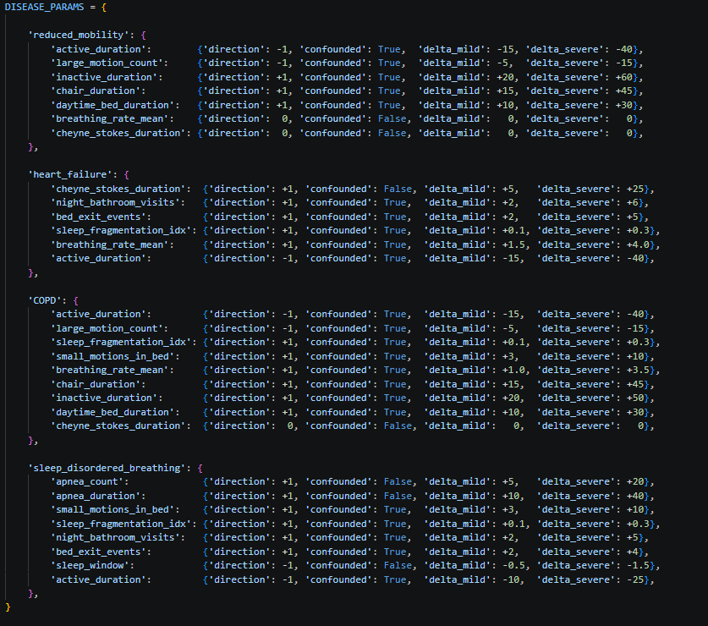

A better version of this would fit these deltas to real (or at least published) patient data instead of picking constants myself. for example, estimating them from a clinical dataset, so the numbers would reflect actual measured effects rather than my own assumptions.

5.4 Labelling each day
Each day gets a label based on whether one of the hidden severity states crosses a threshold of 0.3 (mobility first, then cardiopulmonary, then sleep-disordered breathing, otherwise "normal"). I want to be honest about this number: I fixed it at 0.3 just because it gave reasonable-looking results when I tested it, not because it is based on a study or a formula. I looked but did not find any paper that justifies a specific threshold for this kind of synthetic labelling, so this is one of the weaker points of the current version and a good candidate for improvement.

Limitations and what I would improve
- Baseline: right now, every resident starts from the same generic average because I have no real data to personalize it. With real radar data, I could build per-resident baselines instead of one shared value for everyone.
- Threshold: the 0.3 cut-off used to label a day as a decline event was chosen by hand, not derived from data or literature. It would be worth testing a few thresholds and checking which one makes the labels line up best with the injected severity.
- Noise: I currently add the same kind of random noise to every feature, even though some features (like counts) should behave differently from others (like durations). Using the right kind of noise per feature would make the data look more realistic.
- No feedback loop yet: a bad night doesn't currently make the next day more tired/inactive, even though this connection is mentioned in the proposal.

