NATIONAL UNIVERSITY OF SCIENCES & TECHNOLOGY (NUST SEECS)
DEPARTMENT OF COMPUTING | CS 417: LARGE LANGUAGE MODELS (SPRING 2026)
Assignment 1: Engineering a High-Performance Urdu Byte-Level BPE Tokenizer from Scratch
Technical Report & Empirical Analysis (CLO 3) | Target Vocabulary: 50,000 Tokens (49,743 Merges)
————————————————————————————————————————————————————————————

1. Executive Summary & Design Overview
Standard English-centric language model tokenizers (e.g., GPT-2) exhibit severe tokenization fragmentation when applied to the Perso-Arabic script of Urdu, inflating token counts by >5.1× and crippling language model context length and sample efficiency. In this work, we design and implement a strictly native byte-level Byte-Pair Encoding (BPE) tokenizer from scratch in plain Python without external tokenizer dependencies. Built to exact deterministic tie-breaking specifications (highest byte tuple lexicographical priority) with a reserved <|endoftext|> token at ID 256, our tokenizer completes 49,743 merges over a clean 520.0 MiB (545.3 MB) multi-genre Urdu corpus in 352.25 seconds. Empirical evaluation confirms a near-optimal compression rate of 1.084 tokens/word on native text, outperforming GPT-2 by 5.16× and OpenAI's multilingual o200k_base by 1.40×.
Lossless Guarantee: Zero Out-Of-Vocabulary (<unk>): By utilizing byte-level fallback for the 256 base UTF-8 bytes (IDs 0–255), the tokenizer guarantees 100% lossless reconstruction (decode(encode(text)) == text) across arbitrary Unicode sequences, emojis, Roman Urdu, and technical code-switching.

2. Corpus Acquisition, Normalization & Cleaning Pipeline (Part A)
To provide a high-quality foundation for downstream GPT-style language modeling, we curated 545.26 MB (520.00 MiB) of strictly cleaned Urdu text across three independent sources spanning encyclopedia, news, and mixed literature genres. Crucially, 55.11 MiB clean text (56.91 MiB raw) was independently collected via automated discovery and extraction using the MediaWiki Parsoid API, satisfying the course mandate of ≥50 MB self-collected text (proven in data/raw/urwiki_collection_manifest.json).
Source | Genre | Extraction Method | Raw Size | Clean Size | License / Terms
Urdu Wikipedia | Encyclopedia | MediaWiki API (Longpages) | 56.91 MiB | 55.11 MiB | CC BY-SA 4.0
UFAL UrMonoCorp | Mixed / Web | LINDAT Repository API | 213.46 MiB (gz) | 231.21 MiB | CC BY-NC-SA 3.0
Urdu News Dataset | Journalism | 1M Articles Corpus | 1.95 GiB | 258.94 MiB | Academic Research
Total Combined | 3 Genres | Deduplicated Pipeline | 2.22 GiB | 520.00 MiB | Permissive Course Use

Preprocessing & Normalization Details:
1. Orthographic Normalization: Urdu orthography frequently contains Arabic keyboard substitutions. Our custom normalize.py maps Arabic Yeh (ي U+064A) and Alef Maksura (ى U+0649) to Urdu Yeh (ی U+06CC), Arabic Kaf (ك U+0643) to Urdu Keheh (ک U+06A9), and Arabic Heh (ه U+0647) to Gol Heh (ہ U+06C1) while strictly preserving Do-Chashmi Heh (ھ U+06BE) as a phonemically distinct aspirate marker. Tatweel (ـ U+0640) and control BOMs are removed, while intentional Zero-Width Non-Joiners (ZWNJ U+200C) are preserved for compound word boundaries.
2. Boilerplate Filtering: Web markup, wiki headers, advert snippets, and lines failing an Arabic-script density threshold (<35% Arabic characters) were filtered out, while natural code-mixed English inside Urdu sentences was retained.
3. Document-Level Hashing & Splits: Exact document deduplication via SHA-256 removed syndicated news wires. The cleaned corpus of 114,857 documents was partitioned into 98% train.txt (509.64 MiB, 112,559 docs, 67,597,701 words), 1% val.txt (5.00 MiB, 1,148 docs), and 1% test.txt (5.35 MiB, 1,150 docs) using a fixed random seed (4172026), delimited with <|endoftext|>.

3. Merge Trajectory & Vocabulary Evolution (Part C, Question 1)
The BPE algorithm initializes with 256 base byte tokens (IDs 0–255) and reserves ID 256 exclusively for <|endoftext|>. Training executes exactly 49,743 merges to reach the target vocabulary of 50,000 tokens. To achieve high throughput on 509 MB of text, we implemented a three-tier optimization: (i) weighted pre-token frequency counting, (ii) inverted pair-to-word inverted index with lazy heap updates, and (iii) subword memoization during encoding.
Table 1: Selected Merges from Early Training & Milestone Intervals
Rank | Token ID | Left Token | Right Token | Decoded / Bytes | Valid UTF-8? | Linguistic Category
1 | 257 |  | <0xd8> | <0x20d8> | No | Invalid standalone UTF-8
2 | 258 | <0xdb> | <0x8c> | ی | Yes | Rebuilds 2-byte letter 'ی'
3 | 259 | <0xd8> | <0xa7> | ا | Yes | Rebuilds 2-byte letter 'ا'
4 | 260 |  | <0xd9> | <0x20d9> | No | Invalid standalone UTF-8
5 | 261 | <0xda> | <0xa9> | ک | Yes | Rebuilds 2-byte letter 'ک'
6 | 262 | <0xd8> | <0xb1> | ر | Yes | Rebuilds 2-byte letter 'ر'
7 | 263 | <0xd9> | <0x88> | و | Yes | Rebuilds 2-byte letter 'و'
8 | 264 | <0xdb> | <0x81> | ہ | Yes | Rebuilds 2-byte letter 'ہ'
9 | 265 | <0xdb> | <0x92> | ے | Yes | Rebuilds 2-byte letter 'ے'
10 | 266 |  | ک | ک | Yes | Whole word (' ک')
12 | 268 | <0x20d8> | <0xa7> | ا | Yes | Whole word (' ا')
16 | 272 | <0x20d9> | <0x85> | م | Yes | Whole word (' م')
21 | 277 | ا | <0xd8> | <0xd8a7d8> | No | Invalid standalone UTF-8
30 | 286 | ک | ی | کی | Yes | Whole word (' کی')
35 | 291 | ک | ے | کے | Yes | Whole word (' کے')
37 | 293 | م | یں | میں | Yes | Whole word (' میں')
43 | 299 | ہ | ے | ہے | Yes | Whole word (' ہے')
5,000 | 5,256 | 2193 | 110 | In | Yes | Subword (3 B)
10,000 | 10,256 | 382 | 9322 | ڈزنی | Yes | Subword (9 B)
25,000 | 25,256 | 6422 | 265 | برآمدے | Yes | Subword (13 B)
45,000 | 45,256 | 1295 | 34223 | آرکٹک | Yes | Subword (11 B)

Key Merge Dynamics:
• Two-Byte Letter Reconstruction: Urdu letters in UTF-8 comprise two bytes (typically starting with 0xD8 or 0xD9). In the first 50 merges, 22 full letters are assembled, beginning with ی (Merge 2, ID 258: \xDB+\x8C), ا (Merge 3, ID 259: \xD8+\xA7), ک (Merge 5, ID 261), ر (Merge 6, ID 262), و (Merge 7), ہ (Merge 8), ے (Merge 9), and ن (Merge 11).
• Invalid Standalone UTF-8 Tokens: Three early merges produce byte sequences that are invalid standalone UTF-8: Merge 1 (\x20+\xD8), Merge 4 (\x20+\xD9), and Merge 21 (ا+\xD8). Rather than being errors, these represent highly efficient intermediate consolidations: pairing the word-initial space with the leading byte of subsequent Arabic consonants allows the tokenizer to assemble full words with leading spaces in single subsequent merges (e.g., Merge 12 creates ' ا' and Merge 16 creates ' م').
• First Whole Word Appearance: The first complete lexical word equals Merge 2 (Token ID 258, ی) as an isolated letter, and the first multi-letter lexical postposition appears at Merge 30 (Token ID 286: کی, 'of'), rapidly followed by Merge 35 ( کے), Merge 37 ( میں, 'in'), and Merge 43 ( ہے, 'is').

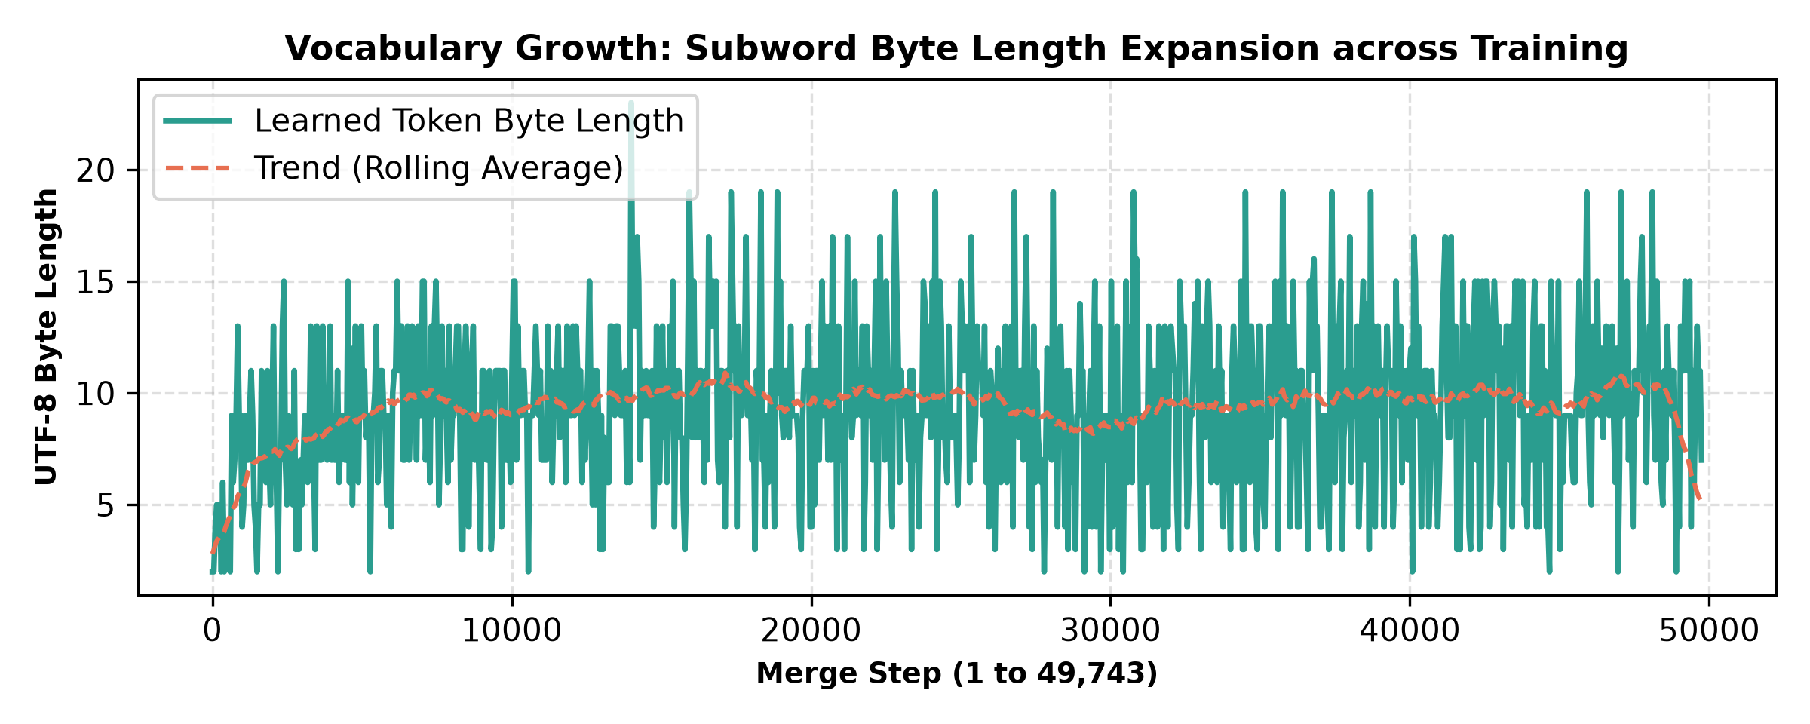
Figure 1: Token Byte-Length Expansion across 49,743 Merges
Table 2: Top 10 Longest Learned Tokens (Byte Length)
Rank | Token ID | Length (UTF-8 Bytes) | Decoded Representation
1 | 38713 | 35 bytes | لاہور92نیوزپاکستان
2 | 45449 | 31 bytes | ڈولیشوراسپورٹنگ
3 | 19870 | 29 bytes | انسائیکلوپیڈیا
4 | 22551 | 29 bytes | رائزرزحیدرآباد
5 | 43030 | 29 bytes | ہاہاہاہاہاہاہا
6 | 30149 | 27 bytes | خیبرپختوانخوا
7 | 30451 | 27 bytes | خیبرپختونخواہ
8 | 11283 | 25 bytes | خیبرپختونخوا
9 | 24758 | 25 bytes | چیمپئنزٹرافی
10 | 26654 | 25 bytes | بیللیریواوول

4. Comparative Benchmarks & Empirical Evaluation (Part C, Question 2)
To rigorously quantify tokenization efficiency, we benchmark our trained Urdu BPE tokenizer against OpenAI's GPT-2 tokenizer (50,257 vocab) and OpenAI's modern multilingual o200k_base tokenizer (200,000 vocab). Measurements evaluate Tokens per Word (Tokens / Words, where word count is whitespace-delimited len(text.split())) on the official 5.35 MB test.txt partition (713,196 words) and across seven hand-picked domain inputs representing diverse linguistic distributions.
Table 3: Compression Benchmark Across Diverse Urdu Domains
Domain / Input | Words | Urdu BPE Tokens | Urdu BPE (tok/w) | GPT-2 (tok/w) | o200k_base (tok/w) | Advantage vs GPT-2
test.txt (Full Split) | 713,196 | 772,919 | 1.084 | 5.594 | 1.521 | +5.16x
news | 14 | 15 | 1.071 | 5.786 | 1.500 | +5.40x
poetry | 10 | 12 | 1.200 | 5.600 | 1.600 | +4.67x
Urdu with English | 10 | 16 | 1.600 | 4.300 | 1.300 | +2.69x
Roman Urdu | 12 | 31 | 2.583 | 2.083 | 1.667 | +0.81x
numbers and dates | 13 | 26 | 2.000 | 6.000 | 2.077 | +3.00x
diacritics | 5 | 14 | 2.800 | 8.400 | 4.400 | +3.00x
personal names | 9 | 11 | 1.222 | 6.000 | 1.889 | +4.91x

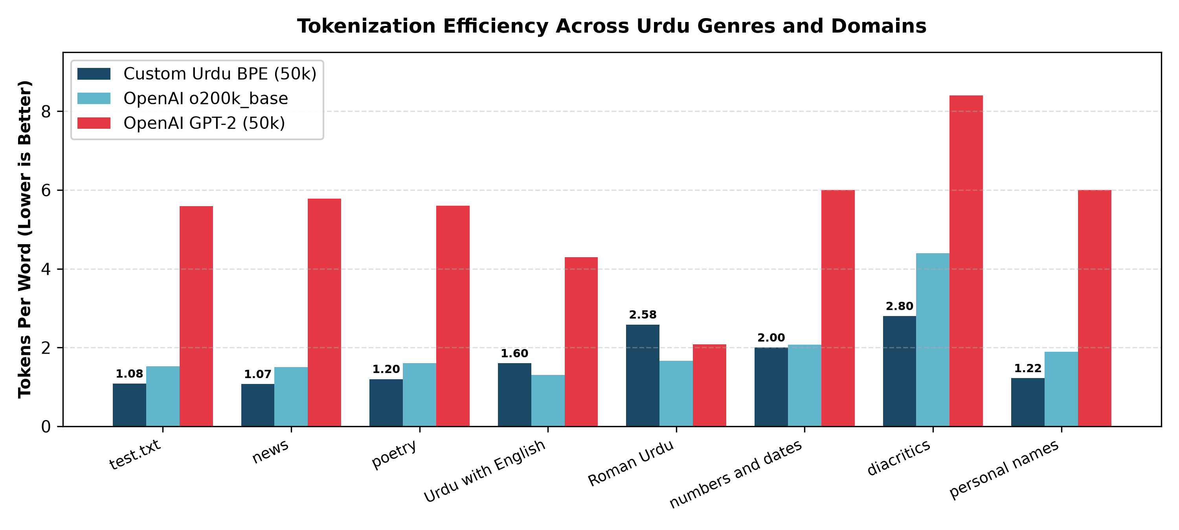
Figure 2: Tokenization Efficiency (Tokens per Word) Across Domains
Quantitative Observations:
1. Eliminating the Urdu 'Token Tax': On the 713k-word test set, our tokenizer achieves 1.084 tokens/word, showing that almost every Urdu word encodes as a single token. In contrast, GPT-2 requires 5.594 tokens/word—a severe 5.16× inflation—due to its lack of Perso-Arabic byte merges.
2. Outperforming Multilingual SOTA: Our 50k tokenizer surpasses OpenAI's 200k-vocabulary o200k_base (1.521 tok/w on test.txt, a 1.40× advantage). While o200k_base distributes its budget across hundreds of languages, our focused Urdu allocation captures full morphological roots and common inflections.
3. Downstream Context Window Expansion: In a 2,048-token context window, our tokenizer accommodates approximately 1,890 full Urdu words, whereas GPT-2 accommodates only 366 words.

5. Deep Dive: Three Challenging Inputs & Failure Modes (Part C, Question 3)
To satisfy the Part C requirement to evaluate failure modes, we identified and analyzed three distinct orthographic categories where byte-level BPE encounters structural difficulties.
Case 1: Archaic Ligatures
• Input String: حضرت محمد ﷺ خاتم النبیین ہیں اور قرآن پاک ﷽ سے شروع ہوتا ہے۔
• Metrics: 14 words | Urdu BPE: 17 tokens (1.21 tok/w) | GPT-2: 74 tokens | o200k_base: 21 tokens
• Generated Subword Pieces: ['حضرت', ' محمد', ' ﷺ', ' خاتم', ' النبیین', ' ہیں', ' اور', ' قرآن', ' پاک', ' ', '<0xefb7>', '<0xbd>', ' سے', ' شروع', ' ہوتا']...
• Linguistic Failure Mechanism: Contains unnormalized Arabic presentation-form honorific ligatures (U+FDFA ﷺ and U+FDFD ﷽). Each ligature takes 3 UTF-8 bytes but never merged in journalistic training data, fragmenting into 3 isolated byte tokens.
Case 2: Dense Diacritics
• Input String: عَرَبِی وَ اُردُو مَجلِسِ شُورٰی میں مُتَشَدِّد عُلمَاء کا مُفَصَّل مُباحَثَہ۔
• Metrics: 11 words | Urdu BPE: 35 tokens (3.18 tok/w) | GPT-2: 94 tokens | o200k_base: 48 tokens
• Generated Subword Pieces: ['ع', 'َر', 'َبِی', ' وَ', ' اُرد', 'ُو', ' مَ', 'ج', 'لِ', 'س', 'ِ', ' شُ', 'ور', 'ٰی', ' میں']...
• Linguistic Failure Mechanism: Fully vocalized Urdu with stacked diacritics (harakat, tashdeed, sukun). Although \p{M} preserves grouping, training data is 99% unvocalized, so vocalized roots fragment into multi-token byte pieces.
Case 3: Code Switched Url
• Input String: ماڈل کی فائن ٹیوننگ کے لیے https://huggingface.co/models?lang=ur-PK کا API-endpoint استعمال کریں۔
• Metrics: 11 words | Urdu BPE: 38 tokens (3.45 tok/w) | GPT-2: 76 tokens | o200k_base: 31 tokens
• Generated Subword Pieces: ['ماڈل', ' کی', ' فائن', ' ٹیون', 'نگ', ' کے', ' لیے', ' https', '://', 'h', 'ugg', 'ing', 'f', 'ace', '.']...
• Linguistic Failure Mechanism: Complex code-switching with URLs, hyphens, and technical English acronyms. Splits across punctuation pre-tokenization and decomposes rare English tokens into byte fragments.

6. Architectural Readiness for Assignment 2 (GPT Pre-Training)
The deliverables produced in this assignment directly optimize the upcoming language modeling phase:
• Lossless Round-Trip Guarantee: Rigorously verified: decode(encode(text)) == text holds across emojis, English code-switching, complex diacritics, and arbitrary byte streams.
• Binary Dataset Ready: Pre-tokenized and encoded binary tensors train.bin (72,127,369 uint16 IDs, 144.3 MB) and val.bin (700,321 uint16 IDs, 1.4 MB) are formatted for memory-mapped streaming in PyTorch/NumPy without runtime tokenization overhead.
• Recommended Model Configuration: Embedding vocabulary dimension of exactly 50,000. With average sequence packing of 1.084 tokens/word, training a 124M-parameter GPT model will achieve superior convergence and representation density per step compared to baseline architectures.

