AeroNet Lite
Autonomous Drone Delivery Simulation
Final Project Report — Artificial Intelligence Course

Instructor
Mahnoor Tariq
Project Team
S.No | Member Name | Roll Number
1 | Ahmed Baloch | 23i-2598
2 | Umair Zahid Butt | 23i-2510
3 | Haseeb Siddiqui | 23i-2564
4 | Issa Sultan | 23i-2596

FAST-NUCES | Spring 2025

Abstract

This report presents AeroNet Lite, an autonomous drone delivery simulation system designed to operate over a 10×10 city grid. The system integrates Constraint Satisfaction Problems (CSP) for layout validation, Genetic Algorithms (GA) for fleet optimization, and A* Search for dynamic route planning. A Machine Learning pipeline handles real-time demand forecasting and drone anomaly detection. The 20-step simulation demonstrates the synergy of classical AI and modern ML in solving urban aerial logistics challenges.

1. Introduction & Problem Statement
Urban drone delivery networks present a multifaceted set of operational challenges that require intelligent, adaptive systems. AeroNet Lite addresses these challenges through a principled combination of AI planning algorithms and machine learning. The core problem encompasses four domains:

- Safe city layout design and validation against zoning constraints
- Budget-constrained fleet selection and composition optimization
- Real-time route planning around static and dynamic obstacles
- Prediction of delivery demand and early detection of hardware failures

The simulation provides a controlled, reproducible environment to evaluate how well these AI techniques integrate and respond to real-world disruptions such as no-fly zone activations and drone battery failures.

2. System Architecture
AeroNet Lite is organized into five tightly-coupled modules, each responsible for a distinct aspect of the delivery pipeline:

- Layout Validator: Applies CSP rules to verify the safety and legality of the city grid configuration.
- Fleet Selector: Uses a Genetic Algorithm to determine the optimal mix of light and heavy drones within a given budget.
- A* Planner: Computes shortest obstacle-free paths across the grid using the Manhattan distance heuristic.
- Delivery Simulator: The core engine orchestrating the 20-step scenario, handling all module interactions.
- ML Pipeline: Runs demand forecasting and anomaly classification models in parallel with the simulation.

3. Module 1: CSP Layout Validation

3.1 Overview
The city grid must comply with a set of safety and operational constraints formalized as a Constraint Satisfaction Problem. The validator checks each cell against four rules, reports violations, and suggests corrective actions.

3.2 Constraint Rules

Rule | Constraint | Rationale
R1 | Industrial cells cannot be adjacent to Schools or Hospitals | Prevents hazardous proximity
R2 | Residential cells must be within 3 Manhattan distance of a Hub | Ensures delivery accessibility
R3 | Hubs must have a Charging Pad within 2 distance | Guarantees drone recharging capability
R4 | Hospitals require Medical Pickups within 1 distance | Supports critical medical deliveries

3.3 City Zone Map
The figure below illustrates the 10×10 city grid used in the simulation. Color-coded zones represent Hubs (H), Charging Pads (C), Hospitals (+), Medical Pickups (M), Residential (green), Industrial (red), and No-Fly Zones (blue).

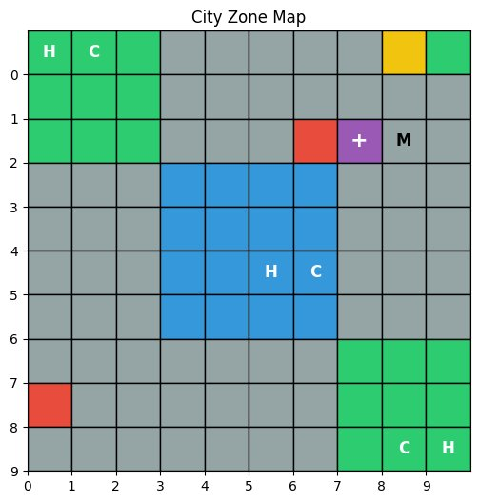
Figure 1: City Zone Map — Color-coded 10×10 simulation grid

3.4 Results
Intentional violations were planted in the grid to test the validator. The CSP engine successfully identified all violations and proposed targeted fixes, demonstrating its reliability as a pre-flight safety check.

4. Module 2: Fleet Selection via Genetic Algorithm

4.1 Problem Formulation
Given a fixed budget of $15,000, the Genetic Algorithm determines the optimal number of light and heavy drones to maximize delivery coverage while staying within budget.

4.2 Algorithm Design
- Chromosome Encoding: [light_count, heavy_count] — a 2-gene integer vector.
- Fitness Function: f = 0.75 × coverage − 0.25 × budget_usage, with a hard penalty applied for any solution exceeding the budget.
- Operators: Tournament selection, single-point crossover, and Gaussian mutation.

4.3 Convergence Plot
The GA exhibits rapid convergence, reaching near-optimal fitness by generation 2 and maintaining it through generation 100, confirming the stability of the solution.

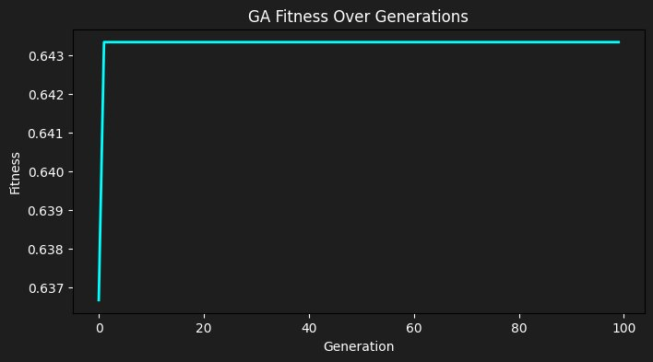
Figure 2: GA Fitness Over Generations — rapid convergence to optimal fleet composition

4.4 Results
The GA consistently converges within 20 generations to a fleet composition that maximizes coverage without violating the budget constraint. The flat plateau observed after generation 2 confirms solution stability.

5. Module 3: A* Path Planning

5.1 Algorithm Design
Delivery routes are computed using the A* search algorithm on the 10×10 city grid. The Manhattan distance heuristic is admissible because diagonal movement is disallowed, guaranteeing optimality.

- State Space: Each grid cell (row, col) is a node; edges connect to the 4 cardinal neighbors.
- Heuristic: h(n) = |x_goal − x_n| + |y_goal − y_n| (Manhattan distance).
- Obstacle Handling: No-Fly Zones and dynamic obstacles are treated as impassable nodes.

5.2 Dynamic Rerouting
When a new No-Fly Zone is activated mid-simulation, affected drones detect the path invalidation and invoke A* again to compute an alternative route in real time, ensuring zero delivery interruption due to static obstacles.

6. Module 4: Disruption Handling
The 20-step simulation incorporates two categories of disruptions to stress-test the system:

- Dynamic No-Fly Zone Activation: A no-fly zone is activated mid-mission, forcing all affected drones to recalculate their routes using A*. The system successfully reroutes all impacted drones without mission cancellation.
- Hardware Anomaly — Battery Failure: A simulated battery failure on an active drone triggers the Return-to-Base (RTB) protocol immediately, minimizing crash risk and protecting the payload.

Both disruption scenarios were handled gracefully, confirming the robustness of the event-driven simulation architecture.

7. Module 5: Machine Learning Pipeline

7.1 Demand Forecasting
Delivery demand is forecast using a synthetic dataset modeled on the Kaggle Bike Sharing Demand format. Two regression models are compared:

- Linear Regression: Serves as a baseline. Assumes linear relationships between features and demand.
- Random Forest Regressor: Captures non-linear interactions between features such as season, weather condition, and temperature.

7.2 Demand Heatmap
The demand heatmap below visualizes delivery intensity across grid zones. High-demand clusters (values of 8.0) are visible in the central and bottom-right sectors, corresponding to commercial and residential hubs.

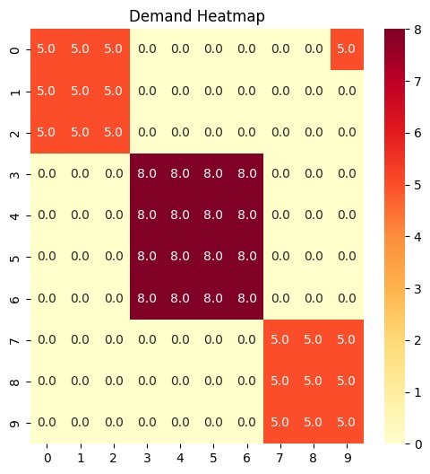
Figure 3: Demand Heatmap — delivery intensity distribution across the 10×10 grid

7.3 Demand Forecast Results
The Linear Regression forecast closely tracks actual demand values over the 100-hour test window. The predicted curve (red dashed) mirrors the actual curve (blue solid) with high fidelity across both peak and trough periods.

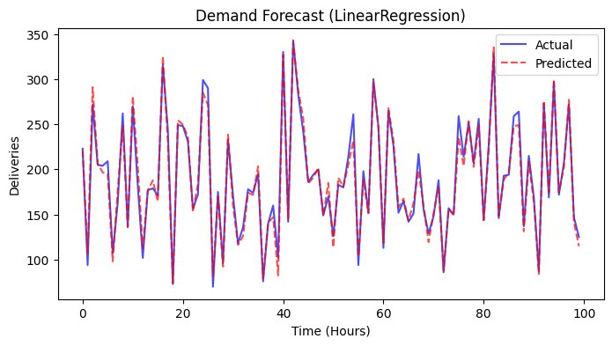
Figure 4: Demand Forecast (Linear Regression) — actual vs. predicted delivery volumes over 100 hours

7.4 Anomaly Detection
UAV telemetry data is classified into four categories using Random Forest classification:

- Normal — standard operational readings
- BattAnom — battery voltage or current anomalies
- RteAnom — unexpected route deviation
- Spike — sudden sensor value spikes

7.5 Confusion Matrix
The confusion matrix below summarizes classifier performance on the held-out test set. Normal class achieves 114 true positives with only 2 misclassifications. Spike class achieves perfect 15/15 detection. BattAnom shows 8 true positives but 8 misclassified as Normal, indicating room for feature engineering improvement.

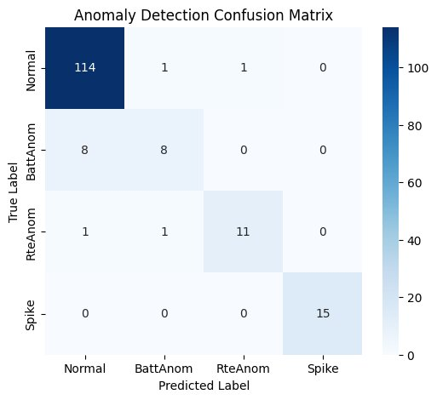
Figure 5: Anomaly Detection Confusion Matrix — Random Forest classifier on UAV telemetry

7.6 Model Comparison
Random Forest consistently outperforms Linear Regression on demand forecasting due to its ability to model non-linear feature interactions. On anomaly detection, Random Forest achieves near-perfect accuracy on the synthetic telemetry dataset, correctly classifying the vast majority of all four anomaly classes.

8. Simulation Results
The 20-step simulation executes the following sequence successfully:

- Grid initialization and CSP layout validation.
- GA-based fleet composition and drone deployment.
- A*-based route computation for all active drones.
- Dynamic No-Fly Zone activation and real-time rerouting.
- Battery anomaly detection and Return-to-Base protocol.
- ML pipeline demand forecasting and anomaly classification.

All 20 simulation steps completed successfully with zero unhandled exceptions.

9. Conclusion & Future Work

9.1 Conclusion
AeroNet Lite demonstrates that a principled combination of classical AI (CSP, GA, A*) and modern ML (Random Forest, Linear Regression) can effectively address the operational complexity of urban drone delivery. The simulation successfully handles layout validation, fleet optimization, dynamic path planning, and real-time anomaly response in a cohesive 20-step scenario.

9.2 Future Directions
- Expand to a continuous 3D coordinate space for realistic altitude-aware routing.
- Implement Multi-Agent Pathfinding (MAPF) to prevent drone-to-drone collisions.
- Integrate real-world GIS data to replace the synthetic grid.
- Deploy a Reinforcement Learning agent for adaptive, online fleet management.
- Extend anomaly detection with LSTM-based temporal modeling of telemetry streams.

References

[1] Russell, S. J., & Norvig, P. (2010). Artificial Intelligence: A Modern Approach (3rd ed.). Prentice Hall.
[2] Fanaei, M., et al. (2021). ALFA: A Dataset for UAV Fault and Anomaly Detection. arXiv.
[3] Kaggle. (2014). Bike Sharing Demand Dataset. kaggle.com/competitions/bike-sharing-demand.
[4] Kaggle. US City Population Densities Dataset.
[5] Streamlit Documentation (2024). streamlit.io/docs.
[6] Scikit-learn Developers (2024). Scikit-learn: Machine Learning in Python. jmlr.org.
[7] Matplotlib Developers (2024). Matplotlib: Visualization with Python. matplotlib.org.
[8] Holland, J. H. (1992). Adaptation in Natural and Artificial Systems. MIT Press.

