**Examica**

A Documentation Submitted to the

Information Technology Institute

In Partial Fulfillment of the

Requirements for the Professional Training Program

(9 Months Diploma- Intake39)

Web Development and User Interface

**Examica**

By: Omar Zayed, Aya Elnahas, Dina Gamal, Fatma Alaa, Hassnaa Ayman, and Sara Elsayed

Under the Supervision of

Eng. Ahmed Adel Eldomairy

Eng. Menna Shata

Table of Contents

Table of Contents ……………………………………………………………………

Acknowledgement …………………………………………………………………...

Abstract ………………………………………………………………………………

CHAPTER 1 INTRODUCTION 7

1.1. Project description 7

1.2. Stakeholders 7

1.3. Constraints 7

1.4. Risks 7

1.5. Resources 7

CHAPTER 2 SYSTEM MANAGEMENT PLAN 8

2.1. System Overview 8

2.2. System Features 8

2.3. Roles 9

2.3.1. General User 9

2.3.2. Owner 9

2.3.3. Admin 9

2.3.4. Examiner 9

2.3.5. Examinee 9

CHAPTER 3 SYSTEM WORK FLOW 11

3.1. General User 11

3.1.1. Home 11

3.1.2. Login 12

3.1.3. Register 12

3.1.4. Contact us 12

3.1.5. About us 13

3.1.6. Pricing Plans 13

3.1.7. Register Organization 14

3.2. Owner 16

3.2.1. Register Organization 16

3.2.2. Assign Roles 16

3.3. Admin 17

3.3.1. Add Users 17

3.3.2. Assign Roles 18

3.4. Examiner 17

3.4.1. Add Exams 17

3.4.2. Add Questions To The Bank 18

3.5. Examinee 17

3.5.1. Edit Profile 17

3.5.2. Take Exams 18

CHAPTER 4 TECHNICAL DESIGN 19

4.1. BackEnd 19

4.2. FrontEnd 19

CHAPTER 5 TECHNICAL TOOLS 20

5.1. BackEnd 20

5.2. FrontEnd 21

CHAPTER 6 FUTURE WORK 23

Acknowledgments

First of all, we want to thank ALLAH for everything; for supporting us in every moment, helping and giving us the patience, strength and ability to manage our resources to launch “Examica”. Then, we would like to thank our parents, for their support, encouragement, quiet patience and their constant prayers for us.

We would like also to express our sincere gratitude and appreciation for our supervisor **Eng. Ahmed Adel Eldomairy** for the continuous support, patience and motivation throughout the past 9 months to make this project the best it can be.

We would also like to thank **Eng. Menna Shata**, for her unconditional support and for taking the time to demonstrate the workflow needed to be shown in Examica.

Thanks are extended to all the engineers in our department, who taught us directly in lectures or by mere communication. Knowing you has enriched us technically and personally.

Abstract

The requested level of knowledge is continuously increasing and education of employees or students is essential for achieving the required level at any organization.

Testing knowledge is an important segment in a process of managing human resources, whether it is a question of entrance testing of a candidate for employment or testing the level of knowledge of persons already employed or even students in colleges or schools. Results of those tests are the basis for management’s decision making and support to the process of placing the right person on the right position.

We as a team elaborated the system that administers the test of knowledge by creating a software that will enable organizations to easily setup a customized exam with multiple question types and invite the users they want to test, it will also auto correct the exams and hands out an endless number of certificates. In this way, the complete process of testing is covered by means of only one tool and all its elements are put under control.

**CHAPTER 1**

**INTRODUCTION**

**1.1. Project description**

Examica is a software service that enables you as an organization to easily setup a customized exam with multiple question types and invite the users you want to test to take it, it also auto correct the exams for you and hands out endless number of certificates.

1.2. Stakeholders

* Owner.
* Admin.
* Examiner.
* Examinee.

1.3. Risks

* Server failure.
* Competitors.

1.4. Constraints

* Create friendly interface, easy to interact with.
* Secure organizations data.
* Time shortage

1.5. Reources

* React Js.
* C#.
* ASP .NET Core API.
* SQL Server.

**CHAPTER 2**

**SYSTEM MANAGEMENT PLAN**

**2.1. System Overview**

Examica is a software service that enables you as an organization to easily setup a customized exam with multiple question types and invite the users you want to test to take it, it also auto correct the exams for you and hands out endless number of certificates.

**2.2. System Features**

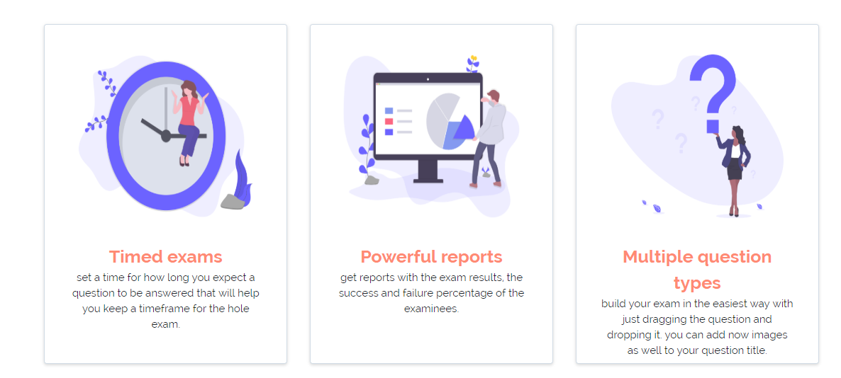

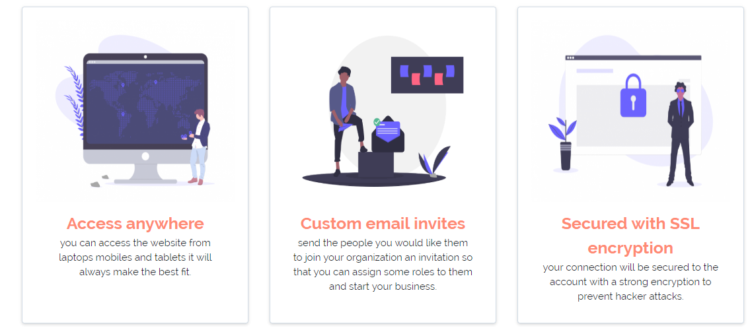

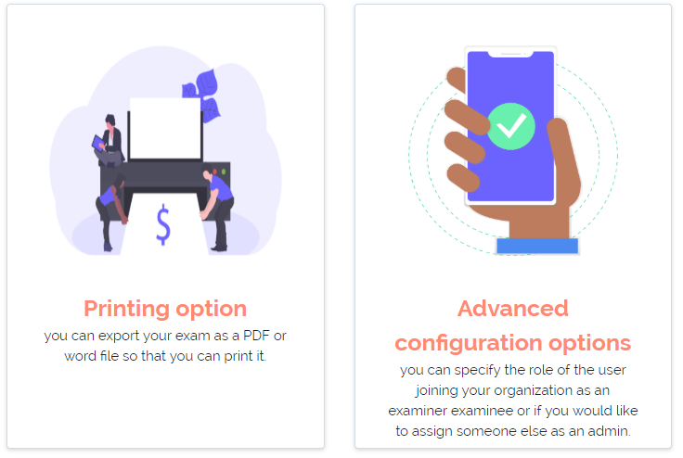

**2.3. Roles**

Examica has 5 main roles:-

**2.3.1.** **General User**

* Navigate in the website public pages.
* Free trial.
* Sign up first.

**2.3.2. Owner**

* Register one or more organizations.
* Assign roles.

**2.3.3. Admin**

* Assign roles except for owner.
* Edit organization details.

**2.3.4. Examiner**

* Add exams.
* Add questions to the pool.

**2.3.5. Examinee**

* Take exams.
* Edit his profile.

**CHAPTER 3**

**SYSTEM WORK FLOW**

**3.1. General User**

3.1.1. Home

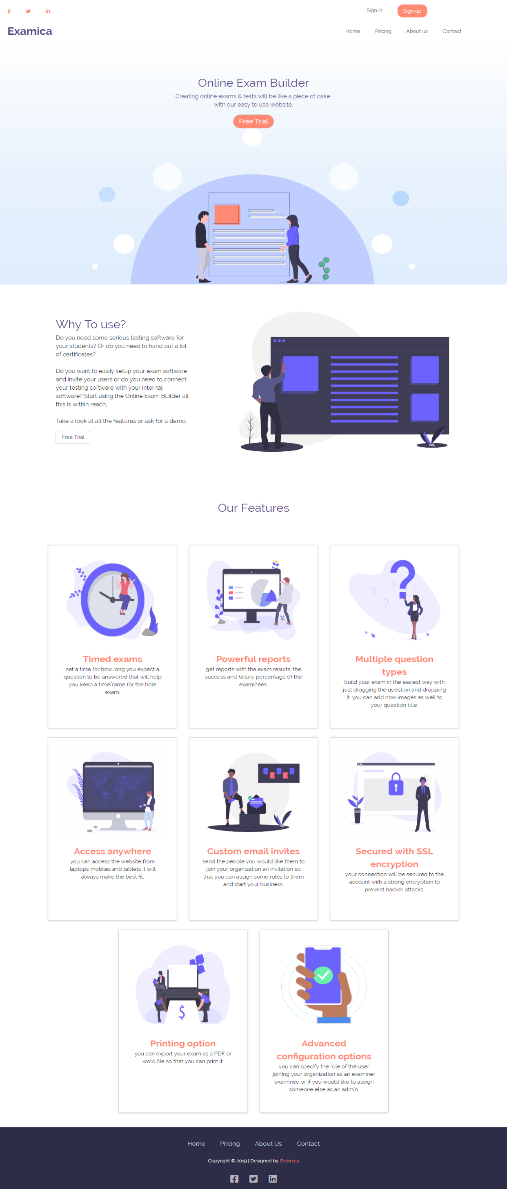

3.1.2. Login

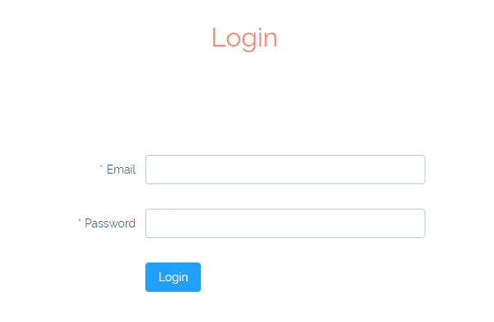

3.1.3. Register

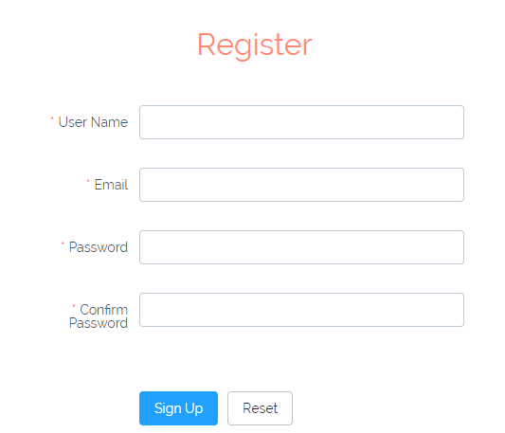

3.1.5. Contact us

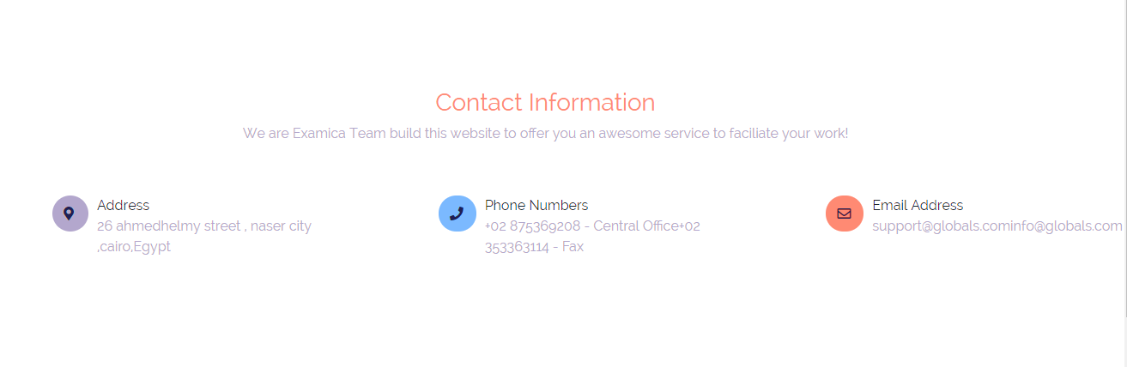

3.1.4. About us

3.1.6. Pricing Plans

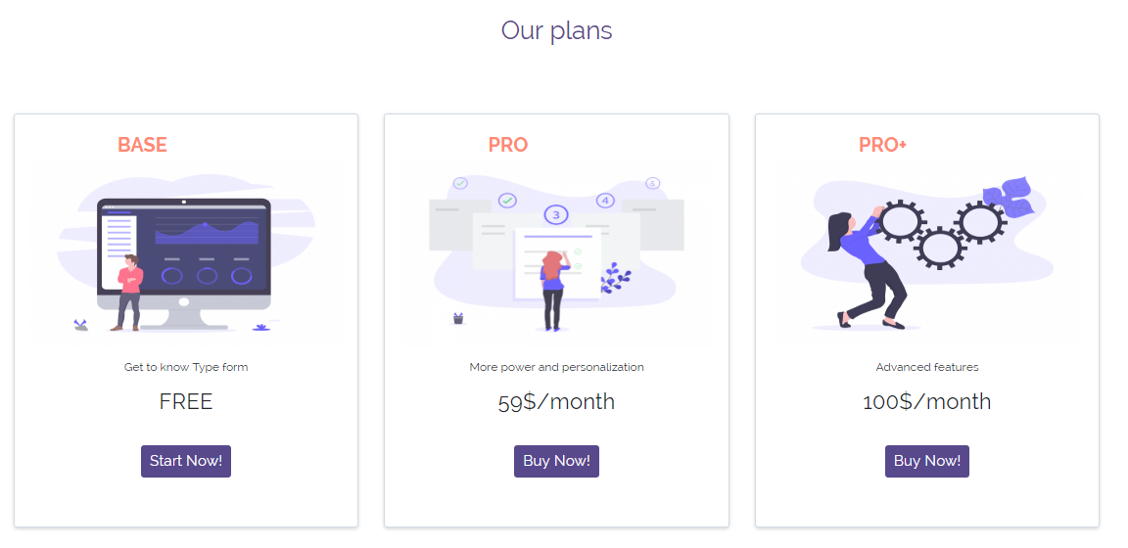

**3.2. Owner**

3.2.1. Register Organization.

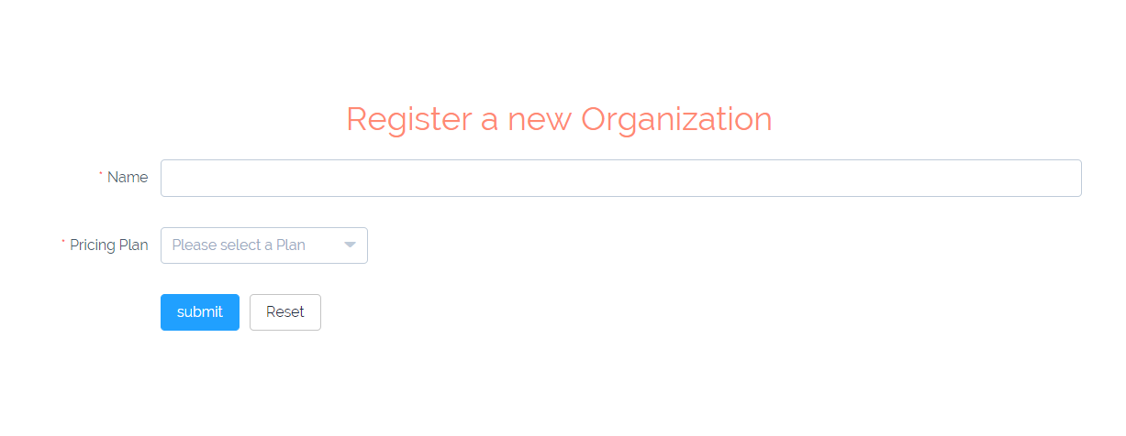

3.2.2. Assign Roles.

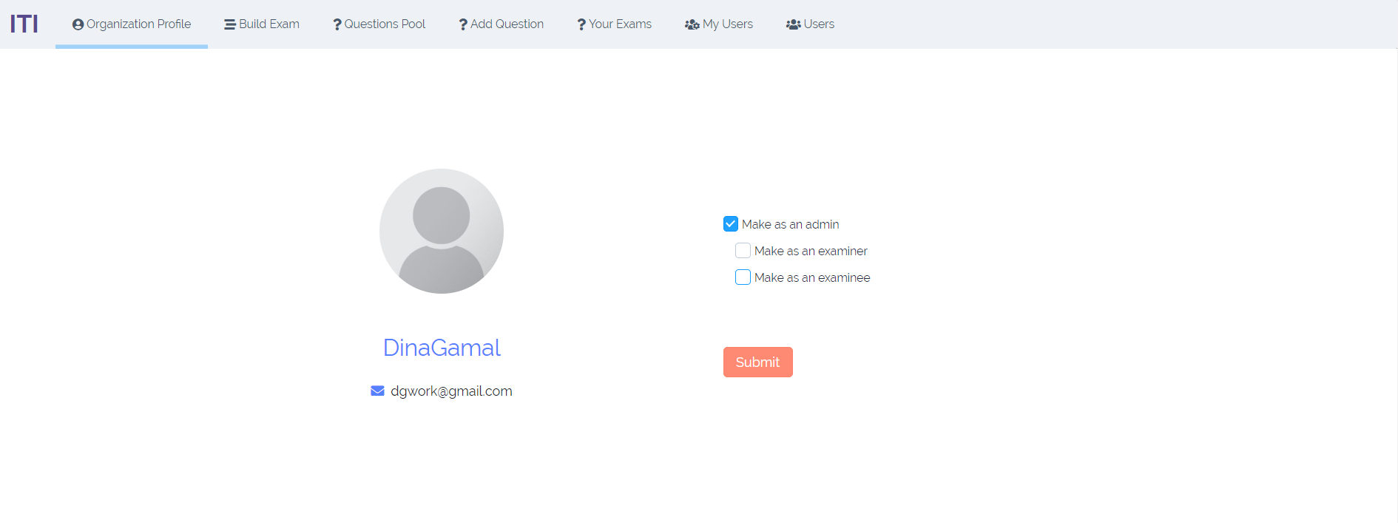

**3.3. Admin**

3.3.1. Add Users.

3.3.2. Assign Roles.

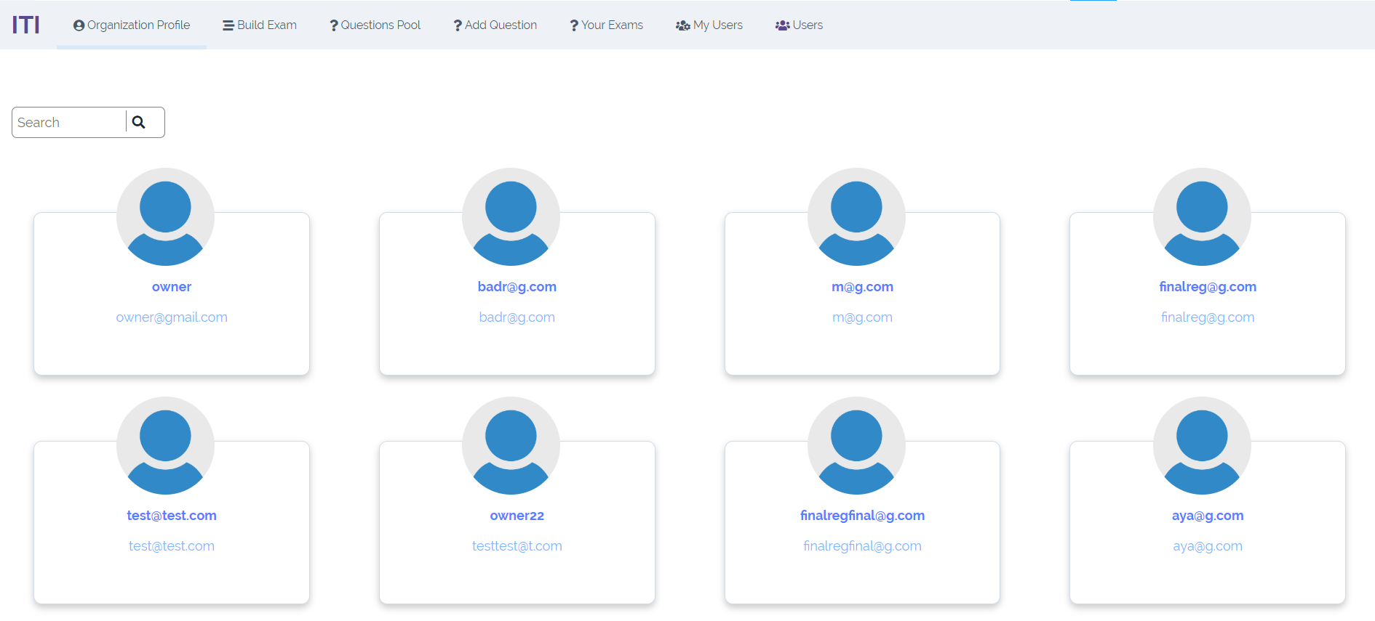

**3.4. Examiner**

3.4.1. Add Exams.

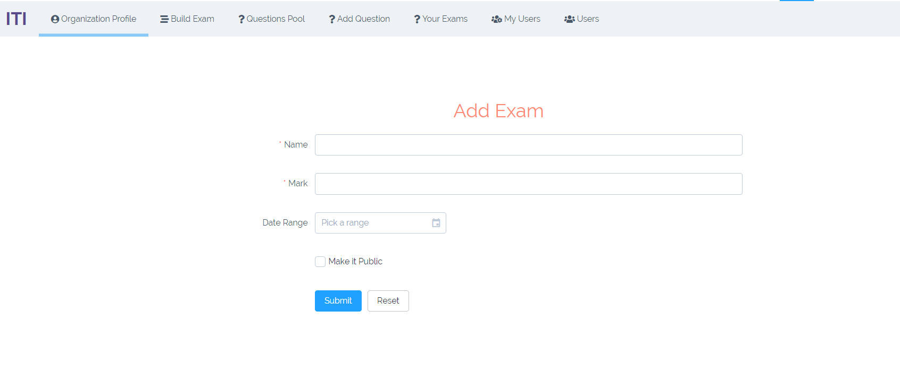

3.4.2. Add Questions To The Bank.

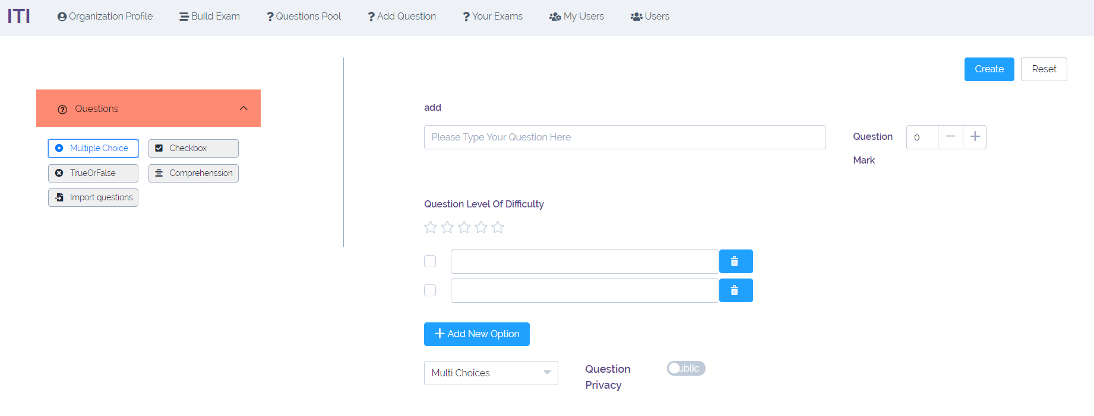

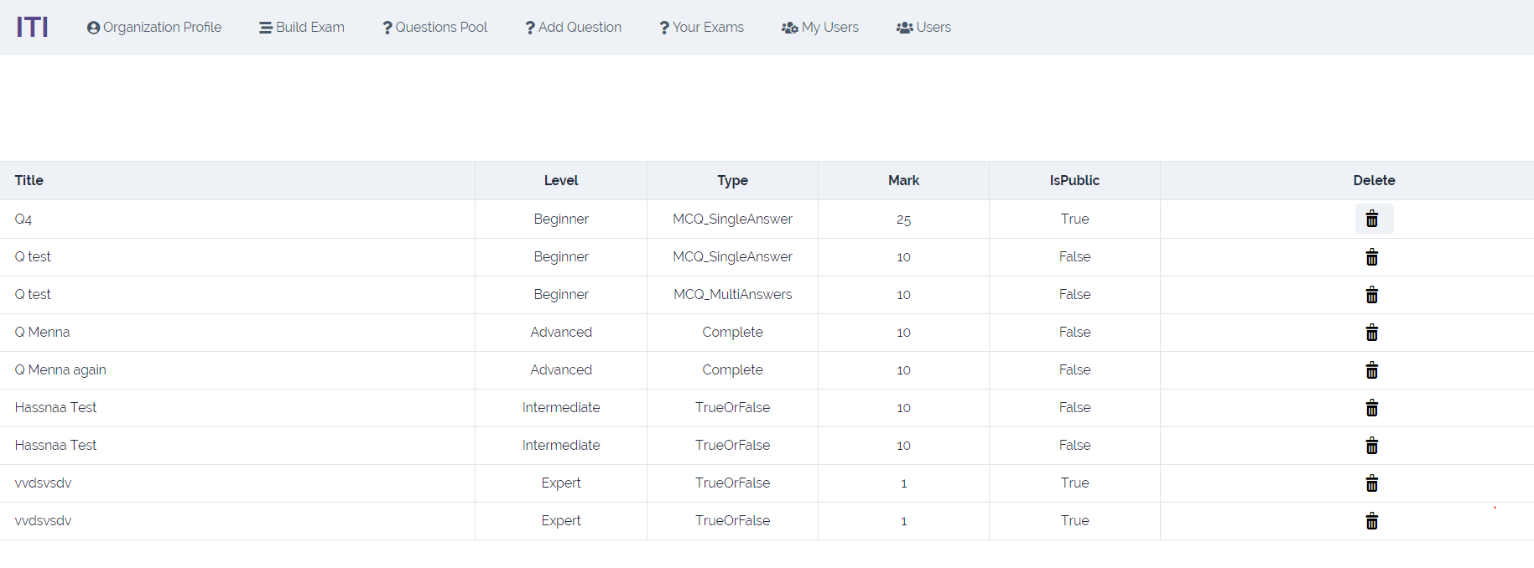

**3.5. Examinee**

3.5.1. Edit Profile.

3.5.2. Take Exams.

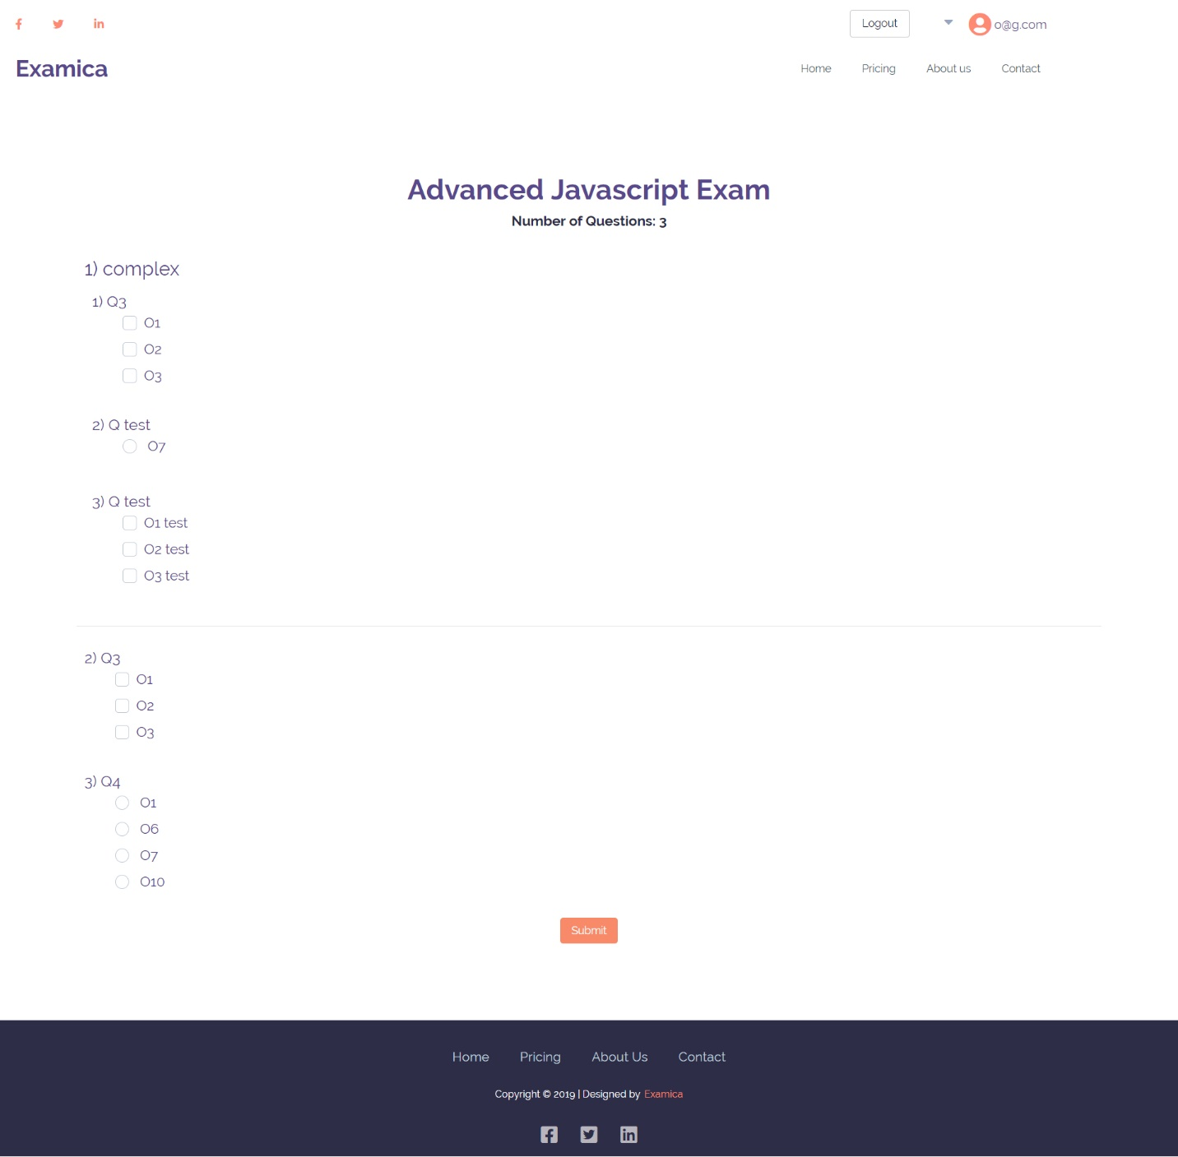

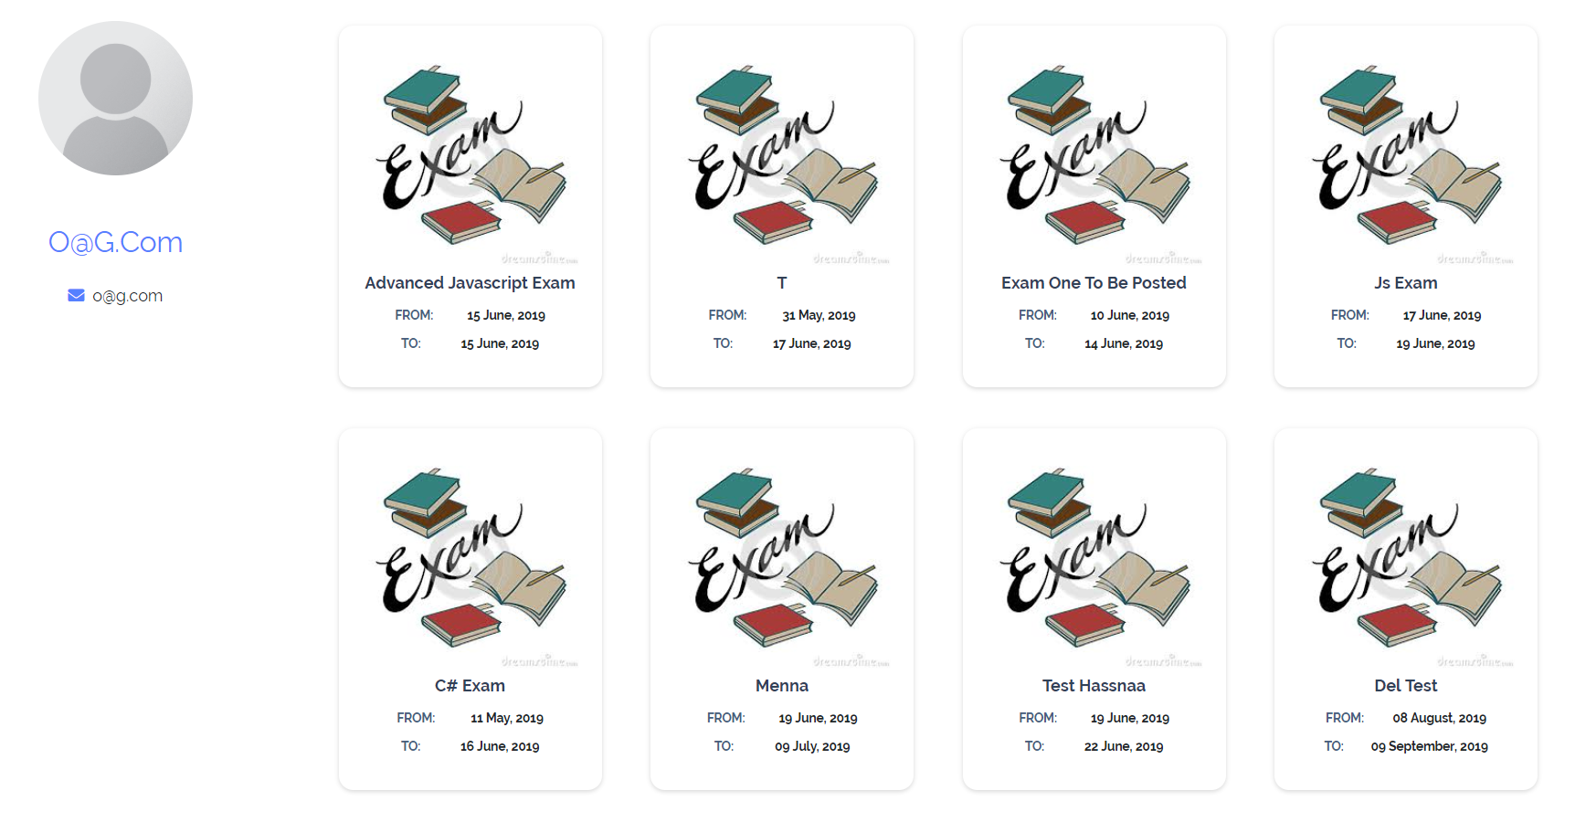

**CHAPTER 4**

**TECHNICAL DESIGN**

**4.1. Backend**

* Structure:
  + Project is separated into 2 parts Model and API to leverage usability and OOP.
* Design/Architectural Pattern:
  + Model: Repository with Unit Of Work DP.
  + API: ASP .NET Core API.



**4.2. Frontend**

* React JS:
  + Create React App (CRA).
  + React Router Dom.
  + Element UI.

**CHAPTER 5**

**TECHNICAL TOOLS**

**5.1. Backend**

Development Tools:

* Visual Studio 2017.
* SQL Server Management Studio.
* Visual Studio Code.

**5.2. Frontend**

For Communications:

* GitHub.
* Zoom Meeting.
* Trello (Agile).









**CHAPTER 6**

**FUTURE WORK**

* Add more question types with images titles along with texts.
* Generate Reports.
* Auto generated exams with random questions.
* Add Observer role to correct the essay questions.

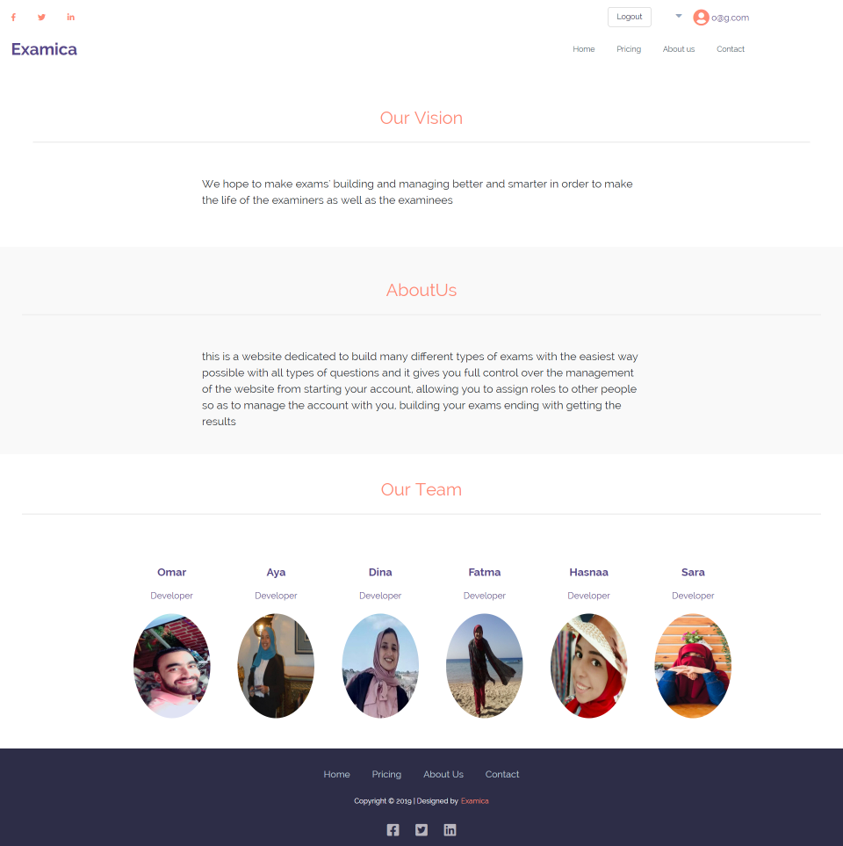

Org

