Banker's Algorithm

Deadlock Avoidance in OS

Course Project Report

Project Team

M.Hassnain 24k-3020
Haseeb Khalid 24k-0003
Syed Khalid Ali Abidi 24k-3005

Supervised by
Sir Syed Faisal Ali
BANKER'S ALGORITHM

Objective

The objective of this project is to design and implement a dynamic resource allocation simulator based on the Banker's Algorithm — a classical deadlock avoidance algorithm in operating systems. The simulator models real-world OS behaviour by managing processes, resource types, and allocation states, and by ensuring the system never enters an unsafe state that could lead to a deadlock.

Specifically, the project aims to:
- Implement the complete Banker's Algorithm in the C programming language
- Simulate runtime resource requests with safe/unsafe state detection
- Provide interactive features for requesting, checking, and logging system states
- Visualize the rollback mechanism when an unsafe request is detected
- Measure and report the performance of the safety checking algorithm
- Log all system state events persistently using UNIX system calls

Introduction

In a multiprogramming operating system, multiple processes compete for a finite set of resources such as memory, CPU time, I/O devices, and semaphores. When two or more processes are each waiting for a resource held by the other, and none can proceed, the system reaches a state called a deadlock. Deadlocks are one of the most critical problems in operating system design because they cause the entire system — or a subset of processes — to freeze indefinitely.

There are three primary strategies for dealing with deadlocks:

Prevention: Eliminate one of the four necessary conditions for deadlock at system design time. Highly restrictive and often impractical.

Detection & Recovery: Allow deadlock to occur, detect it using resource allocation graphs or wait-for graphs, then recover by killing processes or preempting resources. Costly in recovery.

Avoidance: Before granting any resource request, verify that the resulting system state remains safe. The Banker's Algorithm implements this approach

This project implements the Avoidance strategy using the Banker's Algorithm, originally developed by Edsger Dijkstra. The algorithm treats the operating system as a banker who grants loans (resources) only when doing so does not jeopardize the bank's ability to serve all future customers (processes).

Background

1. Deadlock Conditions:
A deadlock can occur only when all four of the following conditions hold simultaneously:
- Mutual Exclusion — at least one resource must be held in a non-shareable mode
- Hold and Wait — a process holding at least one resource is waiting to acquire additional resources
- No Preemption — resources cannot be forcibly taken from a process; they must be released voluntarily
- Circular Wait — a circular chain of processes exists where each process waits for a resource held by the next

2.The Banker's Algorithm:
The Banker's Algorithm works by maintaining four key data structures at all times:

Available[m] | A vector of length m indicating the number of available resources of each type
Maximum[n][m] | An n×m matrix defining the maximum demand of each process for each resource type
Allocation[n][m] | An n×m matrix defining the number of resources of each type currently allocated to each process
Need[n][m] | An n×m matrix indicating the remaining resource need of each process. Computed as: Need[i][j] = Maximum[i][j] - Allocation[i][j]

3.Safe State vs Unsafe State:
A system state is considered safe if there exists at least one sequence of all processes — called a safe sequence — such that for each process in the sequence, the resources it still needs can be satisfied by the currently available resources plus the resources held by all processes that come before it in the sequence.

Safe State: A safe sequence exists → deadlock cannot occur
Unsafe State: No safe sequence exists → deadlock MAY occur

Important: An unsafe state does NOT mean deadlock has occurred.
It means the system cannot guarantee that all processes will eventually complete.

Platform and Languages

Programming Language | C (C99 standard)
Operating System | Linux / Unix-based (Ubuntu compatible)
Compiler | GCC (GNU Compiler Collection)
Compilation Command | gcc banker_algorithm.c -o banker
Execution Command | ./banker
File I/O Method | UNIX system calls: open(), write(), close() — as taught in OS course
Timing Method | clock() from time.h — measures CPU time for performance analysis
Random Generation | rand() with srand(time(NULL)) seed — for randomized request testing
Boolean Support | stdbool.h — provides bool, true, false in C
Log Output | logs.txt — persistent file written using O_WRONLY | O_CREAT | O_APPEND flags

Methodology

1.System Architecture:
The project is structured as a single C file with clearly separated functions, each responsible for one specific task. All data is stored in global arrays so every function can access and modify the system state without complex pointer passing.

Program Flow:
main() → input() → print() → safety_algorithm() [initial check]
→ menu loop:
Case 1: request_resource() → safety_algorithm() → log_state()
Case 2: print()
Case 3: safety_algorithm() → log_state()
Case 4: random_request() → request_resource() → safety_algorithm() → log_state()
Case 5: rollback() → safety_algorithm() → log_state()
Case 6: performance_report()
Case 7: exit()

- Mandatory Features Implemented:

Feature M1 — Resource Type Representation
Resources are represented as integer arrays and 2D matrices declared globally. The system supports up to 50 processes and 50 resource types, defined by compile-time constants max_process and max_resource.

Feature M2 — Allocation, Maximum, and Need Matrices
Three n×m matrices track the complete resource state. The need matrix is automatically computed as need[i][j] = maximum[i][j] - allocated[i][j] after reading input. If any need value is negative — meaning allocated exceeds declared maximum — the program immediately exits with an error message.

Feature M3 — Safety Algorithm
The safety_algorithm() function implements the classical Banker's safety check. It uses a temporary work[] array (copy of available) and a finish[] boolean array. It iteratively finds processes whose needs can be satisfied by the current work vector, simulates their completion, adds their allocation back to work, and marks them finished. If all processes finish, the state is safe and the safe sequence is returned.

Feature M4 — Request Handling Logic
The request_resource() function processes runtime resource requests in four steps: validate request does not exceed declared need, validate request does not exceed available resources, perform pretend allocation on all three matrices, run the safety algorithm on the new state, and either grant permanently or rollback completely.

Feature M5 — Deadlock Avoidance Verification
Every resource grant is preceded by a safety check. The system guarantees that no resource is permanently allocated if doing so would move the system into an unsafe state. This is the core guarantee of the Banker's Algorithm.

- Additional Features Implemented:

Feature A1 — Interactive Input Menu
A persistent while(1) menu loop in main() keeps the program running until the user explicitly exits. Users can make multiple requests, check system state, and use all features in a single session without restarting.

Feature A2 — Logging Safe/Unsafe States
The log_state() function writes every state event to logs.txt using UNIX system calls (open, write, close). snprintf is used instead of sprintf for safe buffer management. The file uses O_APPEND mode so all entries accumulate without overwriting previous records.

Feature A3 — Randomized Resource Requests
The random_request() function automatically generates valid resource requests. It first builds an eligible[] list of processes that still have non-zero need, then selects a random process from that list. Request values are generated as rand()%(need[pid][j]+1) — ensuring values are always within valid range and never cause division by zero. srand(time(NULL)) is called once in main() to ensure different results each run.

Feature A4 — Rollback Simulation
The rollback() function makes the Banker's Algorithm mechanism visible. It prints the complete system state before the request, saves backups of all three matrices, performs pretend allocation, prints the state after allocation, runs the safety check, and if unsafe, restores from backups and prints the restored state — showing the entire rollback process step by step.

Feature A5 — Performance Analysis
Four global counters track total_request, grant_request, deny_request, and t_time. The clock() function wraps every safety_algorithm() call to measure CPU time. The performance_report() function displays all counters and calculates average time per safety check, with a guard against division by zero when no requests have been made.

Results

- Test Data Used:

Standard Test Input:
Processes: 5 Resources: 3

Available: 3 3 2

Maximum Matrix: Allocation Matrix: Need Matrix:
P0: 7 5 3 P0: 0 1 0 P0: 7 4 3
P1: 3 2 2 P1: 2 0 0 P1: 1 2 2
P2: 9 0 2 P2: 3 0 2 P2: 6 0 0
P3: 2 2 2 P3: 2 1 1 P3: 0 1 1
P4: 4 3 3 P4: 0 0 2 P4: 4 3 1

Expected Safe Sequence: P1 → P3 → P0 → P2 → P4

- Test Scenarios and Results:

Test Case | Request | Result | Reason
Initial state check | None | SAFE | Safe sequence exists: P1→P3→P0→P2→P4
P1 requests [1,0,2] | [1, 0, 2] | GRANTED | Request valid, state remains safe after allocation
P4 requests [3,3,0] | [3, 3, 0] | DENIED | Would create unsafe state — rolled back
P0 requests [7,4,3] | [7, 4, 3] | DENIED | Exceeds available resources — process must wait
P1 requests [5,5,5] | [5, 5, 5] | DENIED | Exceeds declared maximum need — process lied
Random request | Auto-generated | VARIES | Eligible process selected, valid request generated
Rollback simulation | Unsafe request | VISIBLE ROLLBACK | Before/after states shown, matrices restored

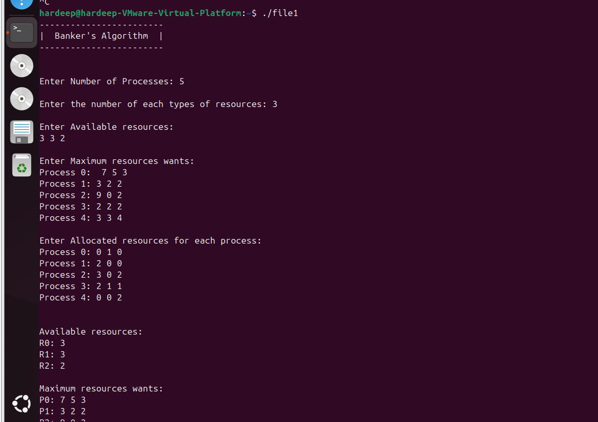

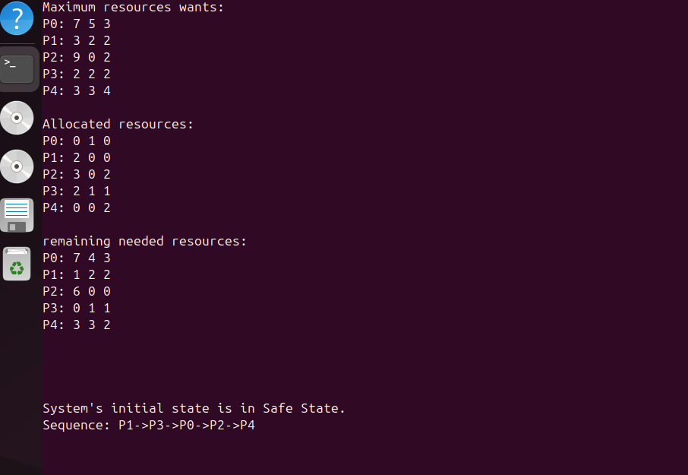

Test Case 2 (Safe Request)
Process P1 requested resources [1, 0, 2].Safety check found the sequence P1→P3→P4→P0→P2.
Output:

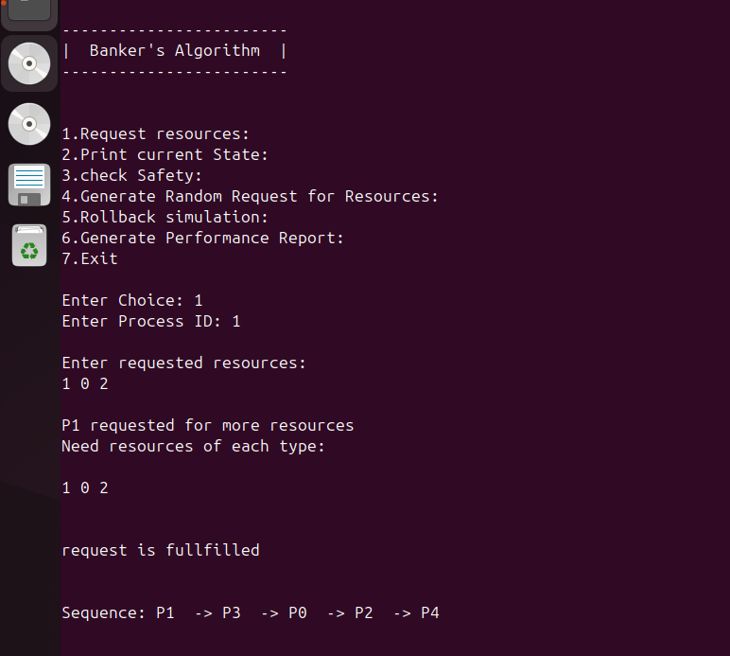

Test Case 3 (Unsafe Request Rollback)
Process P1 requested [2, 3, 3] . Not Safe.
Output:

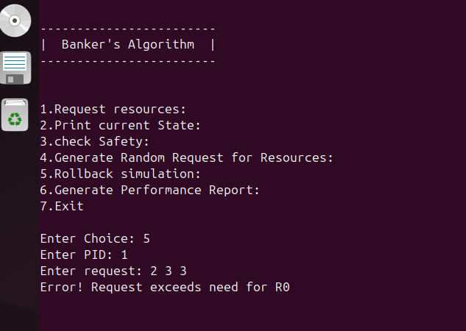

Test Case 4 (Generate Random Request)
Output:

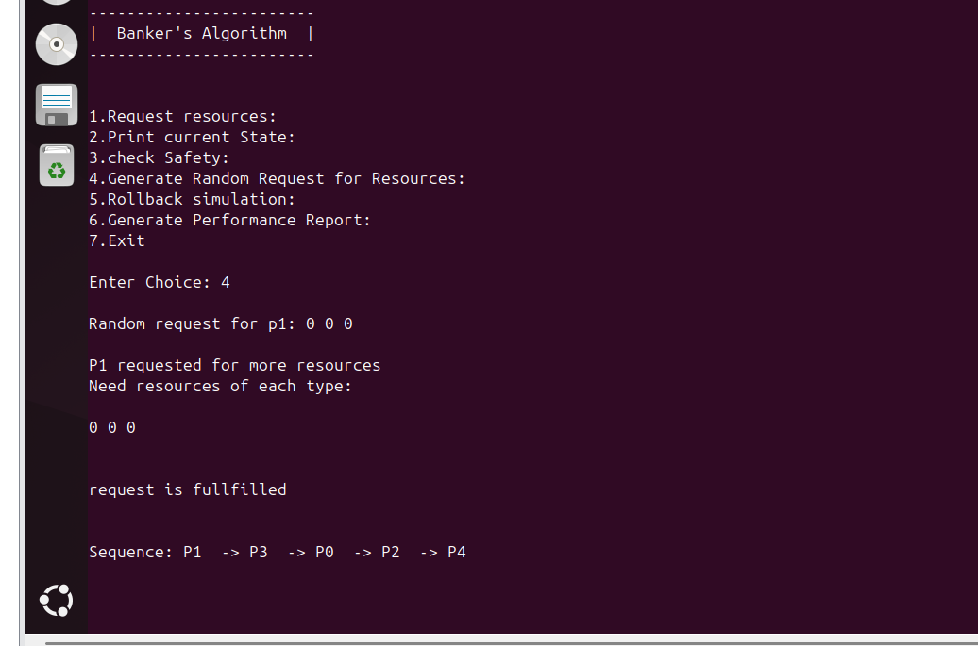

Test Case 5 (Generate Performance Report)
Output:
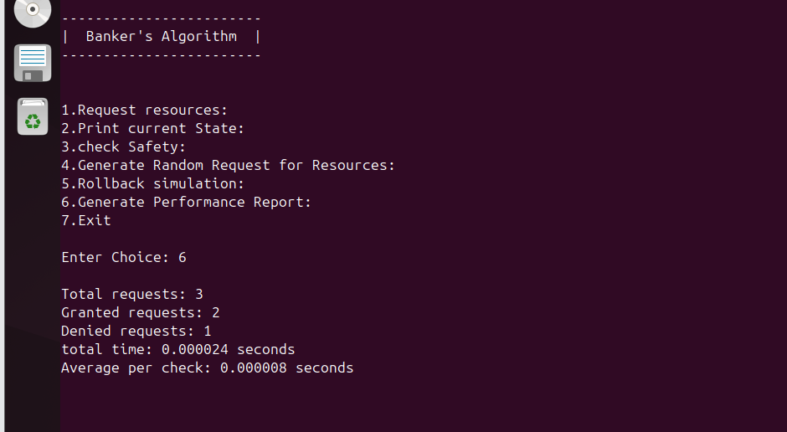

Conclusion

This project successfully implements the Banker's Algorithm for deadlock avoidance in the C programming language. The simulator demonstrates the core principles of operating system resource management — specifically how a safe state can be maintained at all times by verifying each resource request before granting it.

The mandatory features — resource representation, matrix management, the safety algorithm, and request handling — are fully implemented and tested. The five additional features — interactive menu, UNIX-based logging, randomized requests, rollback visualization, and performance analysis — extend the simulator beyond the basic requirements to produce a comprehensive, educational tool.

Key takeaways from this project:
- The Banker's Algorithm guarantees deadlock-free operation by never allowing the system to enter an unsafe state
- The rollback mechanism is the most critical implementation detail — pretend allocation followed by safety check followed by restore or commit
- UNIX system calls provide direct, low-level file I/O that is more efficient and OS-appropriate than standard C library functions for logging
- Performance analysis shows that the safety algorithm runs in near-zero time for small systems, confirming its practical viability
- The eligible process selection in randomized requests prevents the edge case where processes with zero need monopolize the random selection

A known limitation of this simulator is that processes never complete and release their resources — in a real OS, a process that has received all its needed resources would eventually finish and return them to the available pool. This feature was identified as future work for extending the simulator into a more complete OS resource management model.

