AI PROJECT DESIGN & DEVELOPMENT LAB 02

Submitted By: Hassan Bin Saqib
Roll No.: 231170

Submitted To: Sir Farhan
Date: 4th Oct, 26

Dept of Creative Technologies (AI)
AIR UNIVERSITY ISLAMABAD

Task 1 Functional and Non Functional Requirements
Scenario: a smart attendance system recognizes registered students at the classroom entrance and records attendance. A teacher reviews uncertain matches. These are proposed targets. Markdown deliverable: lab-02/requirements.md.
Functional requirements
ID | Requirement | Simple acceptance check
FR1 | An admin can enroll a student using their ID, name and consented face images. | The enrolled student appears in the class roster.
FR2 | The system detects faces in the camera feed and compares them with enrolled students. | A known student is matched; an unknown face is marked unknown.
FR3 | It records student ID, class, date and time for a recognized student. | A timestamped attendance record is saved.
FR4 | It avoids duplicate attendance for the same student in the same class session. | Two detections produce one attendance record.
FR5 | The teacher can review, correct and export attendance; offline records sync when the connection returns. | An edited record appears in the export and pending records sync without duplicates.

Non functional requirements
ID | Requirement | Proposed target
NFR1 | Attendance should appear promptly after a usable face is captured. | Within 2 seconds on the chosen device.
NFR2 | Camera processing should remain responsive. | At least 5 processed frames per second at 640 x 640.
NFR3 | Recognition should be reliable on a held-out, consented test set. | At least 95% correct identity decisions and below 1% false acceptance.
NFR4 | Student records and face data must have restricted access. | Only authorized admins and teachers can access records; encrypt stored face data.
NFR5 | The system should fit a modest classroom computer. | At most 2 GB application RAM and 15 W average power on a selected edge device.

Task 2 System Boundary and Input Output Mapping
Scenario: a classroom camera flags visible phones and suspicious activity for teacher review. Final disciplinary decisions stay outside the software.
Actor | Persona and responsibility
Teacher / operator | Supervises an exam, sees alerts and confirms or dismisses them.
Admin | Configures the camera, allowed objects, alert thresholds and access.
Camera / automated trigger | Supplies frames; detection and timing rules trigger candidate events.

Inside the system | Outside the system
Frame capture, preprocessing, object inference, filtering, event logging and alert display. | Camera hardware, classroom network and storage hardware.
Configuration loading and teacher review records. | Final disciplinary decisions, student identity verification and university policy.

Input | Format and meaning
Classroom video | USB camera index 0 or an RTSP URL; 1280 x 720 BGR frames at up to 15 FPS.
Camera metadata | Camera ID and capture timestamp attached to each frame.
Settings | JSON confidence threshold 0.65, target classes person and cell phone, and a 4-second proposed behavior threshold.
Operator decision | Confirm or dismiss an event by event ID.

Output | Format and meaning
Detection | Class name, confidence and bounding box (x1, y1, x2, y2) in original-image pixels.
Display | Annotated frame and candidate alert for the operator.
Event log | CSV with timestamp, camera ID, class, confidence and bounding box.
Evidence | A short event snapshot or clip linked to an event ID.
Review record | Event ID, reviewer decision and timestamp.

Constraint | Initial assumption
Compute | One camera on a laptop CPU; process sampled frames at 640 x 640. Do not promise real-time speed before measurement.
Memory | Aim for at most 2 GB application RAM; keep a small frame buffer.
Network | One compressed stream with a 4 Mbps budget; local USB capture needs no network bandwidth.
Visibility | Good lighting and visible faces/objects; occlusion can reduce detection quality.
Storage and privacy | Local restricted event storage; proposed deletion after 7 days. School policy must confirm retention.

Deliverable: lab-02/boundary_specification.md. Object detection alone cannot establish cheating; pose and tracking would be added later for behavior analysis.

Task 3 Data Flow Diagrams
Level 0 shows the camera, admin and teacher around one system process. Level 1 expands the pipeline into ingestion, preprocessing, inference, post-processing and storage with alerts.
Level 0 DFD
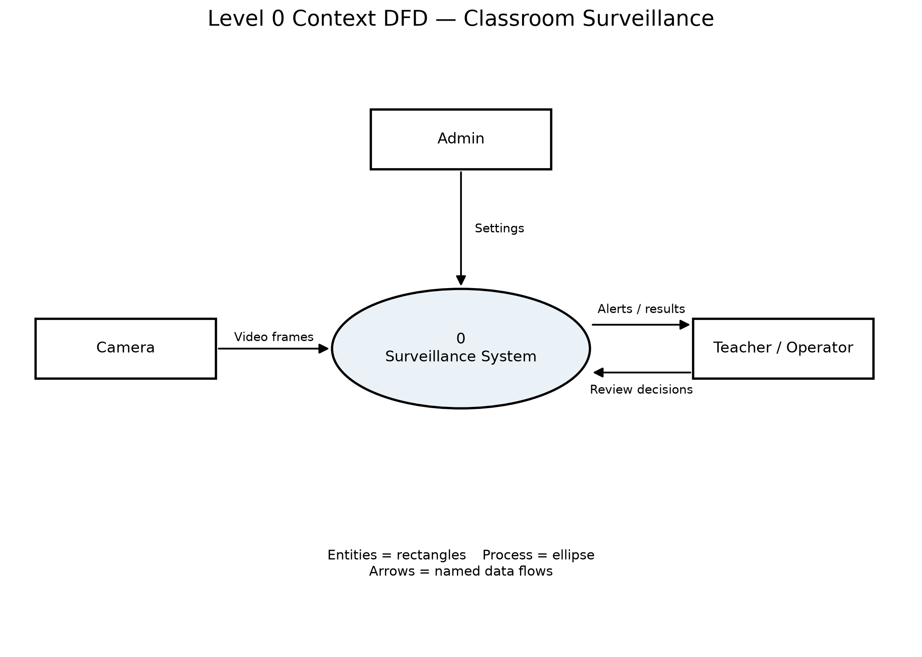
Level 1 DFD
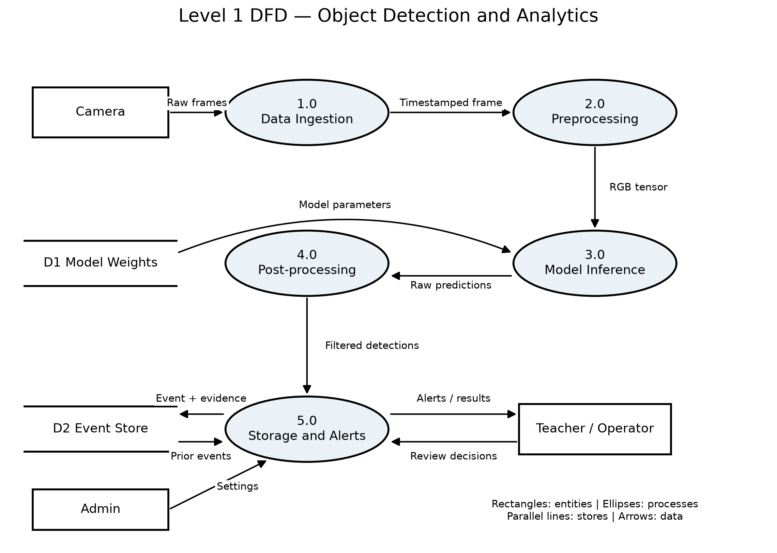
High-resolution image files and editable Mermaid sources are saved in lab-02/diagrams. Rectangles represent entities, ellipses represent processes, parallel lines represent data stores and arrows represent data flows.

Task 4 Modular Software Architecture
The application is split into five modules. The interface file defines classes and typed method signatures; it does not start a camera or run inference.
Module | Responsibility
DataIngestion | Open the source, read timestamped frames and release the camera.
ImagePreprocessor | Letterbox to 640 x 640, convert BGR to RGB and normalize to float32.
ModelInferenceEngine | Load model weights and return predictions using the CPU.
DetectionPostprocessor | Filter predictions and map boxes back to the original image.
AlertLogger | Save qualified events and notify the teacher.

DataIngestion: open(source: int | str) -> None; read_frame() -> FramePacket | None; close() -> None
ImagePreprocessor: preprocess(frame: Frame, size: tuple[int, int] = (640, 640)) -> PreprocessedFrame
ModelInferenceEngine: load_model(weights_path: str, device: str = "cpu") -> None; predict(prepared: PreprocessedFrame) -> Any
DetectionPostprocessor: filter_detections(predictions: Any, prepared: PreprocessedFrame, confidence: float = 0.65) -> list[Detection]
AlertLogger: log_event(packet: FramePacket, detections: list[Detection]) -> str | None; notify(event_id: str, message: str) -> bool
FramePacket holds image, camera ID and timestamp. PreprocessedFrame holds the tensor, original shape, scale and padding. Detection holds class, confidence and (x1, y1, x2, y2). Skeleton code: lab-02/interfaces.py.

Task 5 Unified System Design Specification
ARCHITECTURE.md combines the functional and non-functional requirement tables, input/output sheet, both DFDs and complete Python interface definitions in one repository document.
Repository: https://github.com/Hassnoo999/AI-Project-Design-Development
Validation: interfaces.py compiled successfully; both diagrams were exported. This lab is a design exercise, so no trained detector or camera benchmark is claimed.
Drafted By: Hassan Bin Saqib

