AI PROJECT DESIGN & DEVELOPMENT LAB 01

Submitted By: Hassan Bin Saqib
Roll No.: 231170

Submitted To: Sir Farhan
Date: 4th Oct, 26

Dept of Creative Technologies (AI)
AIR UNIVERSITY ISLAMABAD

Task 1 AI Repository Directory Structure
I used lab-01/setup_structure.py to create the required AI folders. The script can be run again safely. Empty folders are tracked with .gitkeep files.
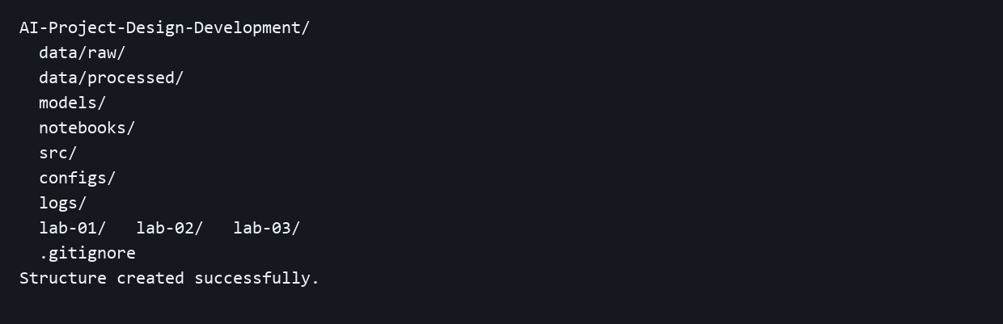
Terminal output from the executed setup script. The root .gitignore excludes Python caches, notebook checkpoints, aipdd_env and binary weights including .pt, .onnx and .h5.

Task 2 Virtual Environment and Pinned Packages
I created and activated aipdd_env, installed NumPy, OpenCV, Matplotlib, Ultralytics and Jupyter, and used CPU builds of PyTorch and torchvision. The full environment is pinned in the root requirements.txt.
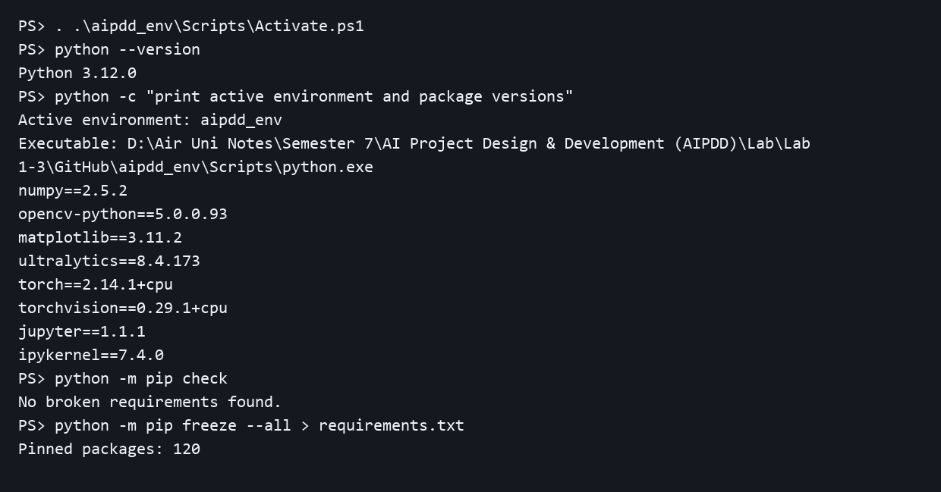
Terminal output from the active environment. Setup commands are in lab-01/setup_environment.ps1. Reinstall command: python -m pip install --extra-index-url https://download.pytorch.org/whl/cpu -r requirements.txt.

Task 3 Git Initialization and Branch Strategy
The provided repository was cloned with its existing initial commit. I committed the project structure, created feature/lab01-setup, committed requirements.txt there and merged it into main with a merge commit.
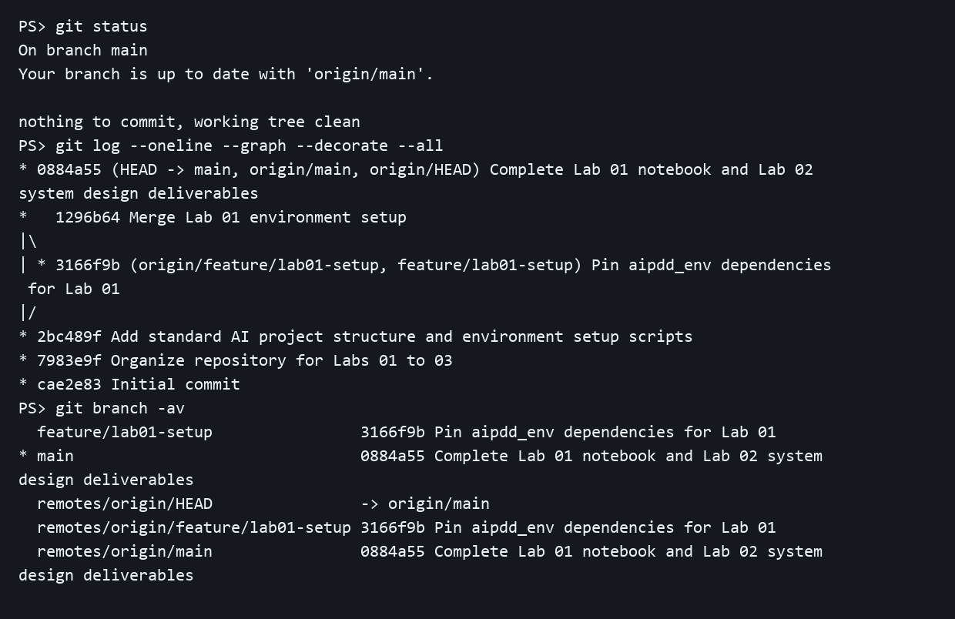
Real Git terminal log showing status, commit graph and branch history. Full text evidence is saved in lab-01/evidence/git_history.txt.

Task 4 Executed Jupyter Notebook
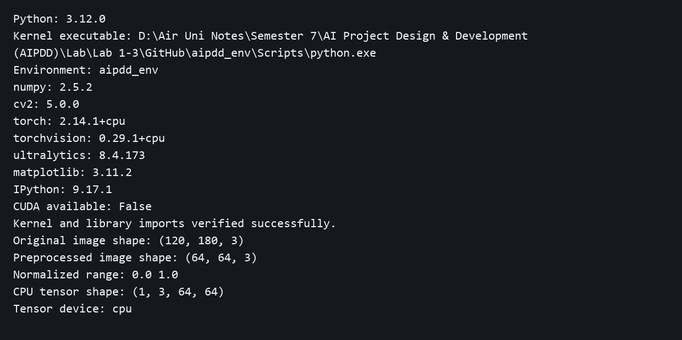
Output captured from the executed notebook. The kernel executable belongs to aipdd_env, imports completed without errors, and the synthetic image/tensor check ran on the CPU. Notebook: notebooks/lab01_setup.ipynb.

Task 5 Project Objectives in Notebook Markdown
Project title: Classroom Cheating Detection Assistant. Problem: a teacher cannot watch every student at once. The proposed system flags visible phones and repeated suspicious activity for teacher review.
Core objectives: read the camera feed, detect relevant objects, add student tracking later, avoid single-glance alerts and save local event records. The notebook includes level 1 to 3 headings, bullet lists, bold text and a PowerShell code block.
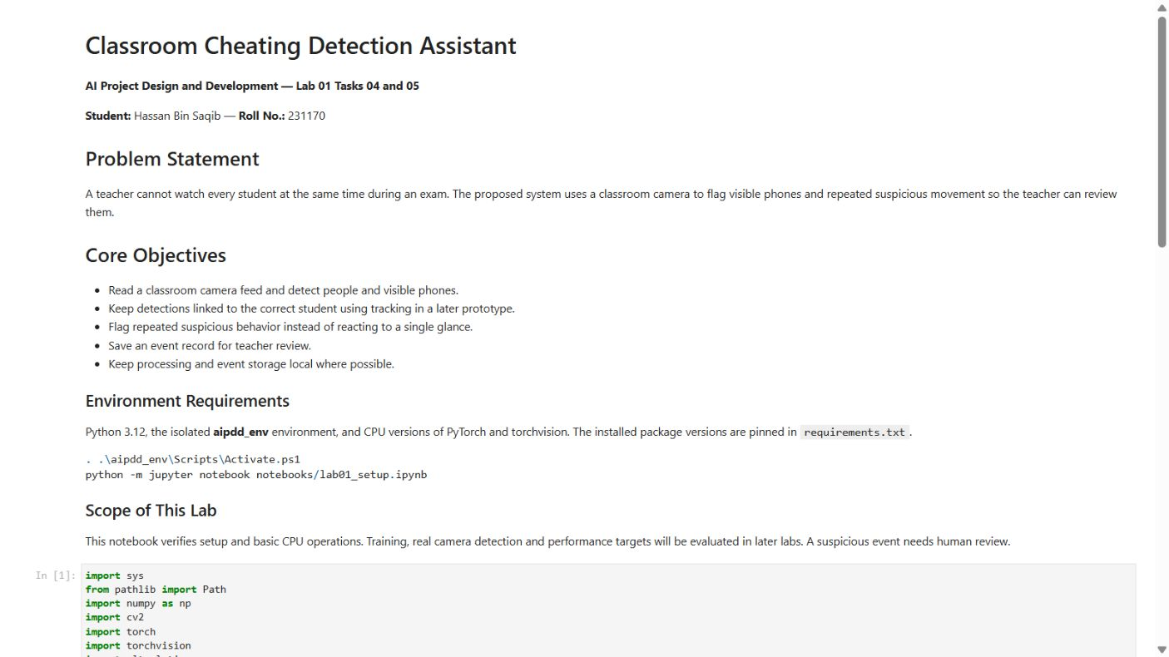
Screenshot of the rendered notebook Markdown cover.
Rendered notebook: lab-01/lab01_setup.html. Submission repository: https://github.com/Hassnoo999/AI-Project-Design-Development
Drafted By: Hassan Bin Saqib

