# **Zagazig University**

# **Faculty of Computers and Informatics**

# **Second grade**

**OOP Coursework Project**

|  |  |
| --- | --- |
| Student name | Hassan Ramadan Ibrahim Abdellatif |
| Seat number | 2123 |
| Email | HassanRamadanEbrahim@gmail.com |
| Grade | second |
| Lecturer | Dr. Ahmed Rafat |
| Tobic | C++ project that uses the object-oriented programming principles to follow up the heat temperature for multiple persons for 14 days in the Quarantine (number 1). |

# Heat Temperature Follow in the Quarantine System

**Abstract**

This system is used to follow up the heat temperature for multiple persons for 14 days in the Quarantine. It is implemented by applying object oriented programming principles using C++. Object oriented programming is a very powerful and popular programming paradigm.

Using the system you can Insert a person and add whose information such as age, residence - the place he/she lives in - and the temperature during 14 days to follow up the person's heat temperature. And it automatically calculates the average of the person's heat temperature.

The system guarantees you also display a person's information and temperature through the Quarantine. Also you can edit this person's information.

**Introduction**

The main advantages of OOP paradigm is it represents everything as an object so it represents the life around us as it is. This makes the code more readable, Because it abstract the data and encapsulate it.

Every object has its own data and methods inside it. You can protect your data from external modification, So the only thing that can access the object data is its methods which makes us avoid security issues.

This is all a very big plus for OOP, But OOP like everything has its advantages and disadvantages. The main disadvantage of OOP is that it loses the speed of execution which procedural programming provides.

This is the flow chart of the program:



**Results**

The code

|  |
| --- |
| *#include* <bits/stdc++.h>  using namespace std;  class Person{  private:  int PersonNumber;  string PersonName;  string PersonGender;  string PersonResidence;  int PersonAge;  int Indx;  float PersonHeatTemp[14];  public:  static int NumberOfPersons;  Person(){  Indx = 0;  PersonNumber = ++NumberOfPersons + 1;  PersonName = "";  PersonResidence = "";  PersonAge = 0;  *for*(int i=0; i<14; i++) PersonHeatTemp[i] = 0;  }  Person(string Name){  Indx = 0;  PersonNumber = ++NumberOfPersons + 1;  PersonName = Name;  PersonResidence = "";  PersonAge = 0;  *for*(int i=0; i<14; i++) PersonHeatTemp[i] = 0;  }  void InsertName(string Name){  PersonName = Name;  }  void InsertGender(string Gender){  PersonGender = Gender;  }  void InsertResidence(string Residence){  PersonResidence = Residence;  }  void InsertAge(int Age){  PersonAge = Age;  }  void InsertHeatTemp(float HeatTemp,int Index){  PersonHeatTemp[Index] = HeatTemp;  }  int GetAndIncrementIndx(){  *return* Indx++;  }  int GetNumber(){  *return* PersonNumber;  }  string GetName(){  *return* PersonName;  }  string GetGender(){  *return* PersonGender;  }  string GetResidence(){  *return* PersonResidence;  }  int GetAge(){  *return* PersonAge;  }  float GetHeatTempOfIndx(int Index){  *return* PersonHeatTemp[Index-1];  }  float* GetAllHeatTemps(){  *return* PersonHeatTemp;  }  float GetAverageHeatTemp(){  float sum = 0;  *for*(int i=0;i<14;i++) sum += PersonHeatTemp[i];  *return* (sum/Indx);  }  };  int Person::NumberOfPersons = 0;  int main(void)  {  Person person1,person2,person3,person4,person5;  int Option;  int ID = 0;  *while*(true){  cout << "Heat Temperature Follow in the Quarantine System" << endl << endl;  cout << "\tOptions:" << endl;  cout << "\t\t1. Insert a new person." << endl;  cout << "\t\t2. Add today's temperature for existing person." << endl;  cout << "\t\t3. Display a person." << endl;  cout << "\t\t4. Edit a person information(Name, Age, Residence, or Temperature)." << endl;  cout << "\t\t5. Exit the System." << endl;  cout << "\tChoose Option: ";  cin >> Option;  *if*(Option==1){  string name,gender,residence,YoN;  int age; float temp;  cout << "You can add up to 5 persons in the system. There is " << ID << " persons in the system, now!" << endl;  *if*(ID == Person::NumberOfPersons) { cout<< "There is no capacity to store more"; *continue*;}  cout << "Enter the person's name: ";  cin >> name;  ID++;  *if*(ID == 1){  person1.InsertName(name);  cout << "Enter Age(if not exist Enter 0): ";  cin >> age;  person1.InsertAge(age);  cout << "Enter Gender(if not exist Enter N/A): ";  cin >> gender;  person1.InsertGender(gender);  cout << "Enter Residence(if not exist Enter N/A): ";  cin >> residence;  person1.InsertResidence(residence);  cout << "Do you want insert today's heat temperature of this person(yes/no): ";  cin >> YoN;  *if*(YoN == "yes") {  cout << "Enter The Heat Temperature: ";  cin >> temp;  person1.InsertHeatTemp(temp,person1.GetAndIncrementIndx());  }  cout << "The Person is inserted successfully." << endl;  }  *else* *if* (ID == 2){  person2.InsertName(name);  cout << "Enter Age(if not exist Enter 0): ";  cin >> age;  person2.InsertAge(age);  cout << "Enter Gender(if not exist Enter N/A): ";  cin >> gender;  person2.InsertGender(gender);  cout << "Enter Residence(if not exist Enter N/A): ";  cin >> residence;  person2.InsertResidence(residence);  cout << "Do you want insert today's heat temperature of this person(yes/no): ";  cin >> YoN;  *if*(YoN == "yes") {  cout << "Enter The Heat Temperature: ";  cin >> temp;  person2.InsertHeatTemp(temp,person2.GetAndIncrementIndx());  }  cout << "The Person is inserted successfully." << endl;  }  *else* *if* (ID == 3){  person3.InsertName(name);  cout << "Enter Age(if not exist Enter 0): ";  cin >> age;  person3.InsertAge(age);  cout << "Enter Gender(if not exist Enter N/A): ";  cin >> gender;  person3.InsertGender(gender);  cout << "Enter Residence(if not exist Enter N/A): ";  cin >> residence;  person3.InsertResidence(residence);  cout << "Do you want insert today's heat temperature of this person(yes/no): ";  cin >> YoN;  *if*(YoN == "yes") {  cout << "Enter The Heat Temperature: ";  cin >> temp;  person3.InsertHeatTemp(temp,person3.GetAndIncrementIndx());  }  cout << "The Person is inserted successfully." << endl;  }  *else* *if* (ID == 4){  person4.InsertName(name);  cout << "Enter Age(if not exist Enter 0): ";  cin >> age;  person4.InsertAge(age);  cout << "Enter Gender(if not exist Enter N/A): ";  cin >> gender;  person4.InsertGender(gender);  cout << "Enter Residence(if not exist Enter N/A): ";  cin >> residence;  person4.InsertResidence(residence);  cout << "Do you want insert today's heat temperature of this person(yes/no): ";  cin >> YoN;  *if*(YoN == "yes") {  cout << "Enter The Heat Temperature: ";  cin >> temp;  person4.InsertHeatTemp(temp,person4.GetAndIncrementIndx());  }  cout << "The Person is inserted successfully." << endl;  }  *else* *if* (ID == 5){  person5.InsertName(name);  cout << "Enter Age(if not exist Enter 0): ";  cin >> age;  person5.InsertAge(age);  cout << "Enter Gender(if not exist Enter N/A): ";  cin >> gender;  person5.InsertGender(gender);  cout << "Enter Residence(if not exist Enter N/A): ";  cin >> residence;  person5.InsertResidence(residence);  cout << "Do you want insert today's heat temperature of this person(yes/no): ";  cin >> YoN;  *if*(YoN == "yes") {  cout << "Enter The Heat Temperature: ";  cin >> temp;  person5.InsertHeatTemp(temp,person5.GetAndIncrementIndx());  }  cout << "The Person is inserted successfully." << endl;  }  }  *else* *if*(Option == 2){  string name;  float temp;  cout << "Enter the person name: ";  cin >> name;  cout << "Enter The Heat Temperature: ";  cin >> temp;  *if*(name == person1.GetName() )  person1.InsertHeatTemp(temp,person1.GetAndIncrementIndx());  *else* *if*(name == person2.GetName() )  person2.InsertHeatTemp(temp,person2.GetAndIncrementIndx());  *else* *if*(name == person3.GetName() )  person3.InsertHeatTemp(temp,person3.GetAndIncrementIndx());  *else* *if*(name == person4.GetName() )  person4.InsertHeatTemp(temp,person4.GetAndIncrementIndx());  *else* *if*(name == person5.GetName() )  person5.InsertHeatTemp(temp,person5.GetAndIncrementIndx());  *else*  cout << "The name you entered is not exist.";  }  *else* *if*(Option == 3){  string name;  cout << "Enter the person name: ";  cin >>name;  *if*(name == person1.GetName() ){  cout << "Person number: " << person1.GetNumber() << endl;  cout << "person name: " << person1.GetName() <<endl;  cout << "person age: " << person1.GetAge() << endl;  cout << "person gender: " << person1.GetGender() << endl;  cout << "person residence: " <<person1.GetResidence() <<endl;  cout << "person Heat Temperature: ";  float* p = person1.GetAllHeatTemps();  *for* (int i = 0; i < 14; i++) cout << *(p + i) << " ";  cout << endl << "Person average temperature: " << person1.GetAverageHeatTemp() << endl << endl ;  }  *else* *if*(name == person2.GetName() ){  cout << "Person number: " << person2.GetNumber() << endl;  cout << "person name: " << person2.GetName() <<endl;  cout << "person age: " << person2.GetAge() << endl;  cout << "person gender: " << person2.GetGender() << endl;  cout << "person residence: " <<person2.GetResidence() <<endl;  cout << "person Heat Temperature: ";  float* p = person2.GetAllHeatTemps();  *for* (int i = 0; i < 14; i++) cout << *(p + i) << " ";  cout << endl << "Person average temperature: " << person2.GetAverageHeatTemp() << endl << endl ;  }  *else* *if*(name == person3.GetName() ){  cout << "Person number: " << person3.GetNumber() << endl;  cout << "person name: " << person3.GetName() <<endl;  cout << "person age: " << person3.GetAge() << endl;  cout << "person gender: " << person3.GetGender() << endl;  cout << "person residence: " <<person3.GetResidence() <<endl;  cout << "person Heat Temperature: ";  float* p = person3.GetAllHeatTemps();  *for* (int i = 0; i < 14; i++) cout << *(p + i) << " ";  cout << endl << "Person average temperature: " << person3.GetAverageHeatTemp() << endl << endl ;  }  *else* *if*(name == person4.GetName() ){  cout << "Person number: " << person4.GetNumber() << endl;  cout << "person name: " << person4.GetName() <<endl;  cout << "person age: " << person4.GetAge() << endl;  cout << "person gender: " << person4.GetGender() << endl;  cout << "person residence: " <<person4.GetResidence() <<endl;  cout << "person Heat Temperature: ";  float* p = person4.GetAllHeatTemps();  *for* (int i = 0; i < 14; i++) cout << *(p + i) << " ";  cout << endl << "Person average temperature: " << person4.GetAverageHeatTemp() << endl << endl ;  }  *else* *if*(name == person5.GetName() ){  cout << "Person number: " << person5.GetNumber() << endl;  cout << "person name: " << person5.GetName() <<endl;  cout << "person age: " << person5.GetAge() << endl;  cout << "person gender: " << person5.GetGender() << endl;  cout << "person residence: " <<person5.GetResidence() <<endl;  cout << "person Heat Temperature: ";  float* p = person5.GetAllHeatTemps();  *for* (int i = 0; i < 14; i++) cout << *(p + i) << " ";  cout << endl << "Person average temperature: " << person5.GetAverageHeatTemp() << endl << endl ;  }  *else*{  cout << "The name you entered is not exist.";  }  }  *else* *if*(Option == 4){  string name, nam, gender, residence, option;  int idx, age;  float temperature;  cout << "Enter the person name: ";  cin >> name;  *if*(name == person1.GetName()){  cout << "What do you want to modify? (Name, Age, Gender, Residence, or Temperature of any day): ";  cin >> option;  *if* (option == "Name"){  cout << "Enter the new name: ";  cin >> nam;  person1.InsertName(nam);  }  *else* *if* (option == "Age"){  cout << "Enter the new age: ";  cin >> age;  person1.InsertAge(age);  }  *else* *if* (option == "Gender"){  cout << "Enter the new Gender: ";  cin >> gender;  person1.InsertGender(gender);  }  *else* *if* (option == "Residence"){  cout << "Enter the new residence: ";  cin >> residence;  person1.InsertResidence(residence);  }  *else* *if* (option == "Temperature"){  cout << "Enter the new Heat temperature followed by the number of the day: ";  cin >> temperature >> idx;  person1.InsertHeatTemp(temperature,idx-1);  }  *else* {  cout << "The name you have entered does not match any person.";  }  }  *else* *if*(name == person2.GetName() ){  cout << "What do you want to modify? (Name, Age, Gender, Residence, or Temperature of any day): ";  cin >> option;  *if* (option == "Name"){  cout << "Enter the new name: ";  cin >> nam;  person2.InsertName(nam);  }  *else* *if* (option == "Age"){  cout << "Enter the new age: ";  cin >> age;  person2.InsertAge(age);  }  *else* *if* (option == "Gender"){  cout << "Enter the new Gender: ";  cin >> gender;  person2.InsertGender(gender);  }  *else* *if* (option == "Residence"){  cout << "Enter the new residence: ";  cin >> residence;  person2.InsertResidence(residence);  }  *else* *if* (option == "Temperature"){  cout << "Enter the new Heat temperature followed by the number of the day: ";  cin >> temperature >> idx;  person2.InsertHeatTemp(temperature,idx-1);  }  *else* {  cout << "The name you have entered does not match any person.";  }  }  *else* *if*(name == person3.GetName() ){  cout << "What do you want to modify? (Name, Age, Gender, Residence, or Temperature of any day): ";  cin >> option;  *if* (option == "Name"){  cout << "Enter the new name: ";  cin >> nam;  person3.InsertName(nam);  }  *else* *if* (option == "Age"){  cout << "Enter the new age: ";  cin >> age;  person3.InsertAge(age);  }  *else* *if* (option == "Gender"){  cout << "Enter the new Gender: ";  cin >> gender;  person3.InsertGender(gender);  }  *else* *if* (option == "Residence"){  cout << "Enter the new residence: ";  cin >> residence;  person3.InsertResidence(residence);  }  *else* *if* (option == "Temperature"){  cout << "Enter the new Heat temperature followed by the number of the day: ";  cin >> temperature >> idx;  person3.InsertHeatTemp(temperature,idx-1);  }  *else* {  cout << "The name you have entered does not match any person.";  }  }  *else* *if*(name == person4.GetName() ){  cout << "What do you want to modify? (Name, Age, Gender, Residence, or Temperature of any day): ";  cin >> option;  *if* (option == "Name"){  cout << "Enter the new name: ";  cin >> nam;  person4.InsertName(nam);  }  *else* *if* (option == "Age"){  cout << "Enter the new age: ";  cin >> age;  person4.InsertAge(age);  }  *else* *if* (option == "Gender"){  cout << "Enter the new Gender: ";  cin >> gender;  person4.InsertGender(gender);  }  *else* *if* (option == "Residence"){  cout << "Enter the new residence: ";  cin >> residence;  person4.InsertResidence(residence);  }  *else* *if* (option == "Temperature"){  cout << "Enter the new Heat temperature followed by the number of the day: ";  cin >> temperature >> idx;  person4.InsertHeatTemp(temperature,idx-1);  }  *else* {  cout << "The name you have entered does not match any person.";  }  }  *else* *if*(name == person5.GetName() ){  cout << "What do you want to modify? (Name, Age, Gender, Residence, or Temperature of any day): ";  cin >> option;  *if* (option == "Name"){  cout << "Enter the new name: ";  cin >> nam;  person5.InsertName(nam);  }  *else* *if* (option == "Age"){  cout << "Enter the new age: ";  cin >> age;  person5.InsertAge(age);  }  *else* *if* (option == "Gender"){  cout << "Enter the new Gender: ";  cin >> gender;  person5.InsertGender(gender);  }  *else* *if* (option == "Residence"){  cout << "Enter the new residence: ";  cin >> residence;  person5.InsertResidence(residence);  }  *else* *if* (option == "Temperature"){  cout << "Enter the new Heat temperature followed by the number of the day: ";  cin >> temperature >> idx;  person5.InsertHeatTemp(temperature,idx-1);  }  *else* {  cout << "The name you have entered does not match any person.";  }  }  *else*  cout << "The name you entered is not exist.";  }  *else* *if*(Option == 5){  *return* 0;  }  *else*{  cout << "The option you have entered does not match any valid option!" << endl;  }  cout << endl << endl;  }  *return* 0;  } |

**Discussion**

*The system in action:*

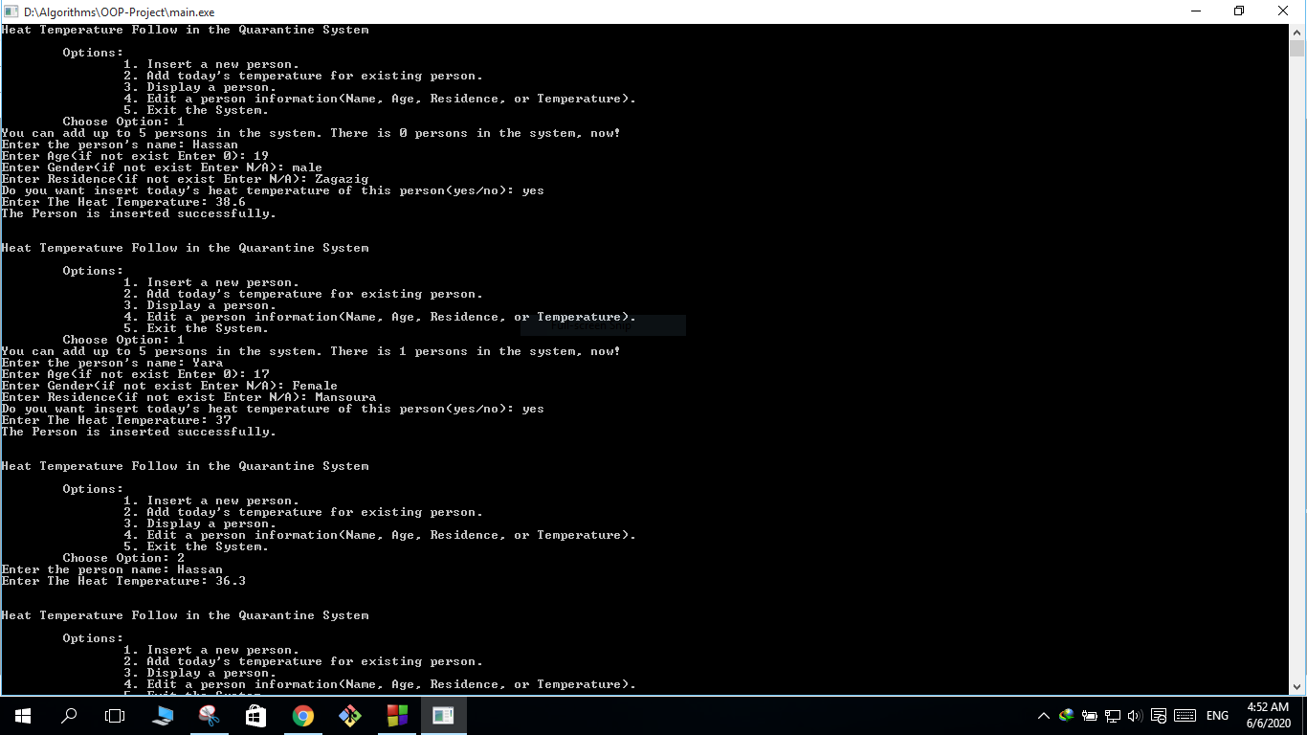

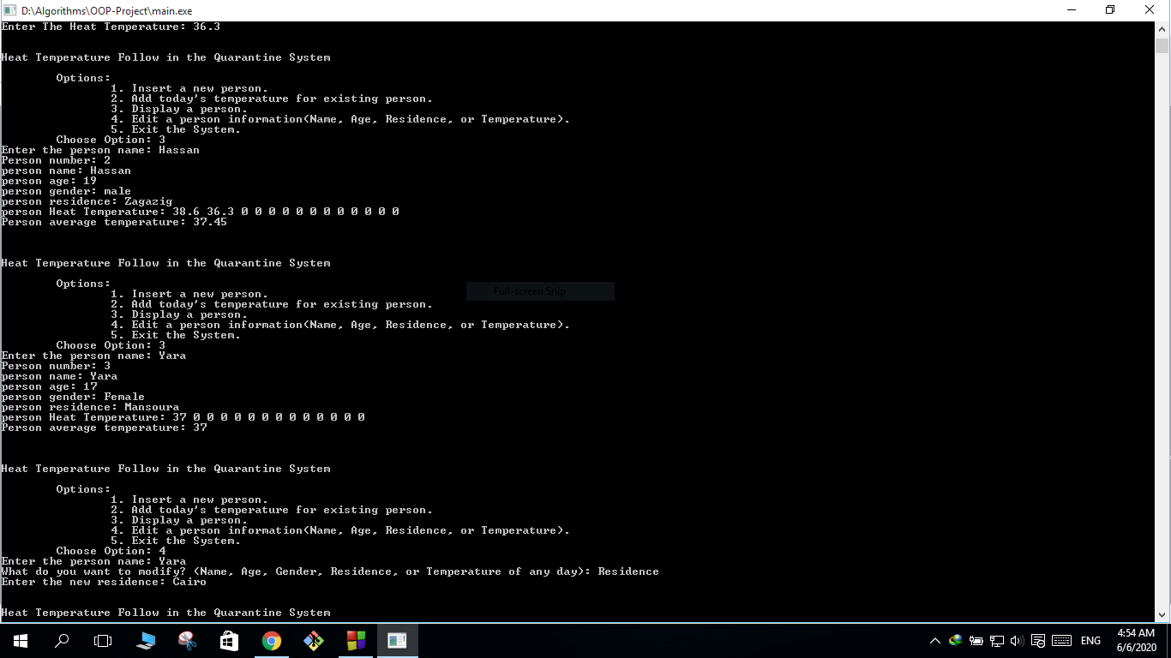

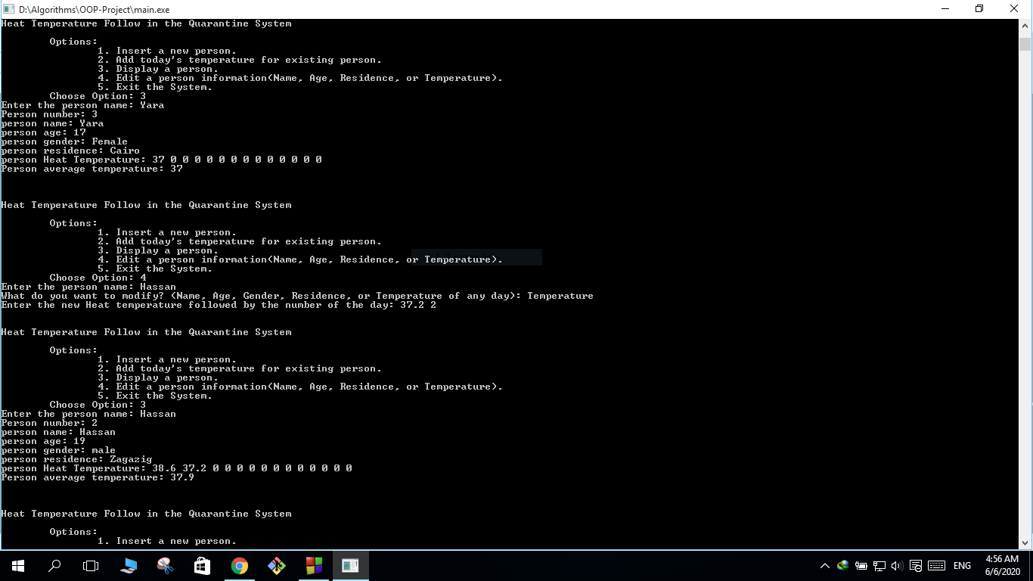

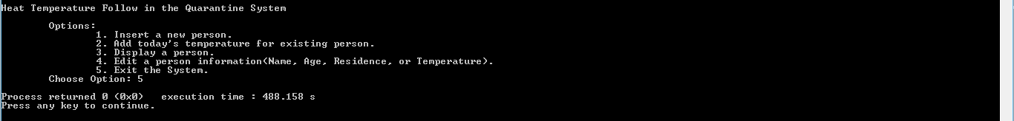

**Conclusion**

This is the diagram for the person class that used to create some person objects to track their heat temperature and for sure their information.



**When we create a new person:**

The object initialized and the number of persons incremented by one directly. Then we can add today's temperature for that person, then we can add the next day's temperature and so on only by inserting the value. Whether we get wrong and assiend a wrong value we can simply edit this value by choosing the option and write the right value, with the same strategy we can edit any piece of information we got wrong with. The average temperature is calculated directly when we insert a new temperature, it is calculated over the existing days inserted. in the system for one person. We can also display a person to check any piece of information we want for any one person registered. Finally we can exit the system..

**References**

1. Lafore, R. W., Waite Group, & Waite Group. (2002). Object-oriented Programming in C++ (4th Edition). San Jose, US: Sams.