**2) Can CSMA/CD be used in wireless network? If not why?**

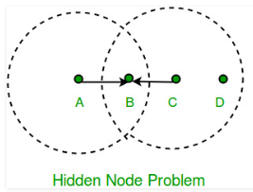

Consider the situation depicted in the figure, where each of four nodes is able to send and receive signals that reach just the nodes to its immediate left and right.  
For example, B can exchange frames with A and C but it cannot reach D, while C can reach B and D but not A. (A and D’s reach is not shown in the figure.) Suppose both A and C want to communicate with B and so they each send it a frame. A and C are unaware of each other since their signals do not carry that far. These two frames collide with each other at B, but unlike an Ethernet, neither A nor C is aware of this collision. A and C are said to be hidden nodes with respect to each other.

**Collision cannot be detected in hidden node problem**

This is because the nodes **A** and **C** are out of range of each other(and so cannot detect a collision while transmitting). Thus, Carrier sense multiple access with collision detection (CSMA/CD) does not work, and collisions occur. The data received by the access point is corrupted due to the collision. To overcome the hidden node problem, RTS/CTS handshaking is implemented in addition to the Carrier sense multiple access with collision avoidance (CSMA/CA) scheme.

**8)Describe how wireless networks can reduce installation time and cost**

Installation time:

The time required to install network cabling is generally significant. Installers must pull wires through the ceiling and then drop cables down the walls to network cutlets. This can take days or even weeks to complete. During that time, employees must somehow continue their work in the midst of the construction zone, which is often difficult to do. Using a wireless LAN eliminates such disruption.

Cost:

Wireless networking may carry a slightly higher initial investment, but the overall expenses over time are lower. It also may have a longer lifecycle than a traditionally connected network.