Title : Quiz management System

**A PROJECT REPORT**

***Submitted by***

**Hasti hajipariya (92100133052)**

**Jalu Riddhi (92100133008)**

***In partial fulfillment for***

***OOP (01CT0105) Project***

**Sem – 2nd**

**Degree ENGINEERING**

***in***

**Information and Communication Technology Engineering**



**Faculty of Technology Studies**

**Marwadi University, Rajkot**

|  |  |  |  |
| --- | --- | --- | --- |
| **Subject:** | Object Oriented Programming with JAVA (01CT0105) | | |
| **Project Title:** | Quiz Management System | | |
| **1) Enrollment No:** | 92100133052 | **Name:** | Hasti Hajipara |
| **2) Enrollment No:** | 92100133008 | **Name:** | Riddhi Jalu |
| **Project Definition:** Quiz Management System | | | |
| Make quiz for faculties and auto-management of it.  - Make a login page for teacher and student.  - take all student and teacher information.  - saw Quiz detail  - Create a Question  - show result  -teacher can add the question and update the question | | | |
| **List of Functionality:** | | | |
| 1. Additional top 3 students (sorting)   2.Student should be able to show his/her progress by graph after every quiz | | | |
| **Project Client Name:**  1) Khushi Pandya - 064  2)Venisha Parmar - 071 | | | |

**Meetings:**

|  |  |  |
| --- | --- | --- |
| Date | Time | Details |
| 28 / 4 / 2022 | 30 min | Discuss about Project definition |
| 7 / 5 /2022 | 15 min | About GUI in Project. |
| 1 / 6 /2022 | 15 min | Excel sheet Reading Writing data |
| 20 / 6 /2022 | 20 min | Final project discussion |

**Bat File :**

set classpath=commons-collections4-4.1.jar;poi-3.17.jar;poi-ooxml-3.17.jar;poi-ooxml-schemas-3.17.jar;xmlbeans-2.6.0.jar;.;

javac -d . *.java

javac *.java

java Main_Frame

**Controller Code :**

import p1.Register;

import p2.Login_model;

import p1.Question;

import org.apache.poi.*;

import org.apache.poi.ss.usermodel.Cell;

import org.apache.poi.ss.usermodel.Row;

import org.apache.poi.ss.usermodel.Sheet;

import org.apache.poi.xssf.usermodel.XSSFSheet;

import org.apache.poi.xssf.usermodel.XSSFWorkbook;

import org.apache.poi.ss.usermodel.Cell;

import org.apache.poi.ss.usermodel.Workbook;

import org.apache.poi.ss.usermodel.WorkbookFactory;

import java.io.File;

import java.io.FileInputStream;

import java.io.FileOutputStream;

import java.util.Iterator;

import java.awt.*;

import java.awt.event.*;

import java.io.*;

import javax.swing.*;

import java.lang.*;

import java.util.ArrayList;

import java.util.Scanner;

import java.util.Calendar;

import java.util.Timer;

import java.util.TimerTask;

public class MyActionListener extends JComponent implements ActionListener,ItemListener,Serializable

{

String s1,s2,s3,s4,s5,sanswer,sans;

int row = 0,flag=0,count=0,tick=0;

int count1=0;

ArrayList<String> ans = new ArrayList<String>();

ArrayList<String> cans =new ArrayList<String>();

ArrayList<String> slogin =new ArrayList<String>();

ArrayList<String> scheck =new ArrayList<String>();

Main_Frame mf;

Main_Frame1 mf1;

Main_Frame2 mf2;

Main_Frame3 mf3;

Main_Frame4 mf4;

Main_Frame5 mf5;

Main_Frame6 mf6;

Main_Frame7 mf7;

Main_Frame8 mf8;

Main_Frame9 mf9;

Main_Frame10 mf10;

Main_Frame11 mf11;

Main_Frame12 mf12;

Main_Frame13 mf13;

MyActionListener(Main_Frame m)

{

this.mf=m;

}

MyActionListener(Main_Frame1 m)

{

this.mf1=m;

}

MyActionListener(Main_Frame2 m)

{

this.mf2=m;

}

MyActionListener(Main_Frame3 m)

{

this.mf3=m;

}

MyActionListener(Main_Frame4 m)

{

this.mf4=m;

}

MyActionListener(Main_Frame5 m)

{

this.mf5=m;

}

MyActionListener(Main_Frame6 m)

{

this.mf6=m;

}

MyActionListener(Main_Frame7 m)

{

this.mf7=m;

}

MyActionListener(Main_Frame8 m)

{

this.mf8=m;

}

MyActionListener(Main_Frame9 m)

{

this.mf9=m;

}

MyActionListener(Main_Frame10 m)

{

this.mf10=m;

}

MyActionListener(Main_Frame11 m)

{

this.mf11=m;

}

MyActionListener(Main_Frame12 m)

{

this.mf12=m;

}

MyActionListener(Main_Frame13 m)

{

this.mf13=m;

}

public String toString()

{

return this.sans;

}

public void actionPerformed(ActionEvent e)

{

if(e.getActionCommand().equals("Student Login"))

{

mf1=new Main_Frame1();

this.mf1.setVisible(true);

this.mf.setVisible(false);

}

if(e.getActionCommand().equals("Teacher Login"))

{

mf2 = new Main_Frame2();

this.mf2.setVisible(true);

this.mf.setVisible(false);

}

if(e.getActionCommand().equals("Add Question"))

{

mf10 = new Main_Frame10();

this.mf9.setVisible(false);

this.mf10.setVisible(true);

}

if(e.getActionCommand().equals("Back Again"))

{

mf9 = new Main_Frame9();

this.mf9.setVisible(true);

this.mf10.setVisible(false);

}

if(e.getActionCommand().equals("Update Question"))

{

try

{

File file = new File("/D:/OOP/Quiz_Project/Quiz_Excel.xlsx");

Desktop.getDesktop().open(file);

}

catch(Exception exe1){}

}

if(e.getActionCommand().equals("Quiz Detail"))

{

mf13 = new Main_Frame13();

this.mf9.setVisible(false);

this.mf13.setVisible(true);

}

if(e.getActionCommand().equals("Register here"))

{

mf3 = new Main_Frame3();

mf3.setVisible(true);

mf1.setVisible(false);

}

if(e.getActionCommand().equals("Register Now"))

{

mf1 = new Main_Frame1();

mf3.setVisible(false);

mf1.setVisible(true);

try

{

BufferedWriter bw = new BufferedWriter(new FileWriter("Student_Login.txt",true));

bw.write(this.mf3.t[0].getText()+"#"+this.mf3.t[1].getText()+"#"+this.mf3.t[2].getText()+"#"+this.mf3.t[3].getText()+"#"+this.mf3.t[4].getText()+"#"+this.mf3.t[5].getText()+"#"+this.mf3.t[6].getText()+"#"+this.mf3.t[7].getText());

bw.write("\n");

bw.close();

}

catch(Exception ep){}

}

if(e.getActionCommand().equals("login"))

{

mf9 = new Main_Frame9();

try

{

BufferedReader br = new BufferedReader(new FileReader("Teacher_Login.txt"));

String st1=br.readLine();

s1 = this.mf2.tId.getText();

s2 = this.mf2.tpassword.getText();

s3 = this.mf2.tsub.getText();

while(st1!=null)

{

//System.out.println(st1);

String arr[] = st1.split("#");

System.out.println(arr[7]);

System.out.println(s1);

if(arr[7].equals(s1) && arr[6].equals(s2) && arr[2].equals(s3))

{

System.out.println("hi");

JOptionPane.showMessageDialog(null,"Login Successfull...","Congratulation",JOptionPane.PLAIN_MESSAGE);

this.mf9.setVisible(true);

this.mf2.setVisible(false);

flag=1;

break;

}

st1=br.readLine();

}

if(flag!=1)

{

JOptionPane.showMessageDialog(null,"Incorret username/password","Sad",JOptionPane.PLAIN_MESSAGE);

this.mf2.tId.setText("");

this.mf2.tpassword.setText("");

this.mf2.tsub.setText("");

this.mf2.setVisible(true);

this.mf9.setVisible(false);

}

}

catch(Exception epe){}

}

if(e.getActionCommand().equals("Login"))

{

mf8 = new Main_Frame8();

try

{

BufferedReader br = new BufferedReader(new FileReader("Student_Login.txt"));

String st1=br.readLine();

s1 = this.mf1.tId.getText();

s2 = this.mf1.tpassword.getText();

while(st1!=null)

{

//System.out.println(st1);

String arr[] = st1.split("#");

System.out.println(arr[7]);

System.out.println(s1);

if(arr[7].equals(s1) && arr[6].equals(s2))

{

System.out.println("hi");

JOptionPane.showMessageDialog(null,"Login Successfull...","Congratulation",JOptionPane.PLAIN_MESSAGE);

this.mf8.setVisible(true);

this.mf1.setVisible(false);

tick=1;

break;

}

st1=br.readLine();

}

if(tick!=1)

{

JOptionPane.showMessageDialog(null,"Incorret username/password","Sad",JOptionPane.PLAIN_MESSAGE);

this.mf1.tId.setText("");

this.mf1.tpassword.setText("");

this.mf1.setVisible(true);

this.mf8.setVisible(false);

}

}

catch(Exception epe){}

}

if(e.getActionCommand().equals("Register Here"))

{

mf12 = new Main_Frame12();

mf12.setVisible(true);

mf2.setVisible(false);

}

if(e.getActionCommand().equals("Register now"))

{

mf2 = new Main_Frame2();

mf12.setVisible(false);

mf2.setVisible(true);

try

{

BufferedWriter bw = new BufferedWriter(new FileWriter("Teacher_Login.txt",true));

bw.write(this.mf12.t[0].getText()+"#"+this.mf12.t[1].getText()+"#"+this.mf12.t[2].getText()+"#"+this.mf12.t[3].getText()+"#"+this.mf12.t[4].getText()+"#"+this.mf12.t[5].getText()+"#"+this.mf12.t[6].getText()+"#"+this.mf12.t[7].getText());

bw.write("\n");

bw.close();

}

catch(Exception ep){}

}

if(e.getActionCommand().equals("Back"))

{

mf = new Main_Frame();

mf1 = new Main_Frame1();

mf2 = new Main_Frame2();

mf.setVisible(true);

mf1.setVisible(false);

mf2.setVisible(false);

}

if(e.getActionCommand().equals("Start"))

{

try

{

mf4 = new Main_Frame4();

this.mf4.setVisible(true);

this.mf8.setVisible(false);

this.mf4.bSave.setEnabled(false);

this.mf4.bSubmit.setEnabled(false);

File file = new File("Quiz_Excel.xlsx");

FileInputStream fis = new FileInputStream(file);

XSSFWorkbook wb = new XSSFWorkbook(fis);

XSSFSheet sheet = wb.getSheetAt(0);

this.mf4.tque.setText(sheet.getRow(row).getCell(0).toString());

this.mf4.l[0].setText(sheet.getRow(row).getCell(1).toString());

this.mf4.l[1].setText(sheet.getRow(row).getCell(2).toString());

this.mf4.l[2].setText(sheet.getRow(row).getCell(3).toString());

this.mf4.l[3].setText(sheet.getRow(row).getCell(4).toString());

String sanswer = sheet.getRow(row).getCell(5).toString();

FileWriter fw = new FileWriter("Current.txt");

fw.write(0);

fw.close();

}

catch(Exception exe){}

}

if(e.getActionCommand().equals("Next"))

{

try

{

FileReader fr = new FileReader("Current.txt");

int q = fr.read();

fr.close();

q++;

row = q;

File file = new File("Quiz_Excel.xlsx");

FileInputStream fis = new FileInputStream(file);

XSSFWorkbook wb = new XSSFWorkbook(fis);

XSSFSheet sheet = wb.getSheetAt(0);

Integer a=row;

String s = a.toString();

this.mf4.l2.setText("Question-"+s);

this.mf4.bSave.setEnabled(true);

this.mf4.bSubmit.setEnabled(false);

this.mf4.tque.setText(sheet.getRow(row).getCell(0).toString());

this.mf4.l[0].setText(sheet.getRow(row).getCell(1).toString());

this.mf4.l[1].setText(sheet.getRow(row).getCell(2).toString());

this.mf4.l[2].setText(sheet.getRow(row).getCell(3).toString());

this.mf4.l[3].setText(sheet.getRow(row).getCell(4).toString());

if(row==12)

{

this.mf4.bSubmit.setEnabled(true);

this.mf4.bNext.setEnabled(false);

}

this.mf4.tque.setEnabled(false);

String sanswer = sheet.getRow(row).getCell(5).toString();

FileWriter fw = new FileWriter("Current.txt");

fw.write(row);

fw.close();

ans.add(new String(sanswer));

}

catch(Exception exe){}

}

if(e.getActionCommand().equals("Add"))

{

try

{

String excelFilePath = "Quiz_Excel.xlsx";

FileInputStream inputStream = new FileInputStream(new File(excelFilePath));

Workbook workbook = WorkbookFactory.create(inputStream);

Sheet sheet = workbook.getSheetAt(0);

Object[] bookData = {this.mf10.tque.getText(),this.mf10.l[0].getText(),this.mf10.l[1].getText(),this.mf10.l[2].getText(),this.mf10.l[3].getText()};

int rowCount = sheet.getLastRowNum();

Row row = sheet.createRow(++rowCount);

System.out.println(rowCount);

int columnCount = 0;

Cell cell = row.createCell(columnCount);

for (Object field : bookData)

{

cell = row.createCell(columnCount++);

if (field instanceof String)

{

cell.setCellValue((String) field);

}

else if (field instanceof Integer)

{

cell.setCellValue((Integer) field);

}

}

inputStream.close();

FileOutputStream outputStream = new FileOutputStream("Quiz_Excel.xlsx");

workbook.write(outputStream);

workbook.close();

outputStream.close();

}

catch(Exception exe2){}

}

if(e.getActionCommand().equals("Save"))

{

if(this.mf4.r1.isSelected())

{

cans.add(new String(this.mf4.l[0].getText()));

}

else if(this.mf4.r2.isSelected())

{

cans.add(new String(this.mf4.l[1].getText()));

}

else if(this.mf4.r3.isSelected())

{

cans.add(new String(this.mf4.l[2].getText()));

}

else if(this.mf4.r4.isSelected())

{

cans.add(new String(this.mf4.l[3].getText()));

}

else

{

System.out.println("Please Select any one option");

}

}

if(e.getActionCommand().equals("Submit Quiz"))

{

//mf7 = new Main_Frame7();

for(int i=0;i<ans.size();i++)

{

if(ans.get(i).equals(cans.get(i)))

{

count++;

}

else

{

System.out.println(ans.get(i));

System.out.println(cans.get(i));

}

}

JOptionPane.showMessageDialog(null,"Your Score is :"+count,"Score",JOptionPane.PLAIN_MESSAGE);

}

}

public void itemStateChanged(ItemEvent it) {}

}

**Main Page :**

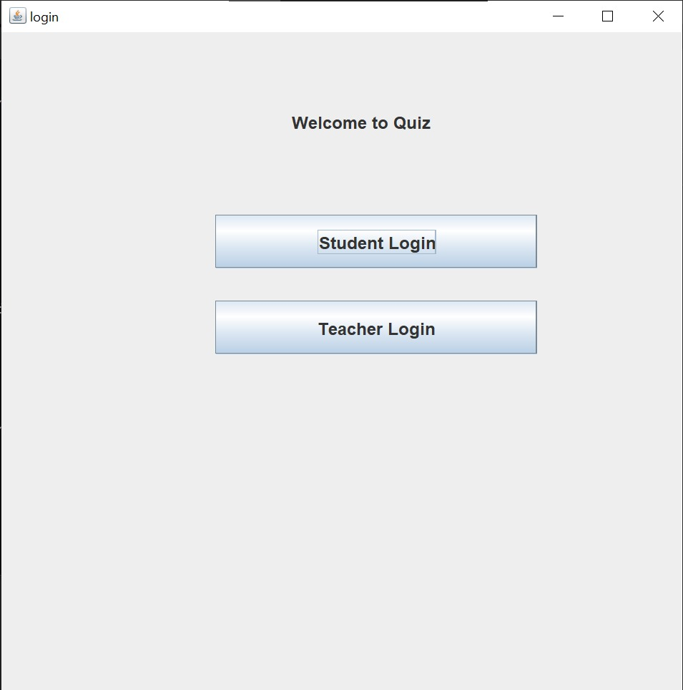

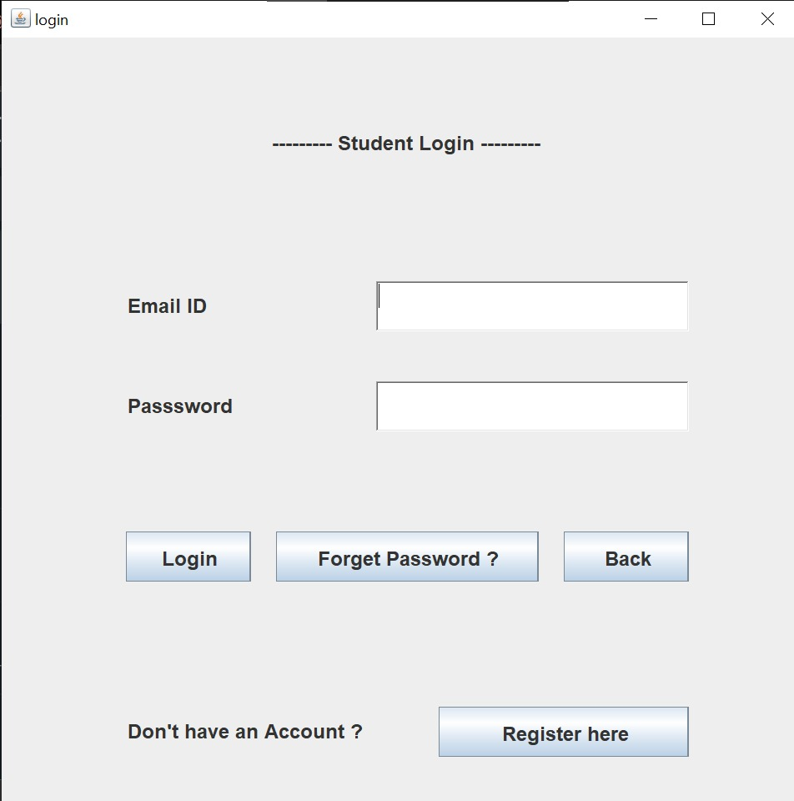

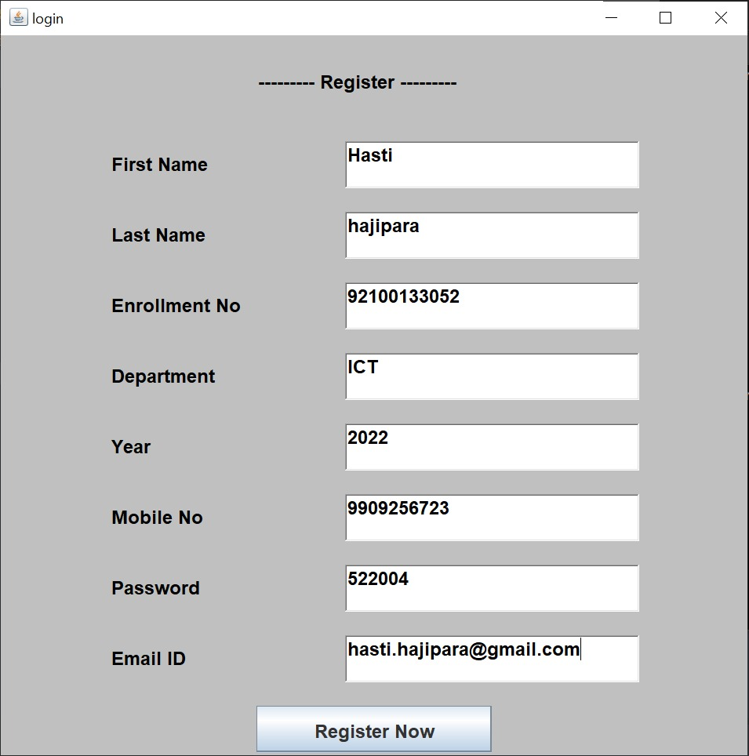

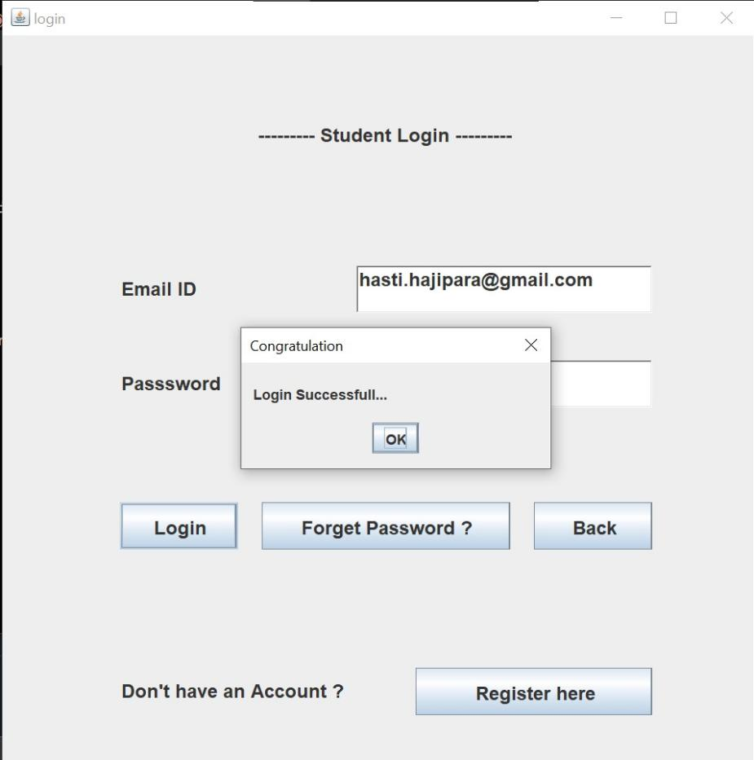

**Quiz Information :**

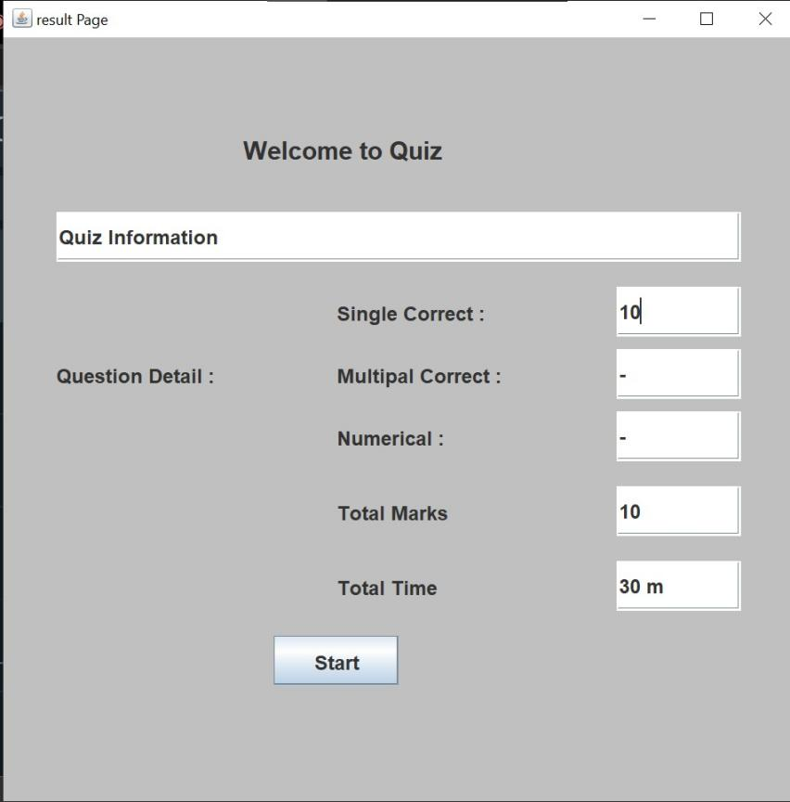

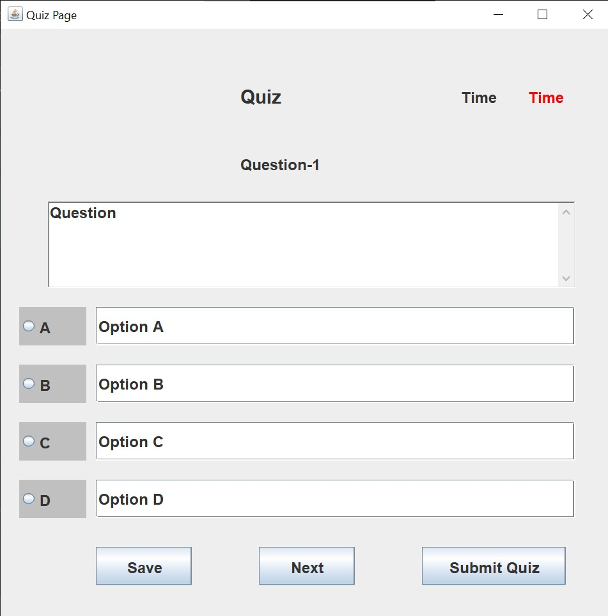

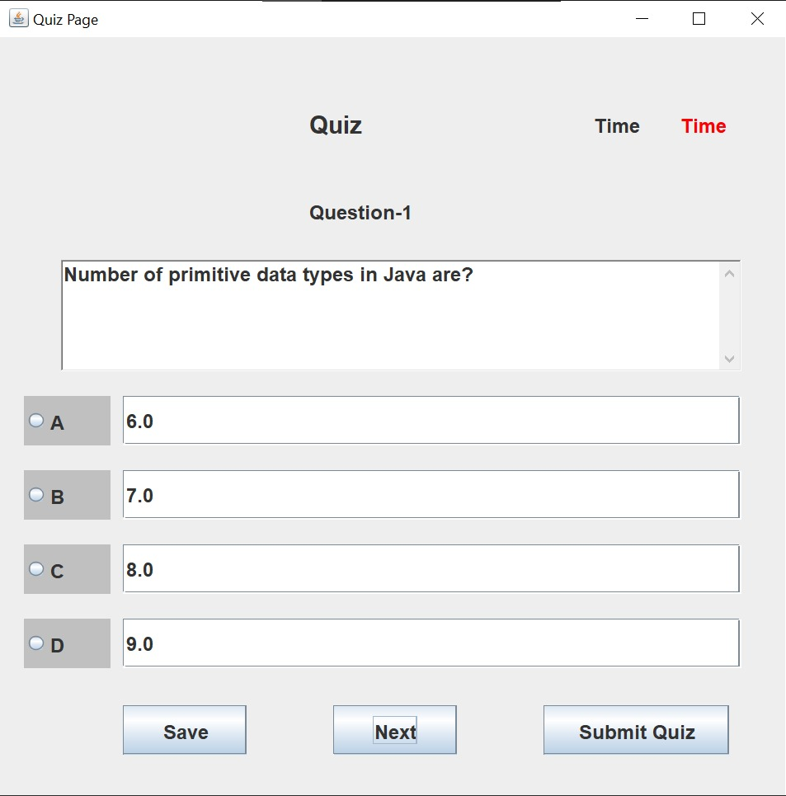

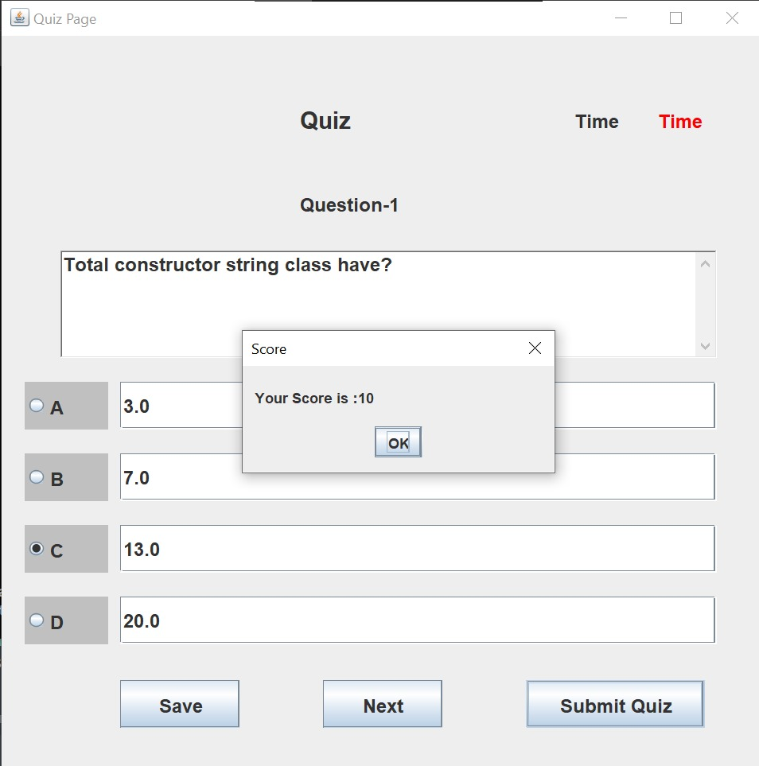

**Teacher Side :**

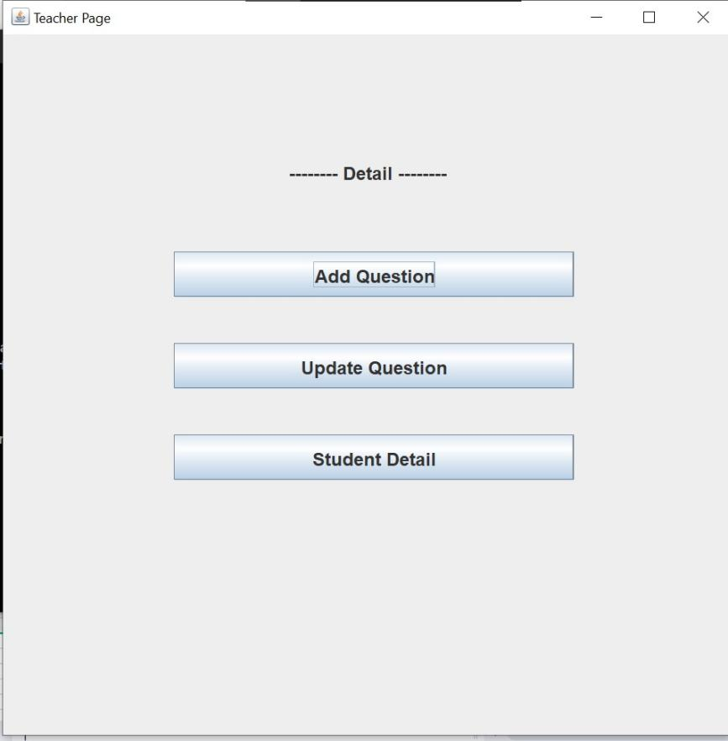

**Add Question :**

