**Basic commands and Version Control**

**Practical 1**

**Basic commands**

1.List all files with details in the directory

A: created file using (ex: cd>file1.txt)

inserted data using echo (ex: echo" content of file-1.">file1.txt)

checked the content of file using cat ( ex: cat file1.txt)

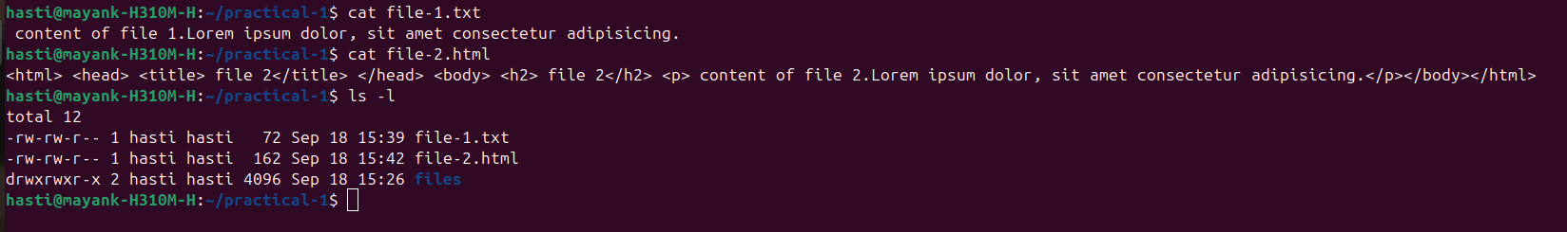

2.Give only read permission to any file

A: gave only read permission using chmod

there are 2 ways:

(1) chmod 400 file1.txt

(2) chmod ugo+r file1.txt

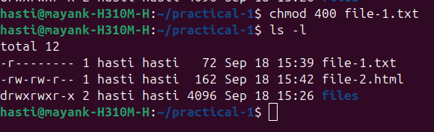

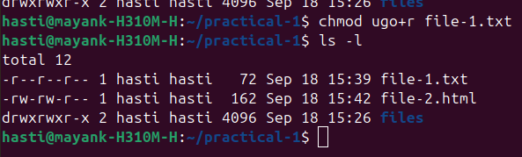

3.Give all read and write permissions to any file

A:using chmod command (ex: chmod ugo+rw file1.txt)

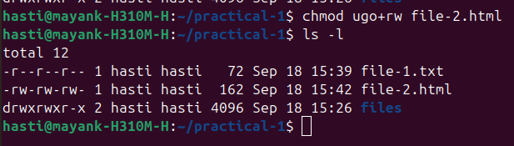

4.Get the IP address of your own pc

A: using hostname -I



5.Observe disk space usage

A: using df command

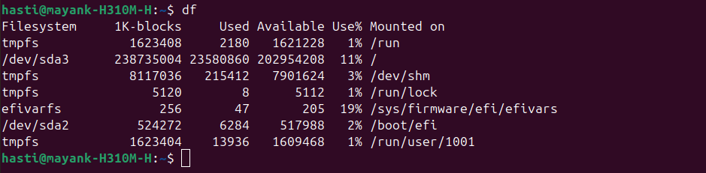

6.View previously executed commands history

A: using history command

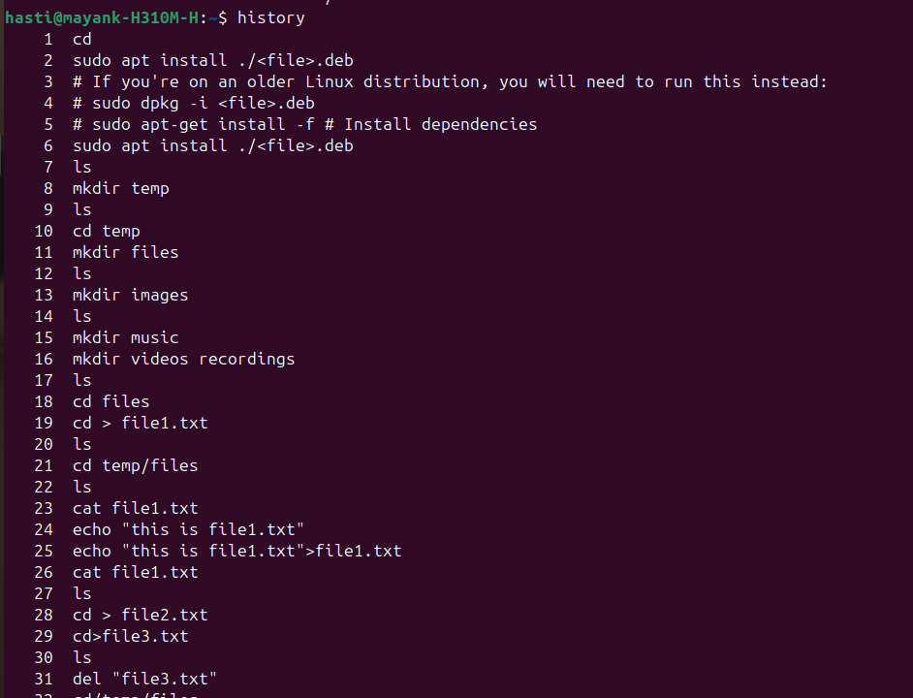

7.Linux command to install/uninstall PHP

A: sudo apt install php ( for installation)

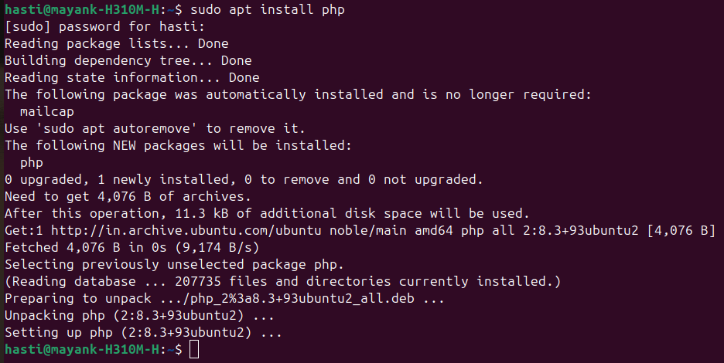

sudo apt-get remove php( for uninstallation)

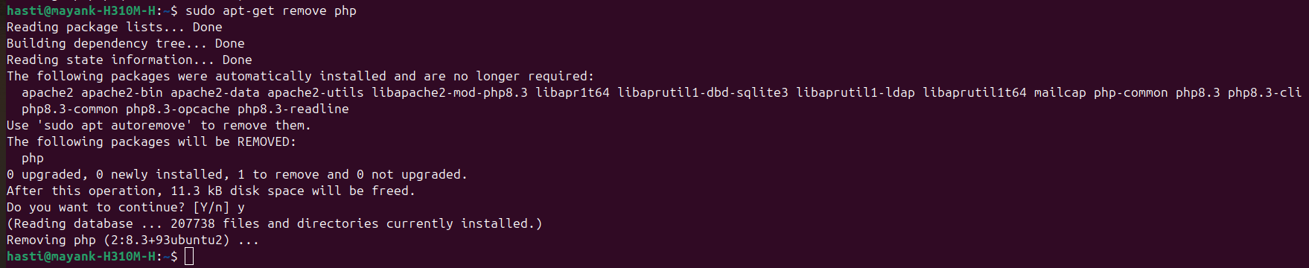

8.Linux command to start/stop mysql service

A: sudo service mysql start (for installation)

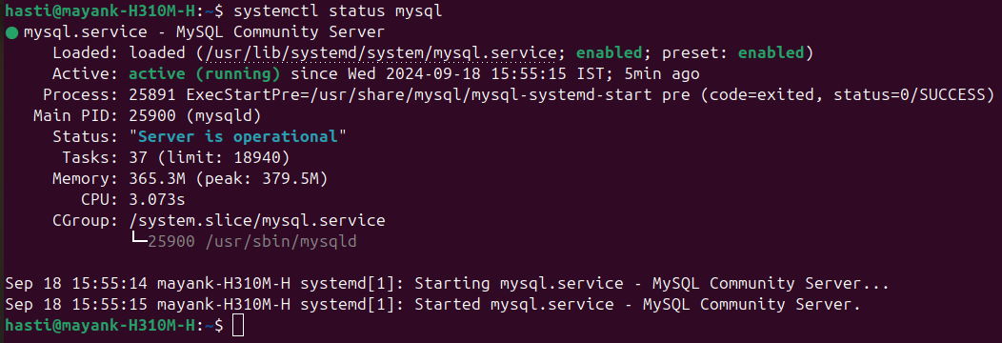

sudo service mysql stop (for un-installation)

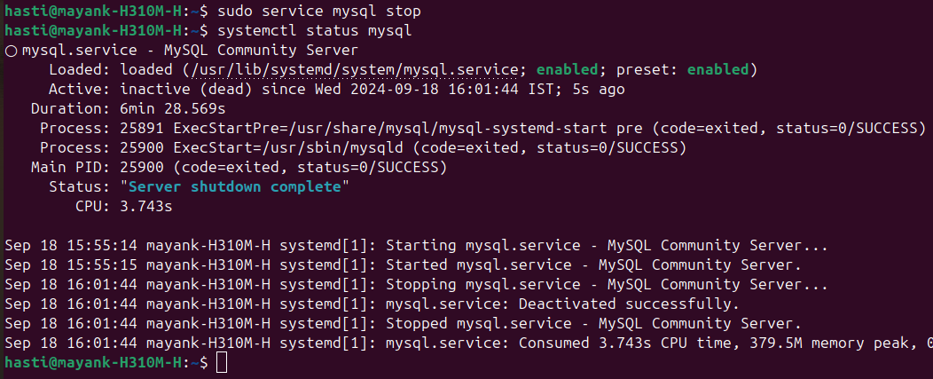

9.Write and save any file from the terminal

A: using nano command

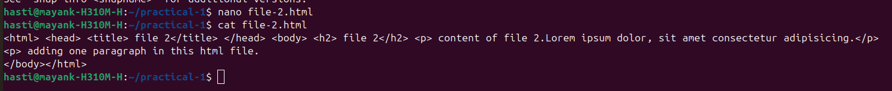

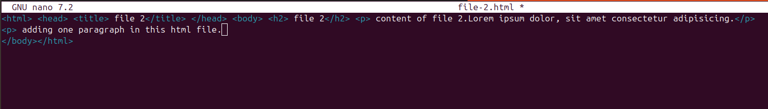

**Version Control**

1.Add files to git

A.(1) git init

(2) git remote add origin (link of repo)

(3) git add file name(ex: git add file1.txt)

(4) git commit -m "message"

(5) git push origin master

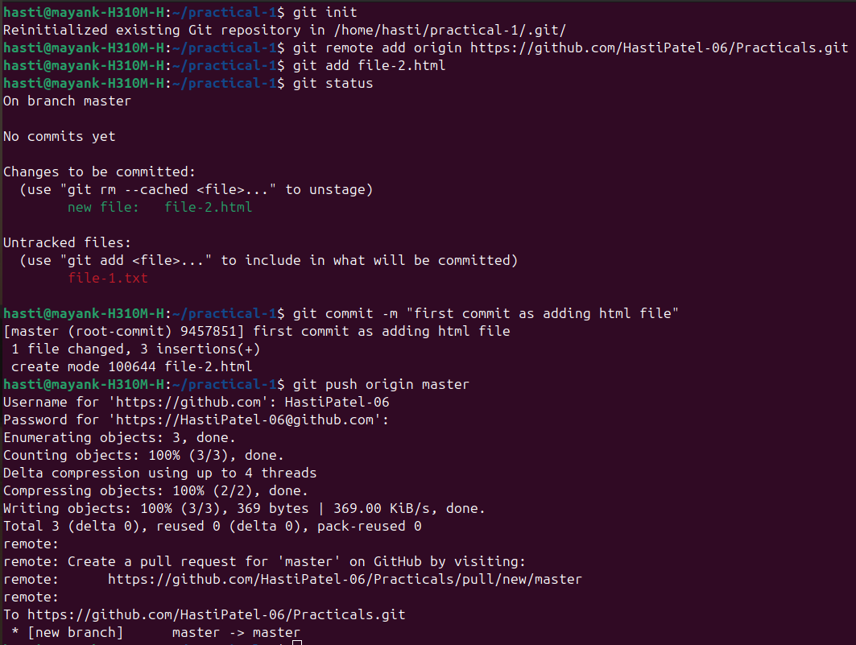

2. Check git remotes

A: git remote add origin(name) url(github repository)



3.Fetch remote branches

A: using git fetch --all

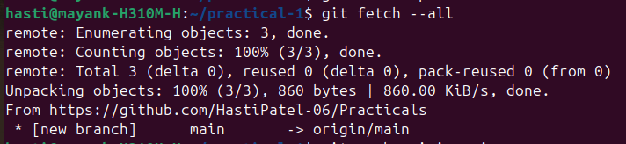

4.Delete branch

A:using git branch -d branchname

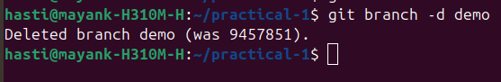

5.Check the git status of the repository

A: using git status

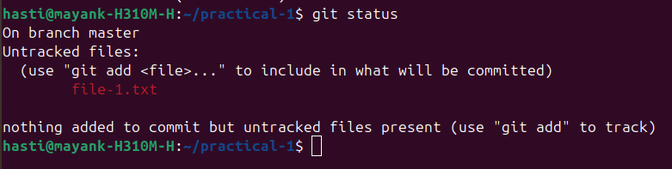

6.Commit new/updated files into a git repository

A: using git commit -m "commit message"

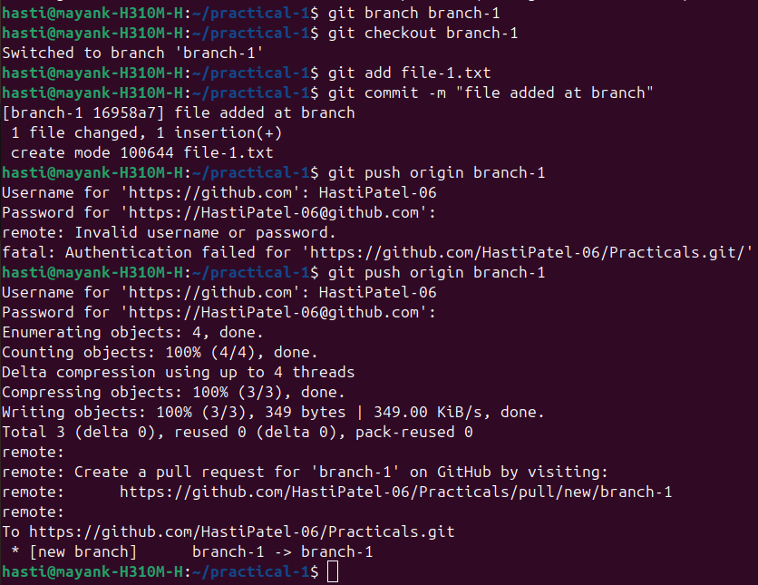

7.Push in a git repository

A: using git push origin master(branch name)

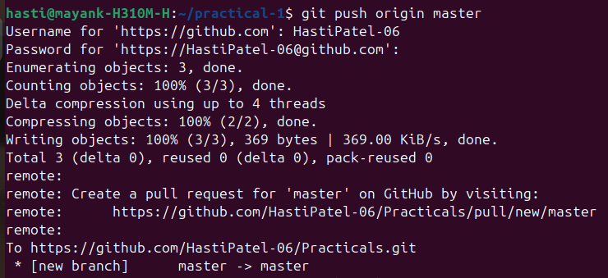

8.Pull new changes from the repository

A: using git pull origin(remote name) main(branch)

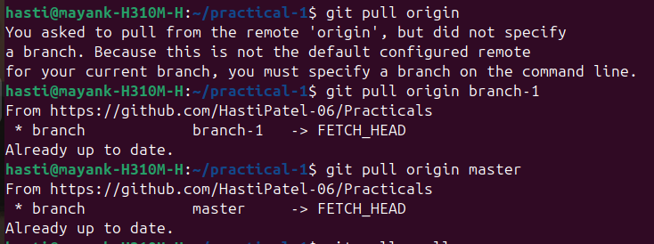

9.Checkout new branch

A: to create new branch git branch branch-name

to checkout that branch git checkout branch-name

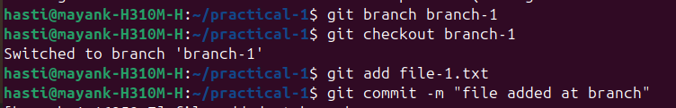

10.Merge branch into another

A: to merge branch git merge branch-name

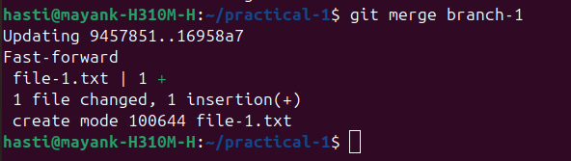

11.See commit history

A: to see commit history git log

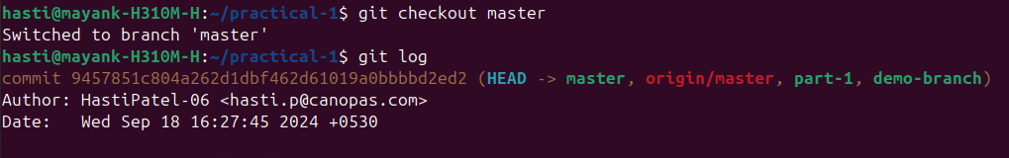

12.Write a command to clone this repo

A: to clone repo git clone link-of-repo

