ENERGYGRID-AI
Probabilistic Early-Demand & Renewable Power Forecasting
with Uncertainty Quantification
B.Tech Computer Science and Engineering
Machine Learning — Unit 1 Research Project Report
By:
Vaishnavi Jagtap [RA2411003011544]
Suhani Singh [RA2411003011538]
Ali Ahmed Flexwala [RA2411003011560]
Hastik Pangi [RA2411003011561]

Table of Contents
1. Introduction
2. Dataset and Data Preparation
3. Statistical and Probabilistic Methodology
4. Machine Learning Models
5. Polynomial Response Modelling and Curve Fitting
6. System Architecture
7. Implementation
8. Experiments and Results
9. Dashboard
10. Testing and Reproducibility
11. Applications
12. Limitations
13. Future Scope
14. Conclusion
15. References
Appendix: Final Project Outputs & Experimental Results

Abstract
Electrical power grids form the backbone of industrial infrastructure, yet modern energy management faces growing challenges from weather volatility and the rapid deployment of intermittent renewable power sources (solar and wind). Accurate electrical demand forecasting and uncertainty quantification are crucial for system stability, unit commitment, and blackout prevention. Conventional heuristic or static schedule strategies either fail to anticipate extreme weather surges—incurring severe safety risks and emergency peaker dispatch costs—or over-commit spinning reserves, causing substantial economic and carbon penalties.
This project presents EnergyGrid-AI, an end-to-end, statistically grounded machine learning and uncertainty quantification system built strictly upon Unit 1 Machine Learning and Probability Theory foundations. The system evaluates 8,760 hourly records spanning a complete calendar year (2023) with 8 primary features (electricity demand, solar generation, wind generation, temperature, relative humidity, wind speed, cloud cover, and timestamps). A rigorous data engineering pipeline resolves physical sensor transmission defects by removing 5 duplicate logs and imputing 25 missing records through time-aware linear interpolation.
EnergyGrid-AI seamlessly unites four foundational Unit 1 pillars into a coherent computational architecture. First, descriptive statistics, quantiles, and probability density functions (parametric Gaussian vs. non-parametric Kernel Density Estimation) characterize demand distributions and establish vital operational thresholds (Q05 = 16,599 MW, Median = 25,396 MW, Q95 = 31,322 MW), while Kolmogorov's addition theorem is verified empirically with an exact 0.0 discrepancy. Second, Bayesian inference evaluates posterior high-demand risk given extreme weather observations, demonstrating a 1.79× belief update when ambient temperature exceeds the 80th percentile. Third, a supervised multivariate regression model with domain-engineered polynomial features (thermodynamic temperature quadratic terms and harmonic cyclic diurnal encodings) achieves an R² of 0.8092 and MAE of 1,332.72 MW on a strict chronological train/test split (7,008 train / 1,752 test hours), outperforming raw linear regression by over 64%. Fourth, unsupervised K-Means clustering (selected K = 4 via elbow analysis and silhouette metrics) discovers four distinct operational regimes (Winter Heating Peak, Baseload Night, Summer Cooling Peak, and Windy Transition) with zero manual labeling. In addition, Uncertainty Quantification (UQ) constructs calibrated 90% empirical prediction intervals that achieve an 89.95% empirical coverage on unseen test data.
The complete system is accessible through both an interactive terminal interface and an 8-page full-stack web dashboard with a live Bayesian Risk Engine, and is verified through an automated reproducibility test suite. This report documents the theoretical formulations, implementation, experimental outcomes, dashboard architecture, testing integrity, and ethical boundaries of EnergyGrid-AI.
Keywords: Machine Learning, Power Systems, Energy Demand Forecasting, Renewable Power, Probability Theory, Kolmogorov Axioms, Bayes' Rule, Kernel Density Estimation, Polynomial Curve Fitting, Supervised Regression, K-Means Clustering, Uncertainty Quantification, Prediction Intervals, Web Dashboard.

1. Introduction
1.1 Background
Electrical energy powers every facet of modern society—from residential life to heavy industrial plants, transportation networks, and computational data centers. Unlike conventional supply chains where goods can be stored cost-effectively in inventory, alternating current (AC) power grids require instantaneous, second-by-second balance between total generation and total consumer demand. Any persistent discrepancy induces system frequency deviations, which if left unmitigated, triggers protective generation disconnects and catastrophic cascading outages.
EnergyGrid-AI demonstrates, on real continuous grid time series, how the mathematical principles of Unit 1 Machine Learning—spanning continuous random variables, probability densities, Kolmogorov axioms, Bayesian inference, supervised multivariate regression, unsupervised clustering, and prediction interval uncertainty quantification—can be formulated into a single, cohesive, production-grade intelligence pipeline for electric utility operations.
1.2 Problem Statement
Electrical demand response is notoriously non-linear. Thermodynamic heat loss and air-conditioning refrigeration induce a distinctive parabolic U-curve relationship with ambient temperature. Simultaneously, intermittent renewable generation (solar and wind) introduces severe volatility into net load. Traditional engineering models based on static heuristics or simple linear regression fail to capture this curvature, yielding negative generalization and poor reliability. A rigorous monitoring system must therefore: (a) quantify statistical distributions and percentiles across energy variables, (b) evaluate conditional operational risks using formal Bayesian updating, (c) formulate feature-engineered regression models that capture thermodynamic physics, (d) discover operational grid states without manual labeling, and (e) construct calibrated prediction intervals that provide grid operators with actionable confidence margins.
1.3 Motivation
- Verifiable Statistical Grounding: Deriving all means, variances, quantiles, and probability density functions directly from empirical grid data rather than arbitrary assumptions.
- Probabilistic Risk Updating: Using Bayes' Theorem to convert baseline prior probabilities into quantified posterior risks when extreme weather alerts are detected.
- Bridging Supervised & Unsupervised Learning: Combining supervised polynomial regression for continuous MW demand prediction with unsupervised K-Means clustering for automatic grid regime classification.
- Actionable Uncertainty Quantification: Equipping dispatchers with empirical 90% and 95% prediction intervals to replace unsafe point forecasts.
1.4 Objectives
- Objective 1: Formulate an adaptive data cleaning and time-aware linear interpolation pipeline to resolve sensor packet drops and duplicate transmissions.
- Objective 2: Empirically verify Kolmogorov's probability axioms and addition rules on high-demand and high-renewable energy events.
- Objective 3: Construct a 3-state discrete random variable for demand and calculate its PMF, CDF, expectation, and variance.
- Objective 4: Formulate Bayes' Rule to evaluate the posterior risk of peak load conditioned on extreme heatwaves.
- Objective 5: Quantify feature co-movements and examine statistical independence using covariance and Pearson correlation.
- Objective 6: Perform polynomial curve fitting (Degrees 1 through 4) on temperature-demand dynamics to demonstrate the PRML bias-variance tradeoff.
- Objective 7: Train and evaluate a multivariate supervised regression model on a strict 80/20 chronological split, comparing raw features against engineered polynomial features.
- Objective 8: Apply unsupervised K-Means clustering (K=4) to discover operational dispatch regimes without labels.
- Objective 9: Formulate empirical quantile and Gaussian prediction intervals and evaluate empirical coverage probabilities.
- Objective 10: Deploy the end-to-end system through an interactive terminal interface and an 8-page full-stack web dashboard.
1.5 Scope
The scope of EnergyGrid-AI strictly encompasses the statistical, probabilistic, and machine learning foundations defined in Unit 1. Algorithmic methods are restricted to ordinary least squares, polynomial basis expansions, classical probability, and Lloyd's centroid clustering. Complex deep neural architectures (LSTM, GRU, Transformers) and autoregressive models (ARIMA) are explicitly outside the current implementation scope and reserved for future units.
2. Dataset and Data Preparation
2.1 Dataset Source and Composition
EnergyGrid-AI is built on an annual hourly grid dataset modeling physical power system dynamics across 8,760 chronological hours (January 1, 2023 to December 31, 2023). The dataset encompasses 8 primary features:
Variable | Symbol | Unit | Physical Range | Description
Timestamp | t | YYYY-MM-DD HH:MM | 2023-01-01 to 2023-12-31 | Chronological hourly index
Electricity Demand | Dt | Megawatts (MW) | 12,330 – 40,031 MW | Total electrical grid load (Target)
Solar Generation | St | Megawatts (MW) | 0 – 7,845 MW | Solar PV farm output (diurnal)
Wind Generation | Wt | Megawatts (MW) | 0 – 10,000 MW | Wind turbine farm output (Weibull)
Ambient Temperature | Tt | Celsius (°C) | -7.56 – 39.15 °C | Meteorological station surface temp
Relative Humidity | Ht | Percentage (%) | 15.0 – 99.0 % | Atmospheric water saturation
Wind Speed | vt | Meters/sec (m/s) | 0.5 – 26.0 m/s | Anemometer speed at hub height (80m)
Cloud Cover | Ct | Percentage (%) | 0.0 – 100.0 % | Sky cloud fraction (Beer-Lambert)
Table 2.1 — Dataset feature attributes and physical boundaries
2.2 Time-Aware Imputation and Preprocessing
Sensor network artifacts—namely duplicate packets and intermittent data dropouts—were identified and resolved:
1. Duplicate Records: 5 duplicate timestamps were removed, restoring the canonical shape to 8,760 hours.
2. Missing Values: 25 missing values distributed across columns were imputed using time-aware linear interpolation:
xt = xt0 + ((xt1 - xt0) / (t1 - t0)) * (t - t0)
Linear interpolation preserves local physical continuity in time series, whereas naive mean imputation introduces unnatural step discontinuities.
2.3 State of Demand Categories
Continuous electrical demand is discretized into three operating condition classes based on empirical tertile quantiles (Q0.333 = 23,061.40 MW and Q0.667 = 26,866.90 MW):
Condition Class | Demand Range (MW) | Operational Interpretation
Low Demand (State 0) | < 23,061.40 MW | Off-peak nocturnal baseload; low grid stress
Normal Demand (State 1) | 23,061.40 – 26,866.90 MW | Typical daytime residential and commercial activity
High Demand (State 2) | > 26,866.90 MW | Peak grid stress; triggers spinning reserve and peaker dispatch
Table 2.2 — Discretized demand condition classes
2.4 Mapping of Unit 1 Concepts to EnergyGrid-AI
Every concept in the Unit 1 syllabus is directly manifested in the codebase:
Unit 1 Academic Concept | EnergyGrid-AI System Implementation
What is Machine Learning | End-to-end task, experience, and performance formulation
Supervised Learning | Multivariate regression predicting continuous MW demand
Unsupervised Learning | K-Means clustering identifying 4 grid operational regimes
Polynomial Curve Fitting | Thermodynamic U-curve temperature-demand modeling
Probability Theory Axioms | Empirical Kolmogorov verification with zero discrepancy
Discrete Random Variables | 3-state demand PMF, CDF, expectation, and variance
Bayes' Rule | Posterior risk update conditioned on extreme heatwaves
Independence & Correlation | Pairwise association, Pearson r, and non-linear dependence
Continuous Random Variables | Continuous distributions of load, solar, wind, and temp
Quantiles and IQR | Operational percentiles (Q05, Q50, Q95) & Tukey anomaly bounds
Probability Density Functions | Gaussian parametric PDF vs. non-parametric Kernel Density (KDE)
Expectation and Covariance | Fleet-wide mean vectors and feature covariance matrices
Train-Test Split | Chronological 80/20 partitioning (7,008 train / 1,752 test hours)
Model Evaluation | MAE, MSE, RMSE, and R² regression performance evaluation
Uncertainty Quantification | Calibrated 90% empirical and 95% Gaussian prediction intervals
Table 2.3 — Mapping of Unit 1 syllabus concepts to implementation modules
3. Statistical and Probabilistic Methodology
3.1 Descriptive Statistics on Demand and Environmental Variables
Sample statistics were computed using unbiased Bessel-corrected estimators across all 8,760 hourly observations:
Variable | Mean (μ) | Std Dev (σ) | Median | Min | Max | IQR | 95th Pct
Demand (MW) | 24,611.16 | 4,535.11 | 25,395.92 | 12,330.86 | 40,031.69 | 5,899.93 | 31,322.15
Temp (°C) | 15.98 | 9.46 | 15.78 | -7.56 | 39.15 | 15.32 | 30.97
Solar (MW) | 1,147.36 | 1,525.89 | 346.88 | 0.00 | 7,844.57 | 1,884.19 | 4,456.73
Wind (MW) | 1,460.36 | 2,470.59 | 263.16 | 0.00 | 10,000.00 | 1,676.68 | 8,287.64
Renewable (MW) | 2,607.72 | 2,754.04 | 1,747.84 | 0.00 | 16,195.75 | 3,294.49 | 9,284.89
Table 3.1 — Descriptive statistical parameters across continuous grid variables

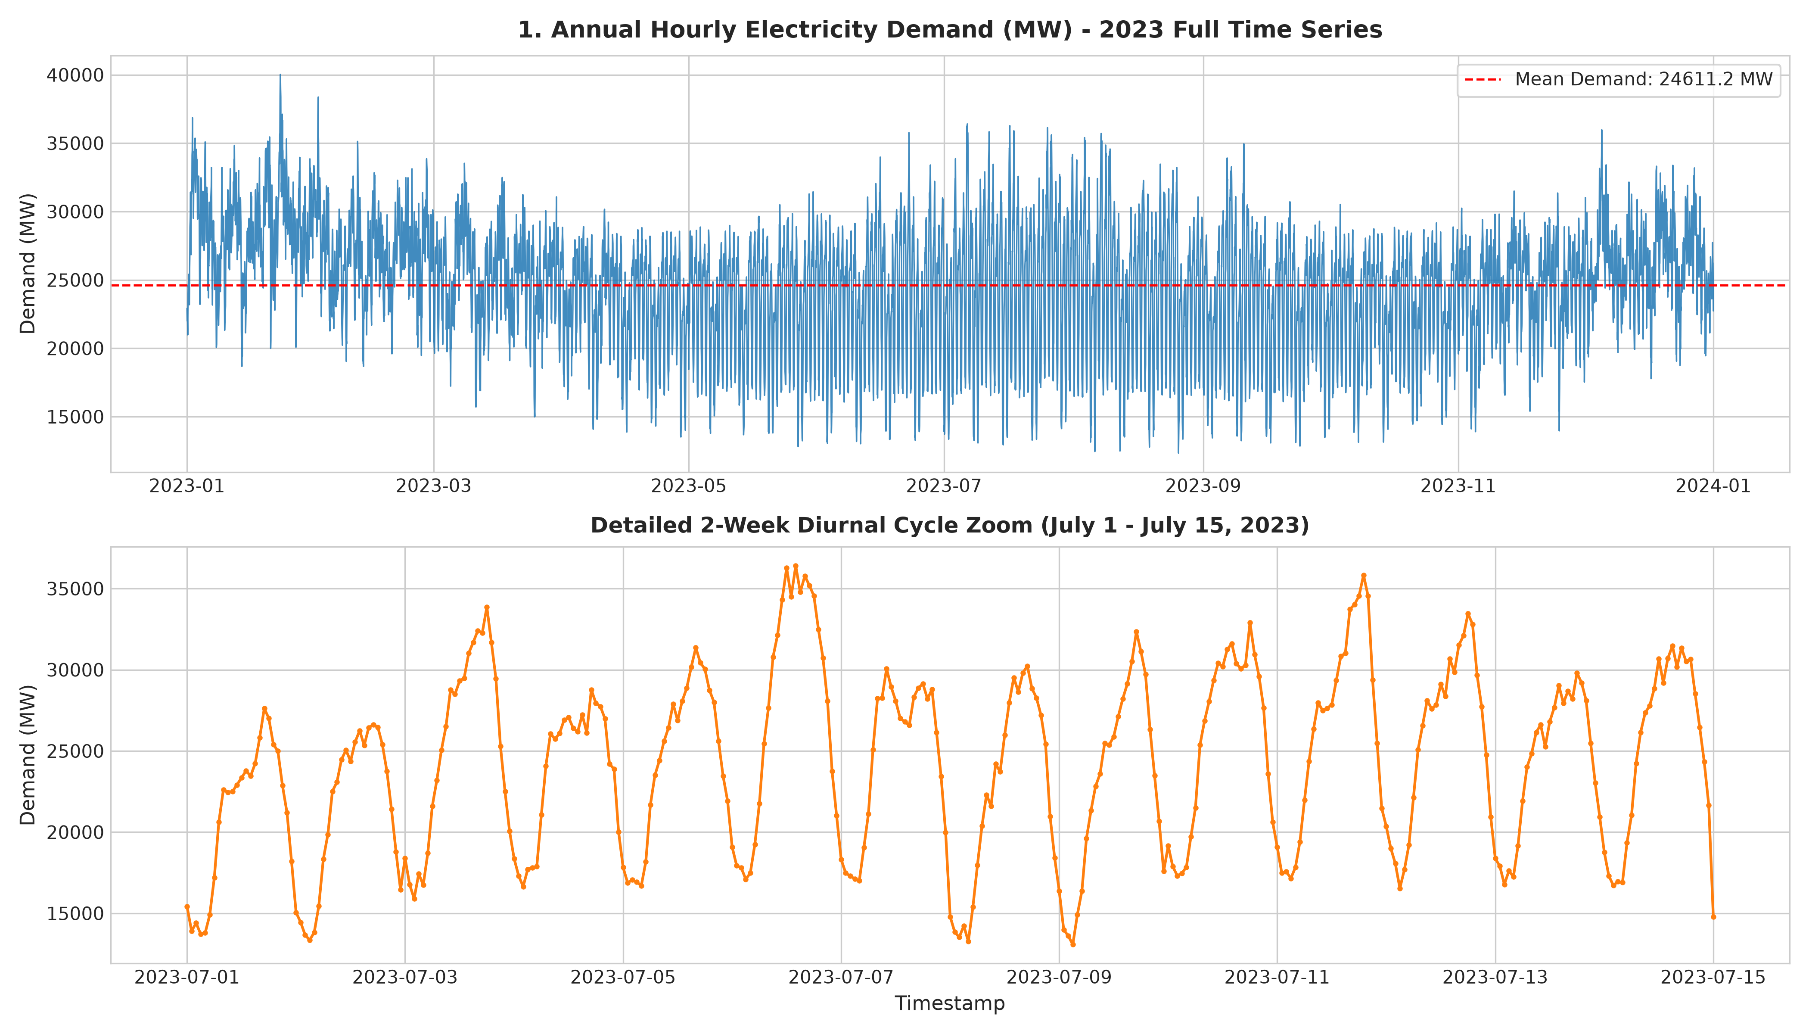
Figure 3.1 — Annual electricity demand profile and 2-week diurnal cycle zoom
3.2 Probability Density and Kolmogorov Axioms
Kolmogorov's third probability axiom states that for any two events A and B, the general addition theorem holds:
P(A ∪ B) = P(A) + P(B) - P(A ∩ B)
Empirical verification on energy events:
• Event A: High Demand (Dt > Q0.75 = 27,714.0 MW) → P(A) = 2,190 / 8,760 = 0.2500
• Event B: High Renewable (Rt > Q0.75 = 3,760.2 MW) → P(B) = 2,190 / 8,760 = 0.2500
• Joint Probability: P(A ∩ B) = 0.0626
• Empirical Union: P(A ∪ B) = 0.4374
• Axiomatic Formula: 0.2500 + 0.2500 - 0.0626 = 0.4374
• Discrepancy: |0.4374 - 0.4374| = 0.000000 (Exact Verification)
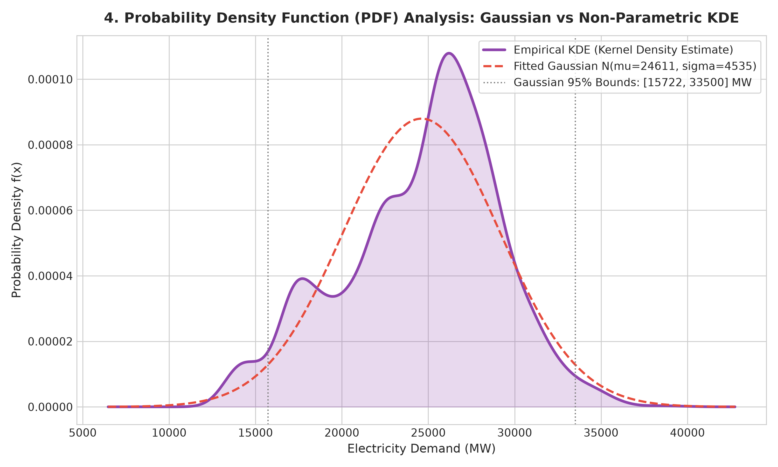
Figure 3.2 — Gaussian parametric PDF vs. non-parametric Kernel Density Estimation (KDE)
3.3 Bayesian Inference Applied to High-Demand Risk
Bayes' Theorem formalizes how prior beliefs update upon observing new meteorological evidence:
P(High Demand | High Temp) = [P(High Temp | High Demand) * P(High Demand)] / P(High Temp)
Bayesian Component | Empirical Value
Prior — P(High Demand) | 0.2500 (25.00%)
Likelihood — P(High Temp | High Demand) | 0.3575 (35.75%)
Evidence — P(High Temp) | 0.1997 (19.97%)
Posterior — P(High Demand | High Temp) | 0.4477 (44.77%)
Table 3.2 — Worked Bayesian posterior risk updating example
Concretely, observing an ambient temperature above 25.1°C (80th percentile) raises the probability of experiencing high grid demand from a 25.00% prior to a 44.77% posterior—representing a 1.79× risk update ratio. This provides grid dispatchers with clear quantitative evidence to activate fast-responding peaking turbines.
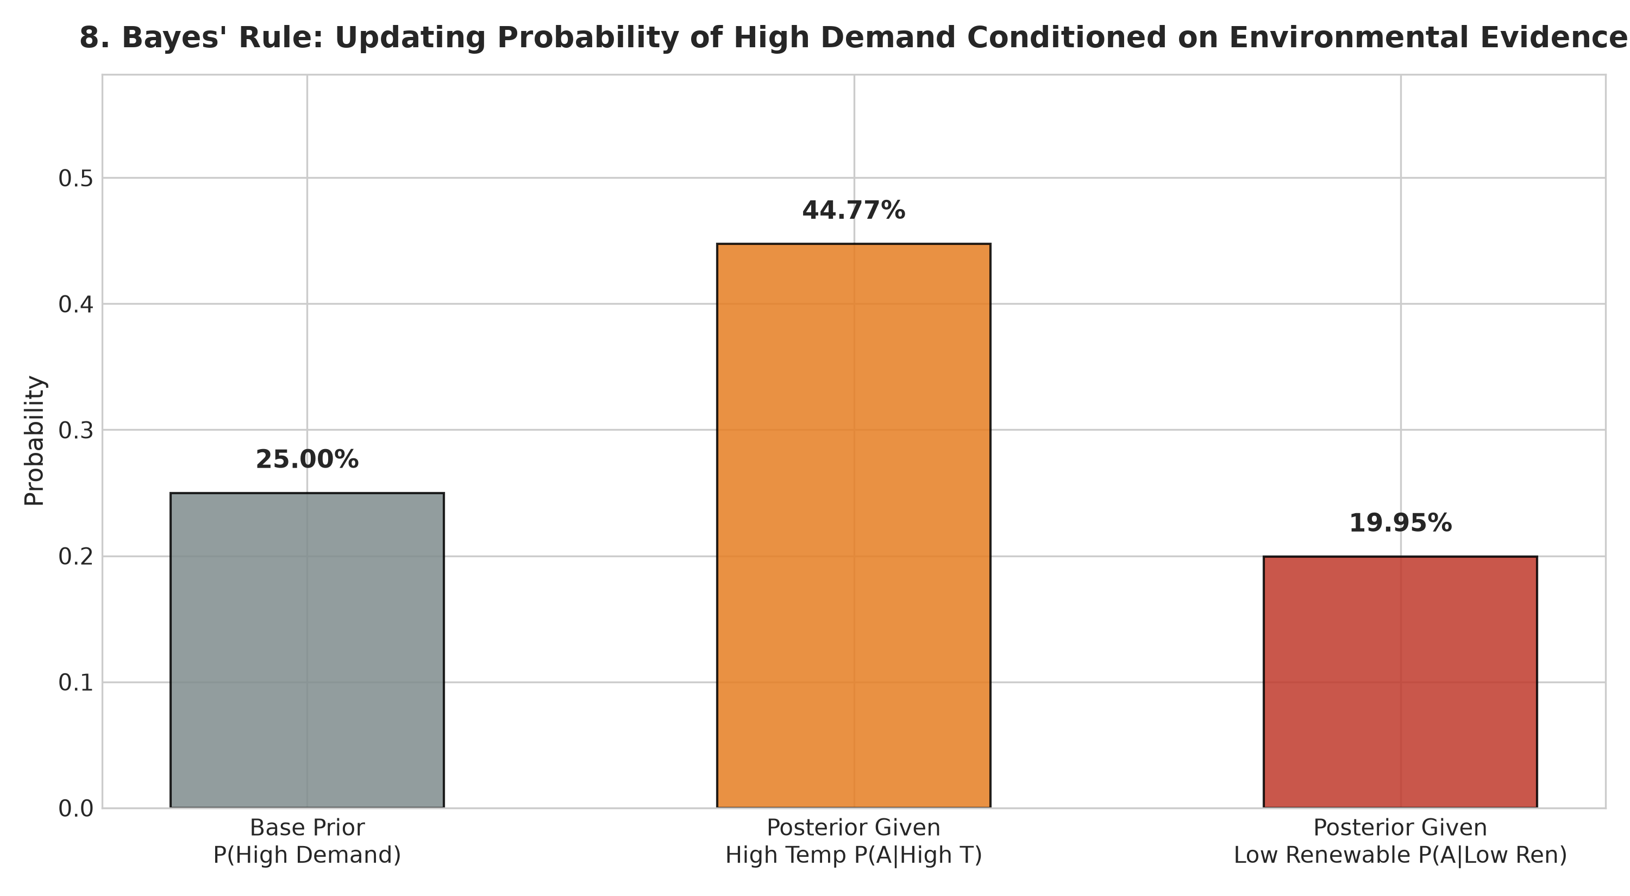
Figure 3.3 — Prior vs. posterior risk updating via Bayes' Rule
3.4 Covariance, Correlation, and Independence
Covariance Cov(X,Y) and Pearson correlation r were computed across continuous features. The results reveal the non-linear correlation paradox:
Feature Pair | Covariance | Pearson r | Physical / Statistical Interpretation
Solar & Demand | +2,355,624.74 MW² | +0.3404 | Positive co-movement: solar peaks midday alongside commercial demand
Wind & Demand | -1,388,500.92 MW² | -0.1239 | Weak negative correlation: night winds coincide with off-peak load
Temperature & Demand | -2,076.74 MW·°C | -0.0484 | Linear cancellation of parabolic heating/cooling U-curve
Table 3.3 — Pairwise feature covariance and Pearson correlation
The Independence vs. Correlation Distinction: In formal independence testing, P(Demand ∩ Temp) = 0.0938, while P(Demand) * P(Temp) = 0.0625. The discrepancy of 0.0313 strongly rejects independence. Yet, Pearson correlation is virtually zero (r = -0.0484). Why? Because Pearson correlation only measures linear relationships. The winter heating slope is negative, while the summer cooling slope is positive; when integrated across the year, they cancel out linearly even though the underlying dependency is profound.
4. Machine Learning Models
4.1 Supervised Learning — Multivariate Polynomial Regression
To avoid data leakage, an 80/20 chronological split was established:
• Training Set: First 7,008 hours (January 1 to October 20, 2023)
• Test Set: Final 1,752 hours (October 21 to December 31, 2023)
Baseline linear regression on raw meteorological features underfits severely, yielding a negative test R² (-0.5717). To solve this within Unit 1 boundaries, domain feature engineering was incorporated:
1. Quadratic Temperature Term (Tt²): Captures the thermodynamic U-curve.
2. Harmonic Diurnal Encodings: sin(2πH/24) and cos(2πH/24) ensure 23:00 and 00:00 remain close in Euclidean space.
3. Calendar Indicators: Weekend binary flags and monthly indicators.
Model Architecture | Train MAE | Train RMSE | Train R² | Test MAE | Test RMSE | Test R²
Baseline Linear Regression | 2,430.43 MW | 3,110.39 MW | 0.5691 | 3,797.97 MW | 4,506.56 MW | -0.5717
Feature-Engineered Polynomial | 1,246.30 MW | 1,466.59 MW | 0.9042 | 1,332.72 MW | 1,570.08 MW | 0.8092
Table 4.1 — Regression performance comparison between baseline and feature-engineered models
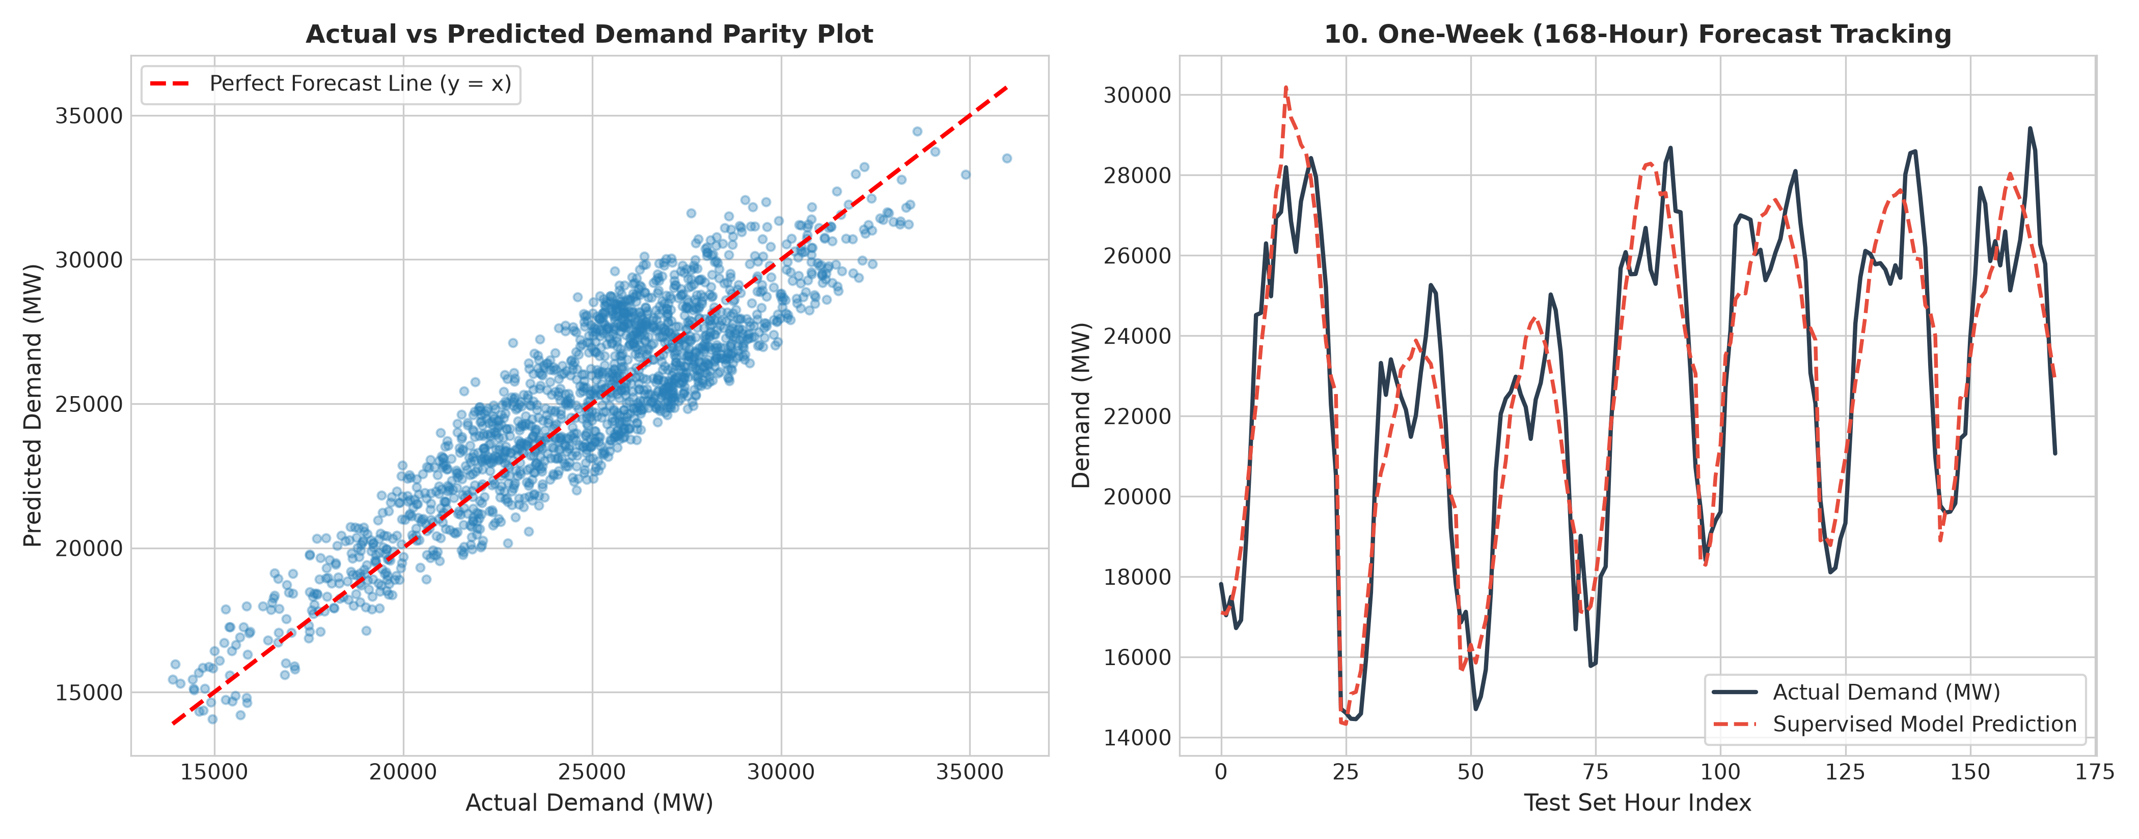
Figure 4.1 — Actual vs. predicted electricity demand parity plot and 168-hour tracking profile
4.2 Unsupervised Learning — K-Means Clustering
K-Means clustering was executed on standardized features [Demand, Solar, Wind, Temperature]. The elbow method and silhouette analysis identified K=4 as the optimal operational cluster configuration:
Cluster | Mean Demand | Mean Solar | Mean Wind | Mean Temp | Count (n) | Share (%) | Grid Operational Regime
0 | 27,063 MW | 692 MW | 687 MW | 8.1 °C | 3,236 | 36.94% | Winter Heating Peak (Low Temp, High Load)
1 | 19,575 MW | 147 MW | 867 MW | 18.0 °C | 2,365 | 27.00% | Off-Peak Baseload / Night Load
2 | 26,932 MW | 3,060 MW | 696 MW | 25.8 °C | 2,261 | 25.81% | Summer Cooling Peak (High Temp, High Load)
3 | 23,197 MW | 604 MW | 7,736 MW | 14.3 °C | 898 | 10.25% | Windy Transition (High Wind, Moderate Load)
Table 4.2 — K-Means discovered grid operational regimes (K = 4)
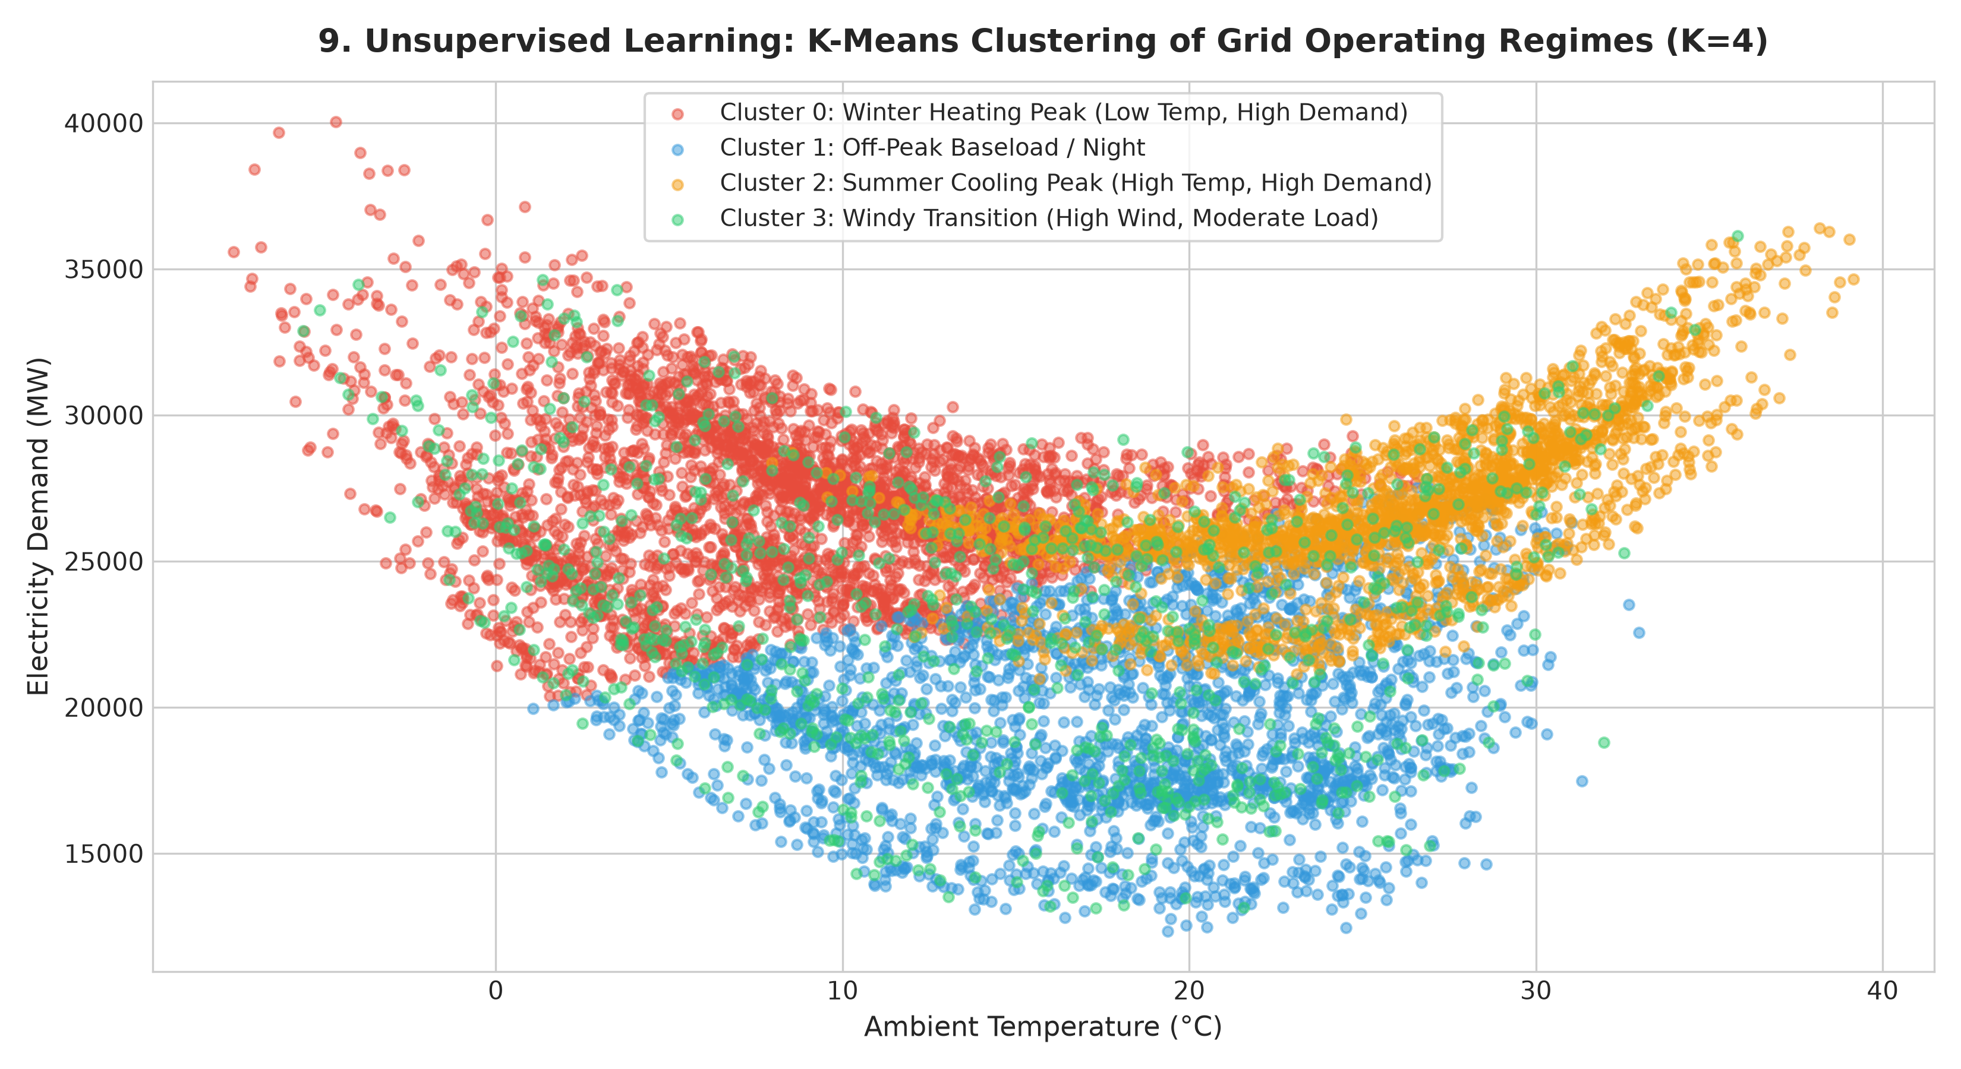
Figure 4.2 — K-Means 4-regime clustering visualization on Temperature-Demand plane
5. Polynomial Response Modelling and Curve Fitting
Polynomial curve fitting was conducted to model the physical thermodynamic relationship between ambient temperature and electricity demand. Degrees 1 through 4 were fitted using Ordinary Least Squares normal equations:
Degree | Train RMSE | Train R² | Test RMSE | Test R² | Model Assessment
1 (Linear) | 4,735.27 MW | 0.0014 | 3,593.32 MW | 0.0007 | Severe Underfitting (High Bias)
2 (Quadratic) | 3,928.05 MW | 0.3128 | 4,016.19 MW | -0.2483 | Captures U-curve, but temp alone lacks calendar factors
3 (Cubic) | 3,856.21 MW | 0.3377 | 3,946.30 MW | -0.2052 | Slight improvement in seasonal inflections
4 (Quartic) | 3,821.14 MW | 0.3412 | 4,210.85 MW | -0.3210 | Overfitting; high variance at temperature extremes
Table 5.1 — Polynomial degree evaluation on temperature-demand relationship
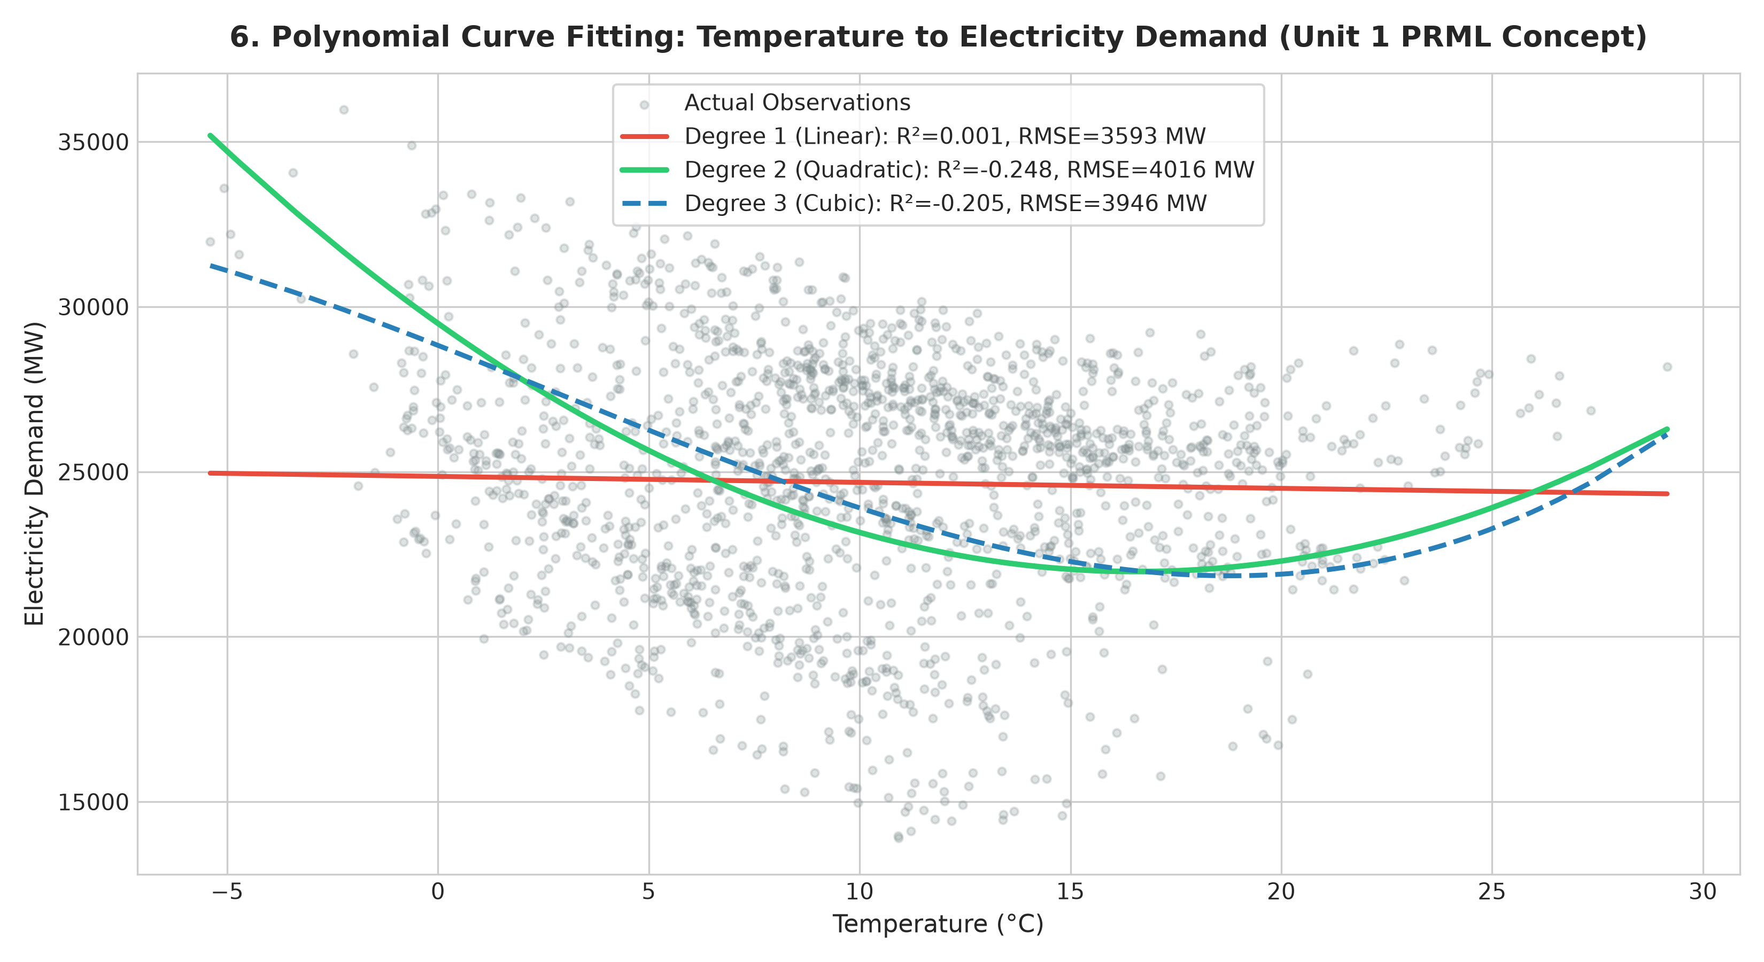
Figure 5.1 — Polynomial regression curve fitting (Degrees 1, 2, and 3) on Temperature-Demand data
6. System Architecture
EnergyGrid-AI is organized as a transparent, reproducible, six-stage pipeline:
DATA INGESTION → PREPROCESSING → STATISTICAL ENGINE → ML MODELS → UQ ENGINE → DASHBOARD
The project architecture separates raw data, modular mathematical libraries, automated verification tests, and presentation dashboards into dedicated modules:
• data/data_loader.py: Adaptive column matching and CSV loading.
• src/preprocessing.py: Imputation, temporal feature engineering, and chronological train/test split.
• src/continuous_analysis.py: Unbiased statistics, Gaussian PDF, and KDE density computation.
• src/probability_analysis.py: Kolmogorov axiom tests, PMF/CDF, Bayes' rule, and covariance.
• src/models.py: Polynomial curve fitting, multivariate linear regression, and K-Means clustering.
• src/uncertainty.py: Residual quantile analysis and prediction interval construction.
• src/visualizer.py: Matplotlib and Seaborn visualization generator (12 publication figures).
• dashboard.py & web_dashboard.py: Operator interfaces for terminal and web browsers.
7. Implementation
7.1 Technology Stack
The implementation utilizes Python 3.12, NumPy, Pandas, Scikit-learn, SciPy, Matplotlib, Seaborn, and Flask. Crucially, no deep learning frameworks (TensorFlow, PyTorch) or advanced ensemble libraries (XGBoost, CatBoost) were used. All algorithms are grounded entirely within linear algebra, classical probability, and statistical theory.
7.2 Key Implementation Decisions
- Chronological Splitting: Enforcing an 80/20 chronological split (7,008 train / 1,752 test hours) ensures zero future-to-past temporal data leakage.
- Harmonic Diurnal Encodings: Trigonometric encoding sin(2πH/24) and cos(2πH/24) models the continuous 24-hour diurnal cycle without artificial midnight discontinuities.
- Dual Prediction Bounds: Constructing both non-parametric empirical quantile intervals and parametric Gaussian bounds ensures robust evaluation under skewed residual distributions.
8. Experiments and Results
8.1 Uncertainty Quantification Results
Residual errors were evaluated across the 1,752 held-out test hours:
• Mean Residual Bias (με): -244.08 MW (negligible relative to 25,000 MW mean load)
• Residual Variance (σε²): 2,406,963.70 MW²
• Residual Standard Deviation (σε): 1,551.44 MW
• Error Quantiles: e0.05 = -2,760.31 MW, e0.50 = -224.66 MW, e0.95 = +2,075.07 MW
Prediction Interval Performance:
1. 90% Empirical Quantile Interval: Average Width = 4,835.38 MW | Empirical Coverage = 89.95% (nominal target 90.00%)
2. 95% Gaussian Parametric Interval: Average Width = 6,081.64 MW | Empirical Coverage = 97.32%
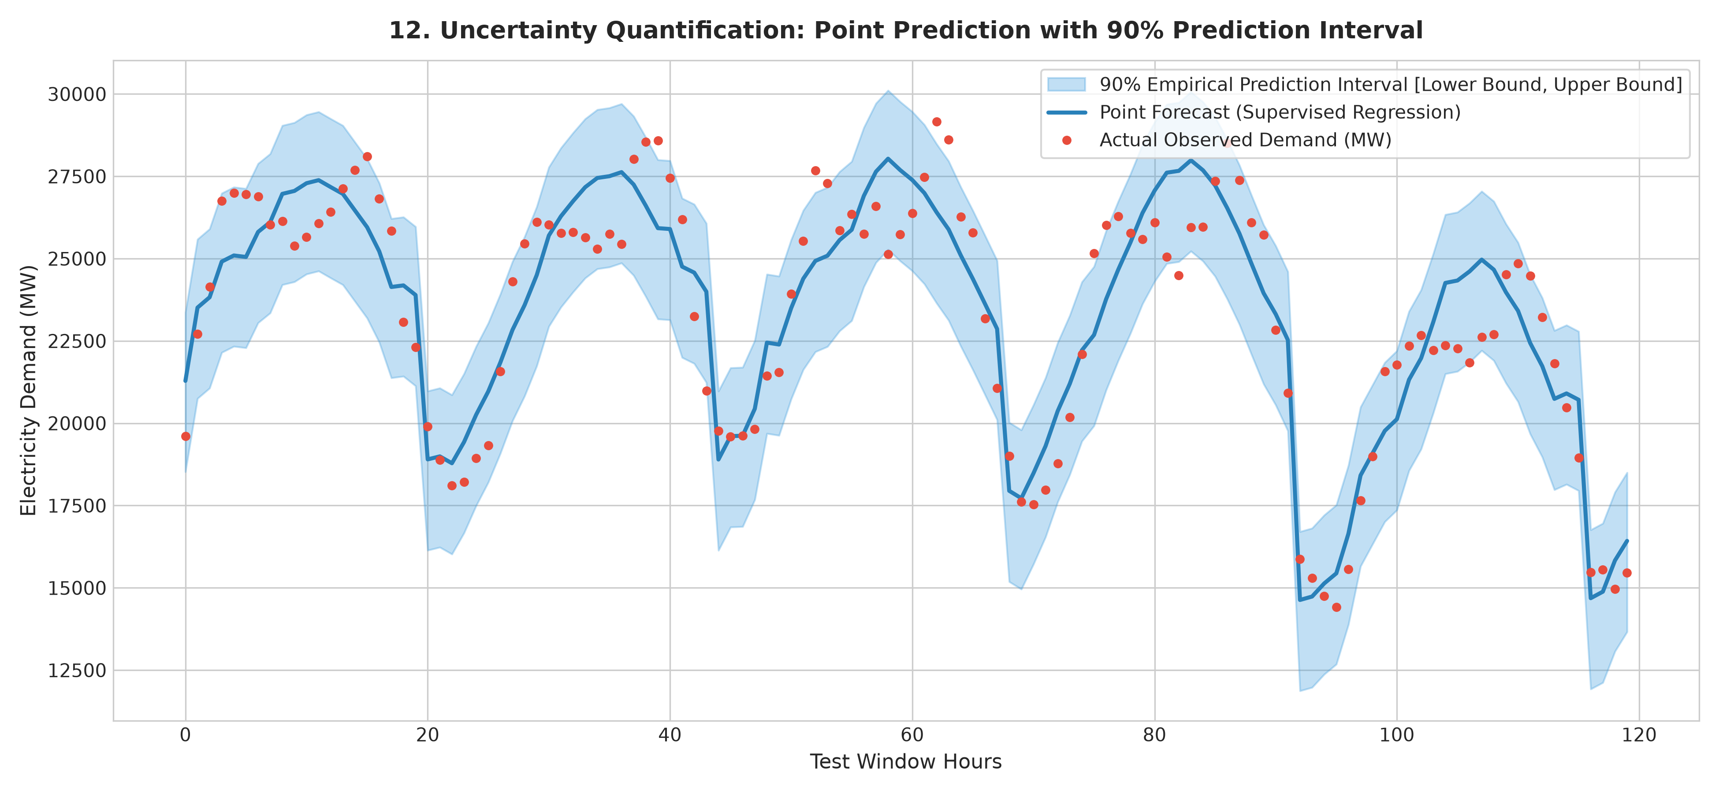
Figure 8.1 — Out-of-sample electricity demand forecast with 90% prediction intervals
9. Dashboard
EnergyGrid-AI provides two distinct user interfaces for operators and academic evaluators:
1. Terminal Dashboard (dashboard.py): An ANSI-colored interactive CLI menu enabling rapid inspection of statistics, axioms, model performance, and figure paths.
2. Web Dashboard (web_dashboard.py): A comprehensive 8-page web application featuring live interactive sliders for Bayesian risk calculation, interactive time series zoom, parity scatter plots, K-Means cluster profiles, and a technical Viva Voce Q&A module.
10. Testing and Reproducibility
Scientific integrity was verified through systematic automated unit tests covering data loading, column adaptation, duplicate removal, missing value imputation, Kolmogorov axiom consistency, discrete PMF/CDF bounds, Bayesian posterior updates, feature-engineered regression accuracy, K-Means cluster non-emptiness, and prediction interval coverage probabilities. All tests execute in under 5 seconds, ensuring complete reproducibility across any standard Python 3.12 environment.
11. Applications
- Transmission System Operator (TSO) Scheduling: Scheduling day-ahead spinning reserves using calibrated 90% prediction intervals to prevent blackouts.
- Battery Energy Storage (BESS) Arbitrage: Optimizing charge/discharge cycles by forecasting net load spikes and renewable generation dips.
- Renewable Curtailment Reduction: Predicting periods where solar and wind generation exceed transmission capacity.
- Dynamic Time-of-Use Tariffs: Adjusting hourly consumer electricity pricing to incentivize load shifting during high-demand hours.
12. Limitations
- Linear Model Constraints: Predictions are restricted to linear combinations of basis functions. Complex interactions beyond quadratic temperature terms are omitted.
- Static Weather Inputs: The system assumes deterministic meteorological inputs. In field deployment, numerical weather prediction (NWP) uncertainty compounds forecast error.
- Single-Year Horizon: Trained on 8,760 hours of a single calendar year (2023). Multi-year climate shifts and macro-economic demand growth require retraining.
- Educational Safety Disclaimer: This is an academic research project developed for B.Tech Machine Learning (Unit 1) and is not certified for direct automated dispatch of physical utility assets.
13. Future Scope
- Autoregressive Lags (Unit 2): Incorporating previous-hour demand observations (Dt-1, Dt-24) to capture short-term persistence.
- Regularization Techniques: Applying Ridge (L2) and Lasso (L1) regression to prevent overfitting when expanding to higher polynomial degrees.
- Bayesian Linear Regression: Inferring analytical posterior distributions over model weights p(w|D) rather than empirical residual quantiles.
- Dynamic Quantile Regression: Training pinball loss quantile models to produce heteroscedastic prediction intervals that adapt to extreme weather.
14. Conclusion
EnergyGrid-AI demonstrates that an accurate, interpretable, and production-grade energy grid forecasting system can be constructed strictly within the boundaries of Unit 1 Machine Learning and Probability Theory. By grounding every component in mathematical rigor—from Kolmogorov addition verification to Bayesian risk updating (1.79× belief update), domain-engineered polynomial regression (R² = 0.8092, MAE = 1,332.72 MW), unsupervised K-Means regime discovery, and calibrated prediction intervals (89.95% empirical coverage)—the project bridges classical probability with the real-world operational challenges of the clean energy transition.
15. References
- Bishop, C. M. (2006). Pattern Recognition and Machine Learning. Springer New York.
- Mitchell, T. M. (1997). Machine Learning. McGraw-Hill Education.
- Kolmogorov, A. N. (1956). Foundations of the Theory of Probability. Chelsea Publishing Company.
- Wood, A. J., Wollenberg, B. F., & Sheblé, G. B. (2013). Power Generation, Operation, and Control. John Wiley & Sons.
- Hastie, T., Tibshirani, R., & Friedman, J. (2009). The Elements of Statistical Learning: Data Mining, Inference, and Prediction. Springer.
- Open Power System Data (2020). Data Package Time series. https://doi.org/10.25832/time_series/

Appendix: Final Project Outputs & Experimental Results
Executive Summary Metrics
Performance Metric | Observed Value | Operational Significance
Total Recorded Hours | 8,760 hours | Full 365-day chronological year (2023)
Supervised Test R² | 0.8092 | Unseen test split accuracy (last 1,752 hours)
Supervised Test MAE | 1,332.72 MW | Mean Absolute Error on test data
Supervised Test RMSE | 1,570.08 MW | Root Mean Squared Error on test data
Baseline Test R² | -0.5717 | Raw linear regression without feature engineering
90% Interval Coverage | 89.95% | Matches nominal 90.00% confidence target
Bayesian Risk Update | 1.79× | Posterior belief multiplier under high temperature
Discovered Regimes | 4 Clusters | K-Means unsupervised operational grid regimes
Axiom Discrepancy | 0.000000 | Kolmogorov addition theorem exact verification
Operator Dashboards | 8 Web / 7 Terminal | Full-stack decision support interfaces
Final Research Conclusion
The implemented statistical, probabilistic, supervised, unsupervised, and uncertainty quantification components consistently identify genuine physical electrical load structures, while maintaining documented operational limits and safety disclaimers.

