**PORTFOLIO**  
21CSC203P – ADVANCED PROGRAMMING PRACTICE

**NAME: Hastik Pangi**  
**Register Number: [RA2411003011561]**

**DEPARTMENT OF COMPUTING TECHNOLOGIES**  
FACULTY OF ENGINEERING AND TECHNOLOGY  
SCHOOL OF COMPUTING  
SRM INSTITUTE OF SCIENCE AND TECHNOLOGY  
KATTANKULATHUR

**OCTOBER 2025**

**About Me**

I am a dedicated and enthusiastic programmer with a passion for software development and technology. My interests lie in building efficient, user-friendly applications and solving complex problems using modern programming languages. I am committed to continuous learning and aspire to excel as a software engineer, with a particular focus on Java development.

**Education**

* **Bachelor of Technology in Computer Science and Engineering**  
  SRM Institute of Science and Technology, Kattankulathur

**Skills**

* Programming Languages: Java, Python, C++
* Web Technologies: HTML, CSS, JavaScript (Basics)
* Database Management: MySQL, JDBC
* Tools & Platforms: Git, GitHub, Leetcode , Hacker rank
* Problem Solving & Algorithms

**Projects**

**-Smart Expense splitter**

**Description**

Smart Expense Splitter is a full-stack web application designed to help users manage and split expenses among individuals and groups. The app allows users to add, view, and delete personal and group expenses, automatically calculates how costs should be shared, and provides features like bill scanning using OCR for quick entry. Built with React for the frontend and Spring Boot with MySQL for the backend, it offers a user-friendly interface, persistent data storage, and transparent expense tracking—making it ideal for roommates, friends, or teams sharing costs.

**GitHub**

* Profile: https://github.com/Hastik172
* Notable Projects:
  + Smart Expense Splitter

**Certificates & Achievements**

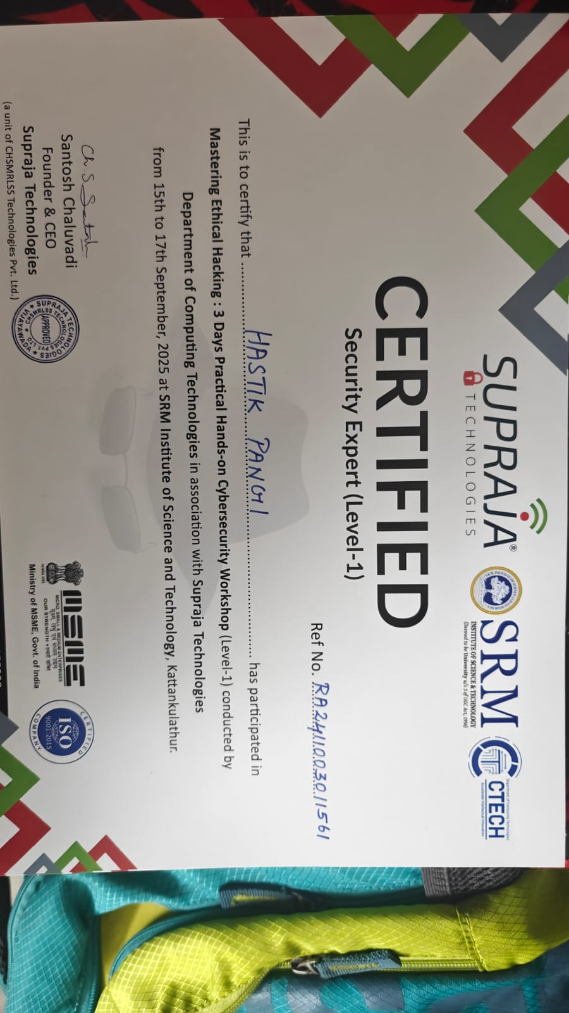

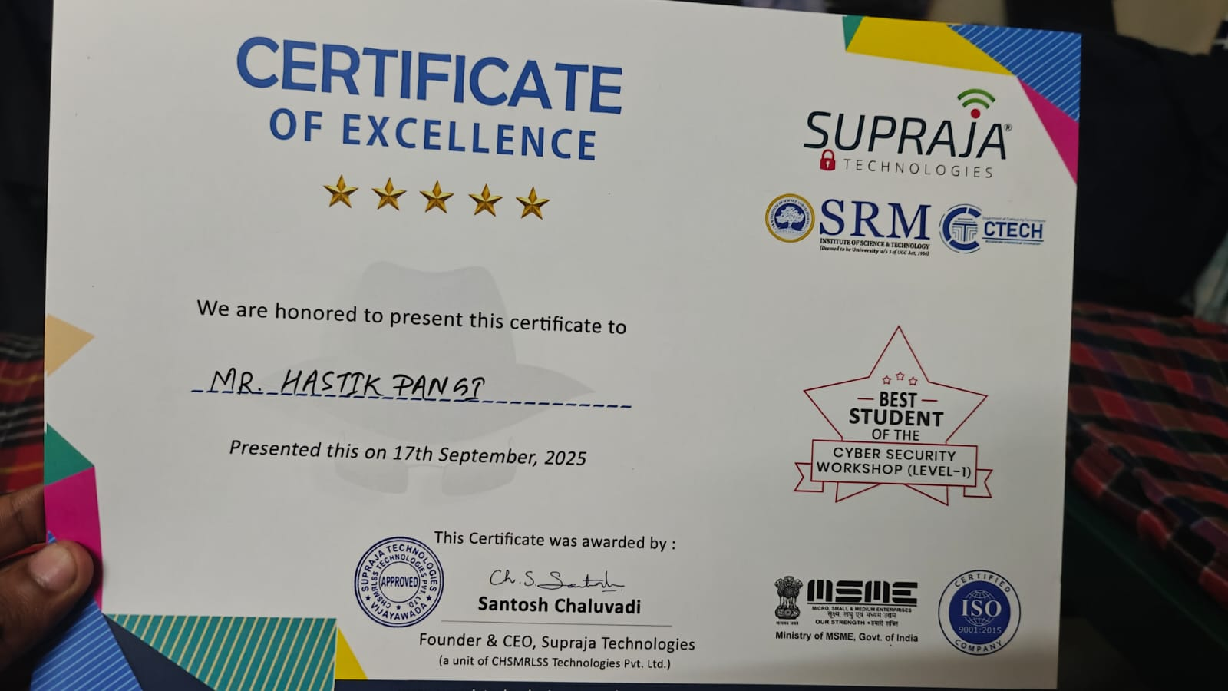**Company Identification Number (CIN Number) : U72900AP2019PTC111909**

**PAN Number : AAICC1770E, TAN Number : HYDC10078F**

**ISO Certificate Number : 031122019107**

**MSME Registration Certificate No : UDYAM-AP-06-0035821**

**Supraja Technologies Trademark Application ID No for Class 41 : 4146139**

**Supraja Technologies Trademark Application ID No for Class 42 : 4146144**

**17th September, 2025**

**To**

**Hastik Pangi**

**CYBER SECURITY INTERNSHIP OFFER LETTER**



Dear

Hastik

Pangi,

Supraja

Technologies

is

pleased

to

offer

you

an

internship

opportunity

as

“

Student

Intern

”

in

our

company.

You

will

report

directly

to

Mr.Santosh

Chaluvadi.

This

position

is

located

in

Vijayawada

branch

office

(

offline

Internship)

OR

online

internship

(

online

)

as

per

student

choice.

You

will

be

entitled

to

receive

intensive

training

&

guidance,

project

works

and

other

benefits

from

the

company

’

s

subject

to

existing

company

rules

and

satisfactory

performance

during

your

internship

program.

The

exact

role,

duties

&

responsibilities,

description

and

schedule

will

be

intimated

upon

the

confirmation

of

your

acceptance

and

shall

be

discussed

accordingly.

Congratulations

and

welcome

to

the

team!

Sincerely,

Authorized

Signatory,

Supraja

Technologies.

**NOTE : Training fee and Project fee is totally waived off and it is completely free of cost. There will be only TOOLKIT CHARGES of 2000 RUPEES applicable as per the organization policy.**

**This offer letter is valid until 30-03-2026.**

**Ref: SUP/2025/09/SRMKTR/RA2411003011561**

***SUPRAJA TECHNOLOGIES***

**(a unit of CHSMRLSS Technologies Private Limited)**

**An MSME & ISO 9001:2015 Certified Company**

**Regd. & Head Office : Door No. 11-9-18, 1st Floor, Majjivari Street, Kothapeta, Vijayawada - 520001.**

**Branch Office : Prabhu Villas, Plot No. 124, 1st Floor, Church Road, Ayyappa Nagar, Vijayawada - 520007. contact@suprajatechnologies.com |** [**www.suprajatechnologies.com**](http://www.suprajatechnologies.com/) **| +91 - 9550055338**

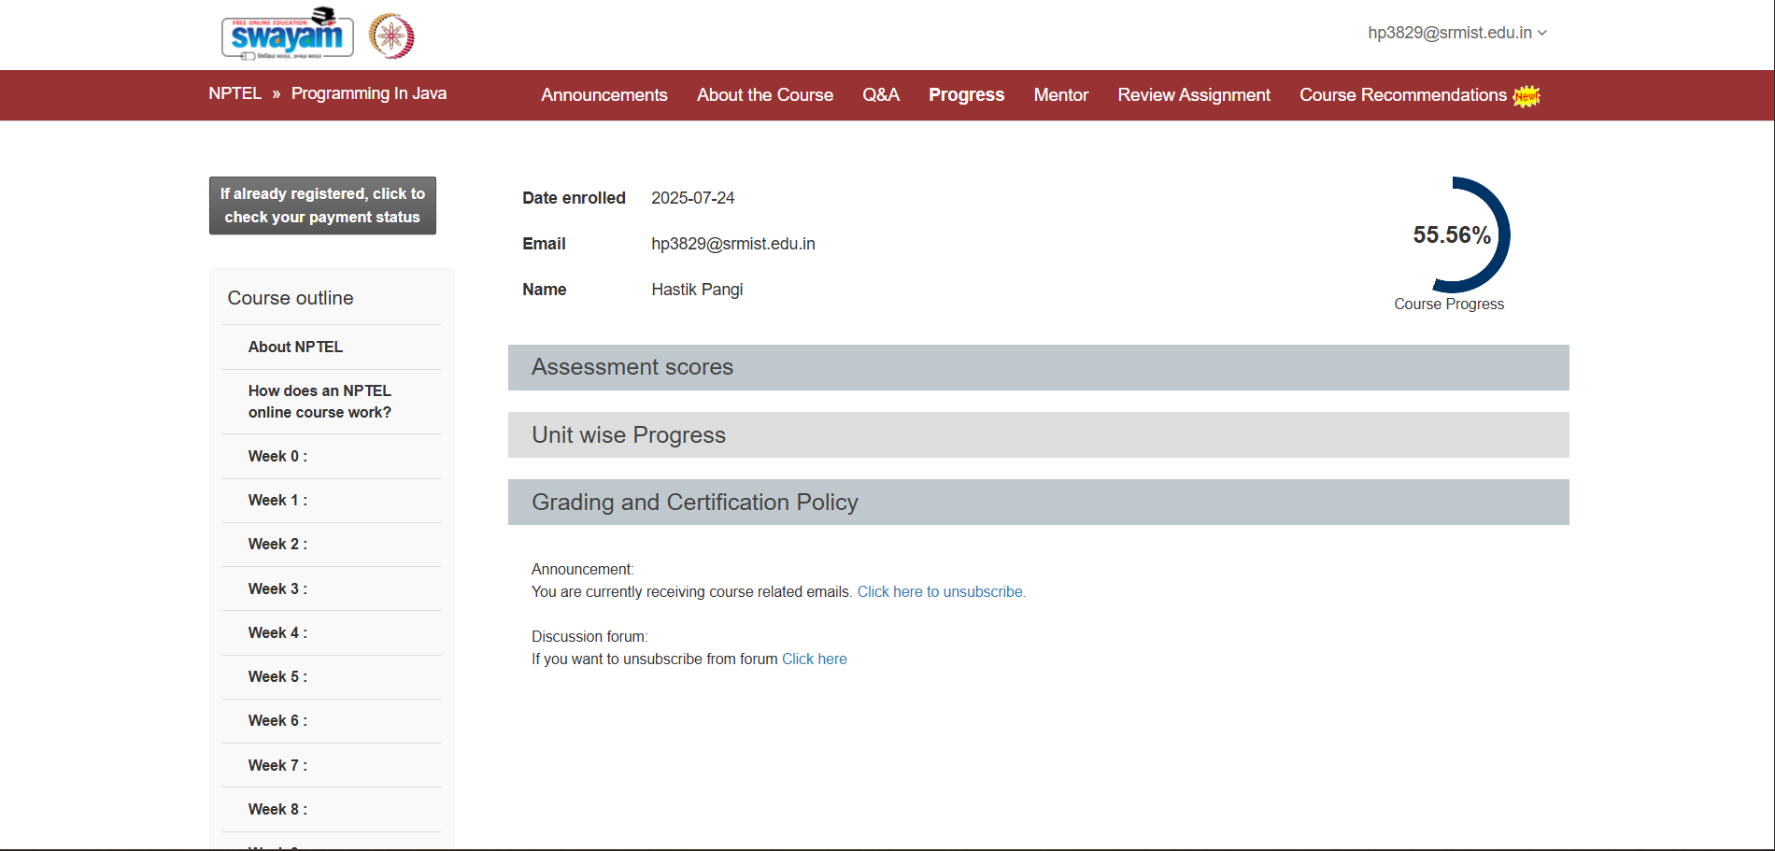**E-Curricula Completion**

* Successfully completed sessions from Units 1, 2, 3, 4, and 5 as part of the E-Curricula program.

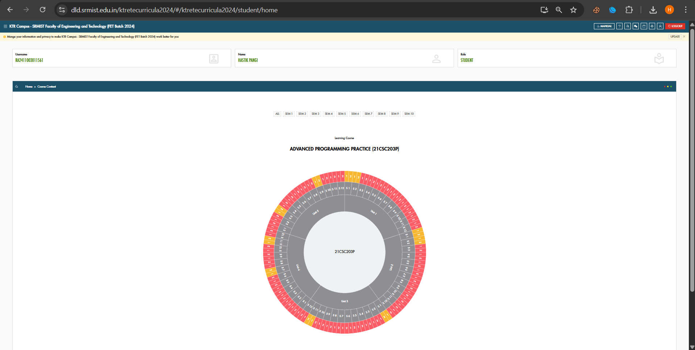

* Attached: E-Curricula Wheel as proof of completion.

**HackerRank Problem Solving**

* Solved 2 easy, 2 medium, and 2 hard problems in Java/Python on HackerRank.

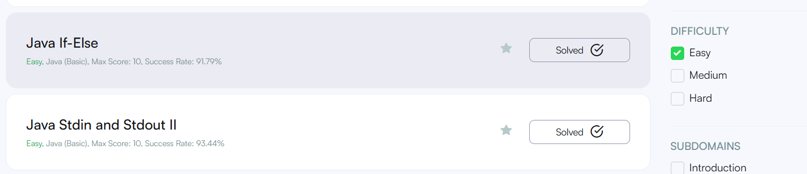

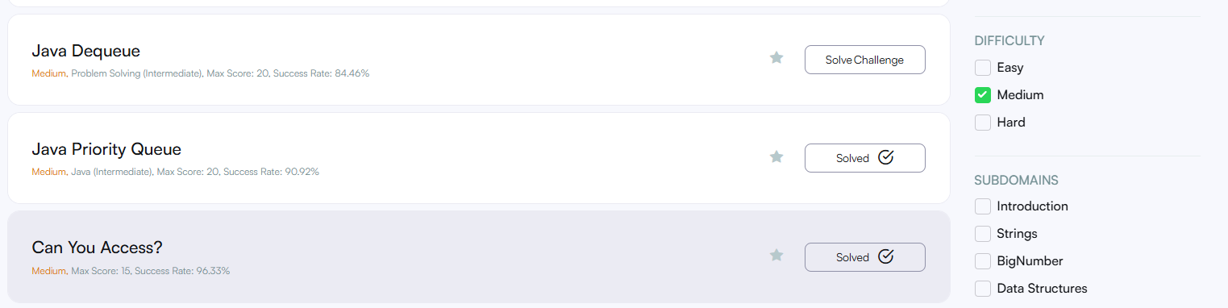

**Contact Details**

* Email: Hastik2003@gmail.com
* Phone: 7008757351