**Introduction**

Now that you’ve had some experience evaluating several active Web GIS applications, it’s time to learn more about the underlying technology of the World Wide Web. In this Assignment, you will learn how to write basic HTML and CSS code. You will use HTML to structure the content of your future web pages, while you will use CSS to control the style and layout of your pages. The goal of this Assignment is to provide you with the skills to develop a basic professional quality webpage. **Pay close attention to the skills that you learn in this Assignment because you will use many of them to complete next week’s assignment where you will develop a basic professional quality webpage to host your course-related materials.**

**Instructions**

In this Assignment, you will use ***Codecademy*** to learn the basics of HTML and CSS. Log in to the ***Codecademy*** website (<http://www.codecademy.com> ) and complete the following courses in the *Web Development* track:

1. **Learn HTML: HTML Elements and Structure** 
   1. [*HTML Document Standards*](https://www.codecademy.com/courses/learn-html/lessons/common-html-elements/exercises/prepare-html)***(5 points)***
2. **Make a Website: Site Structure** 
   1. [*Site Structure*](https://www.codecademy.com/courses/make-a-website/lessons/site-structure/exercises/html-css) ***(3 points)***
3. [**Learn CSS:**](https://www.codecademy.com/learn/learn-css) **Selectors and Visual Rules** 
   1. [*CSS Setup and Selectors*](https://www.codecademy.com/courses/learn-css/lessons/css-setup-selectors/exercises/intro-to-css) ***(3 points)***
   2. [*CSS Visual Rules*](https://www.codecademy.com/courses/learn-css/lessons/css-visual-rules/exercises/css-visual-rules) ***(3 points)***
4. [**Learn CSS**](https://www.codecademy.com/learn/learn-css)**: The Box Model** 
   1. [*The Box Model*](https://www.codecademy.com/courses/learn-css/lessons/box-model-intro/exercises/box-model-intro) ***(3 points)***
5. [**Learn CSS:**](https://www.codecademy.com/learn/learn-css) **Display and Positioning** 
   1. [*CSS Display and Positioning*](https://www.codecademy.com/courses/learn-css/lessons/css-display-positioning/exercises/html-flow) ***(3 points)***

After you have completed the above ***Codecademy*** course topics, you will have earned a minimum of 10 badges shown below:

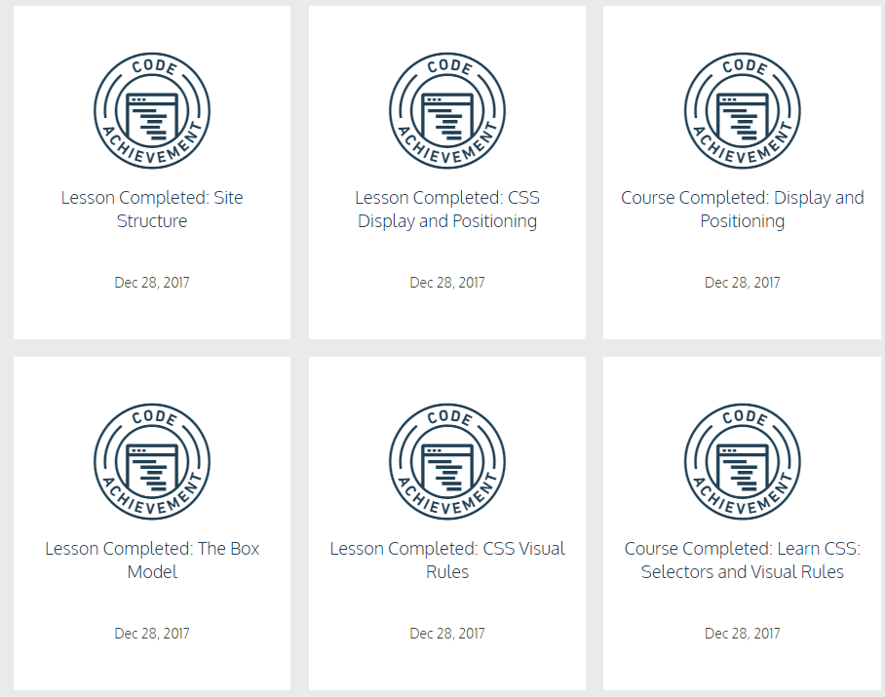

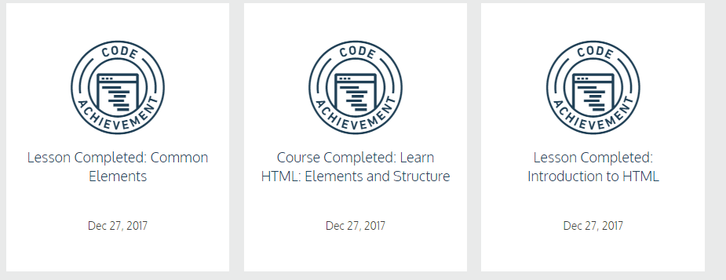

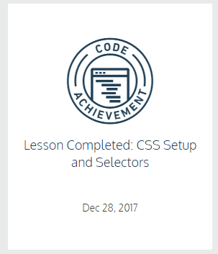

When you have completed the required ***Codecademy*** course for this assignment click the icon n the top right-hand corner of the ***Codecademy*** page, and choose *View my profile* from the pop-up menu. On your profile page click on the Badges button. You should now see your ***Codecademy*** account name at the top of the page, along with all of the badges that you have earned so far. Each badge will list the name of the course to which it corresponds, as well as the date on which it was earned. See the example below:

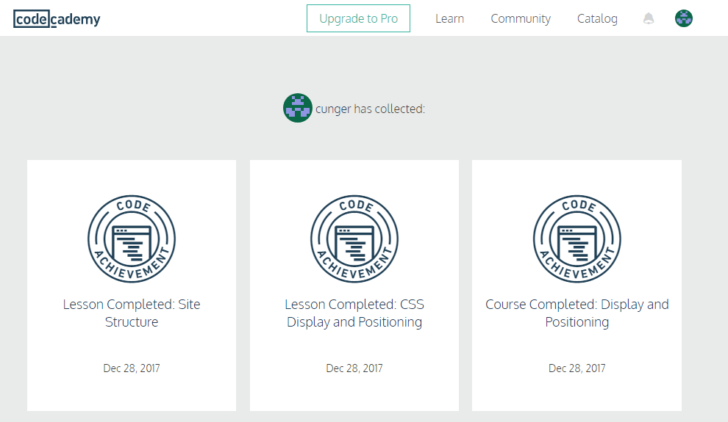

Capture a screenshot (Alt + Print Screen) of your badges (complete with course name and completion date) and paste it into an MS Word document. Save your file as a PDF named *lastname_Badges* where *lastname* is your last name.

**Submission Instructions**

1. Ensure that your Badges file has been saved as PDF
2. Ensure that your Assignment has been saved using the following naming convention: *lastname_Badges*.
3. Upload your completed assignment to CANVAS.