**Introduction**

Now that you’ve had a crash course in HTML and CSS, it’s time to put your new skills to work. In this Assignment, you will use HTML and CSS to develop a basic webpage to host the various projects that you will complete throughout the semester. The goal of this Assignment is for you to apply your new web development knowledge to build a basic professional quality webpage. Later in the semester you will apply these same skills to develop and build your own Web GIS applications.

**Instructions**

In this Assignment, you will apply the skills that you have learned to build your first professional webpage. Write the HTML and CSS code to produce your webpage using the sample layout below as a guide for the elements that should be included (navigation bars, links, images, etc.), the information that you need to include (Name, Program, Research Interests, etc.), and the approximate positioning of elements on the page. You are welcome to use the IDE or code editor of your choice, but I would recommend using Visual Studio Code because we will have to use it to work with the JavaScript API later in the semester.

**Layout Diagram:**

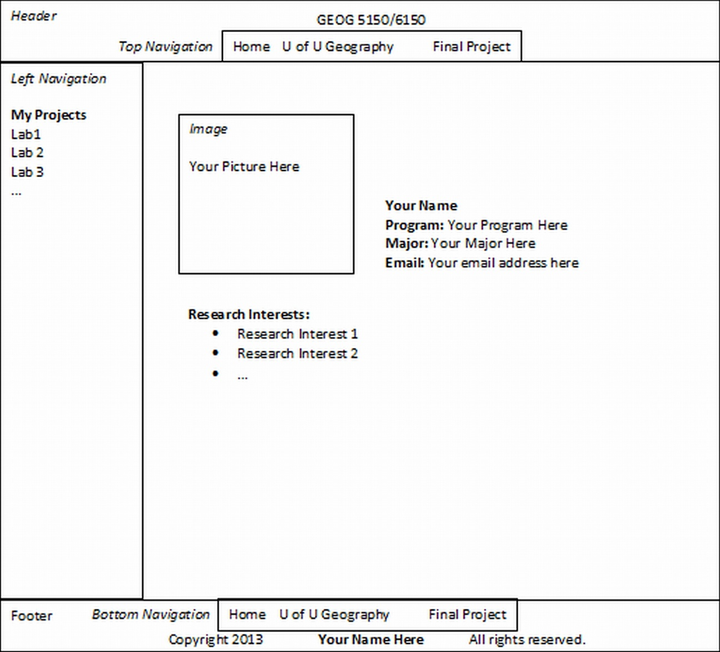

**Layout Diagram Notes:**

1. The words in *italics* should NOT be included in your webpage (*Header, Left Navigation, Footer*, etc.). These items are part of the diagram for your reference only.
2. The general content in each pane of your page (e.g. *Left Navigation, Header, etc.)* should match the **Layout Diagram**. For example, the *Left Navigation* pane should have a heading of **My Projects** and links to Module1 and Module2.
3. **Program** refers to your degree program (e.g. B.S., B.A., M.S., etc.)
4. Graduate students may use the primary sub-discipline addressed by their thesis or dissertation topic for the **Major** (e.g. Water Resources, GIScience, Physical Geography, etc.).
5. The position of each element (panes, content, etc.) in the **Layout Diagram** represents the approximate appearance of your page.
6. The **Email** item should display your email address as a clickable link. Here’s the code: <a href=”mailto:*youremail@somewhere.com”>youremail@somewhere.com</a>*
7. Items that are **bolded** in the **Layout Diagram** should be **bolded** on your webpage. Similarly, items that use **bullet points** should have **bullet points** on your webpage.
8. The *Image* dimensions should be 200 pixels by 200 pixels.
9. The borders shown in the **Layout Diagram** are intended to illustrate that each pane (*Header, Footer, Left Navigation*, etc.) should have a visually discernible boundary. The decision of whether to use color alone, or color along with a visible line border is up to you.

**Coding Requirements**

1. You must write **ALL** of your own code. Later in the semester, you will be allowed and encouraged to “borrow” and adapt code from other sources to meet your specific needs. For now, however, you **MUST** write all of your own code to develop your webpage. **(1 point)**
2. Use **indentation** to make your code easy to read. **(1 point)**
3. Include three HTML comments as the first three lines of code in your document **body** tag. The required comments as follows:
   1. The name of our course **(1 point)**
   2. Author: *Your Name Here* **(1 point)**
   3. The date that the page was produced **(1 point)**
4. Use separate files for your HTML and CSS code. **DO NOT** place your CSS code directly in your HTML file. **(1 point)**
5. Use **relative links** (i.e. do not include the drive letter in the file path) for local files such as images , styles sheets, and documents. Using **relative links** for local files ensures that your webpage will continue to work properly when it is uploaded to the server. Relative Link explanation: <http://compugoddess.com/relative-vs-absolute-links/> **(1 point)**
6. Use a “professional” image for your personal image. Acceptable images include a picture of you engaged in activity related to geography (e.g. conducting fieldwork, hiking, etc.), a head-shot of you in business casual attire, or any other photograph of yourself in a professional setting. For example, a photo from a *Linked In* profile would be acceptable, while a *Facebook* profile picture is probably not appropriate. **(1 point)**
7. The “shell” of your webpage **MUST** contain the following HTML elements:
   1. Doctype  **(1 point)**
   2. html **(1 point)**
   3. head **(1 point)**
   4. title (The page title should include the name of our course and your name) **(1 point)**
   5. body **(1 point)**
8. Use **at least one** of each of the following HTML elements in the **body** of your document:
   1. <p> **(1 point)**
   2. <ul> **(1 point)**
   3. <div> **(1 point)**
9. Use at least one **id** and one **class** in your CSS file. **(1 points)**
10. Reproduce the content and element positioning in the **Layout Diagram** as closely as possible. **(1 point)**
11. Color scheme (Choose one of the following options): **(1 point)**
    1. Use the University of Utah Department of Geography’s home page as a guide
    2. Use basic color theory to choose an appropriate color scheme: <http://webdesign.tutsplus.com/articles/design-theory/an-introduction-to-color-theory-for-web-designers/>
12. Regardless of the color scheme that you choose, the background color of main content pane (the one that contains the image and the information about you) should remain white. **(1 point)**

**Deliverables:**

1. An HTML file (.html file extension) that contains the HTML code for your course webpage.
2. A CSS file (.css file extension) that contains the CSS code for your course webpage.
3. An MS Word document that contains a screenshot of what your webpage looks like in a web browser.

**Submission Instructions**

1. Save your HTML file with an .html file extension and name it index_*lastname* where *lastname* is your last name.
2. Save your CSS file with a .css file extension and name it css_*lastname* where *lastname* is your last name.
3. Save a screenshot of your webpage as it appears in a web browser and upload it with the filename screenshot_*lastname* where *lastname* is your last name.
4. Upload all three files to the Module 3 in the Assignments section of the CANVAS site for our course.