Social Welfare Web Application & n8n Workflow Integration

Overview
The Social Welfare Web Application is a unified platform designed to assist users in discovering and understanding government welfare schemes. It serves as an intelligent bridge between complex government data and user queries.

Core Features
- User Onboarding: Collects user information (demographics, eligibility criteria) to tailor search results.
- Automated Intelligence: Automatically searches the web for relevant schemes based on user data.
- Data Ingestion: Scrapes verified government websites and portals to build a local knowledge base.
- RAG Chatbot: A Retrieval-Augmented Generation (RAG) chatbot that answers user queries using the scraped, verified data stored in the database.

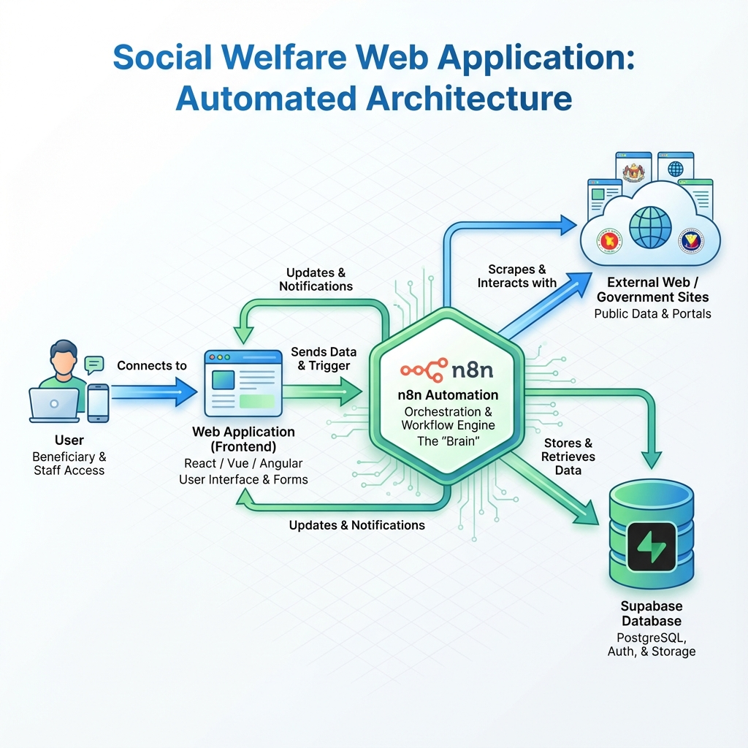
Social Welfare System Architecture

n8n Workflow Architecture
The core intelligence of the application is powered by an n8n workflow (SocialWelfare.json). This workflow handles two main responsibilities: Data Ingestion and Conversational Querying.

1. Data Ingestion Pipeline
This flow is triggered when a user submits their initial profile or a specific search query.
- Trigger: On form submission1 (Testing/Dev)
  - Note: This specific form trigger node is used for internal testing. In the production environment, this flow is initiated via the Chat UI webhook integration.
  - Receives the initial user query or profile data.
- Discovery (AI Agent):
  - An AI Agent (powered by xiaomi/mimo-v2-flash) analyzes the input.
  - Tool: web_search (HTTP Request to host.docker.internal:8089/search) finds relevant government URLs.
- Processing Loop:
  - The workflow loops through the discovered URLs.
  - Crawl: Sends URLs to a local crawling service (/crawl/job).
  - Wait & Check: Waits for the crawl to complete and retrieves the HTML content.
  - Extract: A JavaScript node extracts clean text from the HTML.
- Storage (Vector Database):
  - The extracted text is embedded using nomic-embed-text.
  - Supabase Vector Store: Stores the embeddings and metadata (URL, status) for future retrieval.
graph TD
A[Form/Chat Trigger] --> B[AI Agent]
B -->|Search Query| C[Web Search Tool]
C -->|URLs| D[Crawler Service]
D -->|HTML Content| E[Text Extractor]
E -->|Clean Text| F[Text Embedding]
F -->|Embeddings| G[(Supabase Vector Store)]
style G fill:#f9f,stroke:#333,stroke-width:2px

2. Conversational Chatbot (RAG)
This flow powers the interactive chat interface where users ask follow-up questions.
- Trigger: When chat message received
- Contextual AI Agent:
  - Uses Postgres Chat Memory to remember previous interactions in the session.
  - Tool: supabase_search allows the agent to query the vector database for the specific schemes scraped in the ingestion phase.
  - Tool: web_search is also available for real-time fallback updates.
- Response: The agent synthesizes the retrieved information into a user-friendly answer.
graph TD
A[User Chat Message] --> B[AI Chat Agent]
B -->|Fetch History| C[(Postgres Memory)]
B -->|Semantic Search| D[(Supabase Vector Store)]
B -->|Fallback Search| E[Web Search Tool]
C --> B
D --> B
E --> B
B -->|Final Answer| F[User Interface]
style B fill:#bbf,stroke:#333,stroke-width:2px

Integration: How They Connect
The Web Application and n8n Workflow are tightly coupled via Webhooks and Database.
- Frontend -> n8n (Ingestion): When a user signs up or enters a topic, the Frontend triggers the ingestion workflow (via webhook or chat integration). This initiates the search-and-scrape background job.
- n8n -> Database: The workflow populates the Supabase database with structured, embedded knowledge.
- Frontend -> n8n (Chat): When a user types a message in the chat interface, the message is sent to the when chat message received webhook. The workflow retrieves context from Supabase and returns the AI-generated response directly to the frontend.

Missing Important Features
To move this application from a prototype to a production-ready system, the following features should be implemented:

1. Security & Authentication
- Webhook Security: Currently, the webhooks are open. Implement API Key authentication or specific Header validation (e.g., X-App-Secret) to ensure only your frontend can trigger workflows.
- User Data Privacy: Ensure PII (Personally Identifiable Information) is filtered out before sending data to external LLMs or storing it in logs.

2. Robust Error Handling
- Dead Letter Queues: If a crawl job fails or the vector store is unreachable, the data is currently lost or the workflow errors out. Implement a retry mechanism with exponential backoff and a “failed jobs” table in Supabase.
- Input Validation: Add a schema validation node at the start of the workflow to reject malformed JSON payloads immediately.

3. User Feedback Loop
- Rating System: Add a “Thumbs Up/Down” feature in the chat UI. Pass this feedback to a separate n8n workflow to flag poor responses or outdated vector data for manual review.
- Source Citations: Modify the AI Agent prompt to strictly include the url from the metadata in its final response, so users can verify information (e.g., “According to Scheme Details”).

4. Performance & Scalability
- Rate Limiting: Prevent abuse by limiting the number of requests a single user IP can make to the webhooks per minute.
- Caching: Implement a Redis cache layer for identical queries to save on LLM tokens and reduce latency.

