Mini Todo Management Project using Spring Boot + Spring MVC + JSP + MySQL

The following features are implemented in this mini todo management project:

Sign Up

login

Create Todo

List Todo

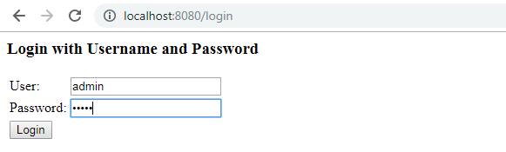

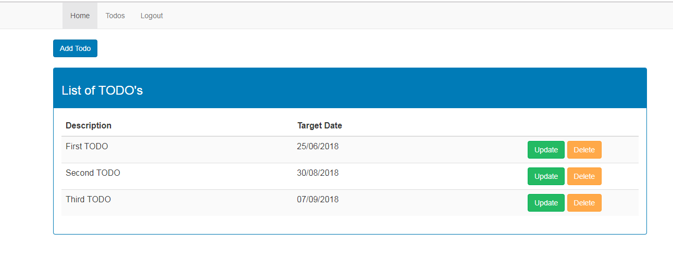

**Tools and Technologies Used**

Spring Boot

JDK

Spring Framework

MYSQL/MariaDB

IDE

Maven

Spring JDBC

### 1. Login Page

URL : <http://localhost:8080/login>

Username: admin

Password: admin

[](https://3.bp.blogspot.com/-wLpgcLFileA/W62_1ieBB5I/AAAAAAAAD-M/tFCt2aSojSgldWP9lZAsDrr-u8ZmU2q3ACLcBGAs/s1600/login-page.PNG)

This is simple Spring Security provided login page. You can also create a custom login page.

### 2. List Todos

URL: http://localhost:8080/list-todos



### 3. Create Todo

URL: http://localhost:8080/add-todo

