Blog Post One: A Curiosity

*The* *Egyptian Gazette* covers a bevy of topics from foreign trade to local deaths, however, one odd thing I have noticed within is the rather blasé coverage of the deaths of common people. Take for instance the incident they reported on in page three of the November 1st issue in 1905, shown below.

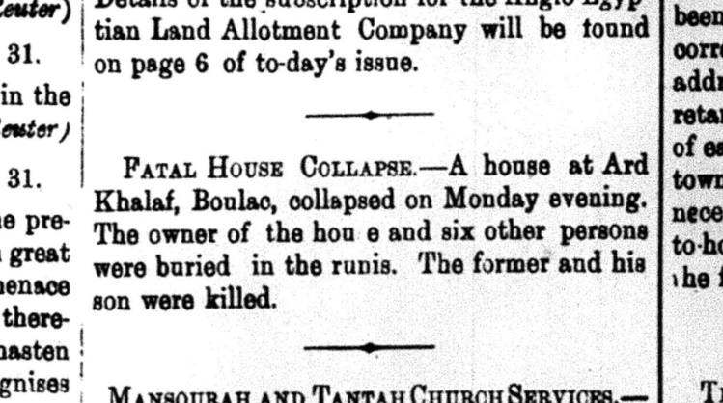The story of a house collapsing in and killing seven people would have been a rather large headline in a local paper today. There would be questions as to what caused the collapse, could it have been prevented, was it up to standard building codes, but *The* *Egyptian Gazette* does not cover any of that. They do not even identify the victims by name, simply stating that seven people in total were killed. The coverage is just shockingly sparse by our modern standards. The paper dedicates an entire section to simply announce that a wealthy woman has left France, yet puts this story within a larger block of smaller local stories as if it is an everyday occurrence. They could have done some sort of research to see if the house was new or not to then determine if other houses built in the same way or by the same company could be at risk.

This is not a one-off occurrence either, there is a story of a young boy drowning in the Nile, reports of deaths from the Plague and murders all treated with the same aloof attitude. This could probably be attributed to the simple fact that death was more common a 111 years ago. It didn’t affect people in the same way and so unless it was someone of renown or importance, most people just didn’t care.