Software Requirements Specifications
for
Online Course Enrollment System

Version1.3
Prepared by Phillip Achemire
University of Arizona Global Campus
11/10/2025

Table of Contents
Feedback Log vi
Executive Summary 7
Introduction 7
Purpose 7
Document Conventions 7
Intended Audience and Reading Suggestions 8
Project Scope 8
References 8
Overall Description 8
Product Perspective 8
Product Features 8
User Classes and Characteristics 9
Operating Environment 9
Design and Implementation Constraints 9
User Documentation 9
Assumptions and Dependencies 9
System Features 10
Registration and Profile Management (Priority: High) 10
Description and Priority 10
Stimulus / Response Sequences 10
Functional Requirements 10
Authentication and Account Security (Priority: High) 11
Requirements 11
Course Catalog & Semesters (Priority: High) 12
Description and Priority 12
Functional Requirements 12
Enrollment & Capacity Enforcement (Priority: High) 13
Description and Priority 13
Stimulus / Response 13
Functional Requirements 13
Waitlist Management (Priority: High) 14
Description and Priority 14
Stimulus / Response 14
Functional Requirements 14
Enrollment Cancellation & Overrides (Priority: High/Medium) 15
Requirements 15
Notifications & Audit Logging (Priority: Medium) 16
Requirements 16
External Interface Requirements 16
User Interfaces 16
Hardware Interfaces 17
Software Interfaces 17
Communications Interfaces 17
Other Nonfunctional Requirements 17
Performance Requirements 17
Safety Requirements 17
Security Requirements 17
Software Quality Attributes 18
Other Requirements 18
References 29

Revision History
Name | Date | Reason For Changes | Version
Phillip Achemire | 11/08/2025 | First draft | 1.0
Phillip Achemire | 11/09/2025 | Added 2FA requirements | 1.1
Phillip Achemire | 11/10/2025 | Added password change workflow requirements | 1.2
Phillip Achemire | 11/14/2025 | Feedback from version1.2 | 1.3

Summary of Changes for Version 1.3
Version 1.3 expands the original requirements into measurable, testable statements with clearly defined acceptance criteria. Sections covering registration, authentication, enrollment, waitlist automation, and notifications were rewritten to remove ambiguity and ensure each requirement can be validated during grading. Email verification was updated to be optional for the local XAMPP demo, with simulated verification documented for graders. The TOTP two-factor authentication workflow and backup-code behavior were clarified for offline use. Document Conventions, Glossary, and the Issues List were updated to reflect new terminology and rule definitions introduced in this version. Overall, Version 1.3 strengthens precision, testability, and consistency across the SRS while keeping all functionality aligned with course expectations and local execution constraints.

Feedback Log
Name | Date | Feedback | Version
Charmelia Butler | 11/12/2025 | One area to continue building on is the level of detail in each requirement. In practice, requirements should be written in a way that avoids ambiguity, is measurable, and can be easily tested later in the development process. As you refine your skills, focus on applying these qualities to each requirement so that the SRS becomes not only a guiding document but also a reference for validation and verification. | 1.2

Executive Summary
This SRS specifies requirements for the Online Course Enrollment System (OCES). OCES is designed as an offline-capable, XAMPP-friendly web application for use as a class assignment and local demo. Key capabilities: user registration and profiles; offline two-factor authentication (TOTP, RFC 6238) with backup codes; semester-based course offering publication; capacity-controlled enrollment; FIFO waitlisting with automated promotion; enrollment cancellation and administrative overrides; immutable audit logging to support grading. This version includes the password-change/reset workflow requirement (REQ-007) and clarifies password-reset delivery options for local demo vs. hosted deployments.

Introduction

Purpose
Provide a complete, testable specification of functional and nonfunctional requirements so developers and graders can implement, run, and validate OCES in a local environment (XAMPP) consistent with course expectations.

Document Conventions
- Requirement identifiers use the form REQ-XXX where XXX is a three-digit number (for example REQ-001).
- Acceptance criteria identifiers use the form AC-REQ-XXX.Y (for example AC-REQ-001.1) or AC-<SECTION>-XXX.Y for domain-specific ACs (for example AC-ENR-030.1).
- Priority levels are specified as High, Medium, or Low.
- Time values are expressed using explicit units (seconds, minutes, hours, days). When scheduling or expiry values are used, the SRS specifies both the numeric value and the unit (for example, 48 hours).
- Dates and timestamps are expressed in ISO 8601 format (YYYY-MM-DD for dates; YYYY-MM-DDThh:mm:ssZ for UTC timestamps) unless otherwise noted. All timestamps recorded or displayed by the system shall be stored in UTC.
- API behavior is described using HTTP verbs, endpoint paths, response codes, and expected payloads. Successful create operations return HTTP 201 where appropriate. Conflicts return HTTP 409. Validation failures return HTTP 400. Unauthorized/forbidden return HTTP 401/403 respectively.
- Database-level constraints and guarantees (for example, unique keys, FK constraints, transaction isolation) are explicitly stated in the requirement text when relevant. Where a requirement demands atomicity, the SRS notes that a DB transaction is required (for example SELECT ... FOR UPDATE, serializable or repeatable-read isolation as appropriate).
- Security and privacy text distinguishes between local demo behavior and hosted/production behavior. The phrase local demo indicates documented simulation steps intended for the grader and reproducible on XAMPP; hosted/production indicates live deployment expectations.
- When a behavior is configurable, the SRS states a default and that the value is configurable via admin settings. Tests and acceptance criteria reference the default unless otherwise noted.
- All code examples, API paths, and test steps use plain ASCII characters. Do not include production credentials, real student PII, or secret keys in the repository.
- Terminology used in the SRS is defined in Appendix A: Glossary. Any undefined term appearing in a requirement should be treated as ambiguous and raised in the Issues List.

Intended Audience and Reading Suggestions
- Graders/Instructors: Will run the local XAMPP demo and validate requirements through acceptance tests. Need reproducible offline test steps and access to audit logs for verification.
- Student Developer: Implements the system, supplies documentation and any test-only accounts/secrets for grading, and ensures reproducible offline behavior.
- Peers/Demonstrators: Classmates who may run the demo locally to verify functionality.
- TAs/Reviewers: Inspect test artifacts, logs, and acceptance criteria.

Project Scope
This SRS covers the v1.2 local/demo OCES: registration and profiles, login with optional offline TOTP 2FA (RFC 6238) plus backup codes, semester-aware course offerings, enrollment with capacity enforcement, FIFO waitlist with offer/promotion logic, cancellation and admin override, local notification options, and audit logging. Out-of-scope for v1.2: institutional SSO/SIS integration, mandatory SMS/email OTP delivery, and enterprise-level HA scaling.
Note: email verification is optional and supported for hosted deployments only. The local XAMPP demo will not require actual email delivery; verification will be simulated.

References
See section 8 for references.

Overall Description

Product Perspective
OCES is a standalone web application designed to run on local stacks (XAMPP: Apache, PHP, MySQL/MariaDB). Architecture: Browser UI ↔ RESTful backend ↔ relational DB (InnoDB, transactions). The system is designed local-first for grading reproducibility; later integration with institutional systems is planned but out of scope for v1.2.

Product Features
- Registration & profile management (unique user IDs).
- Authentication: password + optional offline TOTP 2FA + backup codes.
- Semester-aware course offerings and administrative publishing.
- Atomic enrollment and capacity enforcement.
- FIFO waitlist with automated time-limited offers and promotions.
- Enrollment cancellation and admin override.
- Local notification rendering and optional SMTP adapter.
- Immutable audit logging for graders.

User Classes and Characteristics
- Student: Registers account, maintains profile, searches courses, enrolls, cancels, and monitors waitlist position. Basic web competency required.
- Instructor: Views class rosters and waitlists for courses they teach; may request capacity changes (which require admin approval).
- Registrar / Administrator: Publishes CourseOfferings, sets capacities, performs overrides, views audit logs, configures system policies.
- System / Service Users: Email service, monitoring, and scheduled tasks (e.g., nightly consistency checks).

Operating Environment
- Local server: XAMPP on Windows/macOS/Linux recommended for grading.
- Clients: modern desktop browsers.
- Mobile device: any TOTP-compatible app for second-factor generation (installation of such an app is external to the demo). If a camera is unavailable, manual-secret entry must be supported.
- Network: Designed to work offline after initial TOTP secret exchange. TLS is recommended for production deployments.

Design and Implementation Constraints
- Usernames (user IDs) must be unique, and the uniqueness check must be atomic to avoid duplicate accounts under concurrency. This aligns with standard student-record system practice (Eludire & Arakeji, 2011).
- Enroll/waitlist operations require ACID transactions.
- Password storage: salted hashing (bcrypt or equivalent) mandatory.
- All external communications shall use HTTPS.
- System must maintain immutable audit logs for enrollment and admin actions.
- TOTP secret storage: demo-mode allows plaintext for reproducibility (documented); production requires encryption of secrets.
- Do not commit real PII or secret keys into the repository.

User Documentation
Deliverables: README.md (setup/run), TESTING.md (step-by-step acceptance tests for graders), docs/2fa.md (offline TOTP instructions), Admin Guide.

Assumptions and Dependencies
- Grader can run XAMPP locally.
- Grader can install or use an authenticator app, or will use manual-secret entry/backup codes.
- Optional SMTP configuration is available if email verification is used, but not required.

System Features

Registration and Profile Management (Priority: High)

Description and Priority
Enables new users to create accounts and structured profiles required for enrollment.

Stimulus / Response Sequences
- User accesses the Registration page and submits the required fields.
- Client-side validation occurs; server-side validation follows.
- Server checks the uniqueness of the user ID atomically.
- If unique, an account record is created (password stored as salted hash), and a verification email is sent (or simulated for local demo).
- If the user ID exists or validation fails, the user receives a clear error and suggested remediation.

Functional Requirements
- REQ-001 Registration endpoint and UI (High): The system shall provide a registration endpoint and UI that accepts username, password, full_name, email, and phone. Validation rules: username must match regex ^[A-Za-z0-9._-]{3,100}$. Passwords must meet configured complexity rules (default minimum length 8). The registration endpoint shall return HTTP 201 on success and include the created user_id. The system must persist a users row for the new account.
  - AC-REG-001.1
Test: POST a valid registration payload to /register. Expect HTTP 201 with user_id in the response. Verify a corresponding users row exists in the database.
  - AC-REG-001.2
Test: POST invalid username or weak password. Expect HTTP 400 and a descriptive validation error.
- REQ-002 Username uniqueness and atomicity (High): The system shall enforce username uniqueness by a database unique constraint and application logic so that concurrent attempts to register the same username cannot create multiple accounts. When a duplicate is attempted, the API shall return HTTP 409 Conflict.
  - AC-REG-002.1
Test: Simultaneously send two registration requests with the same username. One request must return HTTP 201 and the other HTTP 409. Verify exactly one users row exists for that username.
- REQ-003 Password storage (High): Passwords shall be stored only as salted cryptographic hashes using bcrypt with cost factor >= 12 or Argon2 with recommended parameters. The stored value must not equal the plaintext password.
  - AC-REG-003.1
Test: Register a user with a known password. Read password_hash from DB. Verify the hash is not equal to plaintext and that bcrypt.verify(plaintext, password_hash) or equivalent returns true.
- REQ-004 Profile updates (Medium): Authenticated users shall be able to update profile fields except username. Profile updates must persist within 1 second of the request and must create an audit log entry with event type profile_updated. The audit entry must include prior and new values for changed fields.
  - AC-REG-005.1
Test: Authenticated PATCH /profile changing full_name. Verify DB update and an audit_logs entry with event_type=profile_updated containing old and new values and a timestamp within ±2 seconds.
- REQ-006 Optional profile fields (Low): The system shall accept optional profile fields major and graduation_year and persist them when provided. Missing optional fields shall not block registration.
  - AC-REG-006.1
Test: Register without major. Later PATCH to add major. Verify value persists.
- REQ-007 Password change and reset workflow (Medium): The system shall support both authenticated password-change and password-reset workflows:
- Authenticated change: endpoint requires current_password, new_password, and confirm_new_password. The server must verify current_password, enforce password complexity and reuse policies (prevent reuse of last N passwords, default N=3), atomically update the password_hash, log event password_changed, and invalidate or require re-authentication of other sessions per configuration.
- Reset flow: issuing endpoint generates a single-use reset token with TTL = 1 hour and stores it hashed or as an opaque record. Hosted deployments shall deliver tokens via SMTP. For local demo, the token shall be exposed to the admin console or logs per documented simulation. Consuming endpoint requires token and new password; on success token is consumed, password is updated atomically, and event password_reset_completed is logged.
  - AC-REG-007.1
Authenticated change test: Authenticated POST /account/change-password with correct current_password and valid new_password. Expect HTTP 200, DB password_hash updated, audit_logs contains password_changed. Old credentials must fail.
  - AC-REG-007.2
Reset test: POST /account/request-reset with registered email. Verify token recorded with TTL. For local demo check admin console for the token. POST /account/reset with token and new password within TTL updates password, consumes token, logs password_reset_completed, and old password fails.

Authentication and Account Security (Priority: High)

Requirements
- REQ-010 Session creation and cookie attributes (High): Upon successful authentication the system shall create a session and set an HTTP-only cookie named OCES_SESSION. When TLS is used the cookie must include Secure and SameSite=Strict. Default session TTL shall be 2 hours and configurable.
  - AC-AUTH-010.1
Test: Perform a successful login. Verify Set-Cookie contains HttpOnly. Over HTTPS check for Secure and SameSite=Strict. Session must allow access to protected endpoints.
- REQ-011 Account lockout and retry policy (Medium): The system shall lock an account after 5 consecutive failed login attempts within 15 minutes. Locked accounts shall remain locked for 15 minutes or until an administrator unlocks them. Failed attempt counters shall reset after a successful login.
  - AC-AUTH-011.1
Test: Submit five failed login attempts within 15 minutes. Confirm the account is locked and subsequent login attempts are denied with HTTP 403 and reason account_locked. After 15 minutes a correct login succeeds.
- REQ-012 Role-based access control (Medium): The system shall implement RBAC with roles student, instructor, and admin. Protected endpoints shall return HTTP 403 for unauthorized roles. Admin-only actions include CourseOffering creation, capacity adjustments, and admin overrides.
  - AC-AUTH-012.1
Test: Attempt to POST /course_offerings as a student. Expect HTTP 403. As an admin expect HTTP 201 and resource creation.
- REQ-013 TOTP 2FA and backup codes (Medium)
The system shall support optional TOTP as specified in RFC 6238 with a 30-second step and acceptance offset {-1,0,+1} by default. On enablement the system shall generate a base32 secret (>= 80 bits entropy), present a QR code data URI plus manual-secret, require a verification TOTP to finalize enablement, generate eight single-use backup codes shown once, and store backup codes hashed. Events 2fa_enabled, 2fa_verified, and backup_code_used shall be logged.
  - AC-AUTH-013.1
Enable flow test: Start 2FA enablement. Confirm QR and manual secret displayed, eight backup codes shown once. Submit a valid current TOTP to confirm enablement. Verify tfa_enabled=true in DB and 2fa_enabled in audit_logs.
  - AC-AUTH-013.2
Login flow test: With 2FA enabled, login with password then TOTP. Invalid TOTP must be rejected with HTTP 401. Valid TOTP must complete authentication and create session.
  - AC-AUTH-013.3
Backup code test: Use one backup code for login. Confirm login succeeds, backup_code_used logged, and that same code cannot be reused.

Course Catalog & Semesters (Priority: High)

Description and Priority
Administrators publish CourseOfferings for each semester (Spring/Summer/Fall). Not all courses run each semester.

Functional Requirements
- REQ-020 CourseOffering model (High): CourseOfferings shall persist the following required fields: course_offering_id (PK), course_code, title, description, semester_id (FK), capacity (integer >= 0), instructor, modality (online, hybrid, in-person), and state (draft, published, open, full, closed). Creating a CourseOffering with missing required fields shall return HTTP 400.
  - AC-CAT-020.1
Test: POST /course_offerings with a valid payload. Expect HTTP 201 and the DB row to match the payload.
  - AC-CAT-020.2
Test: POST without title. Expect HTTP 400 and a descriptive error.
- REQ-021 Search and filtering (Medium): The system shall provide a paginated endpoint GET /course_offerings supporting filters semester_id, department (prefix of course_code), course_code, instructor, and keyword in title or description. Responses shall return total_count and page metadata.
  - AC-CAT-021.1
Test: Seed offerings across semesters. Call GET /course_offerings?semester_id=X&department=CS&page_size=10&page=1. Verify results match filters and total_count present.
  - AC-CAT-021.2
Test: Keyword search returns case-insensitive matches against title or description.
- REQ-022 Modality persistence (Low): The system shall allow administrators to mark CourseOfferings as online, hybrid, or in-person.
  - AC-CAT-022.1
Test: Create offering with modality=online. GET detail returns modality=online.
Rationale: Semester-based availability is standard in academic scheduling and required to present correct offerings to students (Bharamagoudar et al., 2013).

Enrollment & Capacity Enforcement (Priority: High)

Description and Priority
Students enroll in CourseOfferings until capacity is reached.

Stimulus / Response
- Student clicks Enroll on CourseOffering.
- System starts transaction, checks current enrollment count vs capacity, and inserts Enrollment if seats remain.
- System commits the transaction and notifies the student.

Functional Requirements
- REQ-030 Capacity check before enrollment (High)
Allow enrollment only when current active enrollments < capacity. The guarantee must be enforced at the database level using transactions and constraints.
  - AC-ENR-030.1
Test: With an offering at capacity N and N active enrollments, attempt another enroll. Expect HTTP 409 Conflict and no new enrollment row.
- REQ-031 Atomic enrollment transaction (High)
Enrollment operations shall execute within an atomic database transaction that locks necessary rows (for example using SELECT ... FOR UPDATE). If any step fails the transaction must roll back and the database must remain in its prior consistent state.
  - AC-ENR-031.1
Concurrency test: Execute two concurrent enroll requests when one seat remains. Exactly one must succeed (HTTP 201) and the other must return HTTP 409. DB total enrollments must not exceed capacity.
  - AC-ENR-031.2
Rollback test: Force an application error during the enrollment transaction and confirm no partial enrollment is persisted.
- REQ-032 Unique enrollment constraint (High)
The system shall prevent the same user from holding more than one active enrollment for the same CourseOffering by enforcing a unique constraint (course_offering_id, user_id) and by returning HTTP 409 on duplicate attempts.
  - AC-ENR-032.1
Test: Enroll the same user twice for the same offering. Expect first request HTTP 201 and second request HTTP 409. DB contains a single enrollment record for that user_id and course_offering_id.

Waitlist Management (Priority: High)

Description and Priority
If a CourseOffering is full, a student may join a FIFO waitlist with automated promotion.

Stimulus / Response
- Student chooses to join the waitlist. System records WaitlistEntry with timestamp.
- Student may view their position.
- On seat availability, system issues offer to the first waitlisted student; the acceptance window applies.

Functional Requirements
- REQ-040 FIFO waitlist entry (High)
When an offering is full, the system shall let students join a waitlist. Each waitlist entry shall record user_id, joined_at timestamp (UTC), and offer_status enum (none, offered, accepted, expired, declined). FIFO ordering is by ascending joined_at.
  - AC-WL-040.1
Test: Fill offering to capacity. POST /waitlist_entries for a user. Expect HTTP 201 and a DB row with offer_status=none and joined_at set.
- REQ-041 Waitlist position (High)
The system shall compute a user’s waitlist position as 1 + COUNT(entries where joined_at < this.joined_at) for the same offering. The API shall return position and total_waitlist_length.
  - AC-WL-041.1
Test: Seed three waitlist entries in known order. GET position for the second user returns position=2 and total_waitlist_length=3.
- REQ-042 Automated time-limited offer and promotion (High)
When a seat frees, set the earliest waitlist_entry.offer_status='offered' and offer_expires_at = NOW() + offer_window (default 48 hours). Notify the user. Acceptance before expiry enrolls the user atomically and removes or updates the waitlist entry to accepted. Expiration sets offer_status='expired' and the system proceeds to the next eligible waitlist entry. Offer expiry checks shall be implemented by a scheduled job or on-demand checks when processing accept/reject requests.
  - AC-WL-042.1
Test: Cancel an enrollment. Verify the earliest waitlist entry is updated to offered with offer_expires_at ≈ now + 48h.
  - AC-WL-042.2
Test: Offered user accepts before expiry. Verify atomic creation of enrollment, removal, or update of waitlist entry to accepted, and audit_logs contains waitlist_promoted.
  - AC-WL-042.3
Test: Simulate offer expiry. Verify offer_status='expired' and that the next waitlist user transitions to offered.
- REQ-043 Admin manual promotion (Medium)
An admin shall be able to immediately promote a waitlisted user to enrollment. Admin promotions must be logged including admin id and reason. Admin promotions may optionally allow temporary overbooking; such allowance must be recorded in the audit log.
  - AC-WL-043.1
Test: As admin, POST an admin promotion action for a waitlist entry. Expect HTTP 201, an enrollment created, and an audit_logs entry recording admin_id and promotion reason.
Rationale: Automated waitlist promotion reduces registrar workload and ensures fair access. (Operational policies configurable.)

Enrollment Cancellation & Overrides (Priority: High/Medium)

Requirements
- REQ-050 Student cancellation (High)
Students shall be able to cancel active enrollments prior to configured deadlines. Cancellation must be atomic, set the enrollment status='cancelled', free the seat, record an audit_logs entry enrollment_cancel, and trigger waitlist promotion logic described in REQ-042.
  - AC-CAN-050.1
Test: Student cancels enrollment before the deadline. Verify enrollment.status='cancelled', count of active enrollments decremented, audit_logs contains enrollment_cancel with user id and timestamp, and waitlist promotion was initiated.
- REQ-051 Admin overrides (Medium)
Admins may create or remove enrollments directly with reason. Overrides must be logged with admin_user_id, reason, and overbook_flag if capacity is exceeded. Overbook exceptions shall be explicit admin actions and visible in audit logs.
  - AC-CAN-051.1
Test: Admin creates an enrollment when offering is at capacity with overbook=true and reason supplied. Verify enrollment is created and audit log contains overbook=true, admin id, and reason.

Notifications & Audit Logging (Priority: Medium)

Requirements
- REQ-060 Transactional notifications (Medium)
The system shall deliver notifications for these events: account verification, enrollment confirmation, waitlist join, waitlist offer, waitlist promotion, enrollment cancellation, admin override, and password reset token issuance. Hosted deployments shall send via SMTP or provider with up to 3 retries on transient failures. For the local demo, notification delivery shall be simulated by writing notification payloads to a secure admin console or log, and the SRS must document the simulation steps for graders.
  - AC-NOT-060.1
Test: Trigger an enrollment event. If SMTP configured, verify an email is sent and logs show delivery. If local demo, verify notification appears in admin console log.
  - AC-NOT-060.2
Test: Trigger waitlist offer. Verify notification payload contains offer_expires_at.
- REQ-061 Immutable audit logs (Medium)
Critical events shall be recorded in append-only audit logs with fields: event_type, actor_user_id (nullable), target_type, target_id, details JSON, and ts (UTC). The application shall prevent log deletion via API or UI. Default retention shall be 365 days configurable. Audit entries shall be generated for registration, login attempts (success and failure), password changes, and resets, 2FA enable/disable and backup-code use, enrollments, cancellations, waitlist offers and promotions, and admin overrides.
  - AC-NOT-061.1
Test: Perform an enrollment. Query audit_logs for event_type='enrollment_created'. Verify details contains user_id and course_offering_id and ts is within ±2 seconds.
  - AC-NOT-061.2
Test: Attempt to delete an audit log entry through the UI or API. Expect HTTP 403 or equivalent denial. Document that DB-level deletion requires privileged DB access outside the application and should be auditable.

External Interface Requirements

User Interfaces
- Registration page: fields, password policy, and help text.
- Login page: user ID/password, forgot-password link.
- Student dashboard: current enrollments, waitlist positions, notification center, profile editing.
- Course catalog: search, filters, and CourseOffering detail pages showing capacity & status.
- Admin dashboard: course creation/editing, capacity management, rosters, audit log viewer.
Accessibility: UI shall meet WCAG AA guidelines.

Hardware Interfaces
No specialized hardware required; standard web server and database server. Minimum hardware sizing to be determined in the design phase.

Software Interfaces
- Relational DB (MySQL/MariaDB). Tables: users, profiles, semesters, course_offerings, enrollments, waitlist_entries, backup_codes, audit_logs.
- Optional SMTP adapter for email; RESTful JSON back-end endpoints.

Communications Interfaces
Local demo runs over HTTP (localhost) for grading; production requires TLS. TOTP verification uses local time and stored secret only; no outbound network is required after setup.

Other Nonfunctional Requirements

Performance Requirements
- UI page loads < 2 seconds under normal load.
- Enrollment and waitlist transactions complete < 1 second under normal load.
- System shall support peak concurrent active users consistent with SRU expected term registration traffic (target baseline: 1,000 concurrent users for demo sizing; production sizing to be defined during capacity planning).

Safety Requirements
The system does not perform physical-world control; safety requirements are limited to preventing data loss and protecting PII. Automated processes shall include rollback on failed transactions to avoid a partial state.

Security Requirements
- Password hashing (bcrypt/Argon2).
- TOTP secret encryption in production; demo-mode flagged if stored plaintext.
- Backup codes are hashed and single-use.
- Rate-limit login/TOTP attempts (default 5), account lockouts on repeated failure.
- Standard web protections: input validation, prepared statements, XSS/CSRF mitigation..

Software Quality Attributes
- Reliability: ACID compliance for enrollment/waitlist flows.
- Maintainability: Modular API design and coding standards enforced.
- Usability: Student workflows simplified; documentation included.
- Testability: REST APIs and UI flows covered by automated tests.

Other Requirements
- Database requirements: Indexing on CourseOffering.id and Enrollment.user_id for performance; referential integrity enforced.
- Internationalization: English-only in first release; resource files externalized for later localization.
- Legal / Privacy: Compliance with SRU data governance and applicable PII handling policies.
- Reuse objectives: Where possible, reuse institutional authentication/identity services in later phases.
Appendix A: Glossary
- CourseOffering: A specific course instance within a semester (e.g., CS-101 (Fall 20XX)).
- Enrollment: State recording a student’s confirmed seat in a CourseOffering.
- WaitlistEntry: A record indicating a student desires enrollment in a full CourseOffering; ordered by timestamp.
- SRU: Summit Ridge University.
- ACID: Atomicity, Consistency, Isolation, Durability (database transaction properties).
- Admin / Registrar: User role with privileges to publish course offerings, set capacities, perform overrides, and view audit logs.
- API: Application Programming Interface; REST endpoints used by the UI and automated tests.
- Backup code: Single-use, pre-generated codes that allow account authentication in place of a valid time-based one-time password. Backup codes are displayed once at generation and stored hashed.
- DB / Database: The relational persistence layer (MySQL / MariaDB in local demo).
- Demo-mode / local demo: Local XAMPP-hosted instance behavior used for grading; certain external integrations (email, SMS) are simulated and documented for grader reproducibility.
- Offer window: Configurable time window during which a waitlist offer can be accepted (default 48 hours).
- REQ: Requirement identifier prefix used in this SRS. See Document Conventions.
- RBAC: Role-Based Access Control; access model used to restrict actions to student, instructor, or admin.
- RTM: Requirements Traceability Matrix; mapping from requirements to acceptance criteria and tests.
- TOTP: Time-based One-Time Password; RFC 6238 compliant algorithm used for offline 2FA (30 second step default).
- TTL: Time To Live; lifetime of tokens or temporary artifacts (for example reset tokens).
- WCAG: Web Content Accessibility Guidelines; UI should aim for WCAG AA conformance where feasible.
- Workflow terms: offer, accept, expire, promote see REQ-042 for definitions and sequencing.

Appendix B: Analysis Models
Activity Diagram:
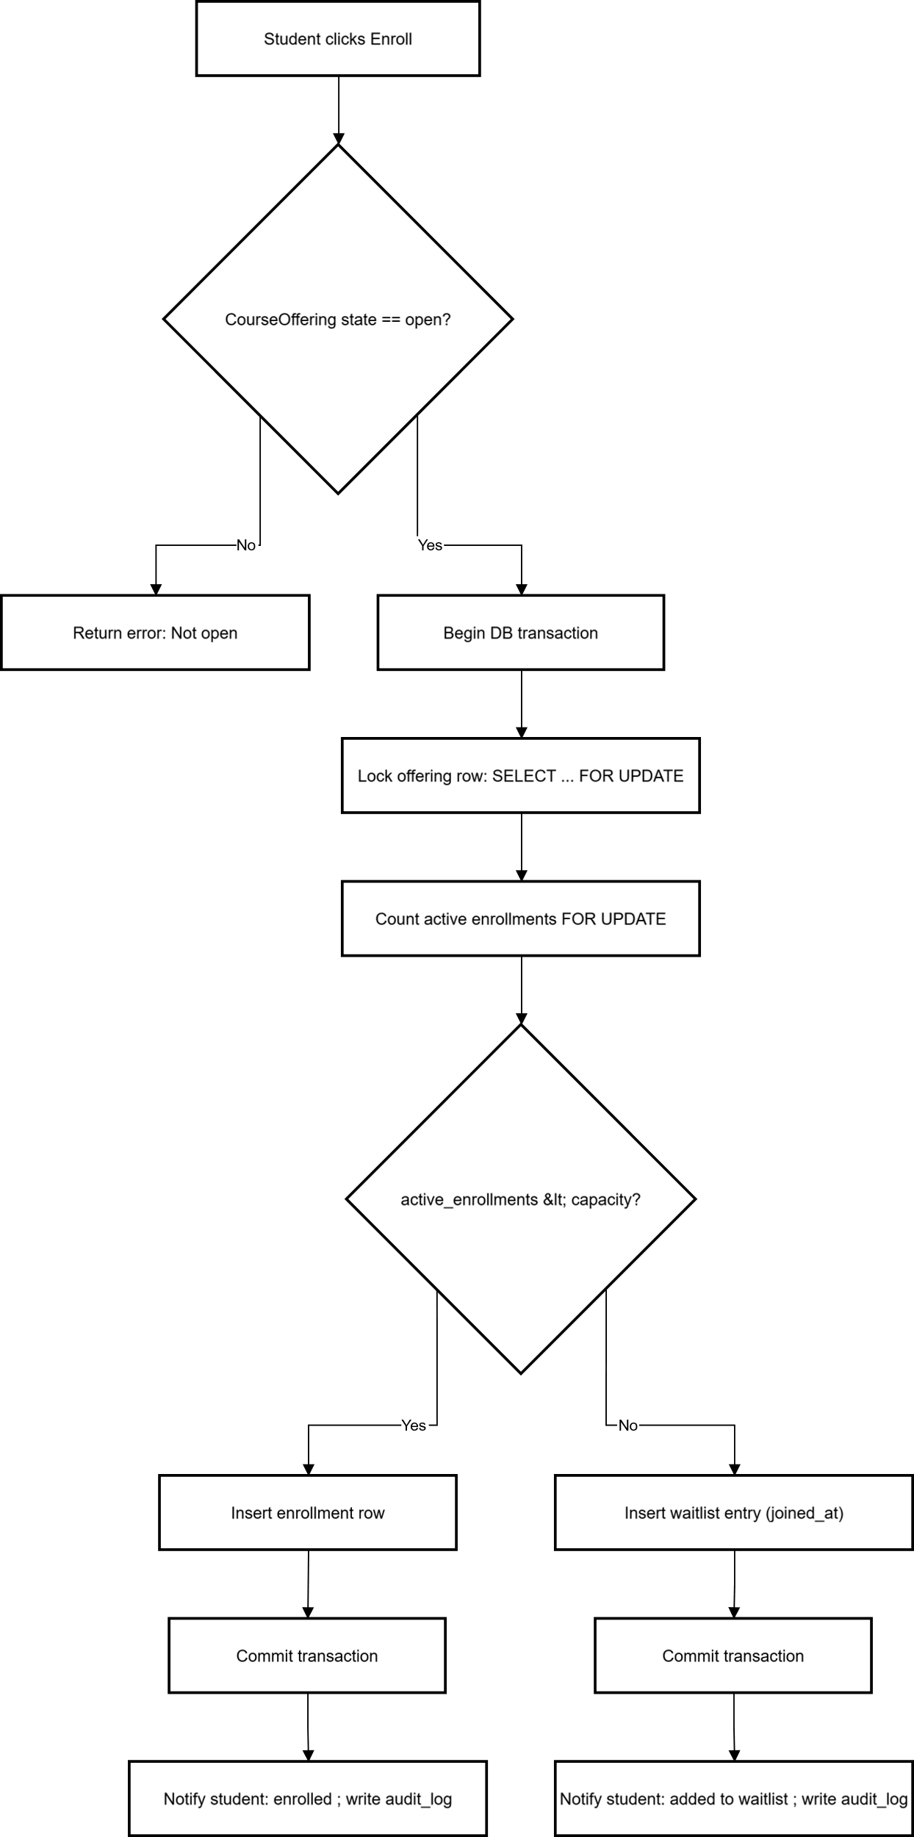
Class Diagram
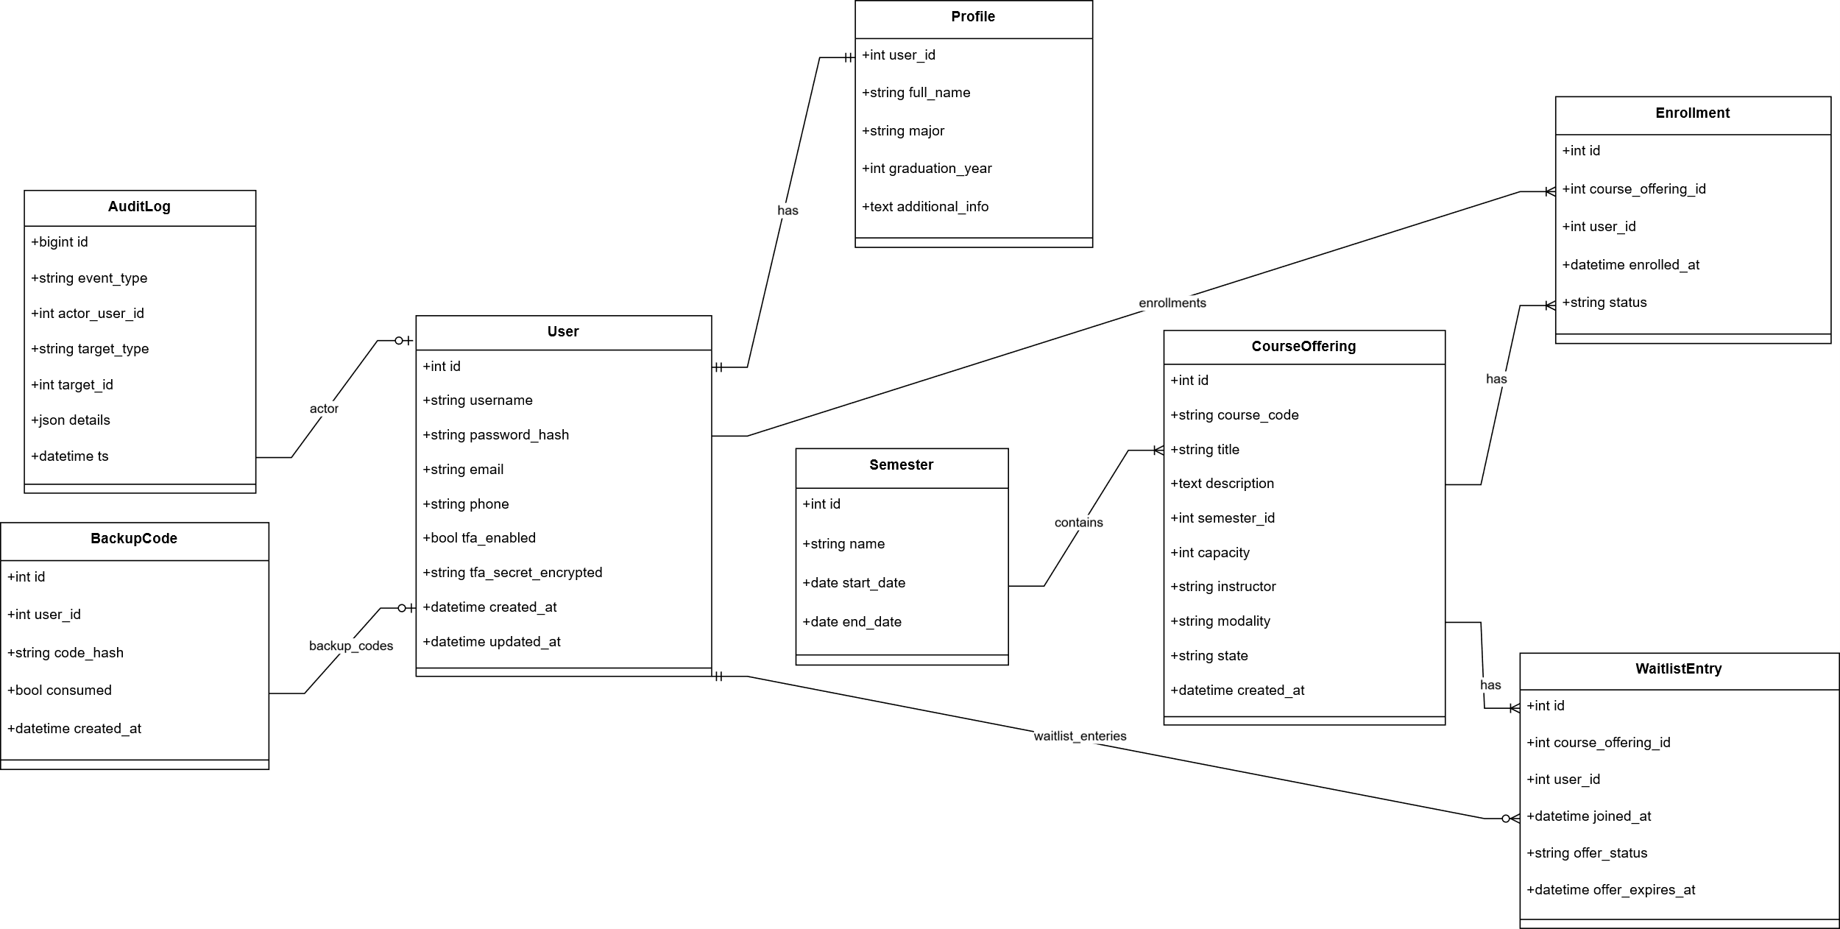

ER-Diagram
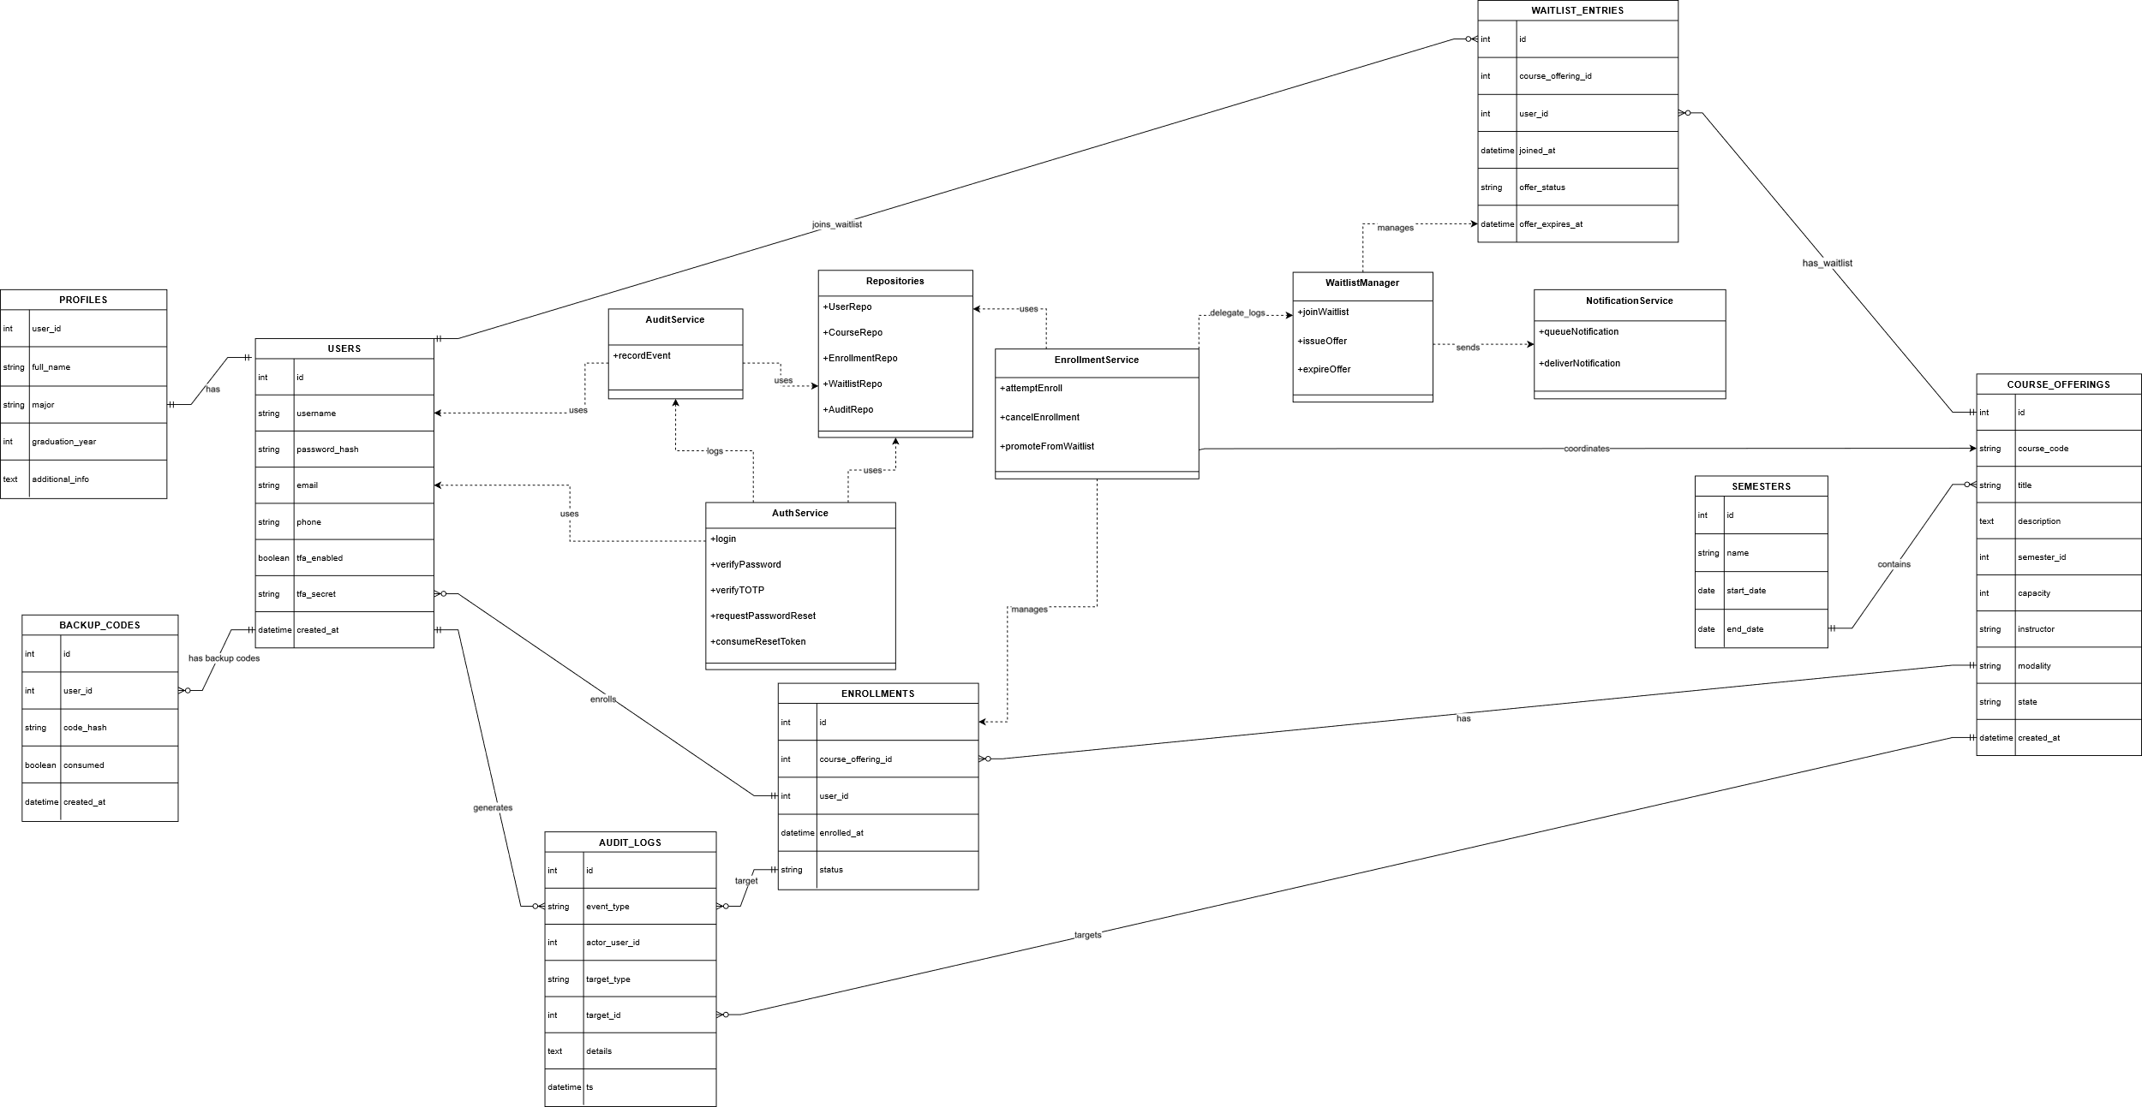

Sequence-2FA Enablement
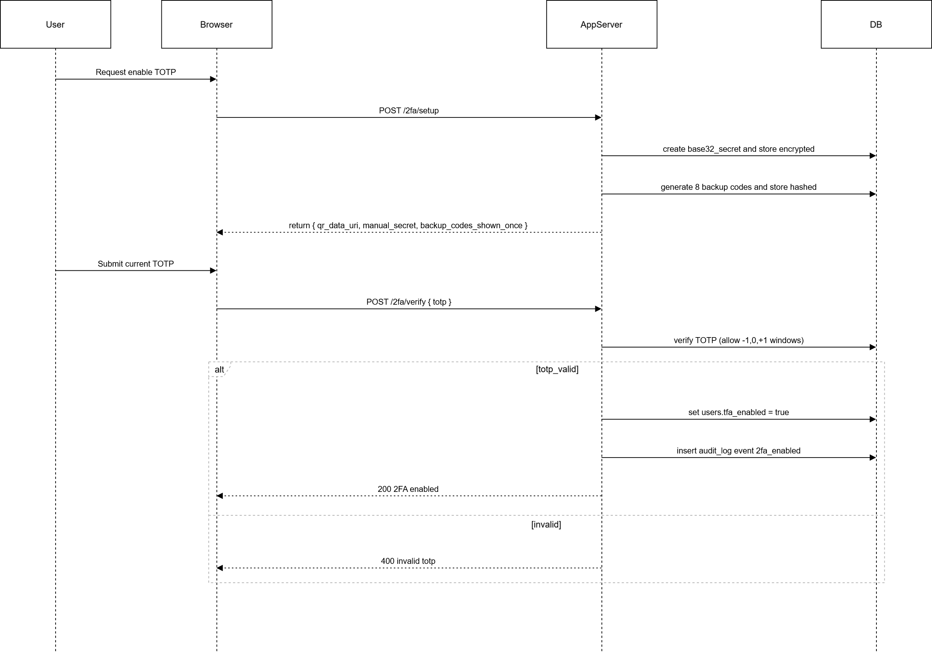

Sequence Enrollment
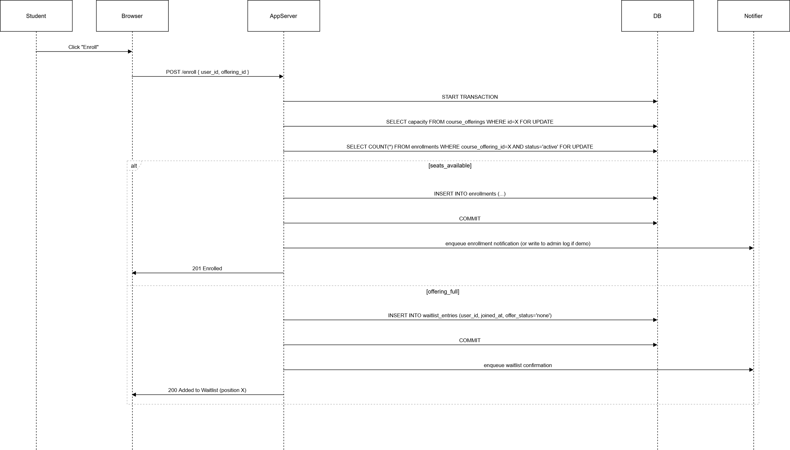

Sequence-Password
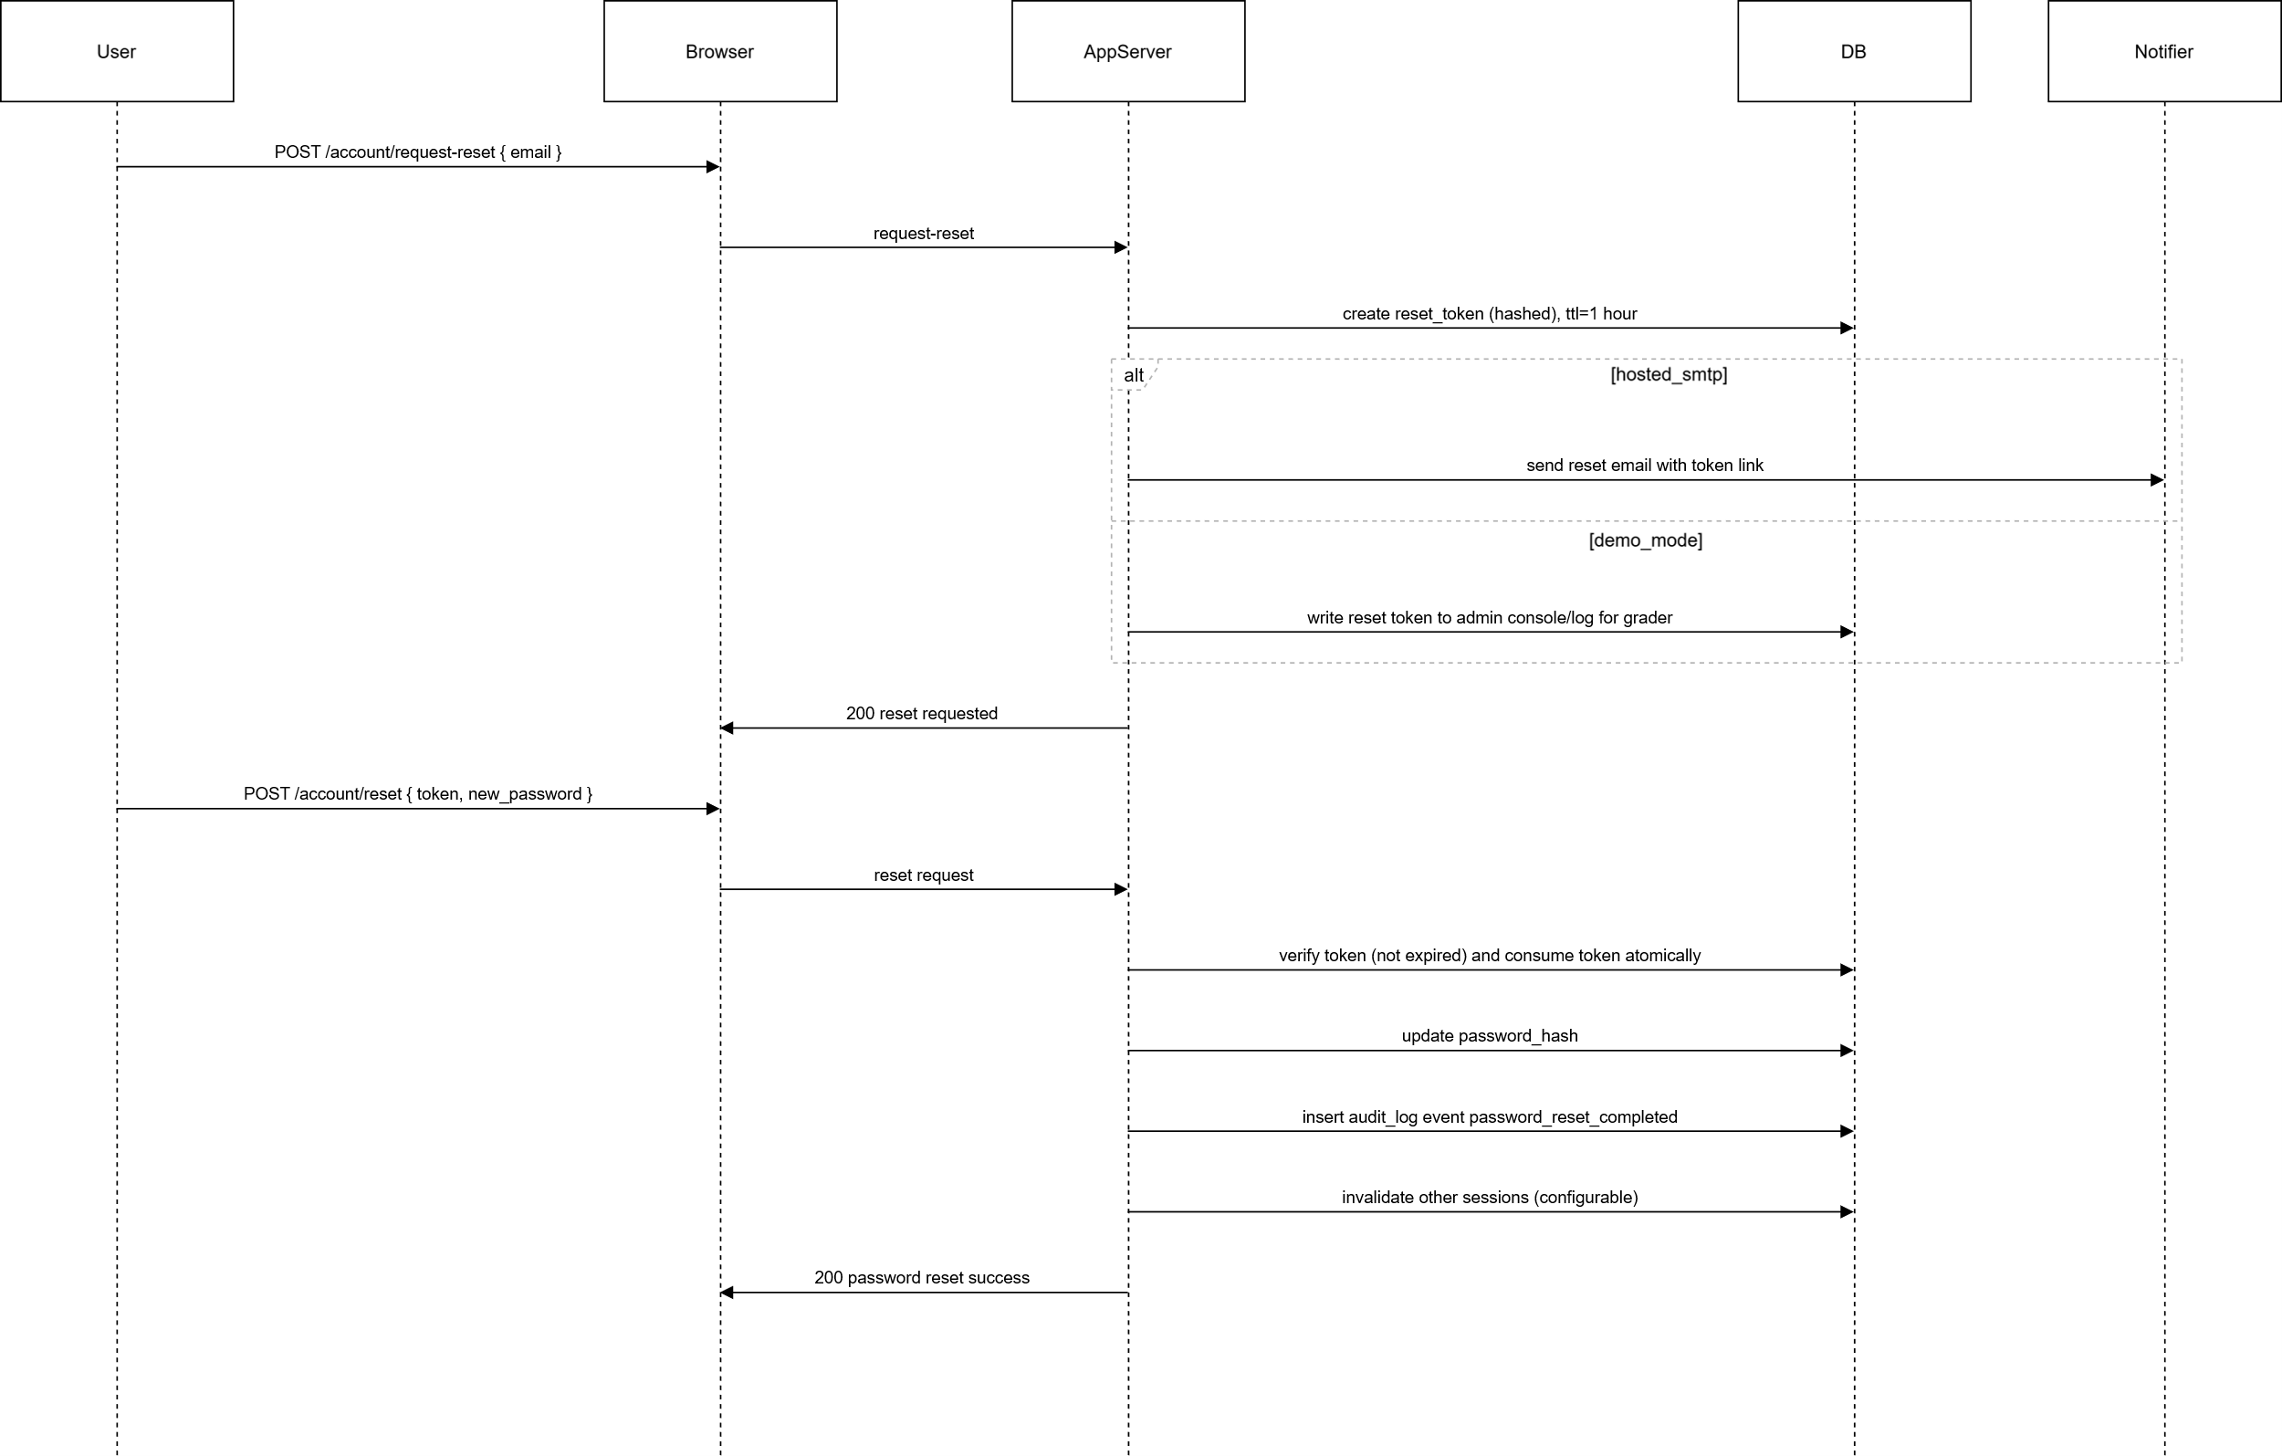

Sequence-Waitlist
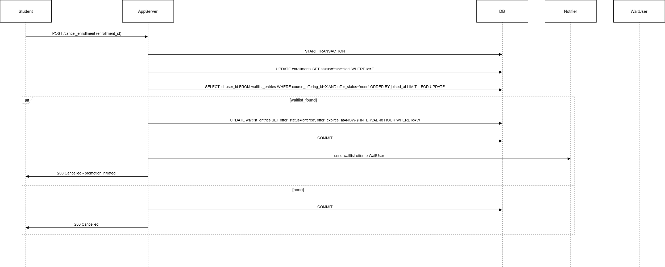
State-Waitlist
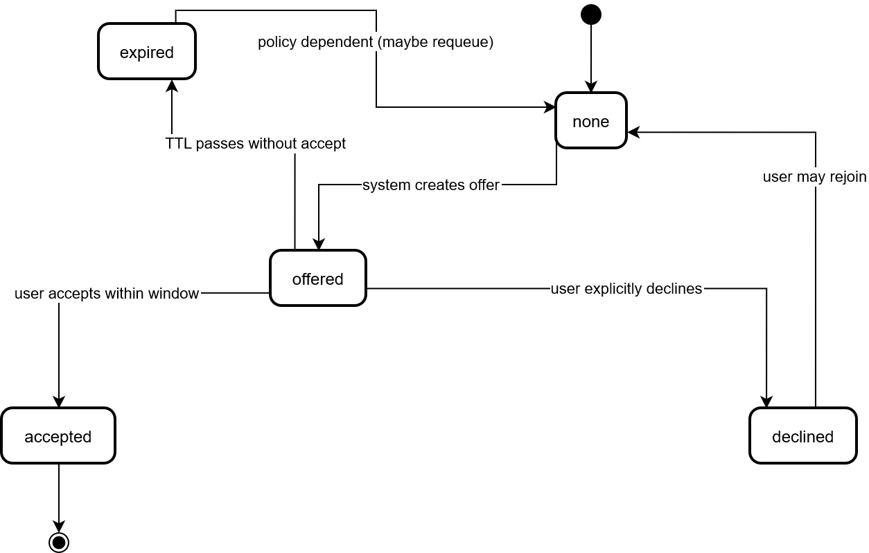

State-Course Offering
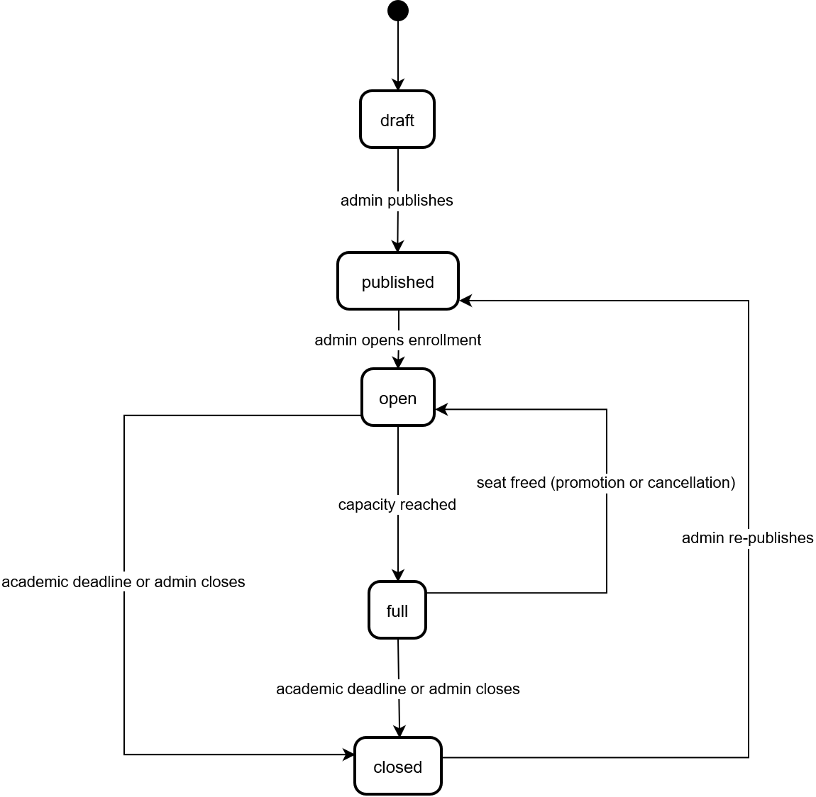

Use Case
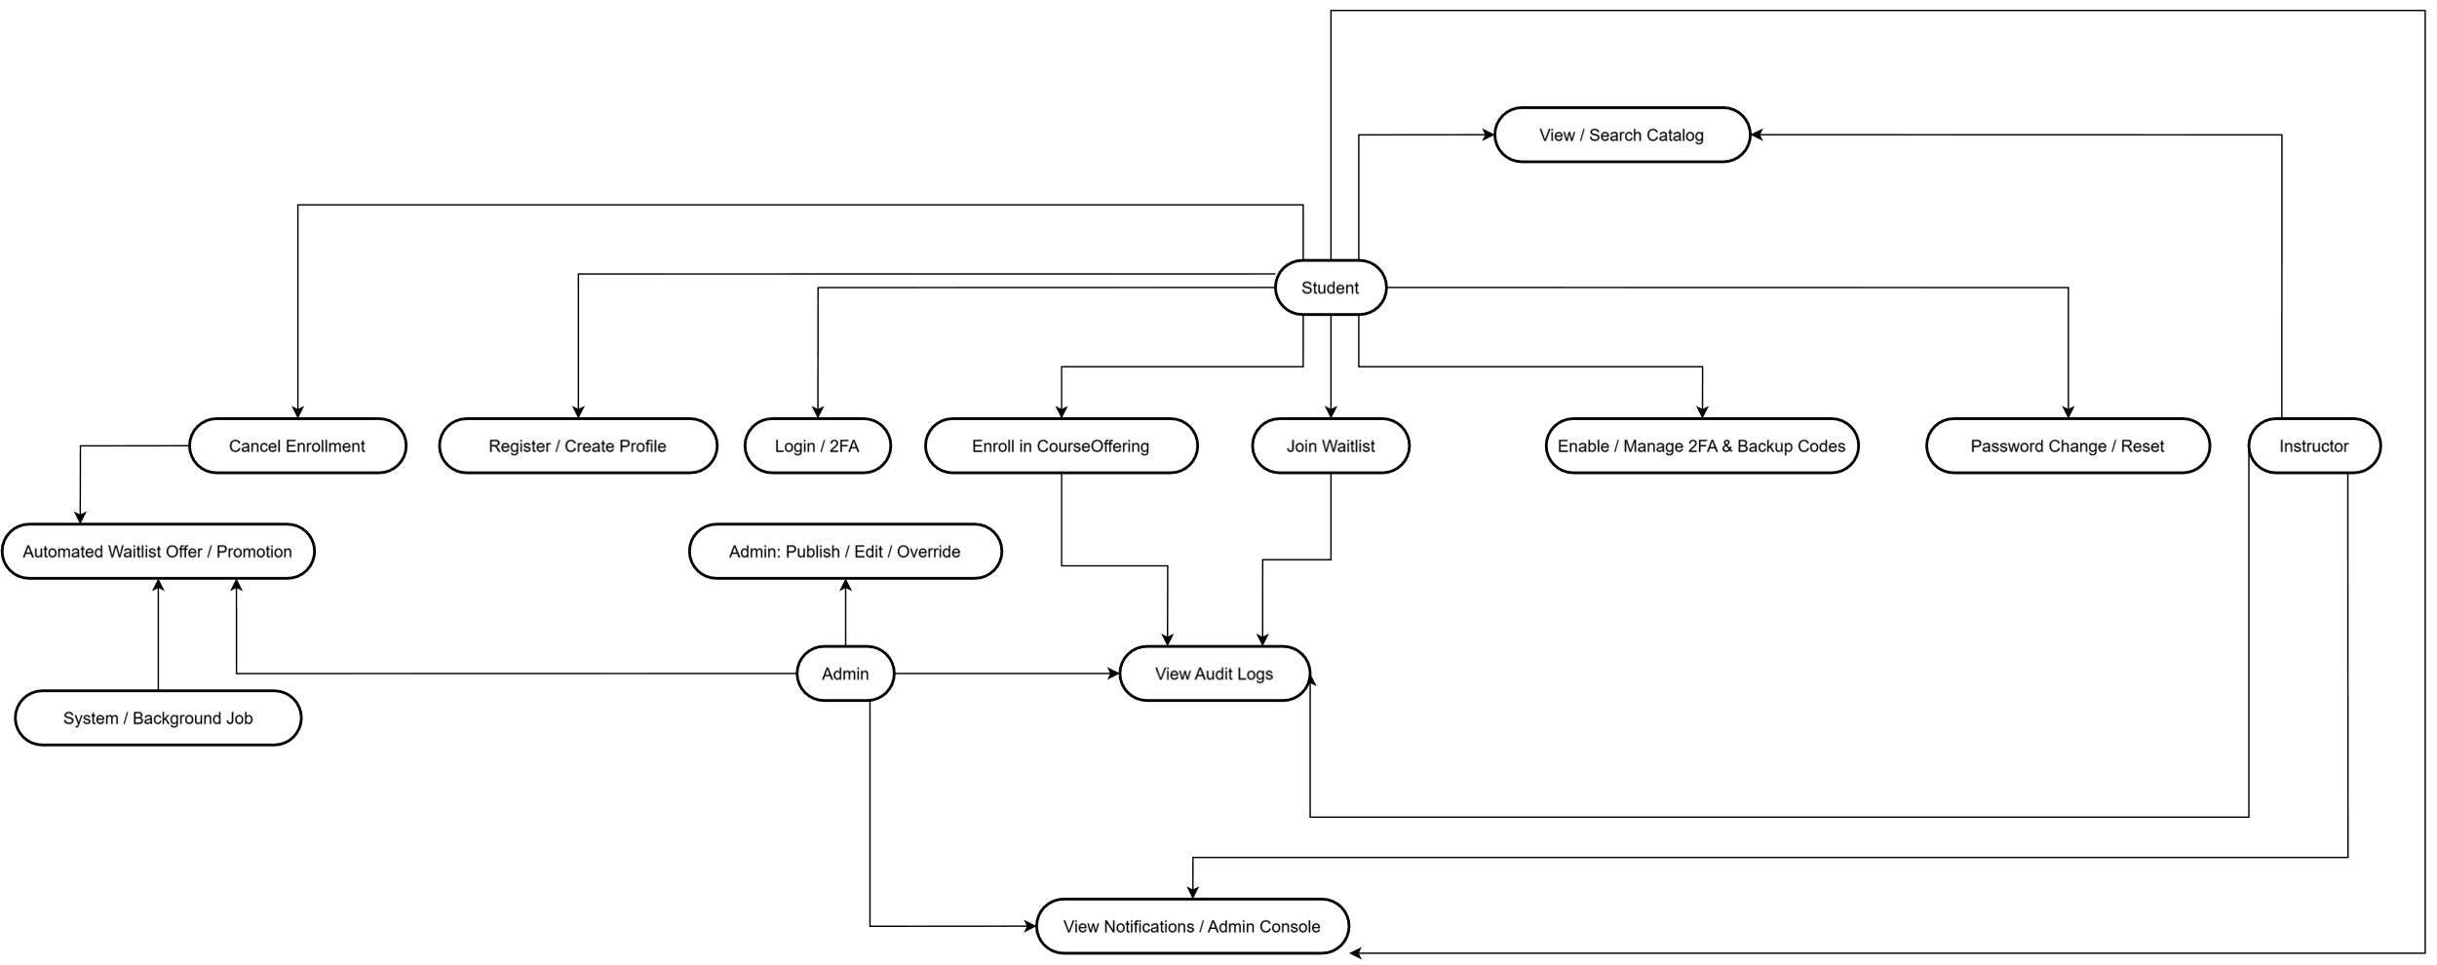
Appendix C: Issues List
- Waitlist offer acceptance window: default 48 hours. Registrar to confirm official window and whether auto-extension is permitted (decision required).
- Add/drop deadlines: define how late cancellations affect waitlist promotion and whether promotions are blocked after certain academic deadlines. Registrar/instructor policy must be specified.
- Demo-mode secret handling: confirm whether plaintext TOTP secrets and tokens are acceptable in the submission artifacts for grader use. If not acceptable, implement encryption of TOTP secrets in the demo and include key-handling documentation.
- SMTP / notification provider: local demo will simulate notifications; decision required whether to configure a test SMTP server for hosted testing or to rely on simulated notifications only.
- Accessibility verification: schedule and owner required to perform WCAG AA checks on primary student-facing pages before submission. Assign to UI owner.
- Retention policy for audit logs: default 365 days is defined; confirm SRU policy and long-term archival approach. Determine owner and export procedures.
- Password reuse policy: default N=3 previous passwords rejected. Confirm whether SRU requires a different value or additional password history controls.
- Admin override and overbook policy: clarify business rules for temporary overbooking (allowed yes/no) and required justification format to be captured in the audit log.
- Rate limiting and lockout policy tuning: defaults provided (5 attempts / 15 minutes, 15 minute lockout). Confirm whether SRU policy requires stricter or more permissive settings.
- Test data and grading accounts: define whether student will include sample accounts and demo secrets in repo, and the policy for removing those artifacts after grading.
- Integration timeline for institutional SSO/SIS: confirm whether instructor expects SSO integration for grading or whether that remains phase 2.
- Sequence/ER diagrams and DDL: diagrams and DDL are planned for Appendix B. Confirm whether diagrams should be included in the public repo or provided separately as instructor-only artifacts.
- Offer expiry job implementation: decide between scheduled background worker versus on-demand evaluation (for example, when processing accept requests). Document chosen approach and required runtime environment for background jobs on hosted deployments.
- SMS provider for optional notifications: if SMS is required later, SRU must provide or approve a provider.
- Test automation and coverage targets: confirm that core modules require automated tests covering positive and negative cases and whether 70% coverage is a hard requirement for submission.

References
Bharamagoudar, S. R., Geeta, R., & Totad, S. G. (2013). Web-Based Student Information Management System. https://ijarcce.com/wp-content/uploads/2012/03/4-shobha-bharamaoudar-WEB-BASED-STUDENT-INFORMATION.pdf
Eludire, A., & Arakeji, I. (2011). The design and implementation of a student academic record management system. https://www.academia.edu/99055843/The_Design_and_Implementation_of_Student_Academic_Record_Management_System
Walia, S., & Gill, S. K. (2014). A Framework for Web-Based Student Record Management System using PHP. IJCSMC, 3(8), 9. https://www.academia.edu/7853090/A_Framework_for_Web_Based_Student_Record_Management_System_using_PHP_

