HateYou the app

HateYou is an account-based app that uses mathematical algorithms to compare its user’s preferences and find them their worst possible match – someone with the most difference in their worldviews.

Central Repo: <https://github.com/HateIncorporated/IHateYourGutsApp>

Our team:

Egor Chernakov BI 161 (git: ChernakovEgor): Main Logic, Testing

George Korneev BI 161 (git: EmeraldChaser): Main Logic, Testing

Arseniy Churilov BI 161 (git: wedfvb): Database, UI design, Testing

Our app relies on database storage and code-first database creation. The database is used to store account information, including the answers to the HateYou Quiz – a list of questions that is used to compare the preferences of our users to find the worst possible match.

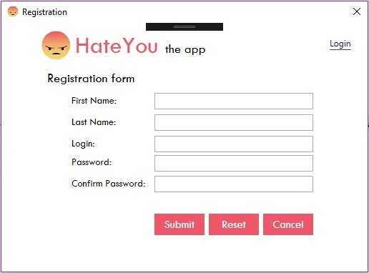

*Fig. 1 – Registration form for a new user*

*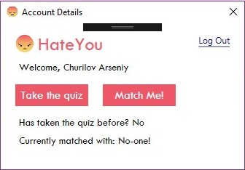*

*Fig. 2 – Account Details*

Unfortunately, there is an error in the main logic of the assignment that none of us can fix – as of 17.12.2017 23:56

The app is really close to being finished though.