SYSTEM ARCHITECTURE
SYS-ARCH-001

STM32F303VCT6 — Bootloader + Drivers + Minimal Application
Primary Input to M1 (HLR Generator) — I-SCEET Toolchain

Field | Value
Document ID | SYS-ARCH-001
Version | 1.0
Status | DRAFT
Date | 2026-04-19
Author | Hatem ADOUANI
Project | I-SCEET — STM32F303VCT6 Test Case
Institution | Capgemini Engineering / ESPRIT
Supervisor | [Supervisor Name]
Target HW | STM32F303VCT6 — ARM Cortex-M4F @ 72MHz, 256KB Flash, 40KB RAM, LQFP100
DAL Level | A — Catastrophic
Fed to | M1 (HLR Generator) alongside PDS-STM32F303-001 and HW Documentation
Standard | RTCA DO-178C / ARP4754A

1. Document Revision History

Version | Date | Author | Description
1.0 | 2026-04-19 | Hatem ADOUANI | Initial release — system architecture for STM32F303VCT6 test project

2. Introduction

2.1 Purpose
This System Architecture document (SYS-ARCH-001) defines the overall software architecture of the STM32F303VCT6 test project for the I-SCEET toolchain. It is the third primary input to M1 (HLR Generator) alongside the PDS and hardware documentation, ensuring generated HLRs are consistent with system-level design decisions.

2.2 System Overview
The STM32F303VCT6 embedded software system consists of three layers:

Layer | Components | Purpose
Application Layer | app_main | LED blink @ 1Hz — validates full toolchain end-to-end
Bootloader Layer | boot_manager | Hardware init, CRC verify, firmware update, jump to app
Driver Layer | clk_driver, flash_driver, uart_driver, gpio_driver, crc_module, wdg_driver, systick_driver | Hardware abstraction — isolates bootloader from register-level code

2.3 Design Principles
- Bare-metal architecture — no RTOS, deterministic execution
- Layered design — application never accesses hardware directly
- Safety-first — watchdog active from boot, CRC verify before jump
- DO-178C DAL A compliant — MC/DC coverage achievable on all modules
- I-SCEET generic — architecture patterns reusable for any future project

3. System Block Diagram
The following diagram shows the complete software architecture from hardware peripherals to application layer, with I-SCEET toolchain input/output flows:

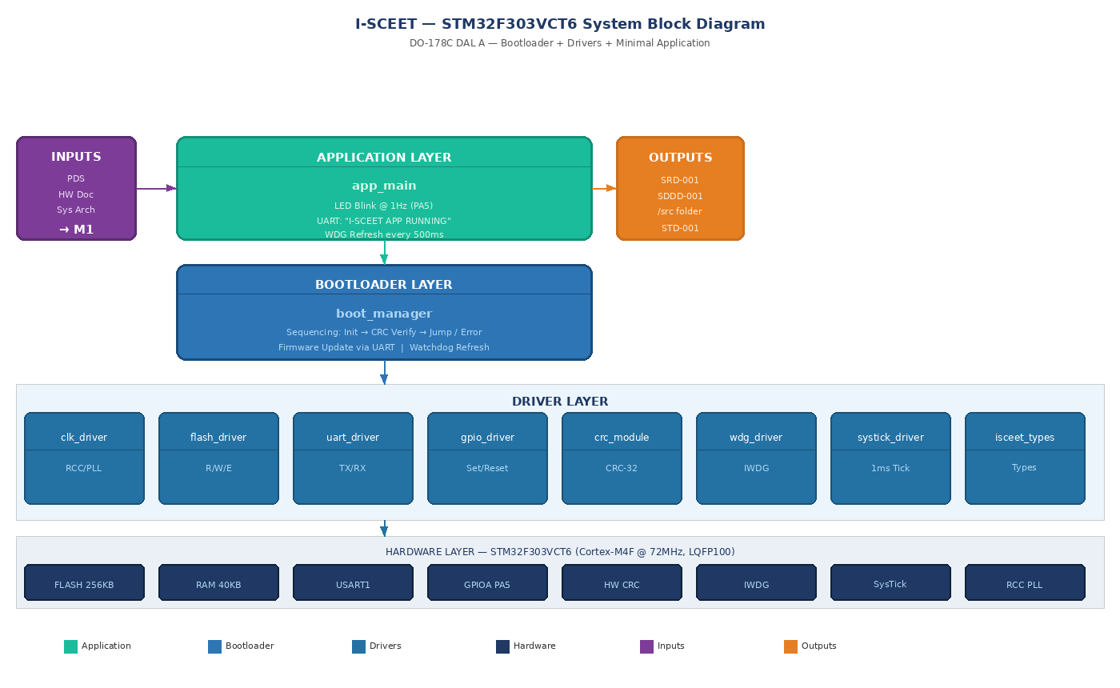

Figure 1 — I-SCEET STM32F303VCT6 System Block Diagram

4. Module Decomposition

4.1 Software Modules

Module | File | Layer | Implements | Dependencies
boot_manager | boot_manager.c/.h | Bootloader | PDS-BOOT-001→007 | all drivers
clk_driver | clk_driver.c/.h | Driver | PDS-CLK-001→004 | isceet_types
flash_driver | flash_driver.c/.h | Driver | PDS-FLASH-001→006 | isceet_types, systick_driver
uart_driver | uart_driver.c/.h | Driver | PDS-UART-001→005 | isceet_types, systick_driver
gpio_driver | gpio_driver.c/.h | Driver | PDS-GPIO-001→004 | isceet_types
crc_module | crc_module.c/.h | Driver | PDS-CRC-001→004 | isceet_types
wdg_driver | wdg_driver.c/.h | Driver | PDS-WDG-001→005 | isceet_types
systick_driver | systick_driver.c/.h | Driver | PDS-TICK-001→004 | isceet_types
app_main | app_main.c/.h | Application | PDS-APP-001→005 | gpio_driver, uart_driver, wdg_driver
isceet_types | isceet_types.h | Shared | Shared types only | none

4.2 Module Initialization Order

Order | Module | Function | Reason
1 | clk_driver | clk_driver_init() | All peripherals depend on correct system clock
2 | systick_driver | systick_driver_init() | All timeout functions depend on SysTick
3 | gpio_driver | gpio_driver_init() | Pin config needed before peripheral use
4 | uart_driver | uart_driver_init() | Debug output available from step 5 onward
5 | flash_driver | flash_driver_init() | Flash must be ready before CRC computation
6 | crc_module | crc_module_init() | CRC unit must be reset before first computation
7 | wdg_driver | wdg_driver_init() | Safety guardian must be active before CRC verify
8 | boot_manager | boot_manager_process() | CRC verify and jump after all init complete

5. Bootloader State Machine
The following state diagram defines all operational states, transition conditions, and error handling paths of the bootloader:

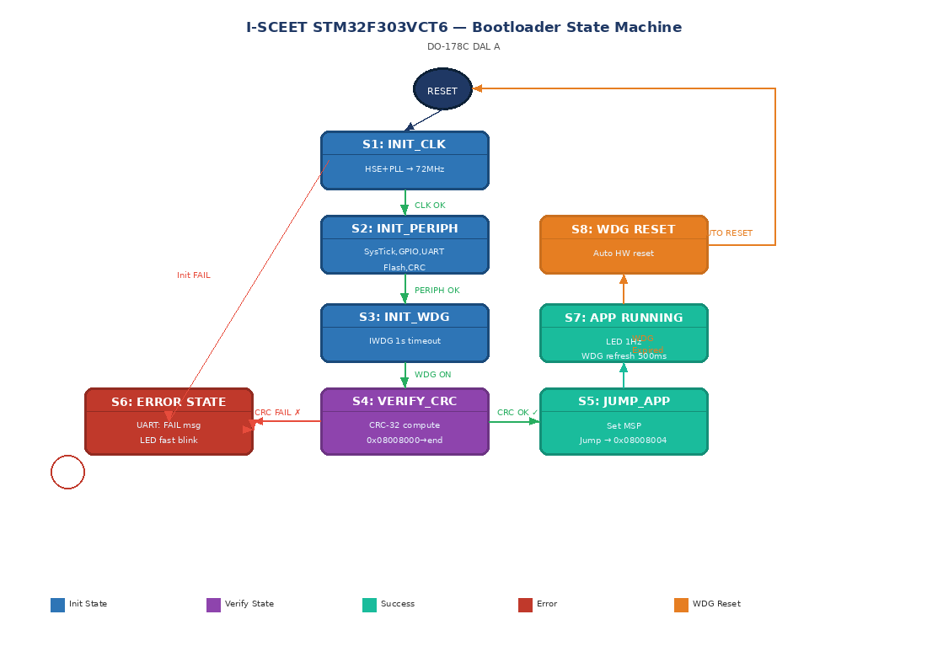

Figure 2 — STM32F303VCT6 Bootloader State Machine (DO-178C DAL A)

5.1 State Descriptions

State | Description | Entry Condition | Exit Condition
RESET | Power-on or watchdog reset | MCU power-on or IWDG expiry | Always → S1: INIT_CLK
S1: INIT_CLK | Configure HSE+PLL to 72MHz | After reset | CLK OK → S2 | FAIL → S6
S2: INIT_PERIPH | Init SysTick, GPIO, UART, Flash, CRC | After S1 success | All OK → S3 | Any FAIL → S6
S3: INIT_WDG | Start IWDG with 1s timeout | After S2 success | WDG ON → S4
S4: VERIFY_CRC | Compute and compare CRC-32 | After S3 success | CRC OK → S5 | CRC FAIL → S6
S5: JUMP_APP | Set MSP, jump to application | CRC verification passed | → APP_RUNNING (irreversible)
S6: ERROR_STATE | UART diagnostic + fast LED blink | Any init fail or CRC fail | Stays in loop until WDG reset
S7: APP_RUNNING | Application executes normally | After successful jump | WDG miss → S8 (IWDG reset)
S8: WDG_RESET | IWDG fires system reset | WDG not refreshed within 1s | → RESET (automatic)

6. Data Flow

6.1 Boot Data Flow

Step | Data | Source | Destination | Description
1 | Clock config | clk_driver | RCC registers | PLL multiplier, AHB/APB prescalers → 72MHz
2 | UART config | uart_driver | USART1 registers | BRR configured for 115200 baud 8N1
3 | Firmware binary | Flash 0x08008000 | crc_module | Raw bytes fed to hardware CRC unit
4 | CRC-32 result | crc_module | boot_manager | Compared against stored value at 0x08007FFC
5 | Boot status | boot_manager | uart_driver | ASCII message: OK or FAIL
6 | App vector addr | boot_manager | Cortex-M4 core | MSP from 0x08008000, PC to 0x08008004

7. Interface Summary

Interface | Peripheral | Pins | Config | Direction
Clock | RCC + HSE | PD0/PD1 (OSC) | HSE 8MHz → PLL → 72MHz | Input (crystal)
Serial / Debug | USART1 | PA9 TX, PA10 RX | 115200 baud 8N1 | Bidirectional
Flash Storage | Internal | N/A | 256KB — 0x08000000 | Read/Write/Erase
Status LED | GPIOA | PA5 | Push-pull output 2MHz | Output
CRC Engine | HW CRC | N/A | CRC-32 poly 0x04C11DB7 | Input data
Watchdog | IWDG | N/A | LSI ~40kHz, 1s timeout | Internal
Timebase | SysTick | N/A | 1ms interrupt at 72MHz | Internal

8. Memory Architecture

Region | Start | End | Size | Content
Vector Table | 0x08000000 | 0x080001FF | 512 B | Cortex-M4 IRQ vectors
Bootloader Code | 0x08000200 | 0x08007FF7 | ~31 KB | boot_manager + all 7 drivers
Firmware Metadata | 0x08007FF8 | 0x08007FFF | 8 B | App size (4B) + CRC-32 (4B)
Application Code | 0x08008000 | 0x0803FFFF | 224 KB | app_main — LED blink
Stack (Bootloader) | 0x20000000 | 0x20001FFF | 8 KB | Bootloader stack (grows down)
Driver Buffers | 0x20002000 | 0x20003FFF | 8 KB | UART buffer, static module vars
App RAM | 0x20004000 | 0x20009FFF | 24 KB | Application stack + data

9. Safety Architecture

Mechanism | Implementation | Failure Covered | DO-178C Objective
CRC-32 Verification | Hardware CRC unit on full app region before jump | Corrupted firmware image | §5 — No unsafe app execution
IWDG Watchdog | 1s timeout, refreshed every 500ms in app | Software hang / infinite loop | §6 — System recovery from hang
Init Error Detection | All init functions return ISCEET_Status_t checked | Hardware peripheral failure | §7 — Safe error handling
Static Allocation Only | No malloc/free anywhere in system | Heap fragmentation / overflow | MISRA-C Rule 21.3
No Recursion | Iterative algorithms only — bounded stack depth | Stack overflow | DAL A stack safety
MC/DC Coverage | All source files covered at 100% MC/DC | Untested code paths | DO-178C §9 DAL A

10. Approvals
This document requires the following approvals before being provided as input to M1:

Role | Name | Signature | Date
Author | Hatem ADOUANI
Project Supervisor | [Supervisor Name]
Systems Engineer | [SE Name]
Quality Assurance | [QA Name]

