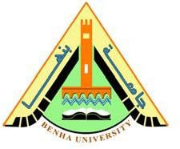

**Faculty of engineering - Shoubra Benha University**

# Research Article / Research Project / Literature Review

in fulfillment of the requirements of

|  |  |
| --- | --- |
| **Department** | Engineering Mathematics and Physics |
| **Division** | ----------- |
| **Academic Year** | 2019-2020 Preparatory |
| **Course name** | Computer |
| **Course code** | ECE001 |

**Title: -**

Operating Systems

By:

|  |  |  |  |
| --- | --- | --- | --- |
|  | Name | Edu mail | B.N |
| 1 | حاتم اشرف ابو حسيبه بكر عبد الرحمن | Hatem195301@feng.be.edu.eg | 272 |

## Approved by:

|  |  |
| --- | --- |
| Examiners committee | Signature |
| Dr.Ahmed Bayoumi |  |
| Dr.Shady Elmashad |  |
| Dr. Abdelhamid Attaby |  |

# Table of contents

|  |  |
| --- | --- |
| **Subject / section** | **Page** |
| Introduction | 2 |
| Literature Review | 3 |
| Source code | 7 |
| Screenshot | 9 |

# List of Figures

|  |  |  |
| --- | --- | --- |
| **Figure I.D** | **Description** | **Page** |
| Fig.1 | Source code 1 | 7 |
| Fig.2 | Source code 2 | 7 |
| Fig.3 | Source code 3 | 8 |
| Fig.4 | Website 1 | 9 |
| Fig.5 | Website 2 | 9 |
| Fig.6 | Website 3 | 10 |

**Introduction**

Modern multi-purpose computers, including personal computers and mainframes, have an operating system to run the rest of the programs, such as software applications. Examples of PC operating systems include Microsoft Windows, Unix, Mac and Linux

When the first generation of computers appearance was designed to carry out specific operations for example a computer designed to do complex calculations, but with the successive development of computer technology and the emergence of many of the physical components that are used in the implementation of the actions required of it and each of them requires a special program to carry out his mission as required, the need arises to organize The operation of these different units in a manner that prevents their contradiction and consequently the failure of the Do any task that you are asked to do. Based on this need, the operating system term appeared as a designation of the program responsible for controlling the work of the computer device and all the attached components, whether these components are physical or software. The operating system is the first program that we deal with when operating the computer and it is also the last program that we deal with when the computer is closed.

All of the various components of the computer system are physical, programmatic, and are handled through a set of programs. These programs are collectively called the operating system, when you transfer a file from one storage unit to another or when you have installed it on your device as a device on your device, Your application programs as a text editor or graphics program all operate it and

organize its operating system tasks. This means that the operating system is responsible for organizing the conduct of these operations and managing the

components of the computer, and

therefore it represents the backbone of life for him, and we can, in light of the above, define the operating system as:

The software system that different devices and programs work on, this system that includes various Internet browsers, media programs, text editing programs, and many other programs that are used. The presence of this device by operating cannot be used for any of the devices, including the computer where Operating system is the official interface that is lost between the computer components and the user.

# Literature Review

**Operating Systems Classification:-**

* **Real-time operating system (RTOS):**

This type of operating system is used to control machinery, scientific instruments, and industrial systems. RTOS usually has very little UI capabilities, and does not include end-user services, because the system will be "closed" when it is delivered to the user. A very important part of RTOS is computer resource management as a specific process is executed at its specified stroke, every time it occurs.

* **Single-user, multi-tasking:**

This is the type of operating system most people use on desktop and laptop computers today. Microsoft Windows and Apple's MacOS platforms are both examples of operating systems that allow one user to have multiple programs running at the same time. For example, it is quite possible for a Windows user to write a note in a word processor while downloading a file from the Internet and at the same time printing the text of an email message.

* **Single-user, single task:**

As the name implies, this operating system is designed to manage the computer so that one user can only effectively perform one task. Palm OS for laptops is a good example of a single-task operating system.

* **Multi-user OS:**

Multi-user - The multi-user operating system allows multiple users to take advantage of computer resources simultaneously. The operating system must ensure that the requirements of users are balanced and that each program that uses it has sufficient and separate resources so that a problem with one user does not affect the rest of the users. Unix, VMS and central operating systems, such as MVS, are examples of multi-user operating systems.

**Operating system functions**

1. Enabling communication between the computer and the user through the user interface that is in the form of commands that the user gives to the Command based device or in the form of a graphical interface and menus from which the user chooses the required command, Graphical User Interface, as is the case in Windows.
2. Distributing common equipment to users in the network and scheduling their use. If there is one printer with several devices connected to each other via the network and a number of users wanted to print their documents using the printer at the same time, the operating system schedules the printing process according to a specific policy so that it happens as a user at the end On a printed document.
3. It facilitates communication between computer components as it facilitates the movement of internal instructions and data between peripherals, the processor, programs and storage devices in another meaning it facilitates secondary input, output and storage operations
4. Protection from errors, monitoring the system, and notifying the user in case of

failure, as the operating system checks the computer system equipment

continuously and the user is notified immediately in the event of any problem.

For example, when giving the command to print a document and the printer is free of paper, a message appears that informs the user that it is not possible to print because the printer is free of paper.

**Types of operating systems:**

* + **Disk Operating System (DOS)**:

This system is one of the old systems that was used in many personal devices

In many companies, in 1981 the President of Bill Gates developed this system and called

this system MS-DOS. This system relies on running text commands directly, and this system is single-tasked.

* + Linux operating system:

It is one of the most famous, widespread and used systems, and it is an open source system, and it is characterized by a beautiful and simple graphic interface, and it has many different versions, and it is characterized by high protection and safety when using it, and it can be modified because it is a completely free system, usually used by engineers specializing in protection in particular and networks in general.

* + Windows operating system:

It is one of the most widely used operating systems around the world. It is mainly used in desktop and laptop computers, in addition to workstations, according to the many advantages that it enjoys, including the following:

1-It allows the user to easily deal with it without the need to understand the complex commands thanks to having a clear and practical graphical user interface.

2- It works at different speeds that vary from one version to another.

3- Compatible with different devices, which is a feature that varies from version to

version.

4- It works smoothly on devices with low specifications because it uses equipment

With low requirements.

* + Mac Operating System:

It is a system developed by the American company Apple, and it has received a great response from users all over the world.

In addition to some other systems

* Haiku operating system
* Chrome Operating System
* MENUET Operating System

## Mobile Operating System:

* Windows Mobile
* Palms OS
* BlackBerry OS
* Symbian OS
* Android

**Source code**

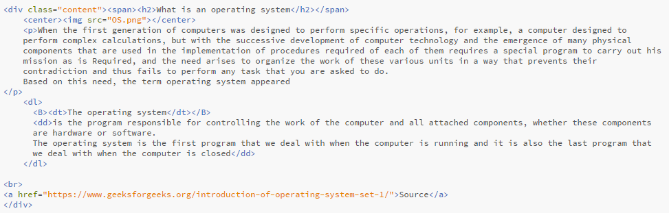

Fig.1

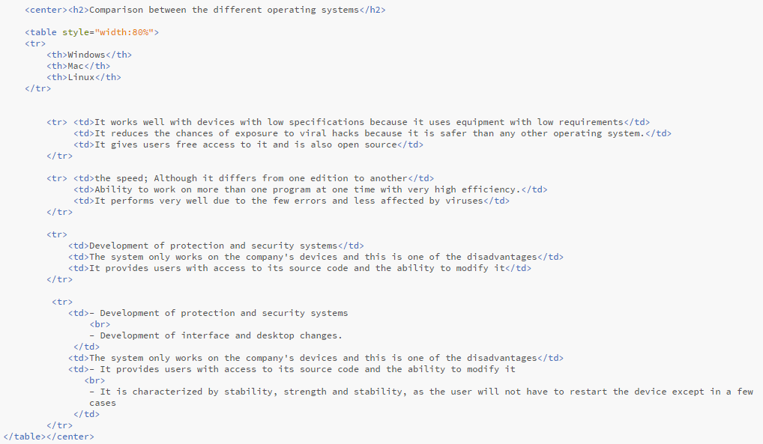

Fig.2

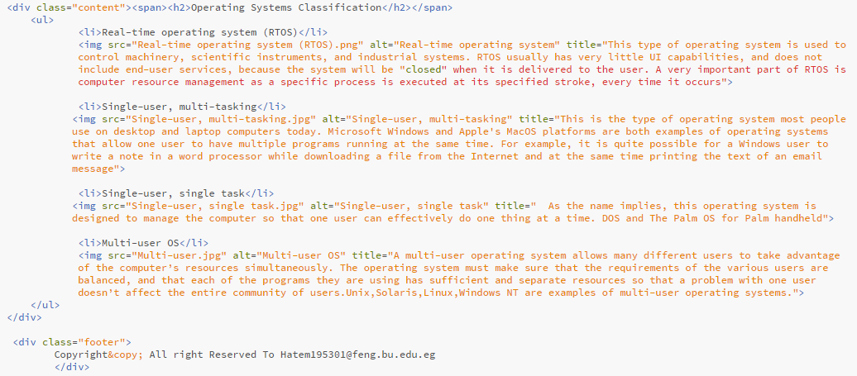

Fig.3

**Screenshot**

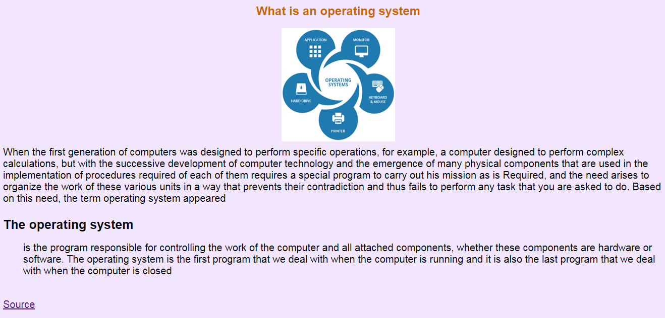

Fig.4

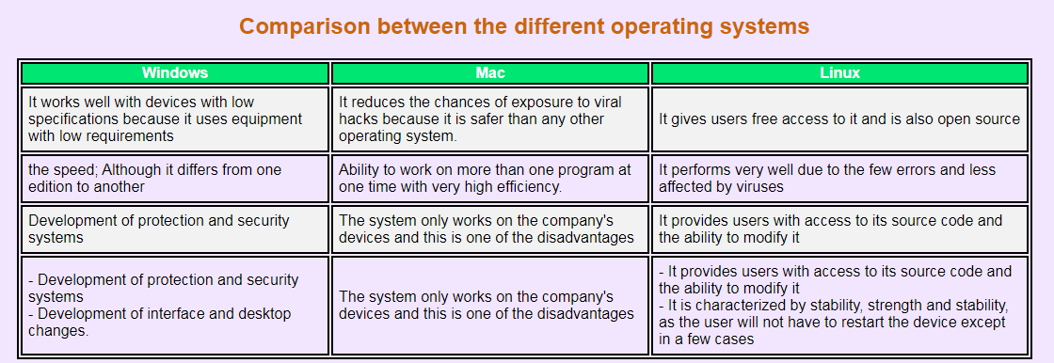

Fig.5

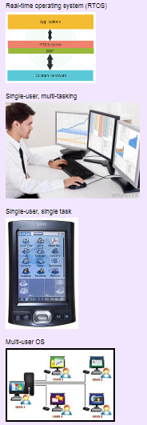

Fig.6

# References

### Link1:

### <https://www.geeksforgeeks.org/functions-of-operating-system/>

### Link2:

### <https://www.ukessays.com/essays/computer-science/classification-of-operating-systems-ii-computer-science-essay.php>

### Link3:

### <https://www.webopedia.com/TERM/O/operating_system.html>

### Link4:

### <https://www.ukessays.com/essays/computer-science/classification-of-operating-systems-ii-computer-science-essay.php>