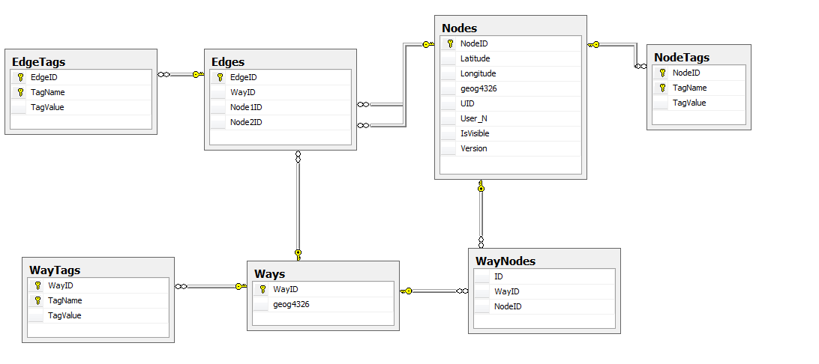

Function:-

* GetWayByName
* GetWayByCords
* GetNodeByCords
* DrawWayByName
* DrawWayByID
* GetRandomNodeInWay
* DrawEdge
* DrawEdges
* GetNodeByCords
* GetNodeByTag
* IfNodeIsInCircle
* GetDistance
* GetNearestFromNode
* Breadth_First_Search
* Dijkstra