NudgeSo
D0–D5 QA Agent & Full-Suite Report
Generated 2026-10-30T12:22:18 · local hermetic run
Scope: read-only site model, deterministic contract generation, evidence integration, repair gate, independent verification and release gate.
All screenshots are supplied as evidence. Non-UI tests use explicitly labelled evidence cards because no browser page exists at teardown; skipped tests also have a labelled status card.

1. Executive summary
Layer | Result
D0 read-only site model | 12 PASS / 0 FAIL / 1 NOT RUN
D1 generated contracts | 12 reviewed contracts; generated suite passed
D2 evidence integration | 70 tests, 66 passed, 4 skipped
D3 repair gate | NO_FAILURES_TO_REPAIR
D4 independent verifier | PASS
D5 release gate | PASS
Full Playwright suite | 66 passed / 0 failed / 4 skipped
Screenshots | 70 / 70 test evidence images
The local D0–D5 gate is PASS. This report does not claim external CI completion; the GitHub Actions run was still in progress at report generation and is recorded separately.

2. D0 — read-only site model
Explored 12 of 13 registry pages. The only NOT RUN is insight-detail because D0 deliberately did not seed an article fixture.
Page | Status | Final URL | Overflow
landing | PASS | http://127.0.0.1:3030/landing.html?lang=en | no
login | PASS | http://127.0.0.1:3030/login.html | no
onboarding | PASS | http://127.0.0.1:3030/onboarding.html?lang=en | no
workspace | PASS | http://127.0.0.1:3030/ | no
queue | PASS | http://127.0.0.1:3030/queue.html | no
customer-chat | PASS | http://127.0.0.1:3030/chat.html?site=b77ff31ca606ee0251916a53 | no
upload | PASS | http://127.0.0.1:3030/upload.html | no
manual | PASS | http://127.0.0.1:3030/manual.html | no
insights | PASS | http://127.0.0.1:3030/insights.html?lang=en | no
privacy-draft | PASS | http://127.0.0.1:3030/privacy.html | no
terms-draft | PASS | http://127.0.0.1:3030/terms.html | no
not-found | PASS | http://127.0.0.1:3030/404.html | no
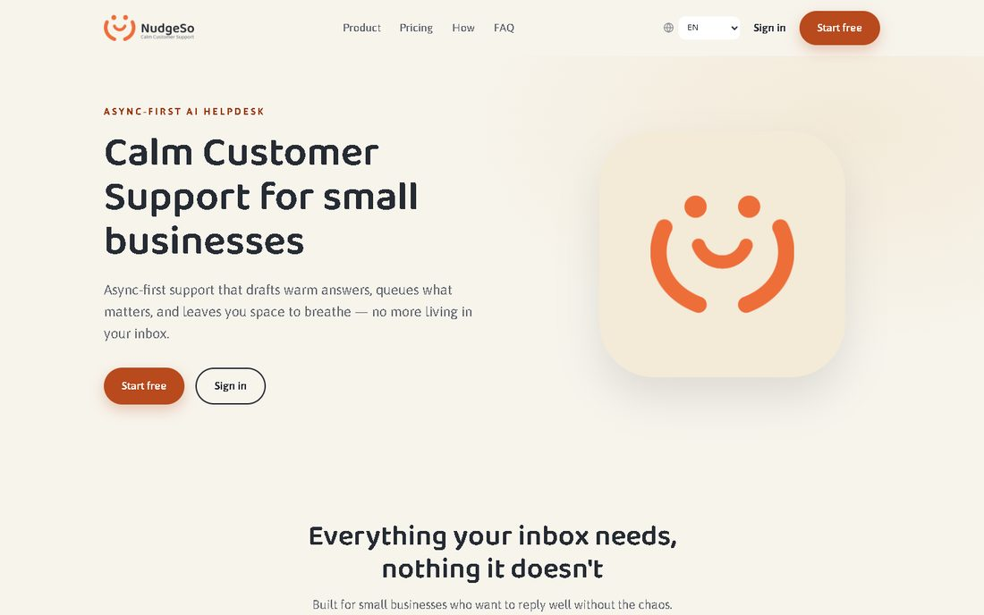
D0 · landing · PASS · http://127.0.0.1:3030/landing.html?lang=en
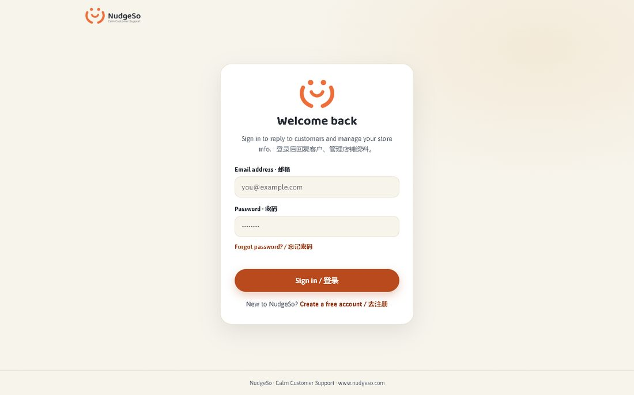
D0 · login · PASS · http://127.0.0.1:3030/login.html
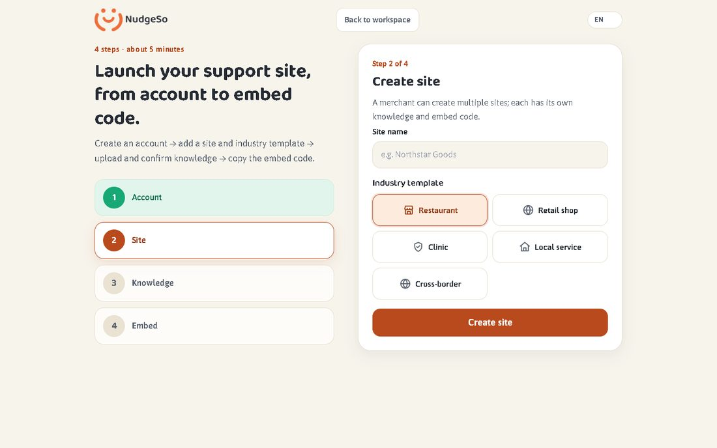
D0 · onboarding · PASS · http://127.0.0.1:3030/onboarding.html?lang=en
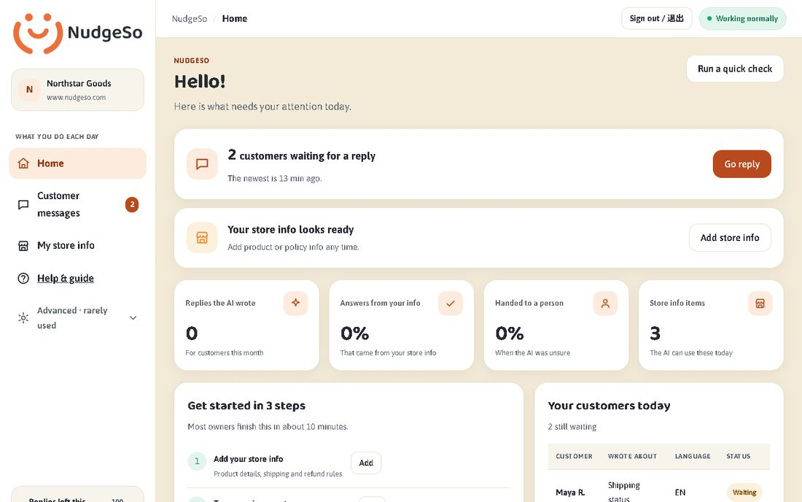
D0 · workspace · PASS · http://127.0.0.1:3030/
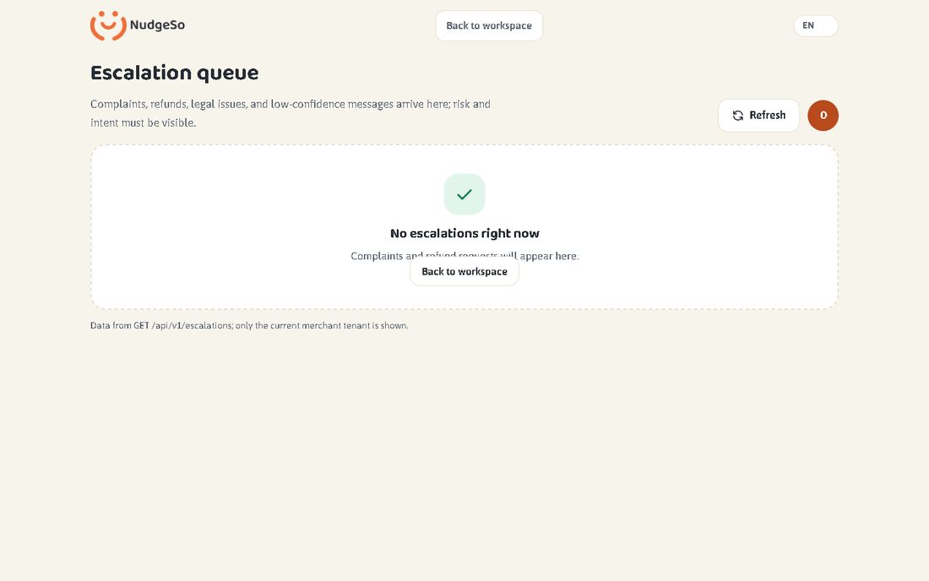
D0 · queue · PASS · http://127.0.0.1:3030/queue.html
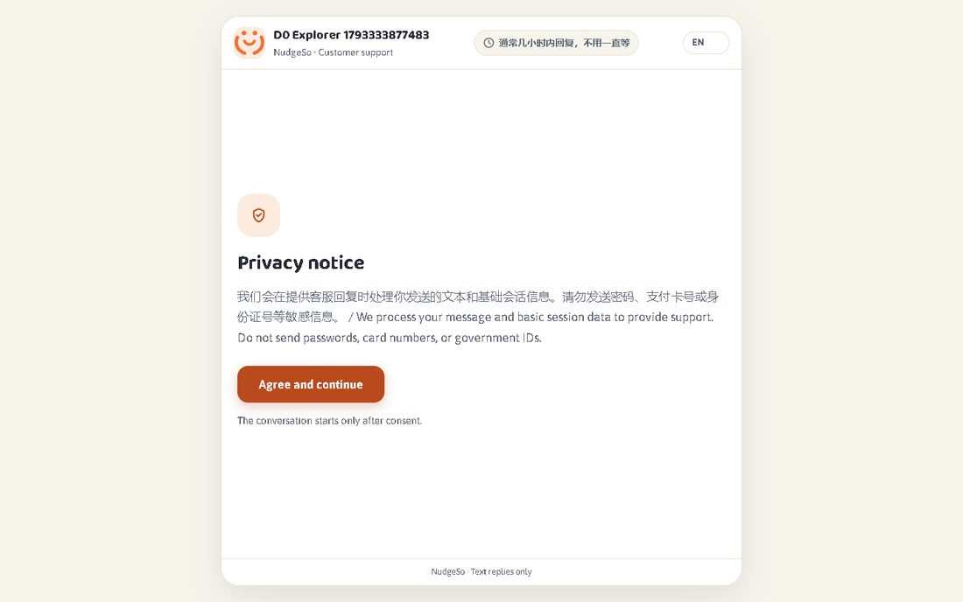
D0 · customer-chat · PASS · http://127.0.0.1:3030/chat.html?site=b77ff31ca606ee0251916a53
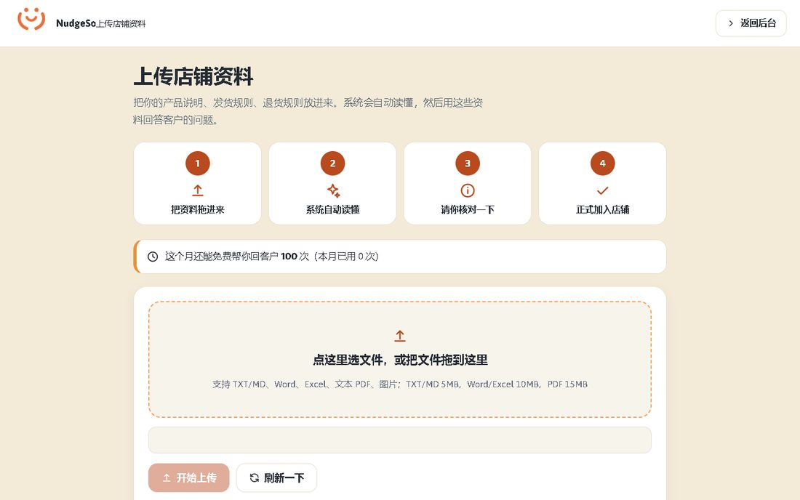
D0 · upload · PASS · http://127.0.0.1:3030/upload.html
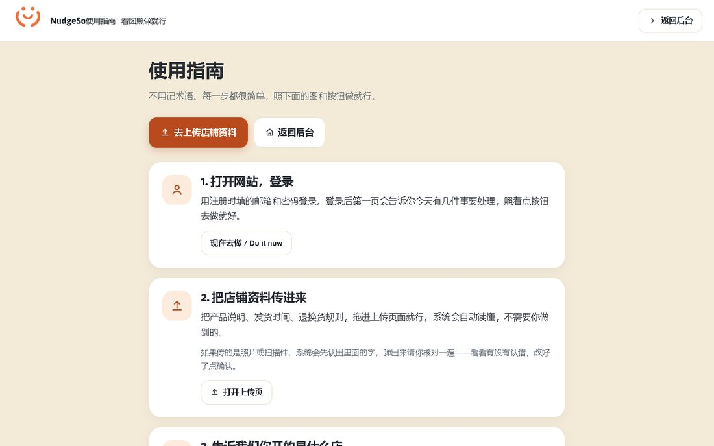
D0 · manual · PASS · http://127.0.0.1:3030/manual.html
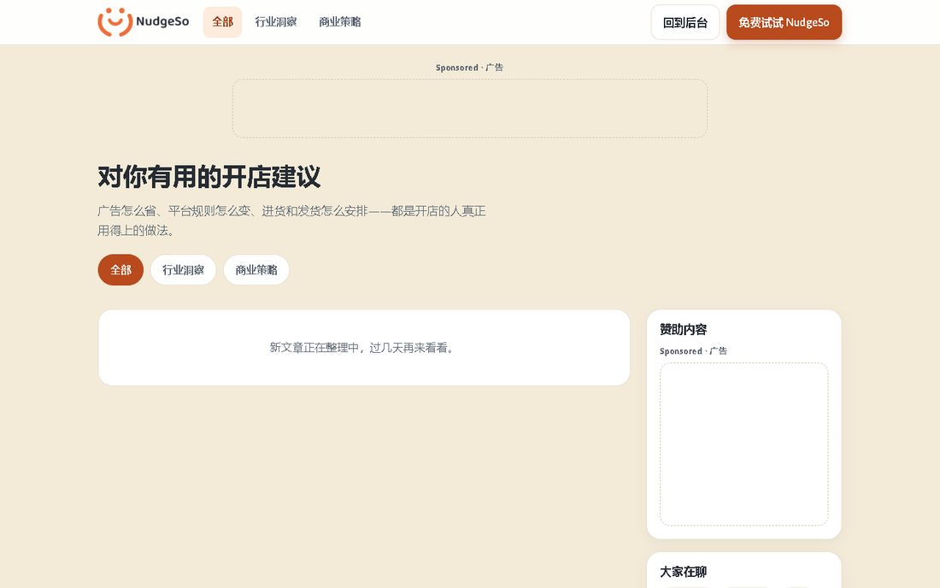
D0 · insights · PASS · http://127.0.0.1:3030/insights.html?lang=en
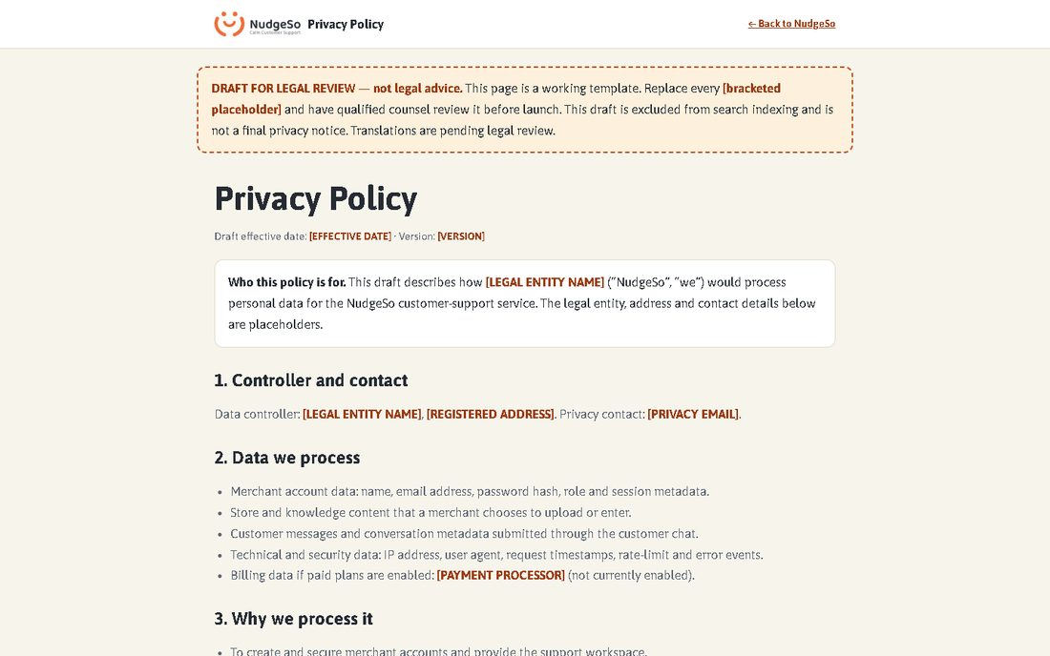
D0 · privacy-draft · PASS · http://127.0.0.1:3030/privacy.html
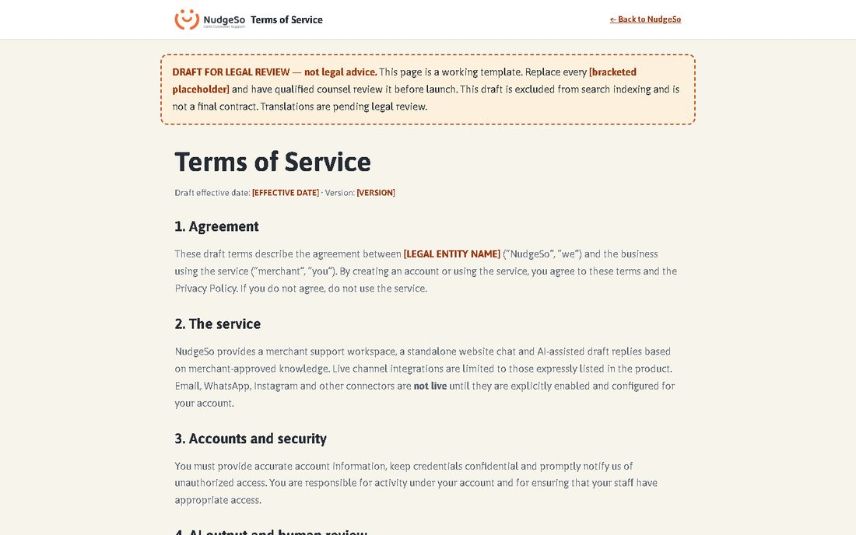
D0 · terms-draft · PASS · http://127.0.0.1:3030/terms.html
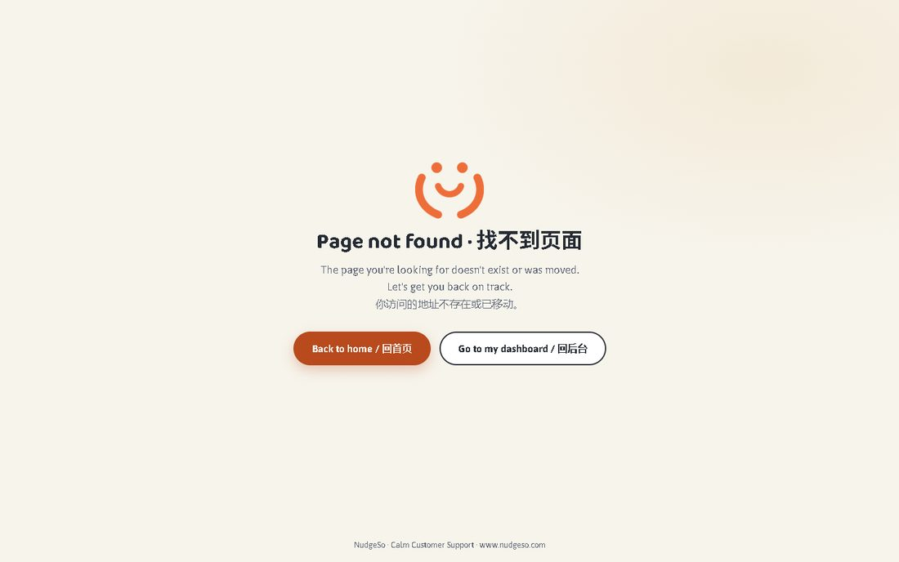
D0 · not-found · PASS · http://127.0.0.1:3030/404.html

3. D1 — deterministic contract generator
Reviewed manifest: 12 routes. The generator refuses an unreviewed manifest or invalid/duplicate contracts. Generated assertions are limited to route, selector, marker, auth boundary, overflow and page errors.
Contract | Route | Auth | Criticality
landing | /landing.html?lang=en | guest | P0
login | /login.html | guest | P0
onboarding | /onboarding.html?lang=en | guest | P0
workspace | / | merchant | P0
queue | /queue.html?lang=en | merchant | P0
customer-chat | /chat.html?site=<embed_key> | customer | P0
upload | /upload.html | merchant | P1
manual | /manual.html | merchant | P2
insights | /insights.html?lang=en | merchant | P2
privacy-draft | /privacy.html | guest | P2
terms-draft | /terms.html | guest | P2
not-found | /404.html | guest | P2
Generated suite: e2e/D1-GENERATED.spec.ts · 12/12 passed inside the full suite.

4. D2–D5 — evidence, repair, verification and release gates
D2 merged full-suite results, D0 coverage and D1 contracts into one evidence report.
Screenshots: 70 available; missing for non-skipped tests: 0.
D3 decision: NO_FAILURES_TO_REPAIR. No failed tests required repair; the repair policy forbids test deletion, skips, assertion weakening and production writes.
D4 independent verifier: PASS across 8 checks.
D5 release gate: PASS. CI integration steps were added; external CI completion is reported separately.

5. Full test report — every test with evidence
The following pages contain the complete Playwright result. Each test has a final screenshot; non-UI tests and intentionally skipped tests have a clearly labelled deterministic evidence card.
1. › chromium › A11Y.spec.ts › Accessibility — axe WCAG 2A/AA core surfaces › no critical or serious axe violations on public and authenticated surfaces
Status: PASSED · Duration: 6481 ms · File: e2e\A11Y.spec.ts:58
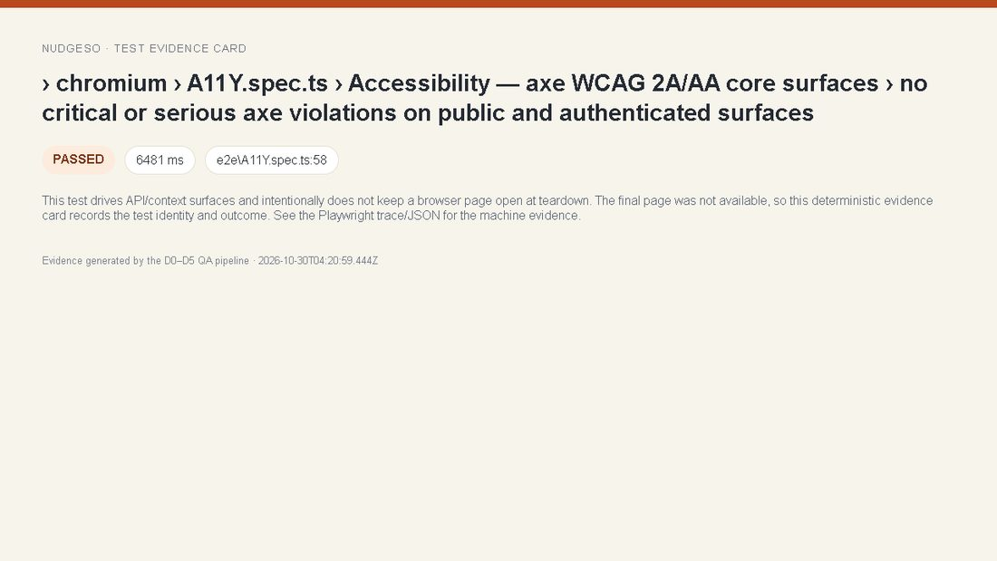
Evidence · › chromium › A11Y.spec.ts › Accessibility — axe WCAG 2A/AA core surfaces › no critical or serious axe violations on public and authenticated surfaces

2. › chromium › AC-01.spec.ts › AC-01 merchant onboarding › register/login -> site + template -> upload/confirm knowledge -> embed code
Status: PASSED · Duration: 2164 ms · File: e2e\AC-01.spec.ts:16
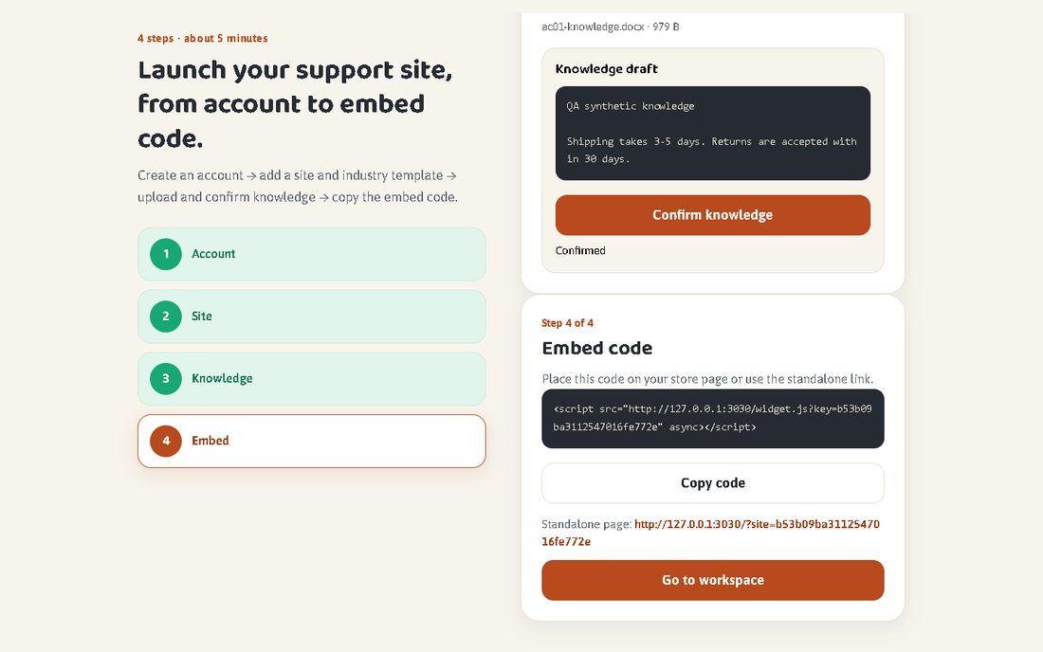
Evidence · › chromium › AC-01.spec.ts › AC-01 merchant onboarding › register/login -> site + template -> upload/confirm knowledge -> embed code

3. › chromium › AC-02.spec.ts › AC-02 customer chat: privacy consent -> Chinese message -> Chinese text reply
Status: PASSED · Duration: 1054 ms · File: e2e\AC-02.spec.ts:20
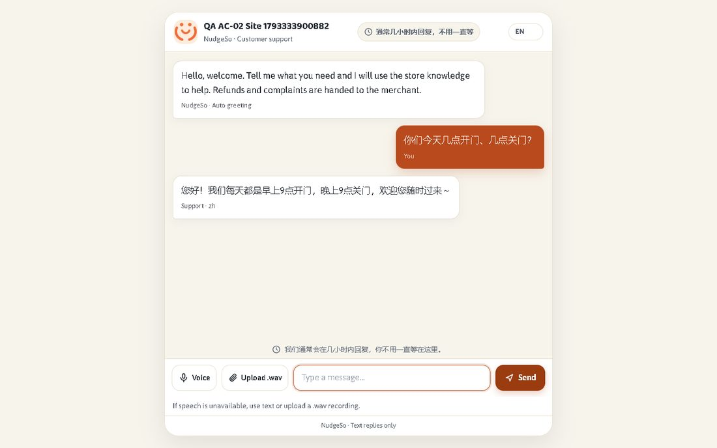
Evidence · › chromium › AC-02.spec.ts › AC-02 customer chat: privacy consent -> Chinese message -> Chinese text reply

4. › chromium › AC-03.spec.ts › AC-03 refund/complaint -> safe template + escalation queue
Status: PASSED · Duration: 1226 ms · File: e2e\AC-03.spec.ts:4
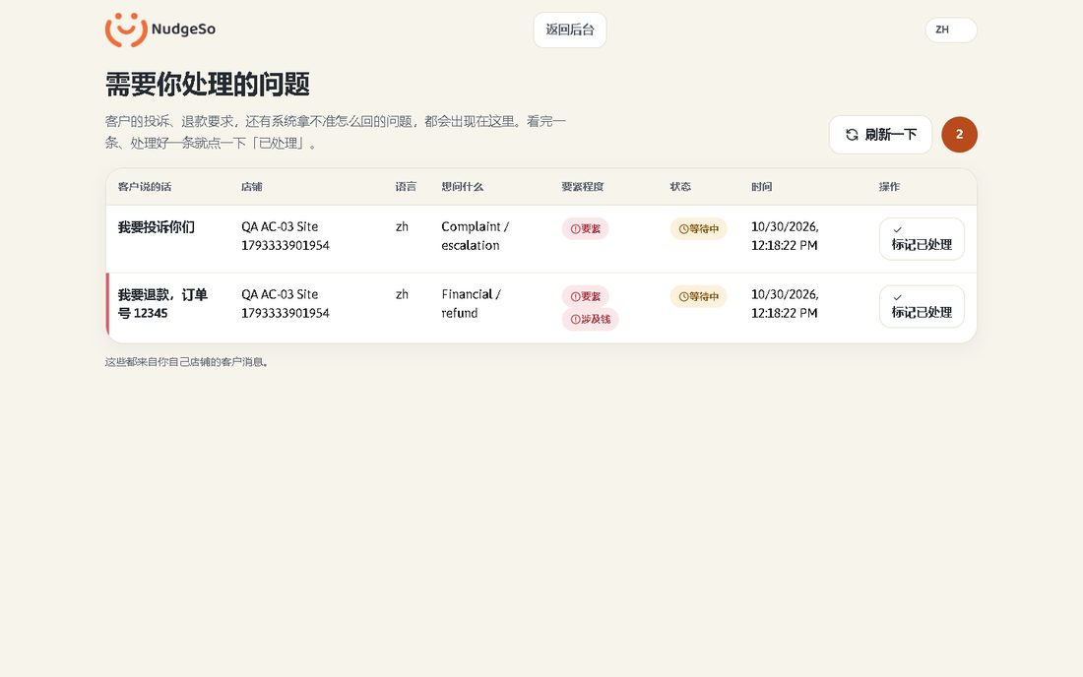
Evidence · › chromium › AC-03.spec.ts › AC-03 refund/complaint -> safe template + escalation queue

5. › chromium › AC-04.spec.ts › AC-04 P2: ASR network fallback -> WAV upload -> soothing/RAG hours + package + high-risk
Status: PASSED · Duration: 2101 ms · File: e2e\AC-04.spec.ts:43
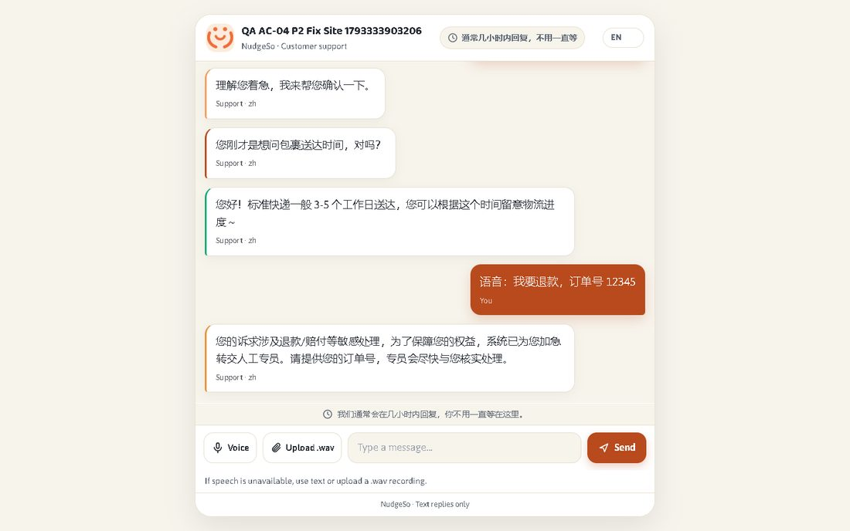
Evidence · › chromium › AC-04.spec.ts › AC-04 P2: ASR network fallback -> WAV upload -> soothing/RAG hours + package + high-risk

6. › chromium › AC-05.spec.ts › AC-05 customer chat window has no ads or third-party ad requests
Status: PASSED · Duration: 878 ms · File: e2e\AC-05.spec.ts:6
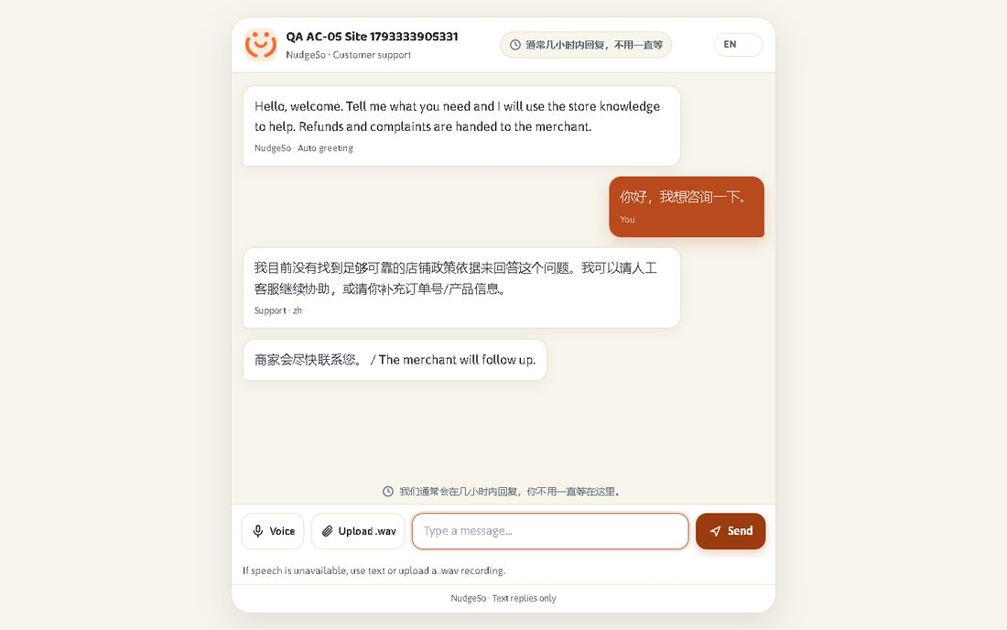
Evidence · › chromium › AC-05.spec.ts › AC-05 customer chat window has no ads or third-party ad requests

7. › chromium › CLOUD-SMOKE.spec.ts › Deployed UI smoke (read-only) › static pages, health and English/Arabic onboarding are reachable
Status: SKIPPED · Duration: 0 ms · File: e2e\CLOUD-SMOKE.spec.ts:10
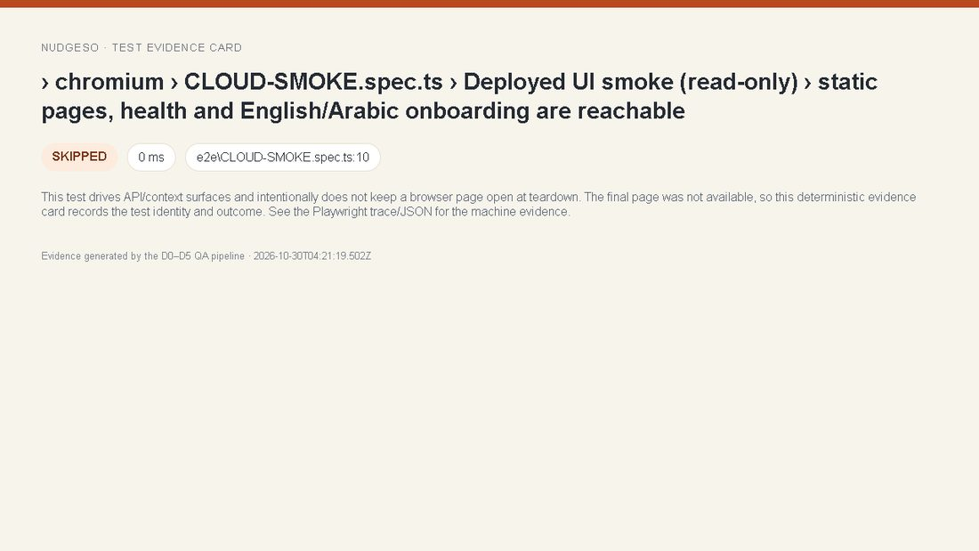
Evidence · › chromium › CLOUD-SMOKE.spec.ts › Deployed UI smoke (read-only) › static pages, health and English/Arabic onboarding are reachable

8. › chromium › CONTEXT-C2-C3.spec.ts › C2 auth returnTo › anonymous protected URL carries the exact returnTo into login
Status: PASSED · Duration: 425 ms · File: e2e\CONTEXT-C2-C3.spec.ts:22
Evidence · › chromium › CONTEXT-C2-C3.spec.ts › C2 auth returnTo › anonymous protected URL carries the exact returnTo into login

9. › chromium › CONTEXT-C2-C3.spec.ts › C2 auth returnTo › every protected surface carries its own returnTo
Status: PASSED · Duration: 981 ms · File: e2e\CONTEXT-C2-C3.spec.ts:30
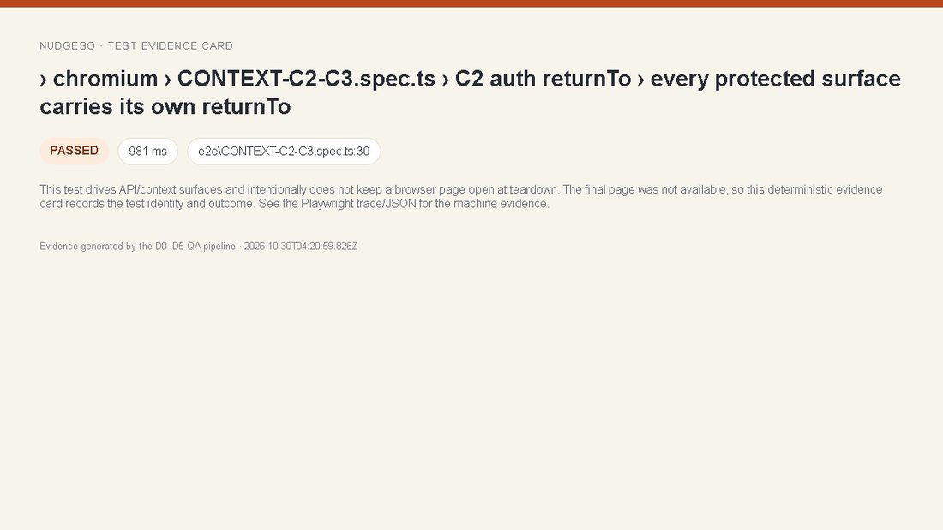
Evidence · › chromium › CONTEXT-C2-C3.spec.ts › C2 auth returnTo › every protected surface carries its own returnTo

10. › chromium › CONTEXT-C2-C3.spec.ts › C2 auth returnTo › a successful login returns to the requested local URL
Status: PASSED · Duration: 713 ms · File: e2e\CONTEXT-C2-C3.spec.ts:41
Evidence · › chromium › CONTEXT-C2-C3.spec.ts › C2 auth returnTo › a successful login returns to the requested local URL

11. › chromium › CONTEXT-C2-C3.spec.ts › C2 auth returnTo › protocol-relative redirect cannot leave the origin
Status: PASSED · Duration: 5397 ms · File: e2e\CONTEXT-C2-C3.spec.ts:52
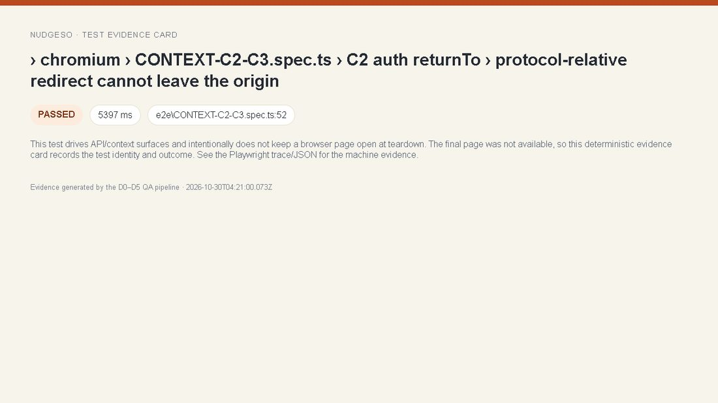
Evidence · › chromium › CONTEXT-C2-C3.spec.ts › C2 auth returnTo › protocol-relative redirect cannot leave the origin

12. › chromium › CONTEXT-C2-C3.spec.ts › C2 auth returnTo › encoded backslash redirect cannot leave the origin
Status: PASSED · Duration: 5397 ms · File: e2e\CONTEXT-C2-C3.spec.ts:64
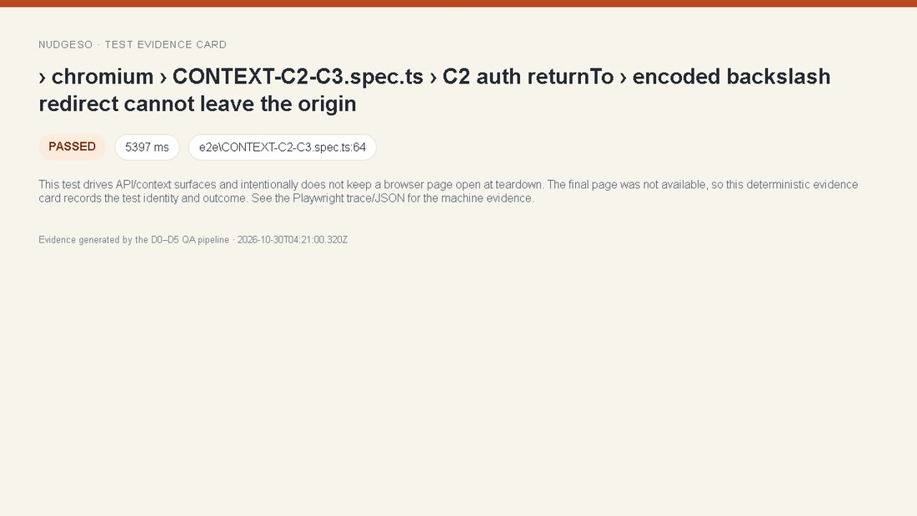
Evidence · › chromium › CONTEXT-C2-C3.spec.ts › C2 auth returnTo › encoded backslash redirect cannot leave the origin

13. › chromium › CONTEXT-C2-C3.spec.ts › C2 auth returnTo › an expired token sends the protected page back to login with returnTo
Status: PASSED · Duration: 577 ms · File: e2e\CONTEXT-C2-C3.spec.ts:76
Evidence · › chromium › CONTEXT-C2-C3.spec.ts › C2 auth returnTo › an expired token sends the protected page back to login with returnTo

14. › chromium › CONTEXT-C2-C3.spec.ts › C3 tenant isolation › browser queue and tenant APIs never expose another tenant
Status: PASSED · Duration: 791 ms · File: e2e\CONTEXT-C2-C3.spec.ts:87
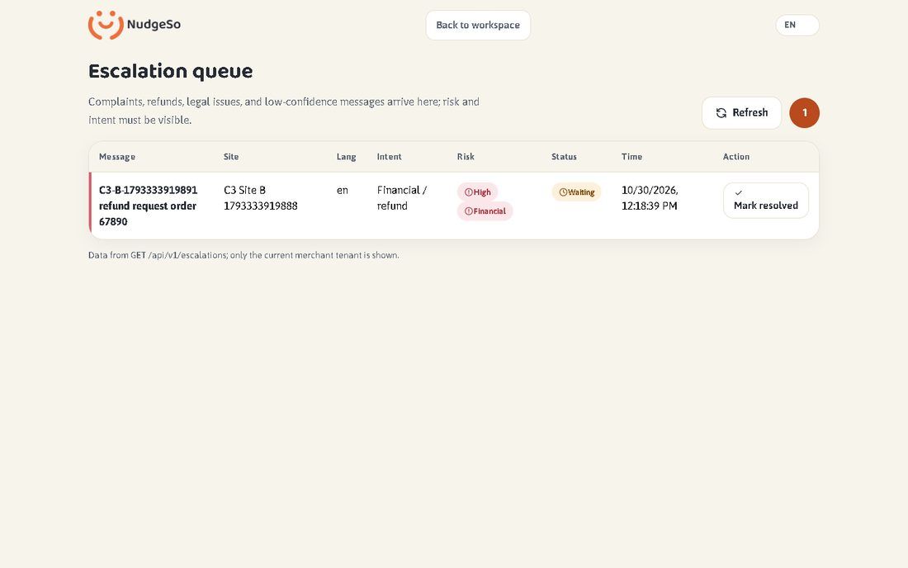
Evidence · › chromium › CONTEXT-C2-C3.spec.ts › C3 tenant isolation › browser queue and tenant APIs never expose another tenant

15. › chromium › CONTEXT-C4-C5.spec.ts › C4 preview plan context › Pro intent is preserved into onboarding without payment
Status: PASSED · Duration: 843 ms · File: e2e\CONTEXT-C4-C5.spec.ts:22
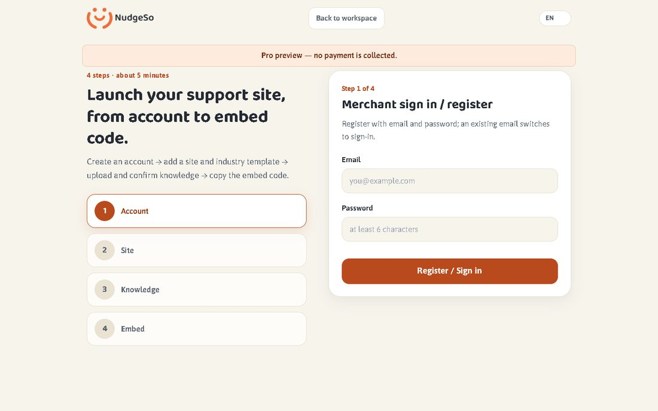
Evidence · › chromium › CONTEXT-C4-C5.spec.ts › C4 preview plan context › Pro intent is preserved into onboarding without payment

16. › chromium › CONTEXT-C4-C5.spec.ts › C4 preview plan context › yearly billing selection reaches the same preview context
Status: PASSED · Duration: 811 ms · File: e2e\CONTEXT-C4-C5.spec.ts:43
Evidence · › chromium › CONTEXT-C4-C5.spec.ts › C4 preview plan context › yearly billing selection reaches the same preview context

17. › chromium › CONTEXT-C4-C5.spec.ts › C5 wizard state › kb step survives refresh for the same tenant
Status: PASSED · Duration: 782 ms · File: e2e\CONTEXT-C4-C5.spec.ts:57
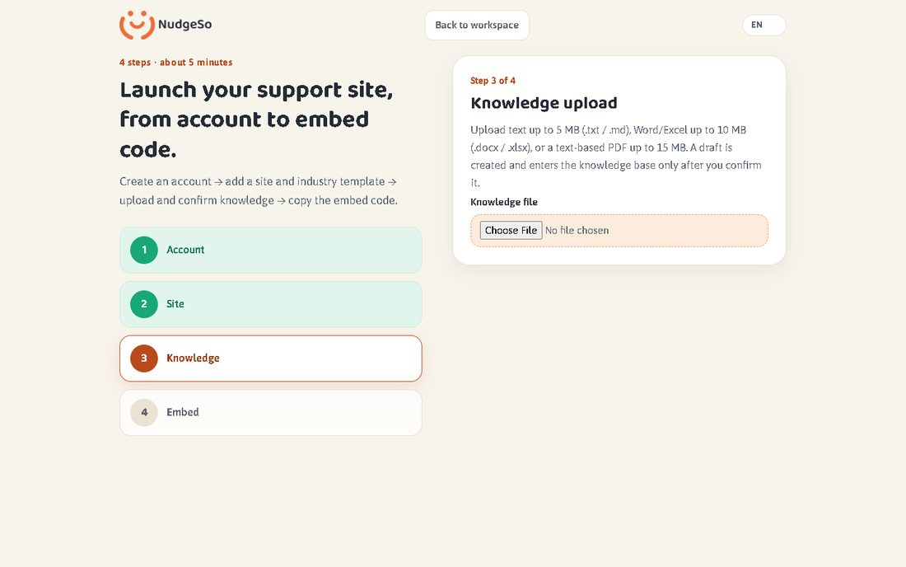
Evidence · › chromium › CONTEXT-C4-C5.spec.ts › C5 wizard state › kb step survives refresh for the same tenant

18. › chromium › CONTEXT-C4-C5.spec.ts › C5 wizard state › tenant switch clears stale wizard state and returns to site creation
Status: PASSED · Duration: 906 ms · File: e2e\CONTEXT-C4-C5.spec.ts:73
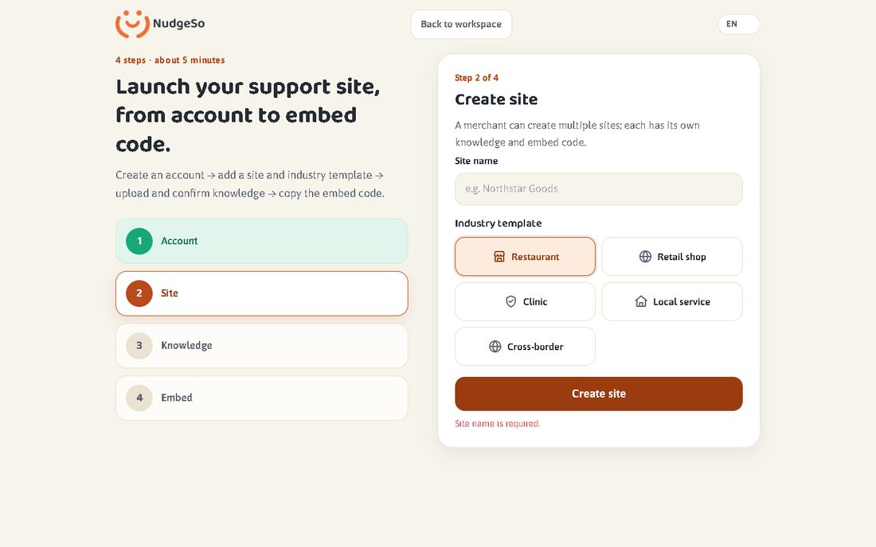
Evidence · › chromium › CONTEXT-C4-C5.spec.ts › C5 wizard state › tenant switch clears stale wizard state and returns to site creation

19. › chromium › CONTEXT-C6.spec.ts › C6 query and filter context › insights category survives refresh, back/forward and keeps other query params
Status: PASSED · Duration: 691 ms · File: e2e\CONTEXT-C6.spec.ts:12
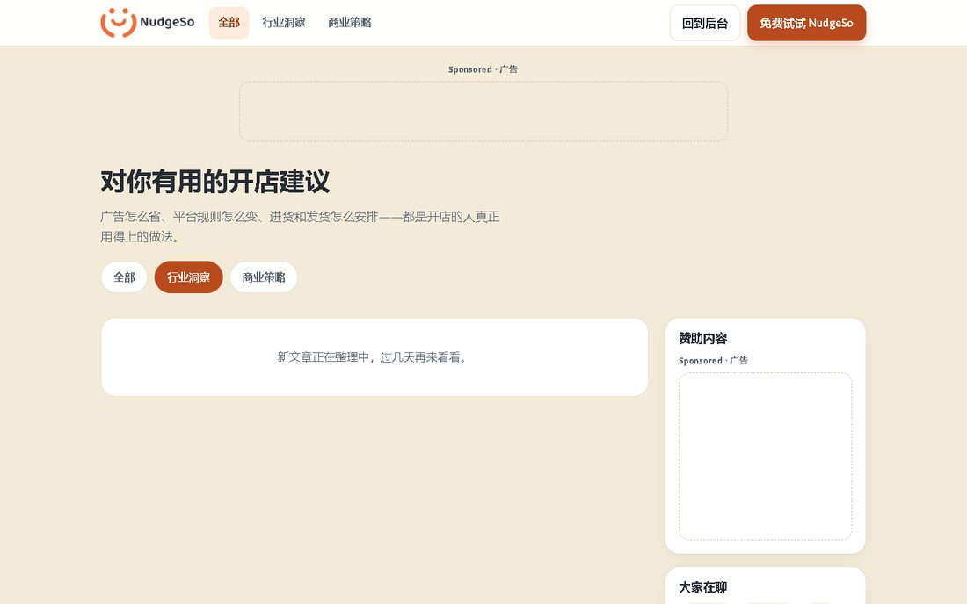
Evidence · › chromium › CONTEXT-C6.spec.ts › C6 query and filter context › insights category survives refresh, back/forward and keeps other query params

20. › chromium › CONTEXT-C6.spec.ts › C6 query and filter context › invalid category normalizes to all without losing other params
Status: PASSED · Duration: 555 ms · File: e2e\CONTEXT-C6.spec.ts:39
Evidence · › chromium › CONTEXT-C6.spec.ts › C6 query and filter context › invalid category normalizes to all without losing other params

21. › chromium › CRAWLER.spec.ts › CRAWLER › Tier 1 — all 11 SPA views render without runtime errors
Status: PASSED · Duration: 4638 ms · File: e2e\CRAWLER.spec.ts:111
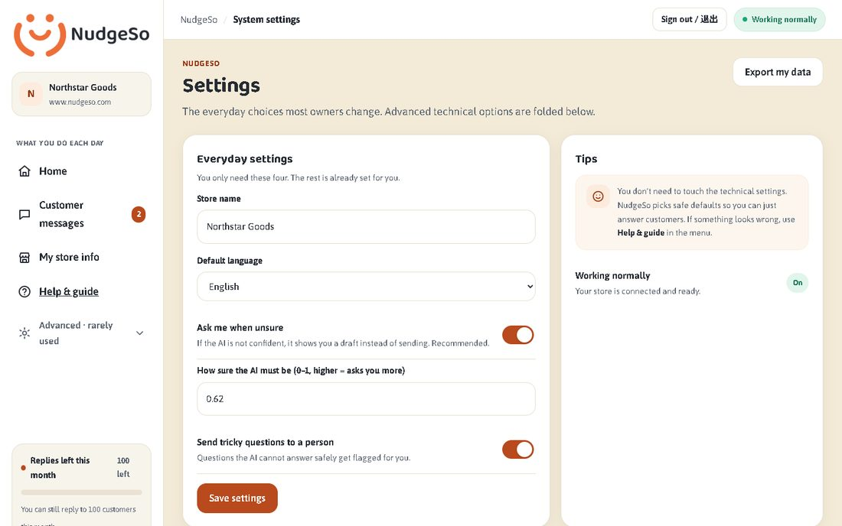
Evidence · › chromium › CRAWLER.spec.ts › CRAWLER › Tier 1 — all 11 SPA views render without runtime errors

22. › chromium › CRAWLER.spec.ts › CRAWLER › Tier 2 — monkey: every control reacts, writes mocked, no JS errors
Status: PASSED · Duration: 30901 ms · File: e2e\CRAWLER.spec.ts:138
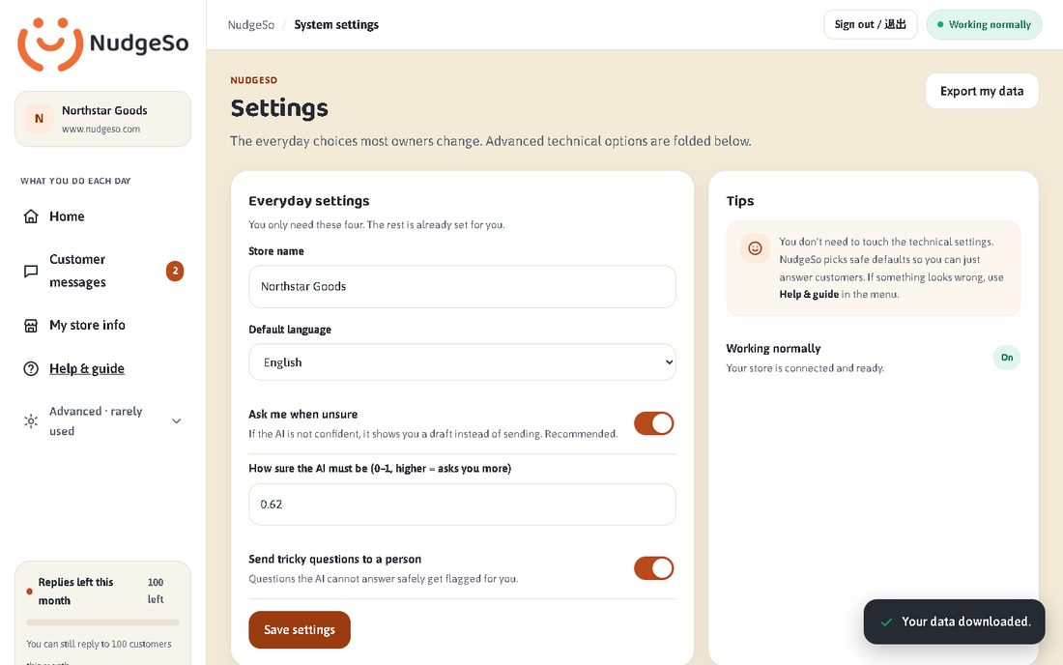
Evidence · › chromium › CRAWLER.spec.ts › CRAWLER › Tier 2 — monkey: every control reacts, writes mocked, no JS errors

23. › chromium › CRAWLER.spec.ts › CRAWLER › Tier 3 — auth gate and 401 interception
Status: PASSED · Duration: 971 ms · File: e2e\CRAWLER.spec.ts:290
Evidence · › chromium › CRAWLER.spec.ts › CRAWLER › Tier 3 — auth gate and 401 interception

24. › chromium › D1-GENERATED.spec.ts › D1 generated route contracts › D1 contract: landing
Status: PASSED · Duration: 517 ms · File: e2e\D1-GENERATED.spec.ts:12
Evidence · › chromium › D1-GENERATED.spec.ts › D1 generated route contracts › D1 contract: landing

25. › chromium › D1-GENERATED.spec.ts › D1 generated route contracts › D1 contract: login
Status: PASSED · Duration: 415 ms · File: e2e\D1-GENERATED.spec.ts:26
Evidence · › chromium › D1-GENERATED.spec.ts › D1 generated route contracts › D1 contract: login

26. › chromium › D1-GENERATED.spec.ts › D1 generated route contracts › D1 contract: onboarding
Status: PASSED · Duration: 514 ms · File: e2e\D1-GENERATED.spec.ts:40
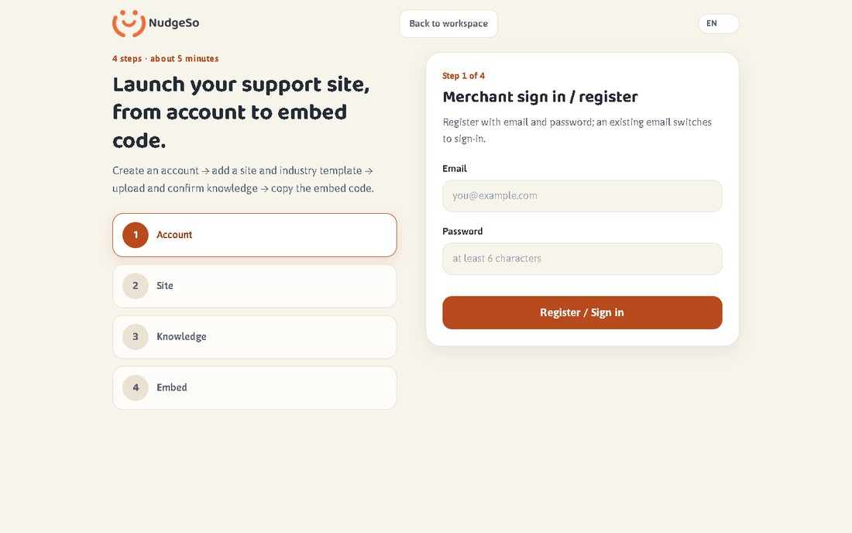
Evidence · › chromium › D1-GENERATED.spec.ts › D1 generated route contracts › D1 contract: onboarding

27. › chromium › D1-GENERATED.spec.ts › D1 generated route contracts › D1 contract: workspace
Status: PASSED · Duration: 441 ms · File: e2e\D1-GENERATED.spec.ts:52
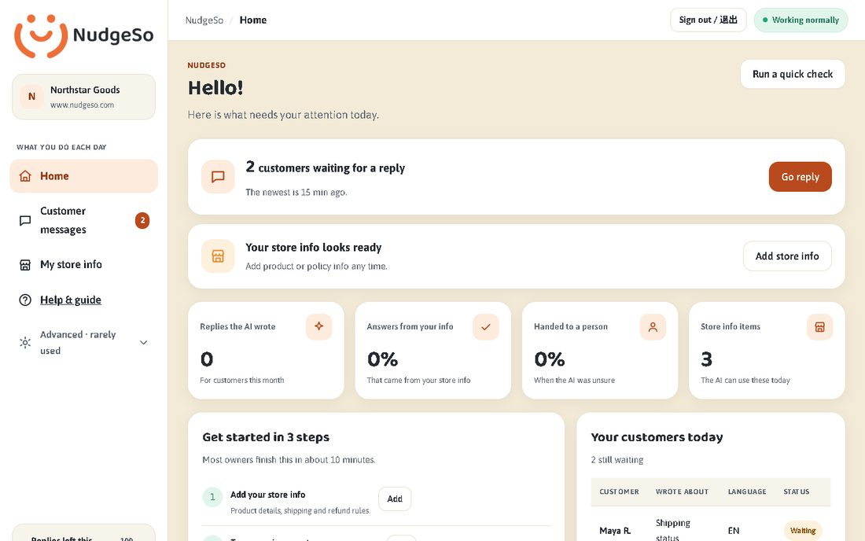
Evidence · › chromium › D1-GENERATED.spec.ts › D1 generated route contracts › D1 contract: workspace

28. › chromium › D1-GENERATED.spec.ts › D1 generated route contracts › D1 contract: queue
Status: PASSED · Duration: 534 ms · File: e2e\D1-GENERATED.spec.ts:69
Evidence · › chromium › D1-GENERATED.spec.ts › D1 generated route contracts › D1 contract: queue

29. › chromium › D1-GENERATED.spec.ts › D1 generated route contracts › D1 contract: customer-chat
Status: PASSED · Duration: 526 ms · File: e2e\D1-GENERATED.spec.ts:86
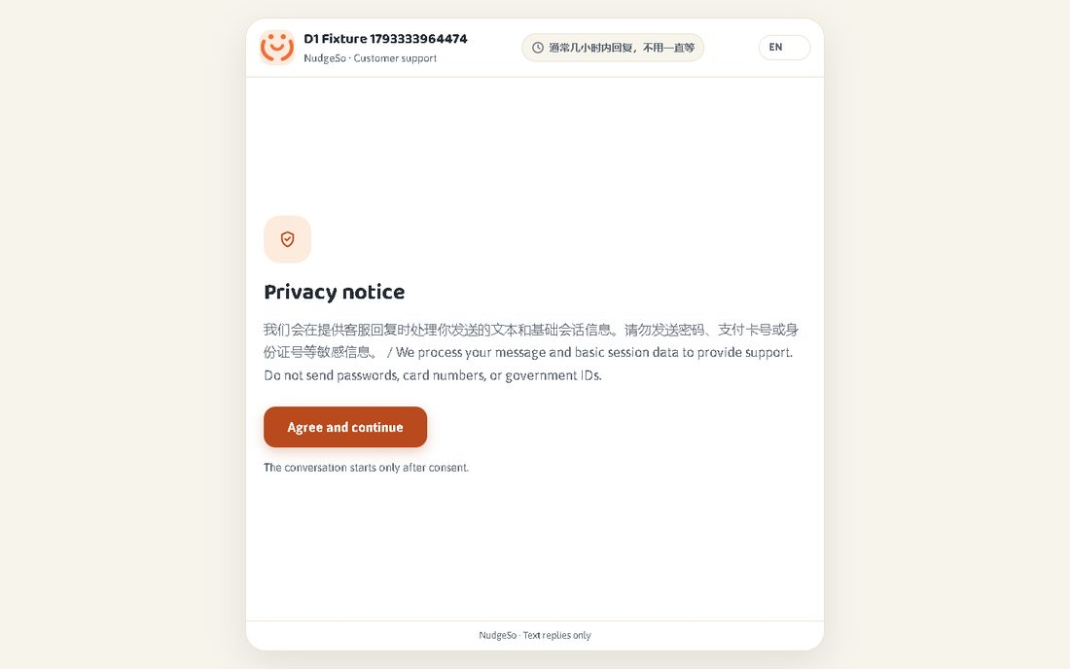
Evidence · › chromium › D1-GENERATED.spec.ts › D1 generated route contracts › D1 contract: customer-chat

30. › chromium › D1-GENERATED.spec.ts › D1 generated route contracts › D1 contract: upload
Status: PASSED · Duration: 479 ms · File: e2e\D1-GENERATED.spec.ts:99
Evidence · › chromium › D1-GENERATED.spec.ts › D1 generated route contracts › D1 contract: upload

31. › chromium › D1-GENERATED.spec.ts › D1 generated route contracts › D1 contract: manual
Status: PASSED · Duration: 471 ms · File: e2e\D1-GENERATED.spec.ts:116
Evidence · › chromium › D1-GENERATED.spec.ts › D1 generated route contracts › D1 contract: manual

32. › chromium › D1-GENERATED.spec.ts › D1 generated route contracts › D1 contract: insights
Status: PASSED · Duration: 485 ms · File: e2e\D1-GENERATED.spec.ts:133
Evidence · › chromium › D1-GENERATED.spec.ts › D1 generated route contracts › D1 contract: insights

33. › chromium › D1-GENERATED.spec.ts › D1 generated route contracts › D1 contract: privacy-draft
Status: PASSED · Duration: 399 ms · File: e2e\D1-GENERATED.spec.ts:150
Evidence · › chromium › D1-GENERATED.spec.ts › D1 generated route contracts › D1 contract: privacy-draft

34. › chromium › D1-GENERATED.spec.ts › D1 generated route contracts › D1 contract: terms-draft
Status: PASSED · Duration: 413 ms · File: e2e\D1-GENERATED.spec.ts:162
Evidence · › chromium › D1-GENERATED.spec.ts › D1 generated route contracts › D1 contract: terms-draft

35. › chromium › D1-GENERATED.spec.ts › D1 generated route contracts › D1 contract: not-found
Status: PASSED · Duration: 387 ms · File: e2e\D1-GENERATED.spec.ts:174
Evidence · › chromium › D1-GENERATED.spec.ts › D1 generated route contracts › D1 contract: not-found

36. › chromium › DASHBOARD.spec.ts › dashboard auth: landing/login gate, login unlocks navigation
Status: PASSED · Duration: 932 ms · File: e2e\DASHBOARD.spec.ts:3
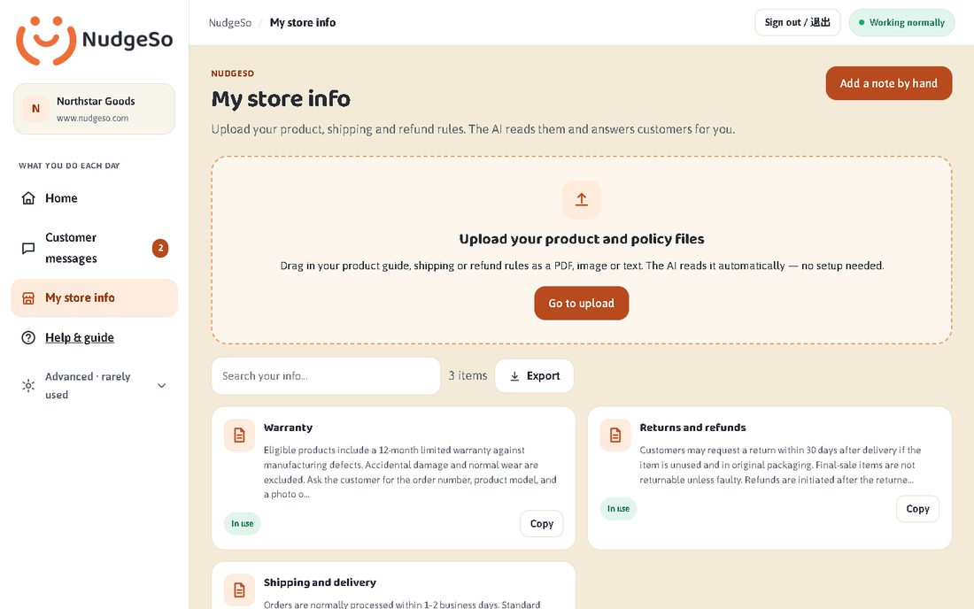
Evidence · › chromium › DASHBOARD.spec.ts › dashboard auth: landing/login gate, login unlocks navigation

37. › chromium › I18N-AR.spec.ts › P3-08 i18n: Arabic RTL for chat, onboarding and queue
Status: PASSED · Duration: 1331 ms · File: e2e\I18N-AR.spec.ts:4
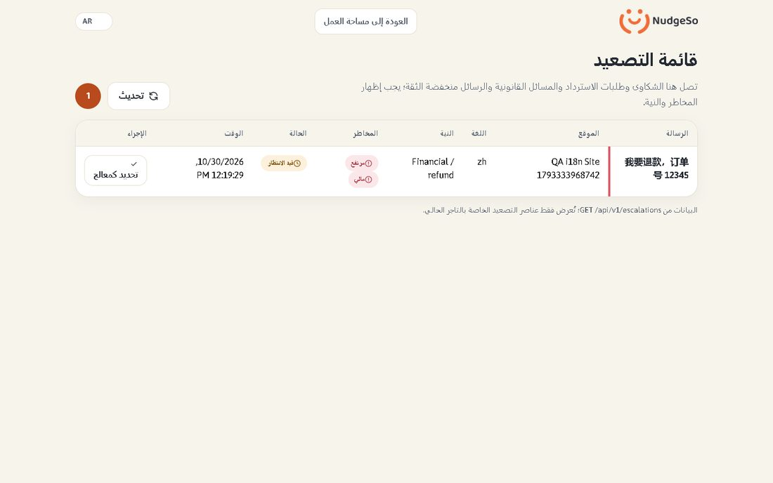
Evidence · › chromium › I18N-AR.spec.ts › P3-08 i18n: Arabic RTL for chat, onboarding and queue

38. › chromium › INSIGHTS.spec.ts › INSIGHTS: list → detail jump renders markdown and keeps both ad slots
Status: PASSED · Duration: 610 ms · File: e2e\INSIGHTS.spec.ts:42
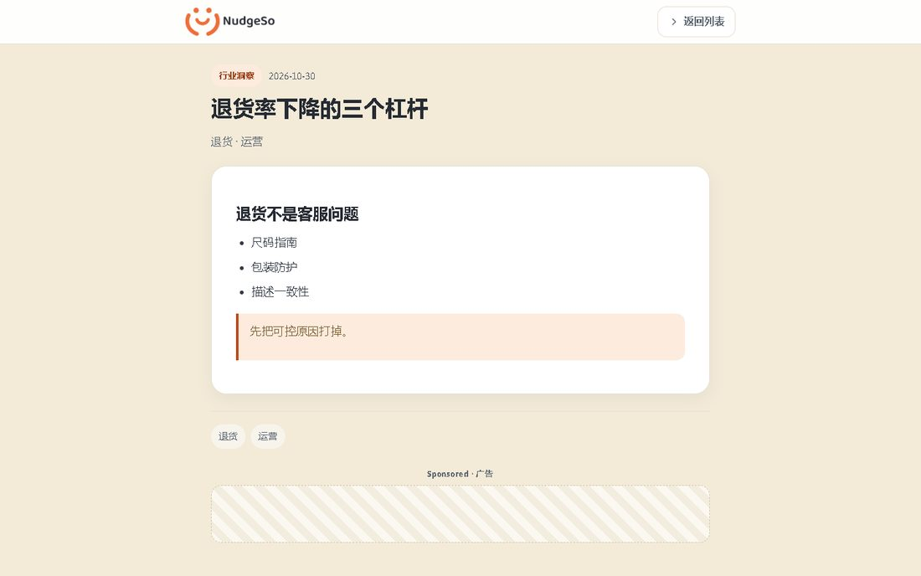
Evidence · › chromium › INSIGHTS.spec.ts › INSIGHTS: list → detail jump renders markdown and keeps both ad slots

39. › chromium › INSIGHTS.spec.ts › INSIGHTS: detail page fits 390px without horizontal overflow
Status: PASSED · Duration: 570 ms · File: e2e\INSIGHTS.spec.ts:74
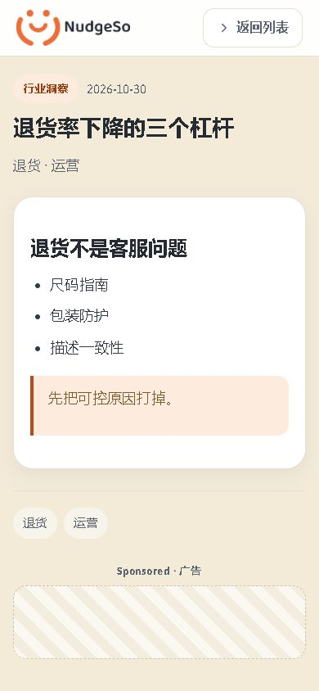
Evidence · › chromium › INSIGHTS.spec.ts › INSIGHTS: detail page fits 390px without horizontal overflow

40. › chromium › LANDING-DEMO.spec.ts › Landing demo carousel › renders multiple scenarios, supports manual navigation and pause
Status: PASSED · Duration: 644 ms · File: e2e\LANDING-DEMO.spec.ts:6
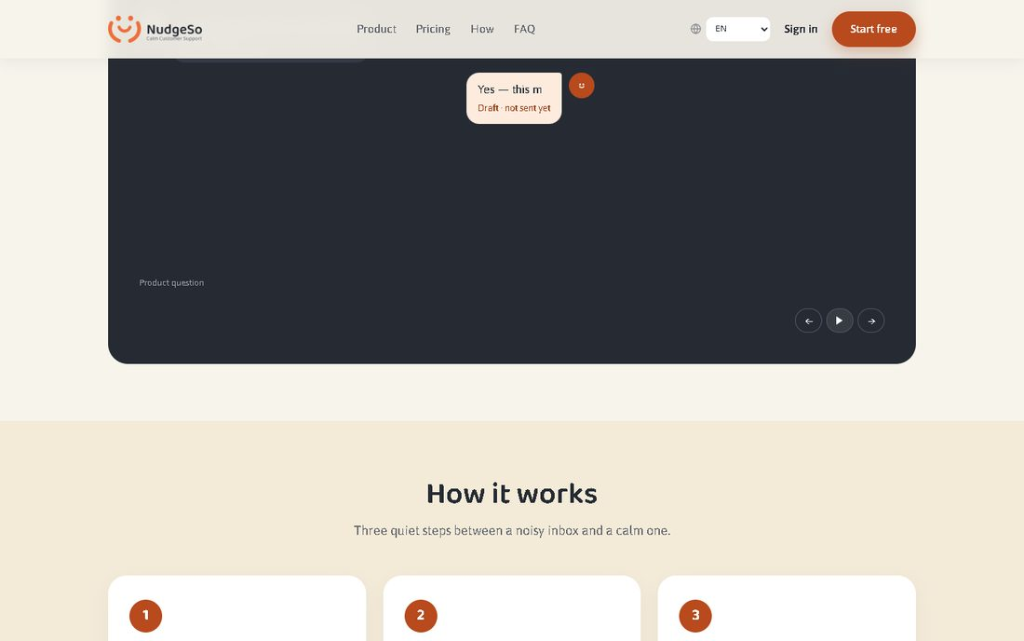
Evidence · › chromium › LANDING-DEMO.spec.ts › Landing demo carousel › renders multiple scenarios, supports manual navigation and pause

41. › chromium › LANDING-DEMO.spec.ts › Landing demo carousel › every supported locale renders without page overflow and correct direction
Status: PASSED · Duration: 3452 ms · File: e2e\LANDING-DEMO.spec.ts:26

Evidence · › chromium › LANDING-DEMO.spec.ts › Landing demo carousel › every supported locale renders without page overflow and correct direction

42. › chromium › LANDING-DEMO.spec.ts › Landing demo carousel › falls back to a static readable demo when motion is reduced
Status: PASSED · Duration: 375 ms · File: e2e\LANDING-DEMO.spec.ts:57
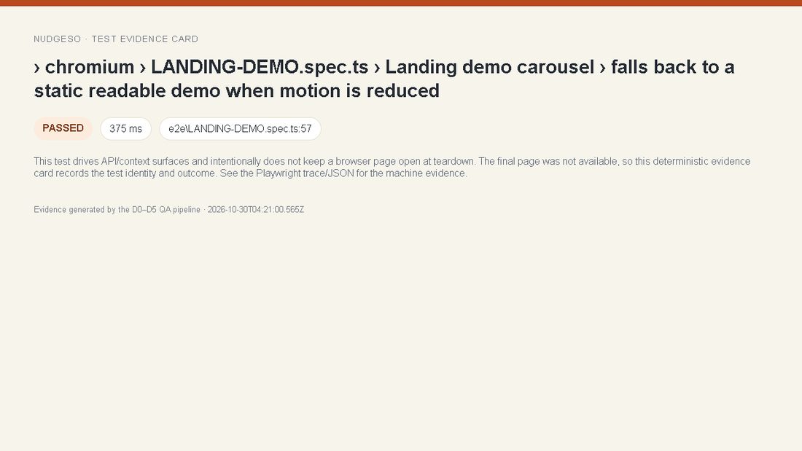
Evidence · › chromium › LANDING-DEMO.spec.ts › Landing demo carousel › falls back to a static readable demo when motion is reduced

43. › chromium › LANDING-DEMO.spec.ts › Landing demo carousel › demo canvas keeps a stable height while the reply is typed
Status: PASSED · Duration: 1800 ms · File: e2e\LANDING-DEMO.spec.ts:66
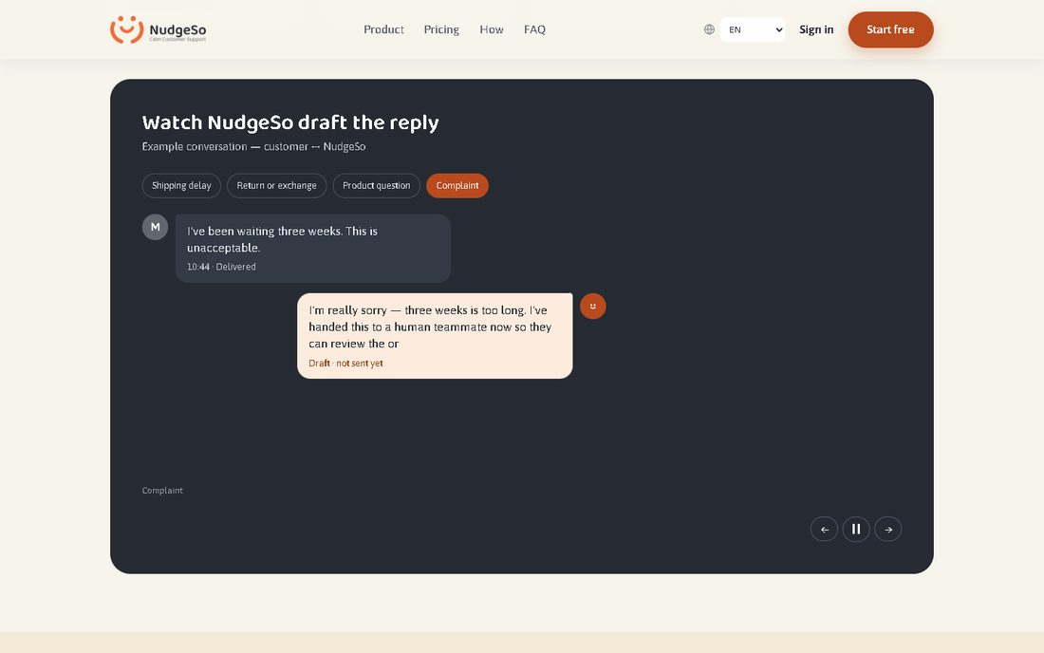
Evidence · › chromium › LANDING-DEMO.spec.ts › Landing demo carousel › demo canvas keeps a stable height while the reply is typed

44. › chromium › LANDING-DEMO.spec.ts › Landing demo carousel › fits the landing demo at 390px without overflow
Status: PASSED · Duration: 491 ms · File: e2e\LANDING-DEMO.spec.ts:78
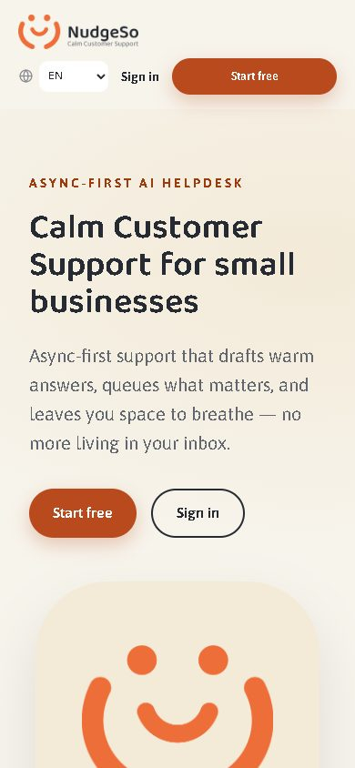
Evidence · › chromium › LANDING-DEMO.spec.ts › Landing demo carousel › fits the landing demo at 390px without overflow

45. › chromium › LANDING-DEMO.spec.ts › Landing demo carousel › auto-advances to the next conversation when visible and playing
Status: PASSED · Duration: 11582 ms · File: e2e\LANDING-DEMO.spec.ts:89
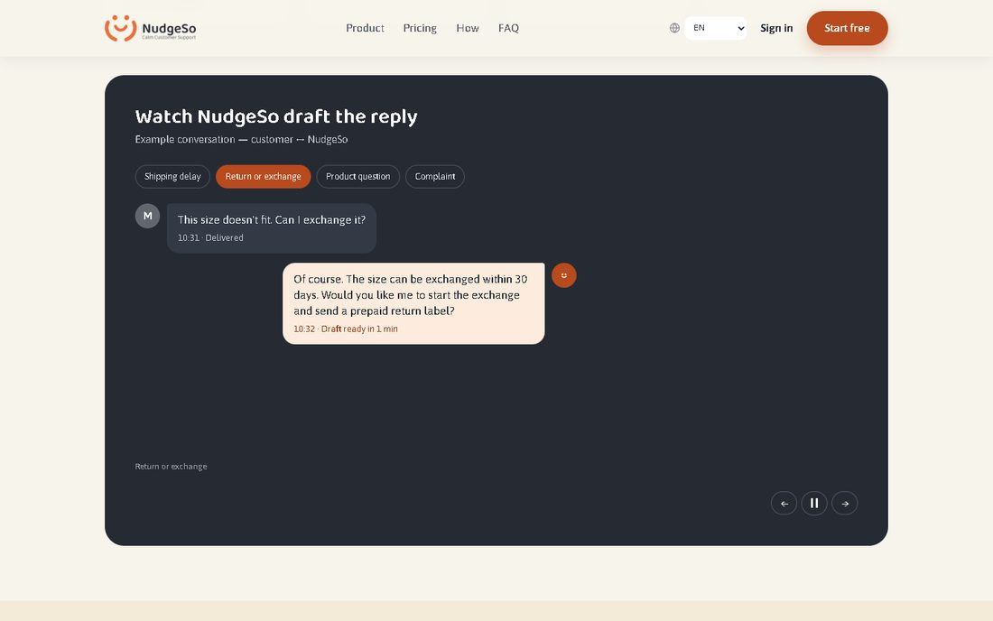
Evidence · › chromium › LANDING-DEMO.spec.ts › Landing demo carousel › auto-advances to the next conversation when visible and playing

46. › chromium › LANDING-DEMO.spec.ts › Landing demo carousel › keeps the brand orange while using the accessible primary orange
Status: PASSED · Duration: 511 ms · File: e2e\LANDING-DEMO.spec.ts:99
Evidence · › chromium › LANDING-DEMO.spec.ts › Landing demo carousel › keeps the brand orange while using the accessible primary orange

47. › chromium › LANDING-DEMO.spec.ts › Landing demo carousel › global language selector localizes the landing page and the demo together
Status: PASSED · Duration: 691 ms · File: e2e\LANDING-DEMO.spec.ts:113
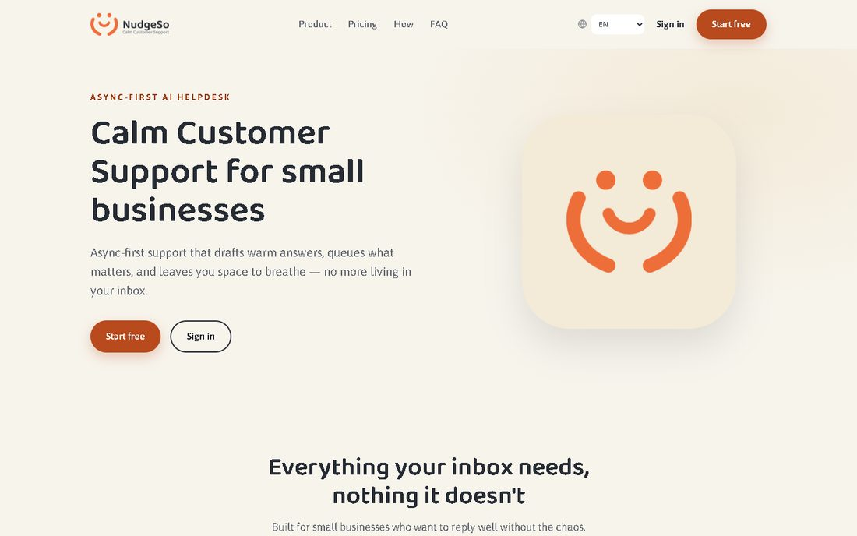
Evidence · › chromium › LANDING-DEMO.spec.ts › Landing demo carousel › global language selector localizes the landing page and the demo together

48. › chromium › LANGUAGE-CONTEXT.spec.ts › Language context across the pricing → onboarding boundary › English is the fallback when no language marker exists
Status: PASSED · Duration: 509 ms · File: e2e\LANGUAGE-CONTEXT.spec.ts:10
Evidence · › chromium › LANGUAGE-CONTEXT.spec.ts › Language context across the pricing → onboarding boundary › English is the fallback when no language marker exists

49. › chromium › LANGUAGE-CONTEXT.spec.ts › Language context across the pricing → onboarding boundary › a language chosen inside onboarding is reused by landing
Status: PASSED · Duration: 848 ms · File: e2e\LANGUAGE-CONTEXT.spec.ts:17
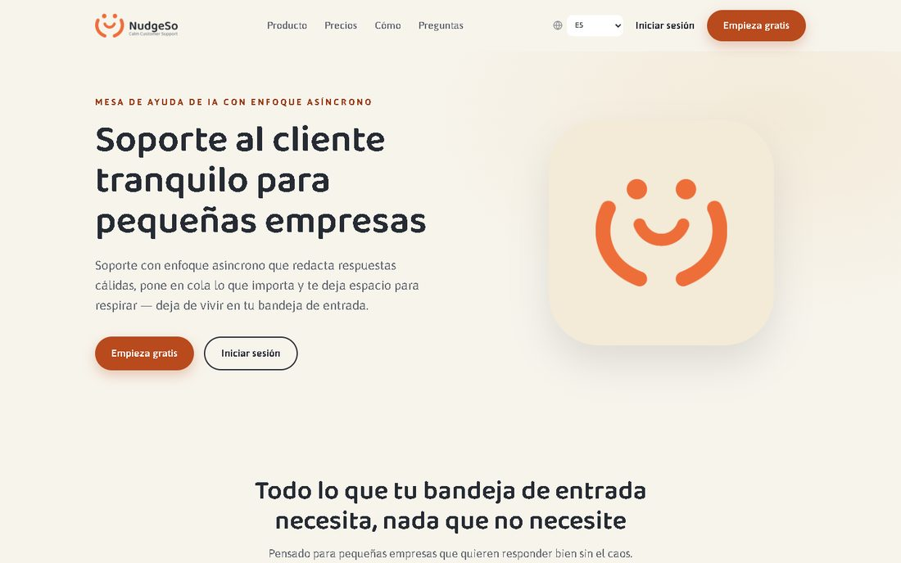
Evidence · › chromium › LANGUAGE-CONTEXT.spec.ts › Language context across the pricing → onboarding boundary › a language chosen inside onboarding is reused by landing

50. › chromium › LANGUAGE-CONTEXT.spec.ts › Language context across the pricing → onboarding boundary › default English pricing keeps every onboarding entry in English
Status: PASSED · Duration: 795 ms · File: e2e\LANGUAGE-CONTEXT.spec.ts:26
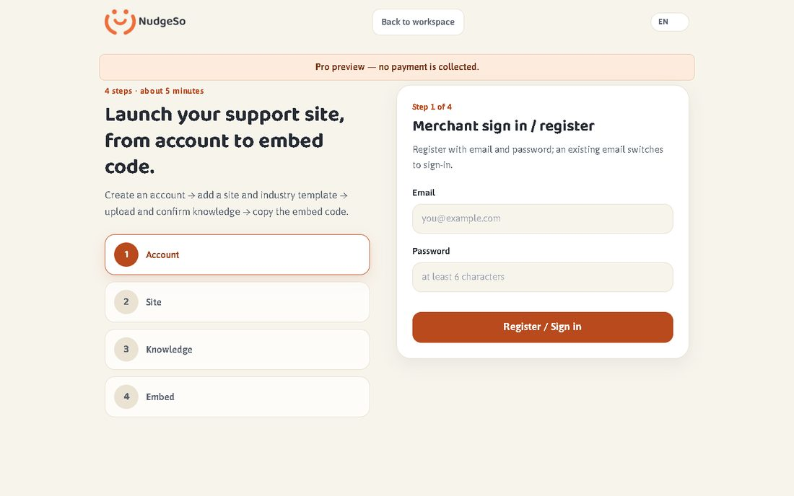
Evidence · › chromium › LANGUAGE-CONTEXT.spec.ts › Language context across the pricing → onboarding boundary › default English pricing keeps every onboarding entry in English

51. › chromium › LANGUAGE-CONTEXT.spec.ts › Language context across the pricing → onboarding boundary › Spanish selection survives the preview CTA and refresh
Status: PASSED · Duration: 1018 ms · File: e2e\LANGUAGE-CONTEXT.spec.ts:45
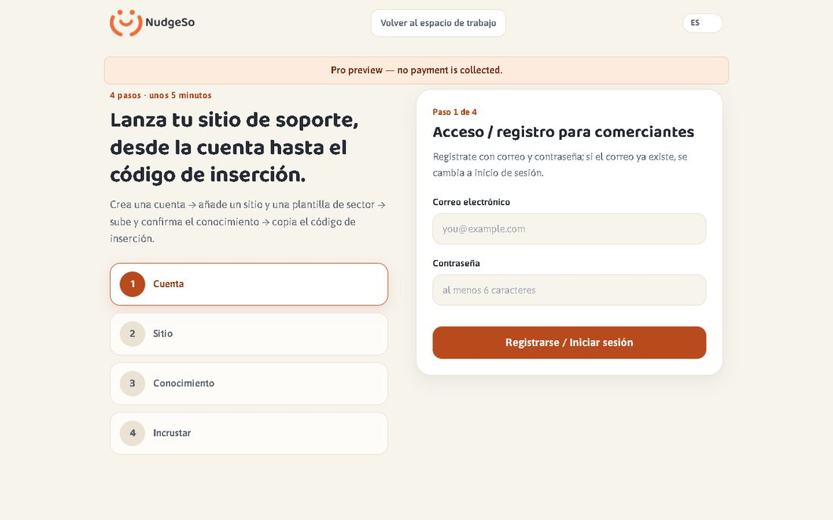
Evidence · › chromium › LANGUAGE-CONTEXT.spec.ts › Language context across the pricing → onboarding boundary › Spanish selection survives the preview CTA and refresh

52. › chromium › LANGUAGE-CONTEXT.spec.ts › Language context across the pricing → onboarding boundary › Arabic selection carries RTL into onboarding
Status: PASSED · Duration: 852 ms · File: e2e\LANGUAGE-CONTEXT.spec.ts:64
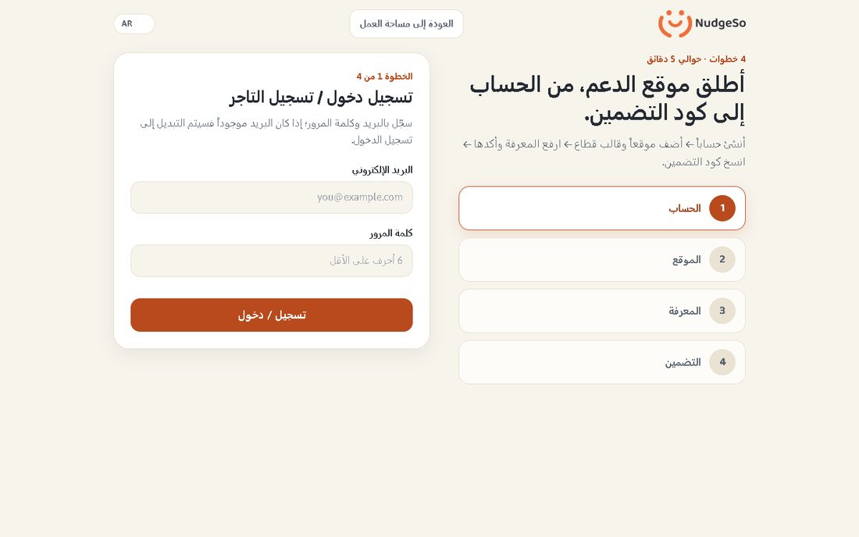
Evidence · › chromium › LANGUAGE-CONTEXT.spec.ts › Language context across the pricing → onboarding boundary › Arabic selection carries RTL into onboarding

53. › chromium › NUDGESO-UI.spec.ts › NudgeSo UI: login, 11 views render, independent pages load without errors
Status: PASSED · Duration: 1232 ms · File: e2e\NUDGESO-UI.spec.ts:6
Evidence · › chromium › NUDGESO-UI.spec.ts › NudgeSo UI: login, 11 views render, independent pages load without errors

54. › chromium › NUDGESO-UI.spec.ts › English onboarding has no Chinese leftovers
Status: PASSED · Duration: 544 ms · File: e2e\NUDGESO-UI.spec.ts:39
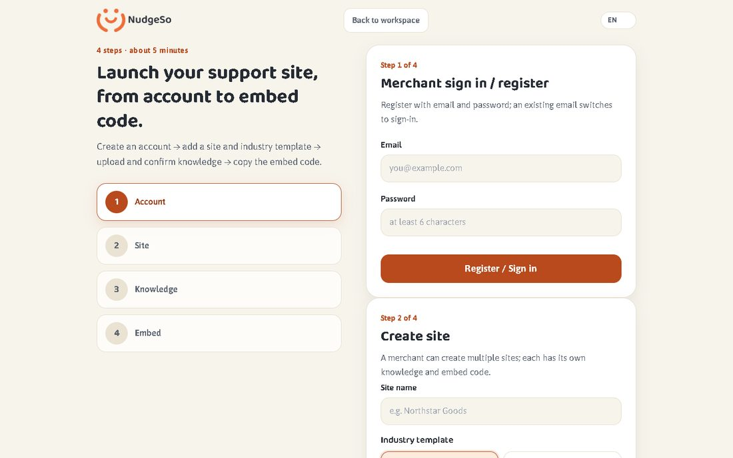
Evidence · › chromium › NUDGESO-UI.spec.ts › English onboarding has no Chinese leftovers

55. › chromium › P2-LIVE.spec.ts › P2 live-compatible: package 3-5 days and hours 09:00-21:00
Status: PASSED · Duration: 943 ms · File: e2e\P2-LIVE.spec.ts:41
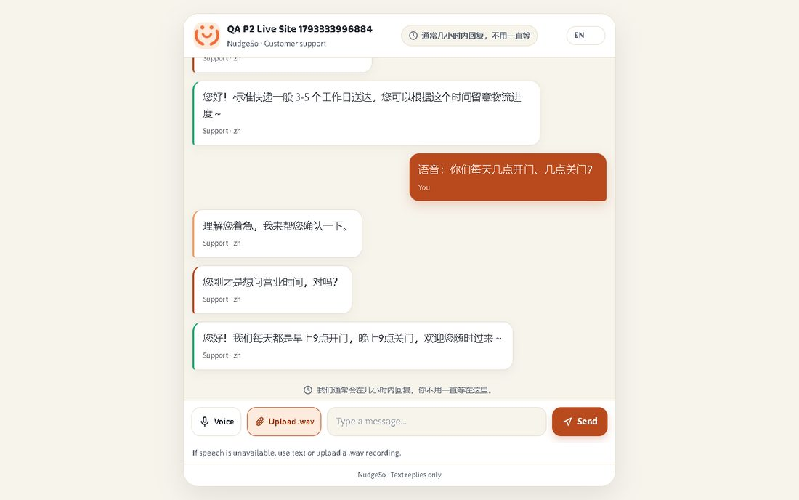
Evidence · › chromium › P2-LIVE.spec.ts › P2 live-compatible: package 3-5 days and hours 09:00-21:00

56. › chromium › PHASE13-UI-MATRIX.spec.ts › Phase 13 — UI link, language and layout matrix › all independent pages load with auth, no JS errors and no 390px overflow
Status: PASSED · Duration: 3069 ms · File: e2e\PHASE13-UI-MATRIX.spec.ts:57
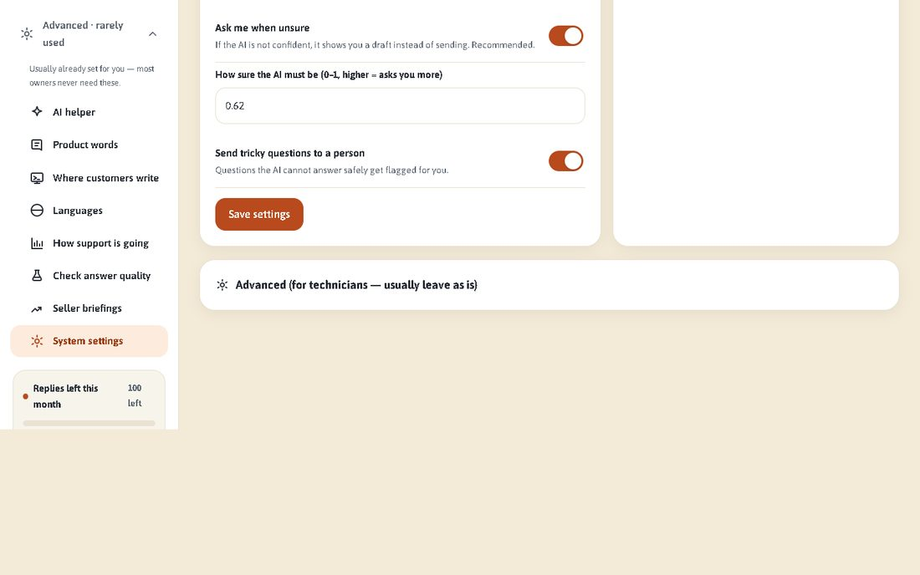
Evidence · › chromium › PHASE13-UI-MATRIX.spec.ts › Phase 13 — UI link, language and layout matrix › all independent pages load with auth, no JS errors and no 390px overflow

57. › chromium › PHASE13-UI-MATRIX.spec.ts › Phase 13 — UI link, language and layout matrix › all internal links resolve (page + asset + health links)
Status: PASSED · Duration: 142 ms · File: e2e\PHASE13-UI-MATRIX.spec.ts:89
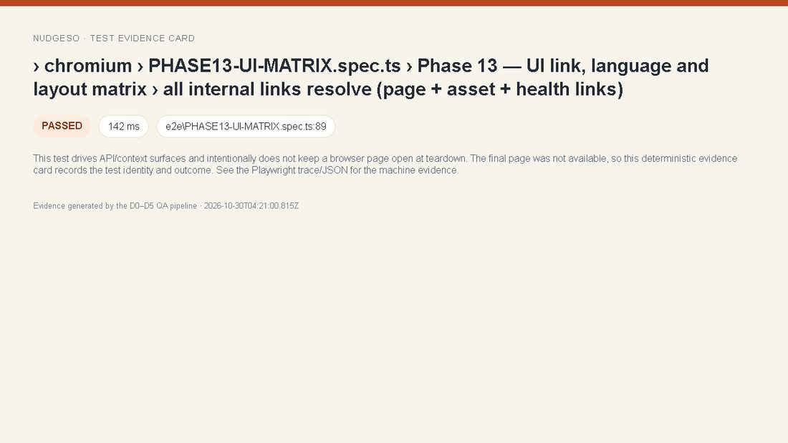
Evidence · › chromium › PHASE13-UI-MATRIX.spec.ts › Phase 13 — UI link, language and layout matrix › all internal links resolve (page + asset + health links)

58. › chromium › PHASE13-UI-MATRIX.spec.ts › Phase 13 — UI link, language and layout matrix › zh / en / ar onboarding have correct direction and no CJK leak in English/Arabic
Status: PASSED · Duration: 819 ms · File: e2e\PHASE13-UI-MATRIX.spec.ts:119
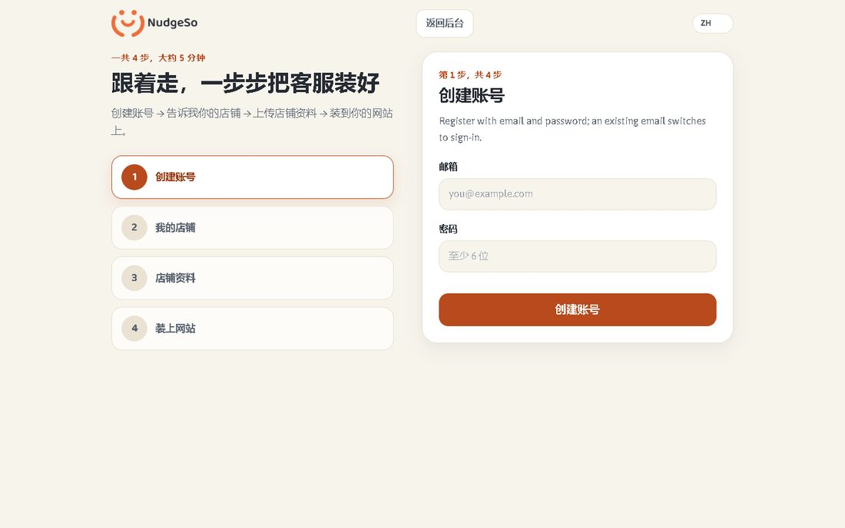
Evidence · › chromium › PHASE13-UI-MATRIX.spec.ts › Phase 13 — UI link, language and layout matrix › zh / en / ar onboarding have correct direction and no CJK leak in English/Arabic

59. › chromium › PHASE13-UI-MATRIX.spec.ts › Phase 13 — UI link, language and layout matrix › queue and chat render English/Arabic without Chinese leftovers
Status: PASSED · Duration: 1060 ms · File: e2e\PHASE13-UI-MATRIX.spec.ts:144
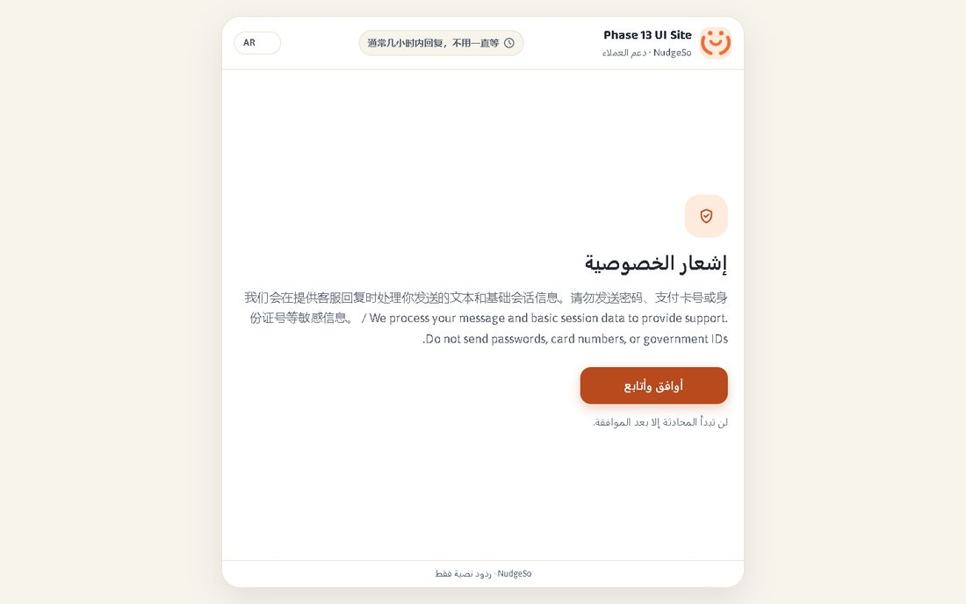
Evidence · › chromium › PHASE13-UI-MATRIX.spec.ts › Phase 13 — UI link, language and layout matrix › queue and chat render English/Arabic without Chinese leftovers

60. › chromium › PHASE13-UI-MATRIX.spec.ts › Phase 13 — UI link, language and layout matrix › all generated UI locales load, stay within 390px and use the right direction
Status: PASSED · Duration: 5855 ms · File: e2e\PHASE13-UI-MATRIX.spec.ts:179
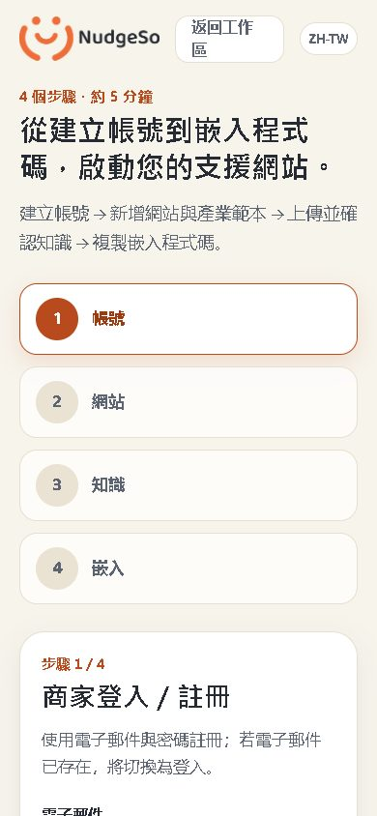
Evidence · › chromium › PHASE13-UI-MATRIX.spec.ts › Phase 13 — UI link, language and layout matrix › all generated UI locales load, stay within 390px and use the right direction

61. › chromium › PHASE13-UI-MATRIX.spec.ts › Phase 13 — UI link, language and layout matrix › capture zh/en/ar onboarding visual evidence
Status: PASSED · Duration: 1109 ms · File: e2e\PHASE13-UI-MATRIX.spec.ts:200
Evidence · › chromium › PHASE13-UI-MATRIX.spec.ts › Phase 13 — UI link, language and layout matrix › capture zh/en/ar onboarding visual evidence

62. › chromium › PHASE13-VISUAL.spec.ts › Phase 13 — onboarding visual regression › onboarding zh matches its visual baseline
Status: SKIPPED · Duration: 0 ms · File: e2e\PHASE13-VISUAL.spec.ts:12
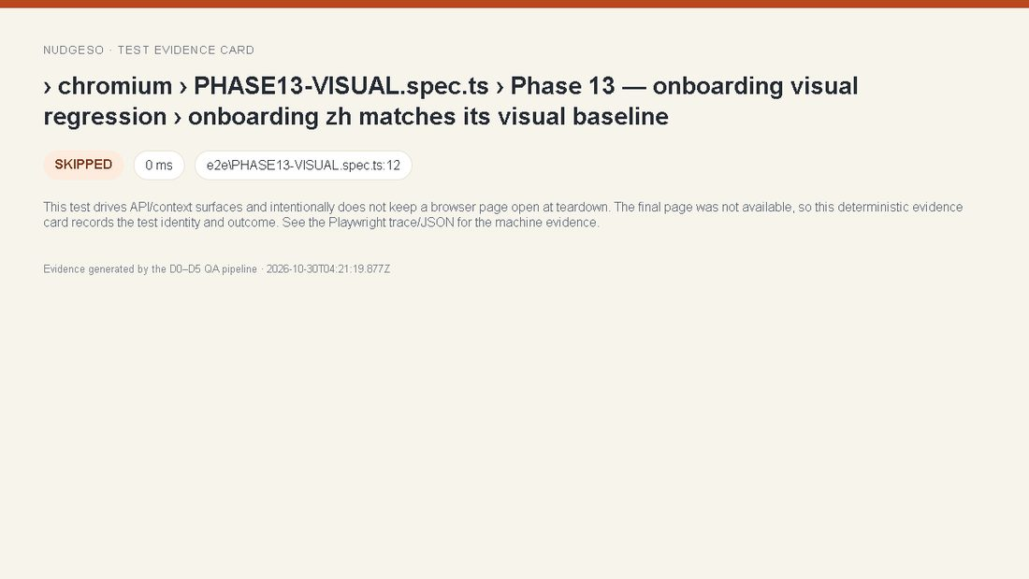
Evidence · › chromium › PHASE13-VISUAL.spec.ts › Phase 13 — onboarding visual regression › onboarding zh matches its visual baseline

63. › chromium › PHASE13-VISUAL.spec.ts › Phase 13 — onboarding visual regression › onboarding en matches its visual baseline
Status: SKIPPED · Duration: 0 ms · File: e2e\PHASE13-VISUAL.spec.ts:12
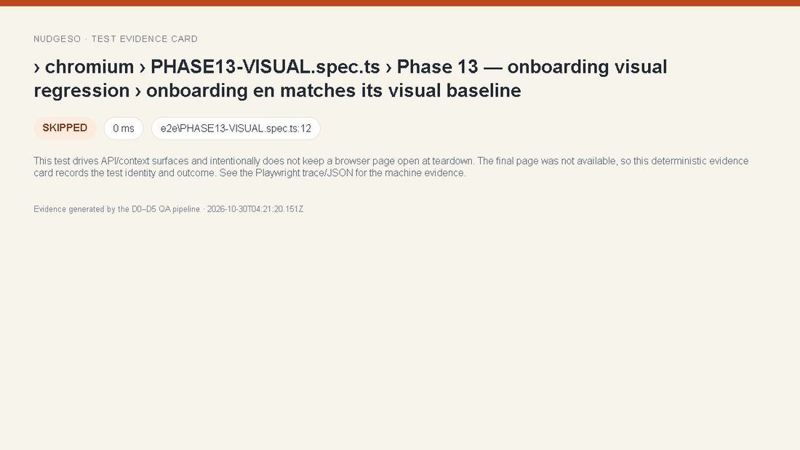
Evidence · › chromium › PHASE13-VISUAL.spec.ts › Phase 13 — onboarding visual regression › onboarding en matches its visual baseline

64. › chromium › PHASE13-VISUAL.spec.ts › Phase 13 — onboarding visual regression › onboarding ar matches its visual baseline
Status: SKIPPED · Duration: 0 ms · File: e2e\PHASE13-VISUAL.spec.ts:12
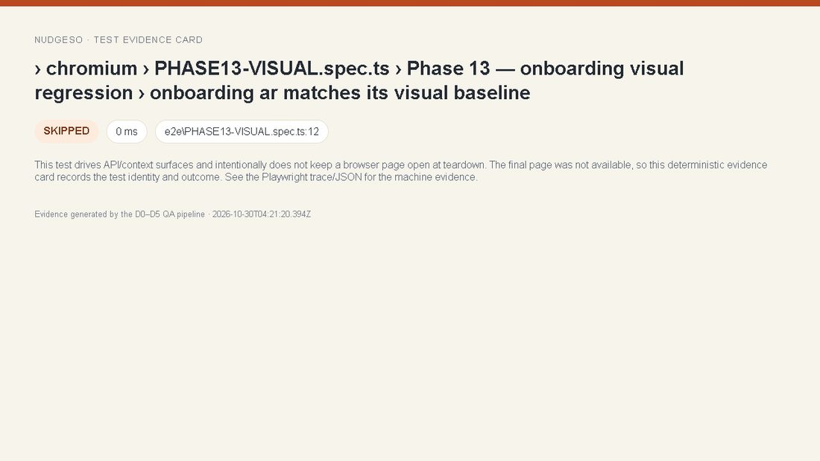
Evidence · › chromium › PHASE13-VISUAL.spec.ts › Phase 13 — onboarding visual regression › onboarding ar matches its visual baseline

65. › chromium › QUALITY-MATRIX.spec.ts › Quality Matrix — complete route surface › all public and authenticated surfaces pass structure, runtime and viewport checks
Status: PASSED · Duration: 14654 ms · File: e2e\QUALITY-MATRIX.spec.ts:114
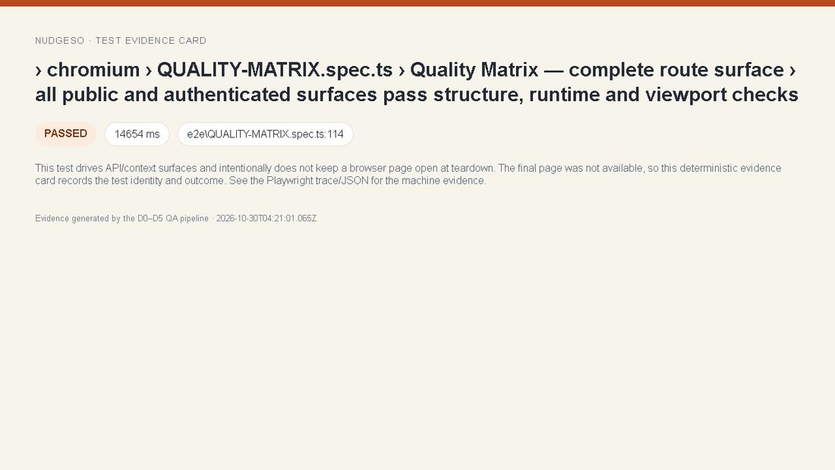
Evidence · › chromium › QUALITY-MATRIX.spec.ts › Quality Matrix — complete route surface › all public and authenticated surfaces pass structure, runtime and viewport checks

66. › chromium › QUALITY-MATRIX.spec.ts › Quality Matrix — complete route surface › all 11 workspace views fit at 320px and 1440px
Status: PASSED · Duration: 1055 ms · File: e2e\QUALITY-MATRIX.spec.ts:186
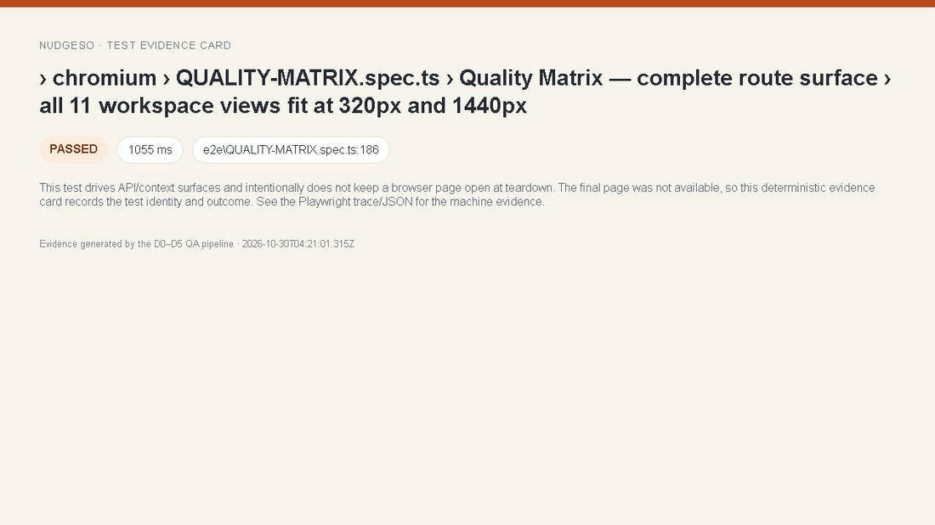
Evidence · › chromium › QUALITY-MATRIX.spec.ts › Quality Matrix — complete route surface › all 11 workspace views fit at 320px and 1440px

67. › chromium › QUALITY-MATRIX.spec.ts › Quality Matrix — complete route surface › legal pages are visibly drafts, noindexed and linked
Status: PASSED · Duration: 641 ms · File: e2e\QUALITY-MATRIX.spec.ts:215
Evidence · › chromium › QUALITY-MATRIX.spec.ts › Quality Matrix — complete route surface › legal pages are visibly drafts, noindexed and linked

68. › chromium › QUALITY-MATRIX.spec.ts › Quality Matrix — complete route surface › API access matrix rejects unauthenticated and malformed calls
Status: PASSED · Duration: 41 ms · File: e2e\QUALITY-MATRIX.spec.ts:229
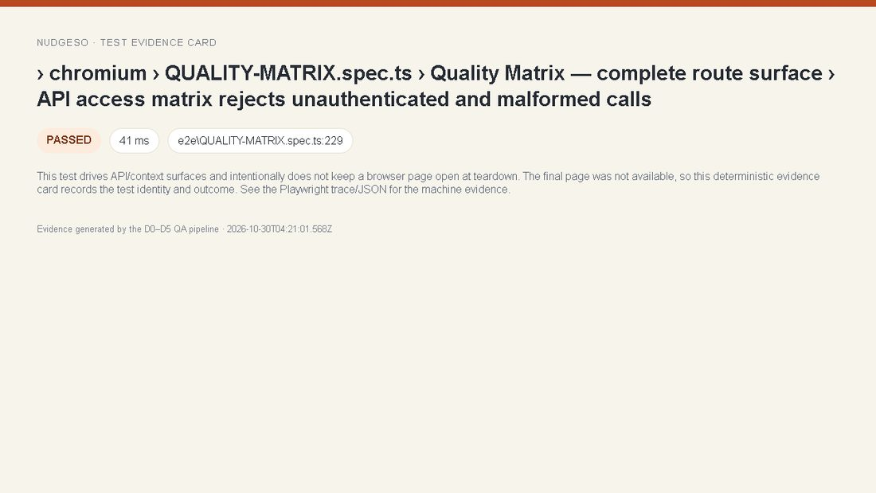
Evidence · › chromium › QUALITY-MATRIX.spec.ts › Quality Matrix — complete route surface › API access matrix rejects unauthenticated and malformed calls

69. › chromium › QUALITY-MATRIX.spec.ts › Quality Matrix — complete route surface › locale switching keeps lang, direction and overflow under control
Status: PASSED · Duration: 995 ms · File: e2e\QUALITY-MATRIX.spec.ts:256
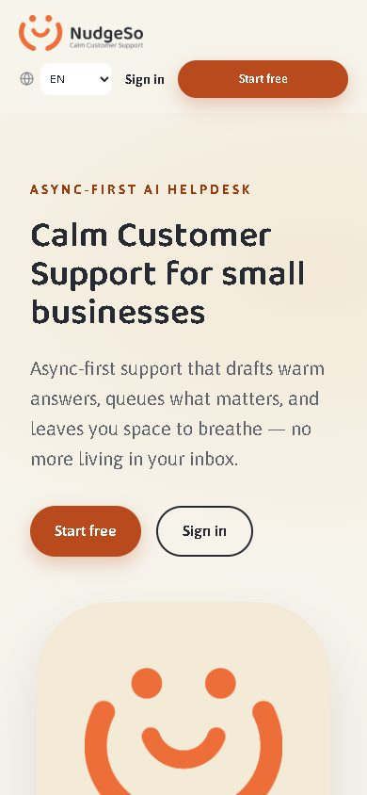
Evidence · › chromium › QUALITY-MATRIX.spec.ts › Quality Matrix — complete route surface › locale switching keeps lang, direction and overflow under control

70. › chromium › UI-390.spec.ts › P3-07 UI: 390px chat, onboarding, 11 views, queue and public pages fit without horizontal overflow
Status: PASSED · Duration: 2392 ms · File: e2e\UI-390.spec.ts:8
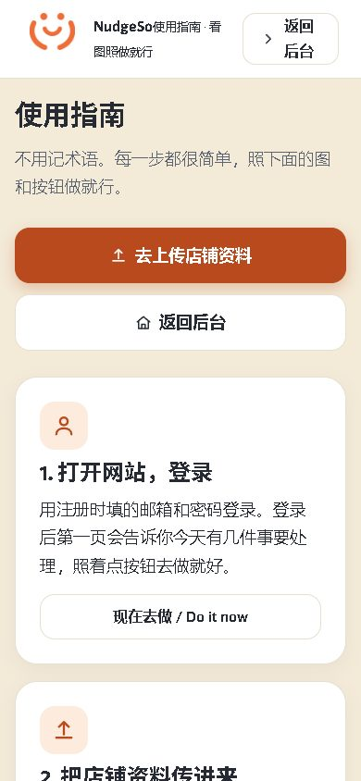
Evidence · › chromium › UI-390.spec.ts › P3-07 UI: 390px chat, onboarding, 11 views, queue and public pages fit without horizontal overflow

6. NOT RUN and residual risk
- insight-detail: No seeded insight-detail fixture in D0.
- External CI completion: pending; local D0–D5 gates are documented in this report.
- Real devices, native-speaker review, legal counsel, payment sandbox, email/WhatsApp/Instagram channels and production writes were not tested.
- The 9 originally page-less tests and 4 intentionally skipped tests use labelled evidence cards; they are not fabricated UI screenshots.
- D0's fixture account/site are disposable local data only.

7. Online verification — Render
Base URL: https://nudgeso.onrender.com
Live commit: df4ac7dd53d255fb87be79175999f7c37831b017 · deploy: dep-dbi2p7cs728c73a0br20
Post-deploy checks | PASS
Cloud smoke | 1/1 PASS
Language context | 5/5 PASS
CI | in_progress (not claimed PASS)
The online run executed read-only smoke and landing/onboarding language-context tests. Production write journeys were intentionally not run.
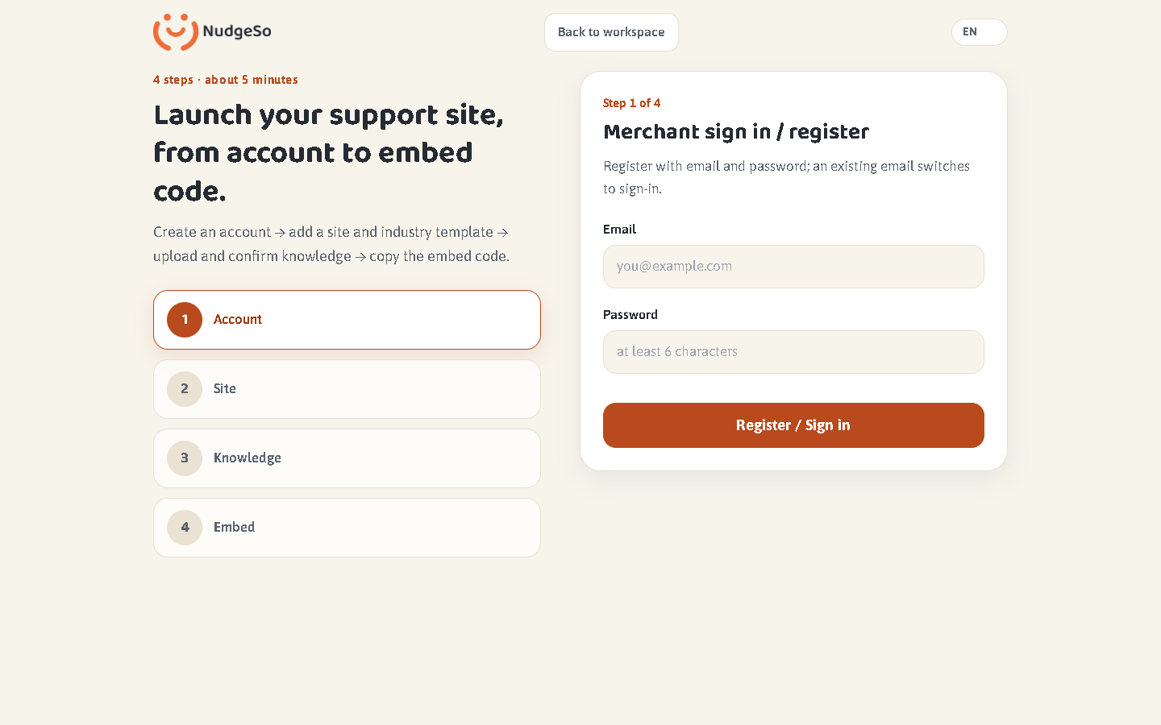
Online language-context evidence 1
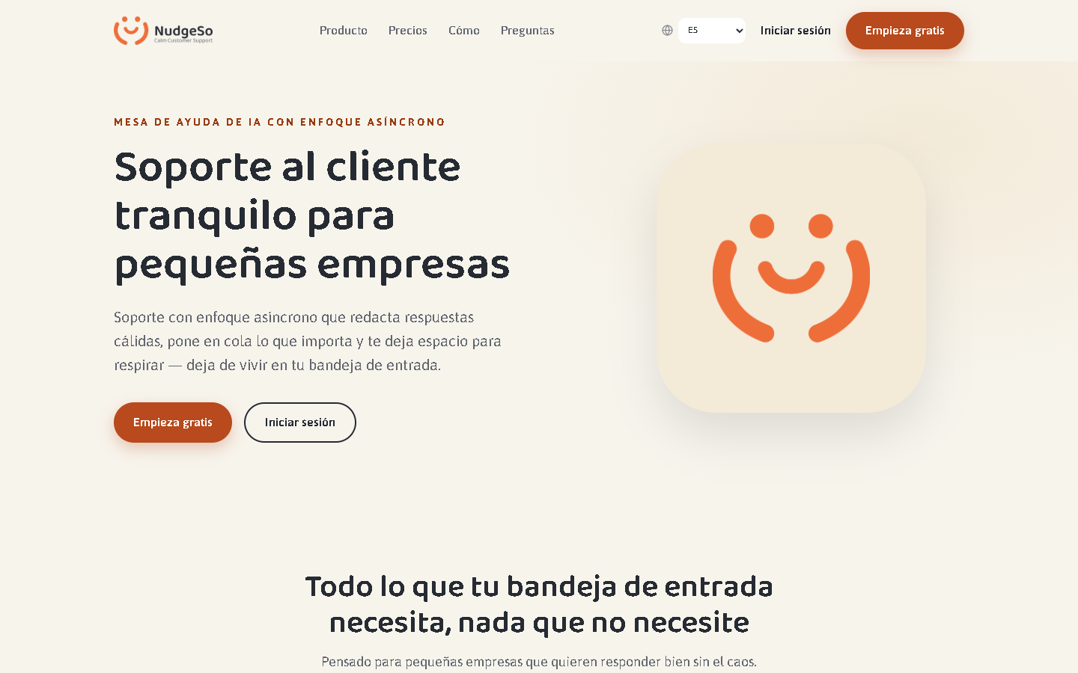
Online language-context evidence 2
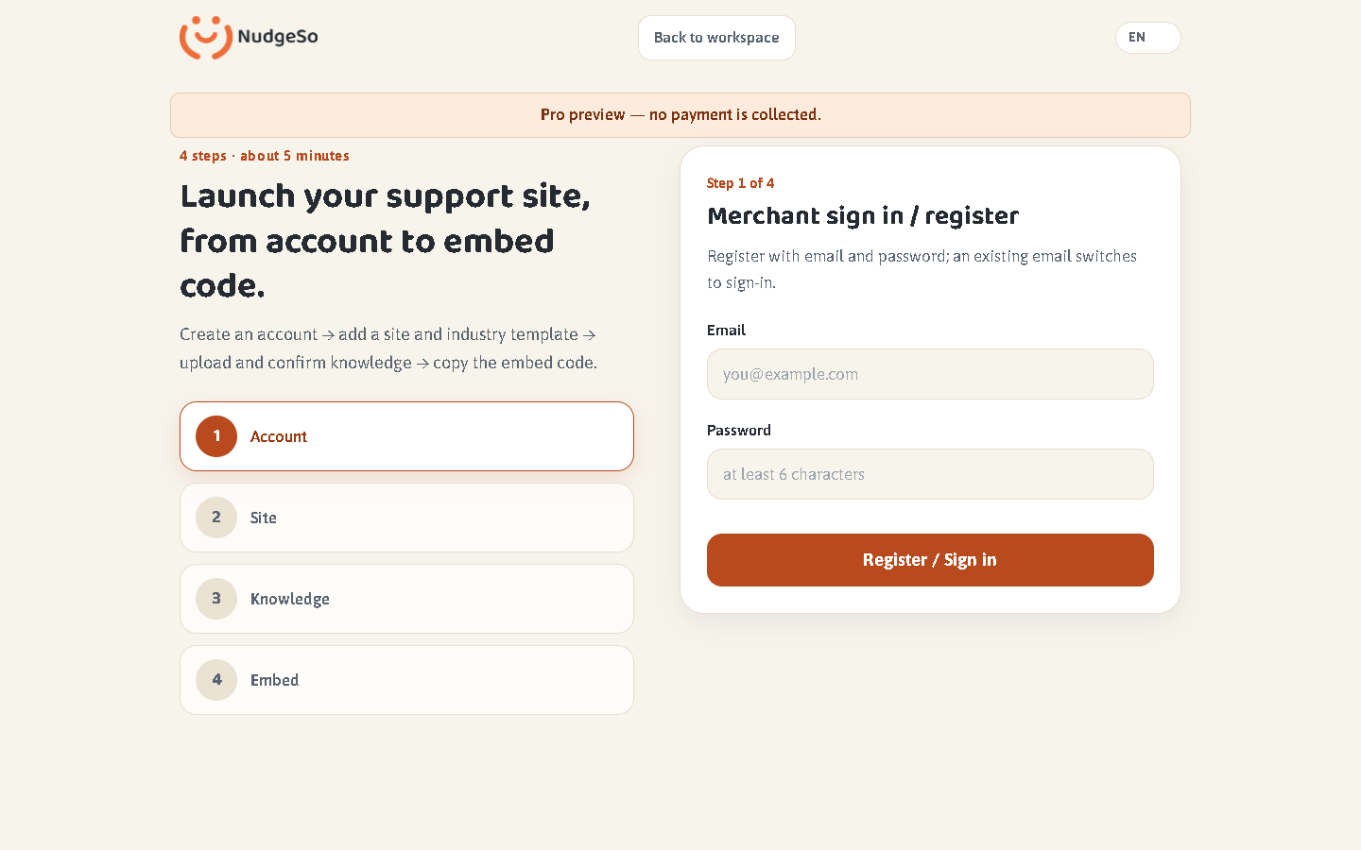
Online language-context evidence 3
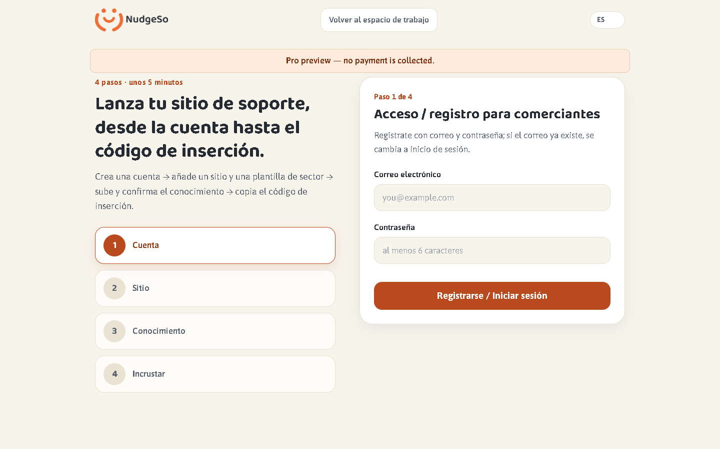
Online language-context evidence 4
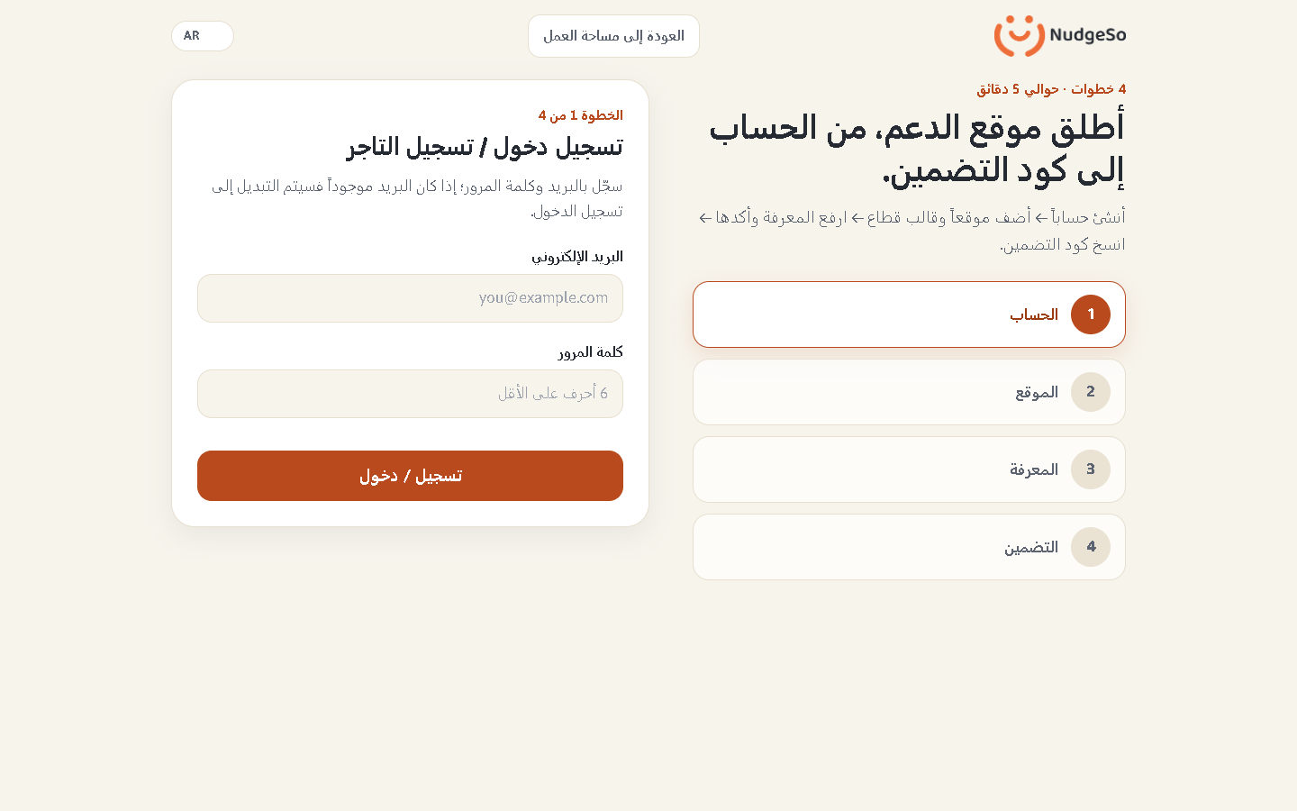
Online language-context evidence 5

8. Isolated Render Staging — write journey
This section records disposable write journeys against an isolated Render Staging service, never against production.
Staging URL: https://nudgeso-staging-qa-1793339470139.onrender.com
Staging commit: df4ac7dd53d255fb87be79175999f7c37831b017 · deploy: dep-dbi30k6i0phs73cn77gg
Result: 14 passed / 0 failed / 0 skipped; evidence images: 14/14.
Write tests: onboarding account + site + DOCX knowledge + embed; auth returnTo; tenant isolation; preview plan context; onboarding step state; insights filter context.
1. › chromium › AC-01.spec.ts › AC-01 merchant onboarding › register/login -> site + template -> upload/confirm knowledge -> embed code
Status: PASSED · 9276 ms · e2e\AC-01.spec.ts:16
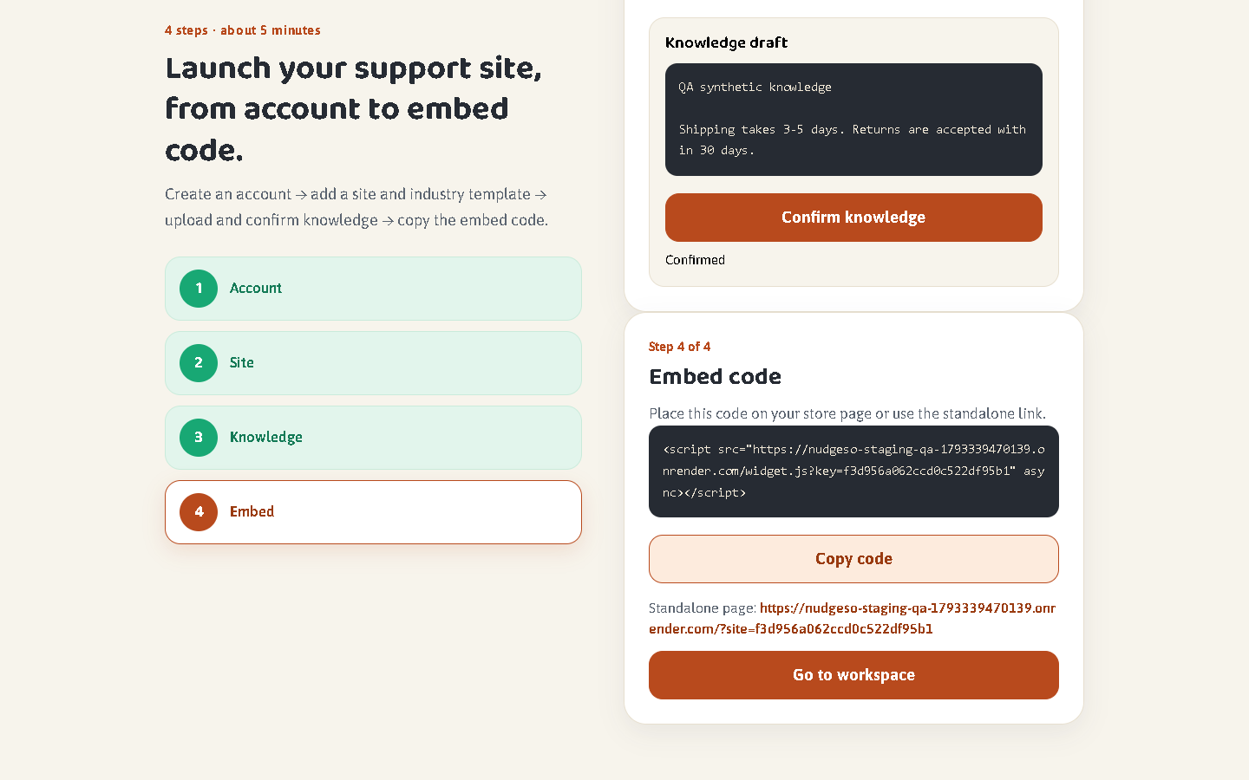

2. › chromium › CONTEXT-C2-C3.spec.ts › C2 auth returnTo › anonymous protected URL carries the exact returnTo into login
Status: PASSED · 2108 ms · e2e\CONTEXT-C2-C3.spec.ts:22
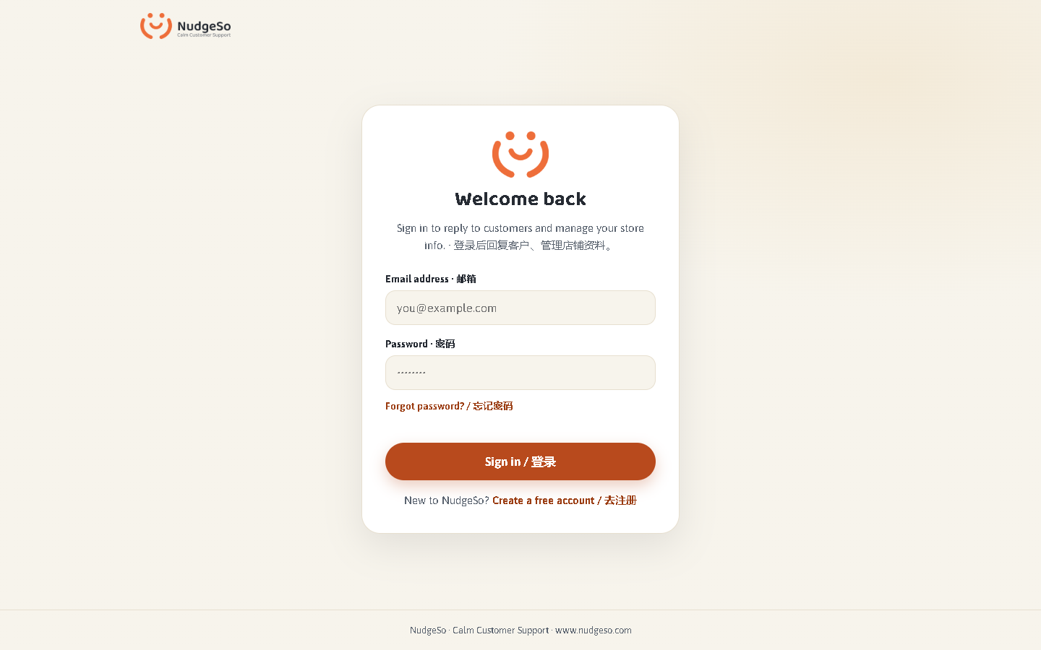

3. › chromium › CONTEXT-C2-C3.spec.ts › C2 auth returnTo › every protected surface carries its own returnTo
Status: PASSED · 11424 ms · e2e\CONTEXT-C2-C3.spec.ts:30
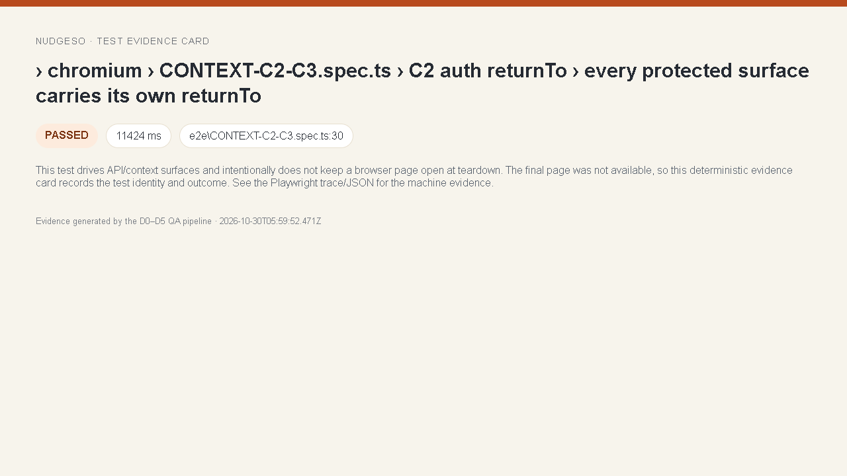

4. › chromium › CONTEXT-C2-C3.spec.ts › C2 auth returnTo › a successful login returns to the requested local URL
Status: PASSED · 9321 ms · e2e\CONTEXT-C2-C3.spec.ts:41
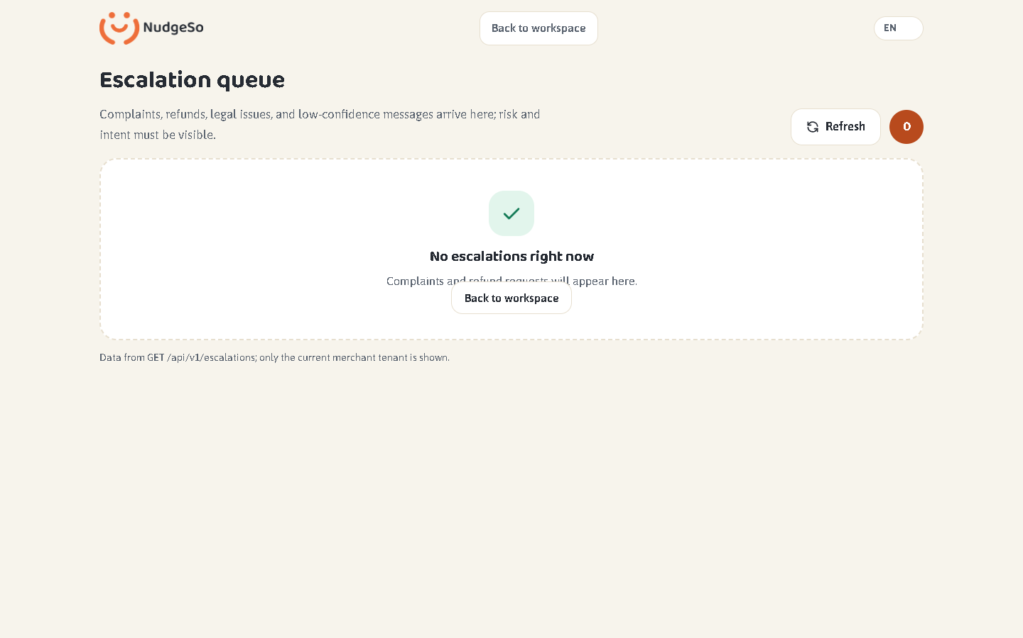

5. › chromium › CONTEXT-C2-C3.spec.ts › C2 auth returnTo › protocol-relative redirect cannot leave the origin
Status: PASSED · 2969 ms · e2e\CONTEXT-C2-C3.spec.ts:52
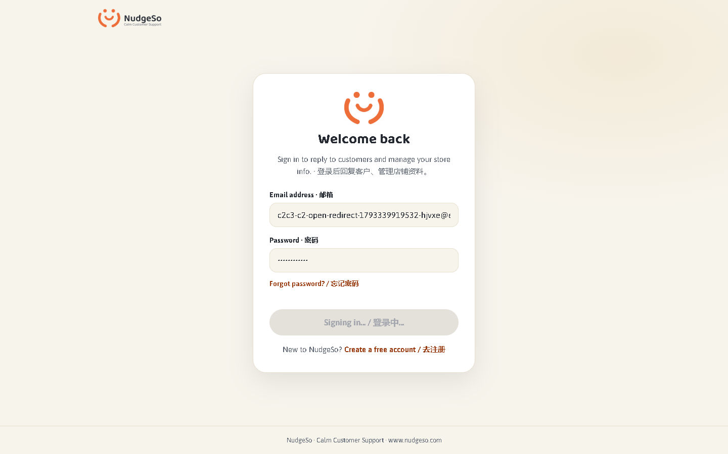

6. › chromium › CONTEXT-C2-C3.spec.ts › C2 auth returnTo › encoded backslash redirect cannot leave the origin
Status: PASSED · 2494 ms · e2e\CONTEXT-C2-C3.spec.ts:64
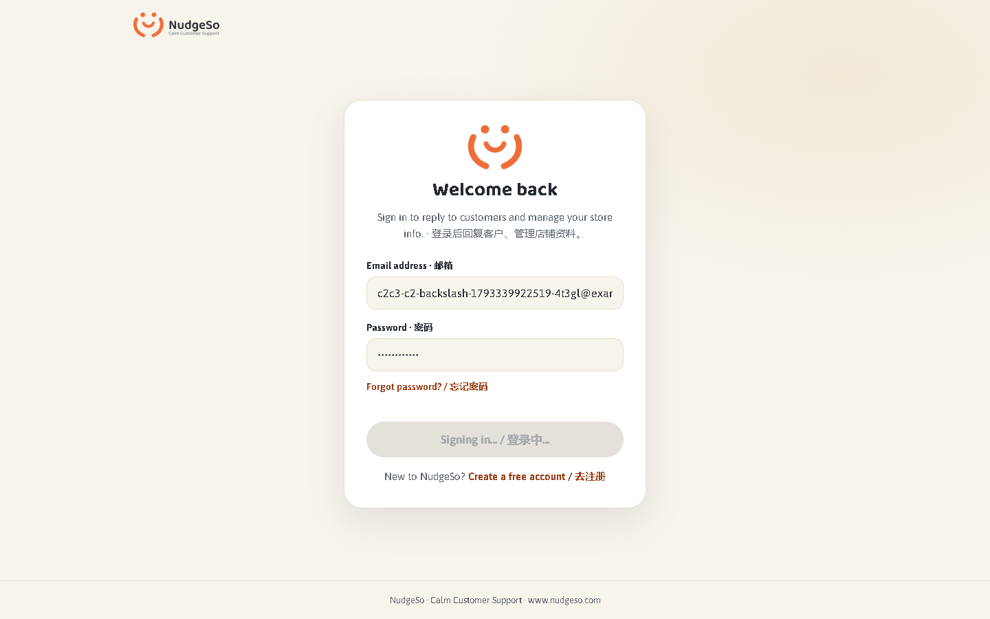

7. › chromium › CONTEXT-C2-C3.spec.ts › C2 auth returnTo › an expired token sends the protected page back to login with returnTo
Status: PASSED · 6013 ms · e2e\CONTEXT-C2-C3.spec.ts:76

8. › chromium › CONTEXT-C2-C3.spec.ts › C3 tenant isolation › browser queue and tenant APIs never expose another tenant
Status: PASSED · 8768 ms · e2e\CONTEXT-C2-C3.spec.ts:87
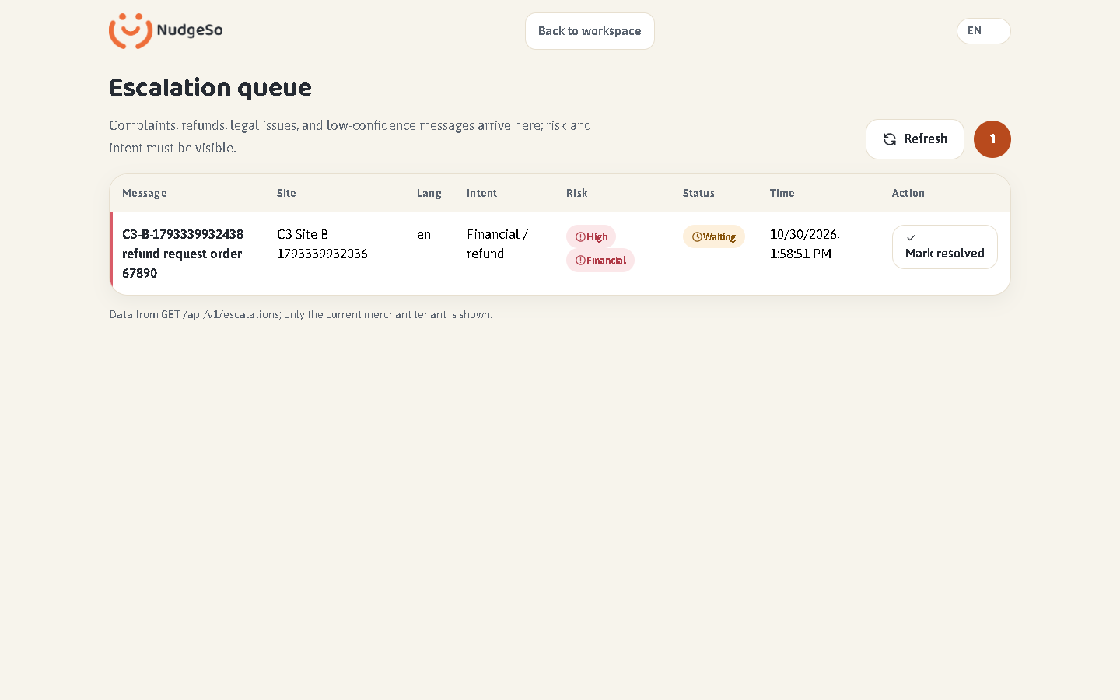

9. › chromium › CONTEXT-C4-C5.spec.ts › C4 preview plan context › Pro intent is preserved into onboarding without payment
Status: PASSED · 5601 ms · e2e\CONTEXT-C4-C5.spec.ts:22
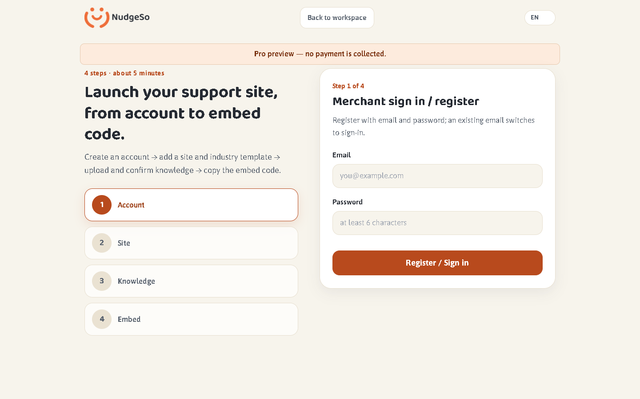

10. › chromium › CONTEXT-C4-C5.spec.ts › C4 preview plan context › yearly billing selection reaches the same preview context
Status: PASSED · 4704 ms · e2e\CONTEXT-C4-C5.spec.ts:44
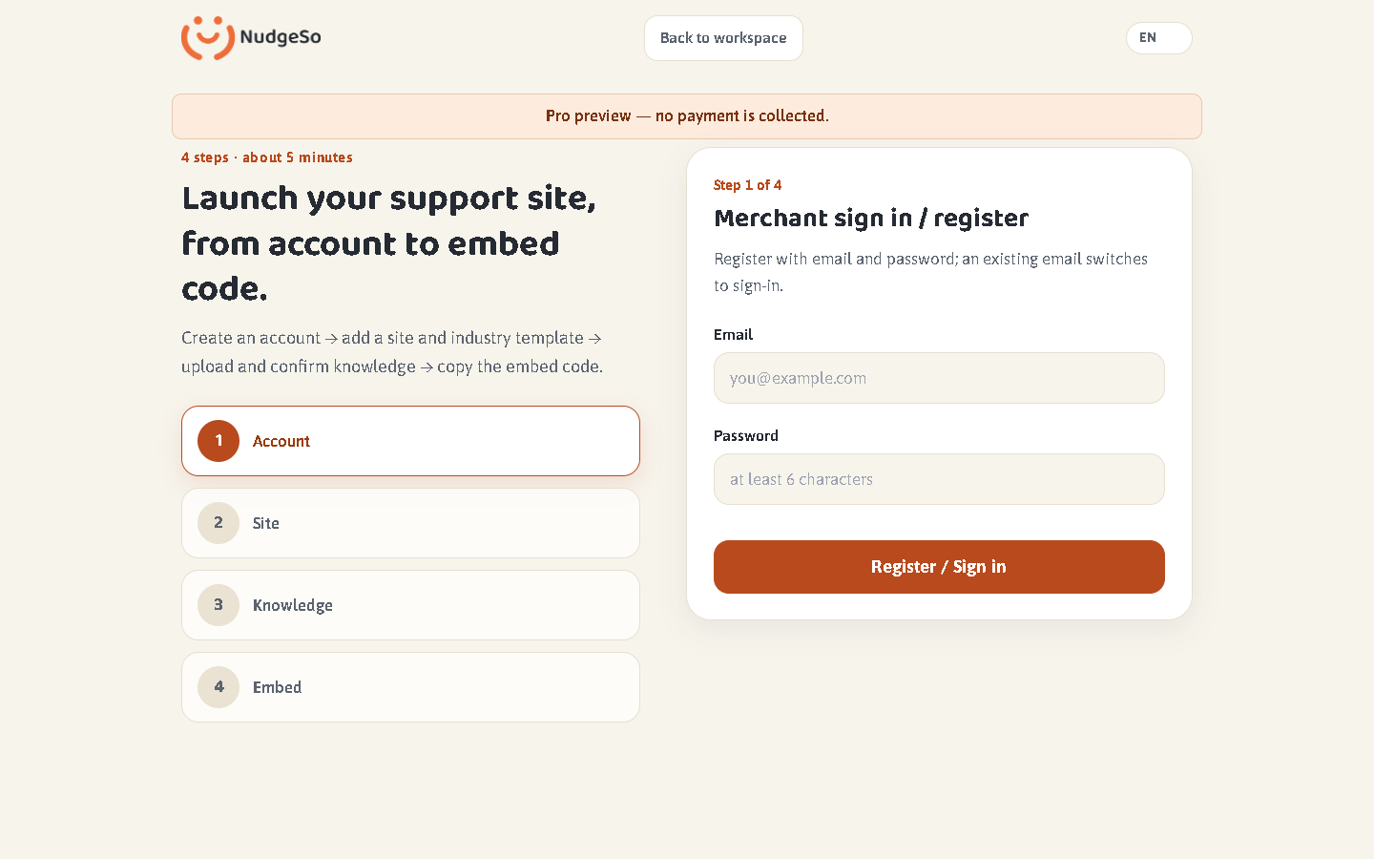

11. › chromium › CONTEXT-C4-C5.spec.ts › C5 wizard state › kb step survives refresh for the same tenant
Status: PASSED · 13099 ms · e2e\CONTEXT-C4-C5.spec.ts:59
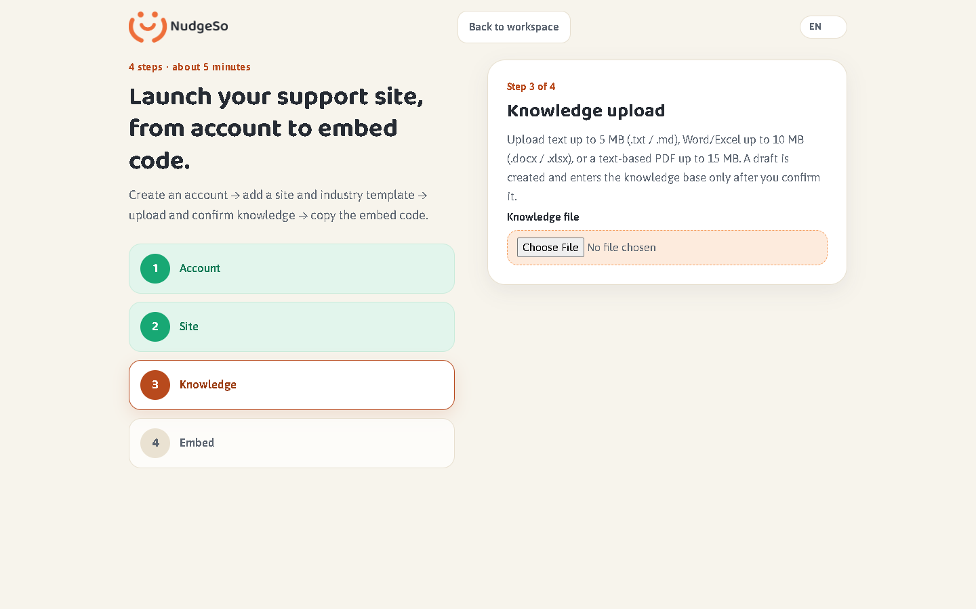

12. › chromium › CONTEXT-C4-C5.spec.ts › C5 wizard state › tenant switch clears stale wizard state and returns to site creation
Status: PASSED · 6174 ms · e2e\CONTEXT-C4-C5.spec.ts:75
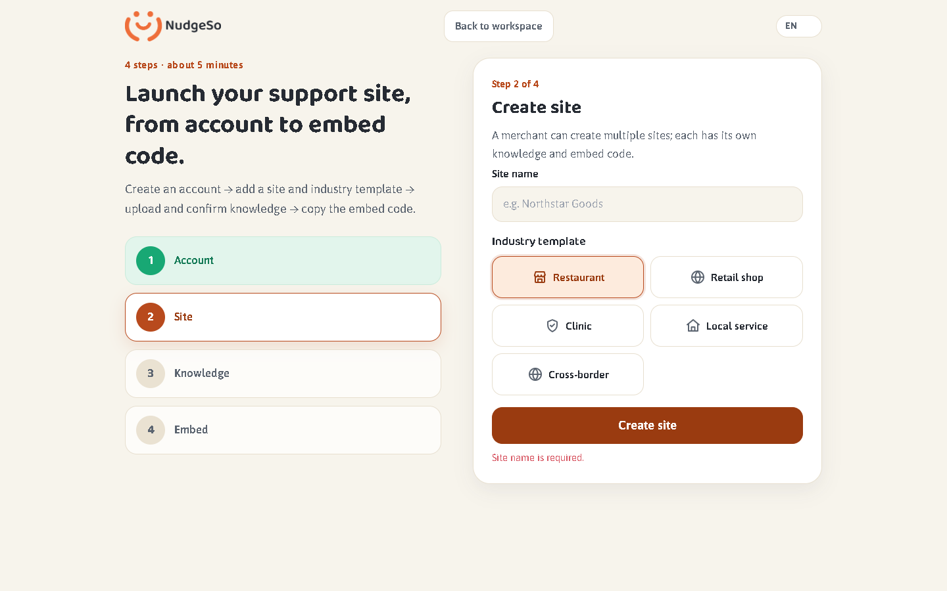

13. › chromium › CONTEXT-C6.spec.ts › C6 query and filter context › insights category survives refresh, back/forward and keeps other query params
Status: PASSED · 6028 ms · e2e\CONTEXT-C6.spec.ts:12
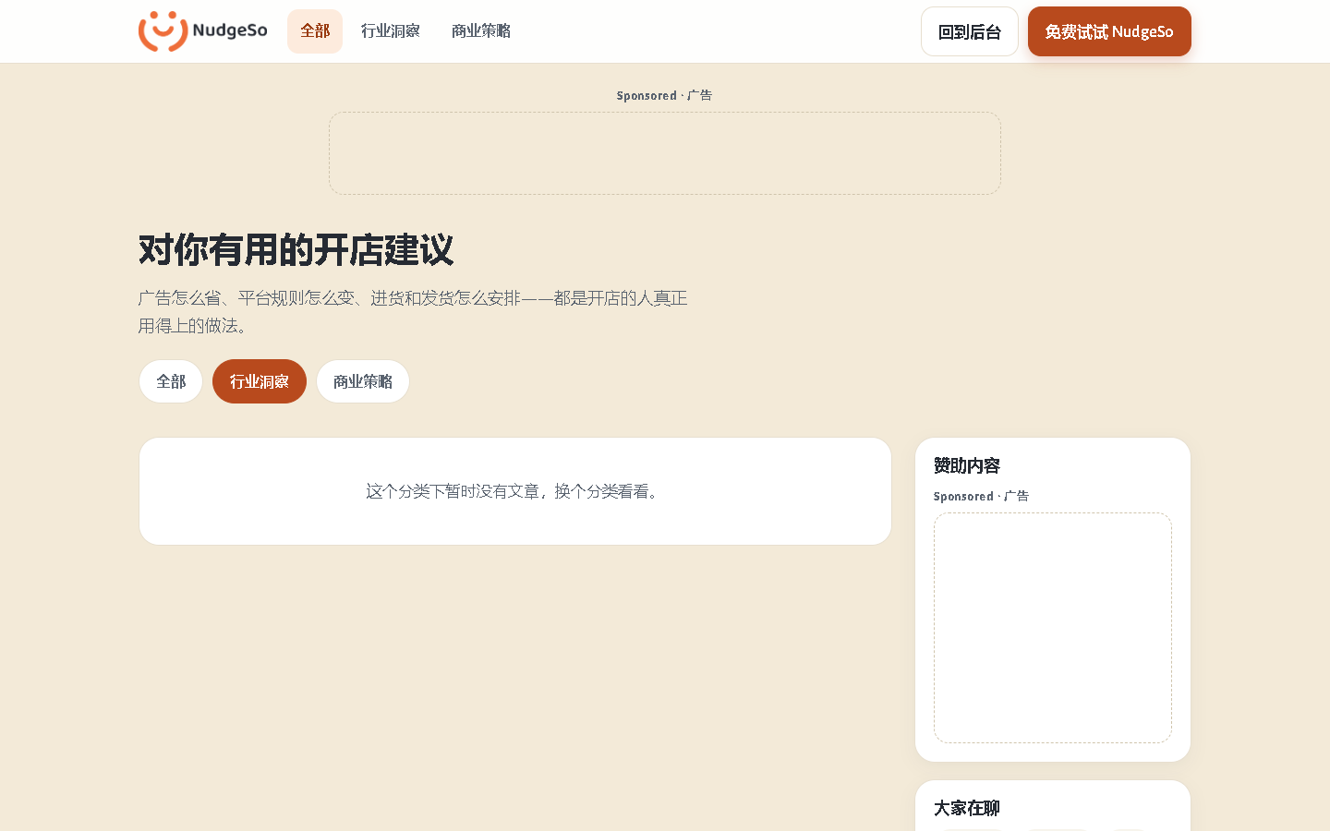

14. › chromium › CONTEXT-C6.spec.ts › C6 query and filter context › invalid category normalizes to all without losing other params
Status: PASSED · 4758 ms · e2e\CONTEXT-C6.spec.ts:39
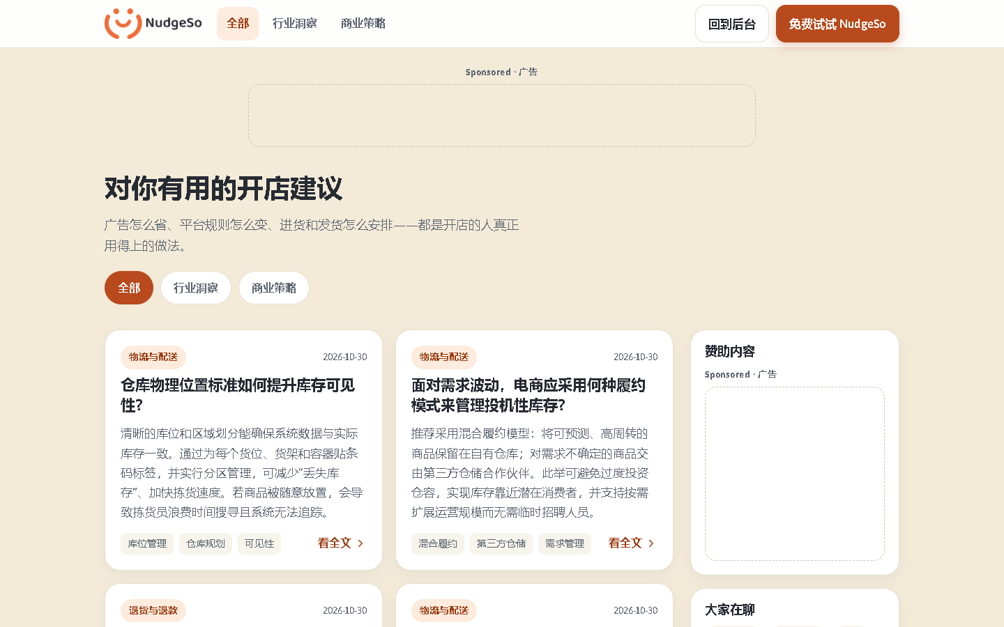

Staging NOT RUN
- Real payment/charge
- Email/WhatsApp/Instagram live channels
- Real iPhone/Android hardware
- Native-speaker final review
- Legal counsel review

9. Final deployment note
After the staging write run, a test-only stabilization commit was pushed and deployed to production:
Production live commit: c83485cd4fdff42da76bb5fec0f85bf31075fefa
Production smoke after deployment: 1/1 PASS (cloud smoke). Staging write suite: 14/14 PASS with 14 evidence images.
Real payment, live Email/WhatsApp/Instagram, real iPhone/Android hardware, native-speaker review and legal counsel review remain BLOCKED / NOT RUN because the required integrations, accounts, devices or human reviewers were not supplied.

