**Level Design Document (LDD)**

**Level Name:** [Zombs]

**Document Date:** [11/3/2016]

**Author/Designer Name**: [Joel Weyel, Enith Sadler, Tyler Purcell]

# Quick Summary

Research facility that is desolate and reeks of doom. The grass outside has grown a little too much. The interior is broken shadow of its former self as a respectable research facility.

# Gameplay Overview

Player will disarm explosives according to specialized manual, while avoiding or exterminating zombies as they go through the area.

# Objective Summary

* Discern and disarm the one real bomb out of 12 bombs in the zombie-overridden facility within the time limit or the cure to the zombie apocalypse will be destroyed.
* Once bombs are disarmed, player will make their way to secure the cure and evacuate the facility.

# Challenge Highlights

There will be 3-5 special fake bombs that will play devious tricks on the player through any of many randomized special methods.

# Water Cooler Moments

I think one of the moments that they might remember is holding onto a special fake bomb and not realizing it until it sends a sound alarm alerting a zombie to chase after the player. The bomb will set a countdown till the real bomb sets off the chain reaction. The player will have to rush to a room and barricade the doors then disarm the special fake bomb before being able to go about their business.

# Level Overview

* **Theme and Mood:** Dread, Chaotic, Stressful
* **Setting:** Research Facility
* **Time of Day:** Day (or Night)
* **Season and Weather:** Summer
* **Play Time:** 15-20 minutes
* **Physical Dimensions:** 1600x1600
* **Overarching Visual Themes:** Desolate, Abandoned, Evacuated

# Level Difficulty (scale of 1–5)

* **Beginning:** 3
* **Middle:** 4
* **End:** 4

# Game Story (or Scenario Rationale)

* **Introduction:** While the player is going into the past through a worm hole, the story will be narrated to them about how they will be trying to disarm the bombs in order to save the cure.
* **In-Game:** The player will mainly have to deal with the zombies and bombs being chaotic with their instructions. Until the player disarms the bombs, then they will have to race to the cure before the zombies get to it.
* **Extro:** Once the player acquires the cure, they will then have to race out of the facility to the extraction portal. A mission success screen will show up with stats on the bomb diffuses and zombies.

# Major Areas/Visual Themes

* **Terrain and Vegetation:** Medium-tall grass, even terrain.
* **Models and Architecture:** Modern Research facility supplies such as desks, counter islands, chairs, etc. Architecture will be a plain sturdy steel building that will have multiple research labs and offices inside.
* **Textures and Lighting:** Textures will include normal requirements for models above and won’t really need any deviations. Lighting however will be a tricky subject as it would be preferred to have a sparse spreading of lights with most of the areas being roughly dark as to require the usage of a flashlight.
* **Characters:** Main character won’t be necessary however Zombie models will be necessary.
* **Vehicles:** None applicable.

# Gameplay Mechanics

* **Prerequisite Skills:** Basic Aiming/Firing and Reading.
* **Skills Learned:** Critical Thinking, Hand-eye coordination, Stress Handling.
* **Primary Objective:** Disarm the one real bomb out of 12 bombs. Then, head to the vault and grab the cure. Finally, evacuate the facility to the emergency portal outside.
* **Secondary Objectives:** Disarm all bombs, Disarm bombs in random special ways that will differ from game to game, Kill no Zombies, Kill X amount of Zombies, Complete in x time, etc.
* **Game Controls:** WASD movement, Q for Manual/Pause, E to Pick up/throw objects and/or bombs, Z to access bomb disarming whilst holding/aiming at bomb, R to reload, F for toggle Flashlight, Shift for Run (DOA), Left-Ctrl for Walk (DOA).

# Necessary Assets

* **Static and Skeletal Meshes:** Desks, Chairs, Beakers, Doors, Bookcases, Books, Bomb cases in varying styles, Zombies, Vault.
* **Textures:** Everything above, including varying textures up to manual specifics with regards to bombs. Building (steel or brick), Flooring (marble or some other kind), ground, grass, fire.
* **Music and SFX:** Zombie groans, bomb explosion, bomb clock beeping. Background music would be nice, though no current suggestion exists, a subtle slow dark emphasis of urgency would be nice to go along with the beeping of the clock.
* **Player Actors:** N/A, First Person perspective so model is not inherently necessary due to time frame of development.

# User Interface

* **Pregame Information:** Pregame menu will have a How to play intro when the player clicks Start, that will remind the player of the mechanics/rules of the game.
* **In-Game Information:** Manual will explain all there will need to be for all potential possibilities and solutions for the game. After they have disarmed the bomb, they will get a mission update to grab the cure from the vault.
* **Post-game Information:** Post Screen will include information regarding completion time, zombie kills, and secondary achievements for the map (it will show as a box with or without a check mark)
* **HUD Elements:** Ammunition, Health, Zombie kills, Current amount of bombs disarmed/Not Disarmed, Time Left.

# User Interface Mock Up

Include a physical drawing or a digital representation of the HUD/UI elements; it may fill the whole page or be attached as a separate file.

*UI Design Notes:*

* *The UI is meant for players to interact with, if needed (think Civilization). Avoid creating hot key only skills.*
* *The UI displays relevant active information (think DOOM). Display things like Ammo, Health, and Time remaining (etc).*
* *Avoid creating a skill bar in your HUD (think League of Legends), because you will need to train your players on all skills.*

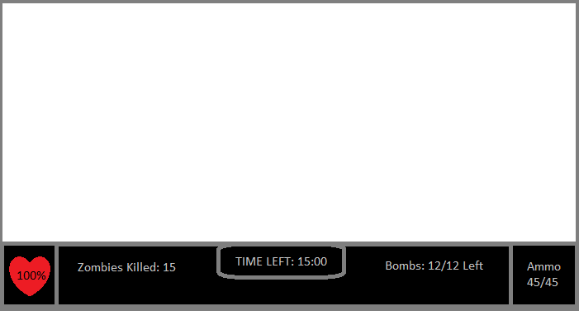

# Level Map

Include a physical drawing or a digital representation of the level; it may fill the whole page or be attached as a separate file.

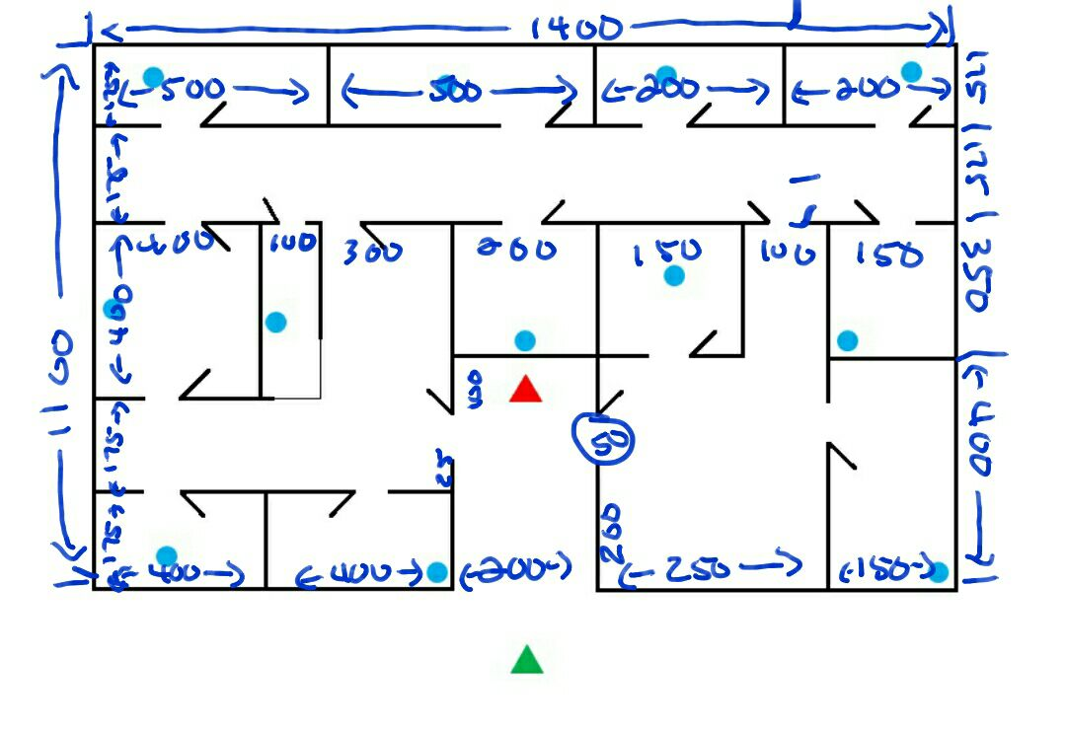

**Map Key (Legend)**

Include a key or legend, and label the following on your map; you may change the label markers.

|  |  |  |  |  |  |
| --- | --- | --- | --- | --- | --- |
| Water Cooler Moments: |  | Player Start Point: |  | ***Main Actors***   Spawn Point: |  |
| Challenge Highlights: |  | Player Optimal Route: |  | ***Main Actors*** Routes/Behavior: |  |
| Objectives: |  | Player Alternate Route: |  | ***Supporting Actors***  Spawn Point: |  |
| Skill Tests: |  | Area End Point: |  | ***Supporting Actors*** Routes/Behavior: |  |