**Level Design Document (LDD)**

**Level Name:** [Zombs]

**Document Date:** [12/17/2016]

**Author/Designer Name**: [Joel Weyel, Enith Sadler, Tyler Purcell]

# Quick Summary

Research facility that is desolate and reeks of doom. The grass outside has grown a little too much. The interior is broken shadow of its former self as a respectable research facility.

# Gameplay Overview

Player will hunt down the Zombie menace, with their trusty flash-lighten rifle.

# Objective Summary

* Hunt, Zombies. Shoot all of them.

# Challenge Highlights

There is a large hallway swarming with zombies… beware.

# Water Cooler Moments

Just when you think it’s just more zombie, poison mist ruins your day.

# Level Overview

* **Theme and Mood:** Dread, Chaotic, Stressful
* **Setting:** Research Facility
* **Time of Day:** Night
* **Season and Weather:** Summer
* **Play Time:** 15+ minutes
* **Physical Dimensions:** 1600x1600
* **Overarching Visual Themes:** Desolate, Abandoned, Evacuated

# Level Difficulty (scale of 1–5)

* **Beginning:** 3
* **Middle:** 4
* **End:** 4

# Game Story (or Scenario Rationale)

* **Introduction:** Gun in hand the player stares down the facility, he intends to raid.
* **In-Game:** Standard mindless shooting game.
* **Extro:** N/A

# Major Areas/Visual Themes

* **Terrain and Vegetation:** Medium-tall grass, even terrain.
* **Models and Architecture:** Modern Research facility supplies such as desks, counter islands, chairs, etc. Architecture will be a plain sturdy steel building that will have multiple research labs and offices inside.
* **Textures and Lighting:** Textures will include normal requirements for models above and won’t really need any deviations. Lighting however will be a tricky subject as it would be preferred to have a sparse spreading of lights with most of the areas being roughly dark as to require the usage of a flashlight.
* **Characters:** Main character won’t be necessary however Zombie models will be necessary.
* **Vehicles:** None applicable.

# Gameplay Mechanics

* **Prerequisite Skills:** Basic Aiming/Firing
* **Skills Learned:** Critical Thinking, Hand-eye coordination, Stress Handling.
* **Primary Objective:** Zombie Hunting Spree
* **Secondary Objectives:** get a higher score
* **Game Controls:** WASD movement, Q for Manual/Pause, E to interact with doors, R to reload, F for toggle Flashlight, Shift for Run (DOA), Left-Ctrl for Walk (DOA).

# Necessary Assets

* **Static and Skeletal Meshes:** Desks, Chairs, Beakers, Doors, Bookcases, Books, Zombies.
* **Textures:** Everything above, including varying textures up to manual specifics with regards to bombs. Building (steel or brick), Flooring (marble or some other kind), ground, grass, fire.
* **Music and SFX:** Zombie groans, footsteps, gun shots. Background music would be nice, though no current suggestion exists, a subtle slow dark emphasis of urgency would be nice.
* **Player Actors:** N/A, First Person perspective so model is not inherently necessary due to time frame of development.

# User Interface

* **Pregame Information:** Jump straight in.
* **In-Game Information:** interact UI to remind the player they and do more that shot things.
* **Post-game Information:** Post Screen will include information regarding completion time, zombie kills.
* **HUD Elements:** Ammunition, Health, Zombie kills, Time Left.

# User Interface Mock Up

Include a physical drawing or a digital representation of the HUD/UI elements; it may fill the whole page or be attached as a separate file.

*UI Design Notes:*

* *The UI is meant for players to interact with, if needed (think Civilization). Avoid creating hot key only skills.*
* *The UI displays relevant active information (think DOOM). Display things like Ammo, Health, and Time remaining (etc).*
* *Avoid creating a skill bar in your HUD (think League of Legends), because you will need to train your players on all skills.*

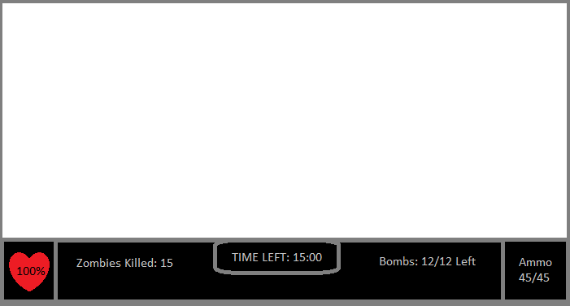

# Level Map

Include a physical drawing or a digital representation of the level; it may fill the whole page or be attached as a separate file.

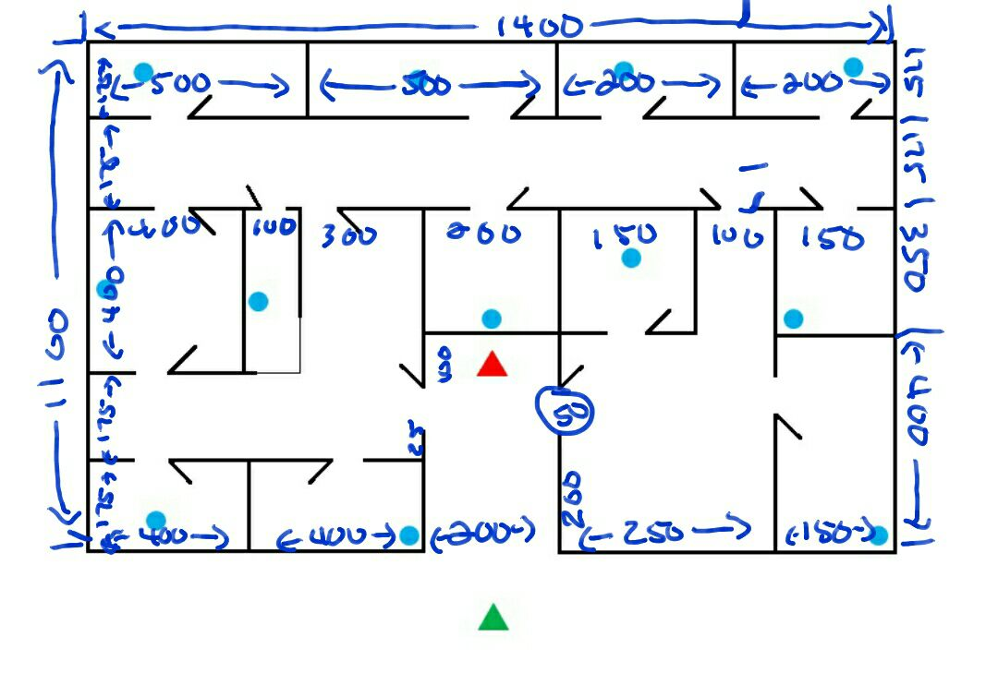

**Map Key (Legend)**

Include a key or legend, and label the following on your map; you may change the label markers.

|  |  |  |  |  |  |
| --- | --- | --- | --- | --- | --- |
| Water Cooler Moments: |  | Player Start Point: |  | ***Main Actors***   Spawn Point: |  |
| Challenge Highlights: |  | Player Optimal Route: |  | ***Main Actors*** Routes/Behavior: |  |
| Objectives: |  | Player Alternate Route: |  | ***Supporting Actors***  Spawn Point: |  |
| Skill Tests: |  | Area End Point: |  | ***Supporting Actors*** Routes/Behavior: |  |