**Level Design Document (LDD)**

**Level Name:** [Office Surprises]

**Document Date:** [10/30/2016]

**Author/Designer Name**: [Joel Weyel]

# Quick Summary

A large, one-floor building, with a many rooms inside, that has a neatly cut grass lawn surrounding it. There is a pathway leading up to the building from the street to the two doorways.

# Gameplay Overview

The Player must find the correct bomb and disable it before the time runs out. There are 12 bombs in total with 11 being fake bombs.

# Objective Summary

* There will be 1 specific bomb that the player will have to find, there will be a Manual that the player will have to use in order to distinguish which bomb is the correct bomb as well as the method to disarm it.
* There will be some fake bombs that will trick the player (and have one or two small differences from the real one that the player will have to check with the manual) that will cause the explosion to occur thus making the player lose.
* Most of the fake bombs will just cause their LED to display “NOPE” when the player attempts to disarm it.

# Water Cooler Moments

I believe the things that will cause a lot of Water Cooler Moments will be the Fake Bombs that trick the players as well as the different conditions that the manual will tell the player to do in order to solve the bomb. There will be moments where the Manual will tell the player to go run around while carrying the bomb with them in order to complete far-fetched objectives. There will also be crazy ways in the manual for the player to extend the time.

# Level Overview

* **Theme and Mood:** Chaotic, Tense, And Filled with Crazy (for the Water Cooler)
* **Setting:** Office Building
* **Time of Day:** Daytime or Night-Time (DOA, depending on my abilities, prefer later)
* **Season and Weather:** Summer (Maybe Rainy DOA ^)
* **Play Time:** 10-20 minutes
* **Physical Dimensions:** Exact Size Depending Further Analysis (will come in Later Revision).
* **Overarching Visual Themes:** Office – Broken Office with Hazard-like Situations i.e. Fire (DOA)

# Level Difficulty (scale of 1–5)

* **Beginning:** 3
* **Middle:** 4
* **End:** 4

# Game Story (or Scenario Rationale)

* **Introduction:** Being from the Future, the Player must save the past by using the manual to disarm the bombs in the Office building. The manual will help explain the Objectives as well as mechanics.
* **In-Game:** Interactions with Bombs will cause changes to the directions one might need to take in order to win (Butterfly Effect in a way).
* **Extro:** Once finished disarming the bombs, the player will have to escape through a (Convenient Plot Device) Time-Portal to go back to the future.

# 

# Major Areas/Visual Themes

* **Terrain and Vegetation:** Flat land with plain even cut grass for an office building. Small bushes along the pathway to the two doors with some flowers.
* **Models and Architecture:** Simple Modern Brick Office building with necessities such as chairs, desks, cabinets, etc.
* **Textures and Lighting:** Not entire sure what is entirely meant by Textures (other than basic textures for models of an Office Building). Lighting may not be evenly spaced depending on theme and ability (to allow more usage of the flashlight and other mechanics). There may be flicking lights.
* **Characters:** Simple Human character for First-person Perspective, There will not be any NPC models needed.
* **Vehicles:** None.

# Gameplay Mechanics

* **Prerequisite Skills:** The level does not require pre-existing skills.
* **Skills Learned:** No game-mechanics skills will be learnt, the player might learn critical-thinking skills for chaotic situations.
* **Primary Objective:** Disable Bombs.
* **Secondary Objectives:** There aren’t currently any secondary objectives or achievements, however the manual will have something like that in order for the primary objective to be completed. There will be many ways to come to the same conclusion and every one of them will be chaotic and sometimes funny.
* **Game Controls:** WASD movement/Rotate Bombs while interacting, Q for Manual/Pause, E to Pick up/throw objects and/or bombs, R to interact with bombs, F for toggle Flashlight/Night-vision (DOA), Shift for Run (DOA), Left-Ctrl for Walk (DOA).

# Necessary Assets

* **Static and Skeletal Meshes:** Chairs, Desks, Cabinets, Papers, Lamp, Lights, Doors, Buildings, Bushes, Flowers, Pavement/Road, Windows, Bombs, Portal (Only appears once finished).
* **Textures:** The above plus different bomb styles/looks/texturing/etc. Potentially Fire and other hazard-like situations.
* **Music and SFX:** Explosions, Soft-walking sounds (hopefully not too annoying, if so then will be removed), Bomb ticking sounds, Collisions sounds from throwing objects, Beep-Booping from interactions with Bomb. Potentially Flame and other hazard-like situation sounds. Maybe background music so heighten tension.
* **Player Actors:** Human Player Character (First Person View).

***Player Actors***

* Model(s): N/A
* Motives/Objectives: N/A

***Other Key Actors***

* Model(s): N/A
* Motives/Objectives: N/A

# User Interface

* **Pregame Information:** Tutorial Page will explain Manual’s Usage as well as the fact that there are 11 fake bombs with only 1 real bomb. Page will explain that depending on actions taken, there will be different steps that need to be taken and that every game will be randomized.
* **In-Game Information:** Manual will explain all there will need to be for all potential possibilities and solutions for the game.
* **Post-game Information:** Time taken to complete and potentially achievements (DOA). Later Revisions might add to this section.
* **HUD Elements:** Time Left on bomb and Manual with Text that says Press Q for Manual/Pause.

# User Interface Mock Up

Include a physical drawing or a digital representation of the HUD/UI elements; it may fill the whole page or be attached as a separate file.

*UI Design Notes:*

* *The UI is meant for players to interact with, if needed (think Civilization). Avoid creating hot key only skills.*
* *The UI displays relevant active information (think DOOM). Display things like Ammo, Health, and Time remaining (etc).*
* *Avoid creating a skill bar in your HUD (think League of Legends), because you will need to train your players on all skills.*

There will be 3D models to replace these 2D representative Pictures

The manual won’t be as big as shown, however will be enough that the player doesn’t forget its existence.

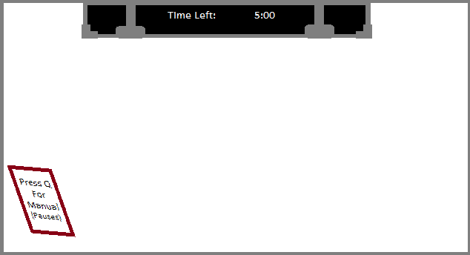

# Level Map

Include a physical drawing or a digital representation of the level; it may fill the whole page or be attached as a separate file.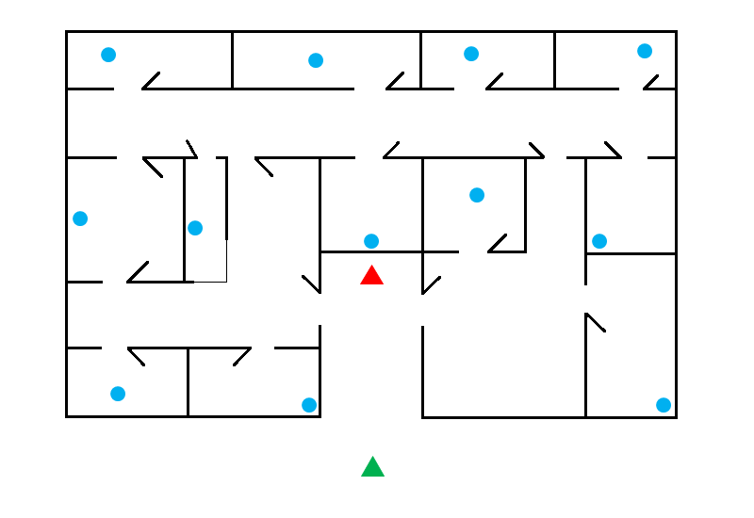

**Map Key (Legend)**

Include a key or legend, and label the following on your map; you may change the label markers.

|  |  |
| --- | --- |
| Player Start Point: |  |
| Objectives(bombs): |  |
| Area End Point: |  |
| Window Counter (Reception): |  |