**Level Design Document (LDD)**

**Level Name:** [Icy Maze]

**Document Date:** [10/30/2016]

**Author/Designer Name**: [Tyler Purcell]

# Quick Summary

Slippery Ice floor Puzzle. Player stops moving when colliding with a wall; then, can select the next direction of movement. Player tries to solve the path that leads to the exit.

# Gameplay Overview

This level is a standard slippery floor puzzle. The player is forced to figure out the path that’ll lead to the exit based on the position of the obstacles/walls/etc. The player has restricted 4 directional movement controls. The environment is a typical ice floor room, with patches of non-slippery terrain and icicle obstacles.

# Objective Summary

* Reach the Exit

# Challenge Highlights

In order to solve the path, the player needs to realize what allows them to stop and change directions, and work out a path starting from the exit. The reason for this is: the path options are unlikely to loop back on its-self while going in reverse, due to the nature of the movements.

# Water Cooler Moments

Yet another slippery floor puzzle?

# Level Overview

* **Theme and Mood:** Cold, Simple, Cave?
* **Setting:** Icy/snowy floor and walls.
* **Time of Day:** Twilight
* **Season and Weather:** Winter, cloudy
* **Play Time:** 10 minutes
* **Physical Dimensions:** N/A
* **Overarching Visual Themes:** ICE!!!!!!

# Level Difficulty (scale of 1–5)

* **Beginning:** 1 (should be straight forward)
* **Middle:** 2 (requires some planning, or luck)
* **End:** 3 (very easy to back track if you don’t figure out the correct route)

# Game Story (or Scenario Rationale)

* **Introduction:** Player enters room and immediately begins sliding on ice. Player is left to solve the puzzle using gained experience from playing out the level.
* **In-Game:** N/A
* **Extro:** N/A

#### 

# Major Areas/Visual Themes

* **Terrain and Vegetation:** Ice and Snow (image reference.)
* **Models and Architecture:** Icicles protruding from the icy floor (image reference.)
* **Textures and Lighting:** Ice and Snow (image reference.)
* **Characters:** some dude in full body winter clothes (image reference.)
* **Vehicles:** N/A

# Gameplay Mechanics

* **Prerequisite Skills:** The ability to control the characters movement…
* **Skills Learned:** Pathfinding (goal to start method)
* **Primary Objective:** Get to the exit
* **Secondary Objectives:** Realize that the easiest solution is to start from the finish.
* **Game Controls:** Up, Down, Left, and Right; while not in moving.

# Necessary Assets

* **Static and Skeletal Meshes:** wall/floor tiles, icicle obstacles, and the player.
* **Textures:** Ice, snow, player character.
* **Music and SFX:** sliding on ice SFX, stepping on snow SFX, Hitting an obstacle SFX, Room transition SFX, ambient cold BMG.
* **Player Actors:** some dude in full body winter clothes

***Player Actors***

* Model(s):
* Motives/Objectives: getting out of this slippery cave.

# User Interface

* **Pregame Information:** None; the level is simple enough to jump straight into it.
* **In-Game Information:** To let the player know they are progressing, the room transition SFX needs to imply success.
* **Post-game Information:** Unless more levels follow, a BG of an open field of snow with the player gazing at their freedom?
* **HUD Elements:** Move Counter; tracks the number of moves the player has made.

# User Interface Mock Up

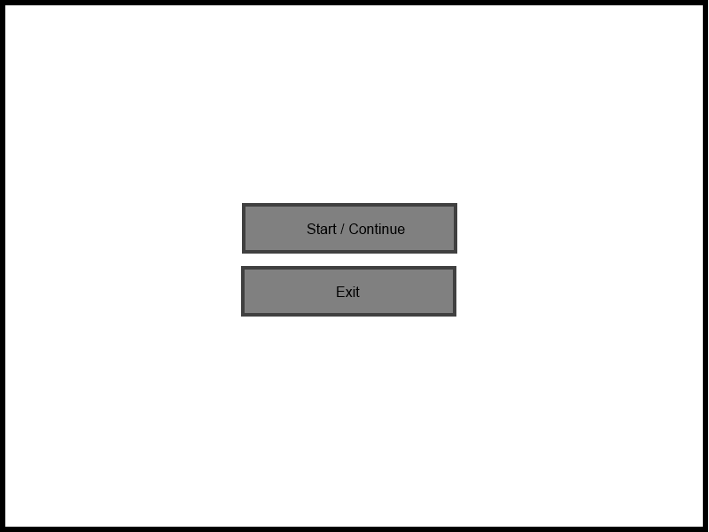

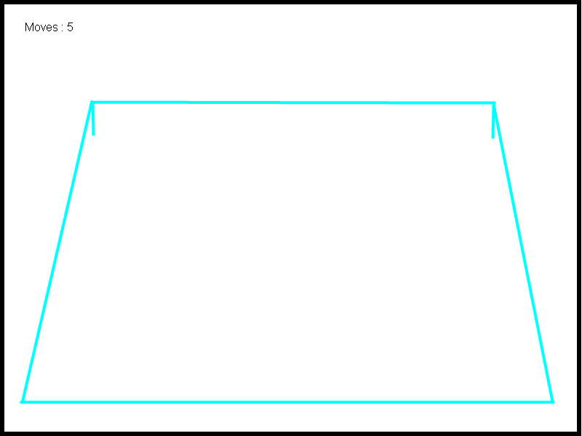

# Level Map

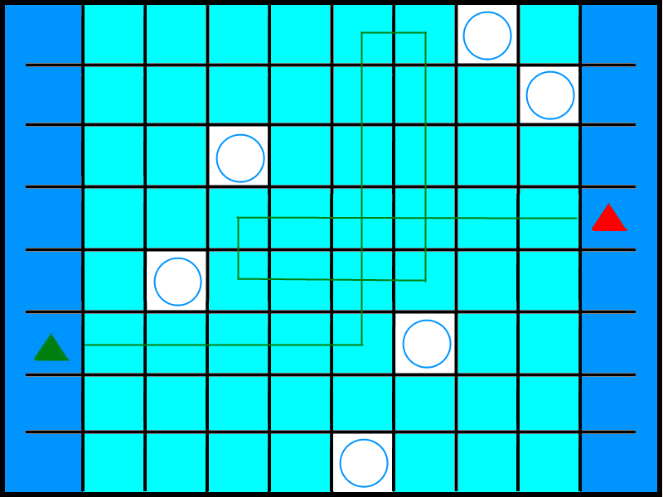

**Map Key (Legend)**

Include a key or legend, and label the following on your map; you may change the label markers.

|  |  |  |  |  |  |
| --- | --- | --- | --- | --- | --- |
| Walls: |  | Player Start Point: |  | Area End Point: |  |
| Slippery Ice: |  | Player Optimal Route: |  | Player Alternate Route: |  |
| Icicle Obstacle: |  |  |  |  |  |