**Zombies: The Apocalypse**

**Level Design Document (LDD)**

**Level Name:** New Beginning

**Document Date:** 10-30-2016

**Author/Designer Name**: Enith D. Sadler

**Revision Number:** Remove this section if it is the first draft.

**Date:** 10-30-2016

**Revision Details:**

* First LDD.

# Quick Summary

Main level or the 4th floor of the building will teach the player some of the most basic skills required to survive in this new Earth. Start with presenting a temporary safe area, like the capsule you just woke up from. On the next room the player will be able to choose their character’s details. Learn to use new weapons that have been created during your slumber period. How to cook basic meals to survive on the third floor of the building, and fulfill a small portion of the curiosity of what happened while you were sleeping. How time has passed?

# Gameplay Overview

Describe the gameplay in 1–2 paragraphs.

The player will have, to explore this new Earth, find ways to fight zombies, learn how to use new weapons created, learn how to cook meals that can help you replenish energy, find shelter as well as information of what happened during your slumber period and for any survivors.

# Objective Summary

* 4th floor
  + Choose your character settings
  + Find new equipment
  + Defeat the nearby zombie
  + Travel to a lower floor through the stairs
* 3rd floor
  + Defeat more enemies.
  + Learn how to cook some basic meals to help you replenish part of your energies.
  + Travel to the next lower floor through stairs
* 2nd floor
  + Player should practice finding items that can help the player improve their equipment
  + Find a way to the main level
* Main level
  + Find a safe exit out of the building to explore outside
  + Learn that this is the location to the mainframe system of the building

# Challenge Highlights

Describe all challenge areas of the level, each as separate paragraphs.

The challenges to the 4th floor is to find new clothing equipment, learning all the possible uses for the capsule of which you, the player, just came out of. Defeating all zombies, learning how to use new weapons.

Third floor challenges are to defeat a few zombies as well as learn how to cook some starting basic recipes, so the player can create foods that can help them replenish their health.

Second floor challenges will include showing the player that some zombies can provide the player with replacement weapons as well.

First floor of the building, will present the challenge of finding a safe exit out of the building, in which the player does not have to encounter zombies.

Outside of the building, the main challenges will be to encounter more zombies, find eatable food, cooking food and finding safe shelter.

# Water Cooler Moments

Describe all points of the level that people will talk about, each as separate paragraphs.

Capsules

Lockers

# Level Overview

* **Theme and Mood:** Quiet, dangerous, constant vigilance
* **Setting:** Everything deserted by human life, only zombies now prowl
* **Time of Day:** Daylight
* **Season and Weather:** Summer, sunny
* **Play Time:** 10 minutes
* **Physical Dimensions:** List exact dimensions per your game engine
* **Overarching Visual Themes:**

# Level Difficulty (scale of 1–5)

* **Beginning:** The level will start at one, the player will be able to earn experience for performing activities like defeating a zombie, cooking, finding specific items, creating/repairing specific items, building a shelter, etc.
* **Middle:** The player will be able to increase level and the enemies will increase their level as well.
* **End:** As the player progresses, so will the player level, which will make the enemies slightly stronger than before. The difficulty of the level will be based on the player’s final level.

# Game Story (or Scenario Rationale)

* **Introduction:** The user becomes the main player; a background of the main player’s past is shown through cut-scenes.
* **In-Game:** After a few levels in/areas, the player find one of the few survivors that will later join the player in their new formed haven.
* **Extro:** The player is shown in modern day, dealing with their normal routine. A commercial catches the player’s attention and they decide to learn more about it. They go the building in which they wake up from and meet with the scientist/doctor in charge. Following, you see the character come back to the building to start their slumber time.

#### 

# Major Areas/Visual Themes

* **Terrain and Vegetation:** Earth is about the healthiest it can be, there are very little humans using all their devices that harm themselves as well the Earth. Many years have passed and Earth has had enough time to recuperate from the damage made.
* **Models and Architecture:** Buildings are decaying, unstable, taken over by the earth.
* **Textures and Lighting:** Lighting will be natural, mainly by the sun, when there is artificial lighting it will be from a fire pit or at least by solar power energy.
* **Characters:** Zombies, Main Player (name to be determined by the player at creation).
* **Vehicles:** No vehicles, at this point due to the time spent in the deep slumber, vehicles are no longer stable to use, in addition they cause too much attraction to the zombies. The player must always walk to their location.

# Gameplay Mechanics

* **Prerequisite Skills:** No prerequisite skills. All skills will be set and learned after each level increase.
* **Skills Learned:** Finding safe shelter, using new weapons, cooking, scavenging.
* **Primary Objective:** Explore your surrounding and learn of the new situation.
* **Secondary Objectives:** Leave the building and look for other survivals, increase and learn new survival skills.
* **Game Controls:** Travel from one area to another, find, pick and store items for future usage. Creating potions and meals to help replenish energy, becoming sick of items that are not healthy to humans. Build and repair weapons, create a new haven for yourself and other survivors.

# Necessary Assets

* **Static and Skeletal Meshes:** Zombies, animals, survivors and the main player.
* **Textures:** Floor tiles, walls, desks, lockers, elevator, stairs, lights, windows, capsule covers, capsule inside, wiring, trees, buildings, roads, grass, etc.
* **Music and SFX:** Little to no music as the player must be aware of its surroundings and any possible enemy attacks.
* **Player Actors:** Main player.

***Player Actors***

* Model(s): Human – main player
* Motives/Objectives:

***Other Key Actors***

* Model(s): Humans – Survivors
* Motives/Objectives:

# User Interface

* **Pregame Information:** The pregame menu will give the player the option to choose story or multiplayer, as well the usual settings. Yet the character creation will be made in the story mode, prior to commencing playing but after playing the cut-scene at the beginning of the game.
* **In-Game Information:** The player will need to be alerted when they level up, zombie kill, weapon creation, food preparation completion, items found.
* **Post-game Information:** There will no post-game screens, the player will be able to see their progress through the HUD or pause menu.
* **HUD Elements:** Health bar, experience bar, bag current number of item/bag max number of items, ammo if a weapon is equipped, health status (any sickness or other affecting statuses).

# User Interface Mock Up

Include a physical drawing or a digital representation of the HUD/UI elements; it may fill the whole page or be attached as a separate file.

*UI Design Notes:*

* *The UI is meant for players to interact with, if needed (think Civilization). Avoid creating hot key only skills.*
* *The UI displays relevant active information (think DOOM). Display things like Ammo, Health, and Time remaining (etc).*
* *Avoid creating a skill bar in your HUD (think League of Legends), because you will need to train your players on all skills.*

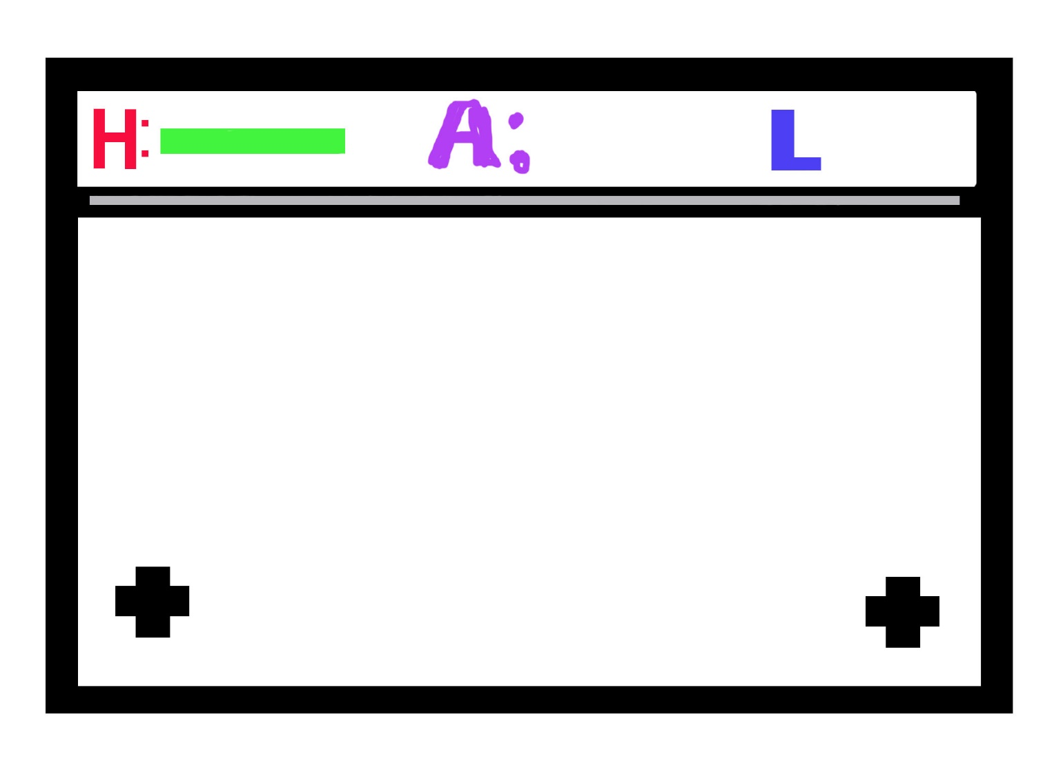

# Level Map

Include a physical drawing or a digital representation of the level; it may fill the whole page or be attached as a separate file.

**Map Key (Legend)**

Include a key or legend, and label the following on your map; you may change the label markers.

|  |  |  |  |  |  |
| --- | --- | --- | --- | --- | --- |
| Water Cooler Moments: |  | Player Start Point: |  | ***Main Actors***   Spawn Point: |  |
| Challenge Highlights: |  | Player Optimal Route: |  | ***Main Actors*** Routes/Behavior: |  |
| Objectives: |  | Player Alternate Route: |  | ***Supporting Actors***  Spawn Point: |  |
| Skill Tests: |  | Area End Point: |  | ***Supporting Actors*** Routes/Behavior: |  |