WRF Config Studio Website User Guide
Version: v1.0.0
Guide scope: online hosted use and local package use
Prepared for: WRF Config Studio website and GitHub documentation
WRF Config Studio is a browser-based configuration environment for WRF domain design, namelist.wps editing, namelist.input editing, WRFDA group review, OBSPROC export, and Registry metadata exploration. The application is designed to help users organize WRF configuration work before running the official WRF, WPS, WRFDA, and OBSPROC programs.
This guide covers both supported ways to use the website build:
- Online hosted mode, where the app is opened from a hosted website or GitHub Pages address.
- Local package mode, where the release package is extracted and served from the user's computer with a local HTTP server.
Important map note: WRF Config Studio v1.0.0 uses online map tiles only. The previous bundled offline vector-map fallback has been removed. Local package mode can run the app files from the user's computer, but the map background still requires network access to online tile providers.

1. What WRF Config Studio Does
WRF Config Studio helps users prepare and review WRF-family configuration files through one browser-based workspace.
It supports:
- interactive WRF domain creation and editing,
- namelist.wps workflow support,
- a full-catalog namelist.input editor,
- WRFDA groups inside namelist.input,
- OBSPROC records exported separately as namelist.obsproc,
- Registry metadata and documentation review,
- ARW Technical Note v4 scientific context, where available,
- required-field warnings before export,
- suggested starting values for selected timing and projection fields,
- 360-degree map wrapping and repeated-world display behavior,
- desktop touch-screen and trackpad support, and
- desktop browser support for Chrome, Edge, Firefox, and Safari.
The tool does not run geogrid.exe, ungrib.exe, metgrid.exe, real.exe, wrf.exe, obsproc.exe, or WRFDA executables. It prepares configuration files for review before the official tools are run.

2. Online Hosted Mode
Online hosted mode is the simplest way to use the app when the project is published through a website or GitHub Pages.

Steps
1. Open the public WRF Config Studio website address.
2. Wait for the map and side panels to load.
3. Open the Domains panel.
4. Create or edit the WRF domain.
5. Open the namelist.input editor if model namelist work is needed.
6. Save or copy the generated files.

What works online
In hosted mode, the browser loads the app from the website. Map tiles are also loaded online. This mode is best for training, demonstrations, classroom use, and quick review when a network connection is available.

Browser cache after website updates
After a new website build is published, browsers can keep older JavaScript, CSS, or JSON files in cache. Use a hard refresh after updates.
Common hard-refresh shortcuts:
Windows/Linux Chrome, Edge, Firefox: Ctrl+F5
macOS Chrome/Firefox: Cmd+Shift+R
macOS Safari: Option+Cmd+E, then reload

3. Local Package Mode
Local package mode is the recommended method when using the downloaded release package.

Steps
1. Download the WRF Config Studio release package.
2. Extract the package to a normal folder.
3. Start a local HTTP server from inside the extracted folder.
4. Open the local address printed by the launcher.
5. Use the application normally in the browser.

Use the included launchers
The package includes helper launchers:
START_LOCAL_SERVER.bat
START_LOCAL_SERVER.sh
START_LOCAL_SERVER.command
launch_local_server.py
On Windows, use:
START_LOCAL_SERVER.bat
On macOS or Linux, use:
START_LOCAL_SERVER.sh
or:
START_LOCAL_SERVER.command
The launcher starts on port 8000 when available. If that port is already in use, the launcher uses the next available port and prints the correct local URL.
Example:
Port 8000 is already in use. Using port 8001 instead.
Open: http://127.0.0.1:8001/

Use Python directly
From the extracted folder, run:
python -m http.server 8000
Then open:
http://127.0.0.1:8000

Local package mode versus offline map mode
Local package mode means the app files, runtime catalogs, documentation, examples, and source references can be served from the user's computer. It does not mean that the map background is fully offline. In v1.0.0, the map uses online tile providers only. If network access is unavailable, the map background may not render until the connection or tile provider becomes available.

4. Main Interface and Domain Intelligence
The Domains panel is the main starting point. It contains the New, Open, and namelist.input buttons, plus the Domain Intelligence tools used to help configure projection and grid behavior.
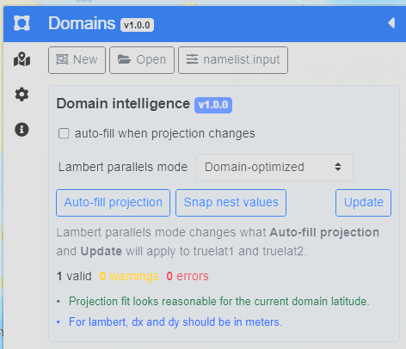
Figure 1. Domain Intelligence panel in the Domains sidebar. The panel shows the Lambert parallels mode selector, Auto-fill projection, Snap nest values, Update, validation messages, and projection notes.
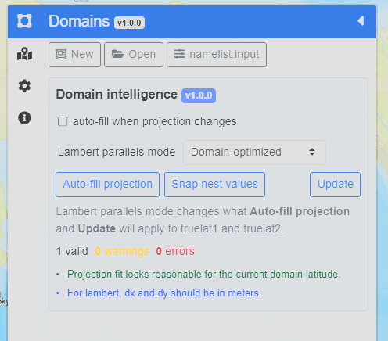
Figure 2. Domain Intelligence panel shown in the full sidebar context. The sidebar keeps the domain controls close to the map workspace so the user can review projection guidance while editing the domain.
The Domain Intelligence panel is designed as a helper, not an enforcement system. It can suggest projection values and report obvious configuration messages, but users remain responsible for reviewing the exported namelists and running the official WRF tools.

5. Lambert Parallels Mode
For Lambert conformal domains, the Lambert parallels mode selector controls how truelat1 and truelat2 are suggested when Auto-fill projection or Update is used.
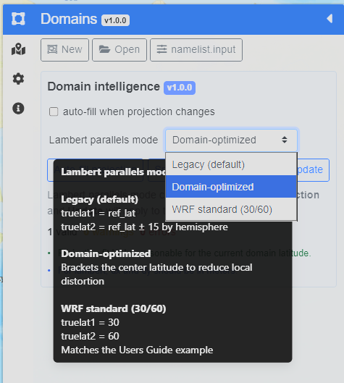
Figure 3. Lambert parallels mode selector and help text. The selector includes Legacy, Domain-optimized, and WRF standard 30/60 options. The tooltip explains how each mode affects truelat1 and truelat2.
The modes are:
- Legacy (default): uses the older behavior, with truelat1 = ref_lat and truelat2 = ref_lat +/- 15 by hemisphere.
- Domain-optimized: brackets the center latitude to reduce local distortion.
- WRF standard (30/60): uses truelat1 = 30 and truelat2 = 60, matching a common WRF Users Guide example.
Press Update after changing the mode so the selected behavior is applied to the current domain.

6. Creating and Editing Domains
To create a domain:
1. Open the Domains panel.
2. Select the projection type.
3. Press New.
4. Draw the domain on the map.
5. Move or resize the domain with the handles.
6. Review the WPS fields in the sidebar.
7. Press Update when changes need to be applied.
8. Save namelist.wps when the WPS configuration is ready.
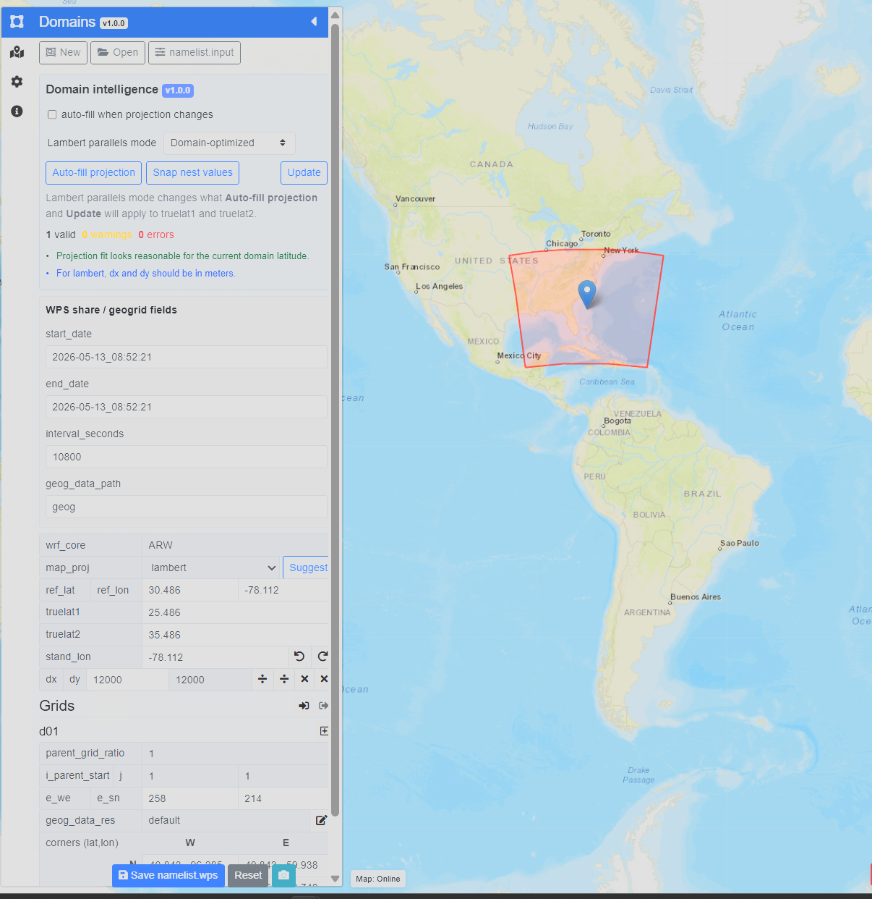
Figure 4. Domain editing with WPS fields visible. The map shows the active domain, and the sidebar shows WPS fields such as start_date, end_date, interval_seconds, geog_data_path, map_proj, ref_lat, ref_lon, truelat1, truelat2, stand_lon, dx, and dy.
The WPS section controls values exported to namelist.wps. These values should be checked before running geogrid.exe, ungrib.exe, or metgrid.exe.

7. Projection and Nest Examples
The map supports common WRF projection workflows, including Lambert conformal, Mercator, polar stereographic, and latitude-longitude configurations. The examples below show how the same UI can be used for different regions and projection choices.
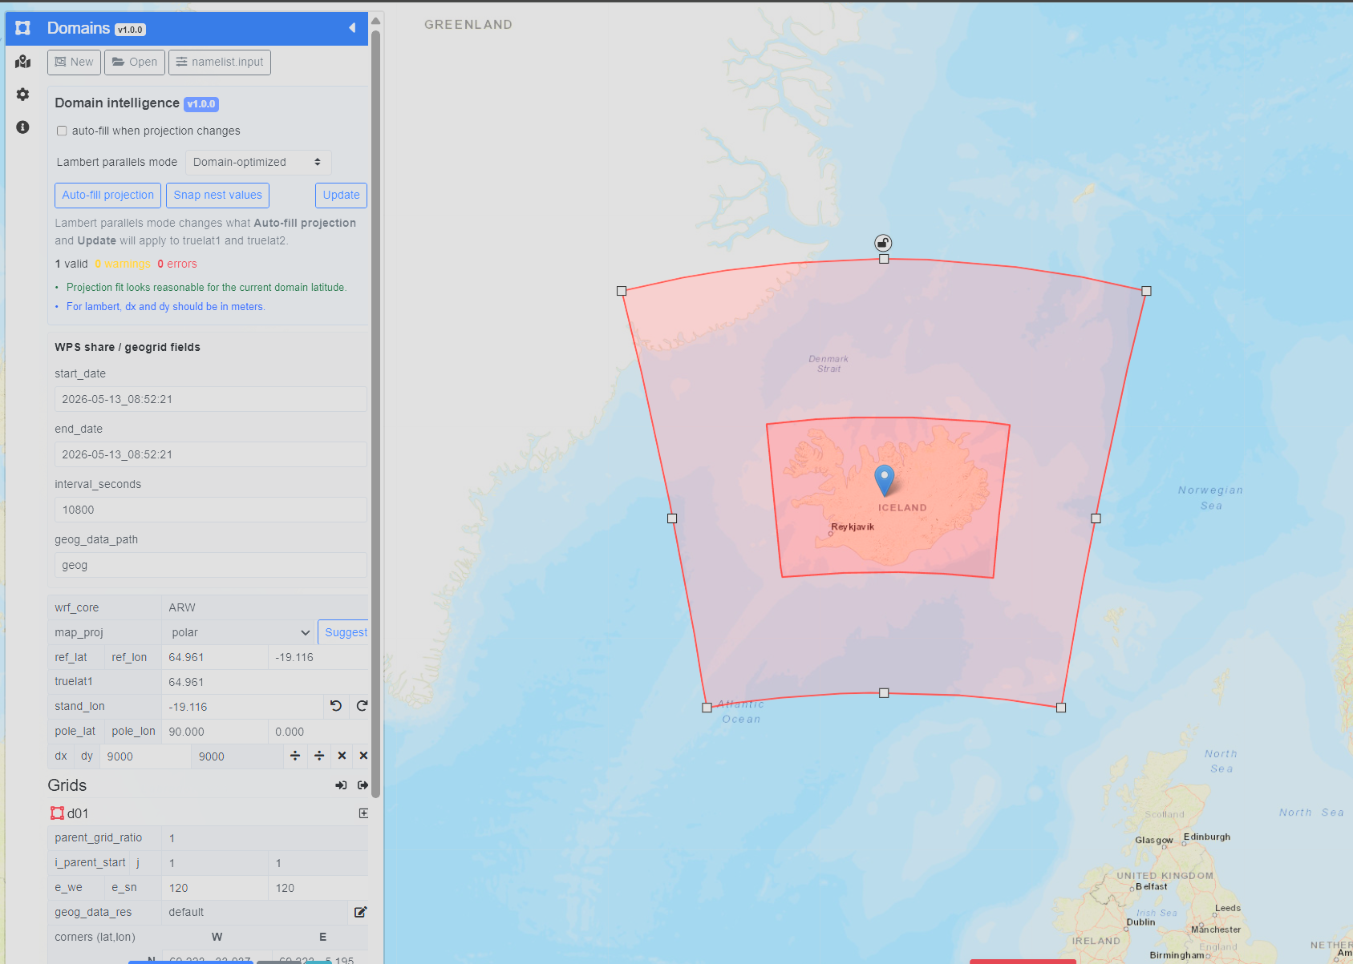
Figure 5. Polar projection example with a nested domain. The sidebar shows polar projection fields, and the map shows a parent domain with a nested grid over Iceland.
Nests are edited from the Grids section. Users should review parent_grid_ratio, i_parent_start, j_parent_start, e_we, e_sn, and geog_data_res before export. The application can help snap nest values, but users should still confirm that the nest placement makes sense for the forecast or research problem.

8. Full 360-Degree Map and Dateline Behavior
WRF Config Studio supports repeated-world map display and graticule behavior. This helps when users pan across the dateline or work near longitude wrap boundaries.
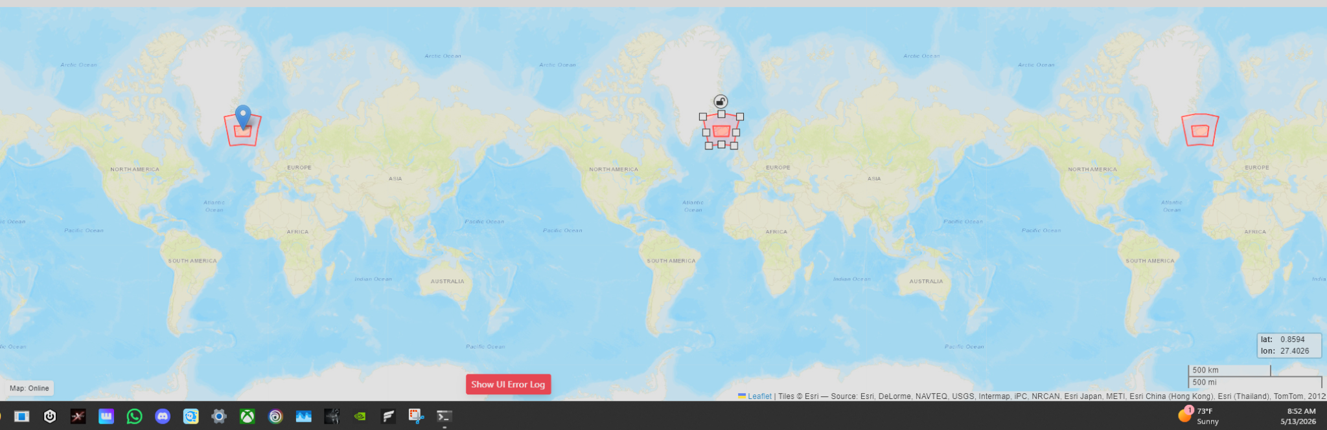
Figure 6. Full 360-degree repeated-world map display. The map can show repeated world copies while preserving canonical longitude values for export.
The visible map can repeat domains and graticules across world copies for editing convenience. This is display behavior only. Exported longitude values are normalized so users can review them in namelist.wps.
The map display is limited to approximately 85 degrees south to 85 degrees north because of Web Mercator display constraints. Users working near polar regions should inspect namelist.wps carefully and validate the domain through the official WPS tools.

9. Domain Size and Grid Warnings
WRF Config Studio includes visible warnings for selected structural issues, such as domains that are too small for typical WRF use.
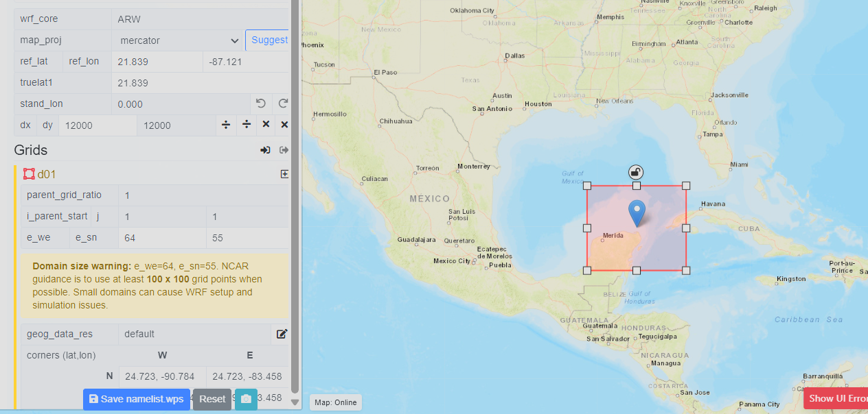
Figure 7. Domain size warning in the Grids section. The warning notes when e_we and e_sn are below commonly recommended minimum values.
Warnings are not the same as scientific validation. A warning should prompt the user to review the domain, grid spacing, nesting, and intended application before running WRF.

10. Settings Panel
The Settings panel controls map overlays and selected editor constraints.
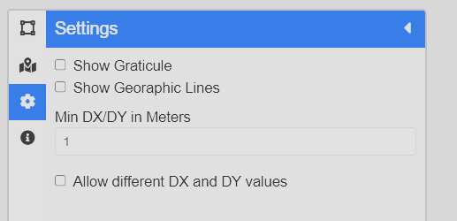
Figure 8. Settings panel. The Settings panel includes controls for graticule display, geographic lines, minimum DX/DY, and whether different DX and DY values are allowed.
The Show Graticule and Show Geographic Lines options control map overlays. The Min DX/DY in Meters field helps prevent accidental grid-spacing values that are too small for the intended workflow.

11. About, Credits, and Project Lineage
The About panel describes the current project, map behavior, lineage, credits, and original project references.
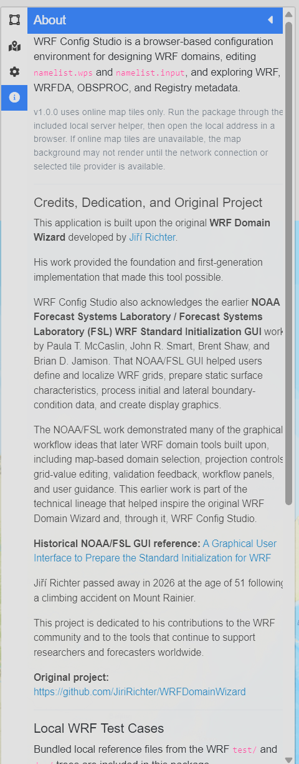
Figure 9. About panel with project lineage and credits. The About panel credits Jiří Richter and the original WRF Domain Wizard, acknowledges NOAA/FSL WRF Standard Initialization GUI work, and links to included references.
WRF Config Studio is built from the original WRF Domain Wizard lineage and acknowledges earlier NOAA/FSL graphical WRF configuration work. This lineage matters because map-based WRF configuration tools have a long history in the WRF community.

12. Full-Catalog namelist.input Editor
Press the namelist.input button in the Domains panel to open the full-catalog editor.
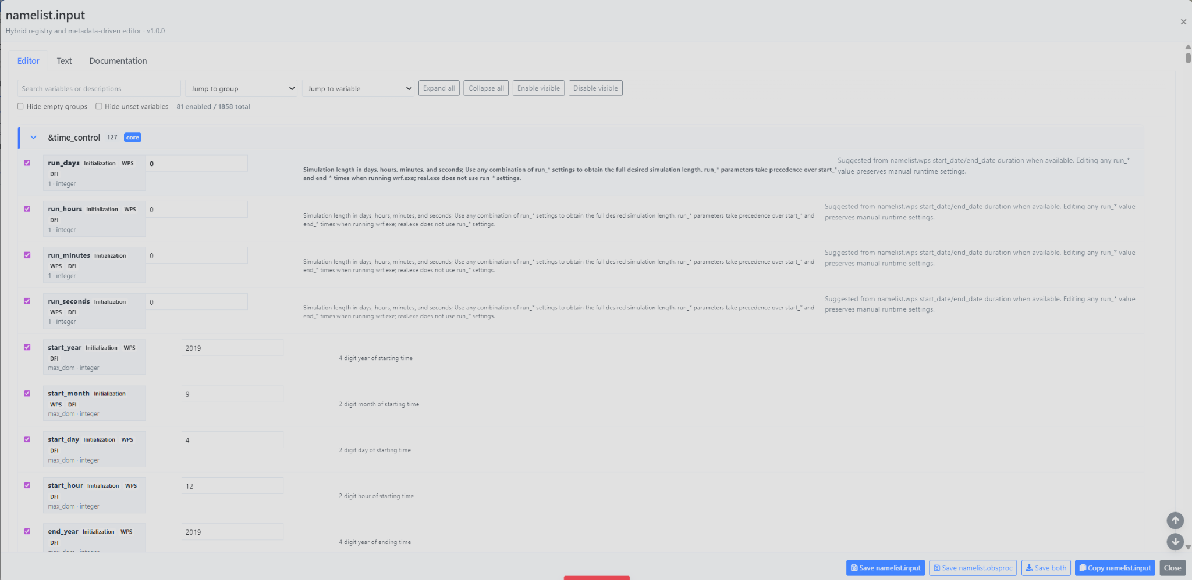
Figure 10. Full-catalog namelist.input editor. The Editor tab shows WRF groups, enabled fields, source labels, descriptions, values, and export controls.
The editor includes WRF core groups, WRFDA groups, OBSPROC record groups, Registry metadata, source notes, and documentation references. The current v1.0.0 policy is everything visible. The editor does not hide advanced variables, does not silently rewrite physics choices, and does not block export solely because compatibility metadata exists.
The top controls include:
- Search variables or descriptions,
- Jump to group,
- Jump to variable,
- Expand all,
- Collapse all,
- Enable visible,
- Disable visible,
- Hide empty groups, and
- Hide unset variables.

13. Jump to Group and Navigation
The editor can contain many groups and variables. The Jump to group menu is used to navigate quickly through the catalog.
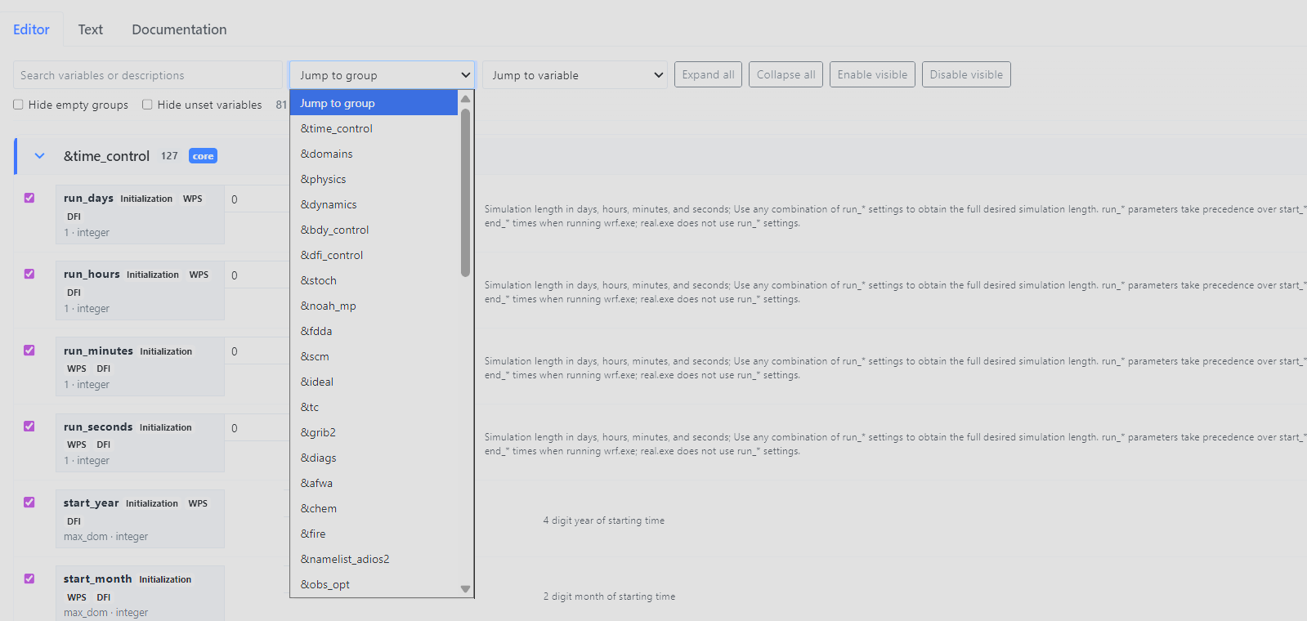
Figure 11. Jump to group menu in the namelist.input editor. The group selector provides quick access to WRF, WRFDA, physics, dynamics, diagnostics, chemistry, fire, and support groups.
Use the group and variable selectors when reviewing large configurations. This is especially useful when moving between &time_control, &domains, &physics, &dynamics, &wrfda, &obs_opt, and other specialized groups.

14. WRFDA and OBSPROC File Split
WRF Config Studio separates WRFDA and OBSPROC export behavior.

WRFDA
WRFDA groups remain in:
namelist.input
This includes &wrfvar* groups and related support groups such as &obs_opt, &radar_da, and &perturbation when enabled.

OBSPROC
OBSPROC records are visible in the editor as:
&obsproc_record1
&obsproc_record2
...
&obsproc_record9
During export, they are saved separately as:
namelist.obsproc
and written as:
&record1
&record2
...
&record9
This prevents OBSPROC records from being written into namelist.input while still allowing users to inspect related settings from one editor.

15. Save, Copy, and Export Controls
The WPS panel saves:
namelist.wps
The namelist.input editor footer includes:
Save namelist.input
Save namelist.obsproc
Save both
Copy namelist.input
Close
Use Save namelist.input for WRF and WRFDA configuration. Use Save namelist.obsproc for OBSPROC records. Use Save both when both files should be written from the same editor session.
The Text tab previews namelist.input only. OBSPROC records are exported separately through the namelist.obsproc save path.

16. Required-Field Warnings
If required namelist.input selections are blank, the editor warns before export. The user can cancel and return to the editor or continue intentionally.
This warning system is designed to prevent accidental incomplete exports while preserving user control. Some research or teaching workflows may require partial files, so WRF Config Studio warns rather than blocking every export.

17. Documentation Tab and Metadata
The Documentation tab gives users access to source material near the editor workflow. It includes links and reference panels for:
- WRF Users Guide namelist variables,
- WRF Registry files,
- run/README.namelist,
- WPS best practices,
- WRF best practices, and
- ARW Technical Note v4 scientific context, where available.
Select a variable in the Editor tab to review merged documentation, defaults, sources, and option metadata in the Documentation tab.

18. Recommended Workflow
A typical workflow is:
1. Open WRF Config Studio in online hosted mode or local package mode.
2. Open the Domains panel.
3. Draw or open a domain.
4. Choose the projection and grid settings.
5. Use Domain Intelligence helpers if needed.
6. Review namelist.wps fields.
7. Save namelist.wps.
8. Open the namelist.input editor.
9. Review &time_control, &domains, &physics, and other required groups.
10. Review WRFDA groups if data assimilation is part of the case.
11. Review OBSPROC records if observation processing is part of the case.
12. Save namelist.input, namelist.obsproc, or both.
13. Run the official WPS, WRF, WRFDA, or OBSPROC tools outside WRF Config Studio.
14. Review logs, model output, diagnostics, and verification results.

19. Troubleshooting

The app does not load local JSON or catalogs
Do not open index.html directly with file://. Start a local HTTP server and open the http://127.0.0.1 address.

Port 8000 is already in use
Use the included launcher. It automatically selects the next available port and prints the correct URL.

The map background is blank
WRF Config Studio v1.0.0 uses online map tiles only. Confirm that the computer has a network connection and that the browser can reach the selected tile provider.

The map or UI looks old after replacing files
Use a hard refresh.
Windows/Linux Chrome, Edge, Firefox: Ctrl+F5
macOS Chrome/Firefox: Cmd+Shift+R
macOS Safari: Option+Cmd+E, then reload

A required-field warning appears
Review the listed fields. Cancel to return to the editor, fill the missing values, and export again. Choose continue only if a partial export is intentional.

A domain size warning appears
Review e_we, e_sn, dx, dy, and the intended domain size. Small domains can cause WRF setup and simulation issues.

Lambert values do not look right
Check the Lambert parallels mode, then press Update. Review truelat1, truelat2, stand_lon, ref_lat, and ref_lon before saving namelist.wps.

20. Known Limitations
WRF Config Studio v1.0.0 does not:
- download meteorological input data,
- run WPS,
- run WRF,
- run WRFDA,
- run OBSPROC,
- ingest emissions,
- run WRF-Chem,
- analyze NetCDF output,
- replace WRF logs,
- replace official documentation, or
- determine whether a configuration is scientifically valid.
The map is an editing and visualization surface. It is not a numerical proof of domain validity. Users should still inspect exported namelists and run the official WRF-family tools.

21. Credits
WRF Config Studio is built on the original WRF Domain Wizard developed by Jiří Richter.
The project also acknowledges earlier NOAA Forecast Systems Laboratory / Forecast Systems Laboratory WRF Standard Initialization GUI work by Paula T. McCaslin, John R. Smart, Brent Shaw, and Brian D. Jamison.
The v1.0.0 documentation also preserves project lineage, release history, technical references, and the historical NOAA/FSL GUI reference material.

22. Quick Reference: Export Files
Workflow area | Exported file | Notes
WPS domain and preprocessing settings | namelist.wps | Saved from the Domains panel
WRF core configuration | namelist.input | Saved from the namelist editor
WRFDA groups | namelist.input | WRFDA remains inside namelist.input
OBSPROC records | namelist.obsproc | obsproc_record* groups export as record* groups
Registry and documentation metadata | not exported as model input | Used for reference and review

23. Quick Reference: Online and Local Use
Mode | Best for | Requirements | Map behavior
Online hosted mode | Website use, training, demonstrations, and quick review | Browser and network access | Online map tiles
Local package mode | Local package testing, classrooms, field laptops, and offline file access | Local HTTP server and browser | App files are local, but map tiles still require network access

