ASSIGNMENT 3 INFORMATION SECURITY HATIB ZUBAIR 241547206

[Assignment 3 COMP421](https://www.youtube.com/watch?v=-HUSz85ntAI)

[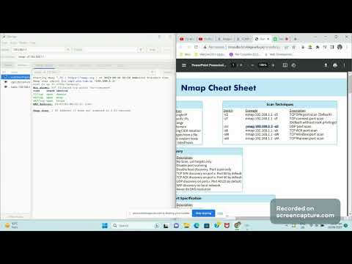](https://www.youtube.com/watch?v=-HUSz85ntAI)