Using Git&Github for storing&sharing, Eclipse for Java implementations, and MS SQL Server to build a database; we create a marketing management system to do the following:

• Normalization and Entity Relationship Model of your tables • CRUD operations • SQL functions • SQL stored procedures • SQL triggers • SQL Views

MARKETING DATABASE

21.03.2019

Ayberk Ece ÖRTEN & Hatice MENTEŞE

Marketing Database

Marketing Management Database for Database Systems2 Term Project

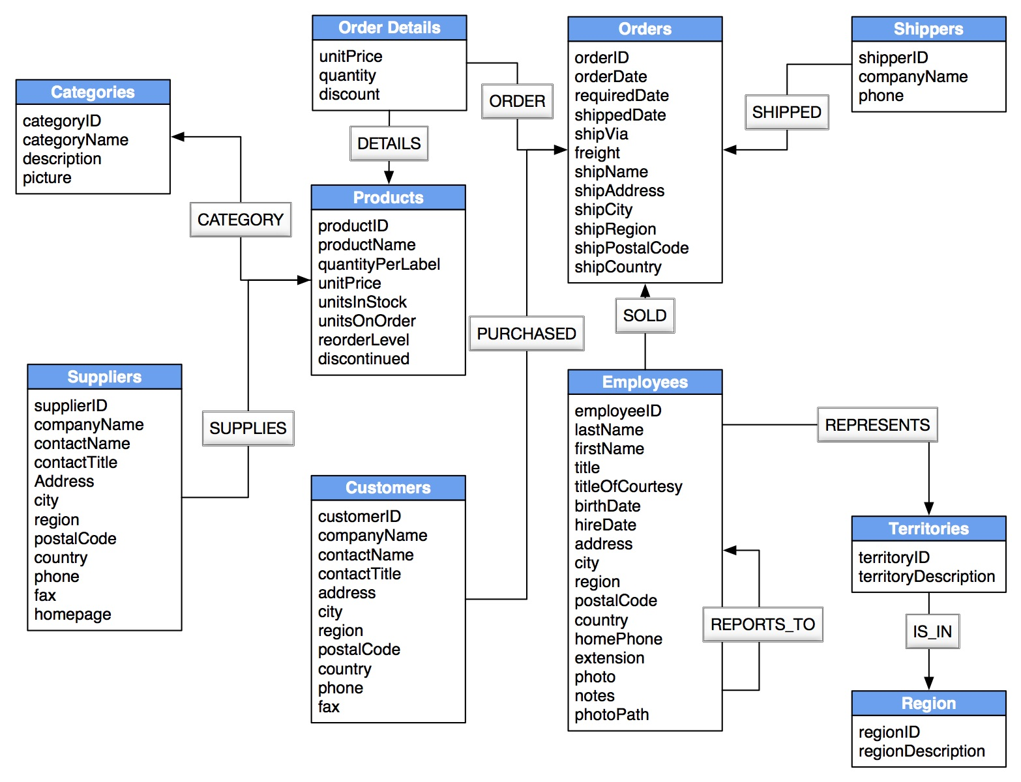

References: https://www.datapine.com/blog/daily-weekly-monthly-marketing-report-examples/