Online Charging System

System/Solution Requirements

Specification

(SRS)

0.Table of Contents………………………………………………………………….2

1.Document Overview…….. ……………………………………………………4

1.1 Scope & Purpose…………………………………………………………………………………………….4

1.2 Version Numbers & Standarts………………………………………………………………………..4

1.3 Audience………………………………………………………………………………………………………..4

1.4 Document Structure and Special Conventions………………………………………………..5

1.5 Definitions, Sysmbols and Abbreviations………………………………………………………..5

2.Functional Requirements……………………………………………………………6

2.1 Android/IOS…………………………………………………………………………………………………….6

2.2 Web…………………………………………………………………………………………………………………7

2.3 SMS Channel……………………………………………………………………………………………………7

2.4 IVR(Phone Call)………………………………………………………………………………………………..7

2.5 MW………………………………………………………………………………………………………………….7

2.6 KAFKA………………………………………………………………………………………………………………8

2.7 SF……………………………………………………………………………………………………………………..8

2.8 ORACLE…………………………………………………………………………………………………………….8

2.9 OCS…………………………………………………………………………………………………………………..8

2.10 VoltDB…………………………………………………………………………………………………………....8

2.11 DGW……………………………………………………………………………………………………………….8

2.12 Hazelcast…………………………………………………………………………………………………………8

2.13 TEST 1……………………………………………………………………………………………………………..9

2.14 TEST 2……………………………………………………………………………………………………………..9

2.15 TEST 3……………………………………………………………………………………………………………..9

3. Solution Overview……………………………………………………………………….10

3.1 Mobil Solution Overview……………………………………………………………………………………10

3.2 Web Solution Overview…………………………………………………………………………………….

3.3 Database Solution Overview……………………………………………………………………………..12

3.4 High Level Design Details…………………………………………………………………………………..15

4. DIAGRAM……………………………………………………………………………………17

5. End to End Use Cases………………………………………………………………….18

1-Document Overview

* 1. **Scope & Purpose**

The scope of this document is to provide system/solution requirements specification (SRS) tool for capturing of the System/Solution related to Account, CRM, OM and MW requirements in TURKUAZ project.

* 1. **Version Numbers & Standards**

This Specification has been produced by the i2i Systems (i2i) following 3GPP specifications alike versioning scheme and follows the recommendations of “IEEE Std 830-1998, IEEE Recommended Practice for Software Requirements Specifications” standard.

The contents of the present document are subject to continuing work and may be changed by i2i. Should the i2i modify the contents of the present document, it will be re-released with an identifying change of **release date** and an increase in **version number** as follows:

Version x.y.z

#### where:

#### the first digit:

* 1. presented for information;
  2. presented for approval;
  3. or greater indicates approved document under change control.

1. **the second digit** is incremented for all changes of substance, i.e. technical enhancements, corrections, updates, etc.
2. **the third digit** is incremented when editorial only changes have been incorporated in the document.

* 1. **Audience**

The document may be read by the below audience;

* Business/System Analysts
* Solution/System Architects

**1.4 Document Structure and Special Conventions**

### 

**1.5 Definitions, Symbols and Abbreviations**

|  |  |  |
| --- | --- | --- |
| **TERM** | **DESCRIPTION** |  |
| OCS | Online Charging Solution |
| API | Application Programming Interface |
|  |  |
|  |  |
| BSS | Business Support System |
| DB | Database |
| GUI | Graphical User Interface |
| SAS | System/Solution Architectural Specification |
| SRS | System/Solution requirements Specification |
| CDR | Call Data Record |
| WA | Workaround |
| SMS | Short Message Service |
| MMS | Multimedia Messaging Service |
| FTP | File Transfer Protocol |
| CCR | Credit Control Request |
| CCA | Credit Control Answer |
| 3GPP | Third Generation Partnership Program |
| UDR | Usage Data Record |
| MSISDN | Mobile Station International Subscriber Directory Number |
| IMSI | International Mobile Subscriber Identity |
| WS | Web Service |
| SOI | Service Oriented Interface |
| CMS | Content Management System |
| CRM | Customer Relations Management |  |
| OM | Order Management |
|  |  |

2-Functional Requirements

2.1.Android/IOS

1. On the Android-IOS main screen, a sign-up button and the necessary button to log in will appear.
2. After clicking the subscribe button, you will be able to register by entering your name, surname, phone number, e-mail, password security key information on the screen that opens.
3. The password should not be less than 8 digits and contain uppercase, lowercase and special characters.
4. The phone number will be just the number and start with the number 5.
5. Turkish characters will be supported.
6. The user who clicks on the forgot password button will be directed to the help screen.
7. The user who forgets his password on the help screen must enter his phone number on the help page and will be able to log in to his account with the sms/email password sent to the user's phone.
8. After the user enters the application, he will see the remaining minutes, internet, and sms information.
9. The subscriber should see up-to-date billing information in the application.
10. There will be an additional package button on the main screen and this button will go to the additional package screen and exit will be the change password button.
11. Subscriber must choose a package while registering.

**2.2.Web**

1. There will be a sign up and login button on the web login screen.
2. After clicking the sign up button, it will go to the user creation screen and you should register here by entering your name, surname, phone number, e-mail, security key information.
3. The password should not be less than 8 digits and contain uppercase, lowercase and special characters.
4. The phone number will be just the number and start with the number 5.
5. Turkish characters will be supported.
6. After clicking the login button on the web, there will be phone number and password entry on the login screen. There will be a remember me and forgot password button.
7. The user who clicks on the forgot password button on the web will be directed to the help screen. By entering the phone number on this screen, the user will be able to log in to his account with the sms password sent to his phone.
8. The user who logs in to the web will be able to see the billing information and phone tariff on the screen.
9. On the web home screen, the user will be able to see the remaining minutes of sms and internet information.
10. Subscriber must choose a package while registering.

**2.3.SMS Channel**

1. The remaining usage in the sms channel will be sent to the user's phone as an sms by contacting MW by typing "KALAN", "5555".
2. Incoming message in SMS channel must support Turkish characters.

**2.4.IVR(Phone Call)**

1. In the IVR (Phone call) section, the user will make a phone call and the remaining usage of the user will be communicated to the user audibly.
2. The speech message IVR sends to the user must support Turkish characters.

**2.5.MW**

1. MW will fetch usage or remaining query messages from CMR and send to VoltDB
2. CMR will send the message from VoltDB.
3. MW will send the remaining query message to VoltDB and retrieve the message from VoltDB.
4. MW will send the user's login information to Hazelcast.
5. It will send the feedback to MW whether the submitted request is true or false.
6. MW will receive data from SF.
7. The remaining tariff amounts, user information and user tariffs from MW SF will be sent to Oracle.
8. MW Oracle configurations and data insertion function will be written.
9. MW Oracle login, membership and balance will be created.
10. MW will send balance update transactions to Oracle.
11. MW will send an e-mail when the user forgets her password.

**2.6.KAFKA**

1. Kafka will be run on Google Cloud.
2. Kafdrop will be installed and run.
3. Topics will be determined and added in Kafka.
4. It will be connected to Kafka SF.
5. Connection will be established to get user data and usage data from Kafka OCS.

**2.7.SF**

1. SF will store new user information, tariff usage and user information from Kafka.
2. SF will send this stored data to MW.

**2.8.ORACLE**

1. User information, tariff usage, new user information and tariff information coming from Oracle MW will be stored in the database.
2. According to the message from Oracle Mw, the database will be updated.

**2.9.OCS**

1. As OCS subscribers use internet, sms and minutes, the amount used will be deducted from the subscriber's balance.
2. OCS will manage the tariffs of subscribers. In tariff management, it will determine the applicable tariffs and pricing for certain services.
3. OCS will send the tariffs it has determined and the amount of sms, internet and minutes that should be reduced from the user's account as a voltdb message.

**2.10.VOLTDB**

1. Updated tariff and used sms, minutes and internet from VoltDB OCS will be updated in its own database.
2. The user from VoltDB MW will receive the request for the remaining tariffs and will find this data and send it back to MW as a message.

**2.11.DGW**

1. An HTTP server will be created over Google Cloud.
2. DGW will receive random requests via Hazelcast.
3. DGW will send requests to OCS.

**2.12.Hazelcast**

1. Hazelcast virtual machine will be installed over Google cloud.
2. It will be possible to access the Hazelcast map from remote servers.
3. Necessary libraries for Hazelcast map will be created for MW.
4. Necessary libraries will be created for the Hazelcast map for DGW.
5. Necessary libraries will be created for the Hazelcast map for the simulator.
6. The simulator will send requests to DGW at regular intervals.
7. The simulator will randomly generate data, sms and minute data.
8. The simulator will send the random requests it generates to the hazelcast map.

**2.13.TEST 1**

1. Test 1 Perform functional tests for OCS to verify that it is properly managing and guiding user interactions.
2. Test 1 OCS should test the accuracy of tariff plans and pricing.
3. Test 1 should perform protocol compatibility test for DGW.
4. Test 1 should test to verify that the Dgw is successfully receiving and transmitting data. (Data reception, storage and transmission to the destination)
5. Test 1 Tests should be performed to verify that the integrity of the data passing over the DGW is maintained.
6. For Test 1 SF, functional tests should be performed to ensure that the system or software performs its basic functions and functions correctly.
7. Test 1 SF should perform data integrity testing to ensure that data integrity is correct and integrity is maintained.
8. For Test 1 Kafka, the data communication test should be performed to verify that the data is correctly arriving at kafka and received successfully by kafka.
9. Test 1 Kafka should perform data integrity testing.

**2.14.TEST 2**

1. Test 2 Perform an installation and configuration test to ensure that VoltDB is installed and configured correctly.
2. Test 2 Verify that VoltDB data insertions are saved and processed with the given success. Load test to ensure it can withstand workload and user traffic.
3. Test 2 Perform data integrity tests to verify the accuracy and integrity of data stored in VoltDB. Make sure that data additions, updates and deletions occur correctly.
4. MW's test will be tested on VoltDB, Hazelcast and Oracle.
5. Test 2 Perform installation and configuration tests to ensure that Hazelcast is installed and configured correctly.
6. Test 2 Perform tests on Hazelcast distributed data structures (map, set, list) these tests run distributed data structures tests to test that the data structure is created correctly and that data is inserted or retrieved.
7. Test 2 For Oracle DB, run installation and configuration tests to ensure that the Oracle database is set up and configured correctly.
8. Test 2 Run tests to verify that oracle db data is added, updated, and deleted correctly.
9. For Test 2 oracle DB, perform data integrity testing to maintain the integrity of the data.
10. Test 2 Test oracle database backup and recovery mechanisms.

**2.15.TEST 3**

1. Test 3 For Ios/Android on different devices (phone, tablet), manually test how the application responds to incorrect inputs, response time and speed.
2. Automatically test core functionality using Test 3 automation testing tools.(Katalon)
3. The password should not be less than 8 digits, contain uppercase, lowercase and special characters. This will be tested by entering data in different ways.
4. The phone number will be just the number and this will be tested by entering different digits starting with the number 5.
5. It will be tested that the user cannot click the button without entering all the boxes.

3-Solution Overview

3.1.Mobil Solution Overview

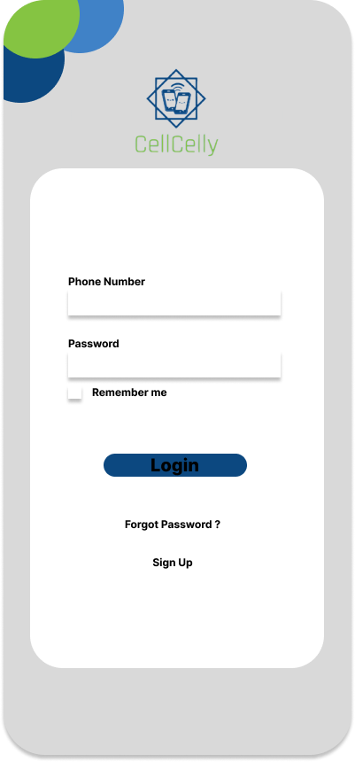 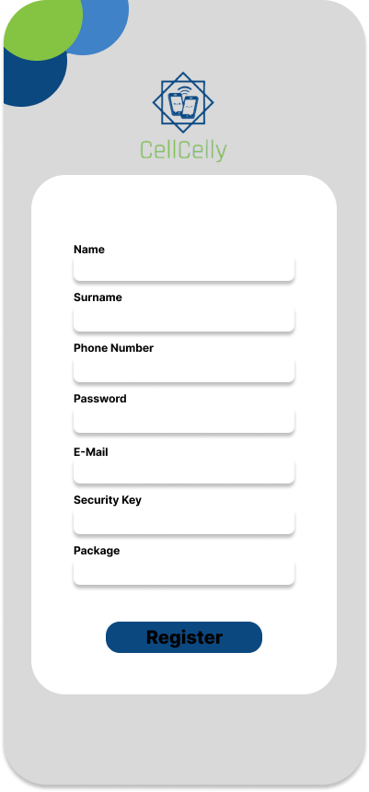

Figure. 1 Mobil-Login Figure.2 Mobil-Register

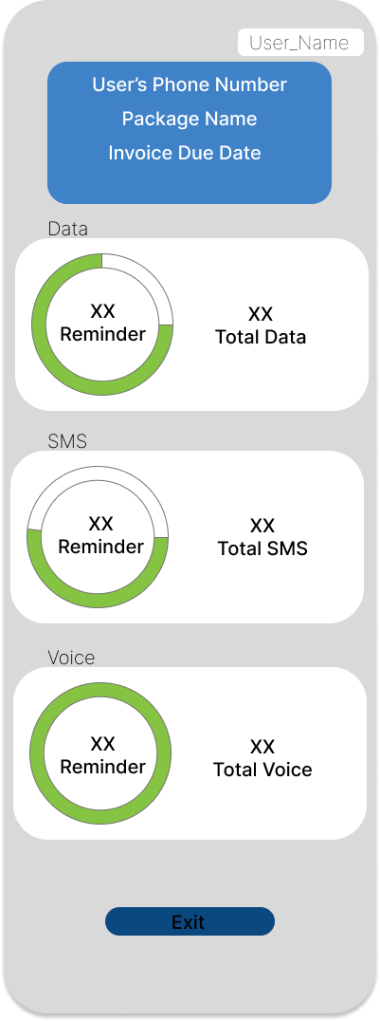 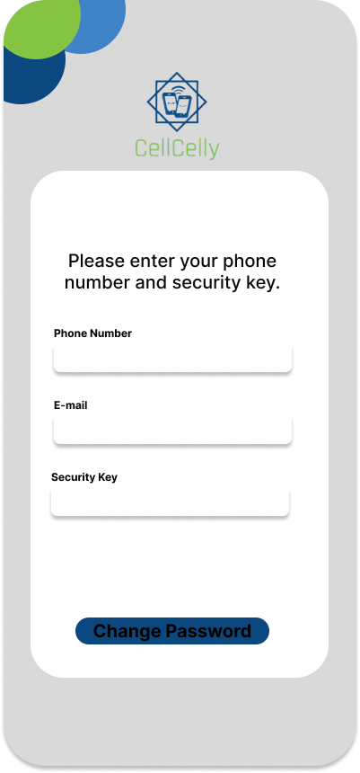

Figure.3 User Interface Figure.4 Forgot password

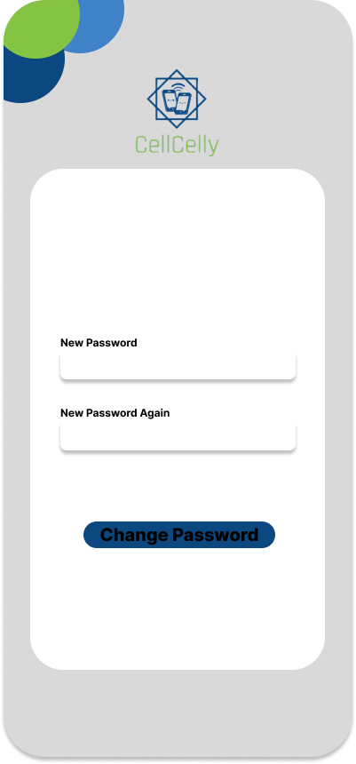

Figure.5 Change Password

3.2 Web Solution Overview

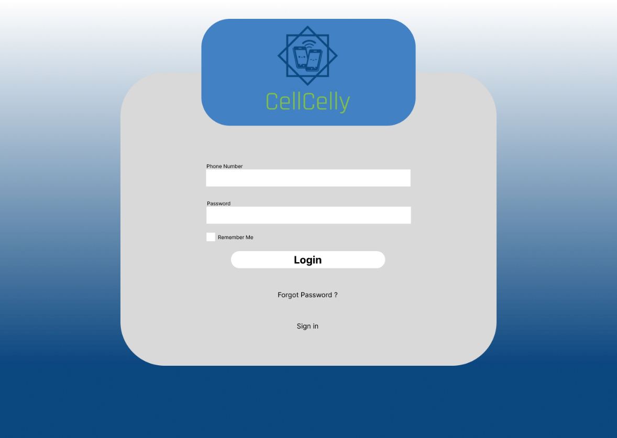

Figure.6 Login

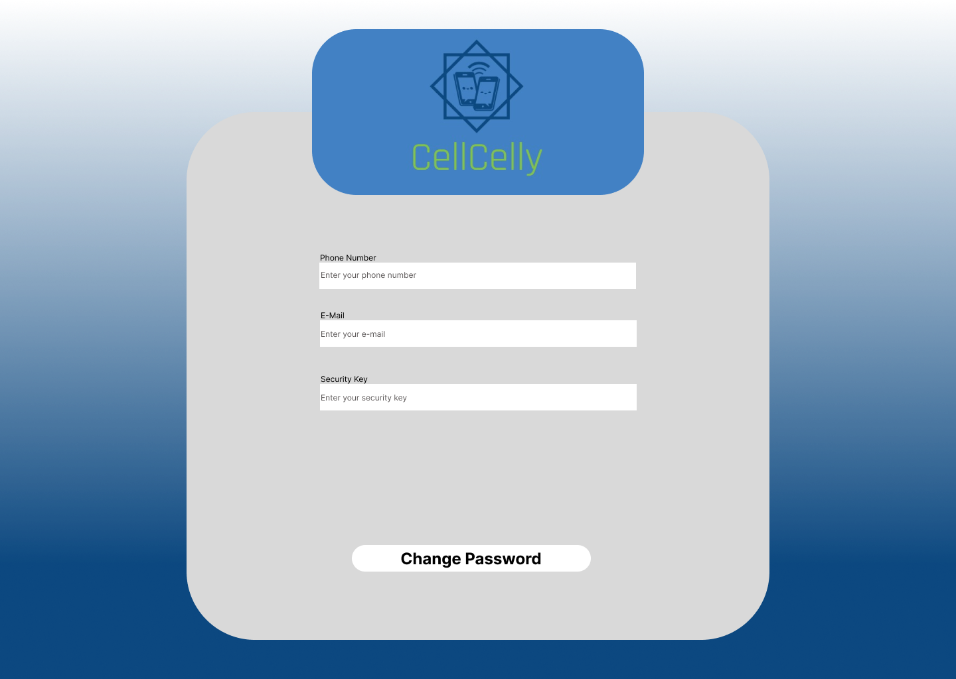

Figure.7 Forgot Password

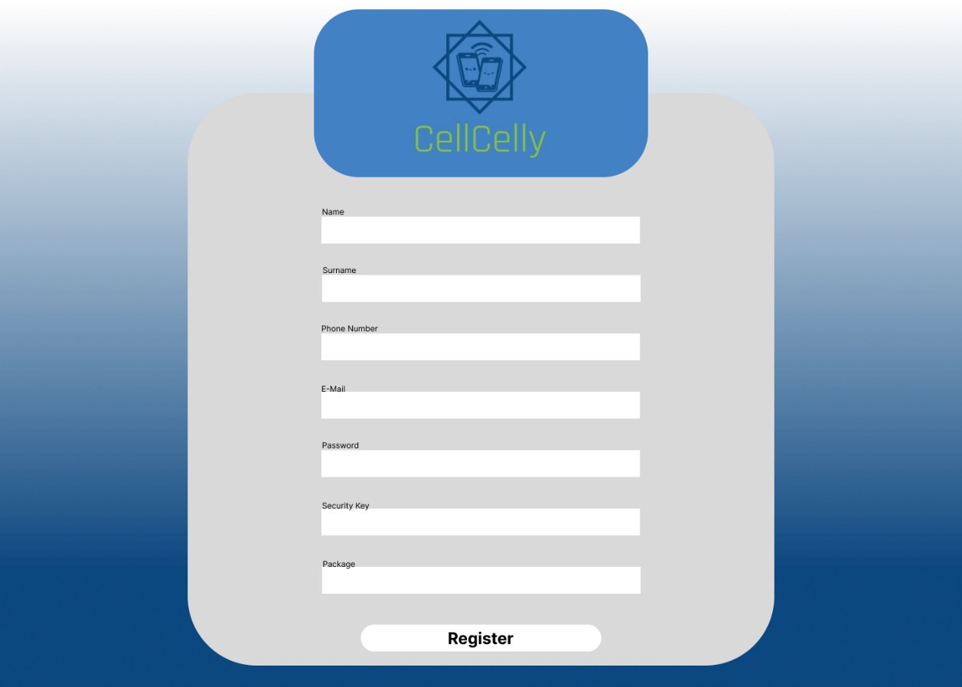

Figure.8 Register

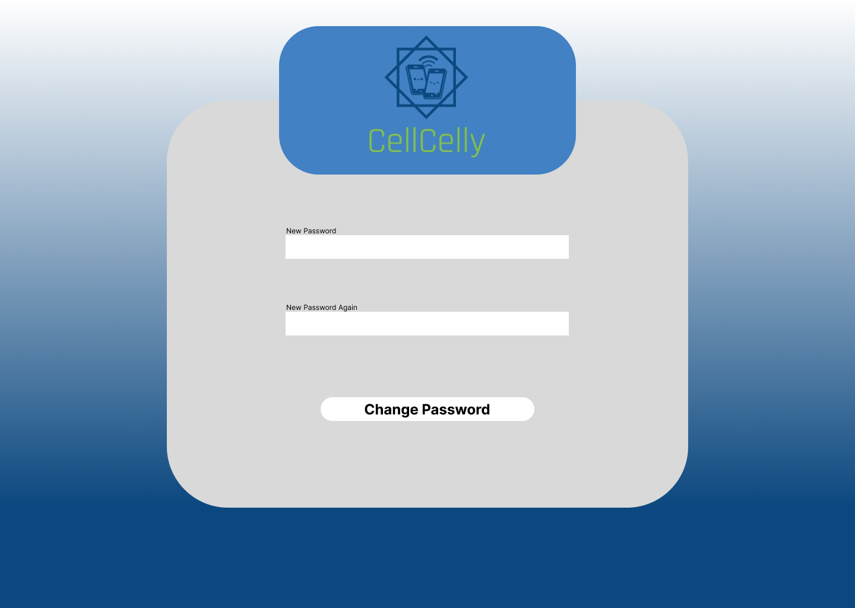

Figure.9 Change Password

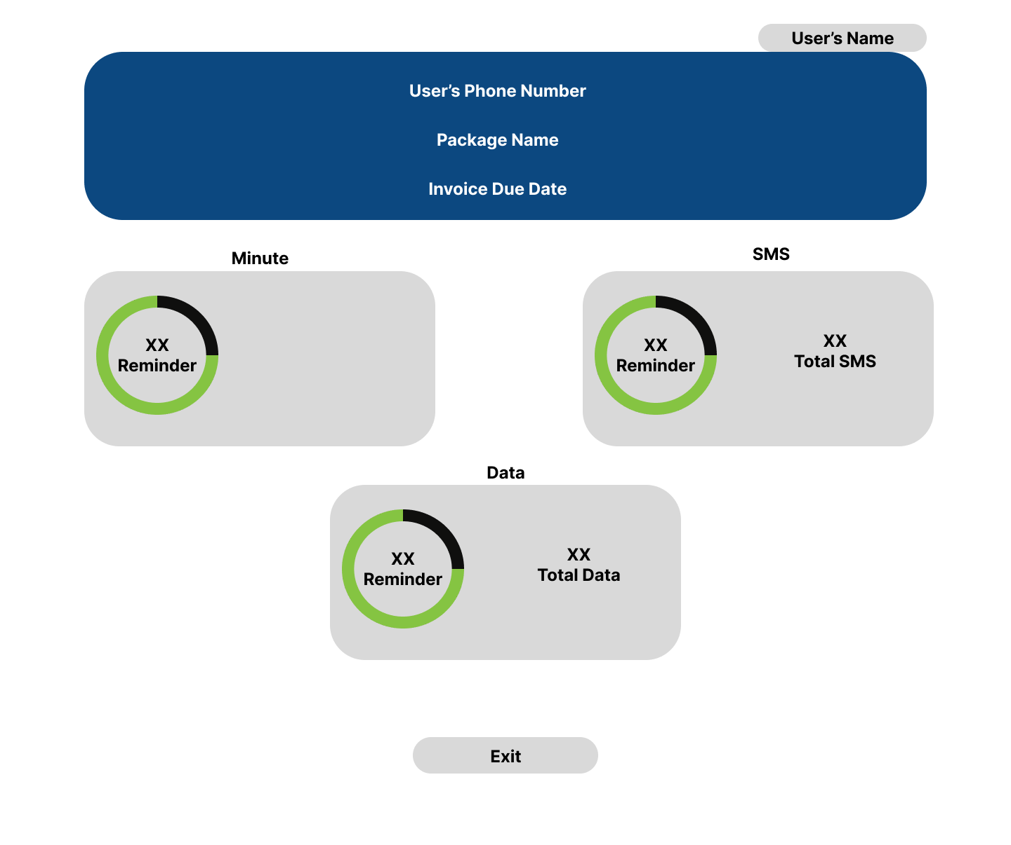

Figure.10 User Interface

3.3 Database Solution Overview

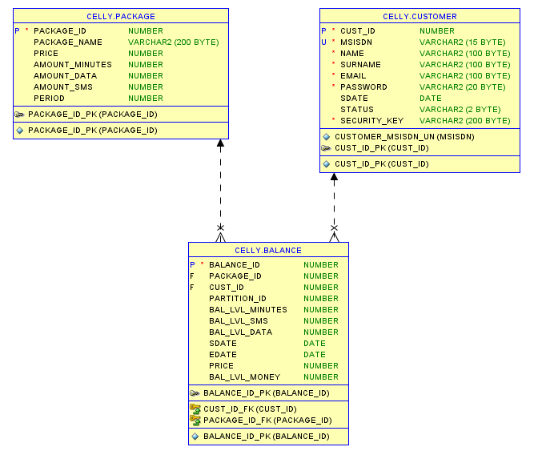

Figure 11 Database

3.4 High Level Design Details

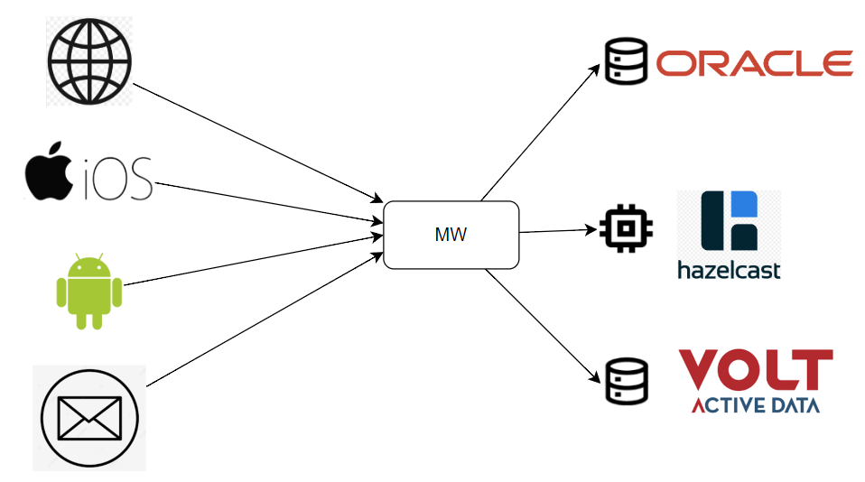

Figure.12 Message Delivery Diagram

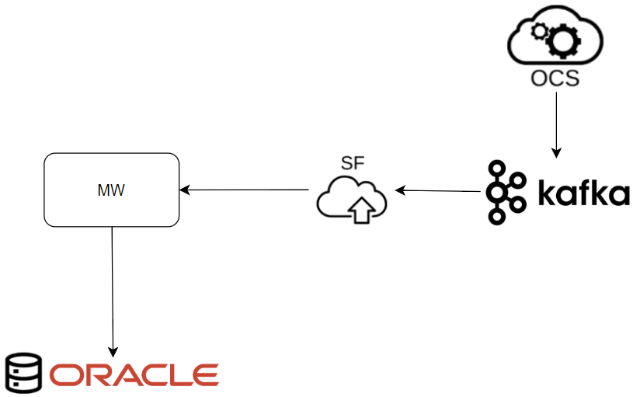

Figure.13 Oracle Data Sync

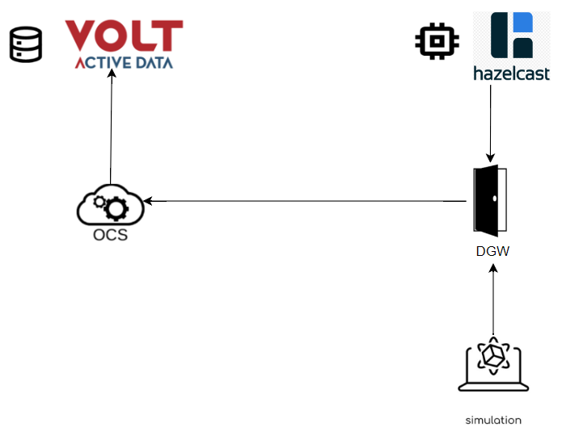

Figure.14

4.Diagram

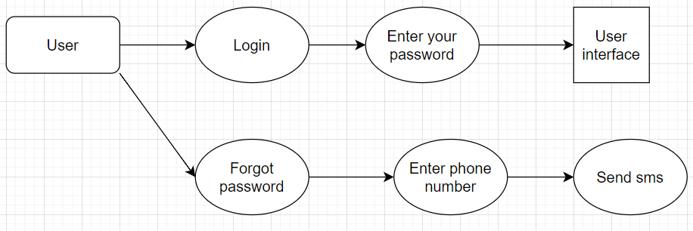

Figure.15 (Login/Forgot password)

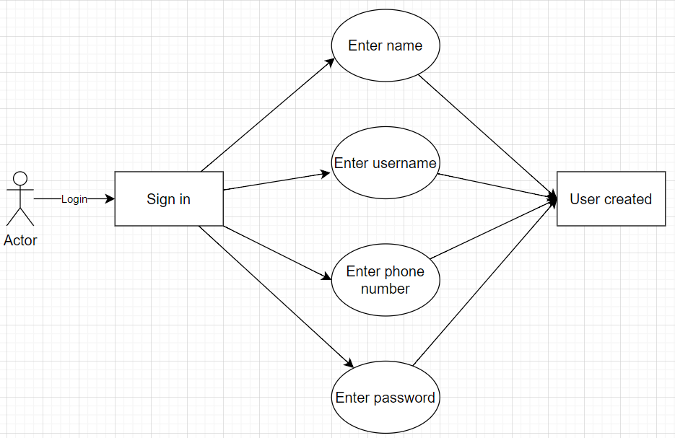

Figure.16 (Register)

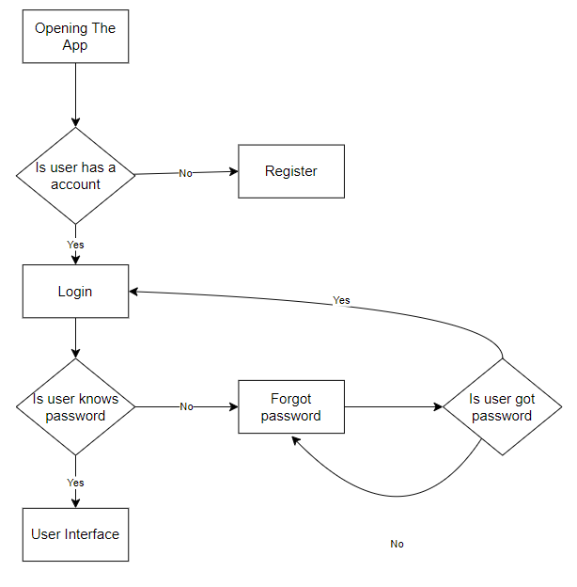

Figure.17 FlowChart

5.End to End Use Cases

**5.1. Use Case 1**

|  |  |
| --- | --- |
| **Summary** | Successful Login |
| **Impacted System Components** | OCS, DGW, MW,AOM, HAZELCAST, VOLTDB, KAFKA |
| **Pre-conditions** | In order for the subscriber to log into the system successfully, users must enter her/his information correctly. |
| **Post-conditions** | The user continues to log in to the system with the new password. |
| **Main Success Scenario** | 1-User enters his/her phone number and password information on the Login Screen and clicks Login button.  2-A check is made to match the user data in the database with the  entered information. If the information is correct, the user logs into the system. |

|  |  |
| --- | --- |
| **Alternate Flows** | Unsuccessful Login |
| **Exceptions/Erro rs** | If the user enters the wrong phone number and/or password, they cannot log into the system. |
| **Open Items** |  |
| **Functional Requirements** |  |

* 1. **Use Case 2**

|  |  |
| --- | --- |
| **Summary** | Unsuccessful Login |
| **Impacted System Components** | OCS, DGW, MW, HAZELCAST, VOLTDB, KAFKA |
| **Pre-conditions** | In order for the subscriber to log into the system successfully, users must enter her/his information correctly. |
| **Post-conditions** | The subscriber cannot log in to the system and receives a warning message. |
| **Main Success Scenario** | 1-User enters his/her phone number and password information on the Login Screen and clicks Login button.  2-A check is made to match the user data in the database with the entered information. If the information is incorrect, the user cannot log in to the system and receives a warning message. |

|  |  |
| --- | --- |
| **Alternate Flows** | Successful Login |
| **Exceptions/Erro rs** | If the information is correct, the user logs into the system. |
| **Open Items** |  |
| **Functional Requirements** |  |

* 1. Use Case 3

|  |  |
| --- | --- |
| **Summary** | Forget Password |
| **Impacted System Components** | OCS, DGW, MW, HAZELCAST, VOLTDB, KAFKA |
| **Pre-conditions** | The user must be registered in the system. |
| **Post-conditions** | The user logs into the system with the new password. |
| **Main Success Scenario** | 1-The user clicks the "Forgot Password" button on the Login Screen.  2-The user enters his e-mail address.  3-The user enters his security key.  4-The security code will be sent to e-mail addresses of the users.  5-The user will enter the code from the e-mail and click the change password button. |

* 1. Use Case 4

|  |  |
| --- | --- |
| **Summary** | Change Password |
| **Impacted System Components** | OCS, DGW, MW, HAZELCAST, VOLTDB, KAFKA |
| **Pre-conditions** | The user must be enter security code. |
| **Post-conditions** | The user logs into the system with the new password. |
| **Main Success Scenario** | 1. The user will enter her new password. 2. The user will re-enter the new password. 3. The user should click on the change my password button. |

5.5 Use Case 5

|  |  |
| --- | --- |
| **Summary** | Sign Up |
| **Impacted System Components** | OCS, DGW, MW, HAZELCAST, VOLTDB, KAFKA |
| **Pre-conditions** | The user must have an account. |
| **Post-conditions** | User successfully registers in the system |
| **Main Success Scenario** | 1. User registers to he/she system with her/his name, surname, password, phone number, e-mail and security key.      1. User must select one of the available packages. 2. The data registered by the user is saved in the database. |

|  |  |
| --- | --- |
| **Alternate Flows** | Unsuccessful Create Costumer |
| **Exceptions/Erro rs** | 1. In case of missing or incorrect data, the subscriber will not be able to register. 2. user must select an available package. The user cannot register without selecting an existing package. |
| **Open Items** |  |
| **Functional Requirements** |  |